Simulating the First-Fit Algorithm for Dynamic Memory Allocation
Zeng Xiong
Colorado State University Global
Foundations of Operating Systems
Dr. Schwartz
November 7, 2026

Simulating the First-Fit Algorithm for Dynamic Memory Allocation
In dynamic memory management within operating system kernels, allocating variable-sized memory contiguous blocks efficiently to requesting processes is a fundamental challenge. The operating system maintains a list of free memory blocks (often termed "holes") and must decide how to satisfy incoming process memory space requests without incurring prohibitive search latency or excessive external memory fragmentation.
Mechanics of the First-Fit Memory Allocation Algorithm
The First-Fit algorithm is a dynamic memory allocation strategy prioritized for its low runtime overhead and implementation simplicity. Its operation follows a sequential evaluation model:
- Free Block Inspection: The memory management unit maintains a linked list or array of free memory blocks indexed by memory address or entry order.
- Sequential Search: When a request arrives from a process requiring S kilobytes of memory, the allocator begins searching the free block list starting from the very first entry.
- Allocation Decision: The moment the search encounters a free block B where Size(B) >= S, the search terminates immediately, and process allocation occurs at block B.
- Splitting Remainder Space: If Size(B) > S, the block is partitioned into two parts: an allocated partition of exact size S assigned to the requesting process, and a remaining unallocated partition retained in the free block list for future process requests.
- Rejection Handling: If the complete free block list is traversed without locating any block where Size(B) >= S, the allocation request fails or is placed in a waiting queue due to insufficient contiguous physical memory.
Simulation Source Code
The complete Python simulation script for all four algorithms and the benchmarking suite is attached to this submission and accessible at https://github.com/zxiong1008/CSC507/blob/main/CSC507_M04_CT.py, or can be found below:

from time import perf_counter_ns

class MemoryBlock:
"""Represents a dynamic block of contiguous memory."""
def __init__(self, block_id, size):
self.block_id = block_id
self.size = size
self.allocated_to = None # None denotes unallocated (free) block

def __repr__(self):
status = f"Allocated to {self.allocated_to}" if self.allocated_to else "Free"
return f"[Block {self.block_id} | Size: {self.size} KB | Status: {status}]"

def simulate_allocation(blocks, processes, strategy):
"""Allocate processes using first-fit, next-fit, best-fit, or worst-fit."""
if strategy not in {"first", "next", "best", "worst"}:
raise ValueError(f"Unknown allocation strategy: {strategy}")

results = []
next_fit_start = 0
for proc_name, proc_size in processes.items():
if strategy == "next":
search_order = [
(next_fit_start + offset) % len(blocks)
for offset in range(len(blocks))
]
else:
search_order = range(len(blocks))

candidates = [
index
for index in search_order
if blocks[index].allocated_to is None and blocks[index].size >= proc_size
]

if not candidates:
results.append((proc_name, proc_size, None))
continue

if strategy in {"first", "next"}:
index = candidates[0]
elif strategy == "best":
index = min(candidates, key=lambda i: blocks[i].size)
else:
index = max(candidates, key=lambda i: blocks[i].size)

block = blocks[index]
original_size = block.size
block.allocated_to = proc_name
block.size = proc_size
results.append((proc_name, proc_size, block.block_id))

remaining_size = original_size - proc_size
if remaining_size > 0:
new_id = max(item.block_id for item in blocks) + 1
blocks.insert(index + 1, MemoryBlock(new_id, remaining_size))

if strategy == "next":
# Begin the next search immediately after this allocation.
next_fit_start = (index + 1) % len(blocks)

return results

def display_simulation(label, blocks, results):
print("==================================================")
print(f" {label.upper()} MEMORY ALLOCATION SIMULATION")
print("==================================================\n")

for proc_name, proc_size, block_id in results:
if block_id is None:
print(
f"Request: {proc_name} ({proc_size} KB) -> "
"FAILED: Insufficient contiguous space\n"
)
else:
print(
f"Request: {proc_name} ({proc_size} KB) -> "
f"SUCCESS: Allocated to Block {block_id}\n"
)

print("--------------------------------------------------")
print(" FINAL MEMORY ALLOCATION STATE")
print("--------------------------------------------------")
for block in sorted(blocks, key=lambda item: item.block_id):
print(block)
print()

def first_fit_allocation(blocks, processes):
"""Backward-compatible First-Fit simulation entry point."""
results = simulate_allocation(blocks, processes, "first")
display_simulation("First-Fit", blocks, results)

def create_initial_blocks():
return [
MemoryBlock(1, 100),
MemoryBlock(2, 500),
MemoryBlock(3, 200),
MemoryBlock(4, 300),
MemoryBlock(5, 600),
]

def benchmark_algorithms(processes, iterations=10_000):
"""Print average runtime per simulation; timings depend on the machine."""
strategies = (
("First-Fit", "first"),
("Next-Fit", "next"),
("Best-Fit", "best"),
("Worst-Fit", "worst"),
)

print("==================================================")
print(f" BENCHMARK ({iterations:,} SIMULATIONS PER ALGORITHM)")
print("==================================================")
print(f"{'Algorithm':<12} {'Average time (µs/run)':>24}")

for label, strategy in strategies:
# Warm up once before measuring each strategy.
simulate_allocation(create_initial_blocks(), processes, strategy)

start = perf_counter_ns()
for _ in range(iterations):
simulate_allocation(create_initial_blocks(), processes, strategy)
elapsed_ns = perf_counter_ns() - start
average_us = elapsed_ns / iterations / 1_000
print(f"{label:<12} {average_us:>24.2f}")

if __name__ == "__main__":
# Process allocation requests in sequential arrival order
process_requests = {
"Process_1": 210,
"Process_2": 410,
"Process_3": 110,
"Process_4": 420,
}

algorithms = (
("First-Fit", "first"),
("Next-Fit", "next"),
("Best-Fit", "best"),
("Worst-Fit", "worst"),
)

for label, strategy in algorithms:
blocks = create_initial_blocks()
results = simulate_allocation(blocks, process_requests, strategy)
display_simulation(label, blocks, results)

benchmark_algorithms(process_requests)

Empirical Benchmark Results & Algorithm Breakdown
1. First-Fit Strategy
- Purpose & Limitations: Allocates the first matching block for maximum speed. Over time, small residual fragments accumulate at the start of memory.
- Empirical Performance: Achieved the fastest runtime (11.49 μs/run), but failed to allocate Process_4 (420 KB) due to early external fragmentation.

Figure 1
First-Fit output
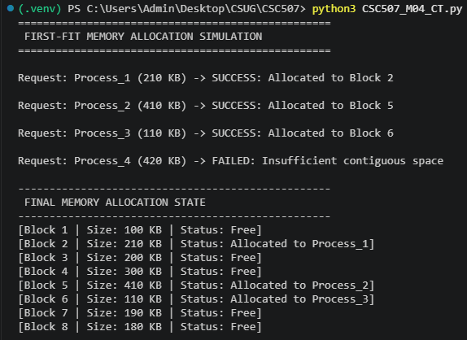
2. Next-Fit Strategy
- Purpose & Limitations: Resumes searches from the last allocation point to avoid front-end scanning, but tends to break up large memory blocks near the end of the address space.
- Empirical Performance: Ran at 15.81 μs/run and failed to allocate Process_4 (420 KB) due to fragmented tail blocks.

Figure 2
Next-Fit output
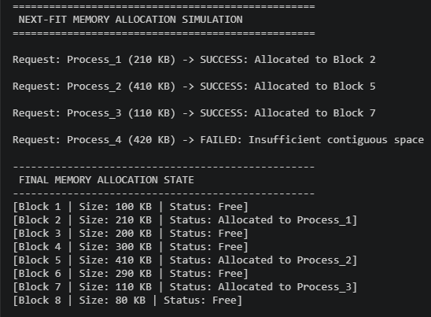
3. Best-Fit Strategy
- Purpose & Limitations: Scans the entire free list to find the block closest in size to the request, minimizing immediate wasted space but leaving tiny, scattered splinters.
- Empirical Performance: Was the only strategy with a 100% success rate, successfully allocating all four processes by preserving large contiguous blocks. It incurred the highest runtime overhead (16.26 μs/run).
Figure 3
Best-Fit output
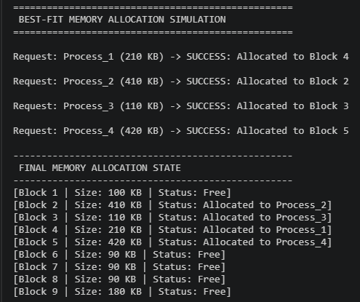
4. Worst-Fit Strategy
- Purpose & Limitations: Allocates the largest available block so leftover space remains usable, but rapidly exhausts large contiguous partitions required for future heavy requests.
- Empirical Performance: Ran at 14.01 μs/run and failed to allocate Process_4 (420 KB) after consuming the largest block prematurely.
Figure 4
Worst-Fit output
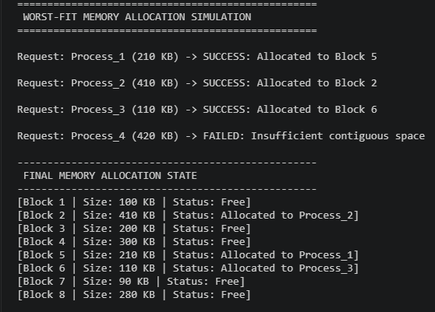
Below is an overview of each tested strategy based on 10,000 simulation runs evaluating Process_1 (210 KB), Process_2 (410 KB), Process_3 (110 KB), and Process_4 (420 KB).

Table 1
Benchmark Summary (10,000 Iterations)
Algorithm | Average Time (μs/run) | All Processes Allocated? | Primary Failure / Success Factor
First-Fit | 11.49 | No (P4 Failed) | Fast search exit; high early fragmentation
Next-Fit | 15.81 | No (P4 Failed) | Avoids front scanning; splits late memory blocks
Best-Fit | 16.26 | Yes (100% Success) | Preserved large blocks via tight initial matching
Worst-Fit | 14.01 | No (P4 Failed) | Prematurely depleted largest memory block

Figure 5
Benchmark time
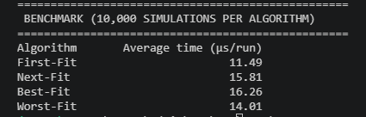
Comparative Analysis & Best-Fit Preference Scenarios
While First-Fit delivers superior speed (11.49 μs/run vs 16.26 μs/run for Best-Fit), Best-Fit is preferable in specific operational contexts:
- Preserving Large Memory Contiguity: As demonstrated in testing, Best-Fit preserves large unallocated blocks for high-memory processes by tightly matching smaller requests first.
- Memory-Constrained & Embedded Systems: In devices with fixed physical RAM, maximizing packing density outweighs short-term allocation latency.
- Long-Running Server Workloads: For persistent microservices allocated at initialization, long-term memory compactness is far more valuable than microsecond-level allocation speed.
References
Colorado State University Global. (2026). Module 4 Overview: Memory Management https://csuglobal.instructure.com/courses/123286/pages/module-4-overview?module_item_id=6638177

