Streaming One Million Numbers: Python Option 2
Zeng Xiong
Colorado State University Global
Foundations of Operating Systems
Dr. Schwartz
November 7, 2026

Streaming One Million Numbers: Python Option 2
For this milestone, I selected Python option 2: reading one line of a file at a time, doubling the number on that line, and writing the result to an output file. I chose this method because it can process a large file without loading all its contents into memory at once. To compare its performance with the other approaches described in the assignment, I also ran Python methods that read the entire file into memory and split the file into two parts. I additionally compared these methods with a Bash script that processes the input line by line.

Method
The standalone Python program reads each line of `file1.txt`, converts it to an integer, doubles it, and writes the result to `newfile1.txt`. It records the number of rows processed and the elapsed time. The program was tested with one million rows, and its output was checked to confirm that every result was twice its corresponding input.
The Python benchmark tested three methods: reading the entire file into memory, processing one line at a time, and reading the file in two parts. Each method was run three times, and the median execution time was recorded. The timed interval included reading, processing, and writing, but excluded the separate output-validation pass. The Bash script used AWK to process the input one line at a time. It was run once, so its result is not a median.
The comparative benchmark used the same Linux virtual machine and input file for Python and Bash. The standalone Python script’s reported 16.090-second run was performed separately on Windows, so it should not be directly compared with the Linux benchmark timings.
The standalone option 2 script processed and validated one million rows in 16.090 seconds during its separate Windows run, as shown in Figure 1. The screenshot below shows the standalone script’s output.
Figure 1
Standalone Python Option 2 Output
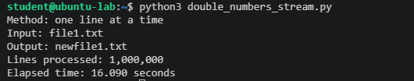
In the Linux benchmark (shown in Figure 2), the entire-file Python method had the shortest measured time, at 10.643 seconds. The two-part method took 13.163 seconds, and option 2, the line-by-line method, took 18.228 seconds. All three methods produced one million correct output rows. The benchmark output is shown below.
Figure 2
Three-Method Python Benchmark Output

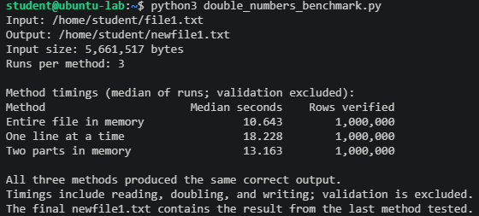
The Bash/AWK script completed in 30.889 seconds and produced one million validated rows, as shown in Figure 3. Its output is shown below.
Figure 3
Bash/AWK Script Output
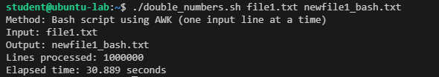
Discussion
The benchmark showed that the entire-file Python method was fastest in this test, while Python option 2 was slower. This surprised me because I initially expected line-by-line processing to be faster due to its lower memory use. The results show that execution speed and memory use are separate considerations. Reading and processing all the data together can be faster, but it requires more memory for the input and intermediate data.
The main advantage of option 2 is that it processes one line at a time rather than keeping the entire file in memory. This makes it useful when the input is too large to fit comfortably in available memory. The two-part method offered a compromise: it processed sections of the input separately and had a runtime between the whole-file method and the line-by-line method.
The Bash/AWK result was slower than the Python results in this run. However, the comparison is limited because the Bash result is from one run, while the Python results are medians of three runs. System load, virtual-machine resources, storage speed, and file-system caching may also affect the timings. Repeating the Bash/AWK test several times and reporting a median would make the comparison more consistent. The standalone Windows timing is reported separately because it was not measured under the same conditions as the Linux benchmark.

Conclusion
Python option 2 successfully doubled all one million numbers while processing the input one line at a time. Although it was not the fastest Python method in the Linux benchmark, it uses less working memory than reading the entire file into memory. This experiment showed me that the best method depends on the goal: whole-file processing may be faster when memory is available, while streaming may be preferable when memory is limited or the file is very large. The results are specific to the tested environment and should not be treated as universal performance rankings.

References
Colorado State University Global. (2026). Module 4 Overview: Memory Management https://csuglobal.instructure.com/courses/123286/pages/module-4-overview?module_item_id=6638177

