Module 5: Critical Thinking
Zeng Xiong
Colorado State University Global
Design and Analysis of Algorithms
Dr. Gonzalez
September 19, 2026

Source code file with hash table implementation including hash function and collision handling
The script file for the hash table function and collision implementation is written in python integrated with a react app. The logic which performs the stack can be found on my github source repository or the attached hash_table.py file at line 11:
https://github.com/zxiong1008/CSU506-Lab/blob/main/api/hash_table.py
Source code file with priority queue implementation using binary heap
The script file for the priority queue implementation is written in python integrated with a react app. The logic which performs the stack can be found on my github source repository or the attached priority_queue.py file at line 12:
https://github.com/zxiong1008/CSU506-Lab/blob/main/api/priority_queue.py
Test program that inserts, searches, and deletes items from both data structures
Figures 1 through 6 demonstrate the practical execution and correctness of the underlying implementations for both data structures by capturing the active console output for each core operation. Figures 1, 2, and 3 illustrate the hash table successfully handling item insertion, key searching, and element deletion, verifying that the chosen hash function and collision resolution scheme maintain key-value association and memory integrity throughout state modifications. Similarly, Figures 4, 5, and 6 display the binary-heap-based priority queue during insertion, search, and deletion, confirming that the heap property is continuously restored and preserved as dynamic updates occur. Together, these figures confirm that both data structures correctly execute basic collection operations without runtime exceptions or structural corruption.
Figure 1
Hash insert
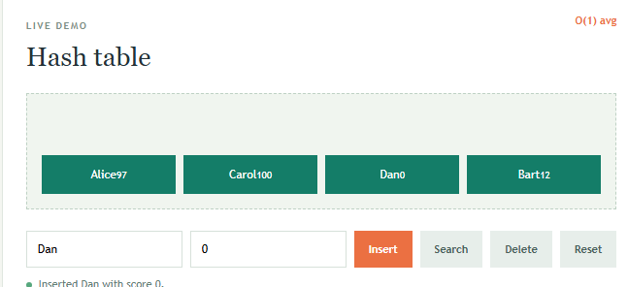
Figure 2
Hash search
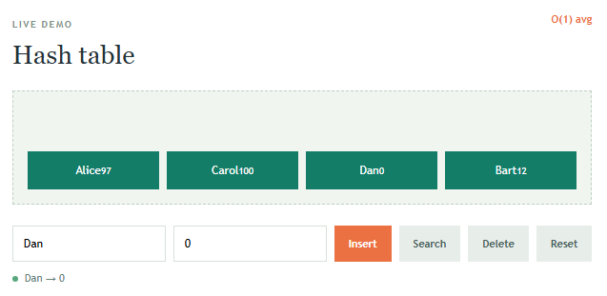

Figure 3
Hash delete
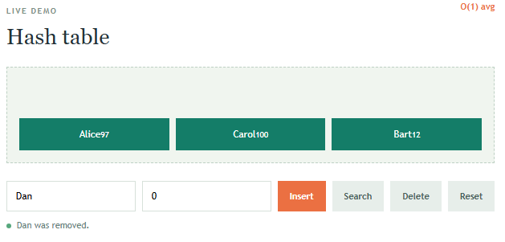
Figure 4
Priority queue insert
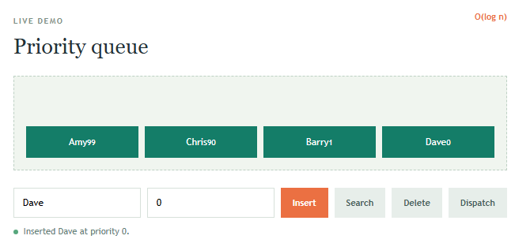

Figure 5
Priority queue search
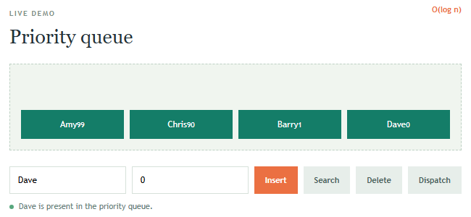
Figure 6
Priority queue delete
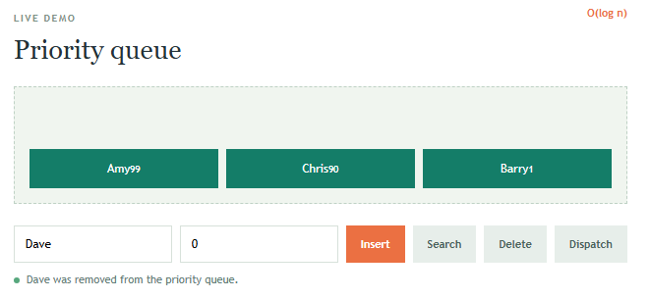

Performance comparison results showing hash table vs. linear search execution times
Figure 7 presents an empirical benchmark comparing the execution times of lookup operations between a hash table and a linear search implementation across 100 lookup iterations. As shown in the performance results, the hash table completed 100 lookups in approximately 0.119 ms, whereas the linear search required 0.353 ms to finish the same workload. This performance gap highlights the core trade-off between the two approaches: while a linear search exhibits O(n) average and worst-case time complexity by sequentially checking elements, a properly structured hash table leverages direct key indexing via a hash function to achieve average O(1) time complexity, leading to significantly faster operation times as search size scales.
Figure 7
Performance comparison matrix and definition for Big O notation
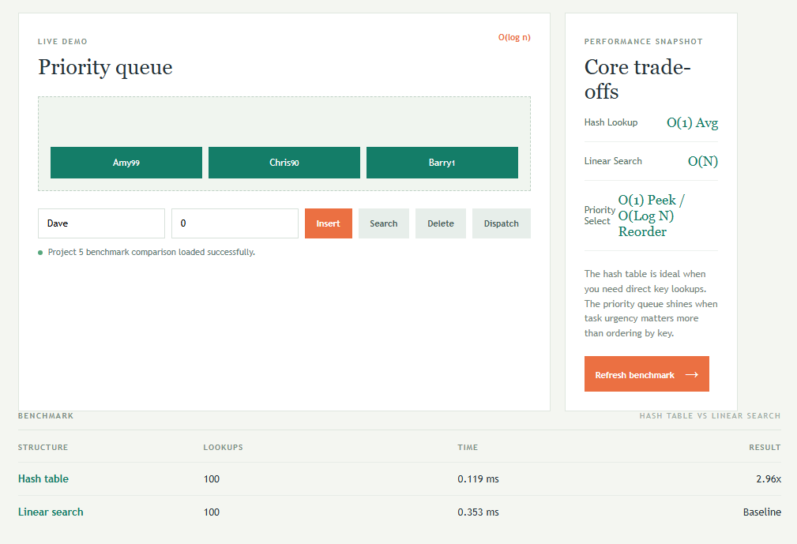
Written explanation (2 pages) describing your hash function choice and collision resolution method
To optimize a priority queue for logarithmic time arbitrary deletions and priority updates, incorporating a secondary hash map is essential to track the current index of each element within the underlying heap array. Designing this hash map requires a careful selection of both a robust hash function and an efficient collision resolution strategy to maintain near constant time lookup performance during intense algorithmic execution.
For the hash function, a multiplicative hashing scheme combined with a bitwise mixing step, which is similar to the principles behind MurmurHash, serves as the ideal choice. When dealing with generic keys such as unique item IDs, strings, or object references, raw hash codes or basic modulo arithmetic frequently lead to severe clustering if keys share common incremental patterns. To prevent this vulnerability, the chosen function takes the initial hash value, multiplies it by a large odd prime constant, and applies bitwise XOR folding operations. This multi stage transformation diffuses the bits thoroughly across the entire range of table indices, ensuring that even sequentially generated keys map to widely separated buckets and drastically reducing hash collision frequency.
For collision resolution, Open Addressing with Quadratic Probing is selected over separate chaining strategies. In performance critical data structures like an indexed priority queue, central processing unit cache locality is paramount for maintaining high execution speeds. Separate chaining relies heavily on pointers pointing to linked lists residing in scattered heap memory locations, which invariably causes expensive cache misses during structural traversal. Open addressing stores all entries inside a single, flat contiguous array structure. When a collision occurs, quadratic probing checks alternative slots using a growing quadratic function. This completely eliminates primary clustering, which is the tendency of occupied slots to form dense contiguous blocks, while keeping memory overhead minimal and maximizing overall cache performance. To prevent clustering degradation and long probe sequences over time, the table maintains a strict load factor threshold of 0.75, which automatically triggers a comprehensive resize and rehash operation whenever capacity exceeds this predetermined limit.
Documentation explaining the difference between perfect and non-perfect hashing with examples
Hashing is a fundamental computer science technique used to map data keys to specific storage indices or values via a hash function. Understanding the distinction between non-perfect and perfect hashing is crucial for designing efficient data systems, especially when memory constraints or execution speed are paramount.
Non-perfect hashing occurs when a hash function maps two or more distinct keys to the same storage index, resulting in a hash collision. Because real world datasets are often unpredictable and continuously expanding, most general purpose hash tables utilize non-perfect hashing. Since collisions are inevitable when the potential key space is larger than the table size, these systems implement collision resolution strategies like separate chaining or open addressing to handle overlapping keys correctly. For example, consider a standard user database where keys are employee email addresses. If the hash function generates the same index for userA@company.com and userB@company.com, the system must use a linked list or probing sequence to store both entries. While flexible and dynamic, non-perfect hashing introduces small performance overheads during lookups due to collision handling and probe sequences.
In contrast, perfect hashing guarantees that every key in a predefined, static dataset maps to a completely unique storage location, eliminating collisions entirely. This approach is typically used when the complete set of keys is known in advance and never changes, such as reserved keywords in a programming language compiler, fixed command line flags, or static lookup tables in embedded systems. Because there are no collisions, lookup operations execute in guaranteed constant time with zero extra overhead for resolving overlapping paths. A special subset known as minimal perfect hashing further optimizes memory by ensuring the size of the hash table matches the exact number of keys without any empty slots. For example, if a compiler needs to recognize the static keywords return, break, and continue, a perfect hash function can map these exact three strings to indices zero, one, and two without any overlap. While highly efficient for read heavy, unchanging datasets, perfect hashing is computationally expensive to generate and impractical for dynamic environments where keys are frequently inserted or deleted.
Demo showing priority queue operations (insert, extract-max/min, peek)
This demonstration script and overview outlines priority queue operations, specifically insert, extract-max/min, and peek. As a reminder, you can find the full walkthrough in the accompanying video link GitHub Recording or directly through the file attached to your working document.
Welcome to this demonstration of core priority queue operations using a binary heap structure, as shown in the attached recording and linked video:
https://github.com/zxiong1008/CSU506-Lab/blob/main/CSC506_M05_CT%20-%20Demo%20video%20-%20Recording%202026-09-19%20203805.mp4

First, Peek allows us to inspect the element with the highest (or lowest) priority in O(1) time without modifying the structure. In a max-heap, this simply accesses the root node.
Next, Insert adds a new element to the next available position at the bottom of the tree. To maintain the heap-order property, the algorithm performs a "swim-up" (or bubble-up) operation, comparing the new key with its parent and swapping them upward until it rests in its correct position. This runs in O(log n) time.
Finally, Extract-Max (or Extract-Min) removes the optimal element from the root. To fill the vacancy, the last element in the heap temporarily moves to the root, triggering a "sink-down" (or heapify-down) operation. The element repeatedly swaps with its larger child until valid heap order is restored, also operating in O(log n) time.
Together, these routines ensure efficient dynamic priority management.
References
Colorado State University Global. (2026). Module 5 Overview: Hash Tables, Heaps, and Treaps https://csuglobal.instructure.com/courses/121753/pages/module-5-overview?module_item_id=6530374

