Module 6: Critical Thinking
Zeng Xiong
Colorado State University Global
Design and Analysis of Algorithms
Dr. Gonzalez
September 26, 2026

Source code file with complete Binary Search Tree implementation
The script file for the binary search tree function and collision implementation is written in python integrated with a react app. The logic which performs the stack can be found on my github source repository or the attached binary_search_tree.py file at line 18:
https://github.com/zxiong1008/CSU506-Lab/blob/main/api/binary_search_tree.py
Source code file with Map class that uses BST for key-value storage
The script file for the map class function and collision implementation is written in python integrated with a react app. The logic which performs the stack can be found on my github source repository or the attached tree_map.py file at line 13: https://github.com/zxiong1008/CSU506-Lab/blob/main/api/tree_map.py
Implementation of all three tree traversal algorithms with output examples
The three tree traversal algorithms are:
- In-order traversal: Visits the left subtree, the current node, then the right subtree. In a binary search tree, this produces values in sorted ascending order.
- Pre-order traversal: Visits the current node, the left subtree, then the right subtree. This is useful for copying or reconstructing a tree.
- Post-order traversal: Visits the left subtree, the right subtree, then the current node. This is useful for deleting a tree or evaluating child nodes before their parent.
See Figure 1-Figure 3 for in-order, pre-order, and post-order traverse.
Figure 1
In-order, pre-order, and post-order traverse.
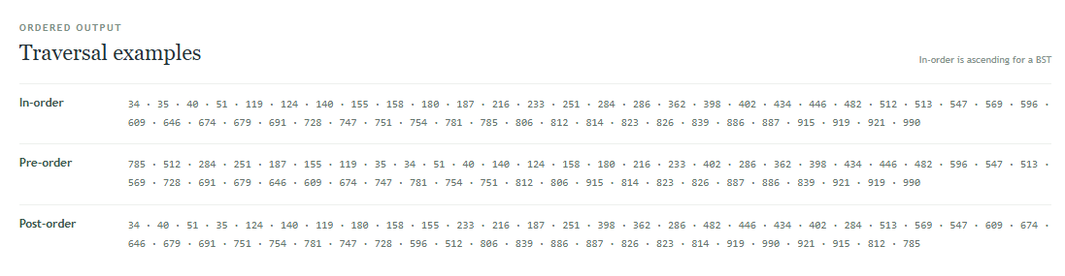
Test program demonstrating tree construction, searching, and manipulation
The binary search tree is constructed by inserting a collection of values one at a time. Each value is compared with the current node: smaller values are placed in the left subtree and larger values in the right subtree. In the UI, the initial 50-item sample dataset demonstrates this construction automatically when the Project 6 tool loads, see Figure 2.
Searching checks whether a specified value exists in the binary search tree. The search begins at the root and compares the target with each node, moving left when the target is smaller or right when it is larger. In the UI, enter a numeric key and click Search to see whether the value is present, see Figure 3.
Manipulation means changing the tree after it has been constructed. In this project, the UI supports manipulation through Insert, which adds a new key, and Delete, which removes an existing key. After each change, the tree visualization, traversal results, size, height, minimum, maximum, and balance status are updated, see Figure 4.
Figure 2
Construction
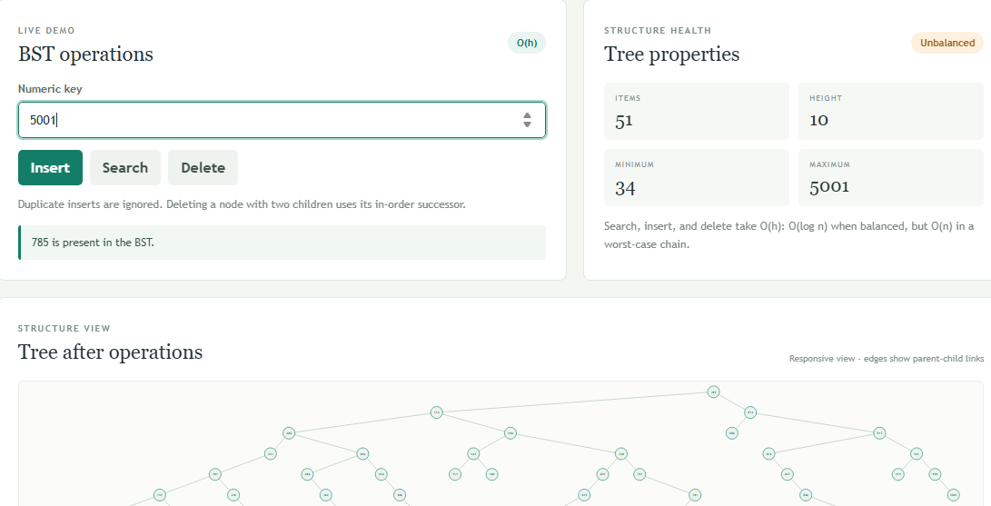
Figure 3
Searching
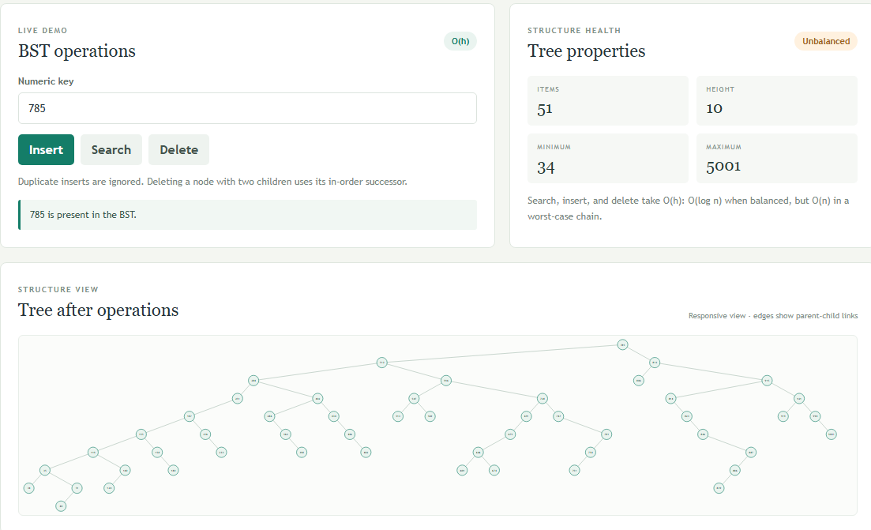
Figure 4
Manipulation
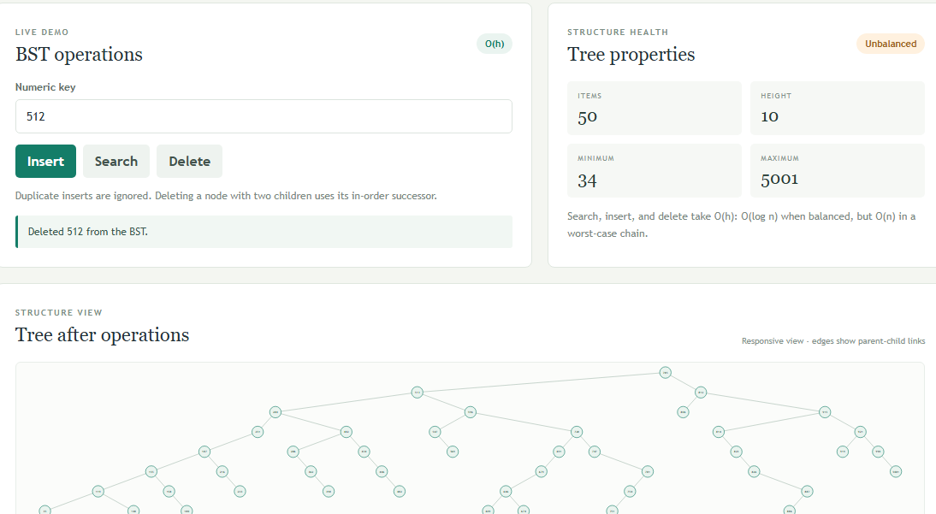
Performance analysis comparing tree-based map vs. list-based map for search operations
The performance analysis compares a tree-based map with a list-based map by measuring search operations across different data sizes, such as 50, 200, and 1,000 entries. The tree-based map searches by following the binary search tree structure and typically requires O(log n) time when balanced, although it can degrade to O(n) when unbalanced. The list-based map searches entries sequentially, requiring O(n) time and more comparisons as the number of entries increases. Therefore, the tree-based map is generally more efficient for larger datasets and repeated searches, while the list-based map is simpler but becomes slower as the dataset grows, see Figure 5 for snapshot.
Figure 5
Performance analysis comparison
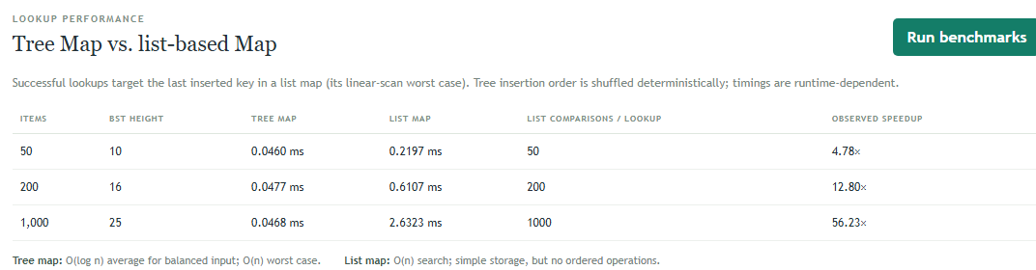

Written evaluation (2 pages) assessing when tree data structures are most beneficial in programming
Tree data structures are most beneficial when applications need to organise hierarchical data, maintain sorted information, or perform repeated searches while preserving relationships between items. Unlike linear structures such as arrays and linked lists, trees represent parent-child relationships naturally. This makes them suitable for file systems, organisational charts, HTML documents, compiler syntax trees, database indexes, and decision-making systems.
A binary search tree is particularly useful when data must remain ordered while supporting insertion, searching, and deletion. In a balanced tree, these operations can typically be completed in O(log n) time. In-order traversal also produces values in sorted order, making tree structures useful for range queries, ordered maps, and retrieving minimum or maximum values. The tree-backed map in this project demonstrates these advantages by storing key-value pairs while maintaining sorted keys.
Tree structures are most effective when the data is dynamic and changes frequently. A new value can be inserted without shifting many existing elements, unlike an array. Deletion can also be efficient when the tree remains well balanced. Self-balancing trees, such as AVL trees and red-black trees, are especially valuable because they prevent the structure from becoming too uneven and maintain predictable performance.

However, ordinary binary search trees are not always the best choice. If values are inserted in sorted order, the tree can become a one-sided chain, causing searching, insertion, and deletion to degrade to O(n). Trees also require additional memory for links between nodes and may be slower than arrays because their nodes are not stored contiguously in memory. Hash tables are usually better when only fast key-based lookup is required and ordering is unnecessary.
Overall, tree data structures are most beneficial when programs need a combination of efficient searching, ordered data, flexible updates, and hierarchical relationships. Their usefulness depends on maintaining a suitable shape and selecting a balanced tree when consistent performance is important.
Visual representation showing tree structure after insertions and deletions
Figure 6 shows the binary search tree after inserting the value `99999`. Since `99999` is greater than the existing keys, it is placed at the far right of the tree, demonstrating how insertion preserves the binary search tree ordering rule. Figure 7 shows the tree after deleting `99999`; the node is removed from the right side, and the remaining tree structure and traversal outputs update to reflect the deletion.
Figure 6
Insert 99999
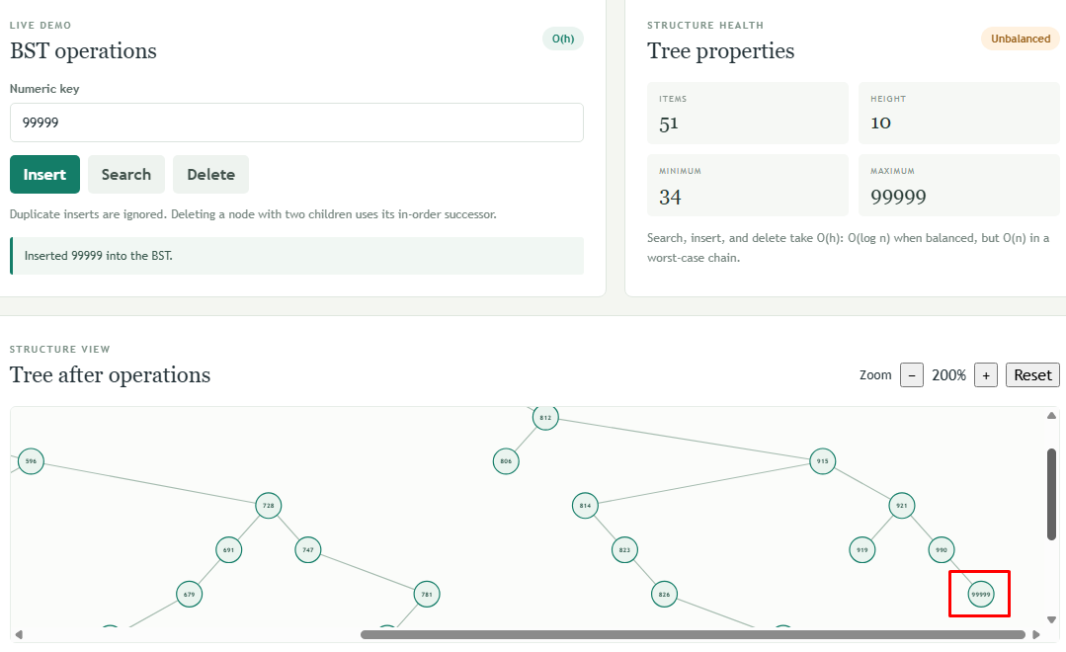
Figure 7
Delete 99999
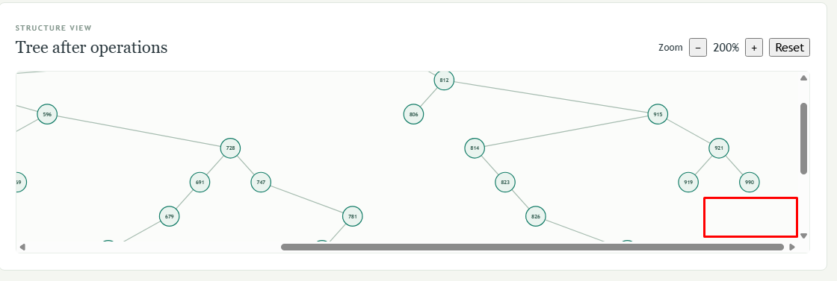

References
Colorado State University Global. (2026). Module 6 Overview: Comprehensive Study of Trees https://csuglobal.instructure.com/courses/121753/pages/module-6-overview?module_item_id=6530403

