Module 4: Critical Thinking
Zeng Xiong
Colorado State University Global
Design and Analysis of Algorithms
Dr. Gonzalez
September 10, 2026

Source code file with Stack implementation and all required operations
The script file for the stack implementation is written in python integrated with a react app. The logic which performs the stack can be found on my github source repository or the attached stack.py file at line 8:
https://github.com/zxiong1008/CSU506-Lab/blob/main/api/stack.py
Source code file with Queue implementation and all required operations
The script file for the queue implementation is written in python integrated with a react app. The logic which performs the queue can be found on my github source repository or the attached queue.py file at line 8:
https://github.com/zxiong1008/CSU506-Lab/blob/main/api/queue.py
Source code file with Deque implementation and all required operations
The script file for the deque implementation is written in python integrated with a react app. The logic which performs the deque can be found on my github source repository or the attached deque.py file at line 8:
https://github.com/zxiong1008/CSU506-Lab/blob/main/api/deque.py
Source code file with LinkedList implementation and all required operations
The script file for the linkedlist implementation is written in python integrated with a react app. The logic which performs the linkedlist can be found on my github source repository or the attached linked_list.py file at line 15:
https://github.com/zxiong1008/CSU506-Lab/blob/main/api/linked_list.py
Test program demonstrating each data structure with sample data
To demonstrate the core operations of the primary data structures, a unified test script was executed using sample data values. The program sequentially processes these inputs to validate key operations, including pushing, peeking, popping, and checking stack state conditions like isEmpty. The resulting console output illustrates the sequential flow and data state changes throughout the test suite. Please refer to Figure 1 below for a screenshot of the test program execution and output.

Figure 1
Program output
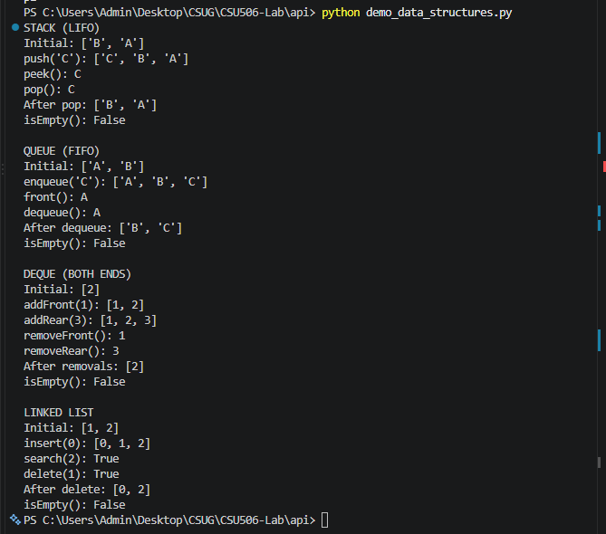
Problem-solving examples showing appropriate use cases for each structure
To demonstrate practical applications, each data structure was implemented to solve real-world algorithms including balanced delimiter matching, round-robin scheduling, palindrome verification, and duplicate elimination. Additionally, performance benchmarks were captured to measure operational execution time alongside theoretical time complexity for each structure. The test output confirms that operations like stack pushes, queue enqueues, and deque front checks execute with optimal performance limits. Please refer to Figure 2 below for a screenshot of the program output demonstrating these problem-solving examples and benchmark results.
Figure 2
Problem solving examples output
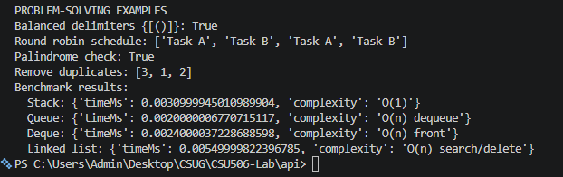

Written analysis (2 pages) contrasting the four data structures and explaining when to use each
Linear data structures, stacks, queues, deques, and linked lists, each offer distinct structural properties, operational constraints, and performance trade-offs that determine their suitability for specific computational problems.

- Stack (LIFO): Operates on a Last-In, First-Out model where elements are added and removed strictly from the top. With O(1) time complexity for push, pop, and peek operations, stacks excel in managing nested execution contexts and tracking historical states. Use a stack when algorithms require backtracking or localized access to the most recently added item, such as function call stack management, undo mechanisms in text editors, or balanced delimiter matching.
- Queue (FIFO): Follows a First-In, First-Out policy where elements enter at the rear and exit from the front. Standard enqueue and dequeue operations maintain sequential ordering. Use a queue when resource sharing or task scheduling requires fair, order-preserving processing, such as breadth-first search (BFS) graph traversals, CPU round-robin scheduling, print job queues, or asynchronous request handling.
- Deque (Double-Ended Queue): Combines features of both stacks and queues by allowing insertion and deletion at both the front and rear ends in O(1) time. Because of its dual capability, a deque provides superior flexibility when data needs to be inspected or modified from either boundary. Use a deque for sliding window algorithms, palindrome validation, job-stealing thread pools, or scenarios requiring bidirectional processing.
- Linked List: Consists of node objects linked sequentially via memory pointers. Unlike contiguous arrays or dynamic lists, a linked list allows O(1) insertions and deletions at known pointer positions without requiring element shifting or array re-allocation. However, accessing arbitrary elements requires O(n) linear search traversals. Use a linked list when memory allocation is dynamic, dataset sizes fluctuate frequently, or frequent insertions and deletions occur without requiring random index access.
Performance comparison showing operation efficiency for each implementation
To evaluate operation efficiency across each data structure, execution times were recorded across varying input sizes and core operations. The benchmark data highlights the constant-time execution O(1) of array-backed stack, queue, and deque operations alongside linked list node manipulations. These metrics demonstrate how underlying storage mechanisms, such as contiguous list allocation versus heap-allocated node pointers, influence runtime performance under scale.Please refer to Figure 3 below for a screenshot showing the performance comparison and operation efficiency for each implementation.

Figure 3
Performance matrix for each operation
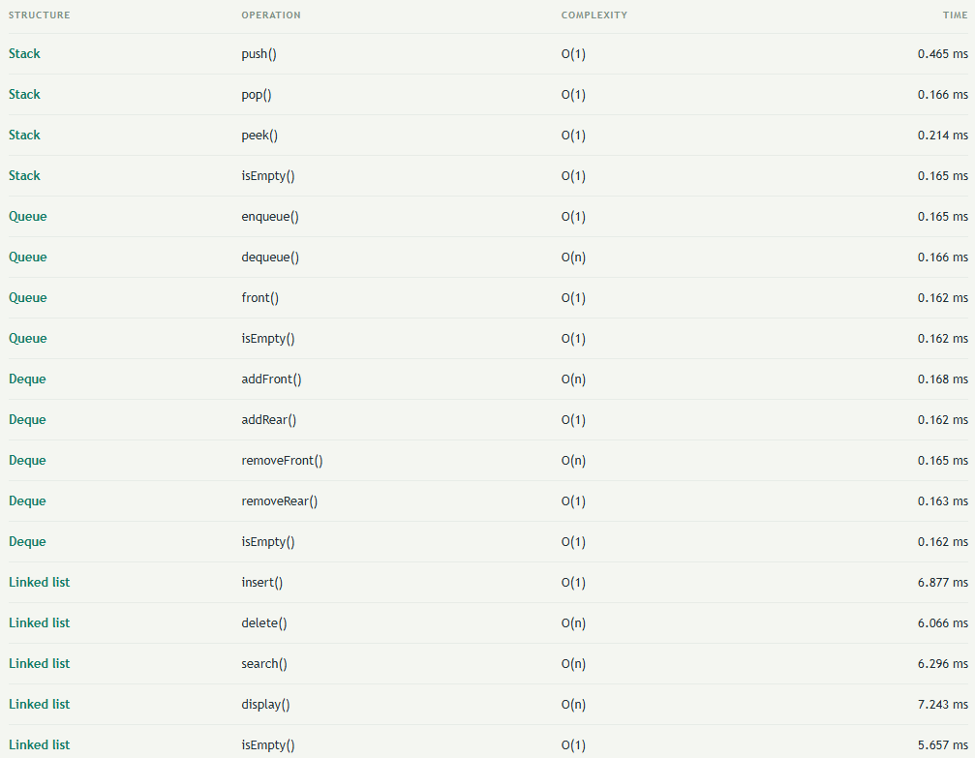

References
Colorado State University Global. (2026). Module 4 Overview: Lists, Stacks, and Queues https://csuglobal.instructure.com/courses/121753/pages/module-4-overview?module_item_id=6530338

