Module 1: Critical Thinking
Zeng Xiong
Colorado State University Global
Design and Analysis of Algorithms
Dr. Gonzalez
August 23, 2026

Working implementations of stack, queue, and linked list with clear documentation
I developed a react web app interface for stack, queue, and linked list. Stack is LIFO (last in, first out). An example would be a deck of cards when you stack them. Queue is FIFO (first in, first out). An example would be waiting in line to checkout at the groceries store. Linked list is nodes. An example would be a music playlist that can insert or remove songs without shifting every other song. You can observe the behavior in the demo video. I also shared the screenshot of the application, Figure 1 - Figure 3.
Figure 1
Stack screenshot
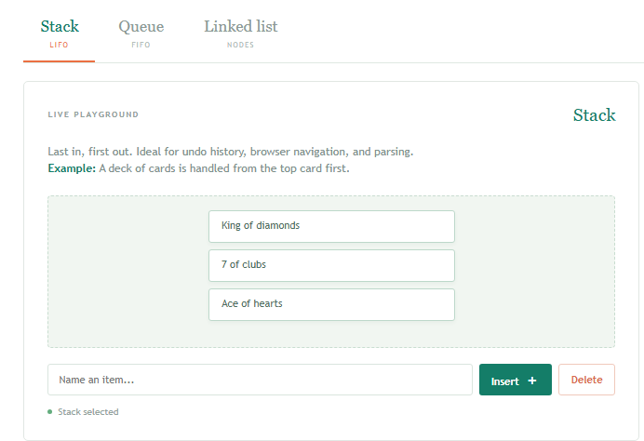
Figure 2
Queue screenshot
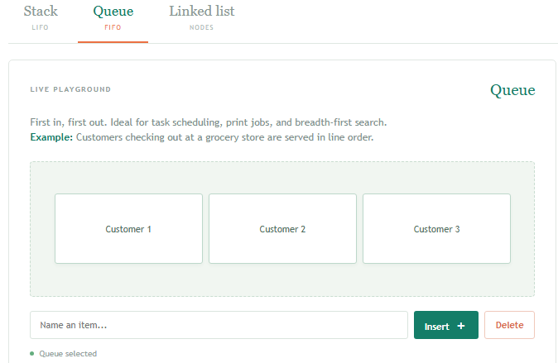
Figure 3
Linked List screenshot
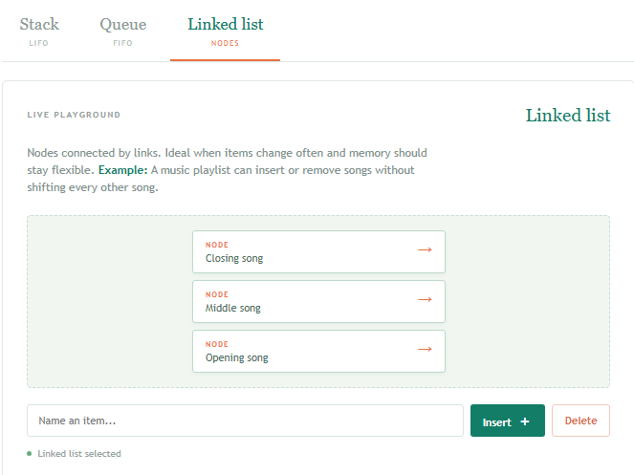
User interface demonstrating each data structure's operations
In the demo video, you will see the demonstration of each data structure from my web application.
Complexity prediction tool showing Big-O estimates for operations
In the second module of my project 01, I created a table to show the complexity analyzer, see Figure 4 below.
Figure 4
Complexity analyzer screenshot
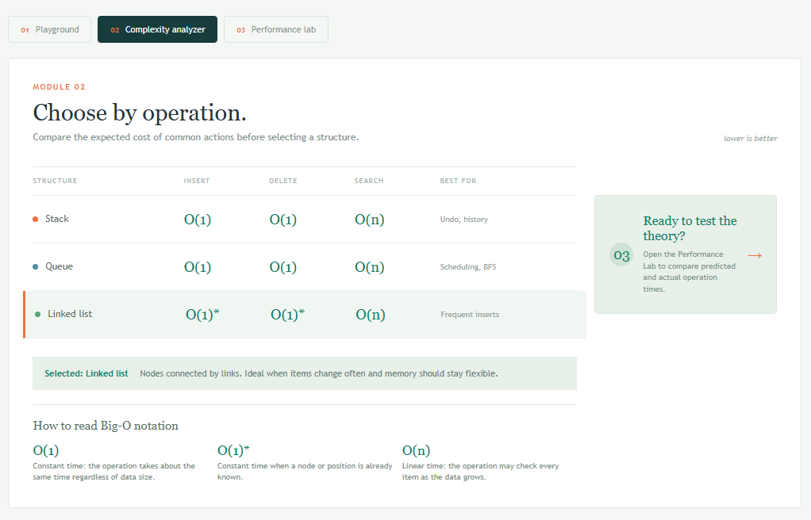
Performance comparison report with charts showing prediction accuracy
From my web application, in project 01 for module 03, I was able to generate the performance report, see Figure 5 below.
Figure 5
Performance Lab screenshot
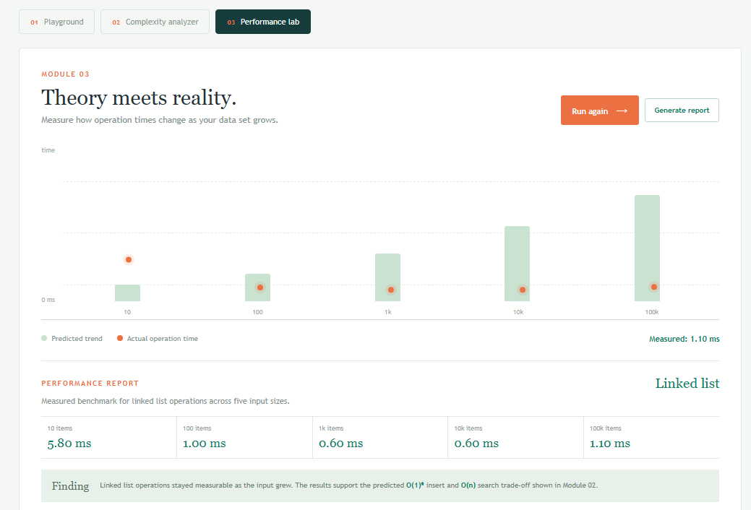
Data structure importance and selection criteria
Data structures dictate how memory is allocated and how efficiently algorithms manipulate data. Selecting the appropriate data structure directly governs execution speed, memory footprint, and overall system scalability.
Choosing an optimal structure ensures operations execute within predictable Big-O bounds. Inefficient choices lead to severe performance bottlenecks:
- Time Complexity: An improper structure turns linear-time operations into quadratic costs, degrading responsiveness under heavy loads.
- Space & Memory Overhead: Dynamic allocations like node pointers in linked structures introduce memory overhead, whereas contiguous arrays leverage CPU cache locality for faster access.
Selecting a data structure requires evaluating access patterns, mutation frequency, and resource constraints:
- Stack (LIFO - Last-In, First-Out): Access, search, and deletion take $O(n)$ time in the worst case, but insertion and deletion at the top are $O(1)$. Best used for call stack management, undo mechanisms, and depth-first traversal.
- Queue (FIFO - First-In, First-Out): Random access and search require $O(n)$ time, while enqueuing and dequeuing operate at $O(1)$ efficiency. Best suited for task scheduling, message buffering, and breadth-first search algorithms.
- Linked List (Sequential Traversal): Accessing or searching an arbitrary element takes $O(n)$ time, but insertion and deletion at a target pointer run in $O(1)$ time without requiring contiguous memory reallocations.
Demo video (3-5 minutes) showing tool functionality
My demo video should be attached to the project or can be found here https://github.com/zxiong1008/CSU506-Lab/blob/main/Demo%20video%20-%20Recording%202026-08-23%20142651.mp4. In the demo video, it was showing the three fundamental data structures, complexity analyzer, and performance test. You can also find my source code published on GitHub (via https://github.com/zxiong1008/CSU506-Lab/tree/main/csu506-app)
References
Colorado State University Global. (2026). Module 1 Overview: Introduction to Data Structures and Algorithms https://csuglobal.instructure.com/courses/121753/pages/module-1-overview?module_item_id=6530208

