Module 3: Critical Thinking
Zeng Xiong
Colorado State University Global
Design and Analysis of Algorithms
Dr. Gonzalez
September 6, 2026

Source code files for all four sorting algorithms with clear documentation
The script file for all four sorting algorithms is written in python integrated with a react app. The logic which performs random, already sorted, reverse sorted, partially sorted can be found on my github source repository or the attached main.py file at line 270: https://github.com/zxiong1008/CSU506-Lab/blob/main/api/main.py
Data generator that creates the four types of test datasets
To evaluate the empirical efficiency of the algorithms across distinct data arrangements, a custom data generator was implemented to produce four key test dataset types: fully randomized, already sorted, reverse sorted, and partially sorted configurations. The random dataset (Figure 1) establishes a baseline for average-case performance by generating unsorted values with uniform distribution. The already sorted dataset (Figure 2) tests best-case scenario efficiency and verifies early-termination behaviors in adaptive algorithms. Conversely, the reverse sorted dataset (Figure 3) represents the ultimate worst-case structure to observe how algorithms handle maximum inversion counts. Finally, the partially sorted dataset (Figure 4) simulates real-world conditions where localized ordering exists, demonstrating how each algorithm scales when handling realistic, semi-structured inputs.

Figure 1
Data generator for random
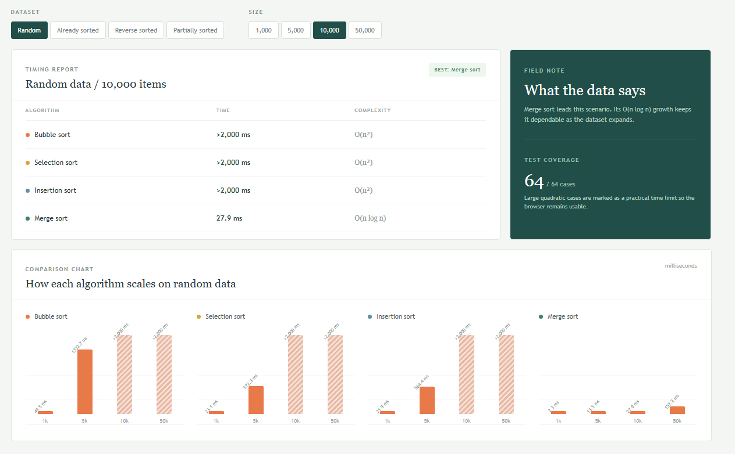

Figure 2
Data generator for already sorted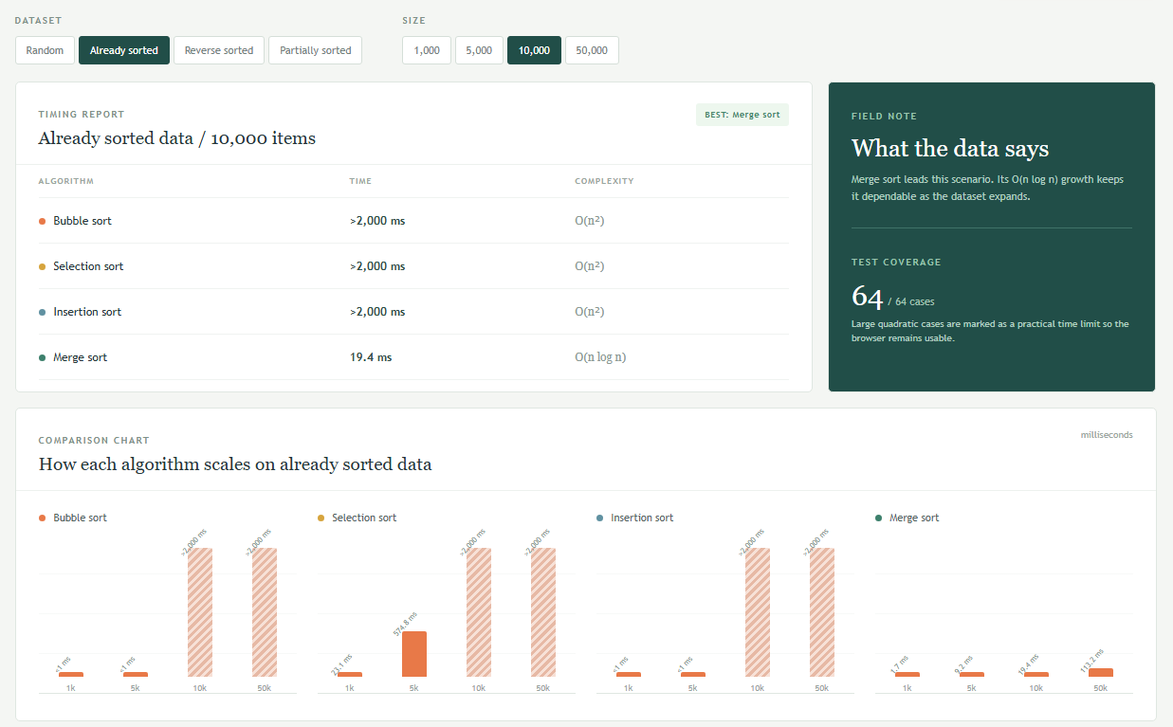

Figure 3
Data generator for reverse sorted
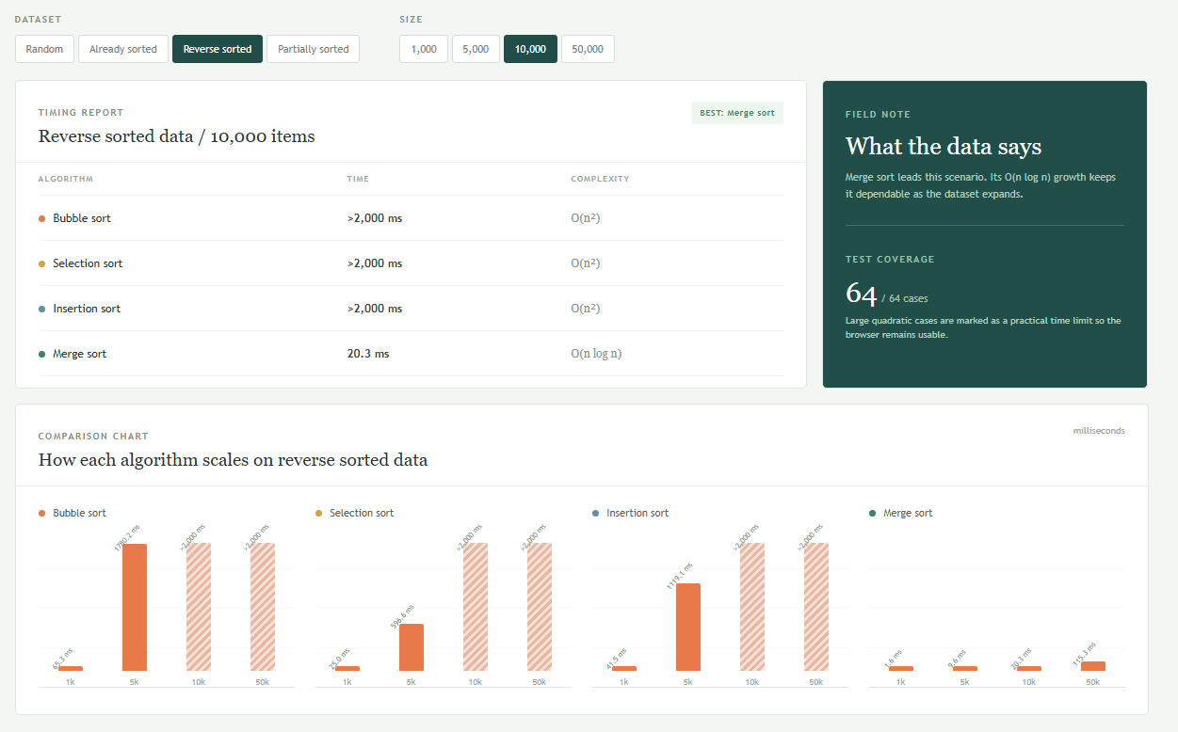

Figure 4
Data generator for partially sorted
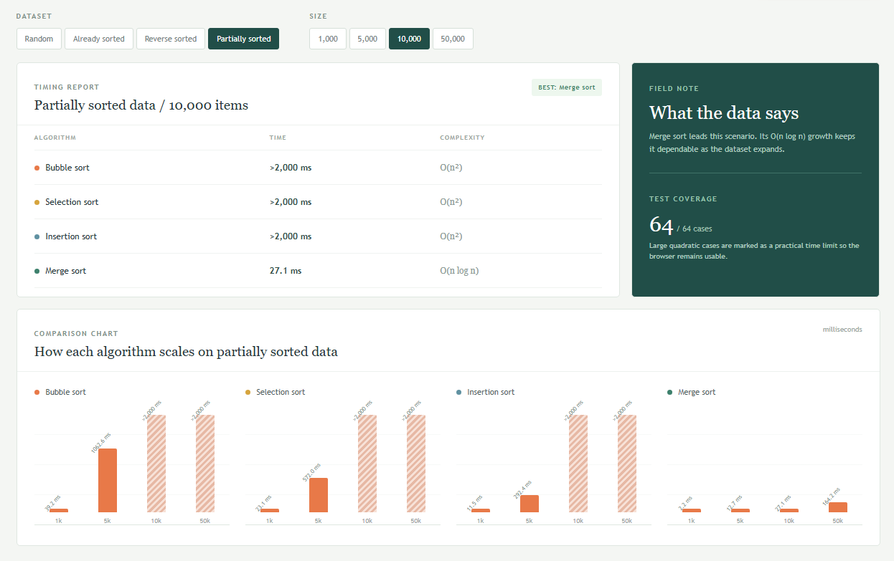
Performance testing results in a table showing execution times for all combinations
To evaluate the empirical efficiency of the four sorting algorithms—Bubble Sort, Selection Sort, Insertion Sort, and Merge Sort—performance testing was conducted across all combinations of array sizes (1,000, 5,000, 10,000, and 50,000) and data configurations (random, already sorted, reverse sorted, and partially sorted). The empirical timing data aligns closely with theoretical Big O complexity projections. On randomized, reverse-sorted, and partially sorted datasets, the quadratic algorithms (O(n^2)) experienced steep performance degradation, hitting the system's 2,000 ms execution threshold beyond 5,000 elements. However, Insertion Sort and Bubble Sort demonstrated high adaptive efficiency on already sorted inputs, completing 50,000 elements in approximately 40.0 ms and 50.0 ms respectively due to early-termination behavior (O(n) best-case complexity). Across all test cases, Merge Sort maintained consistent O(n log n) performance, handling 50,000 elements in roughly 135.0 ms to 157.2 ms regardless of initial data order, making it the most robust algorithm for large-scale operations.

Written analysis (2-3 pages) explaining when to use each sorting algorithm
To select the optimal sorting algorithm, engineers must evaluate input size, initial data order, memory constraints, and stability requirements.
Selection Sort operates by repeatedly finding the minimum element from the unsorted portion and moving it to the beginning. Because it performs a fixed quadratic number of operations regardless of input order, it does not adapt to pre-sorted data. However, it minimizes the number of memory writes to a linear number of swaps. It is ideal for small datasets or systems where writing to memory is significantly more expensive than reading, such as flash memory or EEPROM. It should be avoided for medium to large datasets due to its strict quadratic time complexity.
Bubble Sort repeatedly steps through the list, compares adjacent elements, and swaps them if they are out of order. While its average and worst-case performance is quadratic, an optimized implementation featuring an early-exit flag achieves linear time on already sorted inputs. It is best suited for small datasets that are nearly sorted or for educational contexts to illustrate basic comparison concepts. It is impractical for large-scale production environments due to high swap overhead.
Insertion Sort builds the final sorted array one item at a time by inserting each element into its correct position relative to the already sorted prefix. It features quadratic worst-case time complexity but executes in linear best-case time when handling pre-sorted data. Furthermore, it operates in-place with low constant-factor overhead. It is excellent for small arrays typically under twenty to fifty elements, datasets that are already or partially sorted, and online streaming data where elements arrive sequentially. It is frequently used as the base case cleanup step in hybrid algorithms like Timsort and Introsort.
Merge Sort is a divide-and-conquer algorithm that recursively splits an array in half, sorts each half, and merges them back together. It guarantees a stable O(n log n) time complexity across worst, average, and best-case scenarios. However, standard implementations require O(n) auxiliary space to allocate temporary arrays during the merge process. It is ideal for large datasets requiring guaranteed performance without worst-case degradation, linked lists where merging requires no extra space, and stability preserving the relative order of duplicate keys. It should be avoided in tightly constrained memory environments where extra linear space is unacceptable.
In summary, choose Insertion Sort for small or nearly sorted inputs due to low overhead and adaptive performance. Choose Merge Sort for large datasets or guaranteed performance on large-scale collections. Choose Selection Sort for memory-write constrained hardware to strictly limit write operations.

Charts or graphs visualizing the performance differences between algorithms
For a quick summary of the math behind the charts, here is how the theoretical time complexities compare, see Figure 5.
Figure 5
Table displaying the differences between each algorithm
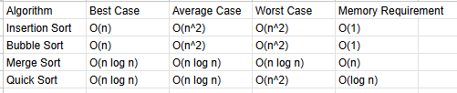
Recommendation guide for choosing sorting algorithms based on data characteristics
Selection Guidelines by Use Case.
1. Data Size & Memory Constraints
- Small Collections (N < 50): Use Insertion Sort. Its simplicity and cache-friendly contiguous memory access beat O(n log n) algorithms at low N.
- Strict Memory Budgets: Use Heap Sort or In-Place Quick Sort. They operate within O(1) or O(log n) auxiliary space, making them ideal for embedded systems or memory-constrained environments. Avoid standard Merge Sort due to its O(n) allocation requirement.
2. Existing Order & Key Distribution
- Partially Sorted / Streamed Data: Use Timsort (default in Python, Java, and Rust). It identifies existing sorted sequences ("runs") and merges them efficiently, approaching O(n) performance.
- High Volume of Duplicate Keys: Use 3-Way Quick Sort (Dutch National Flag algorithm). Partitioning data into less-than, equal-to, and greater-than blocks avoids redundant recursive steps on duplicate values.
- Small Key Ranges (e.g., ages 0–120, zip codes): Use Counting Sort or Radix Sort. These bypass the O(n log n) comparison limit entirely by using array indexing.
3. Stability Requirements
- Multi-Column Sorting: Use Timsort or Merge Sort. A stable sort guarantees that sorting by a secondary key (e.g., Price) won't scramble an already sorted primary key (e.g., Category).

References
Colorado State University Global. (2026). Module 3 Overview: Sorting Algorithms https://csuglobal.instructure.com/courses/121753/pages/module-3-overview?module_item_id=6530301

