Module 7: Critical Thinking
Zeng Xiong
Colorado State University Global
Design and Analysis of Algorithms
Dr. Gonzalez
October 3, 2026

Source code file with adjacency matrix graph implementation
The script file for the adjacency matrix graph implementation is written in python integrated with a react app. The logic which performs the stack can be found on my github source repository or the attached graph_adjacency_matrix.py file:
https://github.com/zxiong1008/CSU506-Lab/blob/main/api/graph_adjacency_matrix.py
Source code file with adjacency list graph implementation
The script file for the adjacency list graph implementation is written in python integrated with a react app. The logic which performs the stack can be found on my github source repository or the attached graph_adjacency_list.py file:
https://github.com/zxiong1008/CSU506-Lab/blob/main/api/graph_adjacency_list.py
Graph manipulation algorithms that work with both representations
Graph manipulation algorithms are designed to operate seamlessly across both adjacency matrix and adjacency list representations, enabling dynamic modifications to network structures (see Figures 1–4). These algorithms support core structural operations, including adding a weighted edge, such as connecting vertex A to G with a weight of 9999 (see Figure 1); adding a new vertex, such as introducing vertex Z (see Figure 2); removing an existing vertex, such as removing vertex G (see Figure 3); and removing a specific edge, such as disconnecting vertex A from B (see Figure 4). By maintaining compatibility with both underlying data structures, these manipulation functions ensure that graph connectivity, vertex counts, edge weights, and live visual representations remain fully synchronized during runtime updates.
Figure 1
Add weighted edge
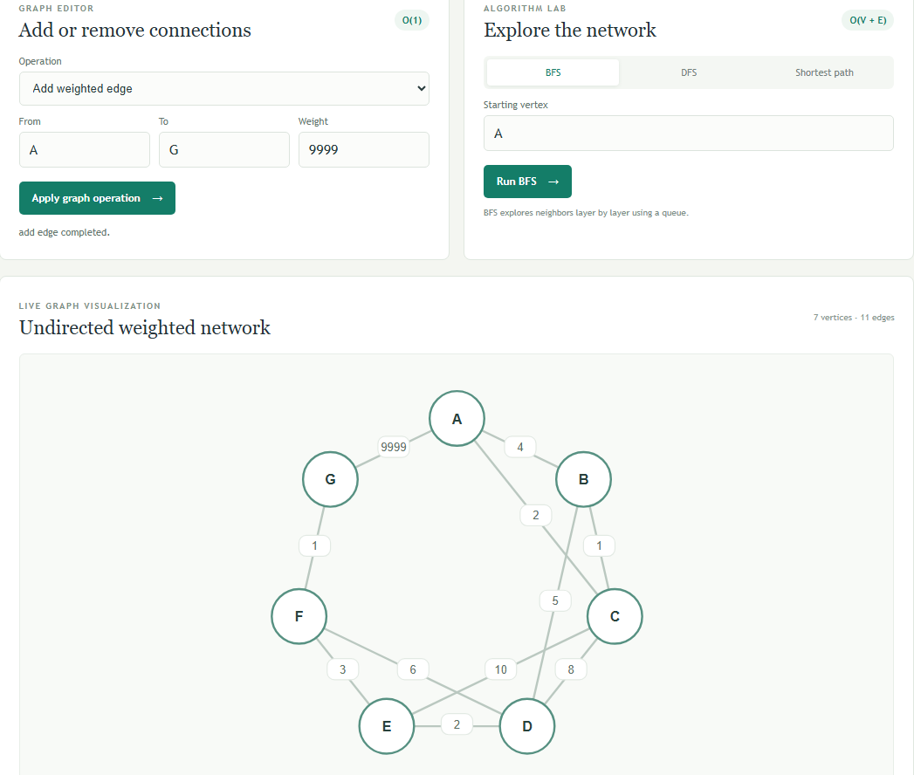

Figure 2
Add vertex
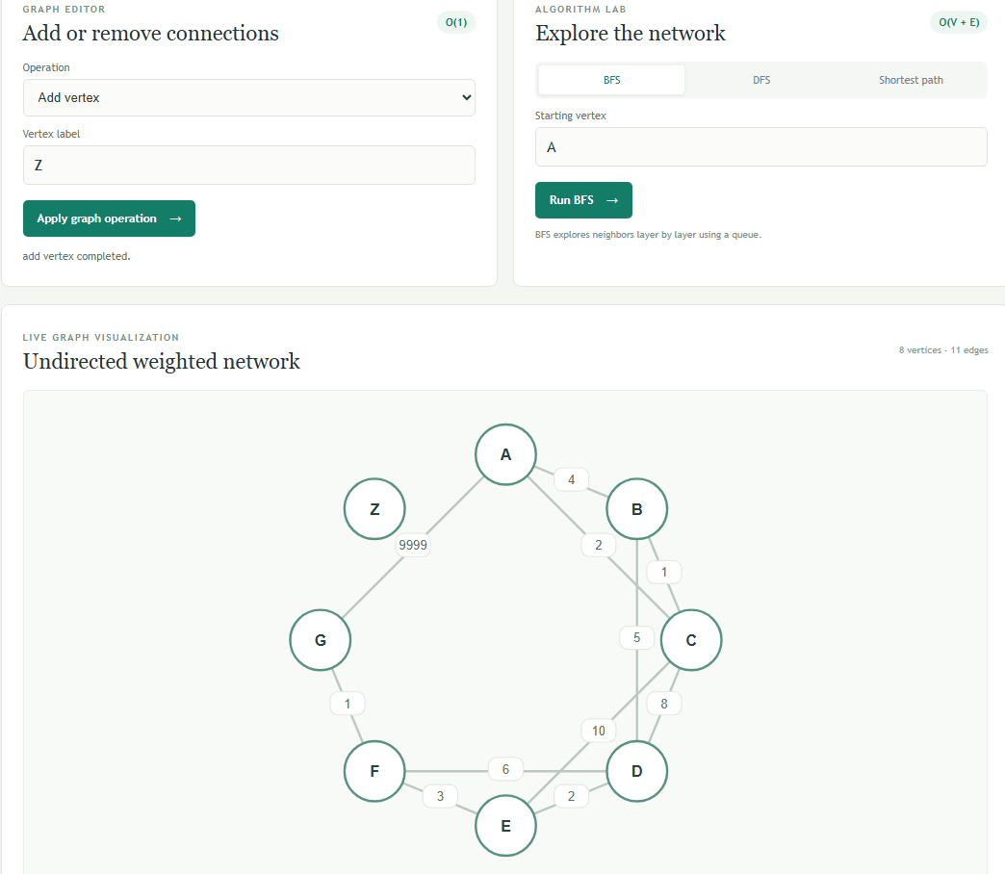

Figure 3
Remove vertex
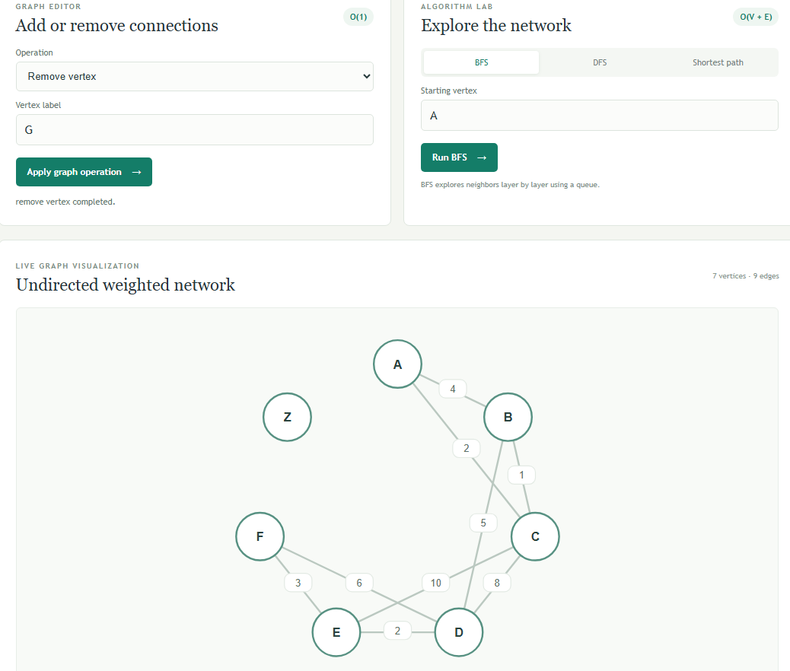

Figure 4
Remove edge
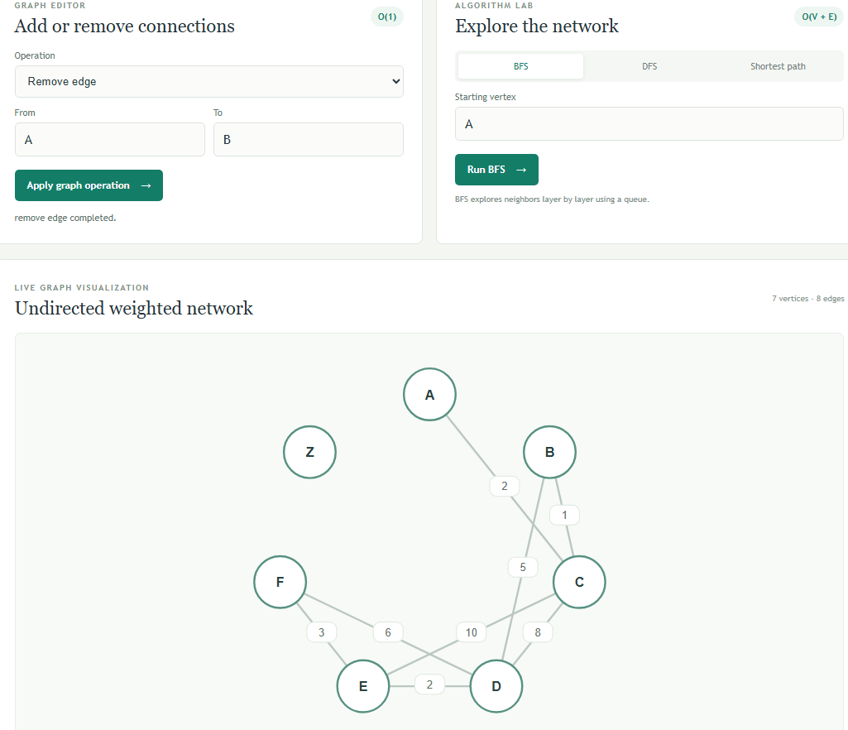
Traversal algorithm implementations (DFS and BFS) with step-by-step output
Traversal algorithm implementations leverage both Breadth-First Search (BFS) and Depth-First Search (DFS) to systematically explore network structures with detailed, step-by-step output tracing. Breadth-First Search utilizes a queue-based frontier to explore neighbors layer by layer, starting from a designated root vertex such as vertex A (see Figure 5), resulting in a structured visit order of A -> C -> B -> D -> E -> F. In contrast, Depth-First Search follows a single branch as deeply as possible using a stack before backtracking, beginning from a starting vertex such as vertex B (see Figure 6), which yields a distinct visit sequence of B -> C -> A -> D -> E -> F.
Figure 5
BFS
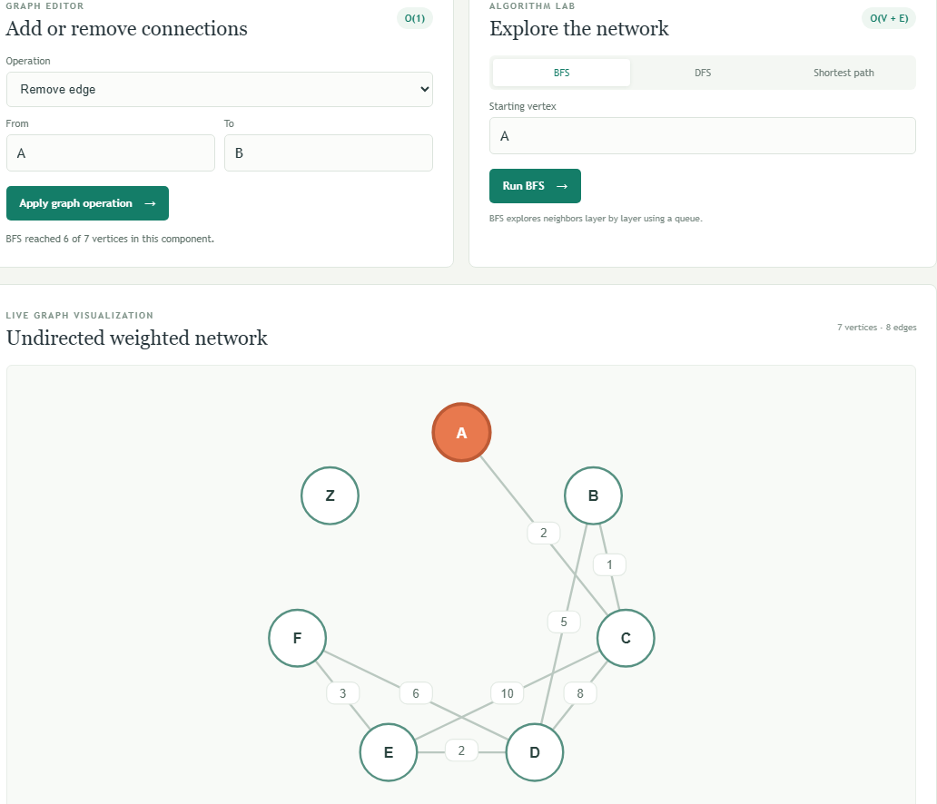
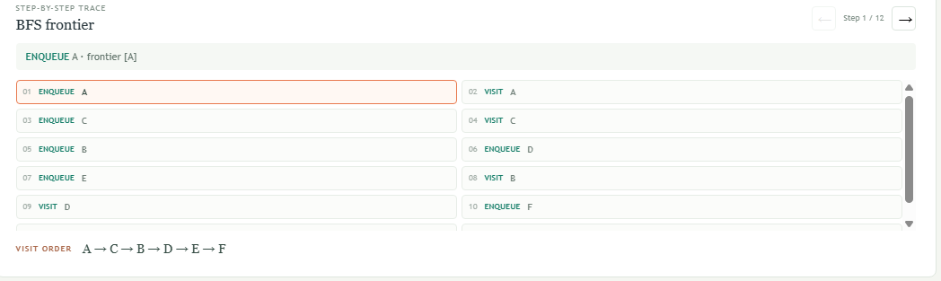
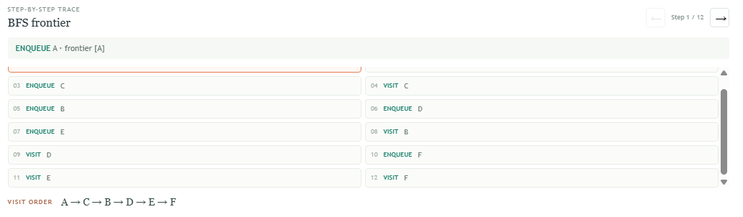

Figure 6
DFS
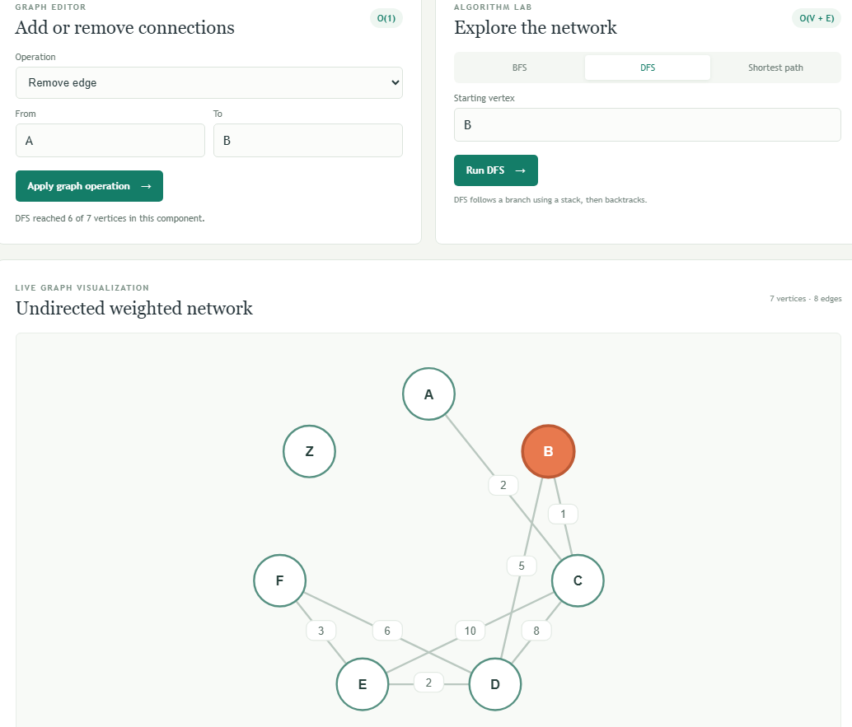
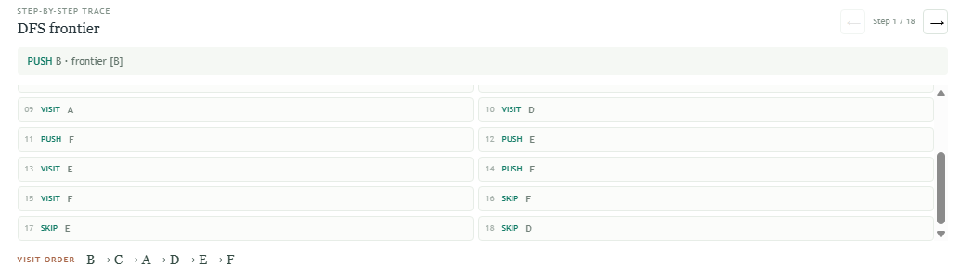
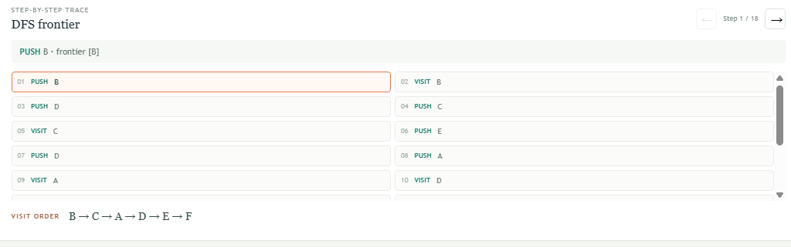
Shortest path algorithm that finds routes between any two vertices
Dijkstra's algorithm is a shortest path method used to find the minimum-weight route between any two vertices in a network, requiring non-negative edge weights. In the provided network example, setting the start vertex to A and the destination to F yields an optimal shortest route of A -> C -> B -> D -> E -> F with a total weight of 13.

Figure 7
Shortest path
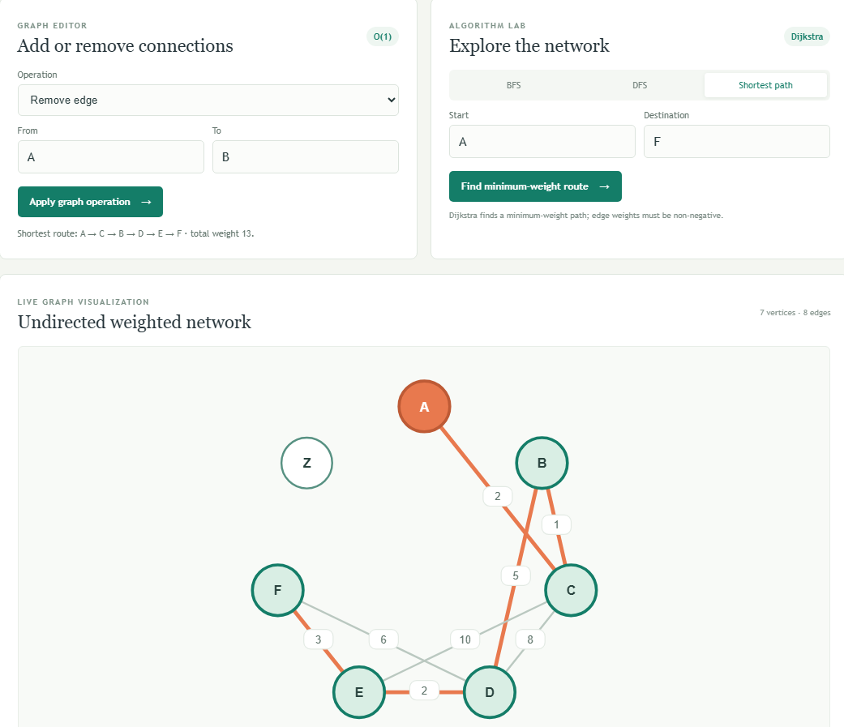
Test program demonstrating graph construction and algorithm execution on sample data
The test program serves as the primary execution harness for validating graph construction, data structure synchronization, and algorithm execution on the sample dataset. Implemented as an integrated Python backend with a React frontend, the test harness automatically initializes a sample undirected weighted network comprising seven vertices (A through G) and eleven distinct weighted edges. Upon loading, the program constructs both the adjacency matrix and adjacency list representations in parallel, ensuring that structural integrity and edge weights remain fully synchronized. The test execution routine then invokes the graph manipulation functions (such as adding or removing vertices and weighted edges), immediately updating live visual representations and recalculating traversal sequences and shortest paths. By feeding predefined sample data into the system, the test program verifies that Breadth-First Search (BFS), Depth-First Search (DFS), and Dijkstra's shortest path algorithm correctly process network topologies, producing accurate, step-by-step trace outputs and confirming robust implementation across both underlying data structures, see Figure 1 - Figure 7.

Performance comparison (2 pages) analyzing when to use adjacency matrix vs. adjacency list
When designing graph-based software systems, choosing between an adjacency matrix and an adjacency list is a fundamental architectural decision that directly impacts both space efficiency and algorithmic execution time. An adjacency matrix utilizes a two-dimensional array of size V x V (where V represents the number of vertices) to store edge weights, whereas an adjacency list maintains an array or hash map of linked lists, mapping each vertex to its immediate neighbors. Understanding the structural trade-offs between these two representations is crucial for optimizing performance in real-world network applications.
From a spatial complexity perspective, the adjacency matrix requires O(V^2) memory regardless of how many actual edges exist in the network. This makes matrices highly memory-inefficient for sparse graphs—networks where the number of edges is much less than the maximum possible V^2. Conversely, an adjacency list consumes O(V + E) memory, scaling linearly with the number of vertices (V) and edges (E). For sparse networks, which are common in routing, social networks, and dependency graphs, the adjacency list preserves substantial system memory by avoiding the storage of non-existent connections. However, for dense graphs where E approaches V^2, the memory overhead of pointers in adjacency lists can become comparable to or even exceed the fixed matrix allocation.
Time complexity for fundamental graph operations further dictates their appropriate use cases. Checking whether a specific edge exists between two vertices takes O(1) constant time in an adjacency matrix via a direct index lookup. In an adjacency list, this same edge lookup operation requires traversing the linked list of vertex u, resulting in O(deg(u)) time in the worst case (where deg(u) is the vertex degree). Therefore, applications requiring frequent, instantaneous edge existence queries benefit significantly from matrix representations.
Conversely, operations that involve traversing a vertex's neighborhood—such as Breadth-First Search (BFS) and Depth-First Search (DFS)—are much more efficient with an adjacency list. Iterating through all neighbors of a vertex takes O(deg(u)) time in an adjacency list, whereas an adjacency matrix requires scanning an entire row of length V, yielding an O(V) time complexity per vertex exploration. Across an entire traversal, adjacency lists achieve O(V + E) performance, whereas matrices degrade to O(V^2).
In summary, adjacency matrices are best suited for dense graphs or small-scale networks where O(1) edge-lookup speed is paramount. Adjacency lists represent the optimal choice for sparse, dynamic networks where memory conservation and rapid neighbor iteration are critical for performance.
Visual representation showing how your algorithms traverse and manipulate graph structures
The visual representation of graph operations is demonstrated through a series of system captures that illustrate both structural manipulation and algorithmic traversal. Figures 1 through 4 document dynamic network modifications, showing the step-by-step addition of weighted edges and vertices, such as connecting vertex A to G with a weight of 9999 and introducing vertex Z, as well as the removal of vertices and specific edges while maintaining live synchronization between the underlying representations. Additionally, Figures 5 and 6 depict the visual execution of graph traversal algorithms, detailing the layer-by-layer frontier expansion of Breadth-First Search (BFS) starting from vertex A and the branch-based stack backtracking of Depth-First Search (DFS) starting from vertex B. Finally, Figure 7 highlights Dijkstra's shortest path algorithm by tracing the optimal weighted route from vertex A to F across the network topology.
References
Colorado State University Global. (2026). Module 7 Overview: Graphs https://csuglobal.instructure.com/courses/121753/pages/module-7-overview?module_item_id=6530429

