Module 2: Critical Thinking
Zeng Xiong
Colorado State University Global
Design and Analysis of Algorithms
Dr. Gonzalez
August 28, 2026

Source code file with linear search implementation
The script file for the linear search implementation is written in python integrated with a react app. The logic which performs the linear search can be found on my github source repository or the attached main.py file at line 163: https://github.com/zxiong1008/CSU506-Lab/blob/main/api/main.py
I decided to split the code into a front end and a back end because it will allow us to read the function as the api and the front end for output.
Source code file with binary search implementation
The script file for the binary search implementation is written in python integrated with a react app. The logic which performs the linear search can be found on my github source repository or the attached main.py file at line 189: https://github.com/zxiong1008/CSU506-Lab/blob/main/api/main.py
I decided to split the code into a front end and a back end because it will allow us to read the function as the api and the front end for output.
Performance testing results showing execution times for different array sizes
I’ve run the linear search performance testing results with the execution time displayed for various array sizes. The test was done for array sizes 100, 1000, and 10000. For an array with 100 elements, the time was 0.0031 ms. For an array with 1000 elements, the time was 0.0035 ms. For an array with 10000 elements, the time was 0.0053 ms. The execution time does grow with the size of the array because there are more elements to search through. The screenshots sculpture below will show the output details, see Figure 1 - Figure 3.

Figure 1
Performance test for array with 100 elements
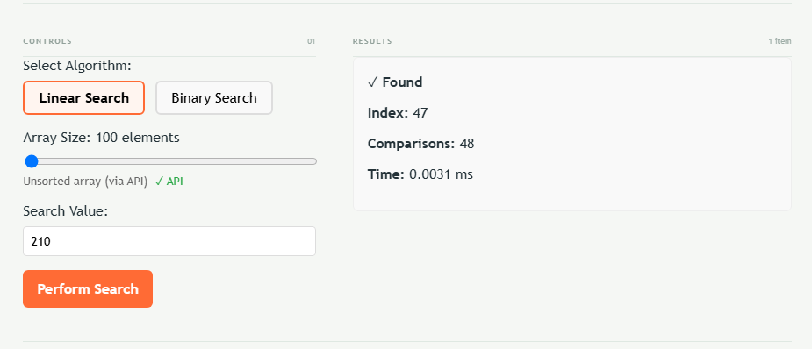
Figure 2
Performance test for array with 1000 elements
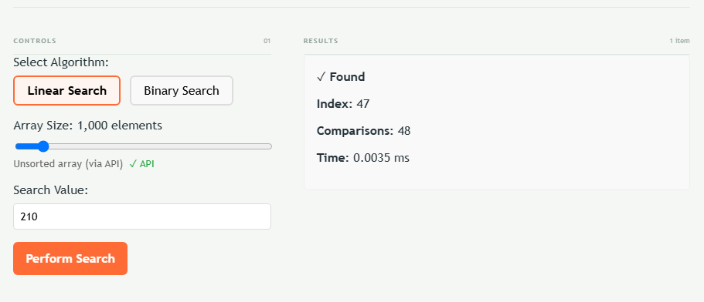
Figure 3
Performance test for array with 10000 elements
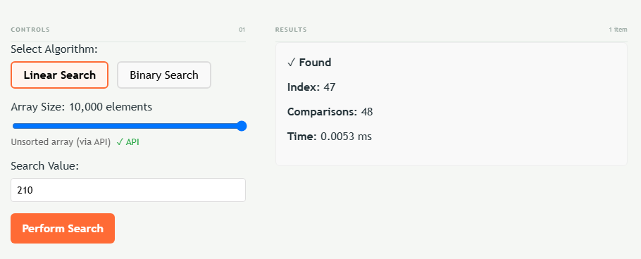
I’ve run the binary search performance testing results with the execution time displayed for various array sizes. The test was done for array sizes 100, 1000, and 10000. For an array with 100 elements, the time was 0.0039 ms. For an array with 1000 elements, the time was 0.0048 ms. For an array with 10000 elements, the time was 0.0064 ms. The execution time does grow with the size of the array because there are more elements to search through. The binary search tree takes longer because it sorts the array first, then it’ll perform the search. This is only noticeable for smaller array sizes with arrays storing one data ty. If we were to measure in the million with an array with more data than just numbers, the binary search would be noticeably faster. The screenshots sculpture below will show the output details, see Figure 4 - Figure 6.
Figure 4
Performance test for array with 100 elements
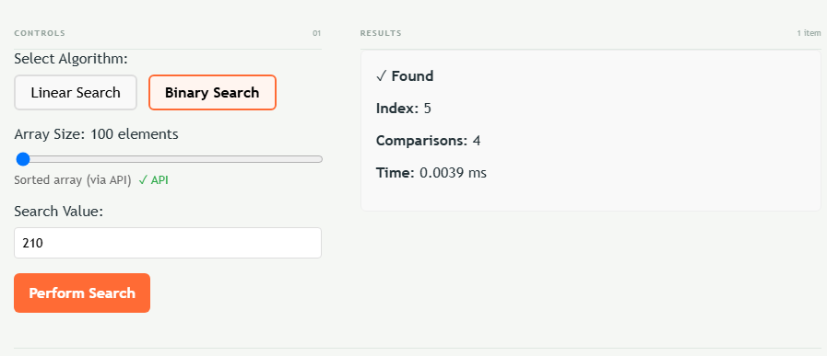
Figure 5
Performance test for array with 1000 elements
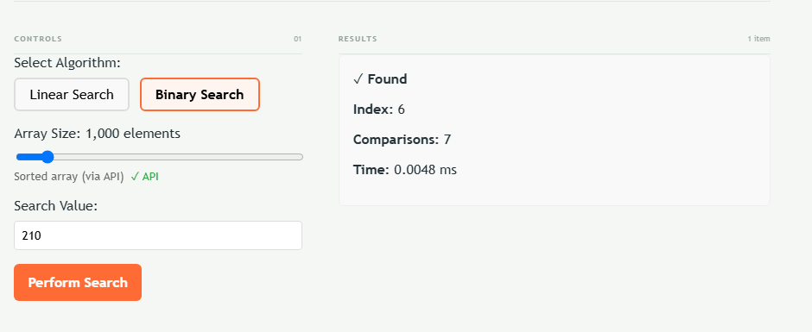
Figure 6
Performance test for array with 10000 elements
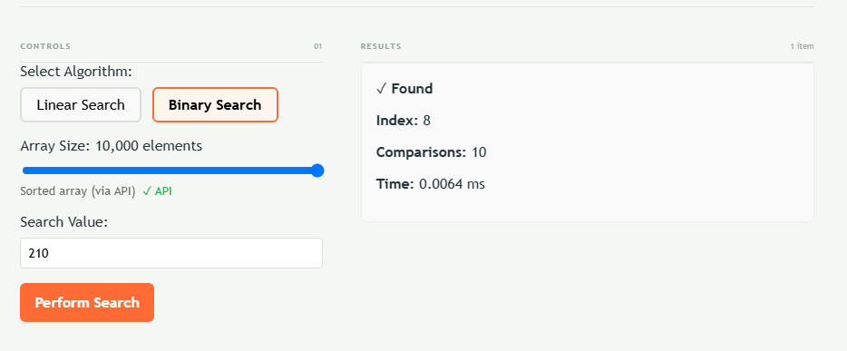

Explain Big O notation for both algorithms
Big O notation describes how an algorithm’s execution time scales as the input size (n) increases. It measures efficiency in terms of growth rates rather than precise clock time, helping developers predict performance on large datasets.
Linear Search: O(n) Complexity
Linear search operates in O(n) (linear time). It scans a collection sequentially from the first element to the last until it finds the target item or reaches the end.
- Worst-Case Scenario: The target is at the very end of the list or not present at all, requiring n comparisons.
- Average Case: The algorithm inspects roughly n/2 items, which simplifies to O(n) in Big O analysis because constant factors are dropped.
- Scaling Behavior: Execution time scales directly in direct proportion to input size. If the dataset grows tenfold from 1,000 to 10,000 elements, the maximum number of operations also increases tenfold.
Binary Search: O(log n) Complexity
Binary search operates in O(log n) (logarithmic time) and strictly requires a sorted dataset. It compares the target value to the middle element of the array. If they match, the search finishes; if not, it eliminates the entire half of the dataset where the target cannot exist and repeats the process on the remaining half.
- Worst-Case Scenario: The search continues dividing the array until only one element remains, requiring log₂(n) steps.
- Scaling Behavior: Execution time grows exceptionally slowly. Doubling the dataset adds only a single additional comparison step.

Input Size (n) | Linear Search O(n) | Binary Search O(log_2 n)
16 | 16 steps | 4 steps
1024 | 1024 steps | 10 steps
1048576 | 1048576 steps | 20 steps

While linear search is simple and works on unsorted collections, binary search’s logarithmic scaling makes it vastly superior for large-scale data retrieval.

Screenshots showing your tool finding items in different sized datasets
For module 2 project, I’ve taken a screenshot for linear search and binary search for array sizes of 100, 1000, and 10000. Please see Figure 1 - Figure 6 for more details.
Recommendation guide explaining when to choose each algorithm
The choice between linear search and binary search comes down to three main factors: data sorting status, dataset size, and memory/data structure constraints.

Table 1
Core Comparison Matrix
Factor | Linear Search | Binary Search
Data Order Requirement | Unsorted or Sorted | Must be sorted
Time Complexity | O(n) | O(log n)
Data Structure Access | Sequential (e.g., Linked Lists, Streams) | Random Access (e.g., Arrays, Vectors)
Pre-processing Overhead | None (O(1) setup) | Sorting required (O(n log n) upfront if unsorted)
Best For | Small or frequently changing datasets | Large, static, or pre-sorted datasets

When to Choose Linear Search
- Data is unsorted and searched infrequently: If you only need to run a search once or twice, sorting the data first (O(n log n)) takes far more work than just checking elements one by one (O(n)).
- Small datasets (n < 50-100): For very small collections, the simplicity of linear search often runs faster in practice due to lower CPU overhead and caching optimization.
- Sequential-only data structures: Ideal for linked lists or continuous data streams where you cannot jump directly to an arbitrary middle index.
- First match in unsorted data: Useful when order doesn't matter and you need to find the first occurring instance that meets a specific condition.
When to Choose Binary Search
- Data is already sorted or static: If dataset values are fixed or sorted upon insertion (e.g., database lookup indices or static configuration tables), binary search offers near-instant results.
- Large datasets (n > 1,000+): As n grows, O(log n) dramatically outperforms O(n). For 1,000,000 items, linear search takes up to 1,000,000 operations, while binary search takes at most 20.
- Repeated lookups on the same dataset: Even if data starts unsorted, sorting it once upfront pays off quickly if you plan to execute multiple search queries against it.
- Random-access data structures: Requires arrays, vectors, or structures allowing direct memory access by index (O(1) access time).

Key Decision Rule
Rule of Thumb: Use Binary Search if your data is already sorted (or will be searched many times after a single sort) and stored in a random-access array. Otherwise, use Linear Search.

References
Colorado State University Global. (2026). Module 2 Overview: Searching and Algorithm Analysis https://csuglobal.instructure.com/courses/121753/pages/module-2-overview?module_item_id=6530256

