**My Conclusion(Code & More details in the jupyter file submitted):**

1. Although the highest risk, **NASDAQ100** has highest profit-potential and return.
2. **HSI** has high risk and low(negative) period return according to many measurements, but its profit-potential is high.
3. NASDAQ100, BSE30, SMI20 and STI always be one of the **‘skyline’ point**, with relatively high return or/and low risk.
4. Although Indices have similar trends, some(like NASDAQ100, CHINA50 and BSE30) can appear some trends days earlier, which may be an indicator for bull and bear market.
5. Amazingly, **CHINA50** has **100%** possibility that an upward overshoot will appear when a directional change with threshold 5% appears! Great opportunities to make fortune by buy-in when upward DC(th=0.05) observed! Although the averaged overshoots gain(AOV) is not the highest, the multiplication of ratio(upward DC has an overshoot follows) and AOV is the highest and far-ahead!
6. When an overshoot appears, **NASDAQ100** tend to have the highest reboost!
7. Figures:

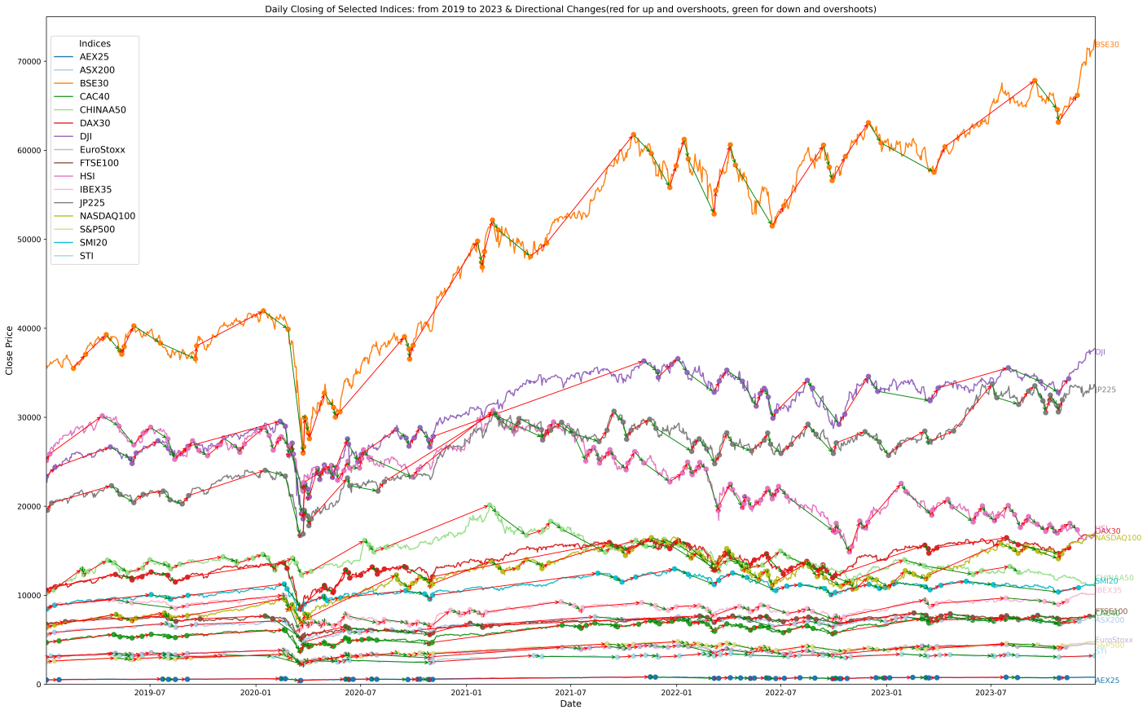



[1] Glattfelder, J. B., A. Dupuis, and R. B. Olsen. "Patterns in high-frequency FX data: Discovery of 12 empirical scaling laws." arXiv preprint arXiv:0809.1040 (2008).