**centos 7.5安装 elasticsearch文档**

**第一步，安装elasticsearch需要Java8**

首先使用 yum list installed | grep java 查看安装的Java版本

如果不是Java 8，则使用 yum -y remove java-1.7.0-openjdk\* 卸载已经安装的Java。

卸载完成之后，安装<jdk安装.docx>文档安装jdk1.8

**第二步，elasticsearch不能使用root启动，创建新用户**

创建用户组

groupadd -g 888 elasticsearch

创建用户

useradd -g elasticsearch -m elasticsearch

**第三步，下载elasticsearch安装包**

下载地址

https://www.elastic.co/downloads/elasticsearch

方式一：[源码](http://www.2cto.com/ym/" \t "_blank)

wget https://artifacts.elastic.co/downloads/elasticsearch/elasticsearch-6.1.1.tar.gz

tar -zxvf elasticsearch-6.1.1.tar.gz

mv elasticsearch-6.1.1 /usr/local

修改elasticsearch目录用户权限

cd /usr/local

chown elasticsearch: elasticsearch -R elasticsearch-6.1.1

**第四步，配置elasticsearch**

启动前需要修改配置文件(需要权限)

1.设置JVM启动内存

vim /usr/local/elasticsearch-6.1.1/config/jvm.options

-Xms512m

-Xmx512m

2.设置内核参数

vim /etc/sysctl.conf

添加如下内容:

fs.file-max=65536

vm.max\_map\_count=262144

之后可以使用sysctl –a查看 –p刷新

3. 设置资源参数

vim /etc/security/limits.conf

添加如下内容:

\* soft nofile 65536

\* hard nofile 131072

\* soft nproc 2048

\* hard nproc 4096

4. 修改进程数

vim /etc/security/limits.d/20-nproc.conf

修改( \* soft nproc )的值为4096

**第五步，修改配置文件**

**cd** /usr/local/elasticsearch-6.1.1/config/

vi elasticsearch.yml

找到network.host将其修改为本机ip

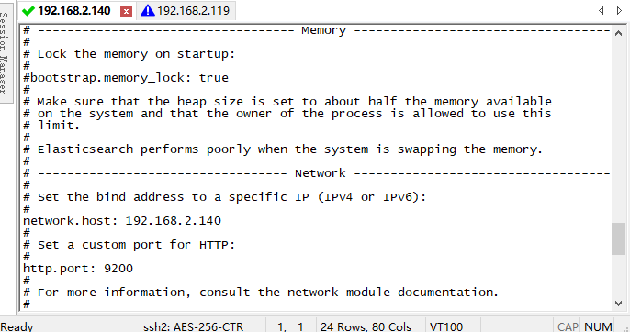

**第六步，新建elasticsearch 启动文件**

添加启动脚本 vi /etc/init.d/elasticsearch

#!/bin/sh

#chkconfig: 2345 80 05

#description: elasticsearch

#改动本地jdk目录

export JAVA\_HOME=/usr/local/java/jdk1.8.0\_171

export JAVA\_BIN=/usr/local/java/jdk1.8.0\_171/bin

export PATH=$PATH:$JAVA\_HOME/bin

export CLASSPATH=.:$JAVA\_HOME/lib/dt.jar:$JAVA\_HOME/lib/tools.jar

export JAVA\_HOME JAVA\_BIN PATH CLASSPATH

case "$1" in

start)

su elasticsearch<<!

cd /usr/local/elasticsearch-6.1.1

./bin/elasticsearch -d

!

echo "elasticsearch startup"

;;

stop)

es\_pid=`ps aux|grep elasticsearch | grep -v 'grep elasticsearch' | awk '{print $2}'`

kill -9 $es\_pid

echo "elasticsearch stopped"

;;

restart)

es\_pid=`ps aux|grep elasticsearch | grep -v 'grep elasticsearch' | awk '{print $2}'`

kill -9 $es\_pid

echo "elasticsearch stopped"

su elasticsearch<<!

cd /usr/local/elasticsearch-6.1.1

./bin/elasticsearch -d

!

echo "elasticsearch startup"

;;

\*)

echo "start|stop|restart"

;;

esac

exit $?

**启动并测试**

chmod +x /etc/init.d/elasticsearch

etc/init.d/elasticsearch start

jps

**测试地址**

**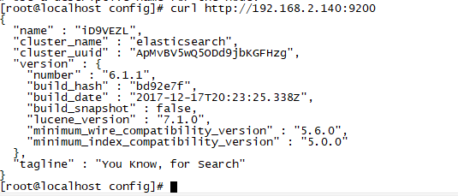**

**或者浏览器输入 <http://192.168.2.140:9200> 备注 ip:9200**

**效果图：**

**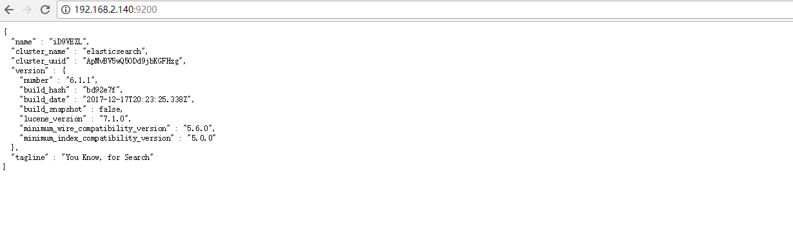**

**开放端口**

[root@localhost]# firewall-cmd --permanent --zone=public

--add-port=9200/tcp

firewall-cmd --permanent --zone=public --add-port=9300/tcp

firewall-cmd --reload

**第七步，中文分词插件安装Ansj分词插件**

****elasticsearch-analysis-ansj****  
Github地址：[https://github.com/NLPchina/elasticsearch-analysis-ansj](https://github.com/NLPchina/elasticsearch-analysis-ansj" \t "https://blog.csdn.net/u012869196/article/details/_blank)

****分词方式****   
Analyzer: index\_ansj，query\_ansj

进入Elasticsearch目录运行如下命令

进入es目录执行如下命令

cd /usr/local/elasticsearch-6.1.1

./bin/elasticsearch-plugin install file:///home/admin/elasticsearch-analysis-ansj-6.1.1.0-release.zip

**第八步，重启es服务**

/etc/init.d/elasticsearch stop

/etc/init.d/elasticsearch start