A meta-analysis of nitrous oxide emissions from agricultural soils in the Loess Plateau
Jingtao Zhou, Tao Huang, Xingjian Zou, Yumeng Guo, Jiangxin Gu *
College of Natural Resources and Environment, Northwest A&F University, 712100 Yangling, China

* Corresponding author:
Jiangxin Gu
ORCID: 0000-0002-7008-9042
College of Natural Resources and Environment, Northwest A&F University, 712100 Yangling, China
Tel: +86 29 8708 0055; Fax: +86 29 8708 0055
E-mail: gujiangxin@nwafu.edu.cn

Abstract
Context and Objective
A systematic analysis of nitrous oxide (N₂O) emissions from agricultural soils is lacking in the Loess Plateau. The objectives of this study were to (1) quantify the variations of N₂O emissions and crop yields, and (2) evaluate the integrated responses of N₂O emissions, direct emission factors (EF) and yield-scaled emissions to various farming practices in the region.
Methods
We extracted the field measurement data from peer-reviewed publications and conducted a pairwise meta-analysis. The dataset composed 366 and 311 records of N₂O emissions and crop yields, respectively, from 38 references published between 2006 and 2025. Cropping systems were majorly spring maize, winter wheat, spring wheat and apple orchards.
Results and Conclusions
The grain yields averaged 11.1, 5.4 and 1.5 t ha-1 for spring maize, winter wheat and spring wheat, respectively, and apple production averaged 44.2 t ha-1 in the Loess Plateau. The mean N2O emission from apple orchards (2.97 kg N ha-1) was significantly larger (p < 0.001) than those from cereal crops (ranging from 0.87 to 1.73 kg N ha-1). However, the mean EFs (ranging from 0.29% to 0.49%) did not differ significantly among the agroecosystems (Kruskal-Wallis p = 0.080). Of note, the mean yield-scaled emission from spring wheat (1.08 kg N t-1) was much larger (p < 0.001) than those from spring maize and winter wheat (ranging from 0.17 to 0.20 kg N t-1). The meta-analysis showed that reducing nitrogen (N) input rate decreased N2O emissions and yield-scaled emissions by 32.2% and 27.6%, respectively, but reduced crop yield by 5.9%, with no significant overall EF response. Across farming practices, manure, biochar and enhanced-efficiency fertilizers decreased N2O emissions, whereas mulching and biochar increased crop yields. We recommend manure application, plastic film mulching and moderate N reduction (25%-50%) as promising practices to balance crop production and N2O mitigation in the region.
Significance
Apple orchards were a hot N₂O source, indicating that massive land-use conversion from cereal cropland to apple orchards might significantly increase N₂O emissions in the Loess Plateau. It was evident that straw retention and straw mulching increased N₂O emissions, highlighting the importance of reasonably managing crop straw in the Loess Plateau. We propose that converting crop straw to animal manure may be a feasible approach to resolve this issue.
Keyword: N₂O emission, crop yields, direct emission factor, yield-scaled emission, mitigation strategy, Loess Plateau
- Introduction
Atmospheric nitrous oxide (N₂O) significantly contributes to global warming and stratospheric ozone depletion (Ravishankara et al., 2009). The tropospheric abundance of N₂O has increased by 23% since the pre-industrial era, mostly owing to the accelerating emissions from fertilized agricultural soils (Davidson, 2009). There has long been a challenge to mitigate N₂O emissions without crop yield penalties (Cui et al., 2021; Linquist et al., 2012).
Soil N₂O is primarily produced via microbial nitrification and denitrification (Butterbach-Bahl et al., 2013). It is widely observed that soil water content and the availability of nitrogen (N) substrates are among the most robust controllers of N₂O fluxes in various agroecosystems (Daba et al., 2025; Gu et al., 2020, 2011; Yao et al., 2023). The annual/seasonal N₂O emissions have large spatiotemporal variations which are generally attributed to weather conditions, soil properties and farming practices (Gu et al., 2017, 2013; Wang et al., 2026; Zhang et al., 2025). In addition to the field-measured N₂O emissions, the direct N₂O emission factor (EF) and yield-scaled N₂O emissions are key parameters for determining the gas emission and mitigation (Cui et al., 2021; Linquist et al., 2012; Yangjin et al., 2021). Several global meta-analyses outline the general understanding about N₂O abatement by evaluating the integrated responses of N₂O emissions, EFs and yield-scaled emissions to nature factors and mitigation strategies (Cui et al., 2021; Linquist et al., 2012; Yao et al., 2024). Meanwhile, a regional analysis is also valuable by providing region-specific insight on this global issue (Xu et al., 2017).
The Loess Plateau in north-central China is overlain by thick loess deposits which are highly subject to erosion (Liu, 1999). The highland has long been an intensive agricultural region, with maize and wheat being the major staple crops. However, the grain production is largely limited by soil degradation and water shortage (Liu, 1999; An et al., 2014). Various farming practices have been developed to increase grain yields while their impacts on N₂O emissions remain inconclusive. A combination of synthetic and organic N fertilizers is normally applied to promote soil fertility, thus posing a risk of large N₂O emissions (Liu et al., 2023; Wei et al., 2010; Yang et al., 2022). Meanwhile, plastic film mulching is widely adopted to conserve soil water, with inconsistent impacts on N₂O emissions (Gao et al., 2022; Liu et al., 2022; Wang et al., 2016). The effects of biochar amendment and application of enhanced efficiency fertilizers (EEFs) are also tested at individual site while lacking a thorough synthesis (Du et al., 2024; Han et al., 2022; Liu et al., 2022). Furthermore, since the ecological restoration program “Grain for Green” being initiated in 1999, a large amount of cereal cropland has been converted to fruit orchards in the Loess Plateau (Lv et al., 2014). Generally, fruit orchards are regarded as a hot N₂O source due to the intensive N managements and relatively large EFs (Gu et al., 2019). It is reasonable to hypothesize that N₂O emissions may increase after the massive land use conversion but requiring validation. Thus, a systematic analysis of N₂O emissions from various agroecosystems is needed in the Loess Plateau.
In this study, we collected measurement data from previous publications and conducted a pairwise meta-analysis, aiming to (1) quantify the variations of N₂O emissions and crop yields, and (2) evaluate the integrated responses of N₂O emissions, EFs and yield-scaled emissions to various farming practices in the Loess Plateau.
- Materials and method

2.1 Data collection
Peer-reviewed publications were collected by searching Web of Science (http://apps.webofknowledge.com) with various combinations of the keywords “Loess plateau,” “cropland,” “cropping system” or “agroecosystems,” and “nitrous oxide,” “N₂O,” “gaseous nitrogen,” or “greenhouse gas.” Only field measurement data were included, without considering laboratory or pot experimental data and modeling results. The N₂O fluxes were always measured using manual chambers, with three or more spatial replicates. The measurement period covered at least a crop growing season. The standard deviations or standard errors of N₂O emissions and crop yields were readily available or could be calculated.
The dataset composed 366 and 311 records of N₂O emissions and crop yields, respectively, from 38 peer-reviewed publications between 2006 and 2025 (Table S1). The data included site location (longitude and latitude), climate (annual temperature and precipitation), soil properties (soil clay content, pH and organic carbon content), experimental years, cropping systems, N fertilizer input rates and N sources, farming practices, and N₂O emissions and crop yields. Of note, an extreme weather event such as frost may lead to harvest failures in spite of intensive managements in the apple orchards (Han et al., 2022). In this case, the apple production was not recorded.
The experimental sites were across the Loess Plateau (Fig. 1). Cropping systems were majorly spring maize, winter wheat, spring wheat, and apple orchards. Specifically, the data of an independent potato field were only involved for evaluating the effect of EEFs (Sun et al., 2023). Conventional N fertilizers referred to synthetic fertilizers, animal manure and crop straw while EEFs included control- or slow-released fertilizers, nitrification inhibitors, and urease inhibitors. Mulching materials included plastic film and crop straw. Of note, straw retention and straw mulching were grouped following the original description in the references and the data did not overlap.
Fig. 1 Map of experimental sites for N₂O flux measurements in the Loess Plateau.

2.2 Data process
The EFs and yield-scaled emissions were generally recorded as being provided in the references. Otherwise, the EF (%) and yield-scaled emissions (kg N t⁻¹) were calculated, as follows:
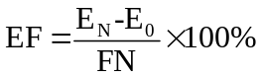 | (1)
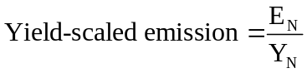 | (2)
where E_{N} and E₀ were N₂O emissions (kg N ha⁻¹) from the fertilized and unfertilized treatments, respectively. FN and Y_{N} were the N input rates (kg N ha⁻¹) and crop yield (t ha⁻¹) for the fertilized treatment, respectively. The standard error of EF (SE_{EF}) and yield-scaled emission (SE_{YSE}) were calculated, as follows:
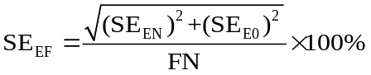 | (3)
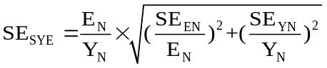 | (4)
where SE_{EN} and SE_{E0} were the standard errors of N₂O emissions (kg N ha⁻¹) from the fertilized and unfertilized treatments, respectively. SE_{YN} was the standard error of crop yields of the fertilized treatment.
The SE was converted to SD, as follows:
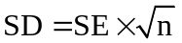 | (5)
where n was the number of measurement replicates.

2.3 Statistical analysis
Statistical analysis was performed using R (version 4.5.1, https://www.r-project.org/). The mean, median and coefficient of variation (CV) were calculated for the data series of crop yields, N2O emissions, EFs and yield-scaled emissions for each cropping system that received the conventional fertilizers. The Kolmogorov-Smirnov test was applied to test if the data series followed normal or log-normal distributions (p > 0.05). Differences in central tendency among cropping systems were examined using one-way ANOVA or Kruskal-Wallis tests, followed by Tukey HSD or pairwise Wilcoxon rank-sum tests with Benjamini-Hochberg adjustment where appropriate (p < 0.05). Pairwise two-sample Kolmogorov-Smirnov tests were retained as distributional diagnostics. The responses of crop yields and N2O emissions to N input rates (including those measurements in unfertilized treatments) were tested by fitting linear or quadratic models (p < 0.05). Of note, the measurements in treatments with application of biochar or EEFs were excluded during the modeling fitting. The slope and intercept of the linear regression between N2O emissions and N input rates were defined as an emission coefficient and background emission, respectively. The agronomic optimal N rate and maximum yield were assigned to the vertex point of the quadratic model between grain yields and N input rates.

2.4 Meta-analysis
The pairwise management practices were organic amendments versus full synthetic fertilizers, mulching versus bare soil, biochar amendment or application of EEFs versus conventional fertilizers, and reducing N fertilizers versus full N input. The proportion of reduced N fertilizers to full input rates ranged from 15% to 75% across the studies (Table S1). We classified reduced-N treatments into three categories (< 25%, 25%-50% and > 50%). Formal meta-analytic estimates were reported only when a group contained at least three effect sizes and at least three independent publications; groups below this threshold were retained in the figures as sample-size notes but were not interpreted as formal effect estimates. Except reducing N fertilizers, the effects of other mitigation strategies were tested at the same N input rates.
The meta-analysis was conducted in R using custom scripts developed for this study. For N2O emissions, crop yields and yield-scaled emissions, effect sizes were calculated as log-transformed response ratios (RR). For EFs, effect sizes were calculated as Hedges' d because negative EFs were recorded. EF baselines were matched within the same reference, crop, year/site, farming management and treatment family before calculating treatment-control contrasts. Weighted mean RR or Hedges' d was obtained using a DerSimonian-Laird random-effects model, and 95% confidence intervals (CIs) were determined by bootstrapping with 999 iterations. RR results were back-transformed and reported as percentage change ([RR - 1] x 100%). Effects were considered significant when the 95% CIs did not overlap with zero. Because some publications contributed multiple treatment-control contrasts, both the number of effect sizes and the number of independent publications were tracked to avoid overinterpreting repeated contrasts.
- Results

3.1 Crop yields
The grain yields of the fertilized spring maize, winter wheat and spring wheat averaged 11.1 (ranging from 3.5 to 21.4 t ha⁻¹, n = 138, CV = 35%), 5.4 (ranging from 4.1 to 6.8 t ha⁻¹, n = 18, CV = 14%) and 1.5 (ranging from 1.1 to 2.3 t ha⁻¹, n = 45, CV = 22%) t ha⁻¹, respectively (Fig. 2). The data always followed normal distributions (p > 0.355) and significant differences were observed among the three cereal crops (p < 0.001). The dependences of grain yields on N input rates always followed quadratic models (p < 0.01), with the maximum yields of 11.9, 5.6 and 1.6 t ha⁻¹ being obtained at the agronomic optimal N rates of 295, 191 and 153 kg N ha⁻¹ for spring maize, winter wheat and spring wheat, respectively (Fig. 2).
Fig. 2 (A) Dependences of grain yields on N input rates for spring maize, winter wheat and spring wheat in the Loess Plateau. Values in the square brackets are the agronomic optimal N rate, maximum yield and the significance of the fitted quadratic models. (B) Comparison of grain yields of the fertilized spring maize, winter wheat and spring wheat. The box and whisker indicate the range between 25% and 75% percentiles and 1.5 interquartile range, respectively. The diamond point and solid line in the boxes indicate the mean and median, respectively.
The apple production averaged 44.2 t ha⁻¹ (ranging from 12.0 to 93.4 t ha⁻¹, n = 25, CV = 38%). The data series followed a normal distribution (p = 0.875). No apparent correlation was fitted between the apple production and N input rates (Fig. S1).

3.2 N₂O emissions, EFs and yield-scaled emissions
The N₂O emissions ranged widely from 0.26 to 8.89 kg N ha⁻¹ across the fertilized agroecosystems in the Loess Plateau (Fig. 3). The data followed a log-normal distribution (p = 0.734), with a mean and median of 1.78 and 1.48 kg N ha⁻¹, respectively. Specifically, the N₂O emissions averaged 1.73 (ranging from 0.26 to 4.95 kg N ha⁻¹, n = 148, CV = 59%), 0.87 (ranging from 0.36 to 1.48 kg N ha⁻¹, n = 24, CV = 37%), 1.59 (ranging from 0.94 to 2.65 kg N ha⁻¹, n = 47, CV = 27%) and 2.97 (ranging from 0.95 to 8.89 kg N ha⁻¹, n = 33, CV = 73%) kg N ha⁻¹ for spring maize, winter wheat, spring wheat and apple orchards, respectively (Fig. 3). The data of the three cereal crops followed normal distributions (p > 0.107) and the data of apple orchards followed a log-normal distribution (p = 0.501). The mean N₂O emission from winter wheat was 45% - 50% lower than those from spring maize and spring wheat (p < 0.001) while the differences between the latter two cereal crops were non-significant (p = 0.385). The mean N₂O emission from apple orchards was 72% - 241% larger than those from cereal crops (p < 0.001). The dependences of N₂O emissions on N input rates always followed linear models (p < 0.001) (Fig. 3). The emission coefficients ranged narrowly from 0.33% to 0.38% and did not differ significantly among the agroecosystems (p > 0.421). The background emission from winter wheat (0.31 kg N ha⁻¹) was significantly lower (p < 0.05) than those from spring maize, spring wheat and apple orchards (ranging from 0.97 to 1.23 kg N ha⁻¹) while the differences were non-significant (p > 0.085) among the latter three agroecosystems.
Fig. 3 (A) Dependences of N₂O emissions on N input rates for spring maize, winter wheat, spring wheat and apple orchards in the Loess Plateau. Values in the square brackets are the background emission, emission coefficient and the significance of the fitted linear models. Different letters in the same column indicate significant differences between the agroecosystems (p < 0.05). (B) Comparison of N₂O emissions from the fertilized spring maize, winter wheat, spring wheat and apple orchards. The box and whisker indicate the range between 25% and 75% percentiles and 1.5 interquartile range, respectively. The diamond point and solid line in the boxes indicate the mean and median, respectively.
The EFs ranged from -0.11% to 1.61% across the agroecosystems in the Loess Plateau (Fig. 4A). The data followed a normal distribution (p = 0.314), with a mean and median of 0.46% and 0.42%, respectively. Specifically, the EFs averaged 0.49% (ranging from 0.11% to 1.27%, n = 80, CV = 55%), 0.29% (ranging from 0.16% to 0.39%, n = 12, CV = 26%), 0.42% (ranging from -0.11% to 1.45%, n = 12, CV = 117%) and 0.48% (ranging from 0.08% to 1.61%, n = 29, CV = 69%) for spring maize, winter wheat, spring wheat and apple orchards, respectively (Fig. 4A). The data always followed normal distributions (p > 0.135). The EFs did not differ significantly among the agroecosystems (Kruskal-Wallis p = 0.080; pairwise Wilcoxon tests with Benjamini-Hochberg adjustment, p > 0.085).
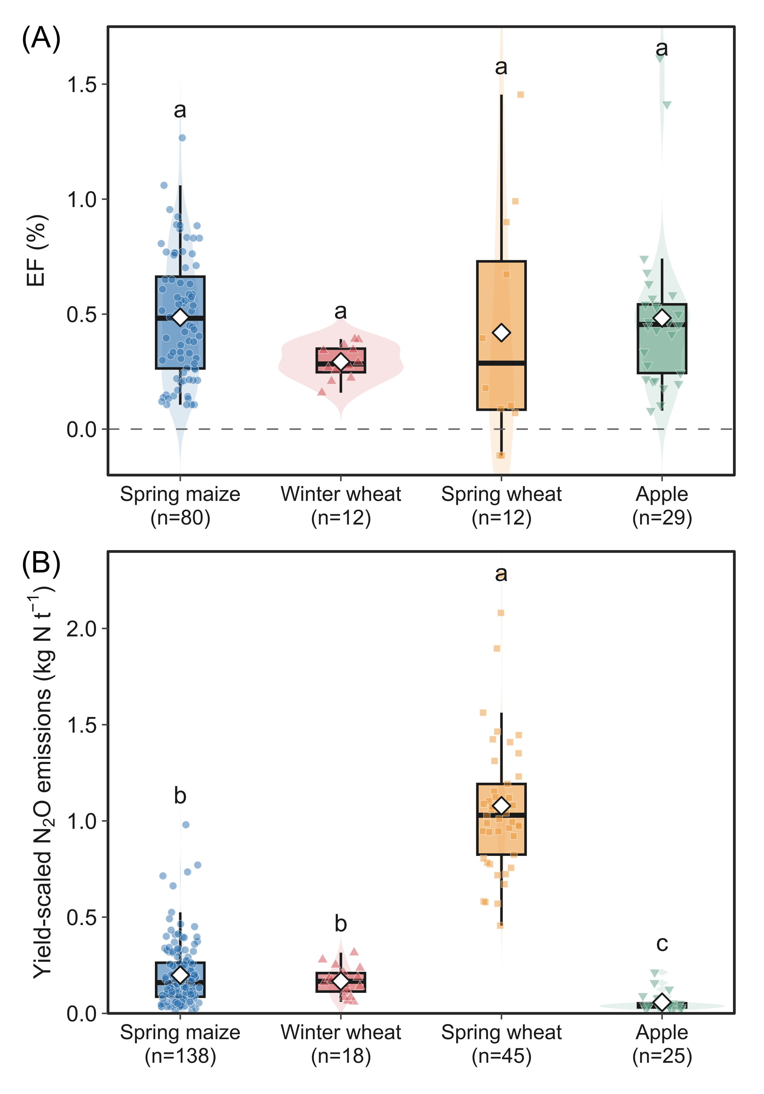
Fig. 4 Comparison of (A) emission factors (EF) and (B) yield-scaled N2O emissions from the fertilized spring maize, winter wheat, spring wheat and apple orchards in the Loess Plateau. The box and whisker indicate the range between 25% and 75% percentiles and 1.5 interquartile range, respectively. The diamond point and solid line in the boxes indicate the mean and median, respectively. Different letters indicate significant differences based on pairwise Wilcoxon rank-sum tests with Benjamini-Hochberg adjustment (p < 0.05).
The yield-scaled emissions averaged 0.20 (ranging from 0.02 to 0.98 kg N t-1, n = 138, CV = 83%), 0.17 (ranging from 0.06 to 0.32 kg N t-1, n = 18, CV = 44%) and 1.08 (ranging from 0.46 to 2.28 kg N t-1, n = 45, CV = 35%) kg N t-1 for the fertilized spring maize, winter wheat and spring wheat, respectively (Fig. 4B). The data of spring maize followed a log-normal distribution (p = 0.761) and the data of winter wheat and spring wheat followed normal distributions (p > 0.170). Yield-scaled emissions from spring wheat were much larger than those from spring maize and winter wheat (Benjamini-Hochberg adjusted p < 0.001), while the difference between the latter two crops was non-significant (p = 0.954). The yield-scaled emissions averaged 0.06 (ranging from 0.02 to 0.21 kg N t-1, n = 25, CV = 80%) kg N t-1 for the apple orchards (Fig. 4B). The apple data followed a log-normal distribution (p = 0.317), and apple orchard values were lower than those of the cereal systems (Benjamini-Hochberg adjusted p < 0.001).

3.3 Effects of farming practices
Organic inputs had non-significant impacts on N2O emissions (-2.7%; 95% CI: -8.0% to 2.5%) and crop yields (7.8%; 95% CI: -2.4% to 18.5%) and did not significantly change yield-scaled emissions (-10.4%; 95% CI: -20.1% to 2.4%) (Fig. 5). Manure application decreased N2O emissions by 7.4% (95% CI: -13.0% to -1.3%) and yield-scaled emissions by 16.6% (95% CI: -27.5% to -3.6%), with a non-significant effect on crop yields (7.9%; 95% CI: -4.2% to 21.8%). In contrast, straw return increased N2O emissions by 10.2% (95% CI: 3.6% to 16.2%) and had non-significant effects on crop yields (8.8%; 95% CI: -9.7% to 21.8%) and yield-scaled emissions (2.7%; 95% CI: -16.6% to 31.2%). The overall EF response to organic inputs was non-significant (Hedges' d = -0.38, 95% CI: -0.98 to 0.25); manure also had a non-significant EF response (Hedges' d = -0.59, 95% CI: -1.18 to 0.03), and straw-return EF estimates were not interpreted because fewer than three publications were available.
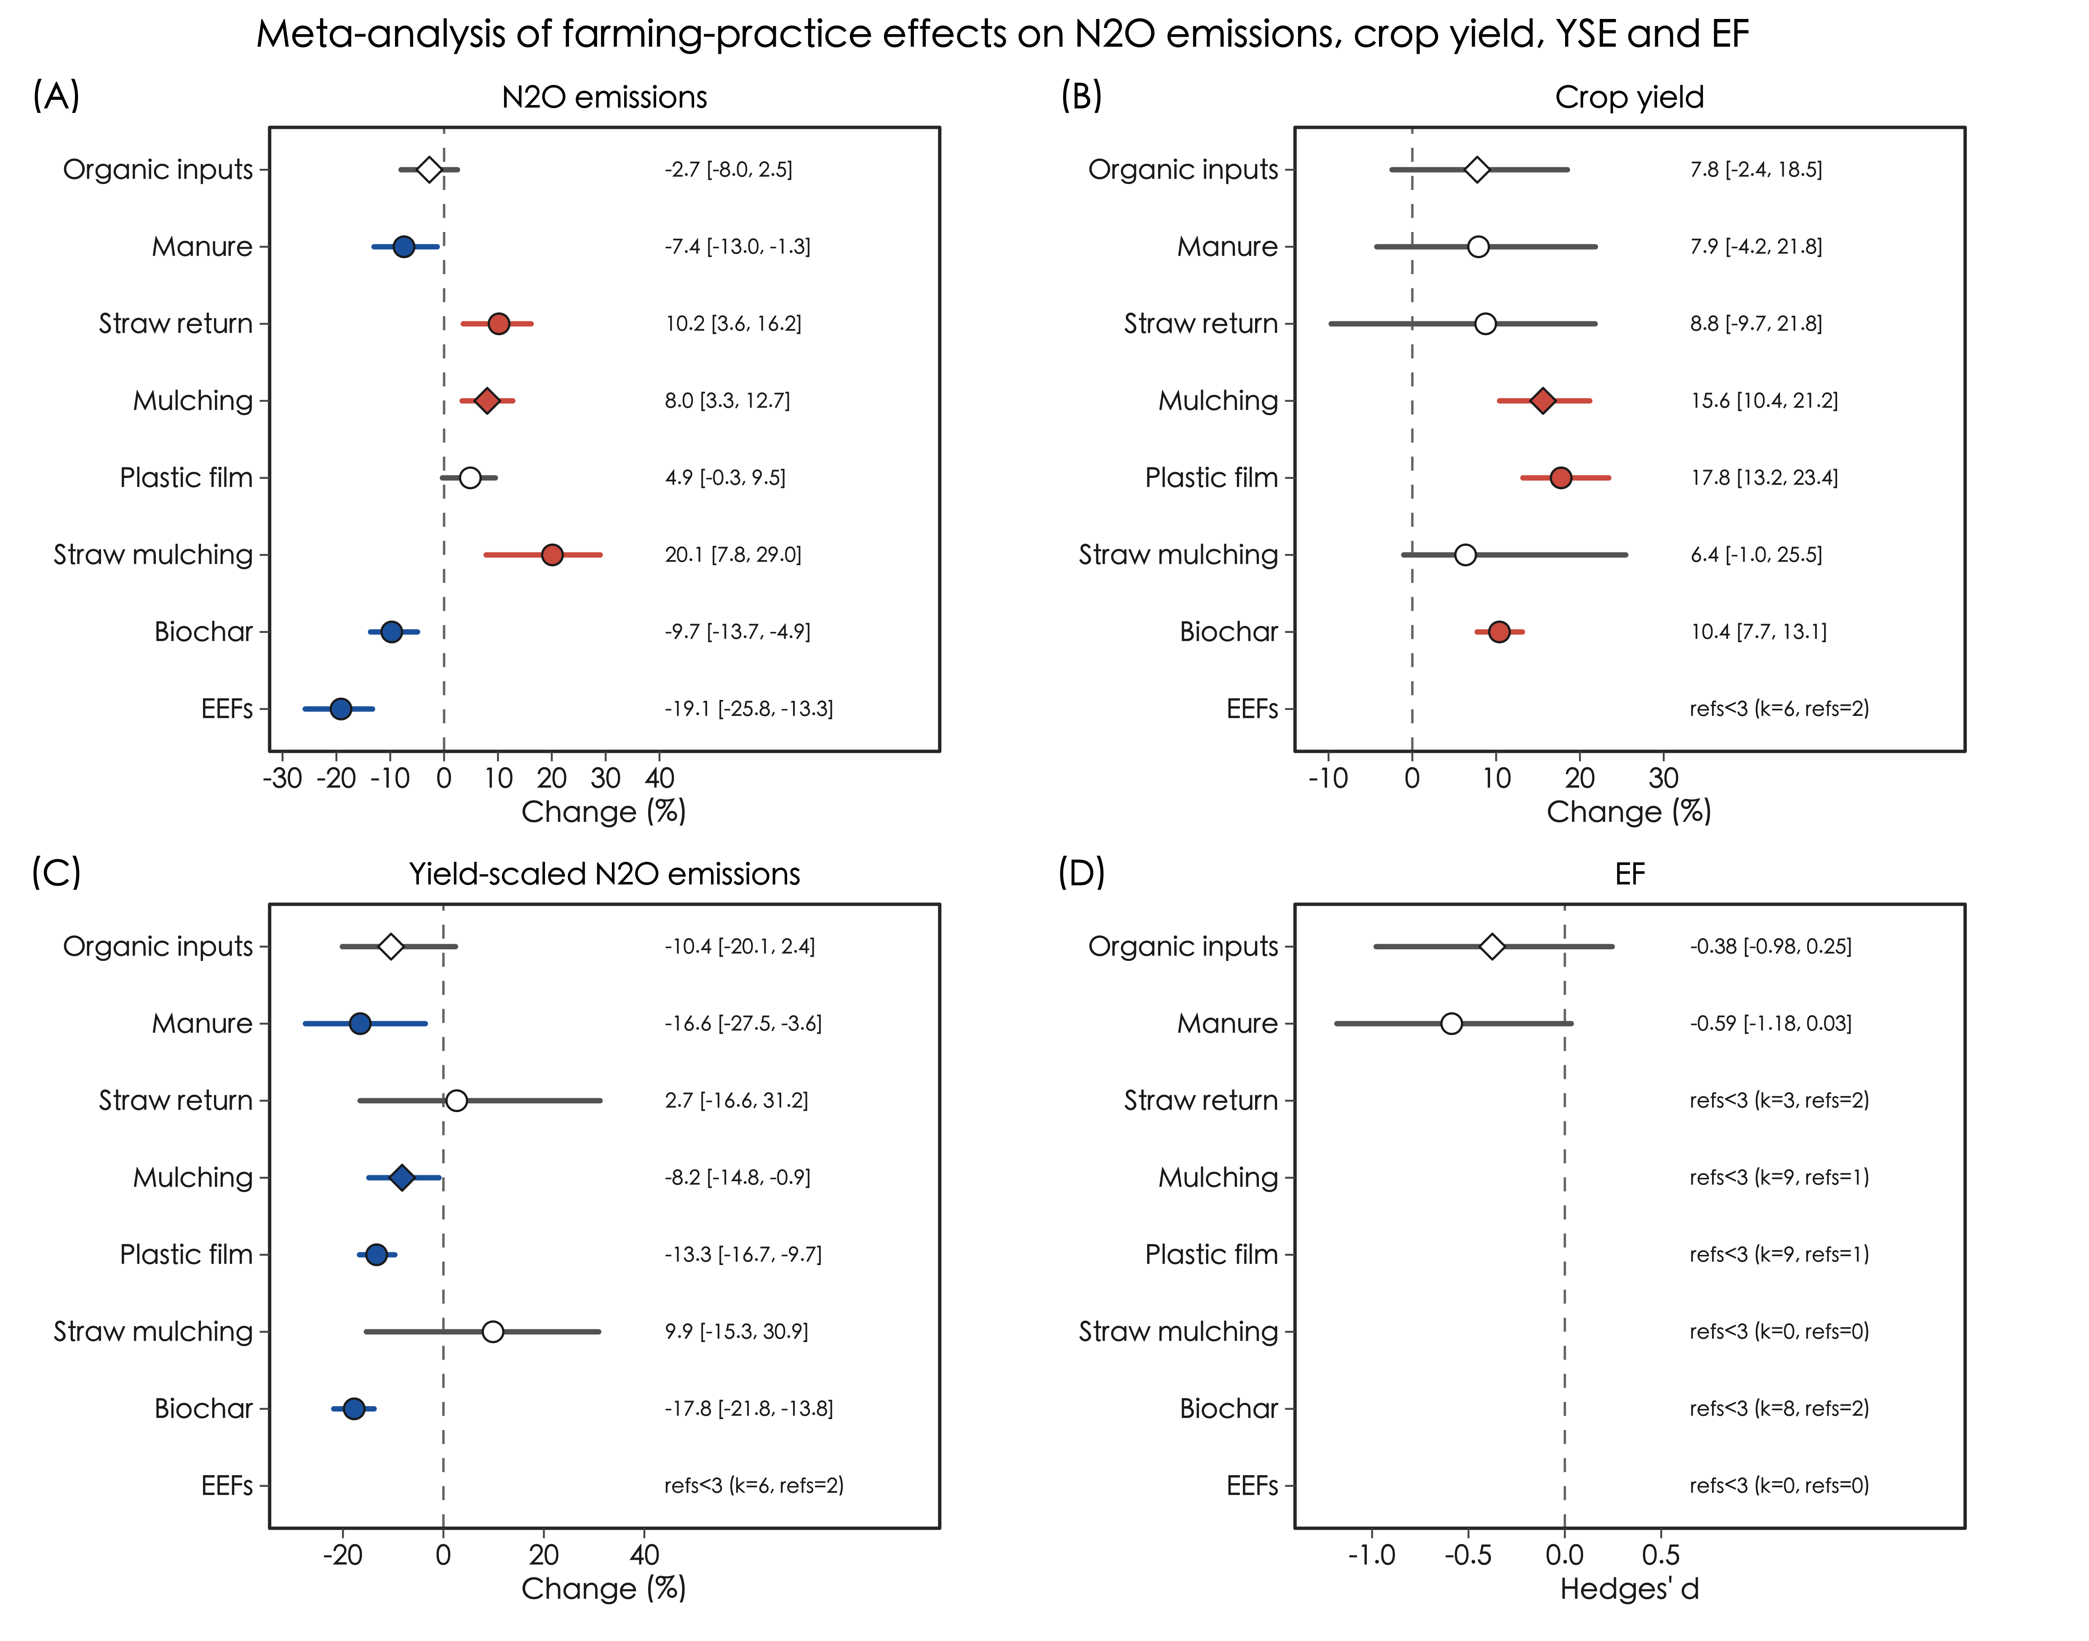
Fig. 5 Impacts of farming practices on N2O emissions, crop yields, yield-scaled emissions and emission factors (EF) in the Loess Plateau. Data points refer to the mean effect size with 95% confidence intervals. Text labels show the mean effect size [95% CI]; refs<3 indicates groups supported by fewer than three independent publications and therefore not interpreted as formal meta-analytic estimates. EEFs are enhanced-efficiency fertilizers.
Mulching increased N2O emissions and crop yields by 8.0% (95% CI: 3.3% to 12.7%) and 15.6% (95% CI: 10.4% to 21.2%), respectively, and decreased yield-scaled emissions by 8.2% (95% CI: -14.8% to -0.9%) (Fig. 5). Plastic film mulching had a non-significant impact on N2O emissions (4.9%; 95% CI: -0.3% to 9.5%), increased crop yields by 17.8% (95% CI: 13.2% to 23.4%) and decreased yield-scaled emissions by 13.3% (95% CI: -16.7% to -9.7%). Straw mulching increased N2O emissions by 20.1% (95% CI: 7.8% to 29.0%) and had non-significant effects on crop yields (6.4%; 95% CI: -1.0% to 25.5%) and yield-scaled emissions (9.9%; 95% CI: -15.3% to 30.9%). EF estimates for mulching, plastic film mulching and straw mulching were not interpreted because fewer than three publications were available.
Biochar amendment decreased N2O emissions by 9.7% (95% CI: -13.7% to -4.9%), increased crop yields by 10.4% (95% CI: 7.7% to 13.1%) and decreased yield-scaled emissions by 17.8% (95% CI: -21.8% to -13.8%) (Fig. 5). The EF estimate for biochar amendment was not interpreted because fewer than three publications were available. Application of EEFs decreased N2O emissions by 19.1% (95% CI: -25.8% to -13.3%), whereas its crop-yield, yield-scaled-emission and EF estimates did not meet the three-publication threshold and were not interpreted as formal effects (Fig. 5).
Reducing N input rate decreased N2O emissions, crop yields and yield-scaled emissions by 32.2% (95% CI: -36.7% to -27.9%), 5.9% (95% CI: -10.0% to -1.8%) and 27.6% (95% CI: -32.3% to -21.9%), respectively (Fig. 6). The overall EF response was non-significant (Hedges' d = -0.01, 95% CI: -0.27 to 0.26). In crop-specific analyses, N reduction decreased N2O emissions and yield-scaled emissions for both spring maize and spring wheat, but the yield loss was significant for spring maize (-13.8%; 95% CI: -20.9% to -7.0%) and non-significant for spring wheat (-1.6%; 95% CI: -6.6% to 4.9%). The < 25% N-reduction category was supported by only two publications and was therefore not interpreted. Reducing N by 25%-50% decreased N2O emissions (-27.3%; 95% CI: -32.8% to -21.8%) and yield-scaled emissions (-24.5%; 95% CI: -31.1% to -16.2%) without a significant yield response (-1.7%; 95% CI: -7.3% to 4.4%), whereas reducing N by > 50% caused larger decreases in N2O emissions (-44.9%; 95% CI: -51.4% to -37.8%) and yield-scaled emissions (-34.3%; 95% CI: -42.8% to -24.9%) but also a significant yield loss (-12.4%; 95% CI: -22.7% to -5.9%). EF responses were not significant for the interpretable N-reduction groups.
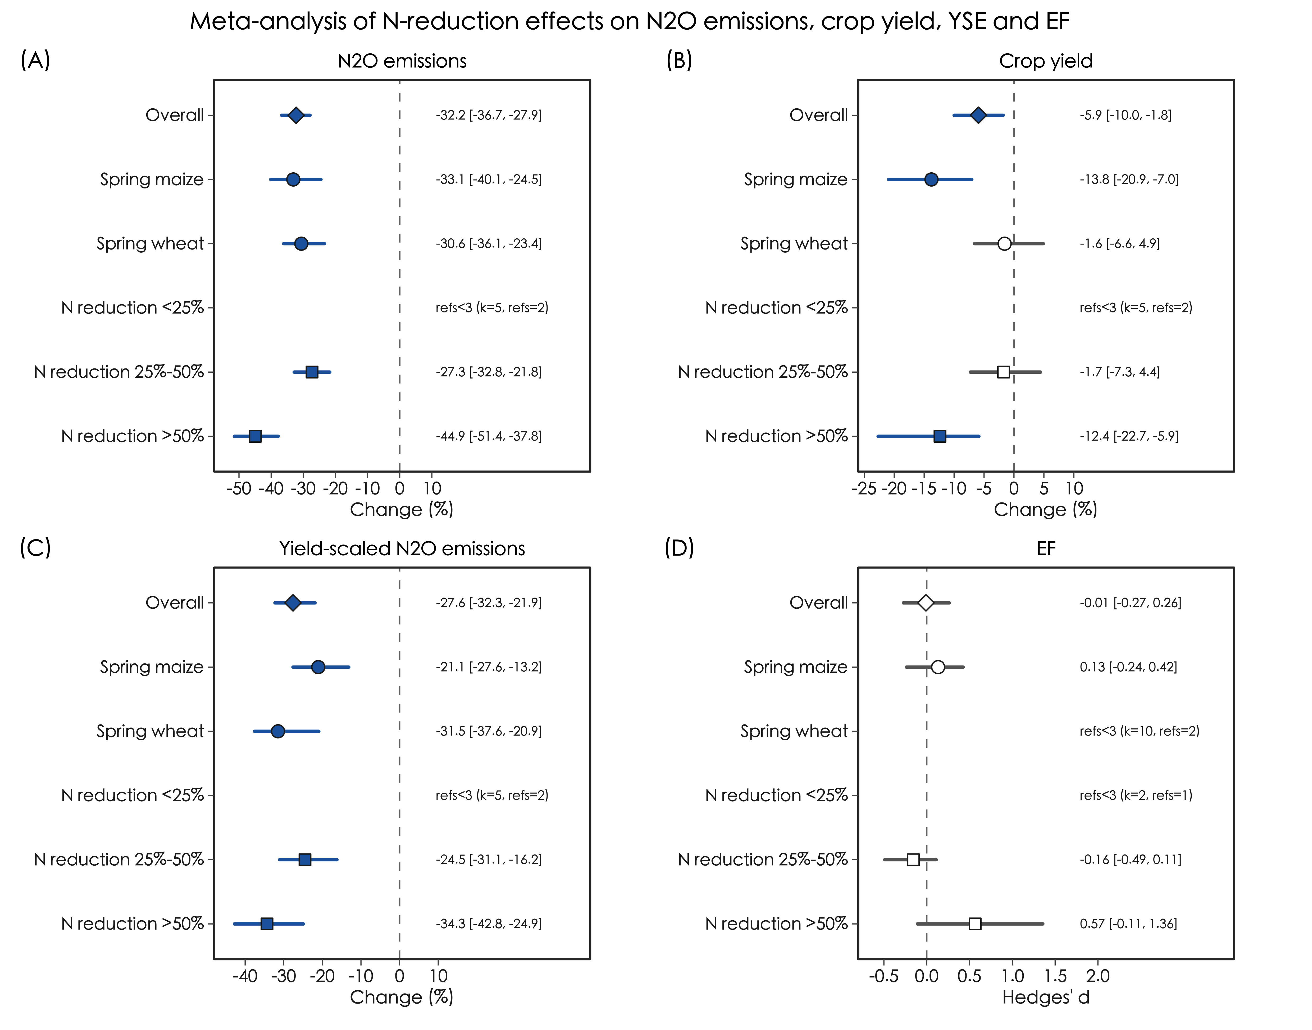
Fig. 6 Impacts of reducing N input rates on N2O emissions, crop yields, yield-scaled emissions and emission factors (EF) in the Loess Plateau. Data points refer to the mean effect size with 95% confidence intervals. Text labels show the mean effect size [95% CI]; refs<3 indicates groups supported by fewer than three independent publications and therefore not interpreted as formal meta-analytic estimates.
- Discussion

4.1 Region-specific N₂O emissions
The N₂O emissions from agroecosystems in the Loess Plateau (ranging from 0.26 to 8.89 kg N ha⁻¹) were within the wide variations of emissions (ranging from –0.12 to 26.0 kg N ha⁻¹) at global scales (Table 1). The mean emission from spring maize in the Loess Plateau (1.73 kg N ha⁻¹) was within the variation of mean emissions from maize (ranging from 1.50 to 3.01 kg N ha⁻¹) at global scales (Table 1). The mean emissions from winter wheat and spring wheat in the Loess Plateau (0.87 and 1.51 kg N ha⁻¹, respectively) were moderately below and above the variations of mean emissions from wheat (ranging from 1.38 to 1.44 kg N ha⁻¹) at global scales, respectively (Table 1). Of note, the global datasets pooled winter wheat and spring wheat together (Linquist et al., 2012; Yao et al., 2024). It was reasonable to suppose that the N₂O emissions from wheat in the Loess Plateau were comparable to those at global scales. Conversely, the significant difference in N₂O emissions between winter wheat and spring wheat may imply a necessity to separate these two wheat crops during data synthesis (Fig. 3B). Meanwhile, the mean emission from apple orchards in the Loess Plateau (2.97 kg N ha⁻¹) was marginally below the mean emission from fruit orchards (3.06 kg N ha⁻¹) at a global scale (Table 1). Thus, the region-specific N₂O emissions coincided well with those at global scales.
However, the crop-specific EFs in the Loess Plateau (ranging from 0.29% to 0.49%) were approximately 50% lower than those (ranging from 0.58% to 1.19%) at global scales (Table 1). Similarly, the crop-specific emission coefficients in the Loess Plateau (ranging from 0.33% to 0.38%) were approximately 70% lower than those (ranging from 1.06% to 1.36%) at global scales (Table 1). Firstly, the large background emissions could partly explain the small region-specific EFs and emissions coefficients in the Loess Plateau. This might particularly be the truth for spring wheat and apple orchards because their background emissions (ranging from 1.15 to 1.23 kg N ha⁻¹) were 68% - 102% larger than those at global scales (ranging from 0.59 to 0.73 kg N ha⁻¹) (Table 1). Large background emissions were generally attributed to high soil fertility (Gu et al., 2009, 2007) whilst it appeared not the case in our study because of low organic carbon content in the Loess Plateau (Table S1). Nonetheless, the background emissions in the Loess Plateau were still comparable to the national or global mean (Gu et al., 2009, 2007). Secondly, the small EFs and emissions coefficients for spring maize in the Loess Plateau might result from the high grain yields (11.1 t ha⁻¹), as compared to maize yields (ranging from 7.9 to 8.0 t ha⁻¹) at global scales (Table 1). Finally, cold and dry weather during the growing season might lead to the small EFs, emissions coefficients and background emission from winter wheat in the Loess Plateau.
The mean yield-scaled emissions from winter wheat and spring wheat in the Loess Plateau (0.17 and 1.08 kg N t⁻¹, respectively) were approximately 50% lower and more than 200% larger than the mean yield-scaled emissions from wheat (ranging from 0.32 to 0.35 kg N t⁻¹) at global scales (Table 1). The extremely large yield-scaled emissions from spring wheat in the Loess Plateau were mostly a result of low grain yields (1.5 t ha⁻¹), as compared to winter wheat yields in the same region (5.4 t ha⁻¹) and wheat yields at global scales (ranging from 4.8 to 5.1 t ha⁻¹) (Table 1). This observation highlights a possibility of investigating and mitigating the yield-scaled emissions from spring wheat.
  - Mitigation strategies
The evidence indicated that manure application and straw retention had different impacts on N2O emissions in the Loess Plateau (Fig. 5). We observed that animal manure decreased N2O emissions and yield-scaled emissions, whereas crop straw increased N2O emissions without a significant yield-scaled-emission benefit (Fig. 5). This observation coincided with the results of a previous global meta-analysis showing that the type of organic materials played a critical role in regulating N2O emissions (Yangjin et al., 2021). Generally, crop straw favored N2O production and emission by providing additional N and organic carbon substrates (Abalos et al., 2022; Shan and Yan, 2013). Relative to straw retention, we recommend manure application because it reduced N2O emissions and yield-scaled emissions without a detectable yield penalty (Fig. 5).
The results of meta-analysis showed that mulching significantly increased crop yields and N₂O emissions in the Loess Plateau (Fig. 5), largely coinciding with the results of a global meta-analysis (Wang et al., 2021). Of note, plastic film and crop straw appeared contributing to the increases of crop yields and N₂O emissions, respectively (Fig. 5). Relative to straw mulching, we recommend plastic film mulching due to its significant negative effects on yield-scaled emissions.
Biochar amendment increased crop yields and decreased both N2O emissions and yield-scaled emissions in the Loess Plateau (Fig. 5). Application of EEFs also decreased N2O emissions, but the available evidence for crop yields, yield-scaled emissions and EFs did not meet the three-publication threshold after strict matching. A plausible explanation for the positive crop-yield response to biochar was that biochar may improve soil water and nutrient retention even under the generally alkaline soil conditions of the region (Table S1). However, we still note a possible risk of increasing other reactive N losses, such as ammonia volatilization and nitrate leaching, which was beyond the scope of the present dataset.
We observed that reducing N input rate was effective in decreasing N2O emissions and yield-scaled emissions, although the overall response included a significant yield loss and no significant EF change (Fig. 6). The previous inference that reducing < 25% N could promote crop yields was not retained because this category was supported by only two publications under the updated threshold. Instead, the 25%-50% N-reduction category decreased N2O emissions and yield-scaled emissions without a significant yield penalty, whereas > 50% N reduction caused a clear yield loss. Considering that full N input rates were generally above the agronomic optimal N rates (Fig. 2), we recommend moderate N reduction (25%-50%) as a promising but crop-specific mitigation strategy.
  - Implication of this study
It was unexpected that the mean grain yield of spring maize in the Loess Plateau (11.1 t ha⁻¹) was apparent higher relative to the maize yields at global scales (ranging from 7.9 to 8.0 t ha⁻¹) (Table 1). The maximum yield and agronomic optimal N rate for spring maize in the Loess Plateau were 11.9 t ha⁻¹ and 295 kg N ha⁻¹, respectively, being approximately 25% higher than those obtained for summer maize in the adjacent North China Plain (Xu et al., 2017). Meanwhile, the results of meta-analysis showed that reducing N input rate decreased crop yields and the yield penalty was particularly severe for spring maize relative to spring wheat (Fig. 6). These observations indicated that the high grain yields of spring maize were mostly depending on intensive managements of N fertilizers in the Loess Plateau.
It was evident that apple orchards were a hot N₂O source as compared to cereal cropland in the Loess Plateau (Fig. 3). This observation indicated that massive land-use conversion from cereal cropland to apple orchards might significantly increase N₂O emissions in the region. However, the large N₂O emissions from apple orchards were mostly a result of high N input rates (Fig. 3). It was worthy to note that the mean EFs and emission coefficients did not differ significantly among the agroecosystems (Figs. 3 and 4). These observations imply that optimizing N input may be an effective approach for reducing N₂O emissions from apple orchards. More measurement data are required to quantify the agronomic optimal N rates in apple orchards.
Unlike the other farming practices, straw retention and straw mulching were the two that significantly increased N₂O emissions and did not decrease yield-scaled emissions (Fig. 5). This observation highlights the importance of reasonably managing crop straw to limit N₂O emissions in the Loess Plateau. We propose that converting crop straw to animal manure may be a feasible approach to resolve this issue.
- Conclusion
Apple orchards were a hot N₂O source as compared to cereal cropland in the Loess Plateau, indicating that massive land-use conversion from cereal cropland to apple orchards might significantly increase N₂O emissions in the region. However, the crop-specific EFs and emission coefficients did not differ significantly among the agroecosystems in the Loess Plateau and were apparent lower relative to those at global scales. Additionally, we observed extremely large yield-scaled emissions from spring wheat in the Loess Plateau, highlighting a possibility of investigating and mitigating the yield-scaled emissions from spring wheat.
The results of meta-analysis showed that no single practice simultaneously increased crop yields and decreased all N2O-related measures under the stricter evidence threshold. Manure application decreased N2O emissions and yield-scaled emissions without a detectable yield penalty, plastic film mulching increased crop yields and decreased yield-scaled emissions, and moderate N reduction (25%-50%) decreased N2O emissions and yield-scaled emissions without a significant yield loss. Biochar amendment also increased crop yields and decreased N2O emissions and yield-scaled emissions, although the EF response was not formally interpreted because of limited publications. Above all, we recommend manure application, plastic film mulching and moderate N reduction as potent farming practices for balancing yield maintenance and N2O mitigation in the Loess Plateau. The meta-analysis results further highlighted the importance of reasonably managing crop straw to limit N2O emissions. We propose that converting crop straw to animal manure may be a feasible approach to resolve this issue.

Acknowledgment
This research was supported by National Natural Science Foundation of China (41475128).

References
Abalos, D., Recous, S., Butterbach-Bahl, K., De Notaris, C., Rittl, T.F., Topp, C.F.E., Petersen, S.O., Hansen, S., Bleken, M.A., Rees, R.M., Olesen, J.E., 2022. A review and meta-analysis of mitigation measures for nitrous oxide emissions from crop residues. Science of The Total Environment 828, 154388. https://doi.org/10.1016/j.scitotenv.2022.154388
An, P., Inoue, T., Zheng, M., Egrinya Eneji, A., Inanaga, S., 2014. Agriculture on the Loess Plateau. Restoration and development of the degraded Loess Plateau, China; Tsunekawa, A., Liu, G., Yamanaka, N., Du, S., Eds.; Springer Japan, 2014.
Butterbach-Bahl, K., Baggs, E.M., Dannenmann, M., Kiese, R., Zechmeister-Boltenstern, S., 2013. Nitrous oxide emissions from soils: How well do we understand the processes and their controls? Philosophical Transactions of the Royal Society B: Biological Sciences 368, 20130122. https://doi.org/10.1098/rstb.2013.0122
Cui, X., Zhou, F., Ciais, P., Davidson, E.A., Tubiello, F.N., Niu, X., Ju, X., Canadell, J.G., Bouwman, A.F., Jackson, R.B., Mueller, N.D., Zheng, X., Kanter, D.R., Tian, H., Adalibieke, W., Bo, Y., Wang, Q., Zhan, X., Zhu, D., 2021. Global mapping of crop-specific emission factors highlights hotspots of nitrous oxide mitigation. Nature Food 2, 886–893. https://doi.org/10.1038/s43016-021-00384-9
Daba, N.A., Huang, J., Shen, Z., Han, T., Alam, M.A., Li, J., Tadesse, K.A., Gilbert, N., Kebede, E., Legesse, T.G., Liu, S., Liu, L., Liu, K., Zhang, H., 2025. Green manure substitution for chemical nitrogen reduces greenhouse gas emissions and enhances yield and nitrogen uptake in rice-rice cropping systems. Field Crops Research 322, 109715. https://doi.org/10.1016/j.fcr.2024.109715
Davidson, E., 2009. The contribution of manure and fertilizer nitrogen to atmospheric nitrous oxide since 1860. Nature Geoscience 2, 655–662. https://doi.org/10.1038/ngeo608
Du, Y., Lu, Y., Guo, S., Wang, R., Song, X., Ju, X., 2024. Enhanced efficiency nitrogen fertilizers (EENFs) can reduce nitrous oxide emissions and maintain high grain yields in a rain-fed spring maize cropping system. Field Crops Research 312, 109408. https://doi.org/10.1016/j.fcr.2024.109408
Gao, N., Wei, Y., Zhang, W.W., Yang, B., Shen, Y., Yue, S., Li, S., 2022. Carbon footprint, yield and economic performance assessment of different mulching strategies in a semi-arid spring maize system. Science of The Total Environment 826, 154021. https://doi.org/10.1016/j.scitotenv.2022.154021
Gu, J., Guo, H., Xiang, H., 2020. The utility of a boundary line approach for simulating denitrification and nitrous oxide emissions from a Regosol under summer maize-winter wheat crop rotation in Southwest China. Geoderma Regional 20, e00252. https://doi.org/10.1016/j.geodrs.2020.e00252
Gu, J., Nicoullaud, B., Rochette, P., Grossel, A., Hénault, C., Cellier, P., Richard, G., 2013. A regional experiment suggests that soil texture is a major control of N₂O emissions from tile-drained winter wheat fields during the fertilization period. Soil Biology and Biochemistry 60, 134–141. https://doi.org/10.1016/j.soilbio.2013.01.029
Gu, J., Nicoullaud, B., Rochette, P., Pennock, D.J., Hénault, C., Cellier, P., Richard, G., 2011. Effect of topography on nitrous oxide emissions from winter wheat fields in Central France. Environmental Pollution 159, 3149–3155. https://doi.org/10.1016/j.envpol.2011.04.009
Gu, J., Nie, H., Guo, H., Xu, H., Gunnathorn, T., 2019. Nitrous oxide emissions from fruit orchards: A review. Atmospheric Environment 201, 166–172. https://doi.org/10.1016/j.atmosenv.2018.12.046
Gu, J., Yuan, M., Liu, J., Hao, Y., Zhou, Y., Qu, D., Yang, X., 2017. Trade-off between soil organic carbon sequestration and nitrous oxide emissions from winter wheat-summer maize rotations: Implications of a 25-year fertilization experiment in Northwestern China. Science of the Total Environment 595, 371–379. https://doi.org/10.1016/j.scitotenv.2017.03.280
Gu, J., Zheng, X., Wang, Y., Ding, W., Zhu, B., Chen, X., Wang, Y., Zhao, Z., Shi, Y., Zhu, J., 2007. Regulatory effects of soil properties on background N₂O emissions from agricultural soils in China. Plant and Soil 295, 53–65. https://doi.org/10.1007/s11104-007-9260-2
Gu, J., Zheng, X., Zhang, W., 2009. Background nitrous oxide emissions from croplands in China in the year 2000. Plant and Soil 320, 307–320. https://doi.org/10.1007/s11104-009-9896-1
Han, J., Zhang, A., Kang, Y., Han, J., Yang, B., Hussain, Q., Wang, X., Zhang, M., Khan, M.A., 2022. Biochar promotes soil organic carbon sequestration and reduces net global warming potential in apple orchard: A two-year study in the Loess Plateau of China. Science of the Total Environment 803, 150035. https://doi.org/10.1016/j.scitotenv.2021.150035
Jeffery, S., Abalos, D., Prodana, M., Bastos, A.C., Van Groenigen, J.W., Hungate, B.A., Verheijen, F., 2017. Biochar boosts tropical but not temperate crop yields. Environmental Research Letters 12, 053001. https://doi.org/10.1088/1748-9326/aa67bd
Linquist, B., Van Groenigen, K.J., Adviento-Borbe, M.A., Pittelkow, C., Van Kessel, C., 2012. An agronomic assessment of greenhouse gas emissions from major cereal crops. Global Change Biology 18, 194–209. https://doi.org/10.1111/j.1365-2486.2011.02502.x
Liu, G., 1999. Soil Conservation and Sustainable Agriculture on the Loess Plateau: Challenges and prospects. Ambio 28, 663–668. https://www.jstor.org/stable/4314979
Liu, P., Lin, Y., Liu, X., Deng, M., Zhang, P., Ren, X., Chen, X., 2023. Manure substitution with appropriate N rate enhanced the soil quality, crop productivity and net ecosystem economic benefit: A sustainable rainfed wheat practice. Field Crops Research 304, 109164. https://doi.org/10.1016/j.fcr.2023.109164
Liu, Z., Wang, B., Li, Z., Huang, F., Zhao, C., Zhang, P., Jia, Z.K., 2022. Plastic film mulch combined with adding biochar improved soil carbon budget, carbon footprint, and maize yield in a rainfed region. Field Crops Research 284, 108574. https://doi.org/10.1016/j.fcr.2022.108574
Lv, M.Q., Xia, Z.L., Wang, J.J., 2014. Recent changes on the Loess Plateau: Land resource development and rapid urbanization. Restoration and development of the degraded Loess Plateau, China; Tsunekawa, A., Liu, G., Yamanaka, N., Du, S., Eds.; Springer Japan, 2014.
Ravishankara, A.R., Daniel, J.S., Portmann, R.W., 2009. Nitrous oxide (N₂O): The dominant ozone-depleting substance emitted in the 21st century. Science 326, 123–125. https://doi.org/10.1126/science.1176985
Shan, J., Yan, X., 2013. Effects of crop residue returning on nitrous oxide emissions in agricultural soils. Atmospheric Environment 71, 170–175. https://doi.org/10.1016/j.atmosenv.2013.02.009
Sun, M., Ma, B., Lu, P., Bai, J., Mi, J., Liu, J., 2023. Blending controlled-release urea and urea under ridge-furrow with plastic film mulching improves yield while mitigating carbon footprint in rainfed potato. Scientific Reports 13, 4018. https://doi.org/10.1038/S41598-022-25845-4
Wang, H., Zheng, J., Fan, J., Zhang, F., Huang, C., 2021. Grain yield and greenhouse gas emissions from maize and wheat fields under plastic film and straw mulching: A meta-analysis. Field Crops Research 270, 108210. https://doi.org/10.1016/j.fcr.2021.108210
Wang, S., Luo, S., Li, X., Yue, S., Shen, Y., Li, S., 2016. Effect of split application of nitrogen on nitrous oxide emissions from plastic mulching maize in the semiarid Loess Plateau. Agriculture Ecosystems and Environment 220, 21–27. https://doi.org/10.1016/j.agee.2015.12.030
Wang, X., Chu, J., Zhang, M., Hou, M., Zheng, K., Lin, L., Yan, Z., Li, X., Che, Z., Song, H., Wu, G., 2026. Organic substitution for synthetic fertilizer mitigates the negative effects of warming on soil quality, greenhouse gas emissions, and soybean yields. Field Crops Research 336, 110211. https://doi.org/10.1016/j.fcr.2025.110211
Wei, X.R., Hao, M.D., Xue, X.H., Shi, P., Horton, R., Wang, A., Zang, Y.F., 2010. Nitrous oxide emission from highland winter wheat field after long-term fertilization. Biogeosciences 7, 3301–3310. https://doi.org/10.5194/bg-7-3301-2010
Xu, C., Han, X., Bol, R., Smith, P., Wu, W., Meng, F., 2017. Impacts of natural factors and farming practices on greenhouse gas emissions in the North China Plain: A meta-analysis. Ecology and Evolution 7, 6702–6715. https://doi.org/10.1002/ece3.3211
Yang, W., Yue, S., Chang, F., Sun, H., Wang, Y., Niu, Z., Wang, S., Yin, L., Deng, X., 2022. Reducing greenhouse gas emissions and increasing yield through manure substitution and supplemental irrigation in dryland of northwest China. Agriculture Ecosystems and Environment 332, 107937. https://doi.org/10.1016/j.agee.2022.107937
Yangjin, D., Wu, X., Bai, H., Gu, J., 2021. A meta-analysis of management practices for simultaneously mitigating N₂O and NO emissions from agricultural soils. Soil and Tillage Research 213, 105142. https://doi.org/10.1016/j.still.2021.105142
Yao, C., Guo, H., Xu, H., Yang, X., Yao, Z., Gu, J., 2023. Maize stalk incorporation increases N₂O emissions that offset the benefit of SOC sequestration in a winter wheat-summer maize field: A four-year measurement in long-term fertilizer experiments. Agriculture Ecosystems and Environment 352, 108507. https://doi.org/10.1016/j.agee.2023.108507
Yao, Z., Guo, H., Wang, Y., Zhan, Y., Zhang, T., Wang, R., Zheng, X., Butterbach-Bahl, K., 2024. A global meta-analysis of yield-scaled N₂O emissions and its mitigation efforts for maize, wheat, and rice. Global Change Biology 30, e17177. https://doi.org/10.1111/gcb.17177
Zhang, Y., Chen, R., Yao, L., Yan, C., Li, H., Zhang, G., Bahn, M., Mo, F., Han, J., 2025. Extreme climate weakens the effect of biochar in increasing yield and reducing N₂O emissions. Field Crops Research 322, 109765. https://doi.org/10.1016/j.fcr.2025.109765

