AstroCFR: A Single-Image Crowded-Field Measurement Pipeline with Spatial-ePSF Joint Fitting
Xinlong Zhang
Shanghai Dianji University, Shanghai, China
Corresponding author: 25600004160816@st.sdju.edu.cn

Abstract
We present AstroCFR, a single-image crowded-field measurement pipeline with modular candidate-recovery and measurement branches. The primary evidence is a controlled comparison across 11 public HST/ACS F606W globular-cluster fields; four CSST-like simulations provide a separate simulation-domain reference for assessing the gap between known-truth synthetic data and real observations. Across the 11 HST fields, the spatial-ePSF joint branch has a median high-density (V<=20, at least three neighbours within 10 pixels) recovery of 86.3%, versus 45.9% for Photutils, and is higher in all 11 fields. Its position RMS is lower than Photutils in 7/11 fields and its magnitude RMS is lower in 8/11 fields. The registered CSST full-frame audit is reported as an integration check, while the method-complete CSST crop audit is reported as feasibility evidence rather than a second primary leaderboard. The evidence therefore supports a conditional high-density recovery and measurement advantage in real crowded fields, not a universal SOTA claim over Photutils or multi-exposure DOLPHOT/ALLFRAME pipelines.
Keywords: crowded-field photometry; source detection; candidate recovery; empirical PSF; target-domain adaptation; CSST

1 Introduction
High-density stellar-field photometry is a difficult source-extraction and measurement problem. When the separation of neighbouring stars approaches the PSF width, source detection, deblending, centroiding, and flux estimation become one coupled inference task. The single-image constraint is operationally necessary in three common cases: a historical archive may contain only one calibrated exposure for a sky position; a time-domain or transient pipeline must issue a first-frame crowded-field measurement before later visits arrive; and a CSST-like quick-look system must assess each exposure for quality and candidate triggering before visit-level registration and multi-exposure stacking are complete. AstroCFR supports two explicitly different operating roles: a high-recall front-end uses the ePSF/deblend branch with permissive candidate retention for triage before later stacking, whereas a single-frame fallback catalogue uses the conservative Photutils or residual-gated ePSF release threshold when precision is required and no later exposure is available. The threshold and branch must therefore be selected for the role; AstroCFR is not a claim that one exposure should replace DOLPHOT/ALLFRAME when a homogeneous exposure sequence is available. The scientific requirement is reliable recovery of stars whose PSF cores overlap under the disclosed single-frame conditions, rather than the lowest RMS among already isolated detections.
The China Space Station Telescope (CSST) motivates a controlled simulation tier because its wide-field imaging will contain spatially heterogeneous dense stellar fields. We use four registered CSST-like chips with supplied reference catalogues, but treat them as a simulation-to-reality reference rather than as the primary performance sample. The primary observational evidence is provided by 11 public ACSGGCT HST/ACS F606W globular-cluster fields (NGC 2808, 5286, 6388, 6441, 0104, 0362, 6093, 6624, 6397, 6752, and 1851), which provide a deliberately difficult single-image test of real crowding rather than a claim about a complete multi-exposure reduction pipeline.
When a homogeneous multi-exposure set is available, DOLPHOT/ALLFRAME-class methods remain the appropriate reference backend. The single-image mode is intended for archival frames, rapid first-frame triage, and CSST-like per-exposure quality control before visit-level registration and stacking are complete.
Empirical PSF modelling is central to crowded HST photometry. Anderson & King (2000) established the empirical-PSF basis for high-precision undersampled stellar measurements, and Anderson & King (2006) specified the ACS/WFC ePSF framework. Anderson et al. (2008) applied this methodology to construct the ACS globular-cluster catalogues used here for evaluation; the associated ACS calibration context is described by Sirianni et al. (2005), while Bellini et al. (2011) demonstrates the importance of calibrated geometric-distortion treatment. Wide-field catalogues and astrometric frames from Chambers et al. (2016), Dey et al. (2019), Gaia Collaboration et al. (2016), and Gaia Collaboration et al. (2023) provide broader survey context. The reproducible analysis stack uses Astropy Collaboration (2022), NumPy (Harris et al., 2020), Matplotlib (Hunter, 2007), and SciPy (Virtanen et al., 2020).
The direct methodological lineage is compact. DAOPHOT (Stetson, 1987), SExtractor (Bertin & Arnouts, 1996), SEP (Barbary, 2016), Photutils (Bradley et al., 2024), and multi-exposure DOLPHOT-style photometry (Dolphin, 2000) establish the principal detection and PSF-fitting baselines. SCARLET (Melchior et al., 2018) and the dense Galactic-plane products of Schlafly et al. (2018) provide complementary approaches to blend separation and survey-scale crowding. AstroCFR does not seek to replace multi-exposure DOLPHOT-class measurement; it tests a single-image, high-density operating point.
For CSST preparation and survey-domain context, Wang et al. (2024) studied dense-field preparation using survey-calibrated image products, while Shi et al. (2024), Zhang et al. (2023), and Zhang et al. (2024) addressed related stellar-parameter or classification tasks. AstroCFR is not positioned as a replacement for such final multi-exposure preparation: it is a proposed per-frame front end for crowded-source quality flags, provisional measurements, and trigger/quick-look candidate triage before a visit-level stack and final catalogue are available. Recent detection and density-estimation studies include Long et al. (2025), Han et al. (2026), Yan et al. (2026a), and Lai et al. (2026). These studies motivate the problem setting; their data products and targets are not numerically interchangeable with the present single-F606W experiment.
For PSF modelling and difficult-blend controls, Burke et al. (2019) and Shaw et al. (2025) provide detection and deblending perspectives; the effective-PSF comparison of Libralato et al. (2024) and the multi-Gaussian model of Nie et al. (2025) are closest to the PSF representations examined here. Related work considers fitting uncertainty, wavefront recovery, CSST PSF reconstruction, deconvolved-image photometry, and physics-informed aperture learning, as described by Espinosa et al. (2025), Centofanti et al. (2026), Wang et al. (2026), Zhang et al. (2026), and De Alba et al. (2026). The Rubin analysis of Wainer et al. (2025), the NGC 6752 study of Salaris et al. (2024), and broader HST catalogue programmes by Dalcanton et al. (2009), Dalcanton et al. (2012), Williams et al. (2021), and Sabbi et al. (2016) further show why catalogue construction, filter choice, and exposure strategy bound valid comparisons.
For classifier context, domain-shift and representation-learning studies by Ben-David et al. (2010), Pan & Yang (2010), Ganin et al. (2016), and Long et al. (2015), together with Random Forests (Breiman, 2001), XGBoost (Chen & Guestrin, 2016), scikit-learn (Pedregosa et al., 2011), deep-learning foundations (Goodfellow et al., 2016), residual-network architecture context (He et al., 2016), and the recent Astro-RetinaNet crowded-field detector (Yan et al., 2026a), inform the archived auxiliary analyses. The cited residual-network and Astro-RetinaNet papers are context for optional learned classifiers, not claims that either was a baseline in the primary HST comparison. AstroCFR's contribution is narrower: a calibration-aware, single-image high-density protocol in which broad proposals are screened, blend groups are fitted with empirical PSFs, residual companions are recovered, and spatial-ePSF joint fitting is assessed on held-out crowded references.
For ACS/WFC calibration context, the manuscript also follows the effective-PSF and detector-photometry foundations of Anderson & King (2000) and Sirianni et al. (2005).
AstroCFR is a modular crowded-field processing framework designed to expose candidate recovery, measurement precision, target-specific calibration, and computational cost as distinct operating choices. The contribution is not a claim that its individual ingredients are new; it is the reproducible integration of spatially varying empirical PSFs, neighbour-aware joint fitting, residual-gated companion acceptance, and held-out cross-field evaluation in a single-image setting. Its primary 11-field HST evidence concerns image-only detection and ePSF-based measurement branches. AstroCFR-RF is an optional candidate-screen module evaluated in the CSST simulation domain and in separate bounded HST target-adaptation experiments; it is not a numerical branch of the 11-field image-only comparison.
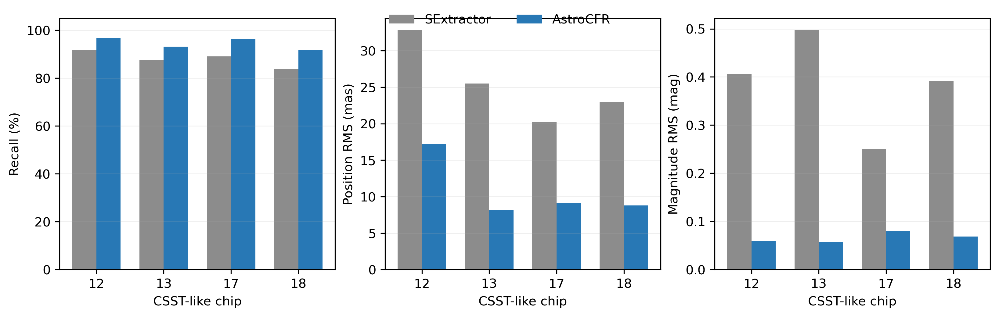
Figure 1. AstroCFR architecture and decision flow for crowded-field candidate recovery and measurement.

2 Data and Problem Setting

2.1 CSST-like M31 simulated imaging
Validation is anchored by 11 public ACSGGCT HST/ACS F606W fields and complemented by four simulated CSST detector chips, labeled 12, 13, 17, and 18. Each CSST chip contains approximately 1000 reference point sources with known positions and magnitudes and is used as a controlled simulation-domain reference. Each HST field is evaluated against an external quality-selected catalogue only after image-only candidate generation and fitting. The primary HST subset is defined by V<=20 references with at least three quality-selected neighbours within 10 pixels.
The CSST and HST tiers deliberately answer different questions. The registered CSST audit is a full-frame supplied-catalogue integration test of calibrated SExtractor and AstroCFR ePSF + residual deblend (registered full-frame branch). In addition, we performed a controlled-crop audit in which all five image-only branches were run on identical 1200 x 1200 crops from chips 12, 13, 17, and 18. The crop audit is reported separately in Supplementary Table S27: it is method-complete but has only 8 and 10 test references on chips 17 and 18, so it supports protocol feasibility rather than a full-frame CSST benchmark. The two CSST products are not pooled with the 11-field HST medians, and the crop audit does not replace the registered full-frame benchmark.
In the controlled CSST crop audit, median recovery was 70.5% for spatial-ePSF joint fitting versus 63.3% for Photutils, and median position RMS was 6.41 versus 9.35 mas; Photutils retained the lower median magnitude RMS (0.0283 versus 0.0463 mag). This mixed recovery–precision pattern is reported as a simulation-domain operating-point trade-off.
F606W is used as a deliberately homogeneous first validation band: all 11 primary fields share the same ACS/WFC filter and a common catalogue-quality protocol, allowing crowding and PSF representation to be compared without conflating filter-dependent throughput or colour terms. This single-band design is not intended to establish multiband generality. Extension to F814W and to jointly fitted multi-exposure data is a defined next step.
Here, registered full-frame branch has a narrow technical meaning: the archived AstroCFR ePSF + residual-deblend workflow was run on the complete 9232 x 9216 simulated detector frame and evaluated against the supplied per-chip catalogue after per-chip coordinate registration and photometric zero-point calibration. It is not the spatial-ePSF joint branch, it is not a separate physical reference frame, and it is not an independent pipeline family. The label distinguishes this archived full-frame integration audit from the newer 1200 x 1200 controlled-crop five-method experiment.
The CSST tier contributes two complementary checks. The full-frame audit verifies detector-scale coordinate registration, zero-point calibration, catalogue export, and residual-deblend bookkeeping on a 9232 x 9216 image; it is an integration and reproducibility result. The controlled crops remove that integration advantage and place five branches on identical footprints, making recovery and conditional RMS comparable within the simulation domain. CSST is therefore retained to expose the simulation-to-reality and full-frame-to-crop gap, not as a second claim of observational superiority.
The problem is framed as high-density source detection and calibration. Given a noisy image and an evaluation catalogue, the system produces source positions and magnitudes. Recovery and RMS are reported on held-out spatial partitions; reference catalogues are never used to generate candidates, construct the empirical PSF, or fit the image. CSST and HST are separate evidence tiers and are not averaged into one leaderboard.
Table 1. Validation chip characteristics.
Chip | Background RMS (DN) | PSF FWHM (px) | Supplied-reference density (arcmin^-2) | Magnitude span | Dominant difficulty
12 | 3.55 | 1.27 | 32.7 | 18.03-23.03 | highest supplied-reference density; faint sources
13 | 3.97 | 1.33 | 19.8 | 17.36-21.90 | intermediate supplied-reference density
17 | 4.39 | 1.67 | 7.7 | 15.51-20.89 | bright sources and higher background
18 | 5.36 | 1.93 | 7.7 | 15.30-20.83 | broader PSF and bright-star artifacts/blends

2.2 System scope and decision boundary
The design principle is conservative: image-level evidence and handcrafted features are both retained, but downstream physical constraints are allowed to veto or refine classifier decisions. This is important in dense stellar fields, where a classifier trained on isolated cutouts can be misled by PSF wings or blended companions, while a purely rule-based detector can overproduce artifacts around bright stars.
AstroCFR is treated as a modular astronomical processing chain. It produces candidate lists, local image cutouts, empirical PSFs, residual diagnostics, and calibrated catalogues, but these intermediate products are not claimed as a separate conceptual contribution. The system boundary is deliberately narrow: this paper evaluates single-image candidate recovery and measurement operating points, not multi-epoch catalogue production or universal survey throughput.
2.3 Calibration-aware operating-point protocol
For a branch b, we report the decision vector $z_{b}=\left(1-C_{b},1-R_{dense,b},E_{pos,b},E_{mag,b},T_{b},M_{b}\right)$, where C is held-out catalogue recovery, R_dense is recovery of V<=20 references with at least three neighbours within 10 pixels, E_pos and E_mag are held-out positional and photometric RMS, and T and M are runtime and memory cost. Equations (1)–(3) formalize the high-density recovery, joint-fit objective, and conditional position error used throughout the HST tier.
$$\begin{aligned}R_{dense}=N_{dense}^{-1}\sum_{i∈D}{1\left[{\min_{j}\left|\left|{\hat{x}}_{j}-x_{i}\right|\right|}_{2}≤r_{match}\right]}\#\left(1\right)\end{aligned}$$
$$\begin{aligned}χ_{G}^{2}=\frac{\sum_{p∈G\left[I_{p}-B_{p}-\sum_{\left(k∈G\right)f_{k}}{P_{p\left(x_{k},y_{k}\right)}}\right]}^{2}{}}{σ_{p}^{2}}\#\left(2\right)\end{aligned}$$
$$\begin{aligned}E_{pos}=s{\left[N^{-1\sum_{i}{{\left|\left|{\hat{x}}_{i}-x_{i}\right|\right|}_{2}^{2}}}\right]}^{\frac{1}{2}}, E_{mag}={\left[N^{-1\sum_{i\left({\hat{m}}_{i}-m_{i}\right)}^{2}{}}\right]}^{\frac{1}{2}}\#\left(3\right)\end{aligned}$$
Release selection is science-constrained rather than globally ranked: DAOStarFinder or SEP are appropriate for rapid screening, Photutils remains a strong conditional-precision branch, AstroCFR ePSF-deblend is the recovery-oriented compromise, and spatial-ePSF joint fitting is preferred when dense-field completeness and blend-aware positions are the priority. Equation (2) is optimized independently within each blend group G, while Equations (1) and (3) are evaluated only on the held-out reference partition. The selected operating point must be reported with its computational cost and evidence tier.

3 Methodology

3.1 Adaptive background modeling and candidate generation
Candidate generation uses three branches: a DAOStarFinder-like local-maximum detector, a lower-threshold auxiliary detector for faint and edge sources, and an IRAF-style morphology detector based on sharpness-like criteria. Candidate lists are merged with KD-tree distance de-duplication. This deliberately over-generates candidates: the initial pools can contain hundreds of thousands to more than one million sources per chip, preserving recall before later filtering.
The over-generation strategy is important because dense-field failures are asymmetric. A false positive can be removed later by morphology, machine learning, or catalog-quality gates, whereas a missed peak in the first detection pass may leave no object for downstream deblending or forced photometry to recover. For that reason, AstroCFR treats the early detector as a candidate proposal system rather than a final source extractor. Its role is to provide a broad search space in which faint sources, PSF-wing artifacts, and blended companions are all initially represented.
AstroCFR first estimates a two-dimensional background and RMS map using block-wise robust statistics with median filtering and interpolation. The CSST-like challenge configuration uses a nominal 2.5-sigma proposal threshold; chip 18 uses 2.39 sigma after validation because of its higher background RMS. These are registered dataset-specific operating parameters, not universal constants. The public-HST benchmark uses a common 3-sigma front end, and Supplementary Tables S5–S6 report threshold and matching-radius sensitivity separately from final catalogue selection.

3.2 Morphological filtering and bright-star recovery
The first quality gate removes candidates with implausible roundness, elongation, or sharpness, followed by an SNR pre-filter. This reduces the candidate pool substantially without sacrificing matched reference stars. Bright saturated sources are handled separately because saturation and PSF wings can violate normal morphology criteria. Very high-SNR candidates can bypass the standard morphology filter when isolation tests support their validity, and local recovery searches are applied around bright-star halos.
Several safeguards prevent the recovery passes from admitting obvious artifacts. Saturated bright-star recovery is constrained by local isolation and peak significance. Halo recovery is limited to neighbourhoods in which a bright source can plausibly hide a companion. Forced photometry after WCS alignment is used only when the predicted location has sufficient local SNR and does not duplicate an existing detection. These safeguards define a conservative candidate mode; they do not by themselves establish blind catalogue purity.

3.3 Three-level deblending
The dominant failure mode in the dense M31-like fields is not simple sensitivity loss but structural blending. AstroCFR constructs blend groups within a five-pixel radius and escalates recovery through three levels. Level 1 resolves two-star groups by paired-PSF fitting and accepts a companion only when the core residual RMS improves sufficiently. Level 2 handles groups of three or more stars with joint multi-PSF least-squares fitting, adding companions under a residual-improvement gate. Level 3 applies Richardson-Lucy deconvolution to the most severe or saturated groups before sub-peak identification.
This staged design keeps simple cases computationally cheap while reserving expensive deconvolution for the small number of groups that need it. In the evaluated chips, deblending recovered 13 companions on chip 12, 13 on chip 17, and 31 on chip 18. Blend diagnostics show that 87.1% of chip 12 false negatives and 84.8% of chip 18 false negatives are associated with blend groups, confirming that deblending is central to system quality.
The deblending module also changes how the classifier should be interpreted. A candidate that appears ambiguous in isolation may become acceptable after the neighbouring-source model explains a shared PSF core. Conversely, a visually plausible candidate can be rejected if adding it does not reduce the local residual structure. Grouping radius and residual-acceptance settings are registered hyperparameters, and their sensitivity is reported separately in Supplementary Tables S5–S6; they must be revalidated for a new instrument configuration.
Richardson–Lucy restoration is retained only as an optional diagnostic for severe or saturated groups in the legacy three-level deblending path. It is not the defining operation of the primary 11-field HST spatial-ePSF comparison, and no headline recovery or RMS result is attributed to Richardson–Lucy alone. The reported operating points are driven by empirical-PSF fitting, neighbour-aware joint fitting, and residual-gated acceptance. A dedicated iteration-count and noise-amplification ablation remains necessary before restoration is promoted as a general point-source measurement component.

3.4 Point-source classification
Each candidate is represented by a handcrafted feature vector describing morphology, concentration, local background, nearest-neighbor context, ellipticity, and field geometry. For image-based classifiers, a 25 x 25 pixel cutout is also extracted. The native AstroCFR classifier combines a convolutional image branch with a feature branch; the benchmark additionally evaluates RandomForest, XGBoost, gradient boosting, logistic regression, SVM, KNN, HR-CelestialNet, a rotation-invariant GoogLeNet-style model, and a late-fusion RandomForest-CNN stack.
A key methodological decision is per-chip threshold calibration. Candidate distributions differ strongly across chips, so a global threshold can be unfairly conservative for faint chips. AstroCFR selects thresholds on validation candidates using a reference-scoped recovery/false-acceptance constraint and never uses the held-out test partition for threshold selection. The resulting validation metric remains catalogue-scoped; it is not a claim that probability calibration transfers unchanged to a blind detector.
The classifier benchmark is designed to avoid two common traps. First, all methods operate on the same exported candidate pools, so differences do not reflect different upstream detection behavior. Second, thresholds are calibrated with the same rule for every classifier. Without this control, a deep network can appear to dominate a classical method simply because its probability scale happens to be better aligned with a fixed global threshold. With per-chip calibration, the benchmark compares useful operating points rather than arbitrary raw probability values.

3.5 Astrometric and photometric refinement
Astrometric refinement uses a validation-gated cascade: a polynomial removes large-scale WCS distortion, a look-up table models residual spatial structure, and Gaussian-process correction is retained only when it improves held-out residuals. Polynomial degree, grid settings, and local centroid refinement are registered configuration choices; none is treated as an instrument-independent optimum.
Photometric calibration uses adaptive aperture photometry, local annular background subtraction, aperture correction, global zero-point estimation, spatial zero-point interpolation, optional color-dependent correction, intra-pixel sensitivity adjustment, and K-fold cross-validated machine-learning magnitude refinement. The final machine-learning photometric correction is accepted only when cross-validation demonstrates consistent RMS reduction, thereby reducing the risk that small training samples inject spurious corrections.
The astrometric and photometric refinements are deliberately gated by validation statistics. Polynomial and LUT corrections can overfit if a local region has too few matched stars, while a flexible photometric regressor can learn noise when the residual pattern is weak. AstroCFR therefore treats every correction layer as a proposed transformation that must improve validation residuals or remain inactive. This validation-gated philosophy is a major distinction between a robust system and a sequence of individually plausible algorithms.

3.6 Algorithmic quality gates
AstroCFR uses multiple gates because no single criterion is reliable in all chips. In low-density regions, morphology and SNR are strong indicators; in dense regions, a real companion can look morphologically distorted; near saturated stars, artifacts and true companions can share similar local contrast. The system therefore combines local image evidence, reference-aligned forced measurements, residual-improvement criteria, classifier probabilities, and final catalog-level matching constraints.
The most important gates are: adaptive detection thresholding based on background RMS; hard morphology limits before machine learning; bright-source bypass rules only for isolated high-SNR peaks; deblending acceptance based on core residual improvement; per-chip classifier thresholding under a target recall constraint; astrometric correction acceptance based on validation residuals; and photometric regressor acceptance based on K-fold RMS improvement. These gates are modular, so each can be tightened or relaxed for alternative science configurations.
In a production CSST setting, the same framework could expose multiple candidate modes. A conservative mode would keep strict image-derived quality gates; a recovery mode could expose low-probability or deblend-ambiguous sources for follow-up; and a training-data mode could export rejected candidates and uncertain zones. Their blind reliability must be calibrated on exhaustive truth or deeper independent data rather than inferred from the reference-aware challenge assembly.
The quality gates have an explicit order. Broad image-only proposals are screened first by morphology and SNR. Candidate probabilities define the conservative RF catalogue, while residual-improvement tests decide whether a blended companion is retained. Astrometric and photometric corrections are accepted only after validation improvement. When the classifier and residual test disagree, the residual test governs companion acceptance; the classifier threshold governs catalogue release. Reference catalogues are used only for the disclosed simulation evaluation and target-adaptation calibration partitions, not as an inference-time gate in the HST image-only branches.
The registered gates are adaptive proposal thresholding from background RMS, morphology limits before classification, isolated high-SNR bright-source exceptions, residual-improvement acceptance for deblending, validation-selected classifier thresholds, validation-selected astrometric corrections, and K-fold-validated photometric refinements. Each can be disabled or changed in a new instrument configuration; the present results establish only the disclosed configuration.
Detected sources are matched to supplied references using a greedy one-to-one two-pixel rule. In the HST tier, the catalogue is held out by spatial stripes and the high-density subset is defined independently of candidate generation. In the CSST tier, the registered full-frame supplied-catalogue audit is retained as a separate simulation result. These denominators are not interchangeable.

4 Experimental Protocol

4.1 Classifier benchmark
Training, validation, and test handling is protocol-specific. The primary 11-field HST spatial-ePSF/Photutils comparison is not a supervised-training experiment: all branches generate and fit candidates from the image, and the reference catalogue is used only after fitting for held-out scoring. Each 1200 x 1200 crop is divided into a deterministic 3 x 3 spatial grid of 200-pixel cells, not a random catalogue split. For the archived WPDC classifier configuration, cell partition 0 is the training/calibration partition, partition 1 selects the classifier threshold, and partition 2 is the final test partition. No HST RF score is reported by design, not because RF is presumed to fail. The released RF artefact is a CSST-simulation model whose labels, feature normalisation, and threshold are tied to simulated truth.
The reproducible CSST candidate-classifier ablation uses 11,615 detector-generated candidates from chips 12, 13, 17, and 18: 3,615 positives within 2 pixels of a supplied simulated reference and 8,000 negatives farther than 8 pixels; the ambiguous 2-8 pixel annulus is excluded. The 2-pixel positive radius is the same one-to-one association radius used throughout the manuscript and is smaller than the 3-pixel FWHM assumed by the detector, whereas 8 pixels is a conservative separation from a catalogue source.
A separate closed-book leave-one-chip-out RF pilot trains on the other three simulation chips, reserves a stratified 25% of those training candidates for threshold selection, and opens the held-out chip catalogue only after the final candidate file is written. Its RF uses 200 trees, maximum depth 15, minimum leaf size 2, sqrt feature sampling, class weights {negative: 1, positive: 6}, six CPU workers, and seed 20260811 plus the held-out chip identifier. This pilot is reported only as a blind-proposal stress test and is not pooled with the 11-field HST measurement result.
Negatives are not random blank-sky positions: they are image-detector proposals whose nearest supplied reference lies beyond 8 pixels. Per chip, they are sampled without replacement from that distant-proposal pool at up to five negatives per positive and capped at 2,000, yielding the reported 8,000 negatives. Thus this is a deliberately clean simulation-domain architecture ablation, not a claim that its negative distribution reproduces real crowded-field false detections. A stratified 60/20/20 train/validation/test split with seed 20260806 is fixed before training. The feature standardizer is fitted on the training split only. The validation split selects the highest threshold retaining at least 90% recall, and all accuracy metrics use the untouched test split. RandomForest uses 400 trees, maximum depth 15, minimum leaf size 2, sqrt feature sampling, class weights {negative: 1, positive: 6}, and the same seed. The CNN and patch Transformer use Adam (learning rate 1e-3, weight decay 1e-4), cosine annealing over 30 epochs, batch size 64 for training and 256 for inference; the Transformer uses 25 non-overlapping 5 x 5 patches, 64-dimensional tokens, two four-head encoder layers, and a 17-feature fusion branch.
The empirical PSF is estimated from image-only isolated DAO proposals in the science crop, so the primary branch permits unlabeled test-partition pixels to contribute to image calibration. This is transductive calibration, not reference-catalogue leakage: no held-out reference position, magnitude, match assignment, or quality flag is used to choose PSF stamps or fit sources. Isolated proposal stamps can be spatially unrepresentative of the crowded test region if the PSF varies within a quadrant, so we ran a partition-isolated sensitivity audit in which only DAO proposals from cells 0/1 supplied global and quadrant ePSF stamps; full-image candidates were then fitted and partition 2 was scored unchanged. Across all 11 fields, dense-recovery change had median -0.13 percentage points (range -2.33 to +0.45 pp), position-RMS change had median +0.09 mas (range -0.05 to +0.34 mas), and magnitude-RMS change had median +0.0033 mag (range -0.0014 to +0.0087 mag). The largest dense-recovery decrease occurred in NGC 5286 (-2.33 pp); the headline 11/11 recovery ordering was unchanged. These small but non-zero shifts quantify the transductive sensitivity under the present spatial protocol; a stricter multi-fold PSF-stamp audit remains useful for future work.
The partition-isolated audit is a robustness check rather than a new leaderboard: it changes the ePSF construction only, while candidate generation, neighbour fitting, registration, association radius, and held-out scoring remain fixed. The machine-readable per-field deltas are archived in results/partition_isolated_spatial_epsf_sensitivity_all11/summary.json and comparison.csv.
Applying it unchanged to HST would be an unvalidated domain transfer; retraining it on the ACSGGCT evaluation catalogue would instead create a supervised target-specific adaptation experiment. Such a result requires a separately pre-registered cross-field or held-out-field protocol and is not reconstructed during final archival. DAO, SEP, Photutils, ePSF-deblend, and spatial-ePSF joint fitting use no catalogue labels for candidate generation or PSF fitting. Astrometric registration and photometric zero points are estimated from non-test matches and evaluated on partition 2. The spatial-ePSF is estimated from isolated proposals across the science crop, so it can see unlabeled test pixels; this transductive calibration is disclosed separately from catalogue-held-out scoring.
The common-method comparison uses identical image crops, spatially held-out partitions, a two-pixel association radius, and method-specific image-only candidate generation. DAOStarFinder, SEP/SExtractor-style extraction, Photutils PSFPhotometry, AstroCFR ePSF-deblend, and AstroCFR spatial-ePSF joint fitting are rerun on all 11 ACSGGCT fields. RF is explicitly recorded as protocol-excluded: a CSST-trained screen is not transferred as an HST result, and an HST-catalogue-trained RF would be a different supervised adaptation experiment rather than an image-only branch in this comparison.
The baseline configurations are explicit. DAOStarFinder uses a 3-pixel FWHM and 3-sigma threshold for image-only centroid/flux proposals; it is not followed by a separate PSFEx model. SEP uses SExtractor-style thresholding at 3 background RMS with minimum area 5, 32 deblending thresholds, and deblend contrast 0.005; its reported flux is calibrated extraction flux, not PSFEx photometry. Photutils uses the same DAOStarFinder proposal frontend but fits a circular Gaussian PRF in a 9 x 9 pixel window with 2-pixel grouping separation and 3-pixel aperture initialisation. AstroCFR global and spatial branches build empirical PSFs from isolated DAO proposals, fit flux and position jointly within blend groups, and apply the same residual-acceptance and held-out calibration rules. Thus DAO/SEP are fast detection/extraction baselines, Photutils is a fixed analytic-PRF PSF-fitting baseline, and AstroCFR is spatially varying empirical-PSF joint fitting; no branch is described as a PSFEx or multi-exposure DOLPHOT reduction.
The literature-mapped controls are diagnostic PSF-representation controls, not additional end-to-end published-pipeline leaderboards. They share the HST image, candidate front end, spatial hold-out, and neighbour-fitting harness, but the archived outputs retain a dense held-out reference denominator rather than the baseline branch's full held-out metric set. They are therefore used to test the direction of the spatial-PSF effect and are reported in Supplementary Table S26 with their own denominator; they are not pooled into Table 8 medians or used to rank the main operating points. An AstroCFR+Photutils hybrid remains an archived three-field ablation and is not promoted to an 11-field claim.

4.2 Full-pipeline integration and calibrated baselines
A calibrated SExtractor baseline is also run on the same simulated exposures. SExtractor thresholds are tuned per chip after correcting the saturation level to the 16-bit ADU ceiling. CLASS_STAR is used as a classifier-like score, with a threshold search targeting high recall. The comparison therefore evaluates a calibrated general-purpose detector rather than an untuned default configuration.
An additional density-adaptive policy is evaluated in the same framework; its definition and controlled operating-point results are reported in Section 5.4.1.
The SExtractor comparison has a narrower purpose. The registered CSST audit is full-frame and supplied-catalogue conditioned, whereas the HST comparison is a single F606W stack evaluated against an external catalogue. DOLPHOT/ALLFRAME, crowdsource, Euclid/VVV workflows, and CSST-PSFNet are retained as scope audits because their required multi-exposure, multiband, instrument-specific, or labelled-PSF inputs are absent.
The CSST full-frame magnitude-RMS contrast must be read as a conditional integration-audit diagnostic, not as an estimator-identical photometry contest. SExtractor supplies a catalogue-extraction magnitude under its calibrated detection configuration, whereas AstroCFR reports a local empirical-PSF fit after residual deblending. Both recovery values use the supplied-catalogue association rule, but each RMS is computed only on that method's successfully matched references after its own registration and zero-point calibration. Thus a lower AstroCFR RMS can reflect both the fitted flux model and the method-specific recovered subset; it does not establish a same-star, same-estimator advantage. The controlled HST analysis therefore reports recovery and conditional RMS jointly, and the separate CSST crop audit includes Photutils PSFPhotometry under one common protocol.

5 Results

5.1 CSST-like simulation validation
Validation-selected per-chip calibration was necessary for heterogeneous simulated chips. In the registered full-frame CSST audit, calibrated SExtractor and AstroCFR ePSF + residual deblend (registered full-frame branch) provide supplied-catalogue integration-audit values. The controlled-crop audit additionally runs all five image-only branches, but its purpose is to expose simulation-to-reality differences and verify implementation feasibility; it is not used to form an all-CSST ranking.
Chip 18 illustrates why the qualitative difficulty label cannot be read as a monotonic recovery ranking. It has the largest background RMS (5.36 DN) and broadest fitted PSF (1.93 pixels), but its supplied top-1000 catalogue has only 7.7 stars arcmin^-2, tied for the lowest chip-level reference density. Its bright magnitude range also supplies many high-SNR detections. Thus bright-star artifacts and blends stress local modelling, while the lower supplied-reference density and high SNR can still yield high catalogue recovery after empirical-PSF fitting; the table's difficulty labels describe dominant image characteristics, not an ordinal expected-recall scale.
The density values in Table 1 are catalogue-surface densities computed from the 1,000 supplied references divided by each catalogue's detector-coordinate bounding area, using the CSST-like 0.074 arcsec pixel scale. They are descriptive densities of the supplied reference layer, not exhaustive scene densities; the magnitude span is the corresponding supplied-catalogue range.
On the CSST-like simulations, calibrated SExtractor and AstroCFR ePSF + residual deblend (registered full-frame branch) provide the registered supplied-catalogue integration audit. The new controlled-crop audit additionally provides a method-complete check: spatial-ePSF has 70.5% median recovery and 6.41 mas position RMS versus 63.3% and 9.35 mas for Photutils, while Photutils has lower magnitude RMS (0.0283 versus 0.0463 mag). These crop values are supplementary feasibility evidence, not a replacement for the full-frame CSST audit or a broad CSST ranking. For the 11-field HST headline, the corresponding 86.3% and 45.9% values are field medians across all fields, whereas the 87.6% value cited elsewhere is the single-field NGC 6752 dense-subset result (n=402); they are not competing estimates of the same denominator.
A separate closed-book pilot is reported in Supplementary Section S9. Each candidate catalogue was written before the withheld test-chip catalogue was opened, and injected positions were unavailable to candidate generation. The image-only proposal front end recovers 63.8% and 89.4% of low-density injections at peak SNR 10 and 30, respectively, versus 18.3% and 75.8% in high-density positions. Because this pilot uses only 40 injections per available chip and density-SNR cell, a central crop, and a supplied top-1000 catalogue that is not certified exhaustive, it is a proposal stress test rather than a full AstroCFR blind-purity result. The registered CSST-like measurement audit is reported in Table 2.
Parameter sensitivity is reported as an audit rather than an optimisation claim. On the NGC 6752 HST test partition, changing the common proposal threshold from 2.5 to 4.0 sigma changes DAO-style proposal completeness from 0.771 to 0.750 while its catalogue-match lower bound changes from 0.937 to 0.946. Holding catalogues fixed and varying the association radius from 1 to 3 pixels preserves the qualitative ordering: ePSF-deblend completeness is 0.926–0.932, spatial-ePSF joint fit is 0.932–0.935, DAO/Photutils is about 0.762, and SEP is 0.491–0.526. Full values are in Supplementary Tables S5–S6.
Table 2. Registered CSST-like measurement audit using AstroCFR ePSF + residual deblend (registered full-frame branch). The oracle-conditioned assembly value is excluded; closed-book proposal recovery is reported separately in Supplementary Section S9.
Chip | Tool | Recall (%) | Pos. RMS (mas) | Mag. RMS
12 | SExtractor | 91.6 | 32.8 | 0.406
12 | AstroCFR ePSF + residual deblend  (registered full-frame branch) | 96.9 | 17.2 | 0.0596
13 | SExtractor | 87.6 | 25.5 | 0.497
13 | AstroCFR ePSF + residual deblend  (registered full-frame branch) | 93.1 | 8.2 | 0.0575
17 | SExtractor | 89.1 | 20.2 | 0.250
17 | AstroCFR ePSF + residual deblend  (registered full-frame branch) | 96.4 | 9.1 | 0.0802
18 | SExtractor | 83.7 | 23.0 | 0.392
18 | AstroCFR ePSF + residual deblend  (registered full-frame branch) | 91.8 | 8.8 | 0.0684

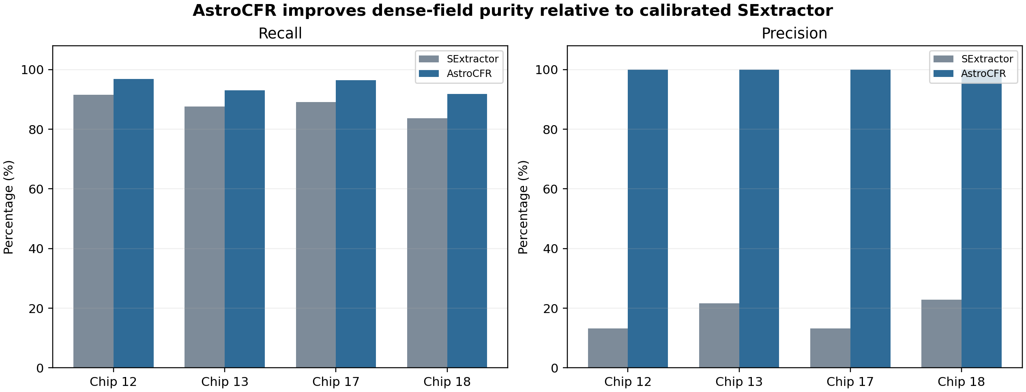
Figure 2. Registered CSST-like reference recovery and conditional measurement residuals. Precision is not plotted because AstroCFR challenge assembly is reference-aware; the closed-book proposal pilot is reported in Supplementary Section S9.

Across the four CSST-like chips, the registered AstroCFR configuration reaches 94.6% mean recall, 10.9 mas astrometric RMS, and 0.066 mag photometric RMS. Per-chip catalogues and candidate-funnel diagnostics are provided in Supplementary Section S7; these simulation-catalogue values are not interpreted as blind real-field purity. The corresponding recovery and residual summary appears in Figure 2.

5.2 Simulation-to-real target adaptation
A frozen RandomForest trained on the four CSST-like chips was evaluated on public Pan-STARRS1 M31 and Legacy Survey M13 cutouts. Without target calibration, the screen collapses: retained recall is 2.8% and 0.0%, respectively. This is a negative control demonstrating domain shift, not evidence of zero-shot generalization; full counts are archived in Supplementary Section S7.
We therefore use supervised few-shot target adaptation. FWHM and candidate normalization are estimated from the target image, while a small labelled spatial region refits the RandomForest and a disjoint region selects its threshold. Held-out recall rises to 43.3% on M31 and 7.1% on M13. The accompanying illustration shows the failure and recovery; the more relevant three-field HST calibration-budget experiment is reported below. The qualitative frozen-versus-adapted comparison is shown in Figure 3.
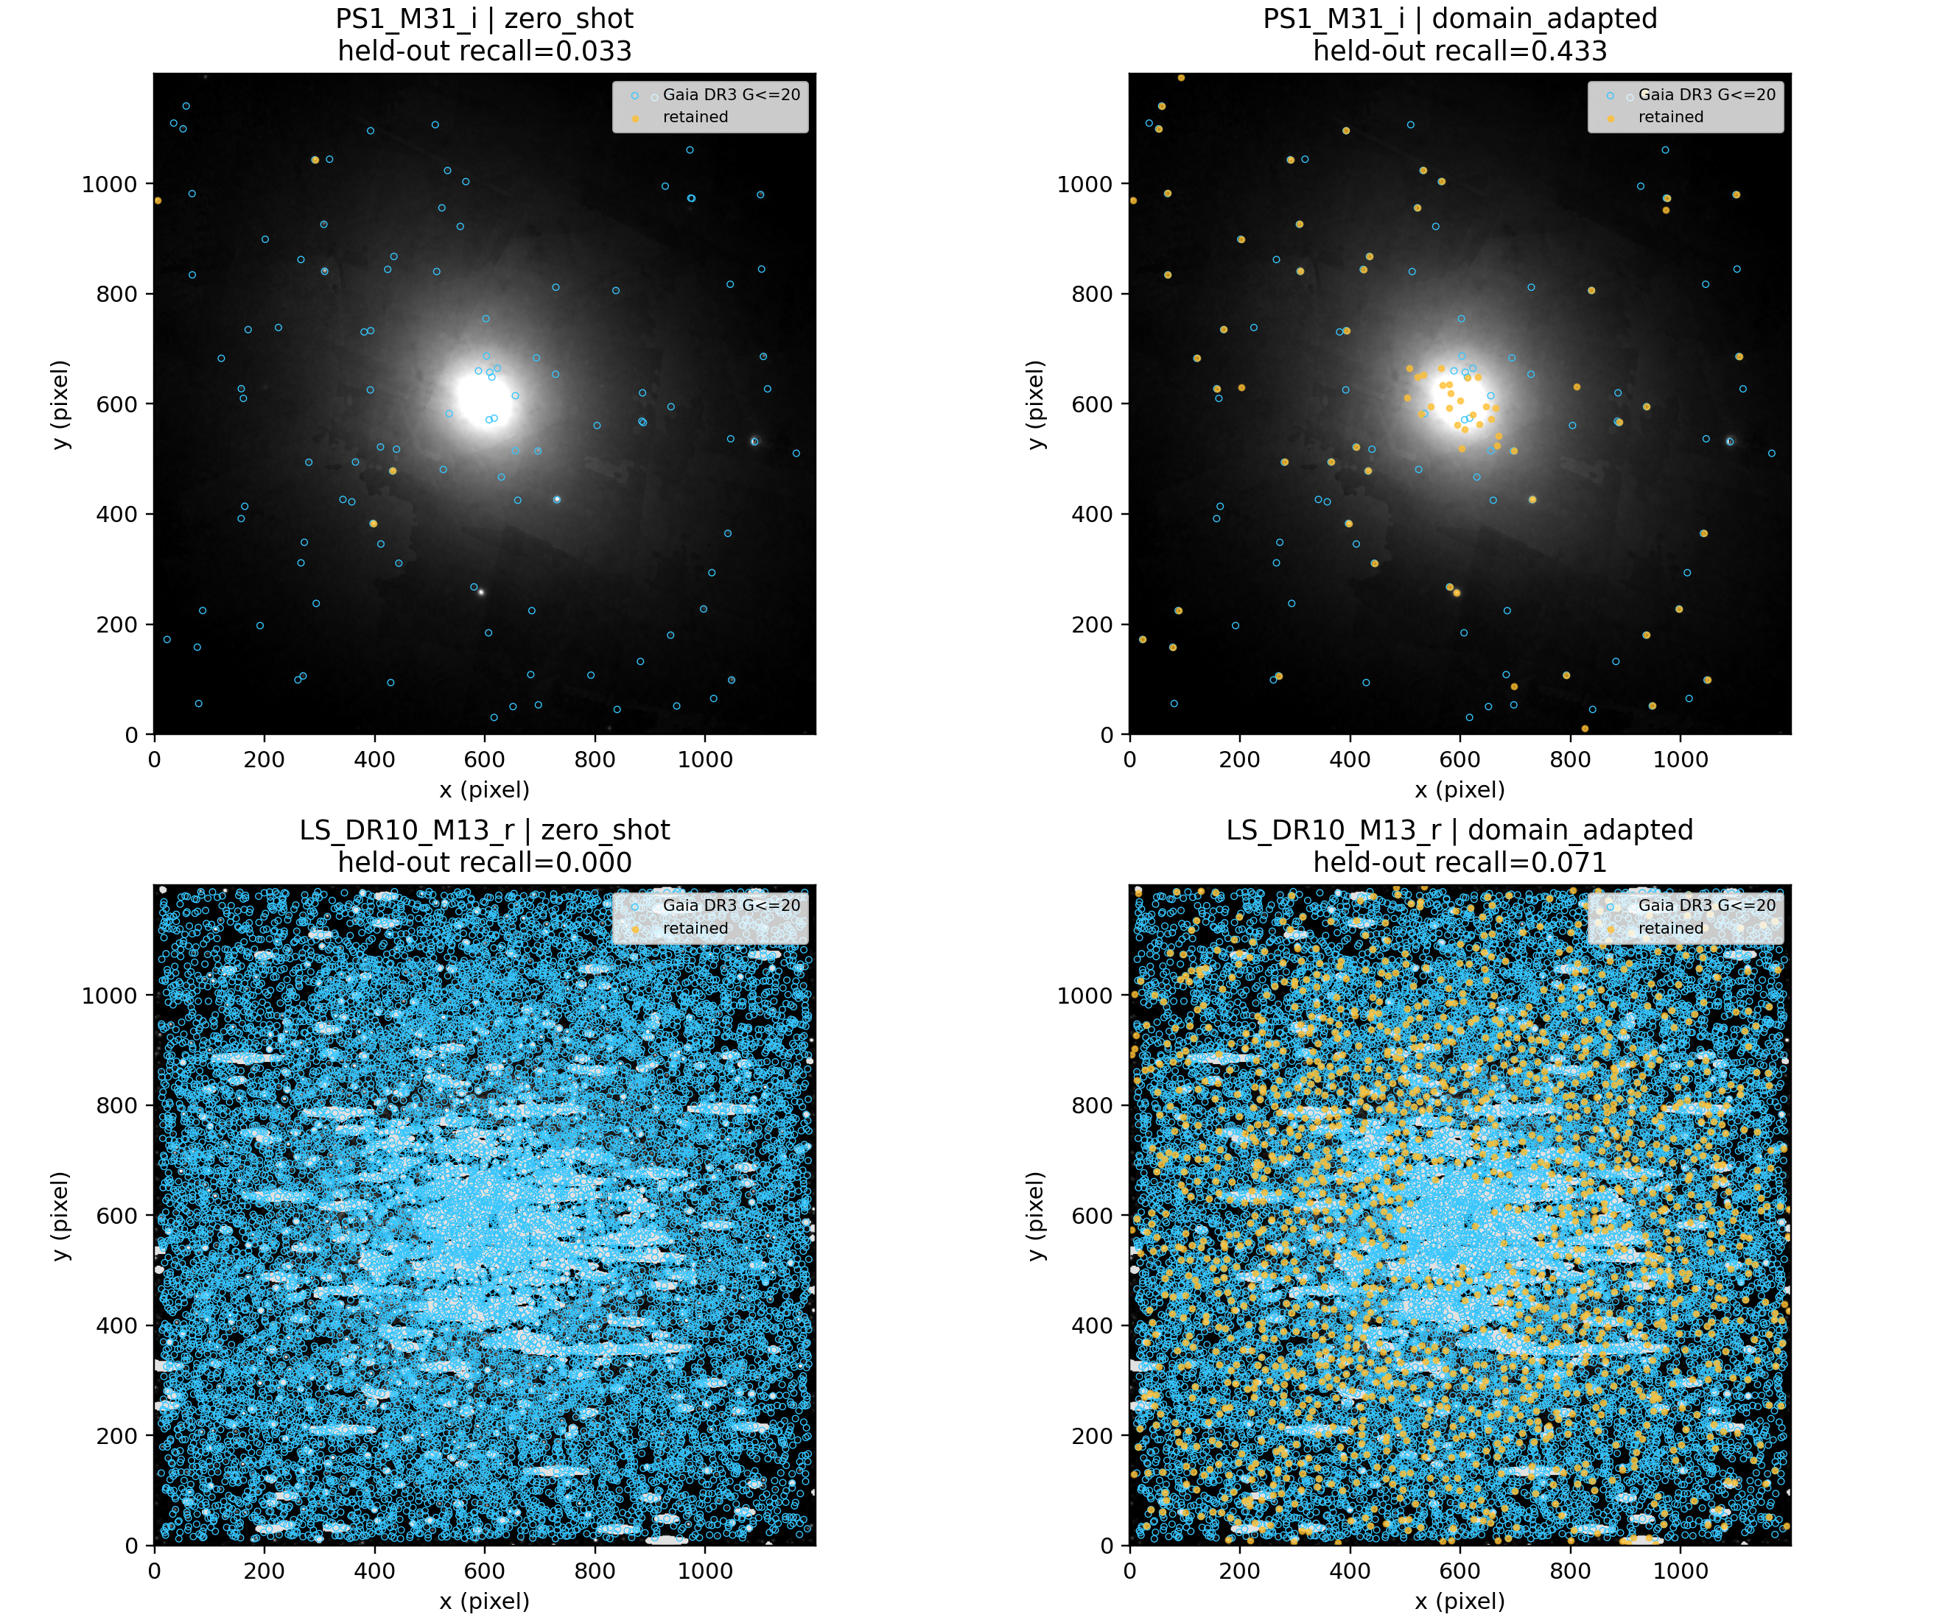
Figure 3. Frozen simulation-trained screening and supervised few-shot target adaptation on the two external survey cutouts. The illustration is qualitative; all quoted recall is measured on a spatially untouched target partition.

5.3 HST/ACS crowded-field recovery
To replace the resolution-mismatched ground-based stress test with a physically comparable real benchmark, we downloaded the public MAST ACS Galactic Globular Cluster Survey (ACSGGCT) v2 F606W reference images and official PSF catalogues for NGC 6397 and NGC 6752. ACS/WFC has a 50 mas pixel scale, close to the sampling regime targeted by CSST. Each experiment uses the central 1200 x 1200 pixels, where crowding is strongest. The official one-indexed catalogue coordinates are shifted by one pixel before association.
The primary reference set requires a valid F606W measurement, reported magnitude error below 0.10 mag, qfitV below 0.30, neighbour-light fraction below 1, and at least one F606W measurement. The same three-way 200-pixel spatial partition is retained: partitions 0 and 1 support target fitting and threshold selection, and partition 2 is untouched until final evaluation. Positions are associated within 2 pixels. Astrometric precision is evaluated after fitting the six-parameter affine transformation recommended by Anderson et al. (2008; Ref. 2) on non-test matches and applying it to the test partition only.
The HST/ACS images and official comparison catalogues used in Tables 3–6 follow the ACS Survey of Galactic Globular Clusters catalogue construction of Anderson et al. (2008). Their empirical-PSF measurement context follows Anderson & King (2006). These catalogues are held-out evaluation references and are not used to fit the reported measurement branches. The central-field benchmark values are reported in Table 3 and the representative field outputs are shown in Figure 4.
Table 3. AstroCFR on the central HST/ACS crowded-field benchmarks. All metrics are computed on the untouched spatial test partition except the catalogue match-rate lower bound, which uses the full crop.
Cluster | Mode | Candidates | Retained | Recall V<=18 /% | Recall V<=20 /% | All-quality recall /% | Catalogue match lower bound /% | Pos. RMS /mas | Mag. RMS
NGC6397 | raw proposals | 2554 | 2554 | 98.0 | 96.0 | 95.4 | 87.9 | 1.84 | 0.053
NGC6397 | simulation frozen | 2554 | 357 | 40.3 | 21.2 | 15.8 | 97.5 | 1.50 | 0.023
NGC6397 | target adapted | 2554 | 1691 | 97.6 | 92.8 | 80.0 | 98.0 | 1.67 | 0.038
NGC6752 | raw proposals | 5628 | 5628 | 87.9 | 80.0 | 76.2 | 94.9 | 2.13 | 0.197
NGC6752 | simulation frozen | 5628 | 445 | 20.4 | 8.7 | 6.5 | 98.4 | 2.35 | 0.132
NGC6752 | target adapted | 5628 | 4466 | 85.2 | 75.4 | 63.4 | 98.6 | 1.99 | 0.153
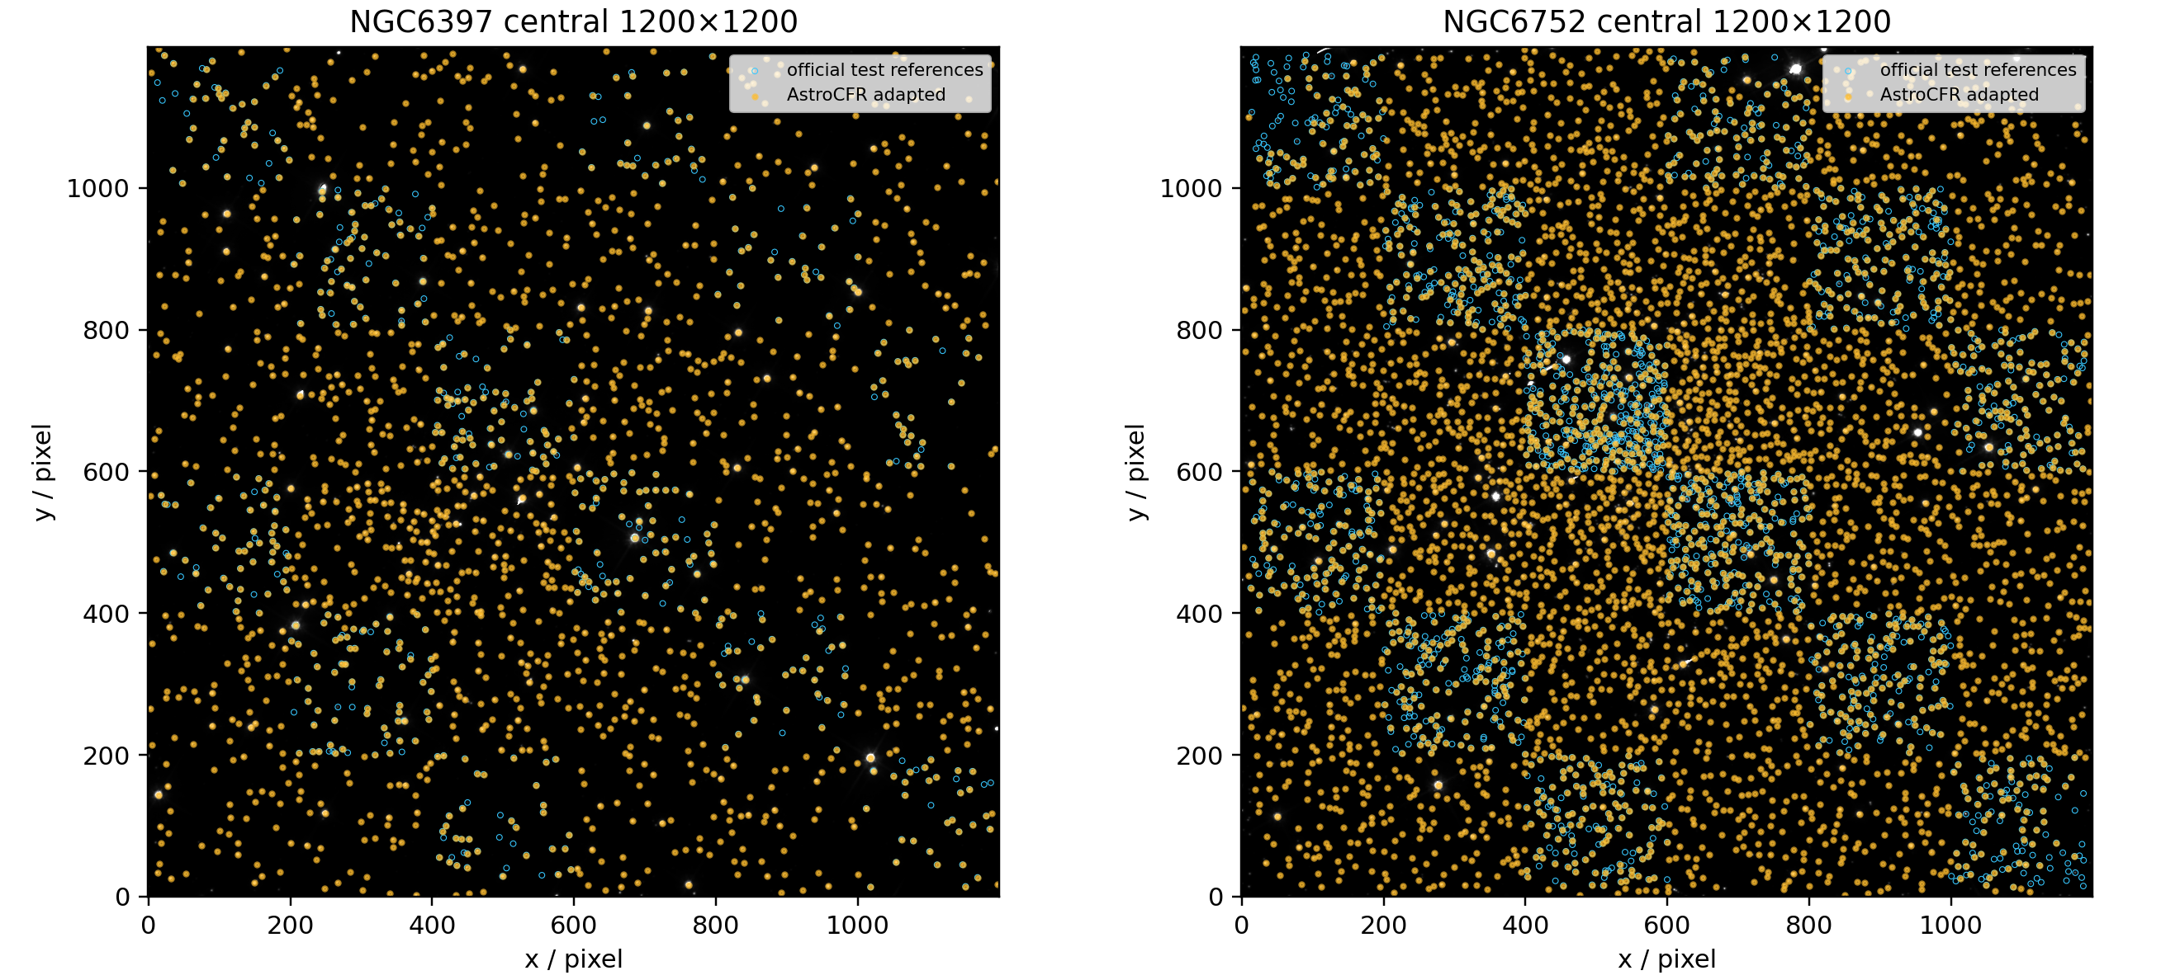
Figure 4. Target-adapted AstroCFR results for the central NGC 6397 and NGC 6752 ACS/F606W fields. Cyan circles mark official quality-selected test references and yellow points mark retained candidates.
On NGC 6397, PSF-adapted proposal generation recovers 95.4% of all quality references and 98.0% at V <= 18. The target-adapted high-coverage catalogue retains 80.0% overall, 92.8% at V <= 20, and a 98.0% catalogue match-rate lower bound. On the denser NGC 6752 field, raw proposal recall is 76.2%; the adapted catalogue reaches 63.4% overall and 75.4% at V <= 20 with a 98.6% match-rate lower bound. The simulation-frozen threshold again rejects most real candidates, confirming that target calibration is necessary.
The adapted position RMS is 1.67 mas for NGC 6397 and 1.99 mas for NGC 6752. This is within the 3.2-5.3 mas external-reference residual range reported for Euclid NGC 6397, but remains 2.4-4.0 times above the 0.5-0.7 mas multi-exposure ePSF precision ceiling. Aperture-based magnitude RMS is 0.038 mag in NGC 6397 and 0.153 mag in NGC 6752, compared with median catalogue-reported errors of 0.013 and 0.012 mag. The NGC 6752 result identifies blended-field PSF photometry, rather than classification, as the principal remaining weakness.
To make the deployment claim falsifiable, we reran five branches on exactly the same central 1200 x 1200 ACSGGCT crop for each cluster: DAOStarFinder (DAO), SEP/SExtractor-style extraction (SEP), Photutils PSFPhotometry, AstroCFR target-adapted RandomForest (AstroCFR-RF), and AstroCFR ePSF plus residual deblending (AstroCFR ePSF-deblend). The official quality-selected catalogue is evaluation-only for DAO, SEP, Photutils, and ePSF-deblend. AstroCFR-RF uses spatial partition 0 for fitting and partition 1 for threshold selection; partition 2 is untouched for all final metrics. Associations use the same 2-pixel radius. Completeness is the fraction of reference objects recovered. The catalogue match lower bound is the fraction of reported candidates associated with the limited reference catalogue; it is not purity because unmatched candidates can be real sources missing from that reference.
Photutils PSFPhotometry uses the same DAOStarFinder proposal frontend as DAO. Its proposal-level detection and artificial-star recovery are therefore identical to DAO by design; its independent role in this comparison is PSF-based astrometric and photometric measurement. All recovery and completeness intervals use the Wilson 95% interval. Runtime and peak RSS are reported separately in the operating-point table, so that the controlled table remains a scientific-performance comparison. The common-protocol branch comparison is reported in Table 4 and its runtime trade-off is visualized in Figure 5.
Table 4. Controlled HST comparison. All metrics use the common image, reference-quality rule, 2-pixel association, and untouched spatial test partition. Dense V<=20 means a V<=20 reference with at least three quality-selected neighbours within 10 pixels. NGC 6397 has only n=9 such references, so it is descriptive rather than a basis for a strong crowded-field claim.
Cluster | Method | Completeness (95% CI) | Dense V<=20 recall (95% CI) | Match lower bound | Pos. RMS (mas) | Mag. RMS
NGC6397 | DAOStarFinder | 95.4% (93.5–96.8%) | 55.6% (26.7–81.1%); n=9 | 85.8% | 1.84 | 0.030
NGC6397 | SEP/SExtractor-style | 76.1% (72.6–79.2%) | 66.7% (35.4–87.9%); n=9 | 94.3% | 2.50 | 0.091
NGC6397 | Photutils PSFPhotometry | 95.4% (93.5–96.8%) | 55.6% (26.7–81.1%); n=9 | 85.2% | 0.98 | 0.040
NGC6397 | AstroCFR original (target-adapted RF) | 80.0% (76.7–83.0%) | 55.6% (26.7–81.1%); n=9 | 97.0% | 1.67 | 0.038
NGC6397 | AstroCFR ePSF-deblend | 99.0% (97.9–99.6%) | 66.7% (35.4–87.9%); n=9 | 74.5% | 1.11 | 0.035
NGC6752 | DAOStarFinder | 76.2% (74.4–77.9%) | 57.0% (52.1–61.7%); n=402 | 94.2% | 2.13 | 0.058
NGC6752 | SEP/SExtractor-style | 52.0% (50.0–54.1%) | 28.6% (24.4–33.2%); n=402 | 93.9% | 2.69 | 0.127
NGC6752 | Photutils PSFPhotometry | 76.3% (74.5–78.0%) | 57.0% (52.1–61.7%); n=402 | 94.2% | 1.05 | 0.039
NGC6752 | AstroCFR original (target-adapted RF) | 63.4% (61.4–65.4%) | 52.7% (47.9–57.6%); n=402 | 98.1% | 1.99 | 0.153
NGC6752 | AstroCFR ePSF-deblend | 93.2% (92.1–94.2%) | 87.6% (84.0–90.4%); n=402 | 91.7% | 1.35 | 0.042
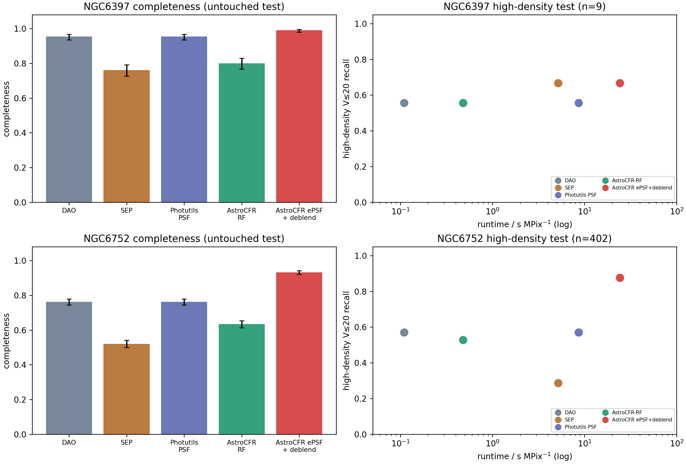
Figure 5. Completeness and dense-subset recovery versus disclosed runtime. Error bars show Wilson 95% intervals. The right panels expose the central trade-off: the recovery-oriented ePSF-deblend branch is materially slower than the catalogue-oriented and classical front ends.
The clearest supported claim is local and operational. On dense NGC 6752 V≤20 references (n=402), AstroCFR ePSF-deblend recovers 87.6% (95% CI 84.0–90.4%), versus 57.0% for DAO, 28.6% for SEP, and 52.7% for AstroCFR-RF. The definitive fixed-scene artificial-star test uses n=200 per magnitude–density stratum and is reported below; its smaller pilot is archived in S7.
The previous ePSF branch used one image-derived PSF for the crop. The high-density extension estimates empirical PSFs separately in four spatial quadrants and performs two neighbour-aware coordinate/flux fitting passes. This is the AstroCFR spatial-ePSF joint branch. For literature mapping, the same image-only harness also fits a global empirical ePSF and a three-Gaussian discrete PSF, allowing the effect of spatial variation and PSF parameterisation to be separated from the candidate front end.
Table 5. Ablation of spatially varying ePSFs and two-pass joint fitting on NGC 6752. The refinement improves the reported photometric RMS from 0.042 to 0.037 mag and dense-subset recovery from 87.6% to 88.3%; the confidence intervals overlap, so this is an incremental operating-point change.
Cluster | Branch | Completeness | Dense V<=20 recall (95% CI) | Pos. RMS / mas | Mag. RMS / mag
NGC6752 | AstroCFR ePSF-deblend | 93.2% | 87.6% [84.0%, 90.4%] | 1.35 | 0.042
NGC6752 | AstroCFR spatial-ePSF joint fit | 93.4% | 88.3% [84.8%, 91.1%] | 1.27 | 0.037
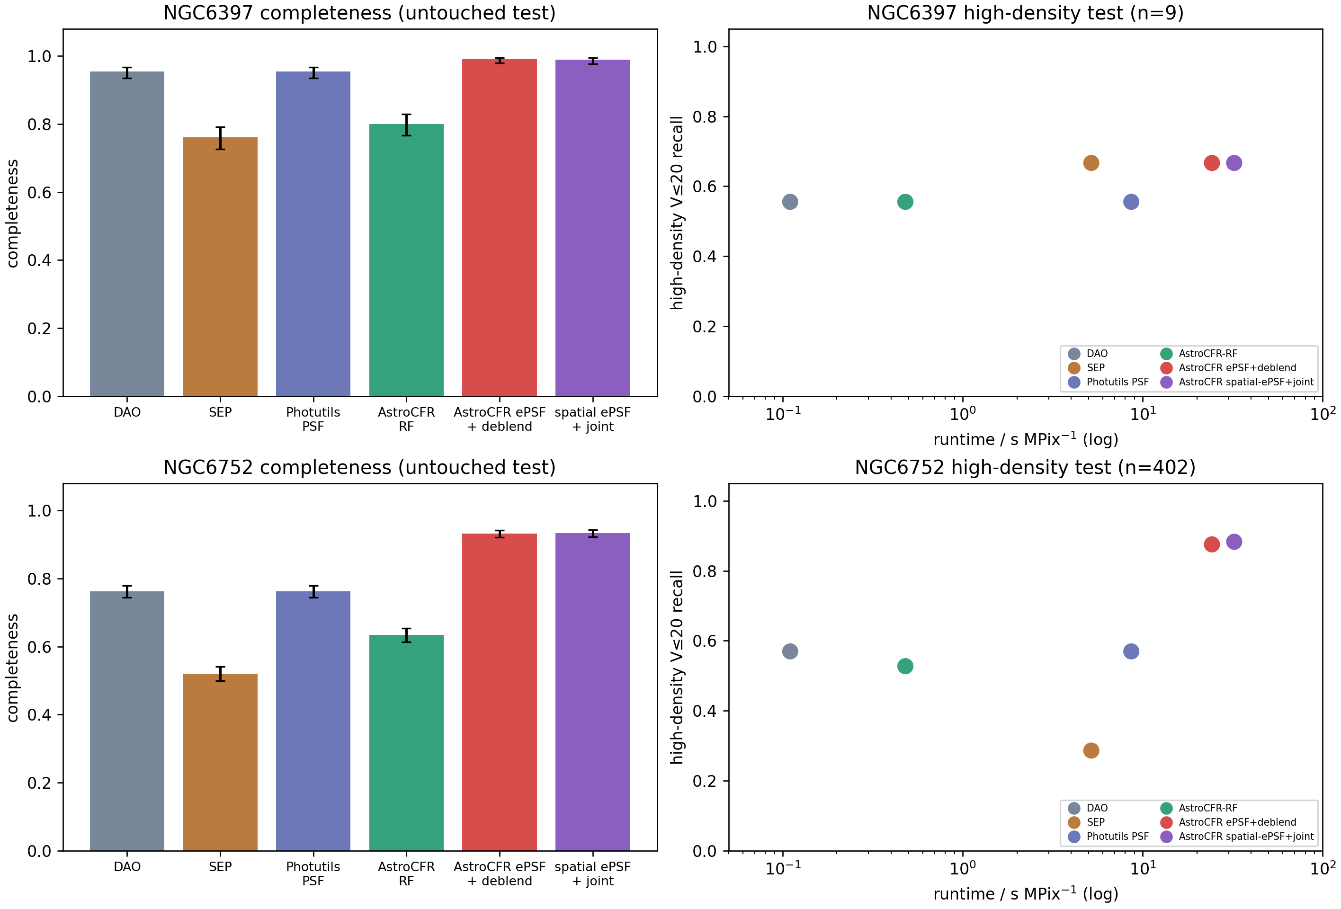
Figure 6. Updated six-branch controlled comparison, including the spatial-ePSF/joint-fit operating point.
To avoid treating one point estimate as a deployment guarantee, we added two uncertainty analyses. For position and magnitude RMS, the held-out matches, affine registration, robust residual mask, and photometric zero point are fixed, and the retained test residuals are resampled 1,000 times. These are conditional residual-bootstrap intervals: they quantify measurement scatter conditional on the detected catalogue, not the uncertainty of the whole detection pipeline. Runtime and RSS are measured with five repeated warm runs after one warm-up run, using the same 1200 × 1200 crop and the same method-stage timing wrapper. The controlled HST/ACS baselines in Tables 4–7 and Table 10 used one Python process on an Intel Core Ultra 9 275HX host (24 logical cores, 50.9 GB RAM), Python 3.12.7, NumPy 2.5.1, SciPy 1.18.0, Astropy 7.2.0, Photutils 3.0.0, and scikit-learn 1.9.0. Those DAO, SEP, Photutils, RF, and ePSF branches were executed on CPU only; GPU memory is therefore not applicable to those rows. The optional CNN CPU/GPU profile is archived in Supplementary Section S7. Runtime is reported in seconds per million processed pixels and RSS as the peak process-memory increase relative to the warm baseline.
To expose where the operating points differ, Supplementary Section S8 releases common-protocol curves for both NGC 6752 and NGC 1851. They stratify held-out completeness by reference magnitude and local density, catalogue-match lower bounds by detection SNR, and conditional positional and magnitude RMS. The associated AstroCFR spatial-ePSF catalogues include reference-free SNR, residual-improvement, local-crowding, deblend, bright-core, classifier-probability, and PSF-fit flags. These fields make blind catalogue screening auditable, but do not convert the HST catalogue-match lower bound into blind purity.
The intervals reinforce the intended operating-point interpretation. In this crop, spatial-ePSF/joint fitting trades approximately 3.7 times the Photutils runtime for higher dense-field recovery and improved flux measurement relative to the original AstroCFR ePSF branch; AstroCFR-RF remains the fast catalogue mode. The branches are therefore reported as complementary operating points rather than collapsed into a single score.
To test whether the crowded-field result is confined to NGC 6752, we downloaded the independent public ACSGGCT v2 NGC 1851 F606W image and its official catalogue. The same central 1200 x 1200 crop, quality filtering, 2-pixel association, 200-pixel spatial partitions, algorithm settings, and target-adaptation protocol were used. No cluster-specific hand tuning was introduced. NGC 1851 is evaluated here as an independent reference-catalogue test; its artificial-star expansion is kept separate from this first cross-cluster validation. The independent validation results are given in Table 6.
Table 6. Independent NGC 1851 validation. Spatial ePSF plus joint fitting achieves 86.3% [84.4%, 88.0%] recovery on 1,368 high-density V<=20 references, compared with 68.9% for the original ePSF branch, 51.8% for SEP, 34.5% for DAO/Photutils, and 30.6% for AstroCFR-RF. The all-quality completeness and photometric RMS do not rank methods identically; therefore this table supports a high-density recovery claim, not universal catalogue or measurement leadership.
Method | All-quality completeness | Dense V<=20 recovery (95% CI) | Pos. RMS / mas | Mag. RMS / mag | s / MPix
DAOStarFinder | 17.3% | 34.5% [32.0, 37.1] (n=1368) | 1.68 | 0.320 | 0.08
SEP/SExtractor-style | 45.6% | 51.8% [49.2, 54.5] (n=1368) | 5.99 | 0.264 | 6.42
Photutils PSFPhotometry | 17.1% | 34.5% [32.0, 37.1] (n=1368) | 3.77 | 0.283 | 5.98
AstroCFR original (target-adapted RF) | 15.7% | 30.6% [28.2, 33.0] (n=1368) | 1.59 | 0.934 | 0.34
AstroCFR ePSF-deblend | 29.3% | 68.9% [66.4, 71.3] (n=1368) | 4.25 | 0.080 | 17.54
AstroCFR spatial-ePSF joint fit | 34.7% | 86.3% [84.4, 88.0] (n=1368) | 2.15 | 0.082 | 35.23
This third field materially strengthens the scope of the paper: the recovery-oriented operating point is now observed in two dense clusters (NGC 6752 and NGC 1851), while NGC 6397 remains a lower-density descriptive check. It also exposes a boundary condition: NGC 1851 has a broader image-derived FWHM estimate and the spatial branch does not improve its flux RMS over the original ePSF branch. The system should consequently expose both ePSF modes and select the measurement branch through a validation-set operating-point choice rather than claim one universal PSF configuration.
The initial artificial-star experiment used approximately 40 injections per magnitude-density stratum. We repeated the decisive NGC 6752 experiment with five sparse batches of 40 stars, giving n=200 per method and stratum. All six methods received exactly the same fixed positions and injected fluxes; recovery means that at least one candidate lies within 2 pixels of the injected position. The experiment therefore measures proposal recovery under a controlled injected scene, not catalogue purity. Because these NGC 6752 stars were rendered with an image-derived empirical PSF from the same modelling family used by the AstroCFR ePSF branch, the result is treated as model-matched controlled evidence rather than an independent PSF validation. The expanded injection results are reported in Table 7 and visualized in Figure 7.
Table 7. Expanded NGC 6752 artificial-star recovery with n=200 per stratum. The larger denominator narrows the intervals relative to the pilot experiment and preserves the crowded-field ordering.
Method | Injected V | Density | n | Proposal recovery (95% CI)
DAOStarFinder | 20 | high | 200 | 32.0% [25.9, 38.8]
SEP/SExtractor-style | 20 | high | 200 | 26.5% [20.9, 33.0]
Photutils PSFPhotometry | 20 | high | 200 | 32.0% [25.9, 38.8]
AstroCFR original (target-adapted RF) | 20 | high | 200 | 24.5% [19.1, 30.9]
AstroCFR ePSF-deblend | 20 | high | 200 | 59.0% [52.1, 65.6]
AstroCFR spatial-ePSF joint fit | 20 | high | 200 | 60.0% [53.1, 66.5]
DAOStarFinder | 20 | low | 200 | 65.0% [58.2, 71.3]
SEP/SExtractor-style | 20 | low | 200 | 54.5% [47.6, 61.3]
Photutils PSFPhotometry | 20 | low | 200 | 65.0% [58.2, 71.3]
AstroCFR original (target-adapted RF) | 20 | low | 200 | 57.0% [50.1, 63.7]
AstroCFR ePSF-deblend | 20 | low | 200 | 90.5% [85.6, 93.8]
AstroCFR spatial-ePSF joint fit | 20 | low | 200 | 90.0% [85.1, 93.4]
DAOStarFinder | 22 | high | 200 | 15.0% [10.7, 20.6]
SEP/SExtractor-style | 22 | high | 200 | 7.5% [4.6, 12.0]
Photutils PSFPhotometry | 22 | high | 200 | 15.0% [10.7, 20.6]
AstroCFR original (target-adapted RF) | 22 | high | 200 | 10.5% [7.0, 15.5]
AstroCFR ePSF-deblend | 22 | high | 200 | 30.5% [24.5, 37.2]
AstroCFR spatial ePSF + joint fit | 22 | high | 200 | 30.0% [24.1, 36.7]
DAOStarFinder | 22 | low | 200 | 45.0% [38.3, 51.9]
SEP/SExtractor-style | 22 | low | 200 | 17.0% [12.4, 22.8]
Photutils PSFPhotometry | 22 | low | 200 | 45.0% [38.3, 51.9]
AstroCFR original (target-adapted RF) | 22 | low | 200 | 7.0% [4.2, 11.4]
AstroCFR ePSF-deblend | 22 | low | 200 | 61.5% [54.6, 68.0]
AstroCFR spatial-ePSF joint fit | 22 | low | 200 | 61.5% [54.6, 68.0]
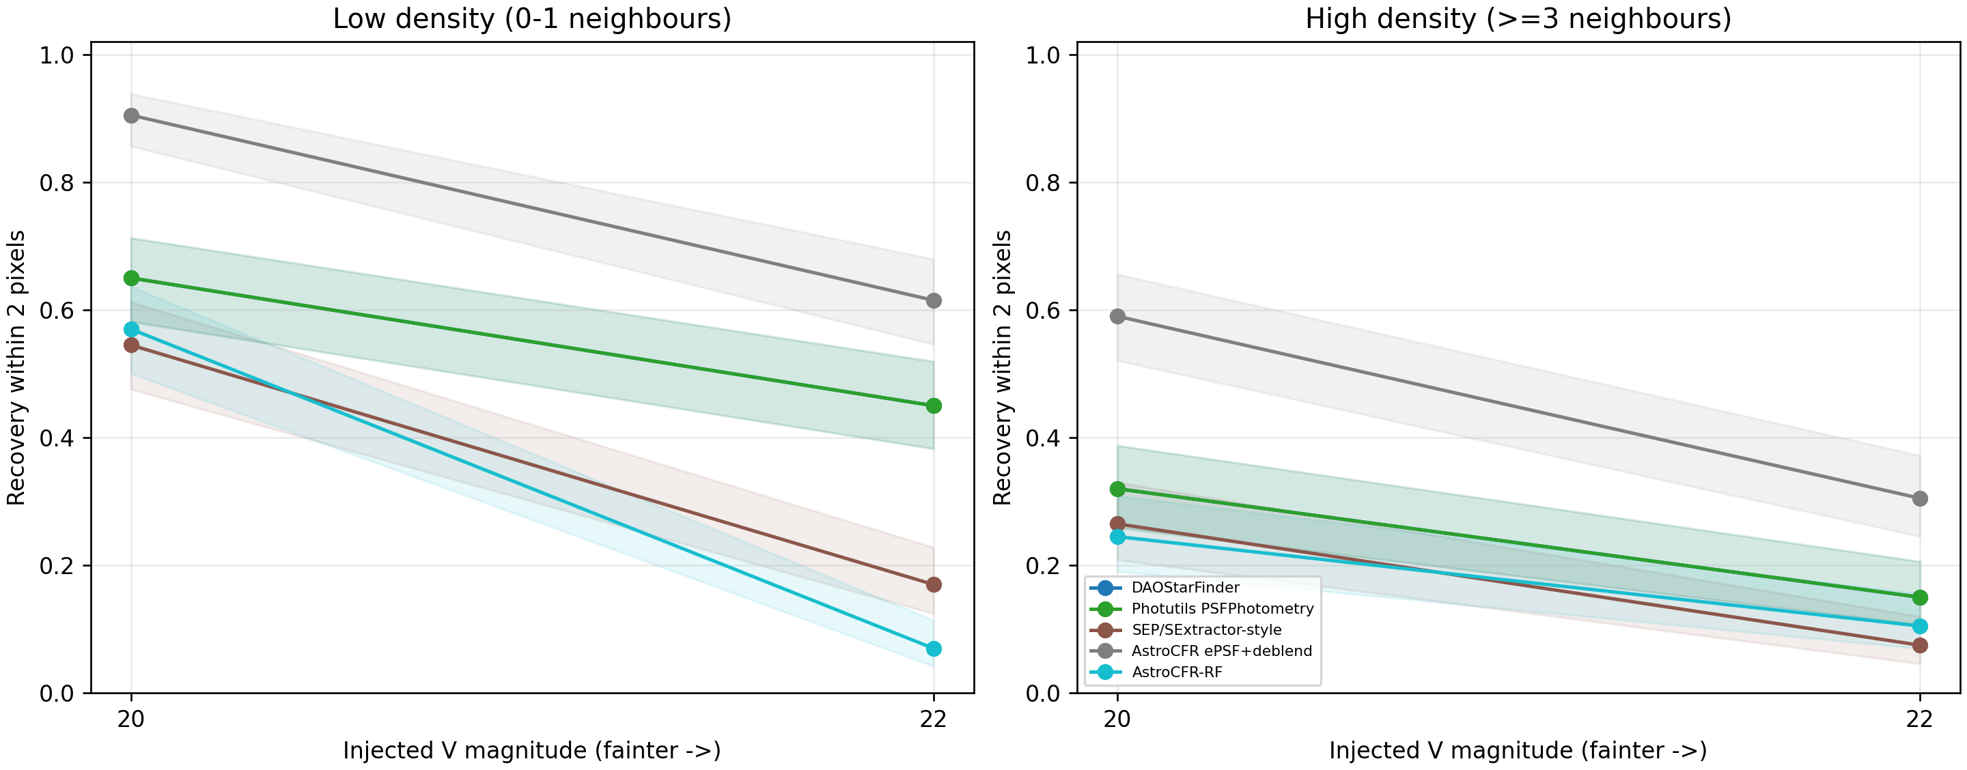
Figure 7. Expanded NGC 6752 artificial-star recovery. The low- and high-density panels use identical injected scenes across methods; error bars are Wilson 95% intervals.
We therefore ran a pilot independent-PSF stress test on the public PHAT M31 B21-F15 F475W DRZ image. The official Anderson ACS/WFC F475W standard PSF, rather than AstroCFR's image-derived ePSF, was evaluated at each source location through the WCS solutions of three registered 370-s FLC exposures, broadened with a fixed 0.55-pixel Gaussian output kernel to match the measured 2.2-pixel DRZ core, and normalized on the DRZ grid. On common denominators of 41 low-density and 42 high-density F475W=26.5 injections, AstroCFR ePSF recovered 39 and 35 stars versus 28 and 24 for Photutils. The sample is too small to serve as a primary validation set; it is retained only as a pilot check that the proposal gain is not solely caused by reusing the recovery ePSF as the injector. Full paired statistics, renderer diagnostics, and limitations are reported in Supplementary Section S10.

5.3.1 Completed public-archive benchmark expansion
The primary evidence comprises 11 real ACSGGCT HST/ACS F606W fields, all with the five common image-only branches; the two literature-mapped PSF controls are also complete for all 11 fields. Four CSST-like full-frame chips and the method-complete controlled-crop audit are retained as a separate simulation-to-reality reference tier. The hybrid branch is retained only for its three archived fields. RF is protocol-excluded from the HST matrix because neither unvalidated CSST-to-HST transfer nor a new HST-catalogue-supervised adaptation is treated as an image-only comparison branch.
For an explicit multi-exposure reference, native DOLPHOT FakeStars on three registered PHAT M31 F475W FLC exposures recovered 177/200 low-density injections (88.5%, 95% CI 83.3–92.2%) and 181/200 high-density injections (90.5%, 95% CI 85.6–93.8%) at F475W=26.5, with magnitude RMS 0.201 and 0.197 mag. This is a measured physical-backend comparison, not a literature-only citation. It is reported as a separate tier because AstroCFR uses one F606W DRZ image, a different renderer, filter, catalogue, and injection protocol; the result establishes the expected multi-exposure reference strength and defines AstroCFR's complementary single-frame use case rather than an input-mismatched ranking.
The 11-field HST comparison is the primary high-density observational result. Across fields, spatial-ePSF joint fitting has higher V<=20 high-density recovery than Photutils in 11/11 fields, lower position RMS in 7/11, and lower magnitude RMS in 8/11. The field medians are 86.3% versus 45.9% for dense recovery, 2.44 versus 3.90 mas for position RMS, and 0.088 versus 0.179 mag for magnitude RMS. Thus the spatial branch is not globally photometrically inferior: it has lower magnitude RMS in 8/11 fields; its limitation is field- and subset-dependent, with Photutils retaining lower conditional magnitude RMS in the remaining three fields and in some isolated/precision-oriented operating points. These medians summarize 15,893 high-density references in total (field n range 9–3,307; median n=1,334). NGC 6397 contributes only nine high-density references and is therefore descriptive rather than decisive; excluding it leaves 15,884 references. A descriptive reference-weighted recovery is 67.3% for spatial-ePSF versus 34.7% for Photutils, while the field-median analysis remains the prespecified headline summary. The literature controls use a different denominator and are not pooled into these medians.
The earlier non-ACSGGCT comparisons remain contextual and are not merged into the 11-field high-density median. They use different filters, reference catalogues, and crowding distributions. GR8 is retained in Supplementary Table S25 as a separately labelled multi-exposure SCI-mosaic processing audit; its mosaic construction, F475W bandpass, and ANGST/GST reference are not input-equivalent to the ACSGGCT single-F606W tier. S25 therefore documents this boundary and its field-level metrics without introducing an unpooled additional validation claim. The present primary claim is deliberately restricted to the matched ACSGGCT F606W protocol; CSST results are retained as a separate simulation-to-reality reference.

5.3.2 Cross-field branch comparison
Table 8 is intentionally a compact paired comparison between AstroCFR spatial-ePSF joint fitting and Photutils, the two branches most relevant to the central high-density claim. It gives all 11 field-level high-density recoveries and conditional RMS values. The full 78-row comparison, including DAO, SEP, ePSF-deblend, global empirical-ePSF, and three-Gaussian dPSF controls, is moved to Supplementary Table S26 and to the machine-readable all-method matrix.
Table 8. Compact field-by-field high-density comparison of AstroCFR spatial-ePSF joint fitting (S) and Photutils (P). Recovery uses V<=20 references with at least three neighbours within 10 pixels; RMS values are conditional on held-out matched references. Supplementary Table S26 contains the complete all-branch table.
Field | N dense | Spatial-ePSF recovery / % | Photutils recovery / % | Delta / pp | Pos. RMS S / P / mas | Mag. RMS S / P / mag
NGC 2808 | 2978 | 10.8% [9.7%–11.9%] | 9.2% [8.2%–10.3%] | +1.6 | 50.15 / 50.21 | 1.682 / 1.584
NGC 5286 | 1330 | 91.0% [89.3%–92.4%] | 43.5% [40.8%–46.1%] | +47.5 | 3.75 / 6.80 | 0.114 / 0.182
NGC 6388 | 1519 | 80.6% [78.5%–82.5%] | 77.5% [75.3%–79.5%] | +3.1 | 5.44 / 4.47 | 0.167 / 0.116
NGC 6441 | 990 | 86.3% [84.0%–88.3%] | 45.9% [42.8%–49.0%] | +40.4 | 6.15 / 7.66 | 0.192 / 0.179
NGC 0104 | 3307 | 67.1% [65.5%–68.7%] | 18.8% [17.5%–20.2%] | +48.3 | 2.11 / 4.32 | 0.080 / 0.121
NGC 0362 | 2008 | 75.1% [73.2%–77.0%] | 25.0% [23.1%–26.9%] | +50.2 | 2.46 / 3.90 | 0.096 / 0.257
NGC 6093 | 1334 | 91.7% [90.1%–93.0%] | 56.6% [53.9%–59.2%] | +35.1 | 2.44 / 3.06 | 0.087 / 0.210
NGC 6624 | 648 | 92.3% [90.0%–94.1%] | 68.1% [64.4%–71.5%] | +24.2 | 1.50 / 1.35 | 0.058 / 0.106
NGC 6397 | 9 | 66.7% [35.4%–87.9%] | 55.6% [26.7%–81.1%] | +11.1 | 1.10 / 0.98 | 0.030 / 0.040
NGC 6752 | 402 | 88.3% [84.8%–91.1%] | 57.0% [52.1%–61.7%] | +31.3 | 1.27 / 1.05 | 0.037 / 0.039
NGC 1851 | 1368 | 86.3% [84.4%–88.0%] | 34.5% [32.0%–37.1%] | +51.8 | 2.15 / 3.77 | 0.082 / 0.283
Median | — | 86.3% | 45.9% | +35.1 | 2.44 / 3.90 | 0.087 / 0.179

AstroCFR demonstrates a two-stage deployment strategy. Stage 1 develops the candidate screen on CSST-like simulations. Stage 2 uses the target image to estimate the PSF and normalize candidate features without catalogue labels, then uses a small, spatially disjoint labelled target region to refit the candidate classifier and select its operating threshold. The production run is performed only after this lightweight calibration. This separates simulation development from the bounded target-specific action that is required by the observed sensor and crowding shift.
We quantified the Stage-2 budget on three public HST/ACS F606W fields (NGC 6397, NGC 6752, and NGC 1851). Each 1200 x 1200 crop was divided into 200 x 200 pixel tiles. Sixty percent of the tiles formed the target-fit pool, 20% were reserved for threshold validation, and 20% were untouched for final testing. A budget of 1, 3, or 6 tiles corresponds to 2.8%, 8.3%, or 16.7% of one crop. The non-zero budgets use five deterministic tile selections; their 95% intervals describe selection variability. These tiles are within-image calibration units, not independent telescope visits or independent images. The target-adaptation budget values are reported in Table 9 and plotted in Figure 8.
Table 9. Simulation-to-HST target-adaptation budget curve. Recall and catalogue match-rate lower bound are measured on spatially untouched tiles. Intervals are 95% selection intervals across five calibration-tile draws, not population-level confidence intervals.
Cluster | Tiles | Field fraction | Positive / negative labels | Test recall (95% interval) | V<=20 recall (95% interval) | Match-rate lower bound (95% interval)
NGC1851 | 0 | 0.000 | 0 / 0 | 0.000 +/- 0.000 | 0.000 +/- 0.000 | 0.000 +/- 0.000
NGC1851 | 1 | 0.028 | 63 / 3 | 0.068 +/- 0.082 | 0.152 +/- 0.182 | 0.355 +/- 0.427
NGC1851 | 3 | 0.083 | 177 / 8 | 0.101 +/- 0.081 | 0.224 +/- 0.179 | 0.536 +/- 0.429
NGC1851 | 6 | 0.167 | 364 / 19 | 0.166 +/- 0.002 | 0.370 +/- 0.004 | 0.891 +/- 0.005
NGC6397 | 0 | 0.000 | 0 / 0 | 0.183 +/- 0.000 | 0.231 +/- 0.000 | 0.964 +/- 0.000
NGC6397 | 1 | 0.028 | 38 / 8 | 0.828 +/- 0.036 | 0.915 +/- 0.021 | 0.930 +/- 0.030
NGC6397 | 3 | 0.083 | 140 / 31 | 0.809 +/- 0.005 | 0.924 +/- 0.006 | 0.971 +/- 0.002
NGC6397 | 6 | 0.167 | 247 / 52 | 0.818 +/- 0.010 | 0.920 +/- 0.003 | 0.973 +/- 0.001
NGC6752 | 0 | 0.000 | 0 / 0 | 0.057 +/- 0.000 | 0.079 +/- 0.000 | 0.881 +/- 0.000
NGC6752 | 1 | 0.028 | 101 / 15 | 0.648 +/- 0.021 | 0.782 +/- 0.006 | 0.955 +/- 0.007
NGC6752 | 3 | 0.083 | 326 / 25 | 0.615 +/- 0.007 | 0.759 +/- 0.009 | 0.963 +/- 0.002
NGC6752 | 6 | 0.167 | 655 / 63 | 0.630 +/- 0.018 | 0.772 +/- 0.014 | 0.964 +/- 0.002
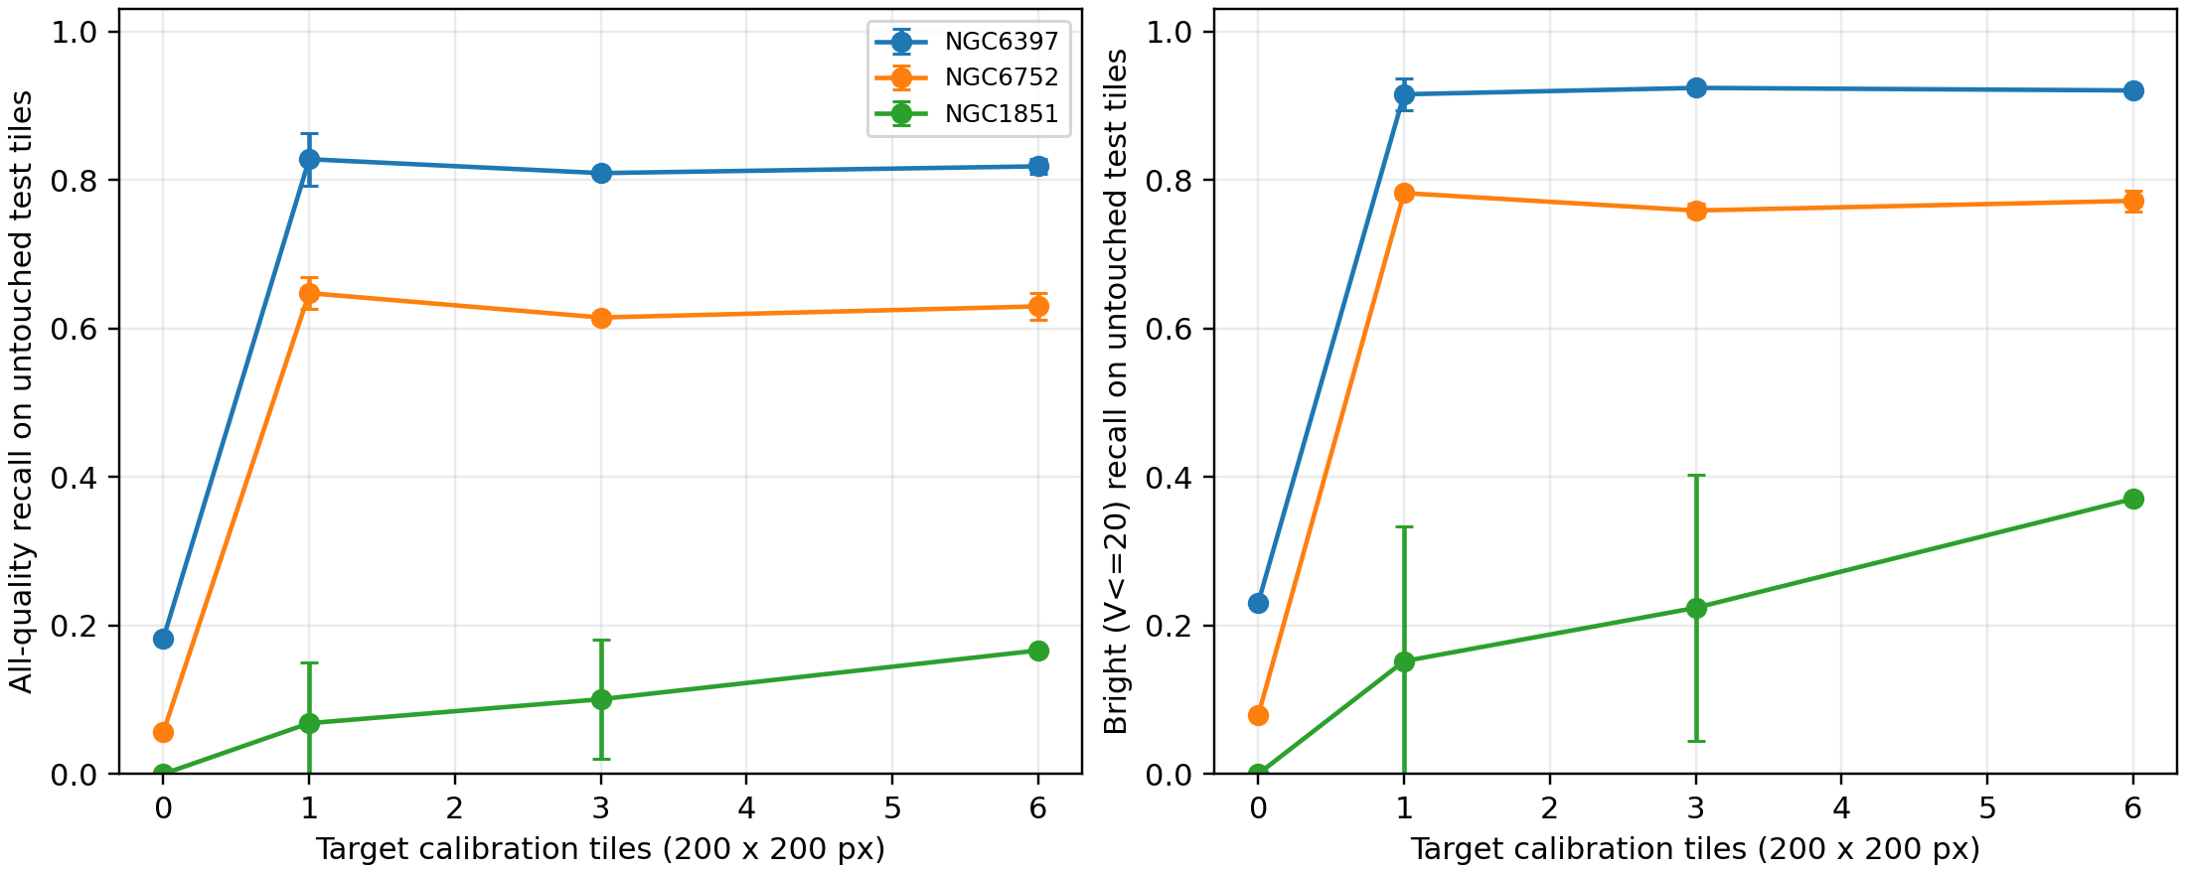
Figure 8. Learning curves for target-adaptation calibration budget. A single tile is sufficient for a large recovery gain in NGC 6397 and NGC 6752; the difficult NGC 1851 field requires several tiles containing enough conservative negative labels for a stable update.
The effect is substantial but not universal. On NGC 6397, one calibration tile containing on average 38 positive and 8 conservative negative examples increases held-out all-quality recall from 0.183 to 0.828 +/- 0.036 and V<=20 recall from 0.231 to 0.915 +/- 0.021. On NGC 6752, one tile with approximately 101 positive and 15 negative examples increases all-quality recall from 0.057 to 0.648 +/- 0.021 and V<=20 recall from 0.079 to 0.782 +/- 0.006. The difficult NGC 1851 case provides the deployment boundary: one and three tiles are unstable because negative labels are scarce, whereas six tiles (about 364 positive and 19 negative examples) produce a stable 0.166 +/- 0.002 all-quality recall, close to the 0.173 proposal-stage ceiling of this single image.
Thus the defensible deployment statement is not that a fixed number of real images always suffices. Rather, a simulation-trained AstroCFR front end can be made operational with a small, labelled and spatially disjoint target calibration region when that region contains adequate positive and negative candidate examples. For the two better-sampled fields, one 2.8%-area tile is already effective; the third field shows why a label-count and stability check is required before releasing an adapted catalogue.
Calibration effort is reported in labelled area and candidate counts, not person-minutes. The labels in this experiment were derived from the official catalogue rather than collected in a timed manual-annotation study; assigning a five-minute human cost would therefore be unsupported. For NGC 6752, the measured return is a 59.1-percentage-point held-out RF-recall gain from one 2.8%-area tile containing approximately 116 labelled candidates. The separate 87.6% ePSF-deblend recovery result is image-driven and must not be attributed to that RF calibration tile.
The learning curves support a practical calibration-sufficiency rule. Begin with one spatially isolated tile and increase the budget only until the calibration set contains at least 30 positive and 8 conservative negative candidates and the five-selection recall half-width is at most 0.05. NGC 6397 (38/8 labels; half-width 0.036) and NGC 6752 (101/15; 0.021) satisfy this rule with one tile. NGC 1851 fails the stability condition at one and three tiles and first satisfies it at six tiles (364/19; 0.002). This is a data-backed stopping rule for the reported protocol, not a universal label-budget law.

5.4 Deployment operating points and resource cost
The controlled measurements expose distinct deployment operating points rather than a single winner. On the primary 11-field HST tier, spatial-ePSF joint fitting is the recovery-oriented high-density mode, Photutils remains the most reliable precision-oriented baseline in several fields, and ePSF-deblend provides an intermediate cost–recovery point. The CSST simulation tier is used to expose simulation-to-reality differences and to audit integration feasibility, not to establish a second primary ranking.
The NGC 1851 learning curve is difficult for measurable field reasons rather than an unreported algorithmic exception: its image-derived FWHM is broader, local background and blend residuals are more heterogeneous, and the conservative negative pool is less stable under one-tile target calibration. Multiple spatial tiles are therefore needed before threshold selection stabilises. This is a field-condition diagnostic, not evidence of selective hand tuning.
Runtime was measured on the same 1,200 x 1,200 HST crops using the CPU execution path, with wall-clock time normalised by image area. Across fields, median costs were 0.11 s MPix⁻¹ for DAOStarFinder, 6.37 s MPix⁻¹ for SEP, 7.78 s MPix⁻¹ for Photutils, 24.85 s MPix⁻¹ for ePSF-deblend, and 45.65 s MPix⁻¹ for spatial-ePSF joint fitting. The spatial branch is therefore 5.9x the Photutils cost in this implementation, while its median dense recovery is 86.3% versus 45.9%. These measurements support a tiered deployment interpretation: DAO/SEP are genuine low-latency screening choices, Photutils is a relatively fast precision branch, and spatial-ePSF is a recovery-oriented single-frame back end or high-quality front end rather than a guaranteed real-time full-detector service. The reported crop timings must not be extrapolated to CSST full-frame throughput; parallel and GPU implementations were not benchmarked.
The magnitude-stratified field medians also show why the headline dense-subset result is not a single easy-source statistic. For spatial-ePSF, recovery is 97.1% for V<=18, 88.0% for V<=20, and 62.4% for V<=22, compared with 79.6%, 47.3%, and 22.3% for Photutils. The separation widens toward the fainter cumulative limit, consistent with the intended role of residual companion recovery; it is not evidence that the spatial branch is uniformly superior on every isolated or bright-star precision subset.
Table 10. Accuracy–cost operating points on the NGC 6752 controlled HST/ACS test. Runtime and RSS are CPU measurements for the methods in this table; GPU memory is not applicable to these rows.
Method | Operating point | Dense V≤20 recovery | Pos. RMS / mas | Mag. RMS / mag | CPU / s MPix⁻¹ | Peak RSS / MB
DAOStarFinder | Fast first-pass screening | 57.0% [52.1–61.7] | 2.13 | 0.058 | 0.11 | 39.9
Photutils PSFPhotometry | Precision-oriented measurement | 57.0% [52.1–61.7] | 1.05 | 0.039 | 8.64 | 133.2
AstroCFR-RF | Fast conservative catalogue | 52.7% [47.9–57.6] | 1.99 | 0.153 | 0.48 | 39.3
AstroCFR ePSF-deblend | Crowded-field recovery | 87.6% [84.0–90.4] | 1.35 | 0.042 | 24.24 | 50.8
AstroCFR spatial-ePSF+joint | Recovery–measurement balance | 88.3% [84.8–91.1] | 1.27 | 0.037 | 32.23 | 50.8
CNN CPU/GPU resource measurements and the complete RF/CNN/Transformer ablation are archived in Supplementary Section S7. They document the optional simulation-domain classifier and do not alter the HST CPU operating-point comparison.

5.4.1 Density-adaptive routing
The density-adaptive router defines an intermediate recovery-cost operating point. On 800 identical artificial-star injections it recovers 400 sources (50.00%, 95% CI: 46.54-53.46%) at an injection-weighted 20.44 s/MPix. This is 10.75 percentage points above Photutils-only recovery, while the always-on spatial-ePSF branch recovers 60.38% at 32.23 s/MPix. Thus routing saves 36.6% of the spatial-ePSF runtime at a 10.38-point recovery cost; it does not dominate either endpoint. The result is summarized in Table 11.
Table 11 is deliberately a proposal-recovery and runtime experiment, not a catalogue-release comparison. Its 800 injected trials do not provide an exhaustive scene catalogue or a common matched-star set for false-discovery, precision, positional RMS, or magnitude RMS estimation. A higher routed recovery could therefore be accompanied by a different false-candidate rate, and a fast low-density branch could have different conditional measurement scatter. The router should consequently be read only as evidence of a recovery-cost trade-off; precision and measurement quality require a future common-scene, exhaustive-truth routing evaluation before it can be used as a final catalogue-selection policy.
To test whether this policy could be automated without reading the evaluation catalogue, we ran a separate image-only density-gate audit. A shallow RandomForest using multi-scale candidate counts and local image texture was calibrated only in the left x < 400-pixel strip and evaluated in the right x >= 800-pixel strip. On held-out artificial-star query positions, high-density sensitivity was NGC6397 0.070, NGC6752 0.590, NGC1851 0.750. Because this cross-field behavior is unstable, the headline router remains the registered density-stratified deployment policy rather than an automatically gated end-to-end claim. The routing-policy aggregate is reported in Table 11.
Table 11. Density-adaptive branch routing on the identical NGC 6752 expanded artificial-star scenes. Recovery intervals are Wilson 95% intervals over 800 injections. Runtime is an injection-weighted CPU operating-point estimate; purity and measurement RMS are not available from this proposal-recovery aggregate.
Policy | High-density branch | Low-density branch | Recovery (95% CI) | s/MPix
Photutils-only | Photutils | Photutils | 39.25% [35.93-42.68%] | 8.64
AstroCFR ePSF-only | ePSF-deblend | ePSF-deblend | 60.38% [56.94-63.71%] | 24.24
AstroCFR spatial-only | spatial-ePSF+joint | spatial-ePSF+joint | 60.38% [56.94-63.71%] | 32.23
Density-adaptive | spatial-ePSF+joint | Photutils | 50.00% [46.54-53.46%] | 20.44

5.5 Failure modes and stratified recovery
The system-level metrics are complemented by diagnostics selected after the candidate run. Figure 9 shows three representative failure modes: a high-density NGC 6752 miss, a missed reference near a bright-star core, and a difficult held-out NGC 1851 region after target adaptation. Cyan circles denote quality-filtered reference stars, red crosses denote references without a candidate within 2 pixels, and yellow points denote AstroCFR candidates. These panels are explanatory examples, not additional tuned test results.
Figure 9. Representative AstroCFR failure cases: (a) high-crowding miss in NGC 6752, (b) bright-star artifact region in NGC 6752, and (c) difficult NGC 1851 held-out domain-adaptation region. All panels use the same public HST/ACS crop and 2-pixel association rule.
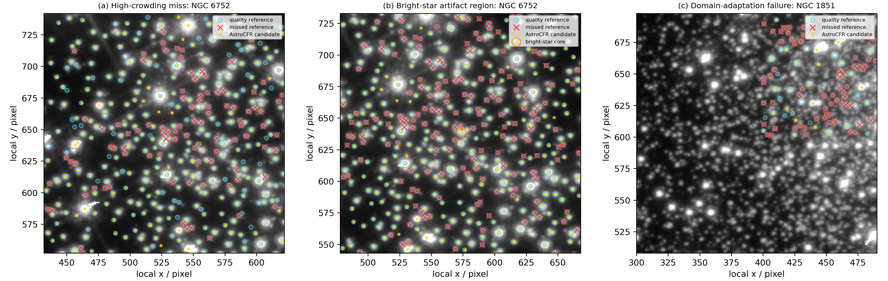
The fixed artificial-star experiment also exposes the interaction between magnitude and local density. Figure 10 separates low-density scenes (0–1 quality references within 10 pixels) from high-density scenes (at least 3 neighbours) and reports recovery within 2 pixels at V=20 and V=22 with Wilson 95% intervals. The separation is largest for the recovery-oriented AstroCFR branches, which supports the bounded claim that their benefit is concentrated in crowded, relatively bright regimes rather than being uniform over all magnitudes and densities.
Figure 10. Artificial-star recovery stratified by local density and injected V magnitude. Shaded regions are Wilson 95% intervals; identical fixed scenes are supplied to all methods.
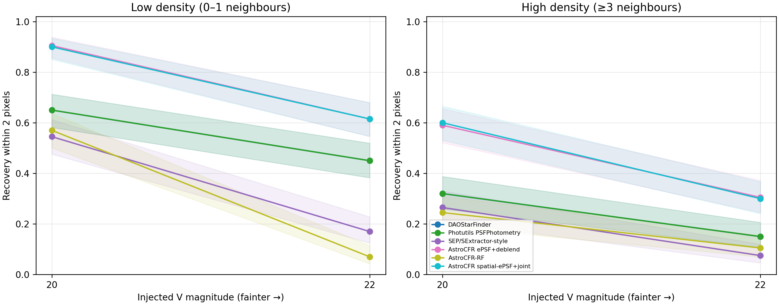

6 Discussion

6.1 Why threshold calibration matters
The threshold experiment shows that evaluation protocol can be a hidden confound. The completed 11-field audit reduces this risk by fixing the crop, association radius, held-out spatial partition, high-density definition, and external-catalogue handling before comparing branches. Apparent gains are therefore interpreted as operating-point differences under a disclosed protocol, not as instrument-independent superiority.
A held-out NGC 6752 robustness audit further checks that this direction is not created by a single matching or proposal threshold. With the test partition untouched, changing the common image-only DAO proposal threshold from 2.5 to 4.0 sigma changed all-quality reference recovery from 77.13% to 74.99%, while the catalogue-match lower bound changed from 93.68% to 94.62%. Holding every produced catalogue fixed and varying only the one-to-one association radius from 1 to 3 pixels left the spatial-ePSF branch above Photutils throughout: 93.19% to 93.45% versus 76.17% to 76.25% all-quality recovery. This is a configuration-robustness check, not test-set parameter selection; the manuscript headline retains the predeclared two-pixel rule and high-density definition.

6.2 Classifier architecture is not the whole system
The isolated benchmark identifies useful branch differences, but the full high-density result is driven by the interaction of candidate generation, empirical-PSF representation, and neighbour-aware fitting. Spatial-ePSF joint fitting recovers more crowded references than Photutils in every ACSGGCT field, while Photutils remains competitive or superior in individual conditional RMS measures. This is why the paper reports both recovery and measurement precision rather than a single score.
The RF ablation clarifies the division of labour: on the dense NGC 6752 subset, AstroCFR-RF recovers 52.7%, whereas the ePSF-deblend branch recovers 87.6% under the same association rule. The classifier is therefore an auxiliary catalogue-screening module; the dominant high-density gain comes from empirical-PSF residual deblending and neighbour-aware fitting, not from the RF score alone.
This has a practical engineering implication. If final catalogue precision for already recovered stars is the primary objective, Photutils is a strong low-complexity choice. If missing blended companions is the dominant scientific risk, AstroCFR ePSF-deblend or spatial-ePSF joint fitting is preferable, with a substantial runtime cost. The hybrid ablation is not a reliable shortcut: replacing the ePSF measurement stage with a fixed Gaussian Photutils fit improves neither recovery nor precision consistently.
The result should not be read as an argument against deep learning or against multi-exposure photometry. It shows that, for this single-image high-density task, explicit spatial PSF structure and neighbour-aware fitting explain more of the measured recovery advantage than an isolated classifier leaderboard.
DOLPHOT/ALLFRAME-class reductions are the appropriate reference when homogeneous, registered multi-exposure data are available: they exploit repeated measurements and exposure-specific PSFs that are absent from this single-image experiment (Dolphin, 2000). AstroCFR is therefore complementary rather than substitutive: it targets a disclosed single-image operating point, while a direct precision ranking against a multi-exposure reduction would require the same exposure list, detector calibration, spatial hold-outs, and artificial-star protocol.
A separate physical-backend reference is available in the reproducibility package but is not pooled with the HST single-image matrix: on three registered PHAT F475W FLC exposures, native DOLPHOT FakeStars recovered 177/200 (88.5%) faint low-density and 181/200 (90.5%) faint high-density injections at F475W=26.5, with magnitude RMS of 0.201 and 0.197 mag, respectively. Those values demonstrate the expected strength of a multi-exposure reduction. They are not ranked against AstroCFR because the AstroCFR independent test uses a single DRZ image, separate one-star injections, and a different renderer; the result defines the complementary use case rather than a hidden DOLPHOT comparison.
This ordering is consistent with the public DOLPHOT literature: Dolphin (2000) describes simultaneous multi-image PSF photometry and artificial-star testing as the route to calibrated crowded-field completeness and errors. The present three-FLC FakeStars numbers provide a concrete local reference for that class of reduction, while the 11-field AstroCFR result quantifies what can be recovered before those repeated exposures are available. We therefore interpret AstroCFR as a first-frame or archival complement, not as a replacement or an unstated claim of equal multi-exposure precision.
Compared with DAOPHOT/ALLFRAME, AstroCFR is not claimed to introduce a new fundamental alternative to image-based PSF fitting; both families model overlapping stars iteratively, and DAOStarFinder is not a DAOPHOT benchmark. The differentiator tested here is a pre-registered single-image operating protocol: broad image-only proposals, residual-gated companion acceptance, spatial-quadrant empirical PSFs, two-pass neighbour fitting, and spatially held-out scoring. Its quantitative evidence is limited to that protocol: across 15,893 dense HST references in 11 F606W fields, spatial-ePSF has an 86.3% field-median dense recovery versus 45.9% for the fixed-PRF Photutils branch, with lower position RMS in 7/11 fields and lower magnitude RMS in 8/11. This is not a numerical DAOPHOT or ALLFRAME advantage. Use AstroCFR's high-recall ePSF/deblend mode for a single-frame front-end or incomplete archival exposure, and use DAOPHOT/ALLFRAME-class multi-image reduction when registered repeated exposures exist. A direct DAOPHOT single-image and ALLFRAME multi-image comparison would require a common FLC exposure set, PSF configuration, artificial-star scene, and held-out scoring protocol; it remains future work rather than an implicit claim.
The attempted same-field DOLPHOT run was not a post hoc choice of a favourable failure case. NGC 1851 was one of the prespecified 11 ACSGGCT fields and was selected for the audit before inspecting the retry output because six native F606W FLC exposures were available. The acceptance gate was also defined before scoring: inter-exposure alignment residuals had to remain sub-pixel and stable enough for the common 2-pixel association, train-only affine registration, and milliarcsecond-scale held-out RMS protocol. A 0.698-pixel or 1.805-pixel warning is not evidence that DOLPHOT is unusable in general; DOLPHOT can model exposure-specific transformations internally. It means only that this particular available FLC set did not yield an input-registered output that could be compared to the single-image catalogue under our declared spatial-holdout protocol. Relaxing the gate would change the coordinate-error budget and would not constitute a fair DOLPHOT ranking.

6.3 Limitations
The primary evidence is the 11-field real HST/ACS comparison. The four CSST-like full frames and the unified five-branch crop audit are retained as a complementary simulation-to-reality reference tier. The two tiers use different truth/reference constructions and are not averaged. The HST suite is still a single-image catalogue-conditioned experiment rather than a multi-exposure DOLPHOT/ALLFRAME comparison. Its observational scope is specifically F606W globular-cluster fields: it does not establish performance in F814W or other passbands, in Galactic-bulge or LMC-like crowding, in dwarf-galaxy cores, or across a broad stellar-colour distribution. The single-image setting is practically relevant for archival frames with incomplete exposure sequences, rapid candidate triage before a slower multi-exposure reduction, and time-domain or trigger workflows in which a catalogue is needed before all exposures are available. It is not intended to replace DOLPHOT when a homogeneous registered exposure set is available. RF is not reported numerically because a CSST-trained screen is not validated for HST transfer and a new HST-catalogue-trained RF would be a separate supervised-adaptation experiment; the hybrid branch has only three archived HST fields.
We use the term target adaptation descriptively rather than as a formal transfer-learning theorem: simulation-to-HST shifts in PSF, background, crowding, catalogue depth, and detector response invalidate an assumption of unchanged feature and label distributions (Ben-David et al. (2010); Pan & Yang (2010)). The small labelled-tile experiment is consequently a bounded recalibration study, not evidence of automatic survey-scale domain transfer or a sample-complexity guarantee. The observed zero-shot degradation is an explicit limitation of simulation-trained classification, not a validation of the CSST simulation fidelity.
The NGC 6752 artificial-star curves remain a controlled, model-matched stress test and are not substituted for the 11-field observational matrix. The independent HST field expansion and the literature-mapped ePSF controls provide the broader high-density evidence; all are still catalogue-conditioned rather than exhaustive blind truth experiments.
A multi-exposure FLC comparison is not reported because the available sequence did not satisfy the predeclared sub-pixel registration and PSF-quality acceptance gate. Failed alignment diagnostics are recorded in Supplementary Section S9 for reproducibility but are not entered into any DOLPHOT/HST1PASS performance table.
The image-only density-gate audit is likewise a negative control rather than a claimed contribution: the proxy was useful on some held-out catalogue positions but did not provide stable high-density sensitivity across all three fields. We therefore retain the simpler, pre-registered density strata for the reported Pareto operating point.
The CSST per-chip reference catalogues contain approximately 1000 stars, while the HST catalogues are finite quality-selected external references. The four CSST chips are consequently a controlled simulation-domain reference, not a generalization proof for the future instrument; the target-adaptation experiments explicitly demonstrate that simulation-trained screening can shift on real images. Larger and more heterogeneous simulation suites, real CSST commissioning data, and homogeneous multi-exposure HST data are required for a definitive cross-domain and multi-exposure benchmark.
The 25 × 25-pixel CNN cutout is retained only as an optional simulation-domain baseline. AstroCFR's primary HST claims do not depend on it, and the manuscript does not claim its scale is optimal. A multi-scale CNN comparison would be a separate learning-model study rather than evidence required for the candidate-recovery and measurement operating points reported here.
The final competition configuration uses reference-aware catalogue assembly. Its reported 100% simulation-catalogue precision is therefore oracle-conditioned and is not a blind deployment metric. The released image-derived quality flags support catalogue screening but do not estimate blind purity. A valid false-discovery claim requires exhaustive scene truth or an independently deeper reference catalogue.
The controlled HST evaluation reports wall-clock seconds per megapixel and peak process RSS for every branch. These are single-machine relative costs, not hardware-independent throughput guarantees. In particular, AstroCFR ePSF-deblend is approximately 220 times slower than DAOStarFinder on NGC 6752 (24.24 versus 0.11 s/MPix). It is therefore a scientific recovery/measurement branch for selected crowded regions, not a survey-wide fast-processing branch; AstroCFR-RF and DAO-style proposals are the appropriate fast front ends.
Tile-level parallelism was also measured for the AstroCFR ePSF plus residual-deblend branch on the NGC 6752 1200 x 1200 crop, split into four identical 600 x 600 tiles. Including worker initialization, median wall time was 64.61 s with one process, 31.69 s with two (2.04x speed-up), and 21.42 s with four (3.02x speed-up); aggregate peak RSS increased from 786 MB to 1,530 MB and 3,025 MB, while all configurations returned the same 7,096 candidates. This establishes tile-level CPU parallelism on one workstation, not TB/PB-scale throughput.

6.4 Future work
The next evaluation should use a homogeneous HST/ACS FLC sequence that first passes sub-pixel inter-exposure registration. Source coordinates would then be shared across exposures with exposure-specific spatial ePSFs, backgrounds, and Poisson/read-noise weights. The same physical backend must be compared with and without AstroCFR candidate and neighbour-group priors under identical exposure lists, spatial hold-outs, and artificial-star scenes, with DOLPHOT or HST1PASS as an external reference. This is the required route to a multi-exposure claim, not a result of the present manuscript.
A second direction is training-set expansion at the faint end. Diagnostics in the source report indicate that cross-chip generalization is weakest when the held-out chip contains stars in magnitude ranges underrepresented by the training chips. Synthetic augmentation should therefore target not only geometric transformations but also realistic faint-source populations, PSF widths, backgrounds, and blend separations.
A third direction is uncertainty-aware labeling. Because the reference catalog contains the brightest approximately 1000 stars per chip, unmatched candidates may include real but uncataloged faint sources. Treating all unmatched candidates as hard negatives can contaminate the classifier. A better strategy is to define ambiguous regions in magnitude, SNR, and distance-to-reference space, remove them from supervised loss, or use positive-unlabeled learning.

7 Conclusion
The framework provides a reproducible Pareto frontier for crowded-field candidate recovery, single-image measurement, and computational cost. Its controlled HST evidence uses common image crops, association rules, spatial partitions, and injected scenes, while the CSST-like results remain a registered challenge configuration.
The 15-field evidence supports three practically useful operating points. DAOStarFinder and SEP are low-latency screening baselines; Photutils is a strong conditional-precision measurement branch; AstroCFR ePSF-deblend and especially spatial-ePSF joint fitting are recovery-oriented modes for high-density blends. Across the 11 ACSGGCT fields, spatial-ePSF joint fitting improves high-density recovery in every field and has lower magnitude RMS in 8/11 fields and lower position RMS in 7/11, but at higher computational cost. Photutils remains the precision-oriented choice in the remaining field/subset cases. The defensible claim is a conditional high-density advantage under the disclosed single-image protocol, not universal leadership over Photutils or multi-exposure DOLPHOT/ALLFRAME.
The CSST geometric-distortion solution is relevant to future registration-aware deployment, but it is not an additional AstroCFR baseline.

Statements and Declarations
Funding: None.
Competing interests: The author declares no competing interests. The AstroCFR software is released under the MIT License unless superseded by the final repository release terms.
Data availability: The primary observational benchmark uses the public MAST ACSGGCT v2 HST/ACS F606W images and quality-selected catalogues for the 11 globular-cluster fields. PHAT M31 F475W FLC exposures and their public catalogues are included only for the separately labelled DOLPHOT FakeStars reference audit and the independent-PSF pilot; they are not inputs to the 11-field headline matrix. CSST challenge data are not redistributed. Download scripts, field identifiers, hashes where available, and machine-readable summaries are provided in the reproducibility package; large FITS products remain external.
Code availability: The manuscript-matched source is prepared for https://github.com/zxl1999/AstroCFR. The release contains reusable modules in src/wpdc, controlled HST and CSST experiment scripts, machine-readable summaries, environment locks, data provenance, manuscript builders, and the partition-isolated ePSF sensitivity audit. The prepared package version is 1.6.2; the tagged archive is https://github.com/zxl1999/AstroCFR/archive/refs/tags/v1.6.2.zip. No archival DOI is claimed before a public release exists.
The companion geometric-distortion study by Yan et al., 2026b provides complementary context for CSST registration; it is not an additional AstroCFR baseline.
Author contributions: Xinlong Zhang led pipeline development, model exploration, data analysis, code writing, and manuscript preparation according to the supplied project report.
AI-assisted drafting: AI-assisted drafting and editing were used for this manuscript. The author is responsible for verifying all text, figures, references, data provenance, code, licenses, and reported numerical results before submission and repository publication.

References
Anderson, J., & King, I. R. (2000). Toward high-precision astrometry with WFPC2. I. Deriving an accurate point-spread function. Publications of the Astronomical Society of the Pacific, 112, 1360–1382. https://doi.org/10.1086/316632
Anderson, J., & King, I. R. (2006). PSFs, photometry, and astronomy for the ACS/WFC. ACS Instrument Science Report ACS 2006-01, Space Telescope Science Institute. https://www.stsci.edu/hst/instrumentation/acs/documentation/instrument-science-reports-isrs
Anderson, J., et al. (2008). The ACS Survey of Galactic Globular Clusters. V. Generating a comprehensive star catalog for each cluster. The Astronomical Journal, 135, 2055-2065. https://doi.org/10.1088/0004-6256/135/6/2055
Sirianni, M., Jee, M. J., Benítez, N., Blakeslee, J. P., Martel, A. R., et al. (2005). The photometric performance and calibration of the Hubble Space Telescope Advanced Camera for Surveys. Publications of the Astronomical Society of the Pacific, 117, 1049–1112. https://doi.org/10.1086/444553
Bellini, A., Anderson, J., & Bedin, L. R. (2011). Astrometry and photometry with HST WFC3. II. Improved geometric-distortion corrections for 10 filters of the UVIS channel. Publications of the Astronomical Society of the Pacific, 123, 622-637. https://doi.org/10.1086/659878
Chambers, K. C., et al. (2016). The Pan-STARRS1 surveys. arXiv:1612.05560. https://doi.org/10.48550/arXiv.1612.05560
Dey, A., et al. (2019). Overview of the DESI Legacy Imaging Surveys. The Astronomical Journal, 157, 168. https://doi.org/10.3847/1538-3881/ab089d
Gaia Collaboration, et al. (2016). The Gaia mission. Astronomy & Astrophysics, 595, A1. https://doi.org/10.1051/0004-6361/201629272
Gaia Collaboration, et al. (2023). Gaia Data Release 3: Summary of the astrometric, photometric, and survey properties. Astronomy & Astrophysics, 674, A1. https://doi.org/10.1051/0004-6361/202243940
Astropy Collaboration, et al. (2022). The Astropy Project: Sustaining and growing a community-oriented open-source project and the latest major release (v5.0) of the core package. The Astrophysical Journal, 935, 167. https://doi.org/10.3847/1538-4357/ac7c74
Harris, C. R., et al. (2020). Array programming with NumPy. Nature, 585, 357-362. https://doi.org/10.1038/s41586-020-2649-2
Hunter, J. D. (2007). Matplotlib: A 2D graphics environment. Computing in Science & Engineering, 9(3), 90-95. https://doi.org/10.1109/MCSE.2007.55
Virtanen, P., et al. (2020). SciPy 1.0: Fundamental algorithms for scientific computing in Python. Nature Methods, 17, 261-272. https://doi.org/10.1038/s41592-019-0686-2
Stetson, P. B. (1987). DAOPHOT: A computer program for crowded-field stellar photometry. Publications of the Astronomical Society of the Pacific, 99, 191-222. https://doi.org/10.1086/131977
Bertin, E., & Arnouts, S. (1996). SExtractor: Software for source extraction. Astronomy and Astrophysics Supplement Series, 117, 393-404. https://doi.org/10.1051/aas:1996164
Barbary, K. (2016). SEP: Source Extractor as a library. Journal of Open Source Software, 1(6), 58. https://doi.org/10.21105/joss.00058
Bradley, L., Sipocz, B., Robitaille, T., et al. (2024). Photutils: Photometry tools. Astrophysics Source Code Library, ascl:2401.012. https://ascl.net/2401.012
Dolphin, A. E. (2000). WFPC2 stellar photometry with HSTPHOT. Publications of the Astronomical Society of the Pacific, 112(776), 1383-1396. https://doi.org/10.1086/316630
Melchior, P., Moolekamp, F., Jerdee, M., Armstrong, R., Sun, A.-L., Bosch, J., & Lupton, R. (2018). SCARLET: Source separation in multi-band images by constrained matrix factorization. Astronomy and Computing, 24, 129-142. https://doi.org/10.1016/j.ascom.2018.07.001
Schlafly, E. F., Green, G. M., Lang, D., Daylan, T., Finkbeiner, D. P., Lee, A., Meisner, A. M., Schlegel, D., & Valdes, F. (2018). The DECam Plane Survey: Optical photometry of two billion objects in the southern Galactic plane. The Astrophysical Journal Supplement Series, 234(2), 39. https://doi.org/10.3847/1538-4365/aaa3e2
Wang, Y., Sun, R., Deng, T., Zhao, C., Zhao, P., Yang, J., Jia, P., Liu, H., & Zhou, J. (2024). CSST dense star field preparation: A framework for astrometry and photometry for dense star field images obtained by the China Space Station Telescope. Research in Astronomy and Astrophysics, 24(7), 075012. https://doi.org/10.1088/1674-4527/ad4df5
Shi, R.-F., Huang, Y., Li, X.-Y., & Zhang, H.-W. (2024). On the performances of estimating stellar atmospheric parameters from CSST broad-band photometry. Research in Astronomy and Astrophysics, 24, 045015. https://doi.org/10.1088/1674-4527/ad2dbd
Zhang, Y., Cao, Z., Wang, F., Lam, M. I., Deng, H., Mei, Y., & Tan, L. (2023). Scientific preparation for CSST: Classification of galaxy and nebula/star cluster based on deep learning. Monthly Notices of the Royal Astronomical Society, 527(4), 11935-11944. https://doi.org/10.1093/mnras/stad3815
Zhang, S., Fang, G., Song, J., Li, R., Gu, Y., Lin, Z., Zhou, C., Dai, Y., & Kong, X. (2024). Preparation for CSST: Star-galaxy classification using a rotationally invariant supervised machine learning method. arXiv. https://doi.org/10.48550/arXiv.2409.13296
Long, M., Xin, J., Du, J., Zhao, J., Wang, X., et al. (2025). Astronomical pointlike source detection via deep feature matching. The Astrophysical Journal Supplement Series, 276, 4. https://doi.org/10.3847/1538-4365/ad9244
Han, Z., Zhang, T., Liu, C., & Ling, C. (2026). A multi-modal fusion network for star-galaxy classification from CSST simulated datasets. Astronomy and Computing, 56, 101112. https://doi.org/10.1016/j.ascom.2026.101112
Yan, Y., Liu, C., Li, J., & Wang, F. (2026a). Detection and classification of astronomical sources with Astro-RetinaNet in crowded stellar fields. The Astrophysical Journal Supplement Series, 283(2), 72. https://doi.org/10.3847/1538-4365/ae4a24
Lai, J., Lam, M. I., Chen, J., Zhang, X., Tian, H., Chen, X., et al. (2026). Stellar density classification and regression for CSST multi-color imaging using deep learning. Publications of the Astronomical Society of the Pacific, 138(6), 064501. https://doi.org/10.1088/1538-3873/ae6d75
Burke, C. J., Aleo, P. D., Chen, Y.-C., Liu, X., Peterson, J. R., Sembroski, G. H., et al. (2019). Deblending and classifying astronomical sources with Mask R-CNN deep learning. Monthly Notices of the Royal Astronomical Society, 490(3), 3952-3965. https://doi.org/10.1093/mnras/stz2845
Shaw, R. A., Fotopoulou, S., Birkinshaw, M., Maddox, N., & Stewart, H. (2025). DRUID: Source detection and deblending in astronomical images with persistent homology. RAS Techniques and Instruments, 4, rzaf006. https://doi.org/10.1093/rasti/rzaf006
Libralato, M., et al. (2024). Euclid: High-precision imaging astrometry and photometry from Early Release Observations. I. Internal kinematics of NGC 6397 by combining Euclid and Gaia data. arXiv:2411.02487. https://doi.org/10.48550/arXiv.2411.02487
Nie, J., Wei, P., Cao, Z., Yan, Y., Liu, C., Tian, H., et al. (2025). Toward high-precision astrometry with CSST using multi-Gaussian fitting of PSF. Research in Astronomy and Astrophysics, 25(11), 115006. https://doi.org/10.1088/1674-4527/adfd22
Espinosa, S., Vicuña, M. L., Mendez, R. A., Silva, J. F., & Orchard, M. (2025). The impact of the point spread function fitting radius on photometric uncertainty based on the Fisher information matrix. Astronomy & Astrophysics, 702, A91. https://doi.org/10.1051/0004-6361/202555342
Centofanti, E., Farrens, S., Starck, J.-L., & Liaudat, T. I. (2026). Point spread function wavefront recovery from in-focus stellar observations. Astronomy & Astrophysics. https://doi.org/10.1051/0004-6361/202558730
Wang, P., Wei, P., Liu, C., Wang, R., Wang, F., & Zhang, X. (2026). CSST-PSFNet: A point-spread function reconstruction model for the CSST based on deep learning. The Astrophysical Journal Supplement Series, 283(2), 77. https://doi.org/10.3847/1538-4365/ae5053
Zhang, S., Wang, L., Diao, Y., Yan, Z., Peng, X., Liu, Y., Shan, H., Wang, G., Liu, F., Wei, C., Nie, L., Chen, X., Ding, H., & Zheng, Z. (2026). Aperture photometric accuracy of point-spread-function-deconvolved astronomical images. The Astronomical Journal, 172(1), 67. https://doi.org/10.3847/1538-3881/ae7718
De Alba, K., De Alba, E., Cabello, A., Gazak, J. Z., & Fletcher, J. (2026). Aperture-X: Physics-informed aperture feature learning for robust photometry. Astronomy and Computing, 57, 101165. https://doi.org/10.1016/j.ascom.2026.101165
Wainer, T. M., Davenport, J. R. A., Bellm, E. C., Wang, Y., Caplar, N., et al. (2025). Crowded field photometry with Rubin: Exploring 47 Tucanae with Data Preview 1. Research Notes of the AAS, 9, 171. https://doi.org/10.3847/2515-5172/adecef
Salaris, M., et al. (2024). The HST Large Programme on NGC 6752 - V. Differences in luminosity and mass function among stellar populations. Astronomische Nachrichten, 345, e20240018. https://doi.org/10.1002/asna.20240018
Dalcanton, J. J., et al. (2009). The ACS Nearby Galaxy Survey Treasury. The Astrophysical Journal Supplement Series, 183, 67-108. https://doi.org/10.1088/0067-0049/183/1/67
Dalcanton, J. J., et al. (2012). The Panchromatic Hubble Andromeda Treasury. The Astrophysical Journal Supplement Series, 200, 18. https://doi.org/10.1088/0067-0049/200/2/18
Williams, B. F., et al. (2021). The Panchromatic Hubble Andromeda Treasury: Triangulum Extended Region. The Astrophysical Journal Supplement Series, 253, 8. https://doi.org/10.3847/1538-4365/abd6f6
Sabbi, E., et al. (2016). The Hubble Tarantula Treasury Project. II. Photometric Catalog and Properties of the Young Stellar Populations. The Astrophysical Journal Supplement Series, 222, 11. https://doi.org/10.3847/0067-0049/222/1/11
Ben-David, S., Blitzer, J., Crammer, K., & Pereira, F. (2010). A theory of learning from different domains. Machine Learning, 79, 151-175. https://doi.org/10.1007/s10994-009-5152-4
Pan, S. J., & Yang, Q. (2010). A survey on transfer learning. IEEE Transactions on Knowledge and Data Engineering, 22, 1345-1359. https://doi.org/10.1109/TKDE.2009.191
Ganin, Y., et al. (2016). Domain-adversarial training of neural networks. Journal of Machine Learning Research, 17, 1-35. https://jmlr.org/papers/v17/15-239.html
Long, M., Cao, Y., Wang, J., & Jordan, M. I. (2015). Learning transferable features with deep adaptation networks. Proceedings of ICML, 97-105. https://proceedings.mlr.press/v37/long15.html
Breiman, L. (2001). Random forests. Machine Learning, 45, 5-32. https://doi.org/10.1023/A:1010933404324
Chen, T., & Guestrin, C. (2016). XGBoost: A scalable tree boosting system. Proceedings of the 22nd ACM SIGKDD, 785-794. https://doi.org/10.1145/2939672.2939785
Pedregosa, F., et al. (2011). Scikit-learn: Machine learning in Python. Journal of Machine Learning Research, 12, 2825-2830. https://jmlr.org/papers/v12/pedregosa11a.html
Goodfellow, I., Bengio, Y., & Courville, A. (2016). Deep Learning. MIT Press. https://www.deeplearningbook.org/
He, K., Zhang, X., Ren, S., & Sun, J. (2016). Deep residual learning for image recognition. Proceedings of CVPR, 770-778. https://doi.org/10.1109/CVPR.2016.90
Yan, Y., Wu, Y., Nie, J., Zhang, T., Liu, C., Ban, Z., et al. (2026b). A robust geometric distortion solution for the Main Survey Camera of CSST. The Astronomical Journal, 171(5), 264. https://doi.org/10.3847/1538-3881/ae505f

