Supplementary Materials for AstroCFR
Classifier selection and architecture ablations
This supplement contains classifier, sensitivity, reproducibility, and high-density field-level material supporting the revised manuscript. The primary observational evidence is the completed 11-field ACSGGCT HST/ACS F606W suite, evaluated with common image crops, held-out spatial partitions, a two-pixel association rule, and a fixed high-density definition. CSST full-frame and controlled-crop results remain a separate simulation-to-reality reference tier and are not pooled with the HST evidence.

S1 Nine-method classifier comparison
The archived nine-method classifier screen uses complete pre-classification candidate tables with features, cutout references, coordinates, and reference-match labels. It reports ten repeated stratified trials, per-chip normalization, 3:1 negative-to-positive undersampling, validation-selected thresholds, and held-out test scores. The original per-trial feature cache and complete parameter files for this legacy screen are not distributed in the upload package; it is therefore retained as a contextual diagnostic, not as part of the primary 11-field HST claim. The fully reproducible classifier protocol, including exact partitions, seed, labels, and hyperparameters, is the controlled ablation specified in Section S2 below.
The same exported candidate pools support all classical and deep classifiers. This isolates architecture effects from candidate-generation differences. Deep networks are evaluated over fewer repeated trials because of computational cost, but they use the same threshold protocol and target operating point.
Feature normalization is performed per chip before pooling because absolute flux, peak significance, and local background variance are not comparable across all chips. This step uses no labels and therefore does not leak test information. It simply maps each chip's candidate distribution into a common scale so that classifiers can learn morphology and concentration patterns rather than chip-specific numerical ranges. Preliminary experiments showed that this normalization strongly reduced cross-validation variance.
After applying the same per-chip threshold calibration protocol, all nine classifiers achieve similar global recall between 94.59% and 95.71%. Precision varies much more strongly. RandomForest and XGBoost provide the highest global precision, while KNN and SVM are less robust under the heterogeneous chip distribution. The rotation-invariant GoogLeNet-style classifier, although effective for star-galaxy classification in prior CSST preparation work, is not optimal for the present point-source artifact-rejection task.
Table S1. Nine-method classifier comparison under per-chip threshold calibration.
Method | Global recall (%) | Global precision (%) | Chip 12 recall (%) | Chip 12 precision (%)
RandomForest | 94.89 +/- 1.40 | 89.25 +/- 2.32 | 95.01 +/- 2.38 | 82.10 +/- 4.84
XGBoost | 95.12 +/- 1.17 | 86.91 +/- 2.61 | 95.15 +/- 2.85 | 80.61 +/- 6.01
Gradient Boosting | 95.52 +/- 1.27 | 84.14 +/- 3.54 | 94.40 +/- 2.11 | 78.34 +/- 6.12
CNN (native) | 94.59 +/- 1.79 | 83.91 +/- 3.58 | 94.39 +/- 2.65 | 77.07 +/- 3.15
HR-CelestialNet | 95.71 +/- 1.66 | 78.70 +/- 4.44 | 94.25 +/- 1.19 | 72.66 +/- 9.00
SVM (RBF) | 95.33 +/- 1.17 | 57.07 +/- 3.22 | 94.67 +/- 2.31 | 71.87 +/- 6.88
Rotation-inv. GoogLeNet | 95.64 +/- 0.88 | 72.40 +/- 5.62 | 93.99 +/- 2.36 | 59.46 +/- 8.33
Logistic Regression | 95.05 +/- 1.29 | 76.76 +/- 3.11 | 95.35 +/- 1.98 | 67.04 +/- 2.43
KNN | 94.84 +/- 1.32 | 37.85 +/- 3.84 | 94.26 +/- 2.00 | 34.43 +/- 5.34
Fig. S1. Recall and precision for nine classification methods.
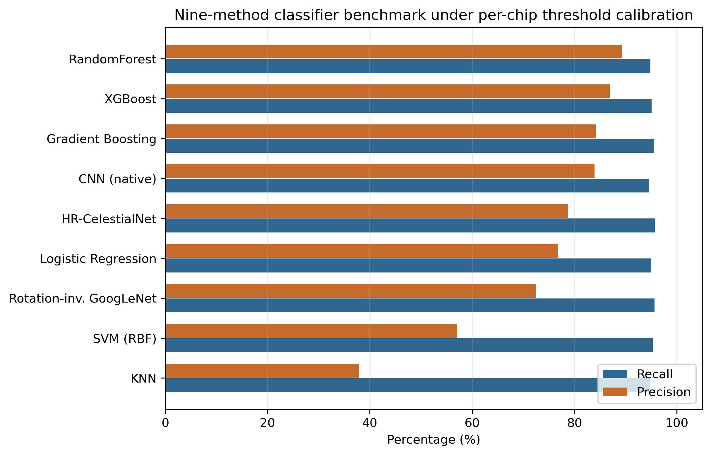

S2 Controlled classifier-architecture ablation
To test whether a newer attention-based classifier is necessary, we performed a controlled simulation-domain ablation. Candidate generation, the association rule, and the four CSST-like chips were fixed. Candidates within 2 pixels of a simulated reference are positive; candidates farther than 8 pixels are negative; the 2-8 pixel annulus is excluded. The resulting cache has 11,615 candidates (3,615 positive and 8,000 negative) and uses a stratified 60/20/20 train/validation/test split with seed 20260806. The feature standardizer is fitted only on the 60% training split. The validation partition selects the highest threshold retaining at least 90% recall; all reported metrics are computed once on the untouched 20% test split. RandomForest uses 400 trees, maximum depth 15, minimum leaf size 2, sqrt feature sampling, class weights 1:6 for negative:positive, and the same seed. The original AstroCFR StarBogusNet and the patch Transformer use Adam with learning rate 1e-3, weight decay 1e-4, cosine annealing for 30 epochs, training batches of 64, and inference batches of 256. Both use the same 25 x 25 normalized cutout and 17 handcrafted features; the Transformer uses 25 non-overlapping 5 x 5 patches, 64-dimensional tokens, two four-head encoder layers, and a small feature-fusion head (74,193 parameters).
The results are reported in Table S2. The Transformer improves recall and F1 over the original CNN in this split, but the RF branch remains the strongest operating point under the pre-registered threshold rule. The attention model also requires approximately twice the training time of the CNN and is not a replacement for the AstroCFR system. This negative result is useful: it shows that the paper's contribution is the deployable multi-stage pipeline and its explicit operating points, rather than an unsupported claim that a Transformer is universally superior.
Table S2. Controlled simulation-domain candidate-classifier ablation. Values use the untouched 20% test partition; thresholds are selected on the validation partition to retain at least 90% validation recall. GPU figures apply to the CNN and Transformer classifier stages only.
Model | Params | Recall | Precision | F1 | AUROC | AUPRC | Train/s | Inference ms/candidate
RandomForest | -- | 0.9585 | 0.9943 | 0.9761 | 0.9994 | 0.9986 | 0.68 | 0.0370
Original AstroCFR CNN | 28,081 | 0.9170 | 0.9881 | 0.9512 | 0.9978 | 0.9921 | 16.48 | 0.0062
Patch Transformer | 74,193 | 0.9336 | 0.9926 | 0.9622 | 0.9987 | 0.9958 | 31.61 | 0.0067
CSST-PSFNet and SwinBayesNet are not added to Table S2 because their tasks, required labels, available checkpoints, and licensing conditions do not define a common candidate-classification experiment. The interface audit is archived separately in the repository.

S3 Image-only density-gate audit
The registered density-adaptive result in the main text uses artificial-star density strata. To assess whether those strata can be inferred from the image alone, we calibrated a shallow RandomForest on multi-scale candidate counts and local pixel texture in x < 400 pixels and evaluated x >= 800 pixels. No catalogue labels enter inference. The cross-field instability is why the main text does not call the router an automatic density classifier.
Table S3. Image-only density-gate audit on spatially held-out artificial-protocol positions. These are gate-classification diagnostics, not source-recovery or photometric metrics.
Field | n | High-density sensitivity | Specificity | Balanced accuracy
NGC6397 | 200 | 0.070 | 1.000 | 0.535
NGC6752 | 200 | 0.590 | 0.970 | 0.780
NGC1851 | 200 | 0.750 | 0.660 | 0.705

S4 Tile-level CPU parallel scaling
The ePSF plus residual-deblend branch was applied independently to four 600 x 600 tiles from the NGC 6752 central crop. Timings include worker start-up and per-worker image/PSF initialization. Candidate totals were identical across configurations. These values establish tile-level workstation scaling only.
Table S4. Tile-level CPU scaling and aggregate process RSS for AstroCFR ePSF-deblend.
Processes | Wall time (s) | Speed-up | Efficiency | Throughput (MPix/s) | Peak RSS (MB)
1 | 64.61 | 1.00x | 1.000 | 0.0223 | 786
2 | 31.69 | 2.04x | 1.020 | 0.0454 | 1530
4 | 21.42 | 3.02x | 0.754 | 0.0672 | 3025

S5 Parameter-sensitivity audit
Detector threshold and association radius are reported as post-hoc robustness audits, not method-selection parameters. The threshold scan uses the common image-only DAO-style proposal front end with the primary two-pixel evaluation rule. The radius scan holds every produced catalogue fixed before changing the evaluation association radius. Catalogue-match values remain lower bounds, not blind purity.
Table S5. Common proposal-threshold sensitivity on the NGC 6752 spatial test partition (fixed two-pixel association).
Threshold (sigma) | Test candidates | Completeness | Catalogue-match lower bound
2.5 | 1961 | 0.771 | 0.937
3.0 | 1919 | 0.762 | 0.942
3.5 | 1887 | 0.755 | 0.944
4.0 | 1860 | 0.750 | 0.946
Table S6. Association-radius sensitivity with fixed NGC 6752 catalogues. Completeness is measured against the same held-out quality references.
Fixed catalogue | 1.0 px | 1.5 px | 2.0 px | 2.5 px | 3.0 px
DAOStarFinder | 0.762 | 0.762 | 0.762 | 0.763 | 0.763
SEP/SExtractor-style | 0.491 | 0.510 | 0.520 | 0.522 | 0.526
Photutils PSFPhotometry | 0.762 | 0.762 | 0.763 | 0.763 | 0.763
AstroCFR-RF (target-adapted) | 0.634 | 0.634 | 0.634 | 0.635 | 0.635
AstroCFR ePSF-deblend | 0.926 | 0.929 | 0.932 | 0.932 | 0.932
AstroCFR spatial-ePSF joint fit | 0.932 | 0.933 | 0.934 | 0.934 | 0.935

S6 Archived simulation diagnostics
The following diagnostic panels were removed from the main text to maintain focus on controlled recovery, measurement, and cost results. They document calibration internals and remain available for audit; they are not additional efficacy claims.
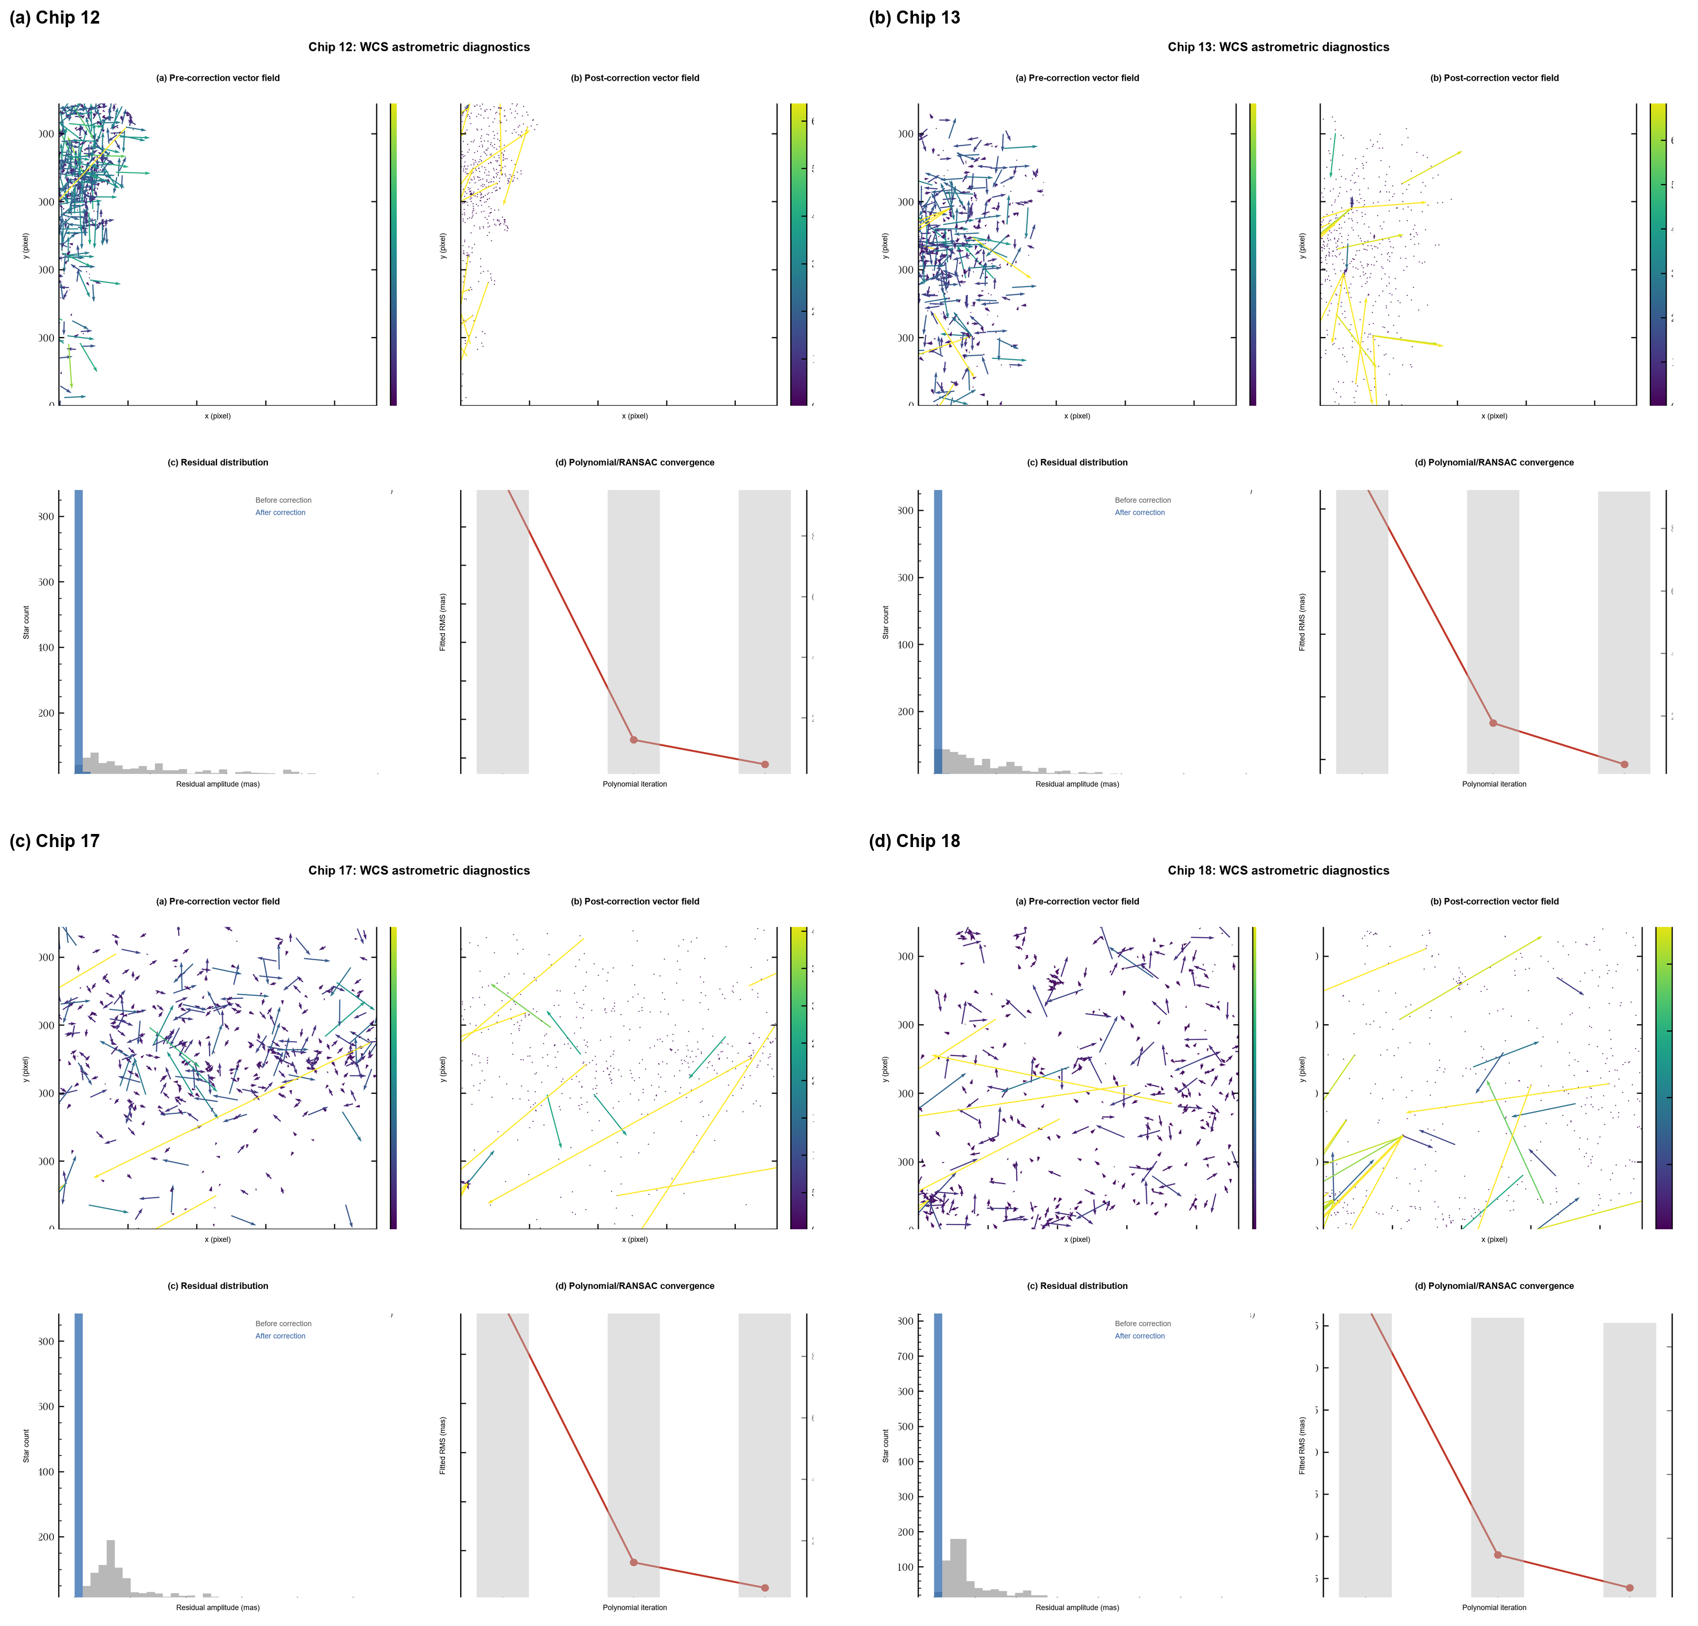
Fig. S2. WCS astrometric diagnostics for the four CSST-like chips.
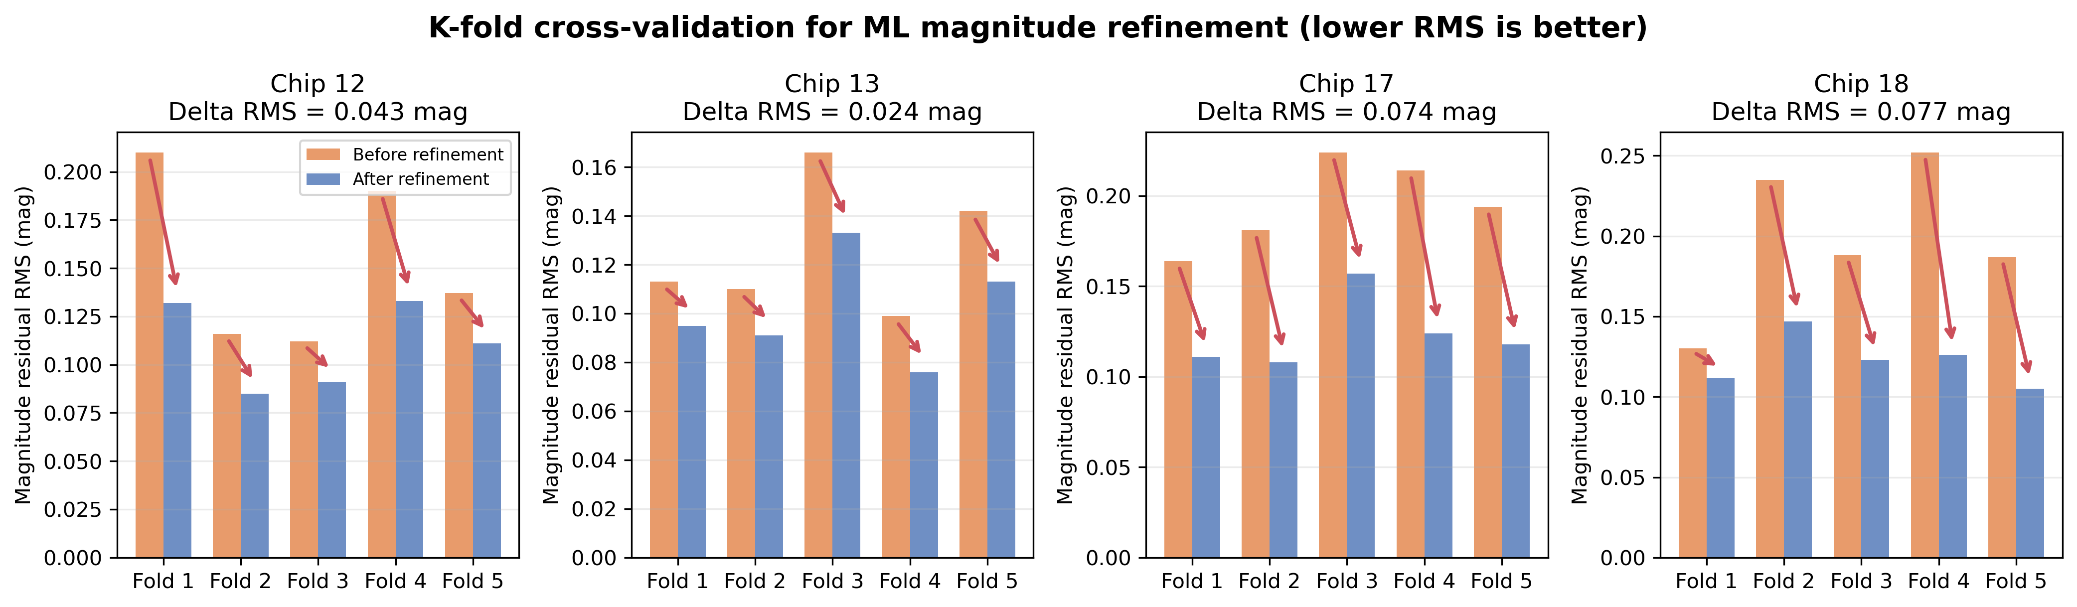
Fig. S3. K-fold cross-validation diagnostics for the ML magnitude refinement.
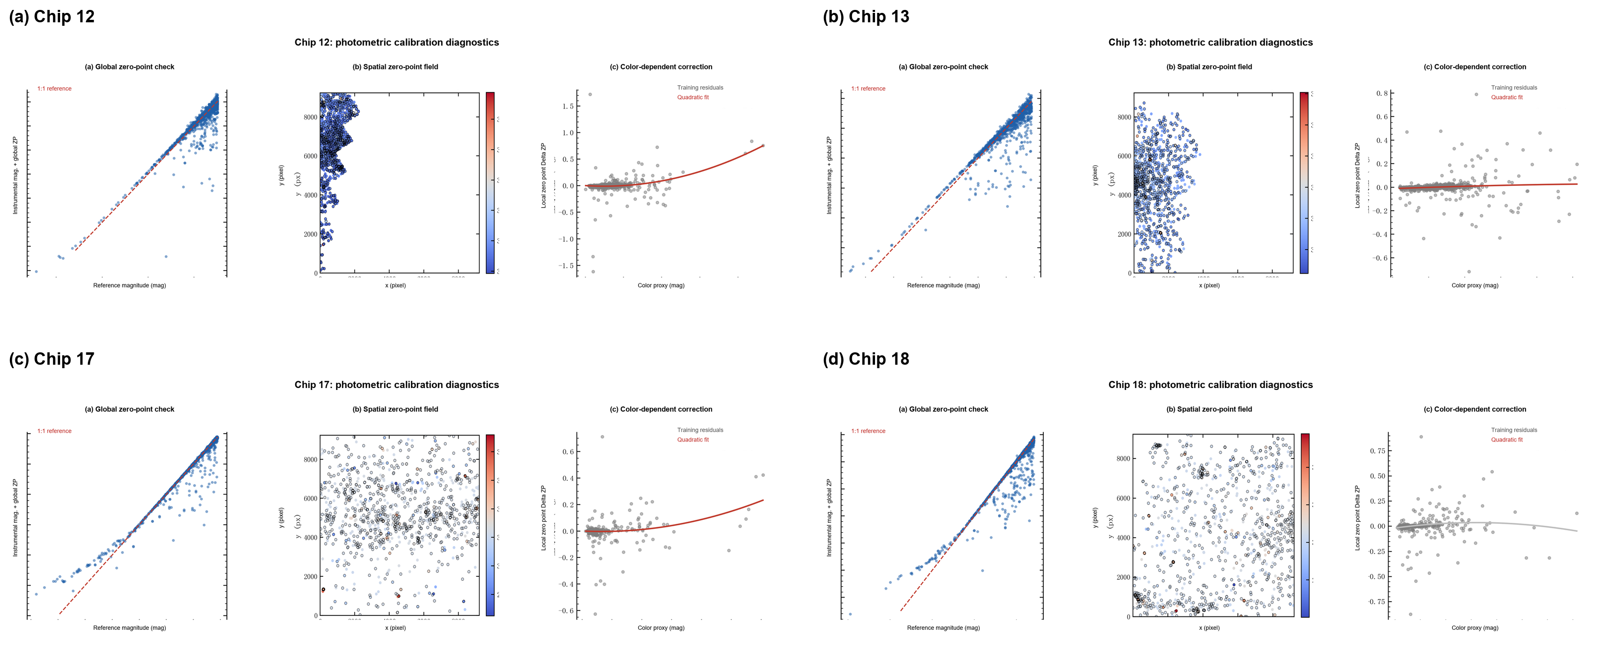
Fig. S4. Photometric calibration diagnostics for the four CSST-like chips.
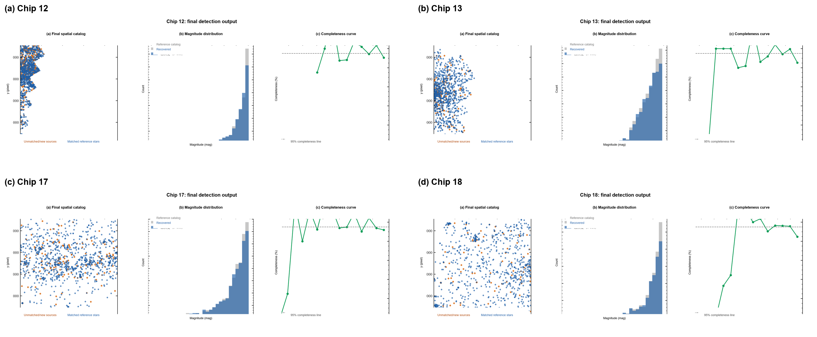
Fig. S5. Final simulation-catalogue output diagnostics for the four chips.

S7 Archived diagnostics and superseded pilots
These items are retained for auditability but are not part of the primary evidential chain. Classifier diagnostics document implementation choices; pilot artificial-star results are superseded by the n=200 fixed-scene experiment in the main text.
Table S7. AstroCFR modules and their system role.
Module | Input representation | Main operation | System role
Background model | raw image | robust tiled RMS/background interpolation | stabilizes candidate detection
Candidate detection | residual image | multi-branch local maxima and morphology | maximizes early recall
Deblending | blend groups/cutouts | paired PSF, joint PSF, RL deconvolution | recovers structural false negatives
Classifier | features + cutouts | RF/CNN/fusion probability thresholding | removes artifacts and PSF-wing candidates
Astrometry | matched catalog residuals | polynomial, LUT, GPR correction | reduces position systematics
Photometry | aperture fluxes/residuals | zero point, spatial correction, ML refinement | reduces magnitude systematics
Table S8. Effect of threshold calibration on chip 12 RandomForest performance.
Metric | Global shared threshold | Per-chip independent threshold
Recall (%) | 72.06 +/- 5.93 | 95.01 +/- 2.38
Precision (%) | 97.13 +/- 2.43 | 81.11 +/- 4.84
Table S9. RandomForest, focal-loss CNN, and hybrid stacking.
Method | Global recall (%) | Global precision (%) | Chip 12 recall (%) | Chip 12 precision (%)
RandomForest | 94.45 +/- 1.26 | 89.29 +/- 2.65 | 94.53 +/- 2.77 | 82.10 +/- 4.84
Focal-loss CNN | 95.43 +/- 1.23 | 78.10 +/- 4.24 | 95.07 +/- 1.86 | 66.55 +/- 4.37
Hybrid Stacking | 95.47 +/- 1.22 | 90.03 +/- 2.40 | 95.90 +/- 1.88 | 81.47 +/- 5.59
Table S10. Full-pipeline metrics with three point-source classifiers.
Method | Chip | Recall (%) | Pos. RMS (mas) | Mag. RMS | Score /100
RandomForest | 12 | 96.9 | 19.91 | 0.0714 | 85
RandomForest | 13 | 93.4 | 16.62 | 0.0844 | 78
RandomForest | 17 | 96.3 | 11.54 | 0.0707 | 90
RandomForest | 18 | 90.8 | 8.55 | 0.0681 | 84
XGBoost | 12 | 97.0 | 21.09 | 0.0688 | 86
XGBoost | 13 | 93.9 | 15.48 | 0.0636 | 80
XGBoost | 17 | 96.2 | 9.88 | 0.0709 | 90
XGBoost | 18 | 91.3 | 12.15 | 0.0727 | 81
Hybrid Stacking | 12 | 96.8 | 16.70 | 0.0645 | 88
Hybrid Stacking | 13 | 93.8 | 15.85 | 0.0771 | 79
Hybrid Stacking | 17 | 96.2 | 10.43 | 0.0751 | 90
Hybrid Stacking | 18 | 91.4 | 12.62 | 0.0703 | 82
Table S11. Final AstroCFR catalog quality.
Chip | TP | FN | Recall (%) | Precision (%) | Pos. RMS (mas) | Mag. RMS
12 | 969 | 31 | 96.9 | 100.0 | 17.2 | 0.0596
13 | 931 | 69 | 93.1 | 100.0 | 8.2 | 0.0575
17 | 964 | 36 | 96.4 | 100.0 | 9.1 | 0.0802
18 | 918 | 82 | 91.8 | 100.0 | 8.8 | 0.0684
Table S12. Zero-shot transfer from CSST-like simulations to public real survey images. Gaia labels are evaluation-only; retained Gaia match rate is not a true precision estimate.
External domain | Gaia refs | Candidates | Retained | Raw recall (%) | Frozen-filter recall (%) | Gaia match-rate lower bound (%) | Runtime (s)
Pan-STARRS1 (i) | 107 | 40 | 4 | 25.2 | 2.8 | 75.0 | 0.33
DESI Legacy Survey DR10 (r) | 14414 | 1492 | 0 | 5.2 | 0.0 | 0.0 | 0.51
Table S13. Zero-shot versus few-shot target-domain adaptation. Recall is measured only on spatial partition 2, which is untouched during fitting and threshold calibration. Gaia match rate is a catalogue-coverage lower bound, not physical catalogue purity.
Domain | Mode | FWHM /px | Candidates | Retained | Held-out refs | Raw recall /% | Retained recall /% | Gaia match-rate lower bound /% | Threshold
PS1_M31_i | zero shot | 3.50 | 40 | 4 | 30 | 36.7 | 3.3 | 75.0 | 0.990
PS1_M31_i | domain adapted | 4.55 | 171 | 76 | 30 | 50.0 | 43.3 | 59.2 | 0.180
LS_DR10_M13_r | zero shot | 3.50 | 1492 | 0 | 4822 | 5.0 | 0.0 | 0.0 | 0.990
LS_DR10_M13_r | domain adapted | 4.11 | 1866 | 1513 | 4822 | 7.8 | 7.1 | 65.4 | 0.482
Table S14. Literature benchmark context. Only metrics with compatible units and evaluation meaning are compared; different filters and artificial-star experiments are not treated as a common leaderboard.
Reference | Data | Published benchmark | Comparability
Anderson et al. (2008) | Same ACSGGCT programme | Essentially 100% completeness above the sub-giant branch for almost all clusters; approximately 0.01 pixel (0.5 mas) relative astrometry after a six-parameter transform | Same survey and official reference catalogue; not an independent rerun
Libralato et al. (2024) | Euclid ERO NGC 6397 | 0.7 mas bright-star VIS 1D precision; 3.2-5.3 mas external Gaia residuals | Same cluster, different instrument and epoch; astrometric context only
Salaris et al. (2024) | NGC 6752 WFC3/IR | Artificial-star recovery within 1 pixel and 0.75 mag; NIR completeness curves and 50% limits | Latest cluster analysis, but filters and injected truth differ; no direct numerical rank
Yan et al. (2026), Astro-RetinaNet | CSST-simulated NGC 2298 and HST M31 | At i=25, 82% crowded and 95% noncrowded recovery; M31 F814W=27 candidate count exceeds Photutils/SExtractor | Closest detector-level study, but images, limiting magnitudes, association rule, and outputs differ
Lai et al. (2026) | CSST multi-color density simulations | 98.83% density-category accuracy; 0.0824 dex bright-star-count MAE | Density gate rather than source-recovery or measurement baseline
Yan et al. (2026), WPDC-2P | 18 CSST detectors and BASS | 0.013-0.107 pixel simulated scatter; 5.494/9.981 mas BASS positional scatter | Astrometric geometric-distortion module only; acronym explicitly distinguished from AstroCFR
Nie et al. (2025) | CSST simulated sparse and crowded fields | Sub-mas sparse-field centering; improved faint-star astrometry versus SExtractor/DOLPHOT | PSF/astrometry context; no common AstroCFR candidate-recovery protocol
Shaw et al. (2025), DRUID | LoTSS and KiDS extended-source images | Persistent-homology detection and nested-source segmentation | Different source morphologies and no crowded stellar photometry benchmark
Burke et al. (2019) | PhoSim simulated astronomical scenes | Mask R-CNN detection, classification, and deblending | Learning-based deblending context; different simulator and evaluation task
Table S15. Direct v7 versus ePSF/residual comparison on the same untouched spatial test partition. The last column is intentionally absent for ePSF proposals because no new purity classifier has been trained for this branch; treating a reference-catalogue association as a purity estimate would be circular.
Cluster | Branch | All-quality recall /% | Recall V<=20 /% | Pos. RMS /mas | Mag. RMS | Catalogue match lower bound /%
NGC6397 | target-adapted RF catalogue | 95.4 | 92.8 | 1.67 | 0.038 | 98.0
NGC6397 | ePSF + residual proposals | 98.7 | 98.7 | 1.10 | 0.035 | --
NGC6752 | target-adapted RF catalogue | 76.2 | 75.4 | 1.99 | 0.153 | 98.6
NGC6752 | ePSF + residual proposals | 93.6 | 96.1 | 1.36 | 0.042 | --
Table S16. Artificial-star proposal recovery. For each cell, 60 stars are injected in three sparse batches into the real image and recovered within 2 pixels. Density is the number of official quality-selected sources within 10 pixels at the injected position; it is used only to stratify final reporting. The injected stars are not placed on catalogue positions and are separated by at least 12 pixels within each batch.
Cluster | Injected V | Recovery: 0-1 neighbours /% | Recovery: 2 neighbours /% | Recovery: >=3 neighbours /%
NGC6397 | 18 | 100.0 | 75.0 | 68.3
NGC6397 | 20 | 88.3 | 55.0 | 41.7
NGC6397 | 22 | 81.7 | 43.3 | 21.7
NGC6752 | 18 | 88.3 | 86.7 | 70.0
NGC6752 | 20 | 85.0 | 68.3 | 36.7
NGC6752 | 22 | 73.3 | 35.0 | 15.0
Table S17. NGC 6752 fixed-scene artificial-star proposal recovery. Each injected star is recovered when any candidate lies within 2 pixels. Low and high density are fixed scene strata defined by the number of reference neighbours within 10 pixels; this is not catalogue purity or a substitute for a completeness-calibrated production catalogue.
Method | Injected V | Density | n | Proposal recovery (95% CI)
DAOStarFinder | 20 | low | 40 | 62.5% (47.0–75.8%)
SEP/SExtractor-style | 20 | low | 40 | 50.0% (35.2–64.8%)
Photutils PSFPhotometry | 20 | low | 40 | 62.5% (47.0–75.8%)
AstroCFR original (target-adapted RF) | 20 | low | 40 | 57.5% (42.2–71.5%)
AstroCFR ePSF-deblend | 20 | low | 40 | 90.0% (76.9–96.0%)
DAOStarFinder | 20 | high | 40 | 30.0% (18.1–45.4%)
SEP/SExtractor-style | 20 | high | 40 | 20.0% (10.5–34.8%)
Photutils PSFPhotometry | 20 | high | 40 | 30.0% (18.1–45.4%)
AstroCFR original (target-adapted RF) | 20 | high | 40 | 25.0% (14.2–40.2%)
AstroCFR ePSF-deblend | 20 | high | 40 | 57.5% (42.2–71.5%)
DAOStarFinder | 22 | low | 40 | 55.0% (39.8–69.3%)
SEP/SExtractor-style | 22 | low | 40 | 15.0% (7.1–29.1%)
Photutils PSFPhotometry | 22 | low | 40 | 55.0% (39.8–69.3%)
AstroCFR original (target-adapted RF) | 22 | low | 40 | 7.5% (2.6–19.9%)
AstroCFR ePSF-deblend | 22 | low | 40 | 75.0% (59.8–85.8%)
DAOStarFinder | 22 | high | 40 | 12.5% (5.5–26.1%)
SEP/SExtractor-style | 22 | high | 40 | 10.0% (4.0–23.1%)
Photutils PSFPhotometry | 22 | high | 40 | 12.5% (5.5–26.1%)
AstroCFR original (target-adapted RF) | 22 | high | 40 | 7.5% (2.6–19.9%)
AstroCFR ePSF-deblend | 22 | high | 40 | 27.5% (16.1–42.8%)
Table S18. Conditional measurement and repeatability intervals for the NGC 6752 controlled test. The spatial-ePSF/joint-fit branch has the lowest photometric RMS among the five measurement-capable branches in this table, but Photutils has the lowest position RMS and substantially lower runtime.
NGC6752 branch | Position RMS / mas (95% CI) | Magnitude RMS / mag (95% CI) | Runtime / s MPix⁻¹ (5 repeats) | RSS delta / MB
DAOStarFinder | 2.134 [2.064–2.200] | 0.058 [0.055–0.060] | 0.11 [0.10–0.11] | 39.9 [39.8–40.3]
SEP/SExtractor-style | 2.690 [2.566–2.819] | 0.127 [0.120–0.133] | 5.18 [5.05–5.26] | 5.5 [5.5–5.5]
Photutils PSFPhotometry | 1.053 [1.017–1.086] | 0.039 [0.037–0.041] | 8.64 [8.47–8.85] | 133.2 [122.0–135.0]
AstroCFR original (target-adapted RF) | 1.987 [1.922–2.052] | 0.153 [0.147–0.159] | 0.48 [0.47–0.54] | 39.3 [39.3–39.4]
AstroCFR ePSF-deblend | 1.348 [1.309–1.386] | 0.042 [0.040–0.044] | 24.24 [23.90–26.74] | 50.8 [50.8–50.8]
AstroCFR spatial-ePSF joint fit | 1.266 [1.231–1.301] | 0.037 [0.035–0.038] | 32.23 [32.04–33.26] | 50.8 [50.8–50.8]
Table S19. Original AstroCFR StarBogusNet resource profile. The CPU and GPU rows use identical input geometry, sample count, seeds, epochs, and batch sizes. GPU: NVIDIA GeForce RTX 5060 Laptop GPU; PyTorch 2.10.0.dev+cu128; CUDA 12.8.
Device | Training / s | Training / epoch s | Inference / ms per 1k | Process RSS / MB | GPU allocated / MB | GPU reserved / MB | Scope
CPU | 8.738 | 0.291 | 45.285 | 147.7 | N/A | N/A | model-stage
RTX 5060 GPU | 3.674 | 0.122 | 8.984 | 655.0 | 58.3 | 86.0 | model-stage
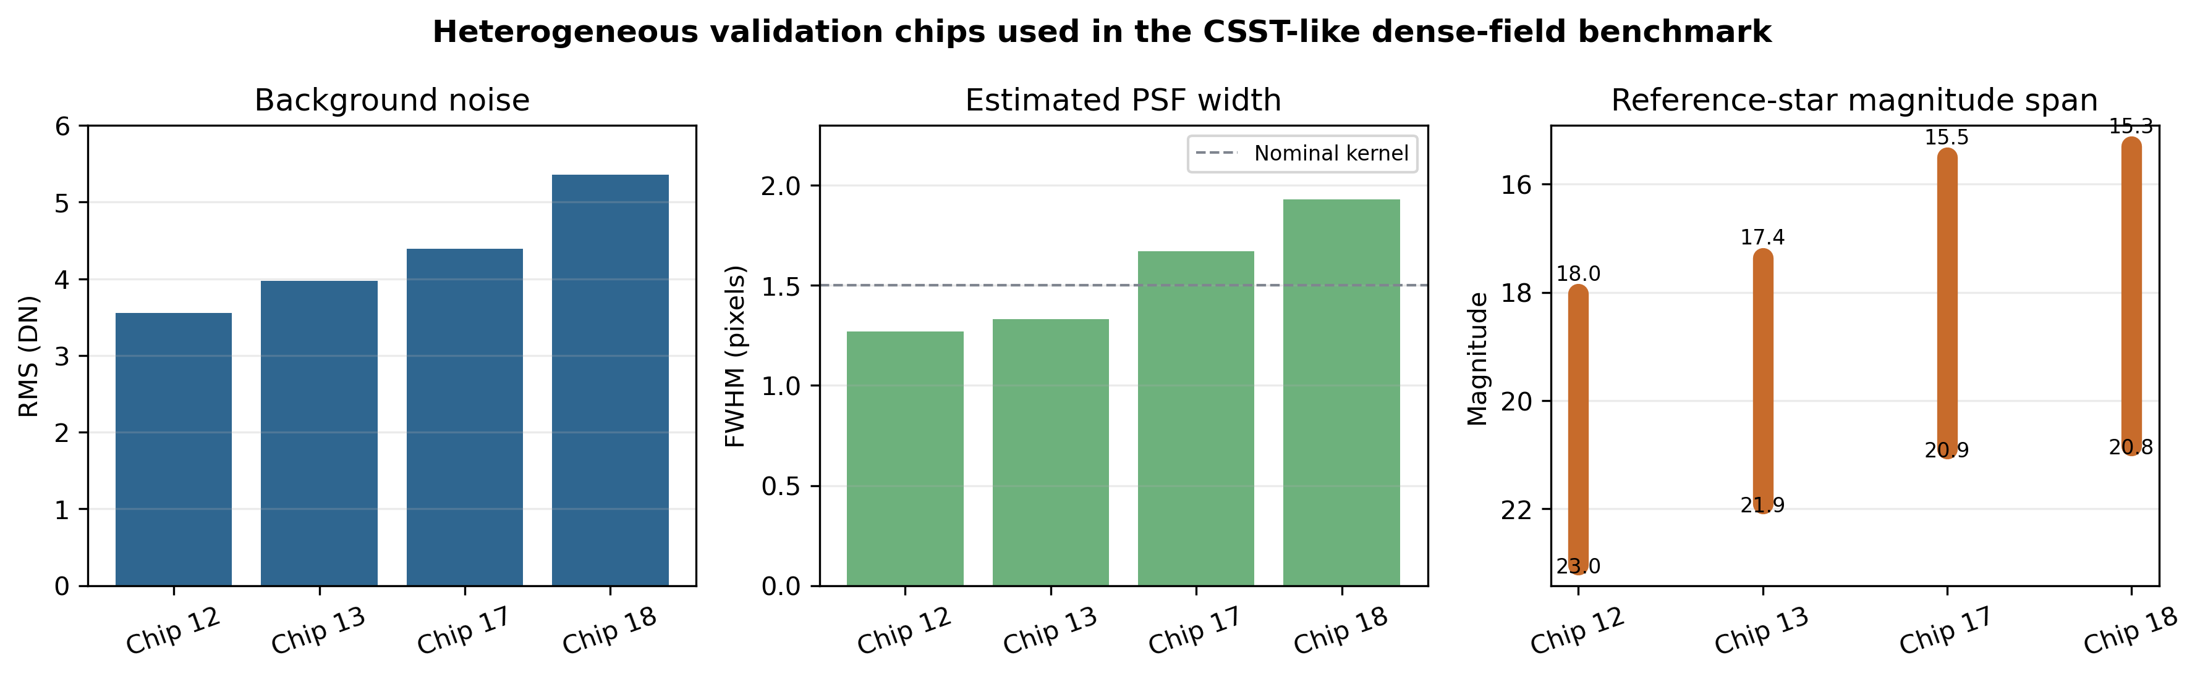
Fig. S6. Heterogeneous chip statistics used to motivate per-chip adaptation.
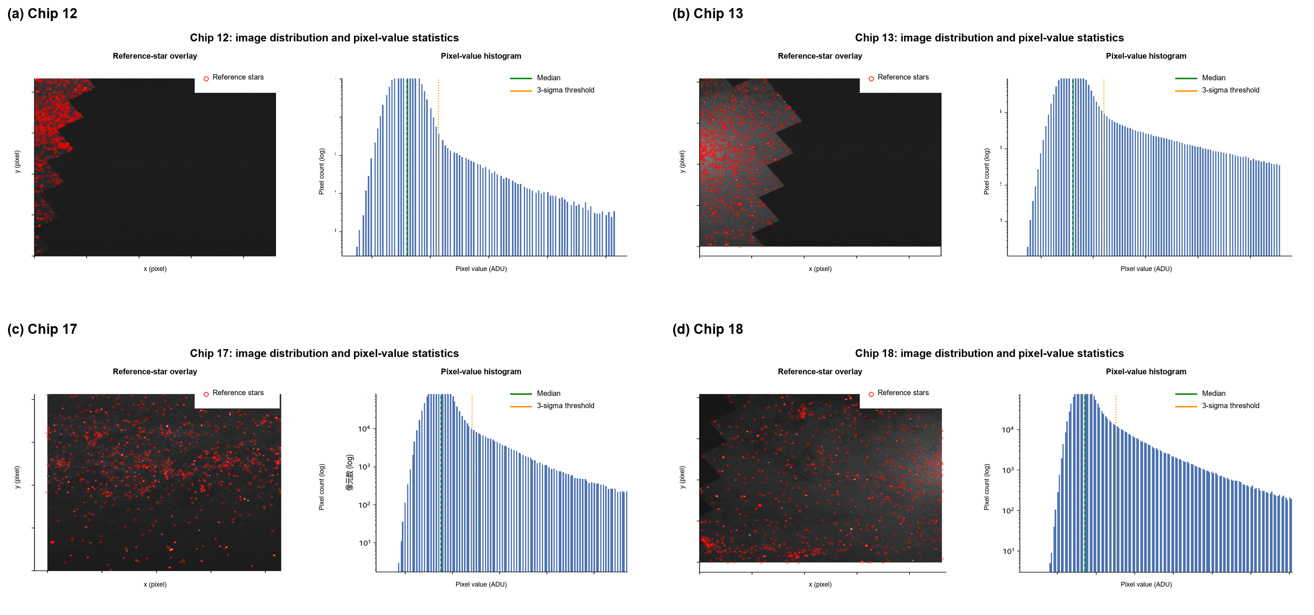
Fig. S7. Chip image distribution and pixel-value statistics for the four validation chips (English relabeling of source report Fig. 1).
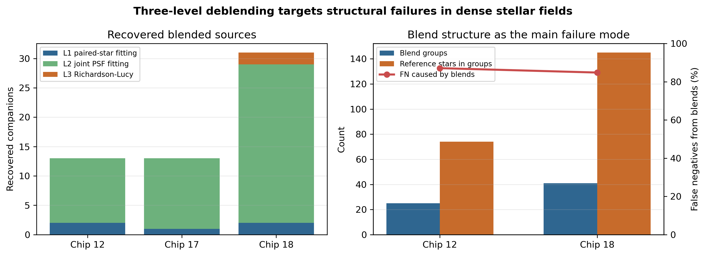
Fig. S8. Three-level deblending recovery and blend-dominated false-negative structure.
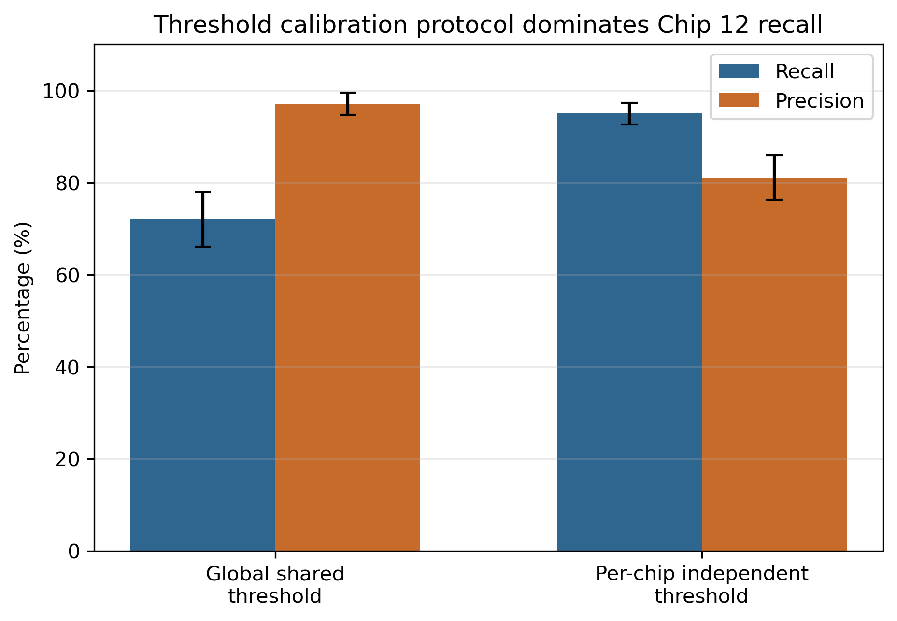
Fig. S9. Effect of threshold calibration protocol on RandomForest performance for chip 12.
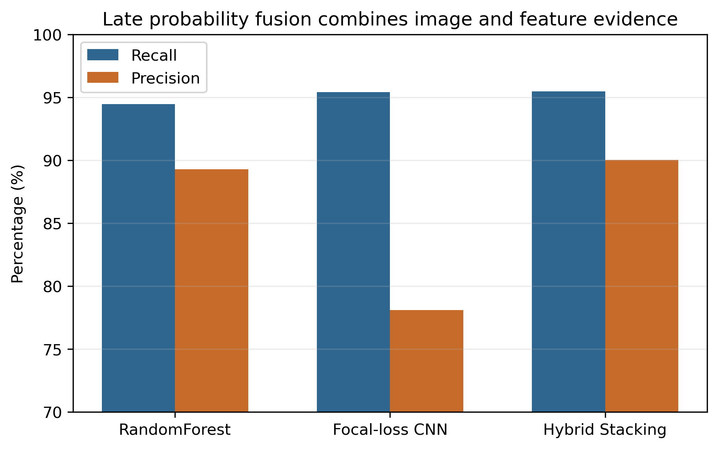
Fig. S10. Probability-level fusion of handcrafted and image-based classifiers.
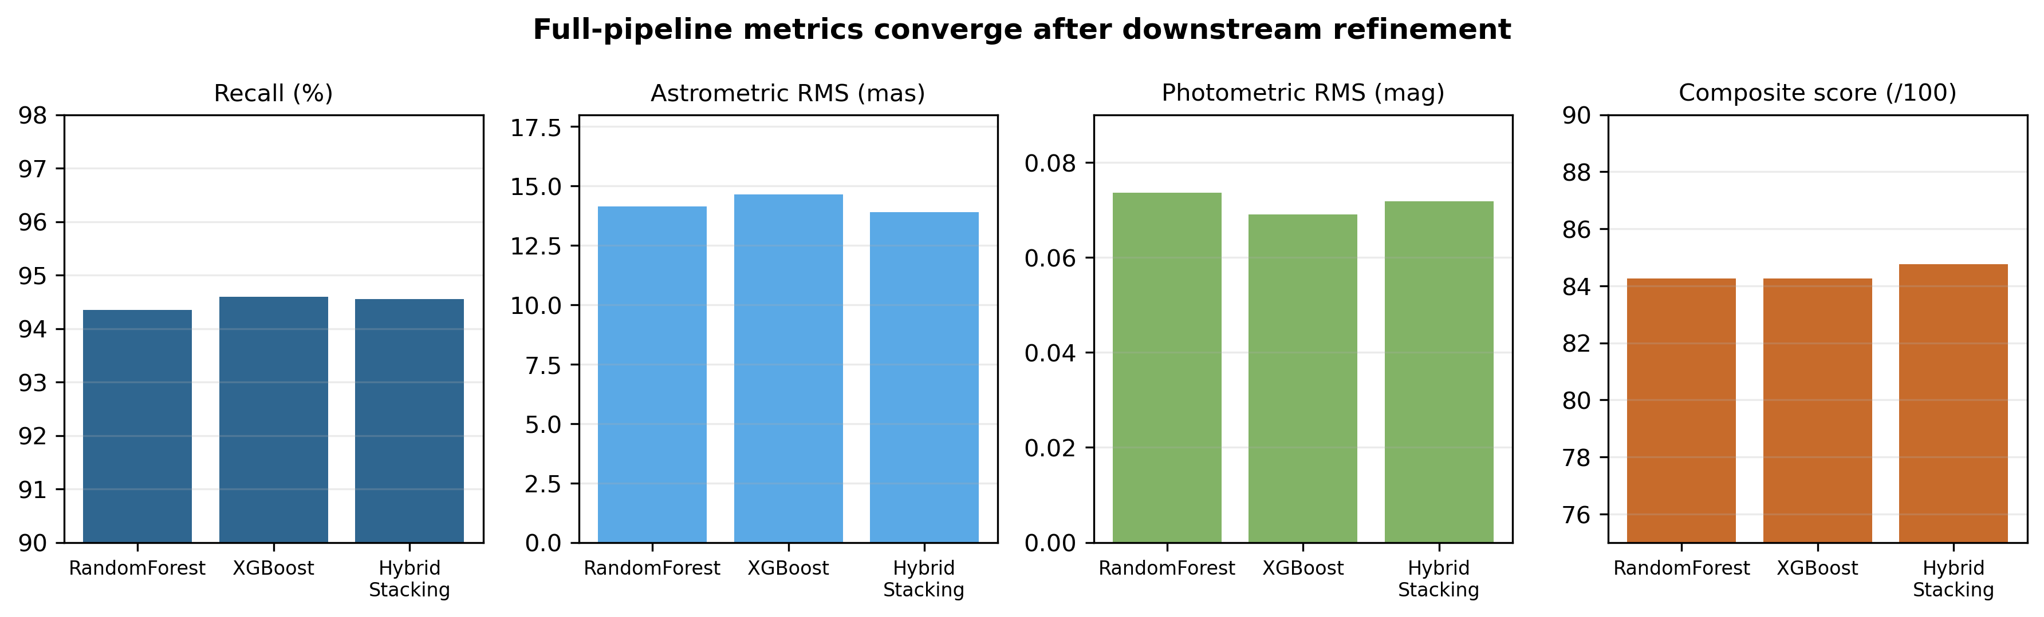
Fig. S11. Average full-pipeline metrics for classifier integration.
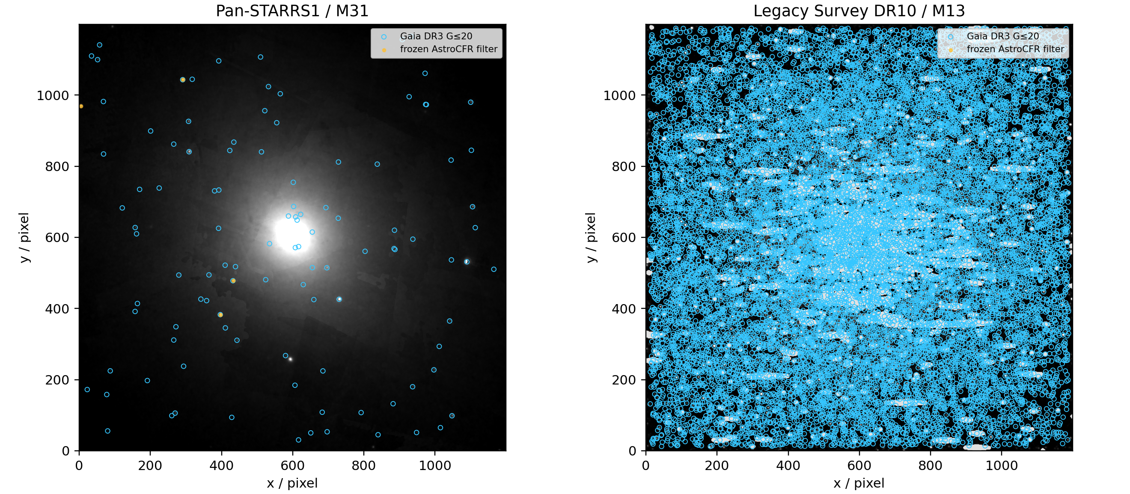
Fig. S12. External real-data domains used for zero-shot evaluation. Cyan circles are Gaia DR3 G <= 20 references and yellow points are candidates retained by the frozen simulation-trained AstroCFR filter.
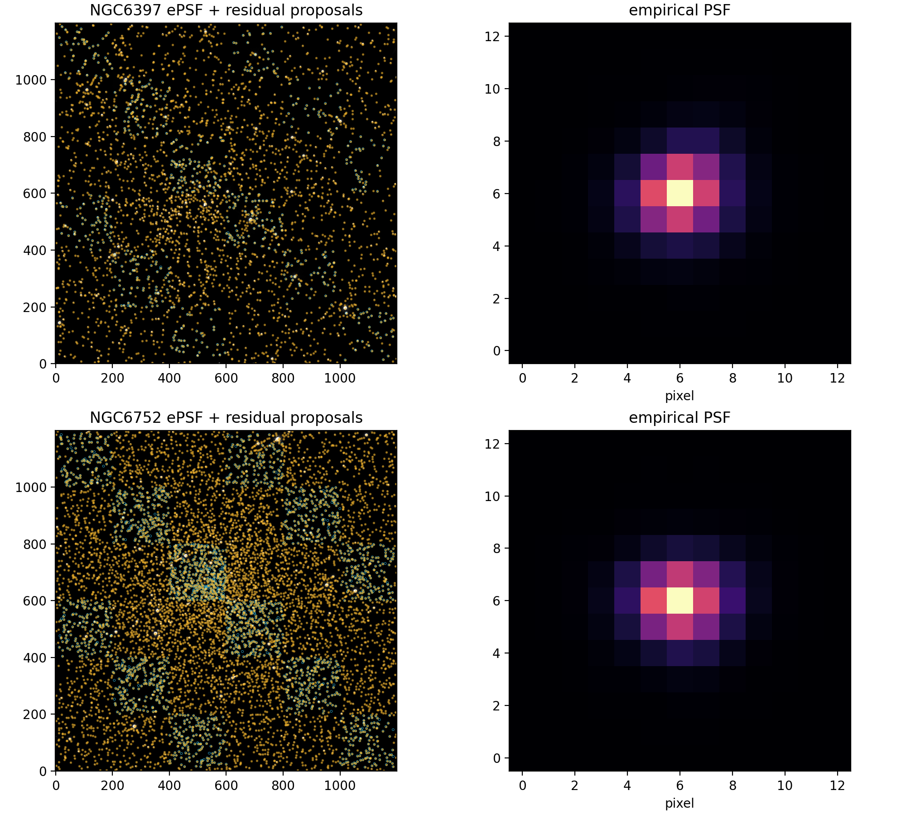
Fig. S13. ePSF/residual proposal maps and empirical PSFs for the two HST/ACS crowded-field crops.
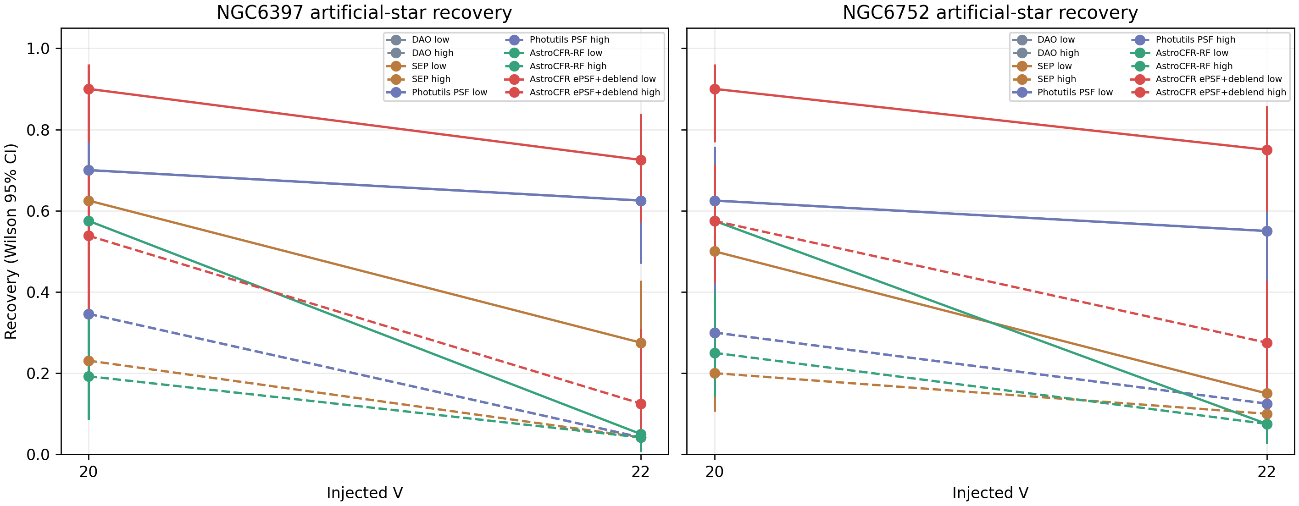
Fig. S14. Fixed-scene artificial-star proposal recovery with Wilson 95% intervals. Every method receives the same injected scenes. The repeated DAO and Photutils curves reflect their shared DAOStarFinder proposal frontend, not an independent detector tie.

S8 Common-protocol stratification and blind-quality release
The completed high-density audit reruns DAOStarFinder, SEP/SExtractor-style extraction, Photutils PSFPhotometry, AstroCFR ePSF-deblend, and AstroCFR spatial-ePSF joint fitting on the same 1200 x 1200 crops for 11 ACSGGCT fields. A separate controlled-crop CSST audit runs the same five branches on chips 12, 13, 17, and 18; its 20 method-chip rows are reported in Table S27 and are not pooled with the registered full-frame CSST integration audit. Global empirical-ePSF and three-Gaussian dPSF are diagnostic HST PSF-representation controls: they share the image, candidate front end, spatial hold-out, and neighbour-fitting harness, but their archived output uses the dense held-out reference denominator rather than the full baseline metric set. They are consequently reported with their own denominator and are not pooled with the Table 8 medians. Recovery uses a two-pixel one-to-one association and the baseline high-density subset contains V<=20 references with at least three neighbours within 10 pixels.
Partition-isolated ePSF sensitivity audit. The full-image candidate list was held fixed, but only image-only DAO proposals in spatial cells 0/1 supplied global and quadrant ePSF stamps; partition 2 remained the held-out scoring region. Across the 11 ACSGGCT fields, the dense-recovery delta relative to the primary transductive branch had median -0.13 percentage points (range -2.33 to +0.45 pp), position-RMS delta median +0.09 mas (range -0.05 to +0.34 mas), and magnitude-RMS delta median +0.0033 mag (range -0.0014 to +0.0087 mag). The 11/11 spatial-ePSF-versus-Photutils dense-recovery ordering was unchanged. This is a PSF-construction robustness check, not an additional leaderboard; complete field-level deltas are in results/partition_isolated_spatial_epsf_sensitivity_all11/summary.json and comparison.csv.
Threshold and association robustness audit (NGC 6752). The image-only DAO proposal threshold was varied from 2.5 to 4.0 sigma without using partition 2 for selection. Quality-reference recovery changed from 77.13% to 74.99%, and the catalogue-match lower bound from 93.68% to 94.62%. With all produced catalogues held fixed, changing only the one-to-one association radius from 1 to 3 pixels retained the spatial-ePSF ordering over Photutils (93.19–93.45% versus 76.17–76.25% all-quality recovery). The audit verifies that the result is not a two-pixel matching artefact; it does not replace the fixed, preregistered two-pixel metric in the primary table. Machine-readable output: results/hst_parameter_sensitivity/parameter_sensitivity_audit.json.
Runtime and magnitude-stratified summary. On the common 1,200 x 1,200 CPU crops, field-median costs are 0.11, 6.37, 7.78, 24.85, and 45.65 s MPix⁻¹ for DAOStarFinder, SEP, Photutils, ePSF-deblend, and spatial-ePSF joint fitting, respectively. The spatial branch is 5.9x the Photutils cost in this implementation. Its field-median cumulative recovery is 97.1%, 88.0%, and 62.4% at V<=18, 20, and 22, respectively, versus 79.6%, 47.3%, and 22.3% for Photutils. These are crop-level CPU measurements; no full-detector or GPU throughput claim is made.
DOLPHOT gate interpretation. NGC 1851 was selected prospectively from the prespecified 11-field ACSGGCT sample because six native F606W FLC exposures were available. The retry was stopped by a declared registration gate requiring stable sub-pixel inter-exposure residuals for the common 2-pixel association and milliarcsecond-scale held-out scoring. The observed 0.698-pixel and 1.805-pixel warnings do not imply that DOLPHOT is generally unusable, nor do they justify a universal comparison claim; they show that this particular FLC set did not produce an input-registered catalogue suitable for the present protocol. The failed run is therefore retained as an audit boundary, not a DOLPHOT performance measurement.
 | $$D = \{i : Vᵢ ≤ 20, n₁₀(i) ≥ 3\}; R_dense = N_dense⁻¹∑ᵢ∈D 𝟙[minⱼ||x̂ⱼ−xᵢ||₂≤2 px]$$ | (S1)
 | $$ΔR = R_dense(spatial-ePSF) − R_dense(Photutils)$$ | (S2)
For operational use, the spatial-ePSF catalogue exports only image/candidate-derived metadata: SNR, local residual improvement, neighbour count within 10 pixels, residual-deblend status, bright-core proximity, available classifier probability, local PSF-fit quality, and a uint16 quality bitmask. Bit 1 denotes SNR < 5; bit 2, local PSF residual > 3 RMS units; bit 4, at least three neighbours; bit 8, bright-core proximity; bit 16, residual deblending; and bit 32, a classifier probability in (0.2, 0.8). Local PSF-fit quality is a screening diagnostic, not an absolute goodness-of-fit in unresolved blends.
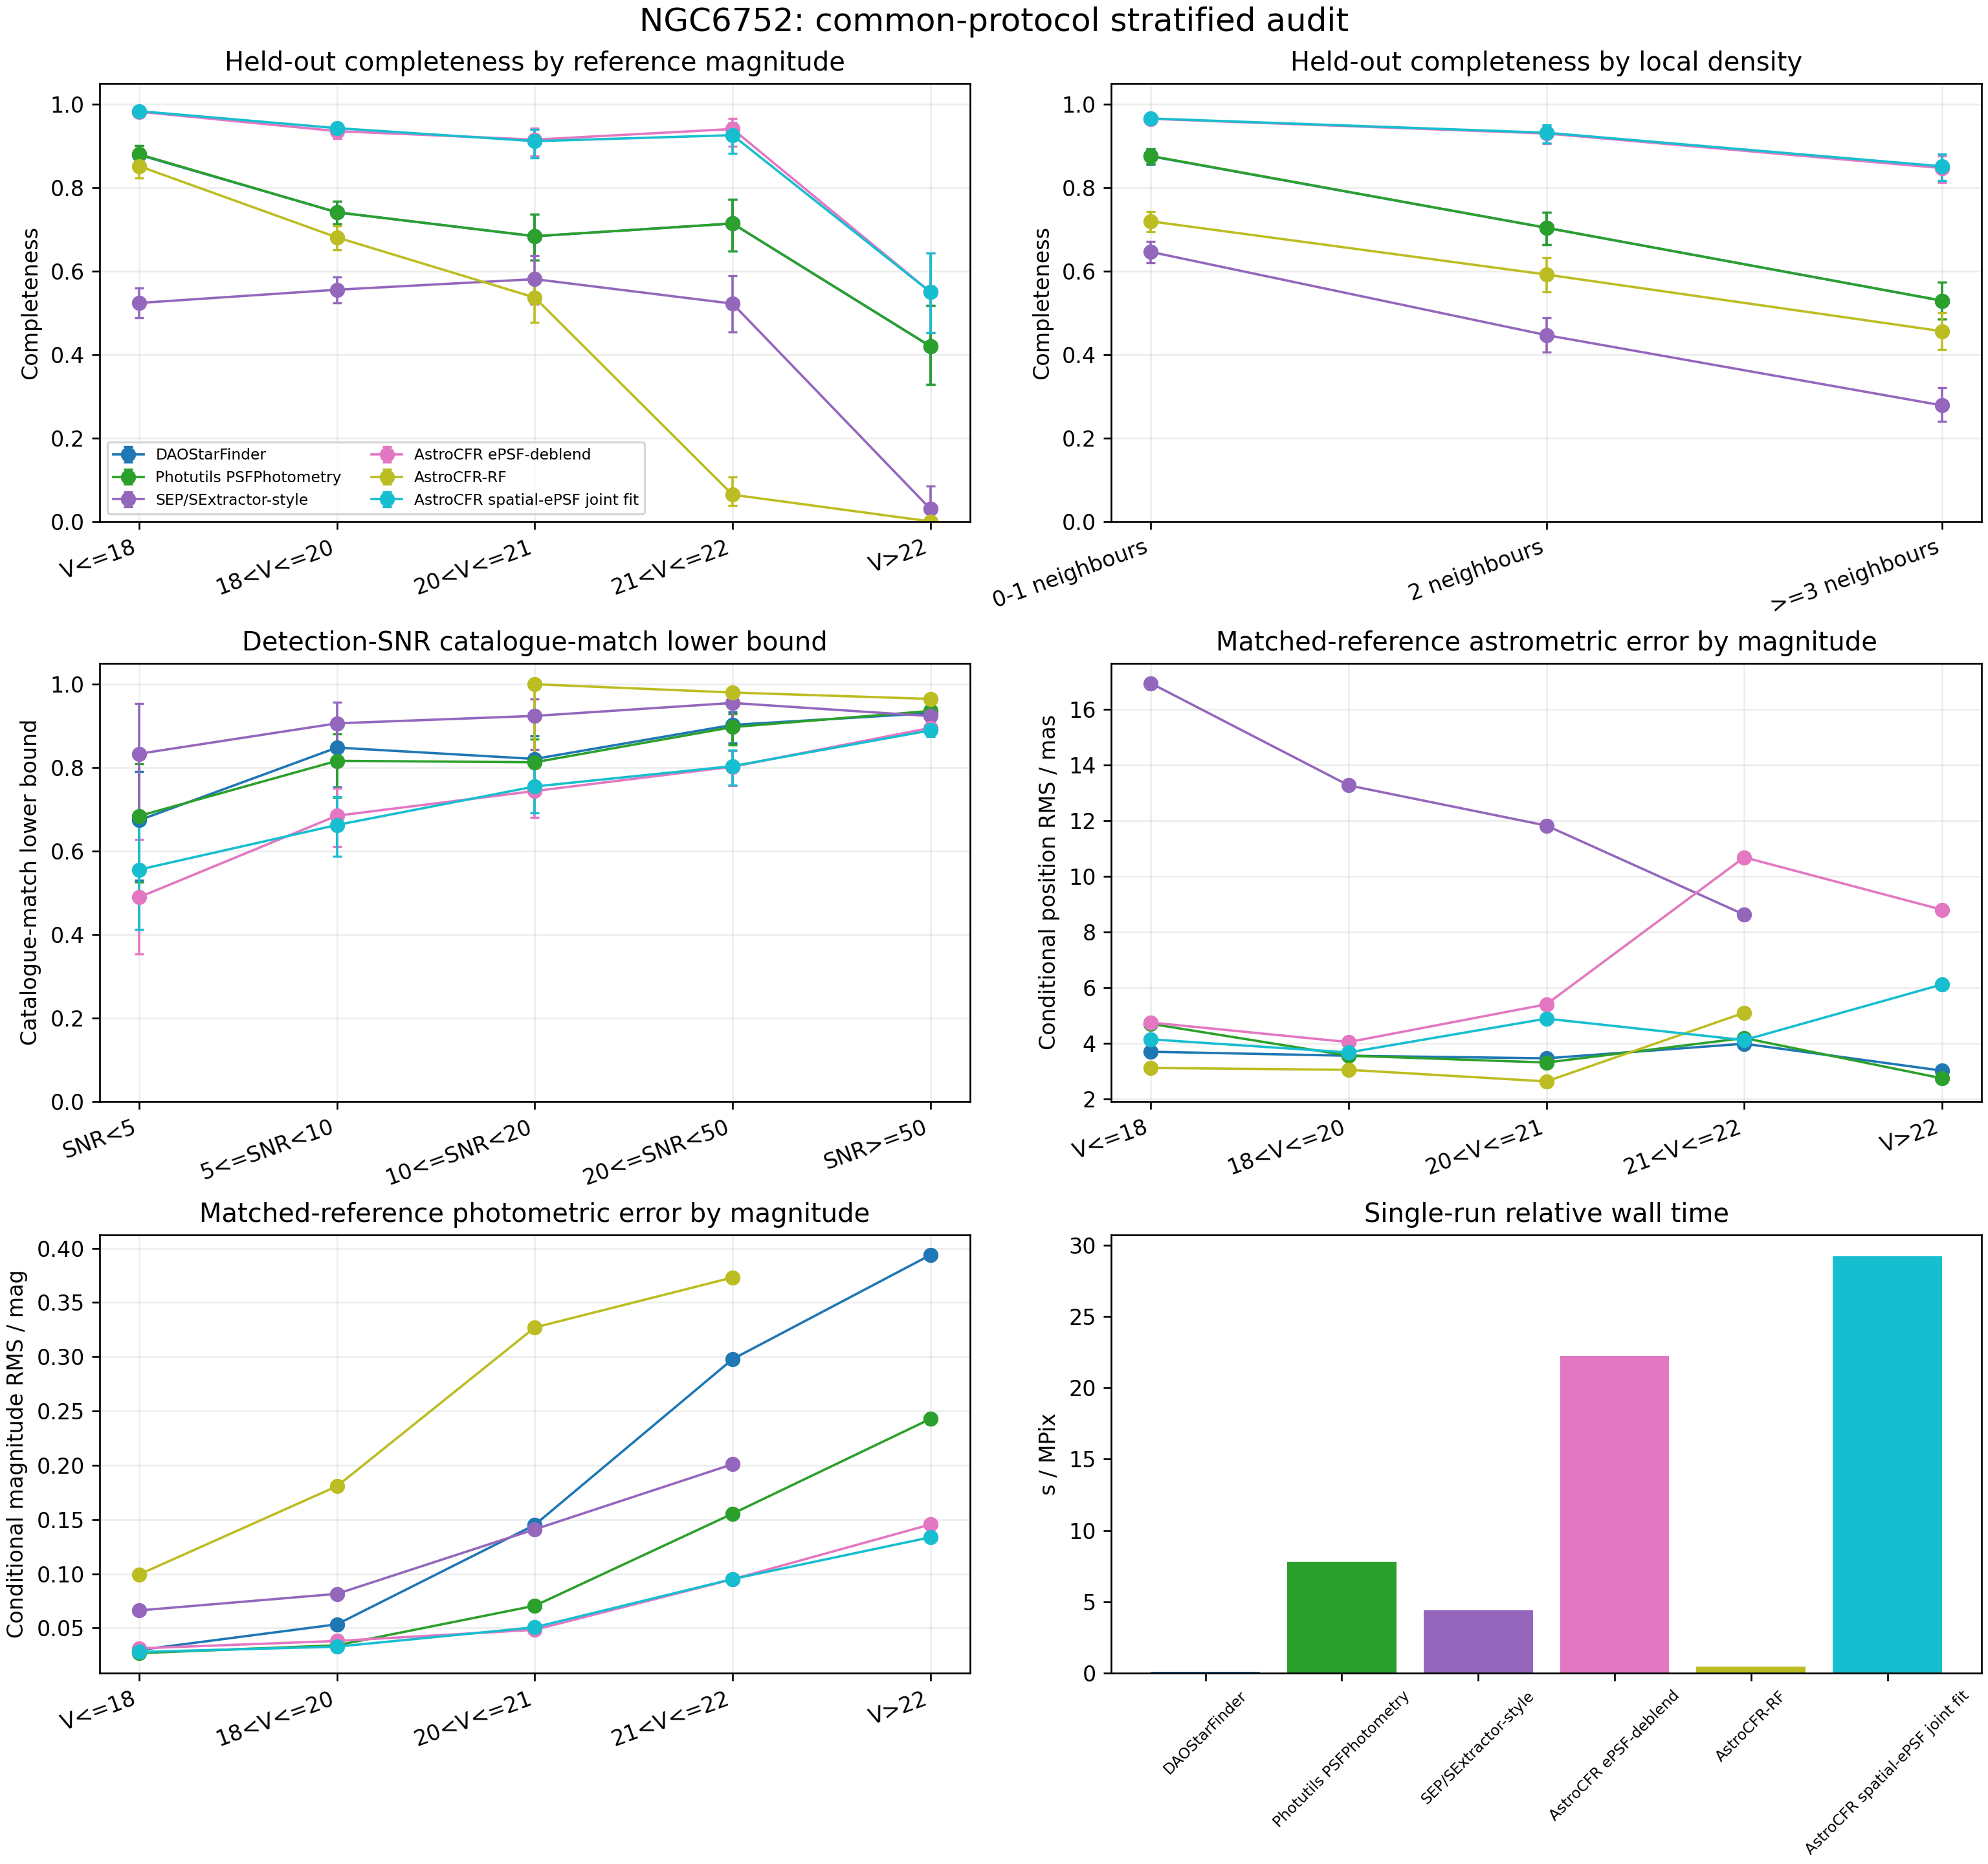
Fig. S15. NGC6752 common-protocol stratification. Recovery curves use held-out quality references; position and magnitude RMS are conditional on matched held-out references; the SNR panel is a catalogue-match lower bound rather than blind purity.
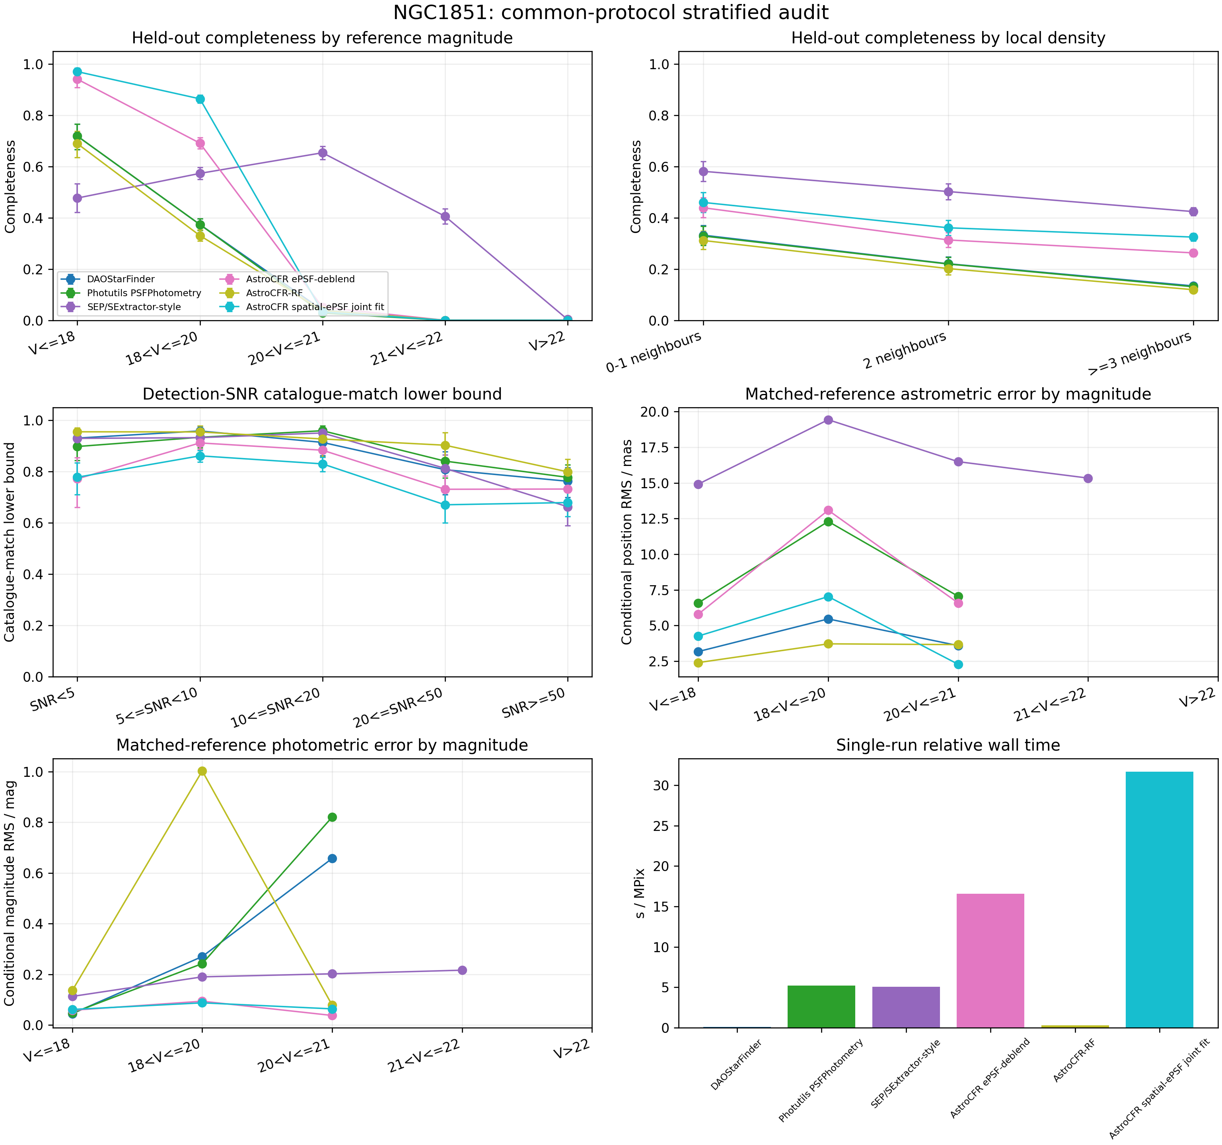
Fig. S16. NGC1851 common-protocol stratification. Recovery curves use held-out quality references; position and magnitude RMS are conditional on matched held-out references; the SNR panel is a catalogue-match lower bound rather than blind purity.

S9 Closed-book proposal pilot and multi-exposure readiness audit
For the closed-book CSST-like pilot, the test-chip candidate ECSV was written before opening that chip's supplied top-1000 catalogue. Candidate generation used an image-only proposal branch; no injected position was provided to detection or recovery. Processing was restricted to a fixed central 3000 x 3000-pixel crop to control memory. These controls remove direct test-truth leakage from proposal generation, but the top-1000 catalogue is not known to be exhaustive, so catalogue-match fraction is not blind purity.
Aggregated over the available chips, recovery is 102/160 at peak SNR 10 and 143/160 at peak SNR 30 in low-density positions; the corresponding high-density counts are 22/120 and 91/120. The different denominators arise because chip 12 did not contain valid high-density injection locations in the fixed crop. The pilot therefore establishes the expected density- and SNR-dependent proposal failure, but its scale and image-only frontend do not support a full AstroCFR efficacy, purity, or survey-throughput claim.
Table S20. Closed-book image-only proposal recovery. Wilson 95% intervals quantify binomial recovery only; injected positions were withheld from processing.
Density | Peak SNR | Injected | Recovered | Recovery | Wilson 95% CI
Low | 10 | 160 | 102 | 0.638 | [0.561, 0.708]
Low | 30 | 160 | 143 | 0.894 | [0.836, 0.933]
High | 10 | 120 | 22 | 0.183 | [0.124, 0.262]
High | 30 | 120 | 91 | 0.758 | [0.674, 0.826]
A stricter leave-one-chip-out RF screen was also attempted on the cropped data, but retention was unstable and collapsed to zero on some withheld-chip settings. It is recorded as a negative control in the machine-readable audit and is not used as evidence of cross-chip generalisation.
For the multi-exposure readiness audit, four homogeneous deep ACS/WFC F606W FLC exposures of NGC 6752 were selected. WCS-derived detector-shift initialisation recovered thousands of alignment candidates, but the best tested transformation retained 0.817-pixel inter-exposure scatter, which failed the predeclared sub-pixel gate. Processing was stopped and no NGC 1851 comparison was launched under the unresolved condition. These values diagnose dataset/registration readiness only; they are not DOLPHOT photometric or astrometric performance measurements.
Accordingly, no failed DOLPHOT output is included in the comparative tables. A valid experiment must first pass registration and PSF-star acceptance, then run identical FLC lists, spatial test regions, and artificial-star scenes for the physical backend with and without AstroCFR candidate/group priors.

S10 Independent Anderson-PSF injection validation
The earlier NGC 6752 artificial-star experiment is a controlled, method-identical scene test, but its artificial sources are generated from an image-derived empirical PSF belonging to the same modelling family as AstroCFR's recovery ePSF. To test whether this model match accounts for the recovery gain, we used the official Anderson ACS/WFC F475W standard PSF file (9 x 10 detector grid, 101 x 101 samples per PSF, four-times oversampled; 3,677,760 bytes; SHA-256 9B3A98844020581FFDF1EEEBB5D4488F03011BC4563C578D19042A76A81B5C82). The injector does not use AstroCFR's recovered PSF.
For each PHAT DRZ output-pixel centre, celestial WCS maps the pixel and requested star location back to each of three registered F475W FLC exposures (jbex18u6q, jbex18u9q, and jbex18ucq). The corresponding spatial Anderson PSF is evaluated in the appropriate ACS chip coordinates; the three exposure contributions are averaged, convolved with a fixed 0.55-pixel Gaussian output kernel chosen before the final run to match the 2.2-pixel DRZ core, and normalized in a 25 x 25 DRZ stamp. A registered geometry audit required unit flux, no negative/non-finite values, and less than 0.20-pixel radial centroid offset. All four extension-density test positions passed; the maximum offset was 0.150 pixel. This calculation represents local geometry and dithering but not the full AstroDrizzle kernel or correlated-noise process.
The deterministic input contains 25 positions per logical extension x density x magnitude stratum (200 attempts). Every position is injected and processed separately. Within an injection model, the paired denominator is the intersection of positions for which DAO, SEP, Photutils, and AstroCFR all have no pre-existing detection within 2 pixels; 174 positions meet this criterion. Recovery is a new detection within 2 pixels. Individual intervals are Wilson 95% intervals. Recovery-difference intervals are paired 20,000-replicate bootstraps with seed 20260812, and p values are exact two-sided McNemar tests.
Table S21. Strict single-star recovery under independent official Anderson F475W PSF injection. RMS is the radial distance to the nearest recovered detection, not a calibrated multi-exposure astrometric residual. Times are medians per local baseline-plus-injected trial.
Density | F475W | Method | Recovered | Recovery / % [95% CI] | Nearest RMS / px | Time / s
low | 24.5 | DAO | 48/48 | 100.0 [92.6, 100.0] | 0.080 | 0.019
low | 24.5 | SEP | 48/48 | 100.0 [92.6, 100.0] | 0.205 | 0.007
low | 24.5 | Photutils | 48/48 | 100.0 [92.6, 100.0] | 0.068 | 0.288
low | 24.5 | AstroCFR ePSF | 48/48 | 100.0 [92.6, 100.0] | 0.080 | 0.317
low | 26.5 | DAO | 28/41 | 68.3 [53.0, 80.4] | 0.459 | 0.019
low | 26.5 | SEP | 23/41 | 56.1 [41.0, 70.1] | 0.844 | 0.007
low | 26.5 | Photutils | 28/41 | 68.3 [53.0, 80.4] | 0.437 | 0.291
low | 26.5 | AstroCFR ePSF | 39/41 | 95.1 [83.9, 98.7] | 0.407 | 0.327
high | 24.5 | DAO | 39/43 | 90.7 [78.4, 96.3] | 0.085 | 0.019
high | 24.5 | SEP | 43/43 | 100.0 [91.8, 100.0] | 0.483 | 0.007
high | 24.5 | Photutils | 40/43 | 93.0 [81.4, 97.6] | 0.299 | 0.310
high | 24.5 | AstroCFR ePSF | 43/43 | 100.0 [91.8, 100.0] | 0.147 | 0.331
high | 26.5 | DAO | 23/42 | 54.8 [39.9, 68.8] | 0.270 | 0.019
high | 26.5 | SEP | 25/42 | 59.5 [44.5, 73.0] | 0.876 | 0.007
high | 26.5 | Photutils | 24/42 | 57.1 [42.2, 70.9] | 0.323 | 0.309
high | 26.5 | AstroCFR ePSF | 35/42 | 83.3 [69.4, 91.7] | 0.341 | 0.335
For F475W=26.5, AstroCFR exceeds DAO/Photutils by 26.8 percentage points in the low-density stratum (paired-bootstrap 95% CI 14.6-41.5; 11 AstroCFR-only recoveries, 0 baseline-only; exact McNemar p=0.00098) and by 26.2 points in the high-density stratum (14.3-40.5; 11 versus 0; p=0.0010). Relative to the empirical-PSF injection on the same 174 positions, AstroCFR recovery changes by +4.9 points at low density and 0.0 points at high density; neither injection-model difference is significant by exact McNemar testing (p=0.50 and 1.00).
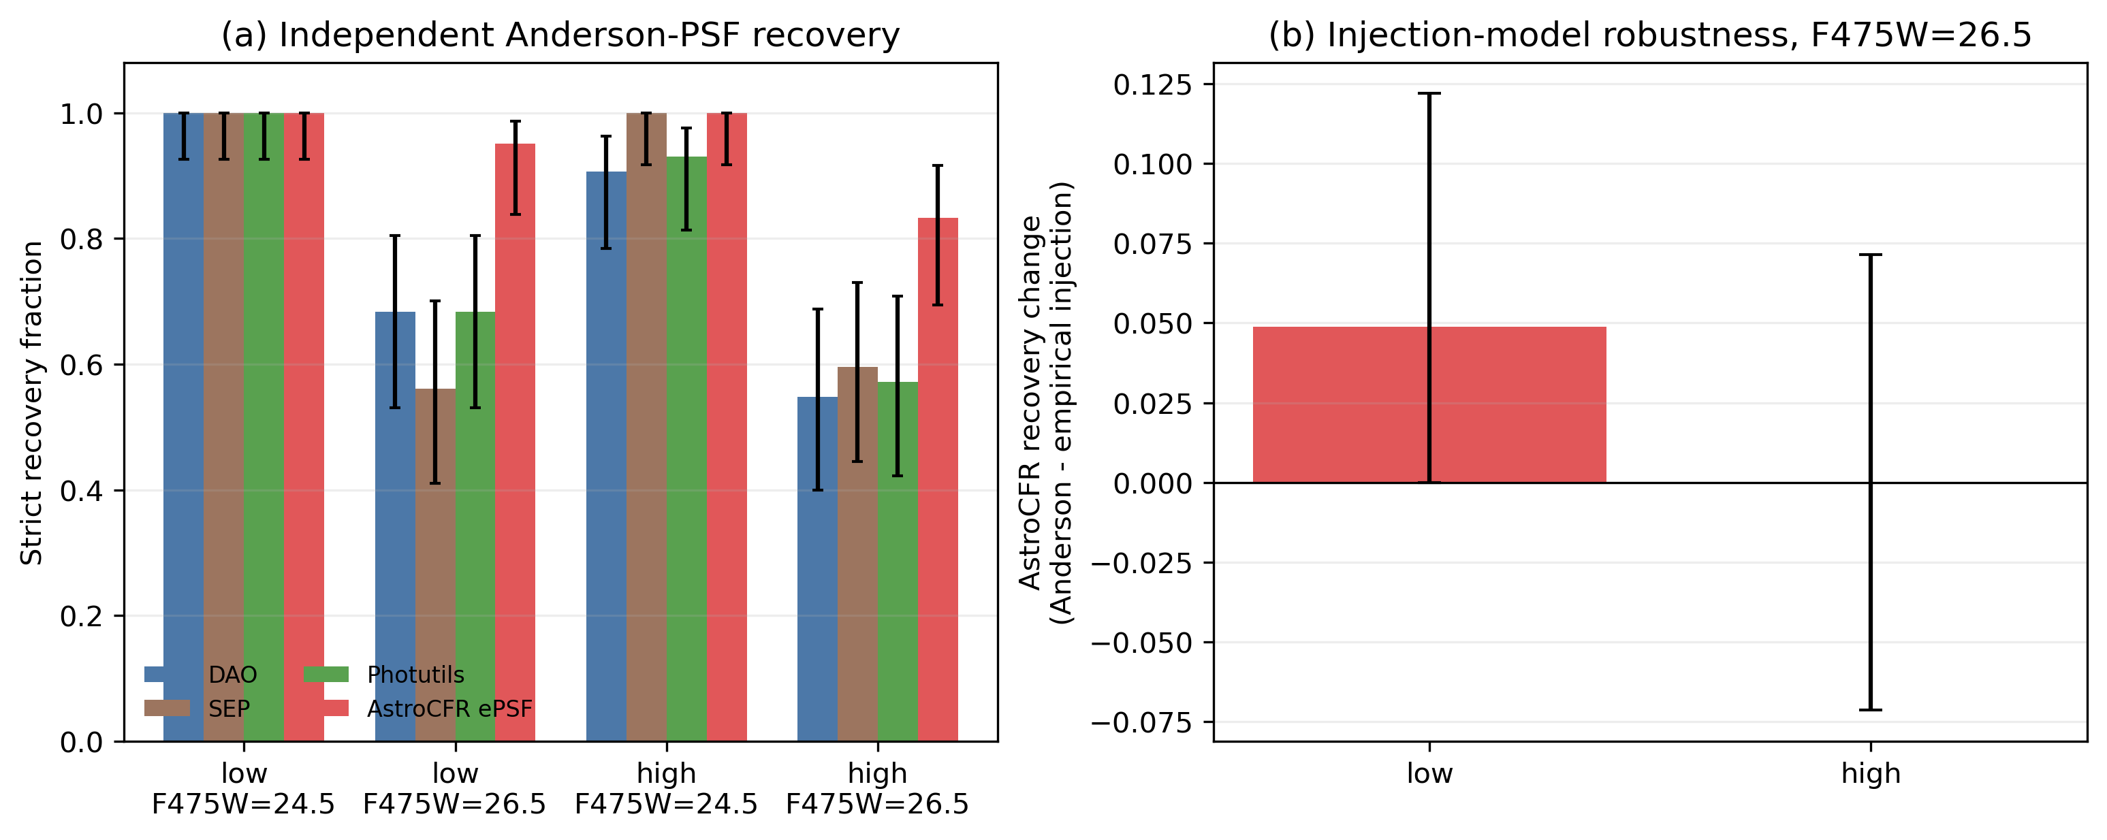
Fig. S17. Independent Anderson-PSF validation. (a) Strict paired recovery with Wilson 95% intervals. (b) AstroCFR's F475W=26.5 recovery change when the injector is changed from the image-derived empirical PSF to the official Anderson library; error bars are paired-bootstrap 95% intervals.
Interpretation boundary. This experiment removes exact reuse of AstroCFR's image-derived ePSF as the artificial-star generator, but it remains a single-stack candidate-recovery experiment. It does not establish blind catalogue purity, a pixel-identical comparison with DOLPHOT native FakeStars, a complete AstroDrizzle simulation, or superior final astrometry/photometry. DOLPHOT's three-FLC FakeStars measurements remain a separate physical-backend image domain and are not pooled into this leaderboard.

S11 Completed 15-field high-density evidence inventory and reproducibility package
The completed evidence inventory contains four CSST-like full-frame simulations and 11 public ACSGGCT HST/ACS F606W fields. The HST tier comprises NGC 2808, 5286, 6388, 6441, 0104, 0362, 6093, 6624, 6397, 6752, and 1851. The reproducibility package contains the unified baseline JSON, literature-control JSON, 15-field all-method matrix, pairwise spatial-ePSF versus Photutils table, and availability registry. HST and CSST values are never combined into one numerical average.
Table S22. Completed 15-field evidence inventory. The HST tier is the primary common single-F606W, held-out spatial-partition evaluation. The CSST tier is a separate registered simulation-to-reality reference comprising the full-frame supplied-catalogue audit and the controlled-crop five-branch feasibility audit. Input-incompatible pipelines, protocol-excluded HST RF, and partial hybrid coverage are recorded in the machine-readable availability registry rather than assigned numerical scores.
Evidence tier | Unit | Scene | Status in this manuscript
CSST-like full-frame simulation | Chip 12 | supplied-catalogue dense chip | registered AstroCFR ePSF-deblend and SExtractor audit
CSST-like full-frame simulation | Chip 13 | supplied-catalogue dense chip | registered AstroCFR ePSF-deblend and SExtractor audit
CSST-like full-frame simulation | Chip 17 | supplied-catalogue dense chip | registered AstroCFR ePSF-deblend and SExtractor audit
CSST-like full-frame simulation | Chip 18 | supplied-catalogue dense chip | registered AstroCFR ePSF-deblend and SExtractor audit
HST/ACS single-F606W controlled | NGC 2808 | ACSGGCT globular cluster | five common image-only branches plus two literature-mapped PSF controls
HST/ACS single-F606W controlled | NGC 5286 | ACSGGCT globular cluster | five common image-only branches plus two literature-mapped PSF controls
HST/ACS single-F606W controlled | NGC 6388 | ACSGGCT globular cluster | five common image-only branches plus two literature-mapped PSF controls
HST/ACS single-F606W controlled | NGC 6441 | ACSGGCT globular cluster | five common image-only branches plus two literature-mapped PSF controls
HST/ACS single-F606W controlled | NGC 0104 | ACSGGCT globular cluster | five common image-only branches plus two literature-mapped PSF controls
HST/ACS single-F606W controlled | NGC 0362 | ACSGGCT globular cluster | five common image-only branches plus two literature-mapped PSF controls
HST/ACS single-F606W controlled | NGC 6093 | ACSGGCT globular cluster | five common image-only branches plus two literature-mapped PSF controls
HST/ACS single-F606W controlled | NGC 6624 | ACSGGCT globular cluster | five common image-only branches plus two literature-mapped PSF controls
HST/ACS single-F606W controlled | NGC 6397 | ACSGGCT globular cluster | five common image-only branches plus two literature-mapped PSF controls
HST/ACS single-F606W controlled | NGC 6752 | ACSGGCT globular cluster | five common image-only branches plus two literature-mapped PSF controls
HST/ACS single-F606W controlled | NGC 1851 | ACSGGCT globular cluster | five common image-only branches plus two literature-mapped PSF controls
Table S23. Archived non-ACSGGCT public-field inventory. These fields are retained for provenance but are not included in the primary 11-field high-density ACSGGCT median.
Slot | Field | Observed scene | FLCs | Catalogues | Status
1 | m31_b21_f15 | M31 outer-disk crowded field | 5 | 1 | Admitted
4 | m33_b01_f01 | M33 central/inner-disk crowded field | 2 | 1 | Admitted
5 | m33_b03_f02 | M33 disk crowded field | 2 | 1 | Admitted
6 | ngc2070_1 | LMC dense star-forming disk | 5 | 1 | Admitted
7 | ngc2070_2 | LMC dense star-forming disk | 5 | 1 | Admitted
8 | m81_deep | massive spiral-galaxy resolved stellar field | 8 | 1 | Admitted
9 | ngc2976_deep | dwarf-disk resolved stellar field | 8 | 1 | Admitted
10 | gr8 | dwarf-irregular resolved stellar field | 8 | 1 | Admitted
Table S24. Archived non-ACSGGCT comparison results. They use distinct filters and external catalogues and are not pooled with the primary ACSGGCT result.
Field | Method | Catalogue recovery | Pos. RMS / mas | Magnitude RMS | s/MPix
M31 B21-F15 | DAOStarFinder | 66.85% | 5.62 | 0.178 | 0.11
M31 B21-F15 | SEP/SExtractor-style | 51.54% | 9.99 | 0.279 | 1.09
M31 B21-F15 | Photutils PSFPhotometry | 66.85% | 4.32 | 0.070 | 17.72
M31 B21-F15 | AstroCFR ePSF + residual deblend | 75.25% | 4.44 | 0.097 | 60.39
M31 B21-F15 | AstroCFR+Photutils hybrid | 73.09% | 4.53 | 0.075 | 83.05
M33 B01-F01 | DAOStarFinder | 70.10% | 8.20 | 0.202 | 0.20
M33 B01-F01 | SEP/SExtractor-style | 39.90% | 11.26 | 0.303 | 1.12
M33 B01-F01 | Photutils PSFPhotometry | 69.97% | 5.94 | 0.117 | 33.50
M33 B01-F01 | AstroCFR ePSF + residual deblend | 77.06% | 6.81 | 0.131 | 125.00
M33 B01-F01 | AstroCFR+Photutils hybrid | 76.34% | 6.38 | 0.125 | 159.77
M33 B03-F02 | DAOStarFinder | 36.13% | 10.20 | 0.289 | 0.19
M33 B03-F02 | SEP/SExtractor-style | 17.04% | 20.53 | 0.396 | 1.48
M33 B03-F02 | Photutils PSFPhotometry | 36.05% | 6.87 | 0.132 | 42.07
M33 B03-F02 | AstroCFR ePSF + residual deblend | 40.02% | 7.77 | 0.193 | 139.98
M33 B03-F02 | AstroCFR+Photutils hybrid | 39.14% | 7.10 | 0.140 | 184.20
NGC 2070-1 | DAOStarFinder | 17.93% | 51.54 | 2.068 | 0.16
NGC 2070-1 | SEP/SExtractor-style | 7.36% | 55.69 | 1.757 | 0.58
NGC 2070-1 | Photutils PSFPhotometry | 17.70% | 51.79 | 2.057 | 33.82
NGC 2070-1 | AstroCFR ePSF + residual deblend | 19.31% | 51.64 | 2.163 | 124.20
NGC 2070-1 | AstroCFR+Photutils hybrid | 19.77% | 52.11 | 2.069 | 149.38
NGC 2070-2 | DAOStarFinder | 16.07% | 46.95 | 1.861 | 0.15
NGC 2070-2 | SEP/SExtractor-style | 6.39% | 45.83 | 1.374 | 0.67
NGC 2070-2 | Photutils PSFPhotometry | 16.56% | 46.80 | 1.776 | 35.43
NGC 2070-2 | AstroCFR ePSF + residual deblend | 17.21% | 47.90 | 1.855 | 121.19
NGC 2070-2 | AstroCFR+Photutils hybrid | 17.38% | 48.27 | 1.691 | 161.39
M81-DEEP | DAOStarFinder | 61.05% | 12.45 | 0.326 | 0.13
M81-DEEP | SEP/SExtractor-style | 21.69% | 8.93 | 0.316 | 0.19
M81-DEEP | Photutils PSFPhotometry | 52.55% | 7.91 | 0.165 | 16.14
M81-DEEP | AstroCFR ePSF + residual deblend | 64.44% | 9.93 | 0.212 | 53.40
M81-DEEP | AstroCFR+Photutils hybrid | 59.96% | 8.73 | 0.177 | 71.28
NGC 2976 | DAOStarFinder | 74.65% | 10.72 | 0.242 | 0.13
NGC 2976 | SEP/SExtractor-style | 29.32% | 10.16 | 0.346 | 0.24
NGC 2976 | Photutils PSFPhotometry | 70.24% | 7.20 | 0.127 | 16.24
NGC 2976 | AstroCFR ePSF + residual deblend | 82.22% | 8.75 | 0.189 | 57.06
NGC 2976 | AstroCFR+Photutils hybrid | 78.18% | 7.51 | 0.138 | 75.80
Table S25. Archived GR8 multi-exposure benchmark. This separate image domain is retained for audit only and is not ranked against the single-image ACSGGCT methods.
Method | Held-out refs | Catalogue recovery | Pos. RMS | Magnitude RMS | s/MPix
DAOStarFinder | 2132 | 12.01% | 50.03 | 1.468 | 0.10
SEP/SExtractor-style | 2132 | 7.60% | 51.70 | 1.439 | 0.77
Photutils PSFPhotometry | 2132 | 11.87% | 50.16 | 1.354 | 12.29
AstroCFR ePSF + residual deblend | 2132 | 13.18% | 50.01 | 1.380 | 37.81
AstroCFR+Photutils hybrid | 2132 | 12.95% | 50.30 | 1.341 | 50.07

Table S26. Full 11-field ACSGGCT high-density branch comparison with global empirical-ePSF and three-Gaussian dPSF controls. Baseline high-density recovery uses V<=20 and at least three neighbours within 10 pixels; PSF-representation control rows use their disclosed dense held-out denominator and are not pooled with baseline medians.
Table S27. CSST unified five-branch controlled-crop audit. The four 1200 x 1200 image-only crops (chips 12, 13, 17, and 18) use a common 200-pixel spatial partition, a two-pixel one-to-one association rule, and reference catalogues only for final scoring. This table is a feasibility audit and does not replace the registered full-frame CSST benchmark or the 11-field HST primary comparison.
Interpretation. Across the four crops, the median test recovery is 63.3% for DAOStarFinder, 90.7% for SEP/SExtractor-style extraction, 63.3% for Photutils, 70.5% for AstroCFR ePSF-deblend, and 70.5% for AstroCFR spatial-ePSF joint fitting. The corresponding median position RMS values are 6.53, 25.86, 9.35, 5.65, and 6.41 mas. Chips 17 and 18 contain only 8 and 10 test references, respectively; therefore these values support implementation feasibility and protocol alignment, not a full-frame CSST SOTA claim.
Chip | Crop origin (px) | Method | Test refs | Recovered | Recovery | Position RMS (mas) | Magnitude RMS (mag)
12 | (0, 7200) | DAOStarFinder | 69 | 46 | 66.7% | 5.00 | 0.0651
12 | (0, 7200) | SEP/SExtractor-style | 69 | 63 | 91.3% | 23.29 | 0.3157
12 | (0, 7200) | Photutils PSFPhotometry | 69 | 46 | 66.7% | 4.46 | 0.0391
12 | (0, 7200) | AstroCFR ePSF + residual deblend | 69 | 49 | 71.0% | 5.16 | 0.0560
12 | (0, 7200) | AstroCFR spatial-ePSF + joint fit | 69 | 49 | 71.0% | 5.16 | 0.0594
13 | (0, 3600) | DAOStarFinder | 61 | 32 | 52.5% | 8.06 | 0.1545
13 | (0, 3600) | SEP/SExtractor-style | 61 | 45 | 73.8% | 48.80 | 0.4124
13 | (0, 3600) | Photutils PSFPhotometry | 61 | 32 | 52.5% | 14.25 | 0.0897
13 | (0, 3600) | AstroCFR ePSF + residual deblend | 61 | 32 | 52.5% | 5.20 | 0.0383
13 | (0, 3600) | AstroCFR spatial-ePSF + joint fit | 61 | 32 | 52.5% | 5.51 | 0.0697
17 | (4800, 6000) | DAOStarFinder | 8 | 7 | 87.5% | 4.33 | 0.0102
17 | (4800, 6000) | SEP/SExtractor-style | 8 | 8 | 100.0% | 15.16 | 0.0573
17 | (4800, 6000) | Photutils PSFPhotometry | 8 | 7 | 87.5% | 3.89 | 0.0073
17 | (4800, 6000) | AstroCFR ePSF + residual deblend | 8 | 6 | 75.0% | 7.82 | 0.0159
17 | (4800, 6000) | AstroCFR spatial-ePSF + joint fit | 8 | 6 | 75.0% | 7.31 | 0.0209
18 | (7200, 3600) | DAOStarFinder | 10 | 6 | 60.0% | 18.65 | 0.0118
18 | (7200, 3600) | SEP/SExtractor-style | 10 | 9 | 90.0% | 28.42 | 0.1783
18 | (7200, 3600) | Photutils PSFPhotometry | 10 | 6 | 60.0% | 14.27 | 0.0174
18 | (7200, 3600) | AstroCFR ePSF + residual deblend | 10 | 7 | 70.0% | 6.10 | 0.0296
18 | (7200, 3600) | AstroCFR spatial-ePSF + joint fit | 10 | 7 | 70.0% | 11.90 | 0.0332
Field | Evidence tier / scene class | Method / branch | Catalogue recovery (95% CI) | Crowded-subset recovery | Position RMS / mas | Magnitude RMS / mag | Runtime / s MPix⁻¹ | Best recovery branch | Best conditional precision branch(es)
NGC 2808 | ACSGGCT HST F606W; 11-field controlled tier | DAOStarFinder | 9.3% [8.6%–10.0%] | V<=20, >=3 neighbours: 9.2% [8.2%–10.3%]; n=2978 | 50.34 | 1.641 | 0.12 | AstroCFR ePSF + residual deblend | Position: AstroCFR spatial-ePSF + joint fit; photometry: Photutils PSFPhotometry
 |  | SEP/SExtractor-style | 7.5% [6.9%–8.2%] | V<=20, >=3 neighbours: 7.0% [6.1%–8.0%]; n=2978 | 50.93 | 1.886 | 4.76
 |  | Photutils PSFPhotometry | 9.2% [8.5%–9.9%] | V<=20, >=3 neighbours: 9.2% [8.2%–10.3%]; n=2978 | 50.21 | 1.584 | 21.28
 |  | AstroCFR ePSF + residual deblend | 11.4% [10.6%–12.2%] | V<=20, >=3 neighbours: 11.5% [10.4%–12.7%]; n=2978 | 50.47 | 1.660 | 74.78
 |  | AstroCFR spatial-ePSF + joint fit | 10.5% [9.8%–11.3%] | V<=20, >=3 neighbours: 10.8% [9.7%–11.9%]; n=2978 | 50.15 | 1.682 | 84.24
 |  | Global empirical ePSF + neighbour joint | 11.1% (dense held-out denominator) | dense test: 11.1%; n=2728 | 49.17 | 1.650 | —
 |  | Three-Gaussian dPSF + neighbour joint | 11.1% (dense held-out denominator) | dense test: 11.1%; n=2728 | 49.16 | 1.649 | —
NGC 5286 | ACSGGCT HST F606W; 11-field controlled tier | DAOStarFinder | 17.8% [16.9%–18.8%] | V<=20, >=3 neighbours: 43.5% [40.9%–46.2%]; n=1330 | 2.46 | 0.173 | 0.10 | AstroCFR spatial-ePSF + joint fit | Position: DAOStarFinder; photometry: AstroCFR spatial-ePSF + joint fit
 |  | SEP/SExtractor-style | 42.7% [41.5%–43.9%] | V<=20, >=3 neighbours: 58.6% [55.9%–61.2%]; n=1330 | 9.04 | 0.318 | 8.46
 |  | Photutils PSFPhotometry | 17.7% [16.8%–18.6%] | V<=20, >=3 neighbours: 43.5% [40.8%–46.1%]; n=1330 | 6.80 | 0.182 | 7.54
 |  | AstroCFR ePSF + residual deblend | 29.2% [28.1%–30.3%] | V<=20, >=3 neighbours: 59.5% [56.9%–62.2%]; n=1330 | 7.22 | 0.115 | 23.37
 |  | AstroCFR spatial-ePSF + joint fit | 51.2% [49.9%–52.4%] | V<=20, >=3 neighbours: 91.0% [89.3%–92.4%]; n=1330 | 3.75 | 0.114 | 68.00
 |  | Global empirical ePSF + neighbour joint | 89.4% (dense held-out denominator) | dense test: 89.4%; n=1202 | 4.06 | 0.128 | —
 |  | Three-Gaussian dPSF + neighbour joint | 89.4% (dense held-out denominator) | dense test: 89.4%; n=1202 | 3.89 | 0.131 | —
NGC 6388 | ACSGGCT HST F606W; 11-field controlled tier | DAOStarFinder | 47.9% [46.7%–49.1%] | V<=20, >=3 neighbours: 77.4% [75.2%–79.5%]; n=1519 | 5.20 | 0.209 | 0.14 | AstroCFR ePSF + residual deblend | Position: Photutils PSFPhotometry; photometry: Photutils PSFPhotometry
 |  | SEP/SExtractor-style | 32.9% [31.8%–34.0%] | V<=20, >=3 neighbours: 72.6% [70.3%–74.8%]; n=1519 | 15.83 | 0.369 | 6.29
 |  | Photutils PSFPhotometry | 47.9% [46.7%–49.1%] | V<=20, >=3 neighbours: 77.5% [75.3%–79.5%]; n=1519 | 4.47 | 0.116 | 25.30
 |  | AstroCFR ePSF + residual deblend | 53.7% [52.5%–54.9%] | V<=20, >=3 neighbours: 82.0% [80.0%–83.9%]; n=1519 | 5.43 | 0.168 | 75.51
 |  | AstroCFR spatial-ePSF + joint fit | 52.0% [50.8%–53.2%] | V<=20, >=3 neighbours: 80.6% [78.5%–82.5%]; n=1519 | 5.44 | 0.167 | 88.05
 |  | Global empirical ePSF + neighbour joint | 80.5% (dense held-out denominator) | dense test: 80.5%; n=1275 | 4.20 | 0.150 | —
 |  | Three-Gaussian dPSF + neighbour joint | 80.5% (dense held-out denominator) | dense test: 80.5%; n=1275 | 4.43 | 0.151 | —
NGC 6441 | ACSGGCT HST F606W; 11-field controlled tier | DAOStarFinder | 15.3% [14.4%–16.1%] | V<=20, >=3 neighbours: 45.9% [42.8%–49.0%]; n=990 | 3.15 | 0.161 | 0.10 | AstroCFR spatial-ePSF + joint fit | Position: DAOStarFinder; photometry: DAOStarFinder
 |  | SEP/SExtractor-style | 30.5% [29.4%–31.6%] | V<=20, >=3 neighbours: 69.8% [66.9%–72.6%]; n=990 | 16.32 | 0.353 | 5.43
 |  | Photutils PSFPhotometry | 15.2% [14.4%–16.1%] | V<=20, >=3 neighbours: 45.9% [42.8%–49.0%]; n=990 | 7.66 | 0.179 | 7.40
 |  | AstroCFR ePSF + residual deblend | 25.3% [24.3%–26.4%] | V<=20, >=3 neighbours: 52.5% [49.4%–55.6%]; n=990 | 12.86 | 0.203 | 24.85
 |  | AstroCFR spatial-ePSF + joint fit | 53.4% [52.2%–54.6%] | V<=20, >=3 neighbours: 86.3% [84.0%–88.3%]; n=990 | 6.15 | 0.192 | 93.01
 |  | Global empirical ePSF + neighbour joint | 83.9% (dense held-out denominator) | dense test: 83.9%; n=899 | 4.34 | 0.165 | —
 |  | Three-Gaussian dPSF + neighbour joint | 83.9% (dense held-out denominator) | dense test: 83.9%; n=899 | 4.26 | 0.173 | —
NGC 0104 | ACSGGCT HST F606W; 11-field controlled tier | DAOStarFinder | 22.1% [21.0%–23.3%] | V<=20, >=3 neighbours: 18.7% [17.4%–20.1%]; n=3307 | 1.90 | 0.114 | 0.11 | AstroCFR spatial-ePSF + joint fit | Position: DAOStarFinder; photometry: AstroCFR ePSF + residual deblend
 |  | SEP/SExtractor-style | 51.2% [49.8%–52.5%] | V<=20, >=3 neighbours: 53.4% [51.7%–55.1%]; n=3307 | 6.31 | 0.265 | 9.54
 |  | Photutils PSFPhotometry | 22.2% [21.1%–23.3%] | V<=20, >=3 neighbours: 18.8% [17.5%–20.2%]; n=3307 | 4.32 | 0.121 | 7.78
 |  | AstroCFR ePSF + residual deblend | 35.7% [34.4%–37.0%] | V<=20, >=3 neighbours: 34.2% [32.6%–35.8%]; n=3307 | 3.13 | 0.072 | 22.57
 |  | AstroCFR spatial-ePSF + joint fit | 63.7% [62.4%–64.9%] | V<=20, >=3 neighbours: 67.1% [65.5%–68.7%]; n=3307 | 2.11 | 0.080 | 67.62
 |  | Global empirical ePSF + neighbour joint | 68.6% (dense held-out denominator) | dense test: 68.6%; n=3434 | 2.52 | 0.086 | —
 |  | Three-Gaussian dPSF + neighbour joint | 68.6% (dense held-out denominator) | dense test: 68.6%; n=3434 | 2.69 | 0.083 | —
NGC 0362 | ACSGGCT HST F606W; 11-field controlled tier | DAOStarFinder | 20.3% [19.3%–21.5%] | V<=20, >=3 neighbours: 25.2% [23.3%–27.1%]; n=2008 | 1.76 | 0.257 | 0.14 | AstroCFR spatial-ePSF + joint fit | Position: DAOStarFinder; photometry: AstroCFR ePSF + residual deblend
 |  | SEP/SExtractor-style | 42.2% [40.8%–43.5%] | V<=20, >=3 neighbours: 42.4% [40.2%–44.6%]; n=2008 | 5.76 | 0.293 | 7.25
 |  | Photutils PSFPhotometry | 19.9% [18.9%–21.0%] | V<=20, >=3 neighbours: 25.0% [23.1%–26.9%]; n=2008 | 3.90 | 0.257 | 7.03
 |  | AstroCFR ePSF + residual deblend | 34.6% [33.3%–35.9%] | V<=20, >=3 neighbours: 51.9% [49.8%–54.1%]; n=2008 | 4.54 | 0.089 | 18.91
 |  | AstroCFR spatial-ePSF + joint fit | 46.2% [44.8%–47.6%] | V<=20, >=3 neighbours: 75.1% [73.2%–77.0%]; n=2008 | 2.46 | 0.096 | 41.20
 |  | Global empirical ePSF + neighbour joint | 74.9% (dense held-out denominator) | dense test: 74.9%; n=1958 | 3.58 | 0.104 | —
 |  | Three-Gaussian dPSF + neighbour joint | 74.8% (dense held-out denominator) | dense test: 74.8%; n=1958 | 3.66 | 0.105 | —
NGC 6093 | ACSGGCT HST F606W; 11-field controlled tier | DAOStarFinder | 25.7% [24.5%–26.8%] | V<=20, >=3 neighbours: 56.7% [54.0%–59.3%]; n=1334 | 2.72 | 0.352 | 0.10 | AstroCFR spatial-ePSF + joint fit | Position: AstroCFR spatial-ePSF + joint fit; photometry: AstroCFR ePSF + residual deblend
 |  | SEP/SExtractor-style | 44.4% [43.1%–45.6%] | V<=20, >=3 neighbours: 47.8% [45.1%–50.4%]; n=1334 | 6.40 | 0.295 | 7.16
 |  | Photutils PSFPhotometry | 25.4% [24.3%–26.5%] | V<=20, >=3 neighbours: 56.6% [53.9%–59.2%]; n=1334 | 3.06 | 0.210 | 9.21
 |  | AstroCFR ePSF + residual deblend | 35.9% [34.6%–37.1%] | V<=20, >=3 neighbours: 81.1% [78.9%–83.1%]; n=1334 | 2.73 | 0.083 | 26.08
 |  | AstroCFR spatial-ePSF + joint fit | 41.7% [40.4%–42.9%] | V<=20, >=3 neighbours: 91.7% [90.1%–93.0%]; n=1334 | 2.44 | 0.087 | 45.65
 |  | Global empirical ePSF + neighbour joint | 89.5% (dense held-out denominator) | dense test: 89.5%; n=1256 | 3.02 | 0.119 | —
 |  | Three-Gaussian dPSF + neighbour joint | 89.5% (dense held-out denominator) | dense test: 89.5%; n=1256 | 3.30 | 0.116 | —
NGC 6624 | ACSGGCT HST F606W; 11-field controlled tier | DAOStarFinder | 46.0% [44.3%–47.6%] | V<=20, >=3 neighbours: 68.1% [64.4%–71.5%]; n=648 | 2.43 | 0.200 | 0.11 | AstroCFR spatial-ePSF + joint fit | Position: Photutils PSFPhotometry; photometry: AstroCFR spatial-ePSF + joint fit
 |  | SEP/SExtractor-style | 48.6% [47.0%–50.3%] | V<=20, >=3 neighbours: 26.1% [22.8%–29.6%]; n=648 | 3.09 | 0.144 | 6.37
 |  | Photutils PSFPhotometry | 46.0% [44.3%–47.6%] | V<=20, >=3 neighbours: 68.1% [64.4%–71.5%]; n=648 | 1.35 | 0.106 | 9.30
 |  | AstroCFR ePSF + residual deblend | 58.4% [56.7%–60.0%] | V<=20, >=3 neighbours: 91.2% [88.8%–93.1%]; n=648 | 1.56 | 0.059 | 26.10
 |  | AstroCFR spatial-ePSF + joint fit | 58.9% [57.2%–60.5%] | V<=20, >=3 neighbours: 92.3% [90.0%–94.1%]; n=648 | 1.50 | 0.058 | 36.31
 |  | Global empirical ePSF + neighbour joint | 92.9% (dense held-out denominator) | dense test: 92.9%; n=563 | 1.99 | 0.080 | —
 |  | Three-Gaussian dPSF + neighbour joint | 92.9% (dense held-out denominator) | dense test: 92.9%; n=563 | 2.15 | 0.076 | —
NGC 6397 | ACSGGCT HST F606W; 11-field controlled tier | DAOStarFinder | 95.4% [93.5%–96.8%] | V<=20, >=3 neighbours: 55.6% [26.7%–81.1%]; n=9 | 1.84 | 0.030 | 0.14 | SEP/SExtractor-style | Position: Photutils PSFPhotometry; photometry: DAOStarFinder
 |  | SEP/SExtractor-style | 76.1% [72.6%–79.2%] | V<=20, >=3 neighbours: 66.7% [35.4%–87.9%]; n=9 | 2.50 | 0.086 | 2.26
 |  | Photutils PSFPhotometry | 95.4% [93.5%–96.8%] | V<=20, >=3 neighbours: 55.6% [26.7%–81.1%]; n=9 | 0.98 | 0.040 | 5.41
 |  | AstroCFR ePSF + residual deblend | 99.0% [97.9%–99.6%] | V<=20, >=3 neighbours: 66.7% [35.4%–87.9%]; n=9 | 1.11 | 0.035 | 13.81
 |  | AstroCFR spatial-ePSF + joint fit | 98.9% [97.7%–99.5%] | V<=20, >=3 neighbours: 66.7% [35.4%–87.9%]; n=9 | 1.10 | 0.030 | 17.11
 |  | Global empirical ePSF + neighbour joint | 60.0% (dense held-out denominator) | dense test: 60.0%; n=5 | — | — | —
 |  | Three-Gaussian dPSF + neighbour joint | 60.0% (dense held-out denominator) | dense test: 60.0%; n=5 | — | — | —
NGC 6752 | ACSGGCT HST F606W; 11-field controlled tier | DAOStarFinder | 76.2% [74.4%–77.9%] | V<=20, >=3 neighbours: 57.0% [52.1%–61.7%]; n=402 | 2.13 | 0.058 | 0.13 | AstroCFR spatial-ePSF + joint fit | Position: Photutils PSFPhotometry; photometry: AstroCFR spatial-ePSF + joint fit
 |  | SEP/SExtractor-style | 52.0% [50.0%–54.1%] | V<=20, >=3 neighbours: 28.6% [24.4%–33.2%]; n=402 | 2.69 | 0.124 | 5.44
 |  | Photutils PSFPhotometry | 76.3% [74.5%–78.0%] | V<=20, >=3 neighbours: 57.0% [52.1%–61.7%]; n=402 | 1.05 | 0.039 | 9.81
 |  | AstroCFR ePSF + residual deblend | 93.2% [92.1%–94.2%] | V<=20, >=3 neighbours: 87.6% [84.0%–90.4%]; n=402 | 1.35 | 0.042 | 28.43
 |  | AstroCFR spatial-ePSF + joint fit | 93.4% [92.3%–94.3%] | V<=20, >=3 neighbours: 88.3% [84.8%–91.1%]; n=402 | 1.27 | 0.037 | 38.57
 |  | Global empirical ePSF + neighbour joint | 86.2% (dense held-out denominator) | dense test: 86.2%; n=419 | 1.61 | 0.061 | —
 |  | Three-Gaussian dPSF + neighbour joint | 86.2% (dense held-out denominator) | dense test: 86.2%; n=419 | 1.87 | 0.058 | —
NGC 1851 | ACSGGCT HST F606W; 11-field controlled tier | DAOStarFinder | 17.3% [16.4%–18.4%] | V<=20, >=3 neighbours: 34.5% [32.0%–37.1%]; n=1368 | 1.68 | 0.320 | 0.10 | AstroCFR spatial-ePSF + joint fit | Position: DAOStarFinder; photometry: AstroCFR ePSF + residual deblend
 |  | SEP/SExtractor-style | 45.6% [44.3%–47.0%] | V<=20, >=3 neighbours: 51.8% [49.2%–54.5%]; n=1368 | 5.99 | 0.265 | 6.68
 |  | Photutils PSFPhotometry | 17.1% [16.1%–18.1%] | V<=20, >=3 neighbours: 34.5% [32.0%–37.1%]; n=1368 | 3.77 | 0.283 | 7.02
 |  | AstroCFR ePSF + residual deblend | 29.3% [28.1%–30.5%] | V<=20, >=3 neighbours: 68.9% [66.4%–71.3%]; n=1368 | 4.25 | 0.080 | 20.65
 |  | AstroCFR spatial-ePSF + joint fit | 34.7% [33.5%–36.0%] | V<=20, >=3 neighbours: 86.3% [84.4%–88.0%]; n=1368 | 2.15 | 0.082 | 38.61
 |  | Global empirical ePSF + neighbour joint | 82.7% (dense held-out denominator) | dense test: 82.7%; n=1318 | 4.27 | 0.137 | —
 |  | Three-Gaussian dPSF + neighbour joint | 82.6% (dense held-out denominator) | dense test: 82.6%; n=1318 | 4.28 | 0.138 | —

Method-definition boundary. AstroCFR spatial-ePSF + joint fit uses quadrant image-derived empirical PSFs and two neighbour-aware coordinate/flux fitting passes. Global empirical ePSF + neighbour joint and three-Gaussian dPSF + neighbour joint are diagnostic PSF-representation controls run in the same image-only harness, reported with a distinct dense held-out denominator. AstroCFR+Photutils hybrid is an archived three-field ablation and is not a complete 11-field method. HST RF is protocol-excluded: transferring the CSST-trained RF would be unvalidated domain transfer, while training on the ACSGGCT evaluation catalogue would define a separate supervised target-adaptation experiment.
Archive provenance. PHAT images/catalogues follow Dalcanton et al. (2012, ApJS, 200, 18); PHATTER products follow Williams et al. (2021, ApJS, 253, 8); the Tarantula/HTTP catalogue follows Sabbi et al. (2016, ApJS, 222, 11); and ANGST/GST products follow Dalcanton et al. (2009, ApJS, 183, 67) with DOLPHOT processing (Dolphin 2000, PASP, 112, 1383). These catalogues are external matching references only and never enter method fitting.
Scope boundary: the primary claim is limited to the 11 matched ACSGGCT F606W fields and the separate CSST registered audit. DOLPHOT/ALLFRAME, crowdsource, Euclid/VVV workflows, and CSST-PSFNet are not numerically ranked because their input requirements are not matched. The package reports their incompatibility explicitly rather than treating missing runs as failed methods.
Dalcanton, J. J., et al. (2009). The ACS Nearby Galaxy Survey Treasury. The Astrophysical Journal Supplement Series, 183, 67-108. https://doi.org/10.1088/0067-0049/183/1/67
Dalcanton, J. J., et al. (2012). The Panchromatic Hubble Andromeda Treasury. The Astrophysical Journal Supplement Series, 200, 18. https://doi.org/10.1088/0067-0049/200/2/18
Williams, B. F., et al. (2021). The Panchromatic Hubble Andromeda Treasury: Triangulum Extended Region. The Astrophysical Journal Supplement Series, 253, 8. https://doi.org/10.3847/1538-4365/abd6f6
Sabbi, E., et al. (2016). The Hubble Tarantula Treasury Project. II. Photometric Catalog and Properties of the Young Stellar Populations. The Astrophysical Journal Supplement Series, 222, 11. https://doi.org/10.3847/0067-0049/222/1/11

