Task-6

6a). Configure and implementation of a Switch within a Network using Packet Tracer.

The Switch is a network device that is used to segment the networks into different subnetworks called subnets or LAN segments. It is responsible for filtering and forwarding the packets between LAN segments based on MAC address.

Switches have many ports, and when data arrives at any port, the destination address is examined first and some checks are also done and then it is processed to the devices. Different types of communication are supported here like unicast, multicast, and broadcast communication.

Modes of operation:

|  |  |  |  |  |
| --- | --- | --- | --- | --- |
| Mode | Purpose | Prompt | Command to enter | Command to exit |
| User EXEC | Allow you to connect with remote devices, perform basic tests, temporary change terminal setting and  list system information | Router > | Default mode after booting. Login with password, if configured. | Use **exit**  command |
| Privileged EXEC | Allow you to set operating parameters. It also includes high level testing and list commands like show, copy and debug. | Router # | Use **enable** command from user exec mode | Use **exit**  command |
| Global Configuration | Contain commands those affect the entire system | Router(config)# | Use **configure terminal** command  from privileged exec mode | Use **exit**  command |
| Interface Configuration | Contain commands those modify the operation of an interface | Router(config- if)# | Use **interface *type number*** command from global configuration mode | Use **exit** command to return in global configuration  mode |
| Sub-Interface Configuration | Configure or modify the virtual interface created from physical interface | Router(config- subif) | Use **interface *type sub interface*** number command from global configuration mode or interface configure mode | Use **exit** to return in previous mode. Use **end** command to return in  privileged exec mode. |

**Step 1: Open Cisco Packet Tracer**

* Launch Cisco Packet Tracer on your computer.

**Step 2: Create a New Project**

* Click on "File" > "New" to start a new project.

**Step 3: Add Devices**

1. **Add a Switch:**
   * From the bottom left device list, choose the "Switch-PT" category.
   * Drag a switch (e.g., 2960) onto the workspace.

**Step 4:** Configure the Host name of the swicth0.

* Click on switch0 and go to Command Line Interface.
* Then change the hostname to “sh”

### Command:

switch> switch>en switch#conf t

switch(config)#hostname sh

**Step 5:** Set a message of the day (MOTD) banner for the users.

### Command:

sh(config)#banner motd $

……………………………………………….

Authorised user only

………………………………………………

$

**Step 6:** Set up line control password and enable secret password.

To configure the Line Control password and Enable secret follow the below commands:

sh#conf t sh(config)#

sh(config)#line con 0

sh(config-line)#password griet123 sh(config-line)#login

sh(config-line)#exit sh(config)#enable secret griet12345

sh(config)#service password-encryption // encrypts the password sh(config)#exit

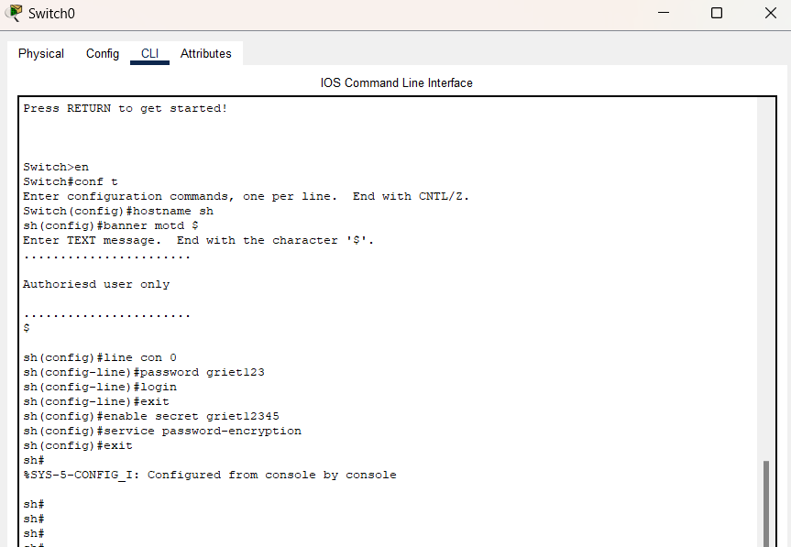

**Step 7:** Verify the password

* When you try to log in first, it will ask for the **line control password.**
* Then, to configure the terminal it will ask to **enable a secret password.**

**Note:** To verify password, need to exit from all commands and enter into user mode

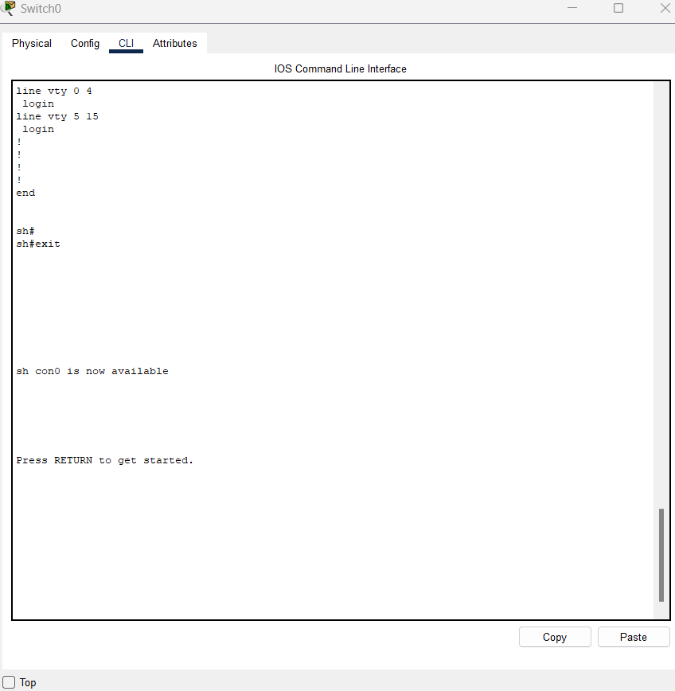

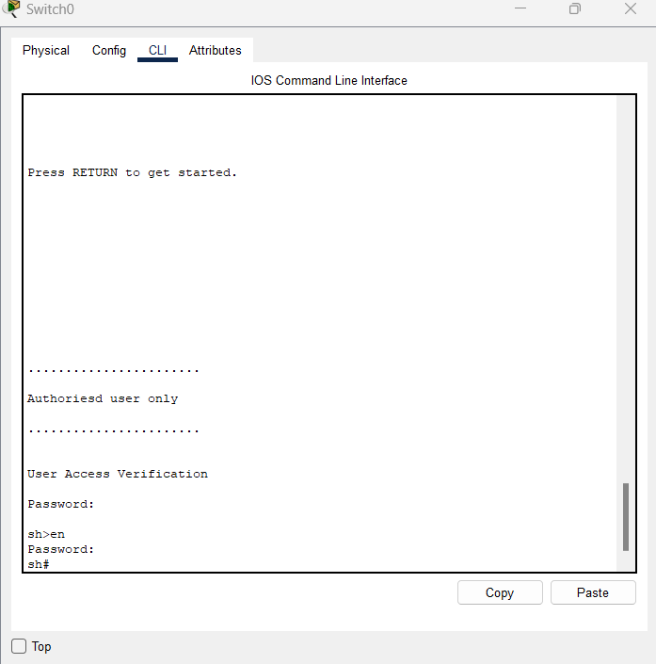

To save the run configuration to startup file use the below command:

### Command:

sh#copy run startup-config (OR) write

sh# no ip domain-lookup // used to prevent the router from trying to resolve incorrectly pasted commands in the cli by sending out a DNS query.

Select the switch – goto cli mode and type the below configuration commands.

Switch> Switch>enable Switch#config terminal

Switch(config)#hostname sh

sh(config)#banner motd #Warning Unauthorised access is prohibited#

sh(config)#line con 0

sh(config-line)#password griet1234 sh(config-line)#login

sh(config-line)#exit

sh(config)#enable secret griet5678 sh(config)#service password-encryption

sh(config)#no ip domain-lookup

sh#copy running-config startup-config Destination filename [startup-config]? Building configuration...

[OK]

sh#show start

sh#show startup-config Using 1238 bytes

!

version 15.0

no service timestamps log datetime msec no service timestamps debug datetime msec service password-encryption

!

hostname sh

!

enable secret 5 $1$mERr$vyUGBRk3bfoMV8qV.wJrB0

!

!

!

no ip domain-lookup

!

!

!

spanning-tree mode pvst spanning-tree extend system-id

!

interface FastEthernet0/1

!

interface FastEthernet0/2

!

interface FastEthernet0/3

!

interface FastEthernet0/4

!

interface FastEthernet0/5

!< deleted some part>

!

interface FastEthernet0/20

!

interface FastEthernet0/21

!

interface FastEthernet0/22

!

interface FastEthernet0/23

!

interface FastEthernet0/24

!

interface GigabitEthernet0/1

!

interface GigabitEthernet0/2

!

interface Vlan1 no ip address shutdown

!

banner motd ^CWarning Unauthorised access is prohibited^C

!

!

!

line con 0

password 7 08265E470C0D5445415F

login

!

line vty 0 4 login

line vty 5 15 login

!

!

!

!

End

6B : Learn and Implement basic commands.

1. **Ping**

Ping is most commonly used network tool used to test the connection between the source and destination host.

Ping command uses Internet Control Message Protocol (ICMP) to send an echo packet from the source host to a destination host and listen to the response. If the source host receives a response from the destination host, this host is reachable. If not there is a connection error.

Using Ping command the user can identify in which area the connection problem is there, is it local or outside their LAN.

Ex: You can ping either by using the IP address or by the website name or URL. In the below example I pinged to my wireless router with its IP Address and google.com by its domain name.

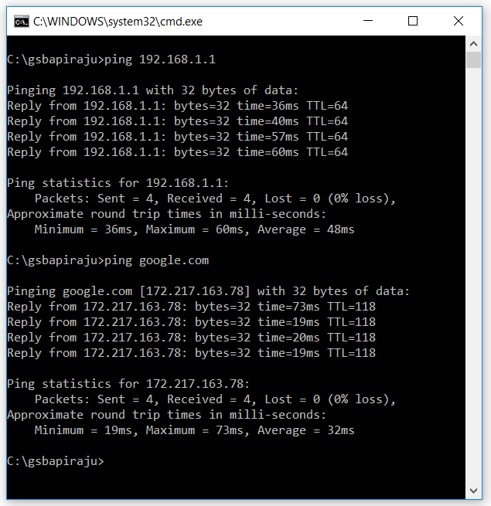

### Tracert/traceroute.

Ping is a basic tool to check the basic connectivity. But if you want to identify the complete path from the source node to the destination node than tracert/traceroute utility is very useful.

The tracert utility for windows and traceroute utility for Linux gives you the entire path, including the number of hops packet travelled.

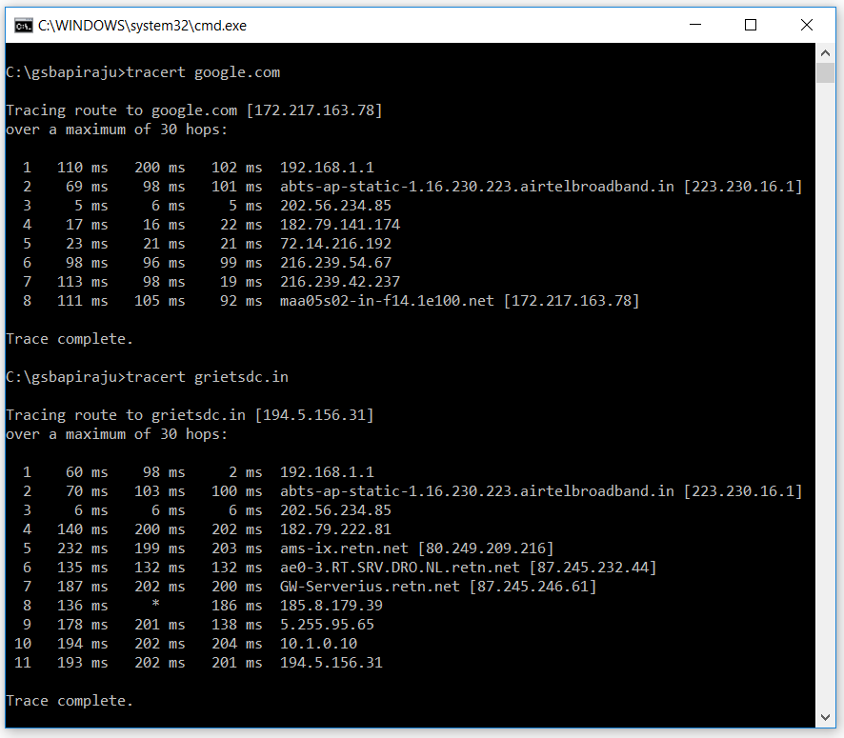

### Ipconfig

Ipconfig is one of the most important tool for system admins for troubleshooting networking issue. It is a command-line tool that shows the current TCP/IP configuration of the installed networking stack of a computer connected to a network.

This tool includes a number of switches to perform different actions. In the below example I am using /all which Produces a detailed configuration report for all interfaces. You can observe the 48 bit MAC address, IPaddress, DHCP details etc**.**

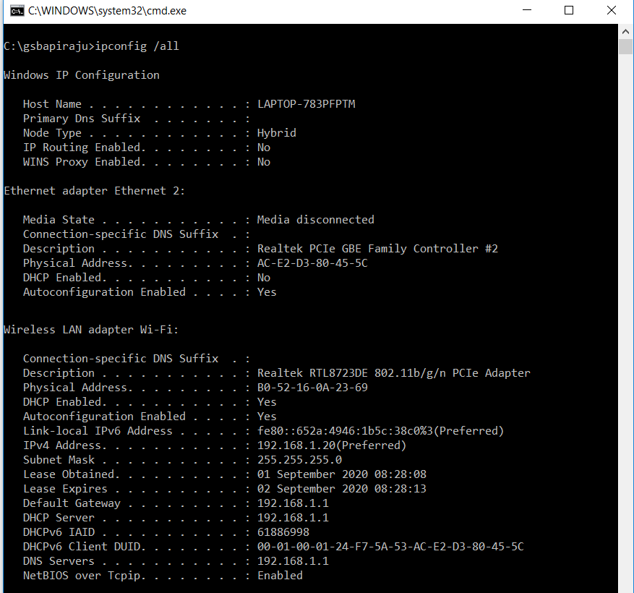

### Nslookup

Some of the most common networking issues revolve around issues with Dynamic Name System (DNS) address resolution issues. nslookup or "name server lookup" is a network administration command-line tool used for querying the Domain Name System to obtain domain name or IP address mapping, or other DNS records. This utility can be used to lookup the specific IP address(es) associated with a domain name. If this utility is unable to resolve this information, there is a DNS issue**.**

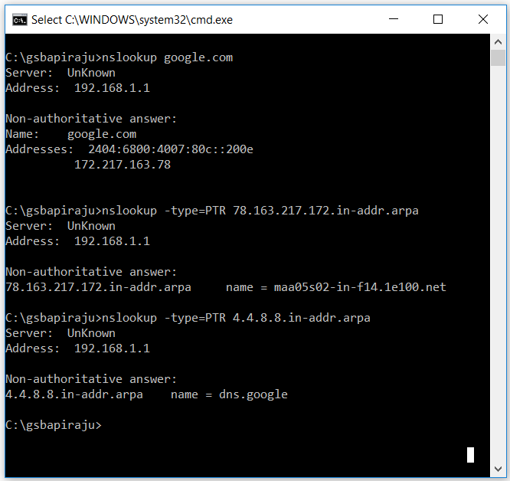

A typical DNS lookup is used to determine which IP address is associated with a hostname. A reverse DNS lookup is used for the opposite, to determine which hostname is associated with an IP address. Sometimes reverse DNS lookups are required for diagnostic purposes.

### Netstat.

Netstat (*network statistics)* is a program that’s controlled via commands issued in the command line. It delivers basic statistics on all network activities and informs users on which **ports and addresses** the corresponding connections (TCP, UDP) are running and which ports are open for tasks. The below example illustrates various switches of netstat.

