Assignment1

zhaoxiuping

2023-11-15

## R Markdown

Load your own . csv file into R, report the dimension of your data frame, then generate a scatter plot using the plot() function:

data1 <- read.csv("/Users/zhaoxiuping/R_zxp/datawork_1.csv")  
attach(data1)  
df <- data.frame(data1)  
df

## gender R python  
## 1 男 82 70  
## 2 女 89 86  
## 3 男 70 56  
## 4 女 84 70  
## 5 女 78 63  
## 6 女 86 62  
## 7 女 84 72  
## 8 女 91 68  
## 9 男 71 60  
## 10 男 76 62

par(mai=c(0.6,0.6,0.4,0.4),cex=0.7,cex.main=1,font.main=1)  
plot(df$R,df$python,main="scatter plot")

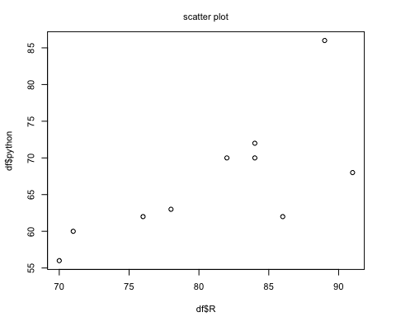

Write a loop to calculate the mean value of a random numeric vector oflength 50:

sum <- 0  
x<- rnorm(50)  
#循环求均值  
for(i in 1:50){  
 sum = sum +x[i]  
}  
avg <- sum/50  
avg

## [1] 0.1612364

#函数求均值验证  
avg1 <- mean(x)  
avg

## [1] 0.1612364