一、项目名称
信用卡项目
二、功能要求
- 注册
- 登录
- 浏览信用卡列表

三、需求分析
普通用户需要注册登录后可以进行信用卡银行列表浏览
四、设计思想

- 使用JAVA语言
- 使用Servelet实现后台服务，使用JSP或者Android实现前端页面
- 使用集合进行数据的存储和管理 主要使用了List、Map集合
- 使用数据库进行数据的存储和管理

五、具体实现
1、技术思路：
界面：基于ServLet使用Tomcat服务器实现用户在Web端的交互
程序流程：通过request 和response进行servlet和jsp之间的数据传输

2、功能子函数划分：
主页显示
注册功能
判断用户名、密码、手机号是否为空
判断注册时手机号码是否符合规范
判断两次密码输入是否一致
访问数据库，判断该用户是否已存在
访问数据库，将数据插入
跳转登录页面
登录功能
访问数据库，用户名和密码是否正确
返回登录状态
跳转个人用户首页
退出功能

六、附录
列出项目运行的截图，源程序

目录结构
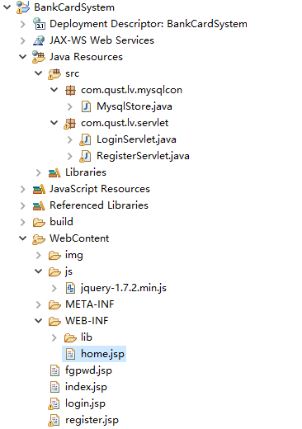
数据库
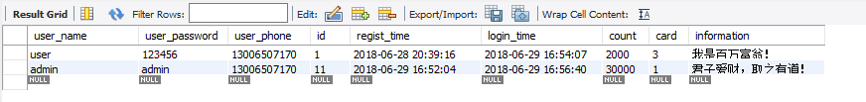

主页
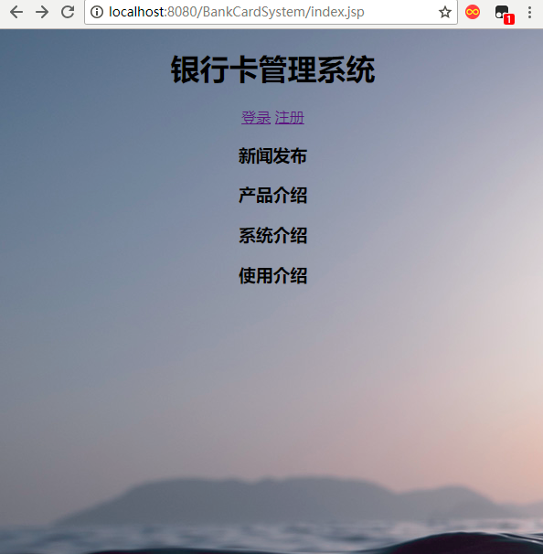

登陆
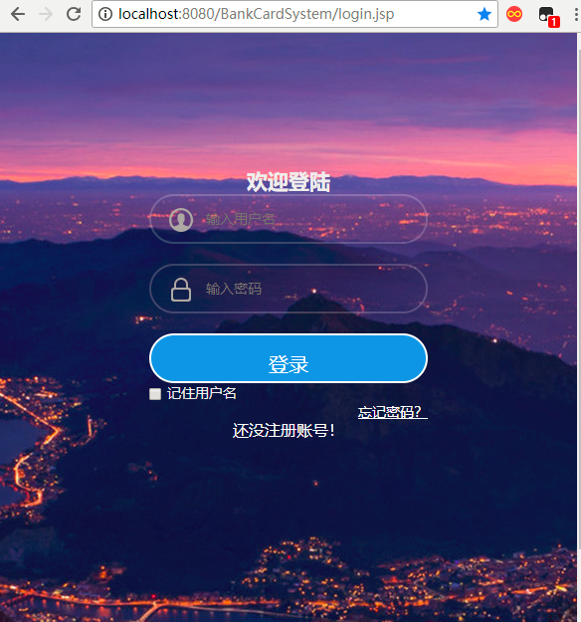

注册
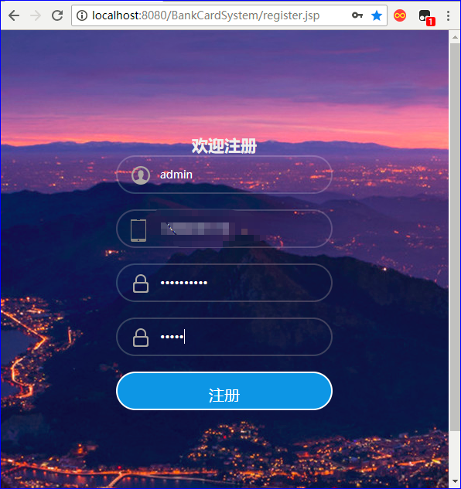

注册成功

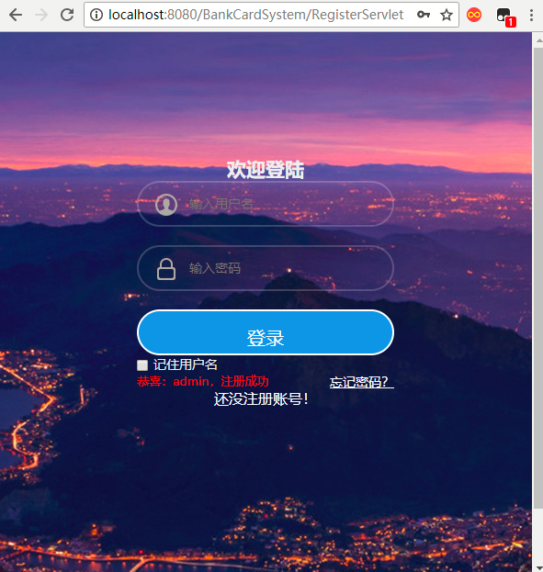

登录成功
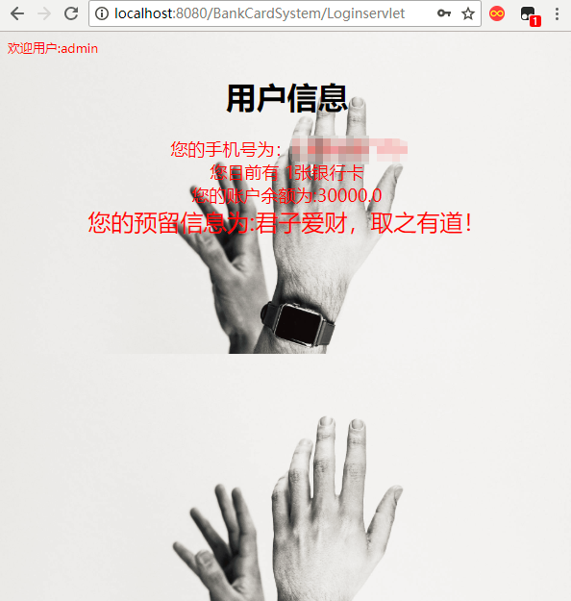

记住用户名
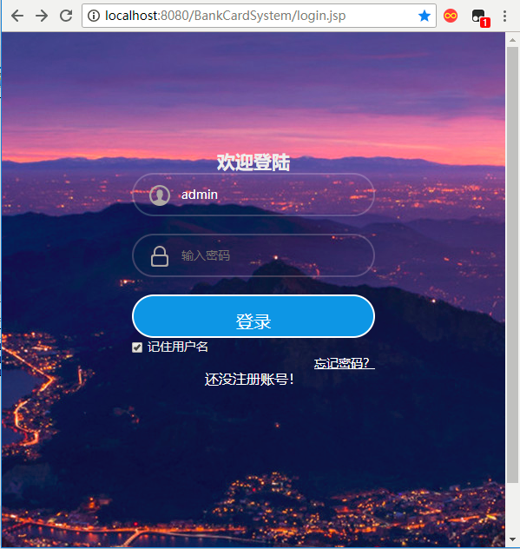

数据库处理
MysqlStore.java

package com.qust.lv.mysqlcon;

import java.sql.*;
import java.util.ArrayList;
import java.util.HashMap;
import java.util.List;
import java.util.Map;

public class MysqlStore {
String driver = "com.mysql.cj.jdbc.Driver";//驱动名称
String url = "jdbc:mysql://localhost:3306/creditcard";//连接字符串
String username = "root";// 用户名
String password = "369258";// 密码

Connection con = null;// 连接对象
PreparedStatement pstmt = null;// 语句 对象
ResultSet rs = null;// 结果集对象

/**
* 获得连接对象
*
* @return 连接对象
* @throws ClassNotFoundException
* @throws SQLException
*/
public Connection getConnection() throws ClassNotFoundException,
SQLException {
Class.forName(driver);
con = DriverManager.getConnection(url, username, password);
return con;
}

/**
* 关闭连接
*
* @throws SQLException
*/
public void close(ResultSet rs, PreparedStatement pstmt, Connection con) {

try {
if (rs != null)
rs.close();
if (pstmt != null)
pstmt.close();
if (con != null)
con.close();
} catch (SQLException e) {
e.printStackTrace();
}
}

public void close(){
try {
if (this.rs != null)
this.rs.close();
if (this.pstmt != null)
this.pstmt.close();
if (this.con != null)
this.con.close();
} catch (SQLException e) {
e.printStackTrace();
}
}
/**
* 执行更新
*
* @param sql 传入预设的sql语句
* @param params 问号参数列表
* @return
* @return 影响行数
*/
public int execUpdate(String sql, Object[] params) {
try {
this.getConnection();// 获得连接对象
this.pstmt = this.con.prepareStatement(sql);//

if (params != null) {
// 设置参数列表
for (int i = 0; i < params.length; i++) {
// 因为问号参数的索引是从1开始，所以是i+1，将所有值都转为字符串形式，好让setObject成功运行
this.pstmt.setObject(i + 1, params[i] + "");
}
}

return this.pstmt.executeUpdate(); // 执行更新，并返回影响行数

} catch (ClassNotFoundException e) {
e.printStackTrace();
} catch (SQLException e) {
e.printStackTrace();
} finally {
this.close(this.rs, this.pstmt, this.con);
}
return 0;
}

/**
* 执行查询
*
* @param sql 输入预设的sql语句
* @param params 问号参数列表
* @return 查询后的结果
*/
public List<Map<String, Object>> execQuery(String sql, Object[] params) {

try {
this.getConnection();// 获得连接对象
this.pstmt = this.con.prepareStatement(sql);

if (params != null) {
// 设置参数列表
for (int i = 0; i < params.length; i++) {
// 因为问号参数的索引是从1开始，所以是i+1，将所有值都转为字符串形式，好让setObject成功运行
this.pstmt.setObject(i + 1, params[i] + "");
}
}

// 执行查询
ResultSet rs = pstmt.executeQuery();

List<Map<String, Object>> al = new ArrayList<Map<String, Object>>();

// 获得结果集元数据（元数据就是描述数据的数据，比如把表的列类型列名等作为数据）
ResultSetMetaData rsmd = rs.getMetaData();

// 获得列的总数
int columnCount = rsmd.getColumnCount();

// 遍历结果集
while (rs.next()) {
Map<String, Object> hm = new HashMap<String, Object>();
for (int i = 0; i < columnCount; i++) {
// 根据列索引取得每一列的列名,索引从1开始
String columnName = rsmd.getColumnName(i + 1);
// 根据列名获得列值
Object columnValue = rs.getObject(columnName);
// 将列名作为key，列值作为值，放入 hm中，每个 hm相当于一条记录
hm.put(columnName, columnValue);
}
// 将每个 hm添加到al中, al相当于是整个表，每个 hm是里面的一条记录
al.add(hm);
}

return al;

} catch (ClassNotFoundException | SQLException e) {
e.printStackTrace();
} finally {
this.close(this.rs, this.pstmt, this.con);
}
return null;
}

public boolean login(String sql, Object[] params) {
boolean result=false;

try {
this.getConnection();
this.pstmt = this.con.prepareStatement(sql);
if (params != null) {
for (int i = 0; i < params.length; i++) {
this.pstmt.setObject(i + 1, params[i] + "");
}
}
ResultSet rs = pstmt.executeQuery();
if(rs.next()) {
result= true;
}else
{
result=false;
}

}catch (Exception e) {
e.printStackTrace();
}finally {
this.close(this.rs, this.pstmt, this.con);
}
return result;
}

}

登录ServLet
LoginServlet.java
package com.qust.lv.servlet;

import java.io.IOException;
import java.text.SimpleDateFormat;
import java.util.ArrayList;
import java.util.List;
import java.util.Map;

import javax.servlet.ServletException;
import javax.servlet.annotation.WebServlet;
import javax.servlet.http.Cookie;
import javax.servlet.http.HttpServlet;
import javax.servlet.http.HttpServletRequest;
import javax.servlet.http.HttpServletResponse;

import com.qust.lv.mysqlcon.MysqlStore;

/**
* Servlet implementation class LoginServlet
*/
@WebServlet("/Loginservlet")
public class LoginServlet extends HttpServlet {
private static final long serialVersionUID = 1L;
private MysqlStore mysqlStore;
private boolean result=false;
String time;
String ph;
Float acount;
int card;
String infor;

/**
* @see HttpServlet#HttpServlet()
*/
public LoginServlet() {
super();
// TODO Auto-generated constructor stub
}
public void init() throws ServletException {
super.init();
this.mysqlStore = new MysqlStore();
}

/**
* @see HttpServlet#doGet(HttpServletRequest request, HttpServletResponse response)
*/
protected void doGet(HttpServletRequest request, HttpServletResponse response) throws ServletException, IOException {
// TODO Auto-generated method stub
request.setCharacterEncoding("UTF-8");
response.setContentType("text/html;charset=UTF-8");
response.getWriter().append("Served at: ").append(request.getContextPath());
}

/**
* @see HttpServlet#doPost(HttpServletRequest request, HttpServletResponse response)
*/
protected void doPost(HttpServletRequest request, HttpServletResponse response) throws ServletException, IOException {
// TODO Auto-generated method stub
doGet(request, response);
request.setCharacterEncoding("UTF-8");
response.setContentType("text/html;charset=UTF-8");
String name=request.getParameter("logname");
String password=request.getParameter("logpassword");
String remember = request.getParameter("savesid");
//int time = Integer.parseInt(request.getParameter("time"));
String sql = "select * from user_information where user_name=? and user_password=?;";
String[] params = {name, password};
boolean state =mysqlStore.login(sql, params);
if(state==true) {
int al=mysqlStore.execUpdate("update user_information set login_time=now() where user_name=? and user_password=?;",new Object[]{name,password});

if (remember!=null) {
Cookie c1 = new Cookie("username", name);
Cookie c2 = new Cookie("password", password);
c1.setMaxAge(1000);
c2.setMaxAge(1000);//这里设置保存这条Cookie的时间
response.addCookie(c1);//添加Cookie
response.addCookie(c2);
}
List<Map<String, Object>> res = mysqlStore.execQuery("select * from user_information where user_name=?;",new Object[]{name});
System.out.println(res);

for (Map<String, Object> m1 : res)
{
ph=(String)m1.get("user_phone");
}
for (Map<String, Object> m1 : res)
{
card=(int)m1.get("card");
}
for (Map<String, Object> m1 : res)
{
acount=(Float)m1.get("count");
}
for (Map<String, Object> m1 : res)
{
infor=(String)m1.get("information");
}
request.setAttribute("ph","您的手机号为："+ph);
request.setAttribute("card","您目前有 "+card+"张银行卡");
request.setAttribute("acount","您的账户余额为:"+acount);
request.setAttribute("infor","您的预留信息为:"+infor);

// request.setAttribute("time","上次登陆时间：:"+time);
request.setAttribute("msg","欢迎用户:"+name);
request.getRequestDispatcher("/WEB-INF/home.jsp").forward(request, response);
}
else {
request.setAttribute("msg", "用户名或密码错误");
request.getRequestDispatcher("/login.jsp").forward(request, response);
}
}

}

注册ServLet
RegisterServlet .java
package com.qust.lv.servlet;

import java.io.IOException;
import java.util.regex.Matcher;
import java.util.regex.Pattern;
import javax.servlet.ServletException;
import javax.servlet.annotation.WebServlet;
import javax.servlet.http.HttpServlet;
import javax.servlet.http.HttpServletRequest;
import javax.servlet.http.HttpServletResponse;
import com.qust.lv.mysqlcon.MysqlStore;
import sun.security.util.Length;

/**
* Servlet implementation class RegisterServlet
*/
@WebServlet("/RegisterServlet")
public class RegisterServlet extends HttpServlet {
private static final long serialVersionUID = 1L;
private MysqlStore mysqlStore;
/**
* @see HttpServlet#HttpServlet()
*/
public RegisterServlet() {
super();
// TODO Auto-generated constructor stub
}
public void init() throws ServletException {
super.init();
this.mysqlStore = new MysqlStore();
}
//构建方法，使用正则表达式验证手机号码格式是否正确
public static boolean checkPhone(String phone) {
Pattern pattern = Pattern
.compile("^(13[0-9]|14[5,7,9]|15[^4]|18[0-9]|17[0,1,3,5,6,7,8])\\d{8}$");
////2018.3.08 ^(13[0-9]|15[0-9]|153|15[6-9]|180|18[23]|18[5-9])\\d{8}$
Matcher matcher = pattern.matcher(phone);

if (matcher.matches()) {
return true;
}
return false;
}
/**
* @see HttpServlet#doGet(HttpServletRequest request, HttpServletResponse response)
*/
protected void doGet(HttpServletRequest request, HttpServletResponse response) throws ServletException, IOException {
// TODO Auto-generated method stub
request.setCharacterEncoding("UTF-8");
response.setContentType("text/html;charset=UTF-8");
response.getWriter().append("Served at: ").append(request.getContextPath());
}

/**
* @see HttpServlet#doPost(HttpServletRequest request, HttpServletResponse response)
*/
protected void doPost(HttpServletRequest request, HttpServletResponse response) throws ServletException, IOException {
// TODO Auto-generated method stub
doGet(request, response);
request.setCharacterEncoding("UTF-8");
response.setContentType("text/html;charset=UTF-8");
String name=request.getParameter("user_name");
String password=request.getParameter("user_password");
String phone=request.getParameter("user_phone");
String rpsw = request.getParameter("rpsw");
System.out.println(name);
System.out.println(password);

if(name==null||name.trim().isEmpty()){
request.setAttribute("msg", "帐号不能为空");
request.getRequestDispatcher("/register.jsp").forward(request, response);
return;
}
Boolean a=false;
a=checkPhone(phone);
if(a==false) {
request.setAttribute("msg", "手机号错误");
request.getRequestDispatcher("/register.jsp").forward(request, response);
return;
}
if(password==null||password.trim().isEmpty()){
request.setAttribute("msg", "密码不能为空");
request.getRequestDispatcher("/register.jsp").forward(request, response);
return;
}
if(!password.equals(rpsw)){
request.setAttribute("msg", "两次输入的密码不同");
request.getRequestDispatcher("/register.jsp").forward(request, response);
return;
}
String sql = "select * from user_information where user_name=?";
String[] nam = {name};
boolean result =mysqlStore.login(sql, nam);
if(result==true){
request.setAttribute("msg", "账号："+name+" 已存在");
request.getRequestDispatcher("/register.jsp").forward(request, response);
return;
}else{
int raw=mysqlStore.execUpdate("insert into user_information(user_name,user_password,user_phone,regist_time) value(?,?,?,now())",
new Object[]{name,password,phone});//返回参数为所影响行数
if(raw==1) {
request.setAttribute("msg", "恭喜："+name+"，注册成功");
request.getRequestDispatcher("/login.jsp").forward(request, response);
}else {
request.setAttribute("msg", "抱歉注册失败");
request.getRequestDispatcher("/login.jsp").forward(request, response);
}
}
//response.sendRedirect("/BankCardSystem/login.jsp");
}
@Override
public void destroy() {
super.destroy();
if(this.mysqlStore != null){
this.mysqlStore.close();
}
}

}
主页jsp
Index.jsp
<%@ page language="java" contentType="text/html; charset=utf-8"
pageEncoding="utf-8"%>
<%@ page import="java.util.Map" %>
<%@ page import="java.util.List" %>
<!DOCTYPE html PUBLIC "-//W3C//DTD HTML 4.01 Transitional//EN" "http://www.w3.org/TR/html4/loose.dtd">
<html>
<head>
<meta http-equiv="Content-Type" content="text/html; charset=utf-8">
<title>主页</title>
</head>
<body background="img/bg2.jpg">
<center>
<h1>银行卡管理系统</h1>
<div>
<a href="/BankCardSystem/login.jsp">登录</a>
<a href="/BankCardSystem/register.jsp">注册</a>
</div>
<div>
<h3>新闻发布</h3>
<h3>产品介绍</h3>
<h3>系统介绍</h3>
<h3>使用介绍</h3>

</div>
<div></div>
<div></div>
</center>
</body>
</html>

注册JSP
Register.jsp

<%@ page language="java" contentType="text/html; charset=utf-8"
pageEncoding="utf-8"%>
<%
String path = request.getContextPath();
String basePath = request.getScheme()+"://"+request.getServerName()+":"+request.getServerPort()+path+"/";
%>
<!DOCTYPE html PUBLIC "-//W3C//DTD HTML 4.01 Transitional//EN" "http://www.w3.org/TR/html4/loose.dtd">
<html>
<head>
<base href="<%=basePath%>">
<meta http-equiv="Content-Type" content="text/html; charset=utf-8">
<title>注册</title>
<style type="text/css">
* {
margin: 0;
padding: 0;
}

.bg-blur {
float: left;
width: 100%;
background-repeat: no-repeat;
background-position: center;
background-size: cover;
-webkit-filter: blur(15px);
-moz-filter: blur(15px);
-o-filter: blur(15px);
-ms-filter: blur(15px);
filter: blur(15px);
}

body {
font-family: "微软雅黑";
font-size: 14px;
background: url(img/bg.jpg) fixed center center;
}

.logo_box {
width: 280px;
height: 490px;
padding: 35px;
color: #EEE;
position: absolute;
left: 50%;
top: 100px;
margin-left: -175px;
}

.forms {
width: 280px;
height: 485px;
}

.logon_inof {
width: 100%;
min-height: 450px;
padding-top: 35px;
position: relative;
}

.input_outer {
height: 46px;
padding: 0 5px;
margin-bottom: 20px;
border-radius: 50px;
position: relative;
border: rgba(255, 255, 255, 0.2) 2px solid !important;
}

.u_user {
width: 25px;
height: 25px;
background: url(img/login_ico.png);
background-position: -125px 0;
position: absolute;
margin: 12px 13px;
}

.us_uer {
width: 25px;
height: 25px;
background-image: url(img/login_ico.png);
background-position: -125px -34px;
position: absolute;
margin: 12px 13px;
}

.u_phone {
width: 25px;
height: 30px;
background: url(img/login_ico.png);
background-position: -85px -110px;
position: absolute;
margin: 11px 10px;
}

.l-login {
position: absolute;
z-index: 1;
left: 50px;
top: 0;
height: 46px;
font: 14px "microsoft yahei", Helvetica, Tahoma, Arial,
"Microsoft jhengHei";
line-height: 46px;
}

.label {
color: rgb(255, 255, 255);
display: block;
}

.text {
width: 220px;
height: 46px;
outline: none;
display: inline-block;
font: 14px "microsoft yahei", Helvetica, Tahoma, Arial,
"Microsoft jhengHei";
margin-left: 50px;
border: none;
background: none;
line-height: 46px;
}

.mb2 {
margin-bottom: 20px
}

.mb2 a {
text-decoration: none;
outline: none;
}

.submit1 {
padding: 15px;
margin-top: 20px;
display: block;
}

.act-but {
height: 20px;
line-height: 20px;
text-align: center;
font-size: 20px;
border-radius: 50px;
background: #0096e6;
}
</style>
</head>
<body>
<script src="js/jquery-1.7.2.min.js" type="text/javascript"></script>

<div class="logo_box">
<center>
<h2>欢迎注册</h2>
</center>
<form action="RegisterServlet" name="f" method="post">
<div class="input_outer">
<span class="u_user"></span> <input name="user_name" class="text"
placeholder="输入用户名"
style="color: #FFFFFF !important" type="text">
</div>
<div class="input_outer">
<span class="u_phone"></span> <input name="user_phone" class="text"
placeholder="输入手机号"
style="color: #FFFFFF !important" type="text">
</div>
<div class="input_outer">
<span class="us_uer"></span>
<input name="user_password" class="text"
style="color: #FFFFFF !important; position: absolute; z-index: 100;"
placeholder="输入密码"
type="password">
</div>
<div class="input_outer">
<span class="us_uer"></span>
<input name="rpsw" class="text"
style="color: #FFFFFF !important; position: absolute; z-index: 100;"
placeholder="再次输入密码"
type="password">
</div>
<div>
<input type="submit" value="注册"
style="border: rgba(255, 255, 255, 1) 2px solid !important; border-radius: 50px; color: #FFFFFF; background: #0096e6; height: 50px; width: 280px; text-align: center; font-size: 20px; padding: 15px; display: block;">
</div>

</form>
<font color="red" size="2"> ${msg }</font>

</div>

</body>
</html>

登录jsp
Login.jsp
<%@ page language="java" contentType="text/html; charset=utf-8"
pageEncoding="utf-8"%>
<%
String path = request.getContextPath();
String basePath = request.getScheme()+"://"+request.getServerName()+":"+request.getServerPort()+path+"/";
%>
<!DOCTYPE html PUBLIC "-//W3C//DTD HTML 4.01 Transitional//EN" "http://www.w3.org/TR/html4/loose.dtd">
<html>
<head>
<base href="<%=basePath%>">
<meta http-equiv="Content-Type" content="text/html; charset=UTF-8">
<title>登录</title>
<style type="text/css">
*{
margin: 0;
padding: 0;
}

.bg-blur {
float: left;
width: 100%;
background-repeat: no-repeat;
background-position: center;
background-size: cover;
-webkit-filter: blur(15px);
-moz-filter: blur(15px);
-o-filter: blur(15px);
-ms-filter: blur(15px);
filter: blur(15px);
}

body{
font-family: "微软雅黑";
font-size: 14px;
background: url(img/bg.jpg) fixed center center;
}
.logo_box{
width: 280px;
height: 490px;
padding: 35px;
color: #EEE;
position: absolute;
left: 50%;
top:100px;
margin-left: -175px;
}
.logo_box h3{
text-align: center;
height: 20px;
font: 20px "microsoft yahei",Helvetica,Tahoma,Arial,"Microsoft jhengHei",sans-serif;
color: #FFFFFF;
height: 20px;
line-height: 20px;
padding:0 0 35px 0;
}
.forms{
width: 280px;
height: 485px;
}
.logon_inof{
width: 100%;
min-height: 450px;
padding-top: 35px;
position: relative;
}
.input_outer{
height: 46px;
padding: 0 5px;
margin-bottom: 20px;
border-radius: 50px;
position: relative;
border: rgba(255,255,255,0.2) 2px solid !important;
}
.u_user{
width: 25px;
height: 25px;
background: url(img/login_ico.png);
background-position: -125px 0;
position: absolute;
margin: 12px 13px;
}
.us_uer{
width: 25px;
height: 25px;
background-image: url(img/login_ico.png);
background-position: -125px -34px;
position: absolute;
margin: 12px 13px;
}
.l-login{
position: absolute;
z-index: 1;
left: 50px;
top: 0;
height: 46px;
font: 14px "microsoft yahei",Helvetica,Tahoma,Arial,"Microsoft jhengHei";
line-height: 46px;
}
label{
color: rgb(255, 255, 255);
display: block;
}
.text{
width: 220px;
height: 46px;
outline: none;
display: inline-block;
font: 14px "microsoft yahei",Helvetica,Tahoma,Arial,"Microsoft jhengHei";
margin-left: 50px;
border: none;
background: none;
line-height: 46px;
}
/*///*/
.mb2{
margin-bottom: 20px
}
.mb2 a{
text-decoration: none;
outline: none;
}
.submit {
padding: 15px;
margin-top: 20px;
display: block;
}
.act-but{
height: 20px;
line-height: 20px;
text-align: center;
font-size: 20px;
border-radius: 50px;
background: #0096e6;
}
/*////*/
.check{
width: 280px;
height: 22px;
}
.clearfix::before{
content: "";
display: table;
}
.clearfix::after{
display: block;
clear: both;
content: "";
visibility: hidden;
height: 0;
}
.login-rm{
float: left;
}
.login-fgetpwd {
float: right;
}
.check{
width: 18px;
height: 18px;
background: #fff;
border: 1px solid #e5e6e7;
margin: 0 5px 0 0;
border-radius: 2px;
}
.check-ok{
background-position: -128px -70px;
width: 18px;
height: 18px;
display: inline-block;
border: 1px solid #e5e6e7;
margin: 0 5px 0 0;
border-radius: 2px;
vertical-align: middle
}
.checkbox{
vertical-align: middle;
margin: 0 5px 0 0;
}
/*////*/
.sas{
width: 280px;
height: 18px;
float: left;
color: #FFFFFF;
text-align: center;
font-size: 16px;
line-height: 16px;
margin-bottom: 50px;
}
.sas a{
width: 280px;
height: 18px;
color: #FFFFFF;
text-align: center;
line-height: 18px;
text-decoration: none;
}
</style>
</head>
<body>
<%
String username = "";
String password = "";
Cookie[] c = request.getCookies();
if (c != null) {
for (int i = 0; i < c.length; i++) {
if ("logname".equals(c[i].getName())) {
username = c[i].getValue();
} else if ("logpassword".equals(c[i].getName())) {
password = c[i].getValue();
}
}
} else {
username = " ";
password = " ";
}
%>

<script src="js/jquery-1.7.2.min.js" type="text/javascript"></script>

<div class="logo_box">
<center><h2>欢迎登陆</h2></center>
<form action="Loginservlet" name="f" method="post">
<div class="input_outer">
<span class="u_user"></span>
<input name="logname" class="text" placeholder="输入用户名" style="color: #FFFFFF !important" type="text" value="<%=username%>">
</div>
<div class="input_outer">
<span class="us_uer"></span>
<input name="logpassword" class="text" style="color: #FFFFFF !important; position:absolute; z-index:100;" placeholder="输入密码" type="password" value="<%=password%>">
</div>
<div>
<input type="submit" value="登录"
style="border: rgba(255, 255, 255, 1) 2px solid !important; border-radius: 50px; color: #FFFFFF; background: #0096e6; height: 50px; width: 280px; text-align: center; font-size: 20px; padding: 15px; display: block;">
</div>
<input name="savesid" value="0" id="check-box" class="checkbox" type="checkbox" value="jizhu" ><span>记住用户名</span>
</form>
<a href="/BankCardSystem/fgpwd.jsp" class="login-fgetpwd" style="color: #FFFFFF">忘记密码？</a>

<div class="sas">
<a href="/BankCardSystem/register.jsp">还没注册账号！</a>
</div>
<div>
<font color="red" size="2"> ${msg }</font>
</div>

</div>

</body>
</html>

</body>
</html>

Homejsp
home.jsp
<%@ page language="java" contentType="text/html; charset=utf-8"
pageEncoding="utf-8"%>
<%@ page import="java.util.Map" %>
<%@ page import="java.util.List" %>
<%
String path = request.getContextPath();
String basePath = request.getScheme()+"://"+request.getServerName()+":"+request.getServerPort()+path+"/";
%>
<!DOCTYPE html PUBLIC "-//W3C//DTD HTML 4.01 Transitional//EN" "http://www.w3.org/TR/html4/loose.dtd">
<html>
<head>
<base href="<%=basePath%>">
<meta http-equiv="Content-Type" content="text/html; charset=utf-8">
<title>用户信息</title>
</head>
<body style="background:url(img/bg3.jpg) ;background-size:cover; ">
<font color="red" size="2"> ${msg}</font>
<font color="red" size="2"> ${time}</font>
<center>
<h1>用户信息</h1>
<div>
<font color="red" size="4"> ${ph}</font>
</div>
<div>
<font color="red" size="4"> ${card}</font>
</div>
<div>
<font color="red" size="4"> ${acount}</font>
</div>
<div>
<font color="red" size="5"> ${infor}</font>
</div>
</center>
</body>
</html>

