題目A:

Mkdir share

Groupadd csie3a

Adduser ivy;

Adduser jane;

Adduser kitty;

Cd /home/share

Vim homework (打入學號)

Chown root:csie3a /home/share

Chmod 770 /home/share

Usermod –a –G csie3a ivy;

Usermod –a –G csie3a jane;

Usermod –a –G csie3a kitty;

Chmod 771 ivy;

Chmod 771 jane;

Chmod 771 kitty;

1.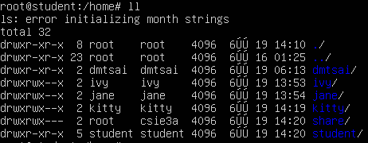

2.

3.

題目B:

Chmod 750 /home/share/homework

Cp –a /home/share/homework /home/ivy/homework

Cp –a /home/share/homework /home/jane/homework

Cp –a /home/share/homework /home/kitty/homework

Chown ivy:csie3a /home/ivy/homework

Chown jane:csie3a /home/jane/homework

Chown kitty:csie3a /home/kitty/homework

1.

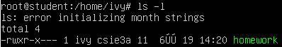



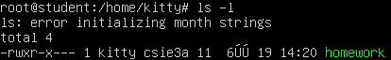

2.

3.

題目C:

Apt-get update

Apt-get install vsftpd

$sudo /etc/init.d/vsftpd status

1.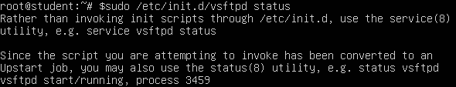

2.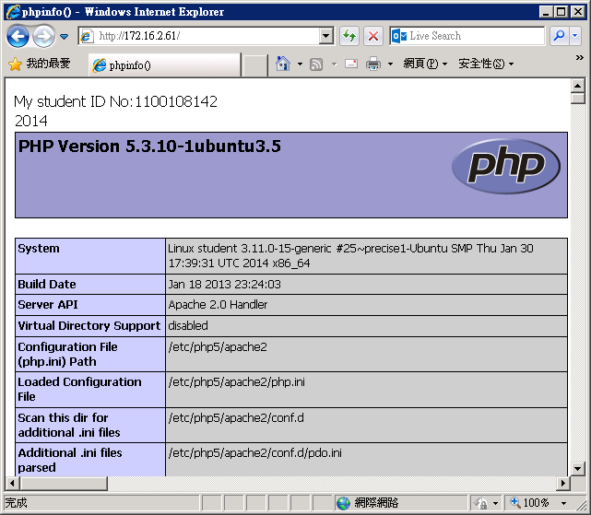

題目D:

$sudo a2enmod userdir

$/etc/init.d/apache2 restart

Cd /home/ivy

Mkdir website

Cd website

Mkdir www

Cd www

Vim ivy_hw.rtf

Chown ivy:csie3a /home/ivy/website/www

Chmod 755 /home/ivy/website/www/ivy_hw.rtf

Cd /home/jane

Mkdir website

Cd website

Mkdir www

Cd www

Vim jane_hw.rtf

Chown jane:csie3a /home/jane/website/www

Chmod 755 /home/jane/website/www/jane_hw.rtf

Cd /home/kitty

Mkdir website

Cd website

Mkdir www

Cd www

Vim kitty_hw.rtf

Chown kitty:csie3a /home/kitty/website/www

Chmod 755 /home/kitty/website/www/kitty_hw.rtf

1.