CIS 285: Software Engineering Tools
University of Michigan – Dearborn

Lab 8
Setting up the SplitSmart Development Environment

Due Date: Thursday 11/12 – Submission is due at 11:59pm on Canvas

Objective
In Labs 6 and 7, you completed the requirements and architecture design for the SplitSmart shared-expense application. In Lab 8, you will establish a Docker-based development environment for implementing SplitSmart
The Dockerfile and devcontainer.json are provided in the Zip. Your responsibility is to clone your repository, configure the environment, verify installed tools, and run the starter application. No SplitSmart features are required in Lab 8.

Specific tasks required:

Part 1 – Prerequisites
- Visual Studio Code
- Docker Desktop (download, install, configure Resources, and verify Engine running)
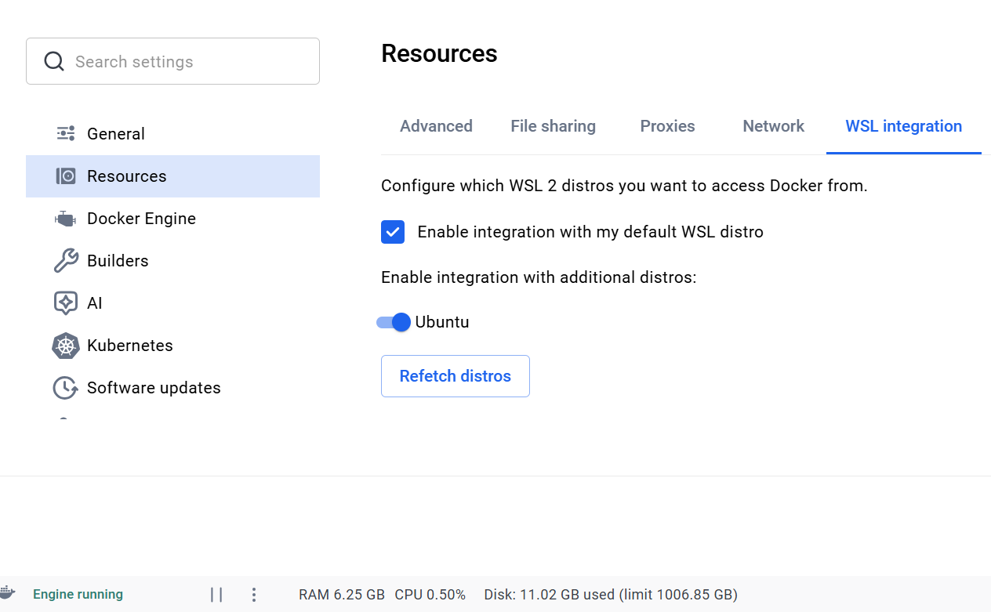
- VS Code Dev Containers extension
- GitHub access to your Lab 6–9 repository
- Watch the instructor tutorial:
https://www.youtube.com/watch?v=BwwTWNYctZw

Part 2 – Clone Your Repository into a Container Volume
- Open Visual Studio Code.
- Press Ctrl + Shift + P to open the Command Palette.
- Select Dev Containers: Clone Repository in Container Volume.
- Enter the HTTPS URL of your GitHub Lab 6–9 repository.
- Select the master branch if prompted and wait for the repository to open.
- Select the Node.js & TypeScript. container template and no need to choose any additional
- Once the repository opens, replace the generated .devcontainer configuration with the two files provided in Zip: (Please note that my workdirectory and folder name may be different from yours. Pay attention to line 142 and 165 in Dockerfile, update them if necessary )
  - - Dockerfile
  - - devcontainer.json
- Select Dev Containers: Rebuild Container.
- The file structure should be similar to this
lab6-9/
.devcontainer/
Dockerfile
devcontainer.json
architecture/
docs/
prototype/
specs/

Using AI for Troubleshooting in Part 2

Every student's computer is different in terms of operating system, hardware, installed software, system settings, and existing configurations. Therefore, even when following the same instructions, you may encounter different issues during Docker Desktop installation, Dev Container setup, or container rebuilding. This is normal and an expected part of working with development environments. You are encouraged to use AI tools such as ChatGPT or Claude to troubleshoot these issues. Copy the complete error message or relevant terminal output into the AI tool, explain what you were trying to accomplish, and ask for step-by-step instructions. Learning how to diagnose and resolve environment-related problems with AI assistance is an important objective of this lab and a valuable software engineering skill.

Part 3 – Verify the Development Tools
Open a terminal inside the development container and run:
cd prototype
node --version
npm --version
npx next --version
npx prisma --version
npx vitest --version
Take a screenshot 1: Show the commands and their output.

Part 4 – Verify the SQLite Database
From the prototype directory, run:
npx prisma validate
sqlite3 prisma/dev.db ".tables"
The Prisma schema should validate, and the table listing should include EnvironmentCheck. This is an environment-check model, not the final SplitSmart data model.
Take a screenshot 2: Show successful schema validation and the SQLite table listing.

Part 5 – Run the Next.js Application
From the prototype directory, run:
npm run dev -- --hostname 0.0.0.0
Open the forwarded port 3000 from the VS Code Ports tab, or visit http://localhost:3000. You should see the default Next.js starter page. Do not modify the starter page.
Take a screenshot 3: Show the application running in your browser.

Part 6 – Save your work and push to GitHub
From the prototype directory, run:
npm run dev -- --hostname 0.0.0.0
Open the forwarded port 3000 from the VS Code Ports tab, or visit http://localhost:3000. You should see the default Next.js starter page. Do not modify the starter page.

Submission to Canvas
- GitHub repository URL.
- Screenshot 1 – development tool versions.
- Screenshot 2 – Prisma and SQLite verification.
- Screenshot 3 – Next.js starter page in the browser.

