I implemented the topology below:

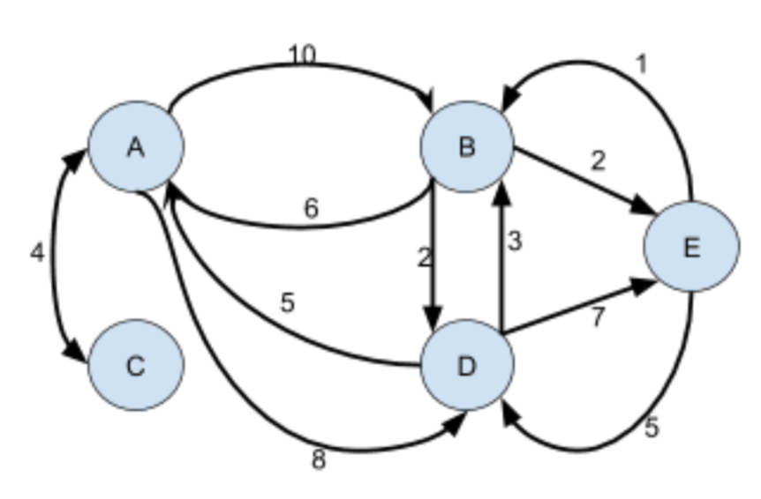

A is localhost:8000

B is localhost:8001

C is localhost:8002

D is localhost:8003

E is localhost:8004

Here are the converging screenshots:

A

./jrip34 -p 8000 localhost:8001:10 localhost:8002:4 localhost:8003:8

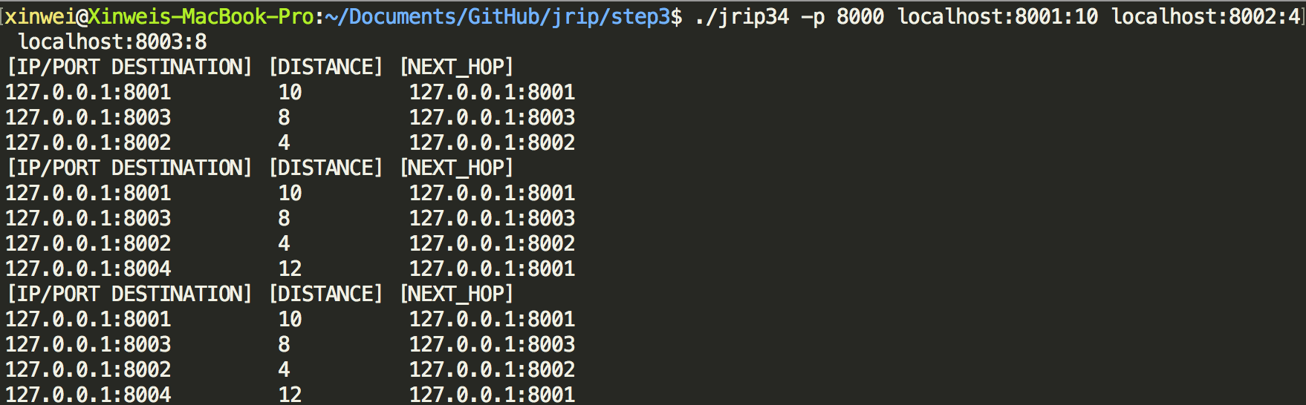

B

./jrip34 -p 8001 localhost:8000:6 localhost:8003:2 localhost:8004:2

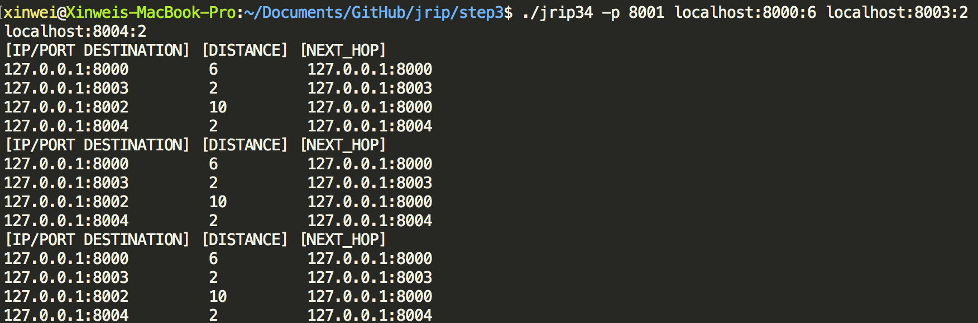

C

./jrip34 -p 8002 localhost:8000:4

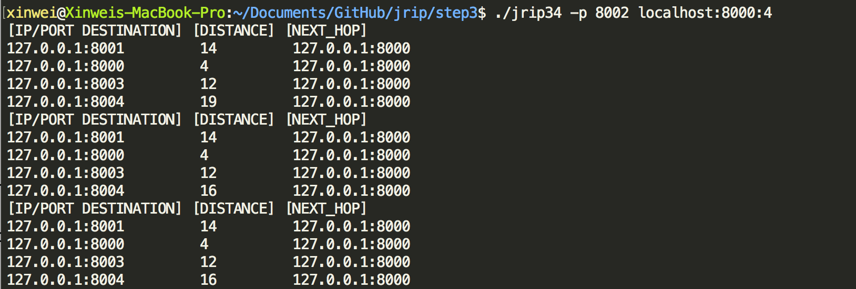

D

./jrip34 -p 8003 localhost:8000:5 localhost:8001:3 localhost:8004:7

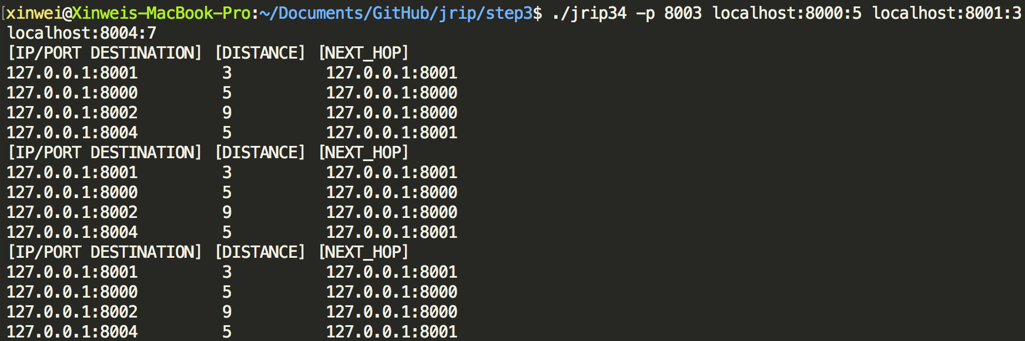

E

./jrip34 -p 8004 localhost:8001:1 localhost:8003:5

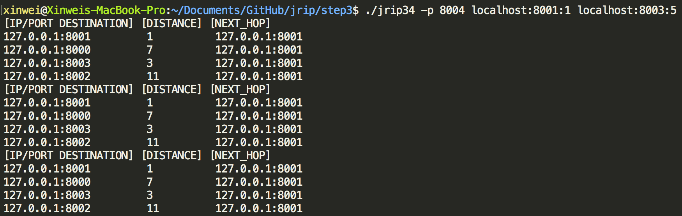

Traceroute is shown as below:

