Distinct networks drive mirror perturbation of translation-related transcription in heart failure and hepatocellular carcinoma
Yuhe Hong1 (ORCID: 0009-0008-5028-0035), Yili Liu1, Xianqi Li1, Junhong Wang1,2* (ORCID: 0000-0003-2314-1810)
1 Department of Cardiology, The First Affiliated Hospital of Nanjing Medical University, Nanjing, China
2 Department of Cardiology, Liyang People’s Hospital, Liyang, China
* Corresponding author. Email: wangjunhong@jsph.org.cn

Heart failure (HF) and hepatocellular carcinoma (HCC) both exhibit dysregulation of translation-related gene expression, yet whether this reflects shared transcriptional organization or disease-specific remodeling remains unresolved. Here we show that translation-related transcriptional programs in HF and HCC are organized through disease-specific co-expression networks, yet converge on opposite-direction pathway perturbation. Weighted gene co-expression network analysis of HF (GSE57338, n = 313) and HCC (GSE141198, n = 148) transcriptomes identified translation-related modules with limited gene-level overlap (62/227 genes; Fisher’s OR = 1.7, P = 0.039). Despite distinct network architecture, 24 of 33 translation-related pathways showed mirror perturbation between diseases (Spearman ρ = −0.598, P = 0.0003). This mirror pattern was absent in same-organ disease controls, including hypertrophic cardiomyopathy (ρ = −0.036) and cirrhosis (ρ = +0.402), supporting disease-context dependence rather than organ-specific confounding. ATF4 was the strongest individual transcription factor correlate with translational activity (ρ = +0.500, FDR < 0.0001), while MYC target pathway activity showed the highest overall association (ρ = +0.753, P < 0.0001). These findings identify disease-context-dependent remodeling — shared functional themes emerging through distinct network configurations with opposite perturbation directions — as an organizing principle of translation-related transcriptional programs across diseases.
Keywords: Translation · Heart failure · Hepatocellular carcinoma · WGCNA · ssGSEA · ATF4 · Integrated stress response · MYC

Heart failure (HF) and hepatocellular carcinoma (HCC) appear clinically divergent: HF is a chronic degenerative condition of the myocardium, HCC an aggressive malignancy of the liver. Yet beneath this superficial distinction lies a shared molecular landscape. Both diseases undergo profound metabolic reprogramming — the failing heart faces chronic ATP deficit and substrate depletion^{[1,2]}, while HCC cells rewire central carbon metabolism to sustain unrestrained proliferation^{[3,4]}. Both exhibit disrupted protein homeostasis, the balance among protein synthesis, folding, and degradation that is essential for cellular function and survival^{[5,6]}. Translational regulation lies at the intersection of these processes, coupling cellular energy status with protein synthesis capacity^{[7]}. Accordingly, both diseases exhibit dysregulation of the translational apparatus — the ribosome, translation factors, and their upstream regulators — which collectively mediate the final and most energetically expensive step of gene expression^{[1,8,9]}.
The nature of this translational dysregulation, however, operates in opposite directions. In HF, myocardial energy deficiency is associated with suppression of anabolic processes, including ribosome biogenesis and cap-dependent translation, as a response associated with energy conservation^{[2,6]}. mTORC1 signaling is inhibited in the failing heart^{[6,10]}. In HCC, by contrast, oncogenic pathways converge on the translational apparatus to upregulate ribosome biogenesis and protein synthesis, supporting uncontrolled proliferation^{[3,8,11,12]}. These mirror-image pressures on the same molecular machinery raise a fundamental question: does the same translation-related transcriptional program operate in both diseases, with disease context determining only the direction of perturbation?
Answering this question requires moving beyond single-disease frameworks. Existing transcriptomic studies in HF and HCC have largely been confined to single-disease contexts, identifying differentially expressed genes, co-expression modules, or prognostic signatures within one disease at a time^{[5]}. While these studies have generated valuable disease-specific insights, they cannot distinguish between features that are disease-specific and features that reflect general organizational principles of the translational system. Cross-disease comparative transcriptomics — the parallel analysis of independent datasets from distinct diseases using identical computational pipelines — provides a direct strategy for addressing this question. Whether translation-related transcriptional programs are organized through conserved network architectures or disease-specific remodeling remains unclear. If translation-related modules identified in each disease share gene composition and regulatory architecture, this would support conserved organizational principles. If instead they converge on similar functional themes through distinct network configurations, this would indicate disease-context-dependent remodeling.
HF and HCC provide an instructive comparison because they represent opposite extremes of translational demand. The failing heart is an energy-depleted environment where translational suppression is adaptive^{[1,2]}; the HCC tumor microenvironment is a pro-growth environment where translational activation supports malignant fitness^{[3,8]}. To investigate how disease context shapes translation-related transcriptional programs, we applied an integrative cross-disease framework with three objectives: (i) identify translation-related co-expression modules in HF and HCC through systematic weighted gene co-expression network analysis (WGCNA)-based module discovery; (ii) quantitatively compare pathway-level perturbation across diseases; and (iii) investigate transcriptional correlates of translation-related activity. Rather than assuming module conservation, we explicitly tested whether network organization is shared or disease-specific, and whether pathway-level perturbation patterns are consistent across independent cohorts.

Results

Disease-specific network remodeling identifies translation-related transcriptional programs
To identify translation-related co-expression modules without imposing predefined gene-selection criteria, we performed signed WGCNA on HF left ventricular myocardium (GSE57338, n = 313; dilated cardiomyopathy, ischemic cardiomyopathy, and non-failing controls) using an expanded gene set (top 6,000 genes by variance, retaining 177 of 214 ribosomal/translation-related genes in the full expression matrix; β = 17, signed scale-free R² = 0.865; Additional file 3: Figure S3b). Eleven co-expression modules were identified. Module functional annotation was performed via GO Biological Process enrichment (clusterProfiler), and the translation-related module was systematically identified by a composite translation-enrichment score integrating GO term count and significance (see Methods), rather than by manual designation.
The green module (227 genes) was identified as a module enriched for translation-associated biological processes (translation-enrichment score = 695.1). GO enrichment confirmed highly significant association with ribosome biogenesis (adjusted P = 2.3 × 10⁻¹³; fold enrichment = 9.6), ribosomal small subunit biogenesis (adjusted P = 4.5 × 10⁻⁸; fold enrichment = 11.7), rRNA processing (adjusted P = 2.2 × 10⁻⁶), rRNA metabolic process (adjusted P = 4.8 × 10⁻⁶), and ribosomal large subunit biogenesis (adjusted P = 2.2 × 10⁻⁴; fold enrichment = 11.2) (Additional file 9: Table S5). The green module eigengene showed a significant negative correlation with HF status (r = −0.521, P = 3.6 × 10⁻²³), indicating that this translation-related transcriptional program is associated with reduced expression in the failing myocardium. Among the 11 modules identified, the strongest correlation with HF was observed in the grey module (r = −0.755, 1,336 unassigned genes), followed by yellow (r = +0.682, 306 genes) and green (r = −0.521). The ribosomal/translation-related genes were distributed across multiple modules (turquoise: 21, green: 17, grey: 9, black: 5, blue: 2, magenta: 1, pink: 1 of 56 retained), indicating that translational machinery genes participate in several distinct co-expression contexts rather than concentrating in a single module.
Hub genes were defined post hoc using dual criteria of |Gene Significance| > 0.2 and |Module Membership| > 0.8 within the green module (Additional file 1: Figure S1). The top ten hub genes ranked by the product of |GS| × |MM| are listed in Additional file 5: Table S1. These hub genes are positioned within the translation-related transcriptional network rather than representing canonical components of the ribosome machinery; they include transcriptional regulators and RNA-processing factors that may participate in coordinating ribosome biogenesis gene expression. None of the seven previously reported canonical hub genes (EEF1A1, FAU, RPL39, RPL3, RPL32, RPL41, RPS28) met the dual criteria for hub designation in the green module: four (FAU, RPL39, RPL32, RPS28) were assigned to the black module, one (RPL3) to blue, and two (EEF1A1, RPL41) were not present in the top-6,000 input gene set. The previously identified hub gene set therefore does not represent the hub structure of the translation-related co-expression module identified through systematic annotation-based analysis.
To determine whether a translation-related module also exists in HCC, we examined the independently constructed HCC WGCNA (GSE141198, n = 148; β = 4, R² = 0.84). The GSE141198 blue module (1,315 genes) showed “cytoplasmic translation” as the most significantly enriched GO term (adjusted P = 6.3 × 10⁻¹²), consistent with the presence of a translation-related transcriptional program in HCC. However, the network topology differed substantially: the HF translation-related program was concentrated in a compact module (green, 227 genes, enriched for ribosome biogenesis), whereas the corresponding HCC program was distributed across a larger module (blue, 1,315 genes, enriched for cytoplasmic translation). Cross-disease gene-level overlap was limited: 62 of 227 HF green module genes were present in the HCC WGCNA input (the top-variability-filtered matrix used for network construction), and their distribution across HCC modules (turquoise: 28, blue: 23, grey: 11) showed only modest enrichment for the HCC blue module (Fisher’s exact test, OR = 1.7, P = 0.039). Importantly, the translation-associated transcriptional score (TATS; see Methods) was calculated from the complete unfiltered normalized expression matrix, not the WGCNA input matrix; all green module genes detected in the full expression matrix contributed to the score, regardless of whether they met the variability threshold for network construction. This limited gene-level overlap suggests that translation-related programs may involve disease-context-dependent network configurations at the gene-module level rather than a universally conserved co-expression module.
Taken together, both HF and HCC contain translation-related transcriptional programs identifiable through systematic WGCNA-based module discovery, but their gene-module organization patterns — including module size, gene composition, and hub gene identity — differed under dataset-specific network construction settings. These findings are consistent with a model of disease-context-dependent network organization (Fig. 1), rather than cross-disease conservation of a single translational co-expression module. Differences in module size and topology should therefore not be interpreted as direct quantitative comparisons of network complexity, but rather as context-dependent representations of disease-associated co-expression organization. Module internal robustness analysis confirmed that the green module represents a genuine co-expression structure (intra-modular TOM Z = 62.8, permutation P < 0.0001; jackknife CV = 1.6%; Additional file 4: Figure S4), rather than an artifact of the β = 17 soft-threshold parameter. We next examined whether this disease-context-dependent network organization is accompanied by oppositely directed pathway-level changes.
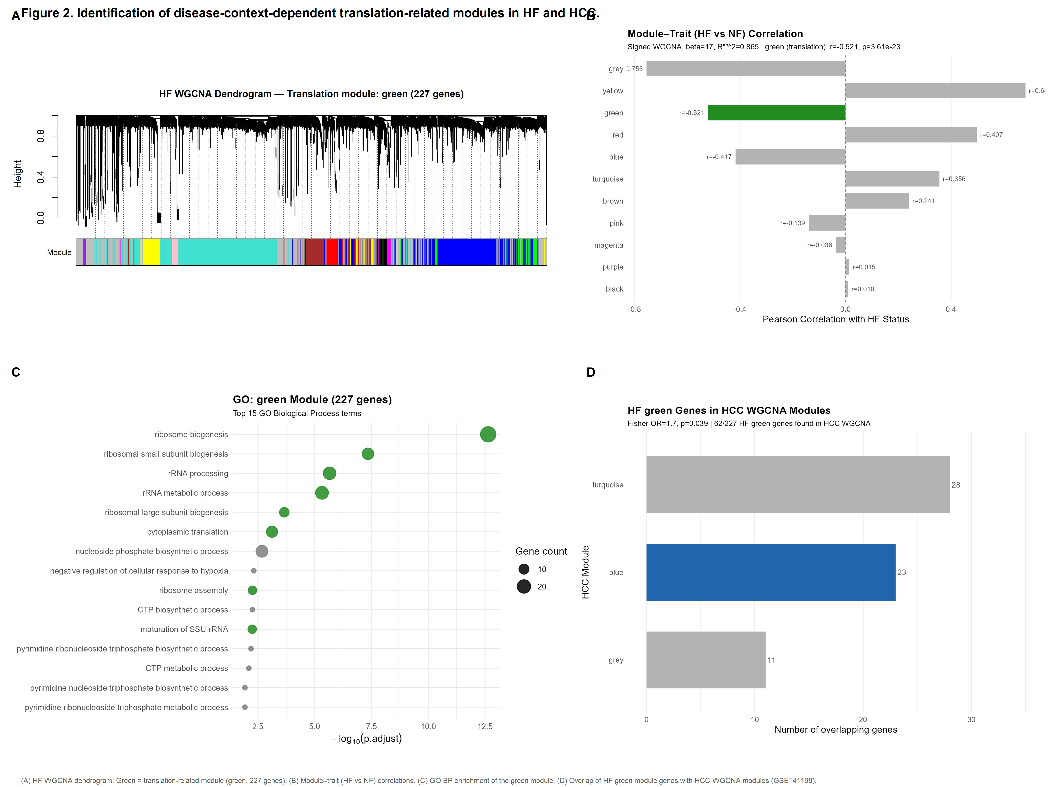
Figure 1
Fig. 1 | Identification of disease-context-dependent translation-related modules in HF and HCC. a, Gene dendrogram and module assignment from signed WGCNA of GSE57338 (HF, n = 313). The green module (227 genes) was identified as the translation-related module via GO-based scoring. b, Module–trait (HF vs. non-failing) correlation coefficients. Green module: r = −0.521 (P = 3.6 × 10⁻²³). c, GO Biological Process enrichment of the green module. Top terms include ribosome biogenesis (adjusted P = 2.3 × 10⁻¹³) and rRNA processing. d, Cross-disease module gene overlap: distribution of HF green module genes across HCC WGCNA modules (GSE141198). Limited gene-level overlap (62 of 227 genes found; Fisher OR = 1.7, P = 0.039), suggesting disease-context-dependent network organization rather than module conservation.

Opposite pathway-level perturbation of translation-related programs between HF and HCC
The network analysis revealed that HF and HCC each contain translation-related transcriptional programs, but organized through disease-specific co-expression architectures with limited gene-level overlap. We next asked whether, despite this network-level divergence, the two diseases exhibit convergent changes at the pathway level. To address this, we performed ssGSEA pathway enrichment scoring in parallel across 81 pathways (48 Hallmark + 1 KEGG ribosome + 32 Reactome translation-related pathways) in TCGA-LIHC (371 tumor vs. 50 normal) and GSE57338 (HF vs. non-failing), and computed Cohen’s d effect sizes for each pathway.
The Spearman correlation of effect sizes across all 81 pathways between the two diseases was ρ = −0.290 (P = 0.0089), reflecting an overall weak negative association. However, when the analysis was restricted to the 33 translation/ribosome-related pathways, the negative correlation in effect sizes increased to ρ = −0.598 (P = 0.0003; bootstrap 95% CI [−0.756, −0.340]). A 10,000-iteration permutation test supported this result (permutation P = 0.0079; Fig. 2). The specific composition of the 33 translation-related pathways and complete effect size data for all 81 pathways are provided in Additional file 6: Table S2.
Detailed examination of translation pathway effect sizes showed a consistent pattern: all 33 translation-related pathways showed positive effect sizes in HCC (Cohen’s d > 0, higher expression in tumor vs. normal tissue), whereas the vast majority showed negative effect sizes in HF (d < 0, lower expression in failing vs. non-failing myocardium). Among the 33 translation-related pathways, 24 exhibited an HCC-positive/HF-negative paired pattern, representing a predominant mirror-direction pattern (binomial test P < 0.0001; Additional file 8: Table S4). The remaining nine pathways were enriched for mitochondrial translation or miRNA-mediated translational regulation rather than canonical cytoplasmic translation pathways (Additional file 6: Table S2). Proliferation-associated pathways (E2F Targets, G2M Checkpoint, and MYC Targets V1) exhibited the largest positive effect sizes in HCC (Cohen’s d = +1.83 to +2.35). The most upregulated pathways in HF were Bile Acid Metabolism (d = +0.79) and Interferon Alpha Response (d = +0.67); their absolute effect sizes were considerably smaller than those of proliferation pathways in HCC.
This pathway-level mirror perturbation — with 24 of 33 translation pathways showing opposite-direction changes in HCC and HF — represents the strongest quantitative signal in this study (ρ = −0.598, permutation P = 0.0079). Importantly, this signal emerges at the pathway level despite the substantial network-level divergence between the two diseases’ translation-related modules. The contrast between distinct network organization and convergent pathway-level alterations illustrates a key analytical principle: co-expression network topology captures disease-specific regulatory configurations, whereas aggregated pathway activity identifies shared functional themes that transcend these configurational differences. This distinction — network-level differences with pathway-level convergence — is a central finding of this study and informs the interpretation of all subsequent analyses.
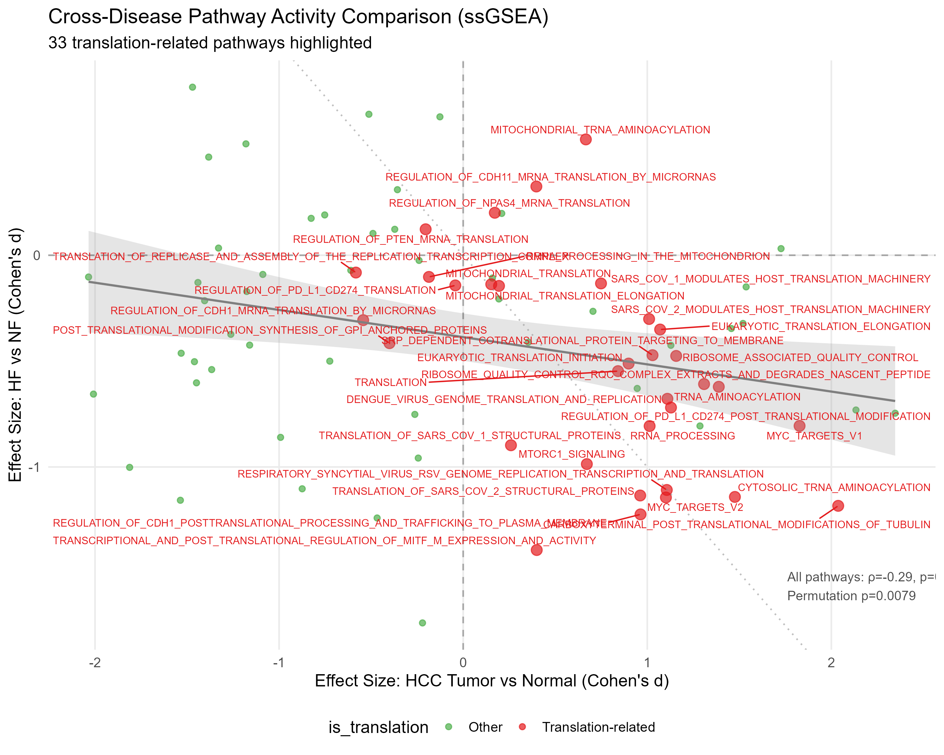
Figure 2
Fig. 2 | Cross-disease pathway-level mirror perturbation between HF and HCC. Scatter plot of Cohen’s d effect sizes for 81 pathways in HCC (TCGA-LIHC, tumor vs. normal, x-axis) versus HF (GSE57338, failing vs. non-failing, y-axis). Translation/ribosome-related pathways (n = 33) are shown as red points; non-translation pathways (n = 48) as gray points. For translation pathways, Spearman ρ = −0.598 (P = 0.0003; permutation test with 10,000 iterations, P = 0.0079). Dashed lines mark d = 0; the dotted diagonal (y = −x) represents perfect mirror symmetry. Twenty-four of 33 translation pathways fall in Quadrant IV (HCC↑ HF↓), representing the predominant mirror-direction pattern (binomial test P < 0.0001). This pathway-level convergence occurs despite distinct co-expression network organization (Fig. 1), indicating that shared functional themes can emerge from disease-specific regulatory architectures.

Disease and cohort context influence the magnitude of translation-related remodeling
The mirror perturbation observed in the GSE57338–TCGA-LIHC comparison (24/33 mirror pathways, ρ = −0.598) raises the question of whether this pattern is reproducible across independent cohorts — and, if not, what the sources of variability reveal about the underlying biology. To assess cross-cohort generalizability, the identical ssGSEA pipeline was applied to an independent HF cohort (GSE116250; 14 NF, 37 DCM, 13 ICM; RNA-seq).
The all-pathway Spearman correlation between GSE116250 HF effect sizes and TCGA-LIHC HCC effect sizes remained negative (ρ = −0.283, P = 0.011), preserving the overall cross-disease trend. However, the translation-pathway subset did not reproduce the magnitude of mirror perturbation observed in GSE57338 (ρ = +0.249, P = 0.162; 14/33 mirror pathways vs. 24/33 in GSE57338). This discrepancy may reflect several contributing factors: (i) disease etiology and severity — GSE57338 comprises advanced HF patients requiring transplantation (DCM/ICM) with severe energetic failure, whereas GSE116250 includes a broader disease spectrum with differing severity distribution; transplant-stage HF may produce a more pronounced reduction in translation-related transcriptional activity; (ii) platform — microarray (GSE57338) vs. RNA-seq RPKM (GSE116250) may differentially affect pathway-level signal resolution; and (iii) statistical power — the smaller sample size (n = 64 vs. n = 313) reduces precision for translation-subset comparisons. These factors collectively suggest that the mirror perturbation may represent a disease-state-associated transition whose magnitude varies with cohort characteristics, rather than a binary (present/absent) feature uniformly detectable across all HF populations. This context-dependent variability in the strength of translation-related remodeling is consistent with the disease-context-dependent framework.
The observed cross-cohort heterogeneity raised the question of whether the mirror perturbation could instead reflect constitutive transcriptional differences between cardiac and hepatic tissue, independent of the specific disease context. To distinguish disease-specific mirror perturbation from tissue-specific baseline characteristics, two same-organ disease comparisons were performed (Fig. 3). In the cardiac same-organ comparison (GSE141910; HCM vs. non-failing myocardium), translation pathway effect sizes showed no correlation with HCC (ρ = −0.036, P = 0.840; 14/33 mirror pathways), consistent with a null distribution. The absence of mirror perturbation in hypertrophic cardiomyopathy argues against a generic cardiac disease effect, indicating that the cross-disease HF–HCC mirror perturbation is unlikely to be explained by baseline cardiac tissue-related expression differences alone. In the liver same-organ comparison (GSE89377; cirrhosis vs. normal liver), translation pathway effect sizes were positively correlated with HCC (ρ = +0.402, P = 0.021; 9/33 mirror pathways), consistent with progressive activation of translation-related transcriptional programs during hepatocarcinogenesis. Together, these same-organ disease controls indicate that the mirror perturbation emerges within specific disease contexts rather than reflecting organ-level baseline differences. Collectively, these analyses indicate that the observed mirror perturbation is context-dependent, reproducible at the level of global pathway organization, and absent in same-organ disease comparisons.
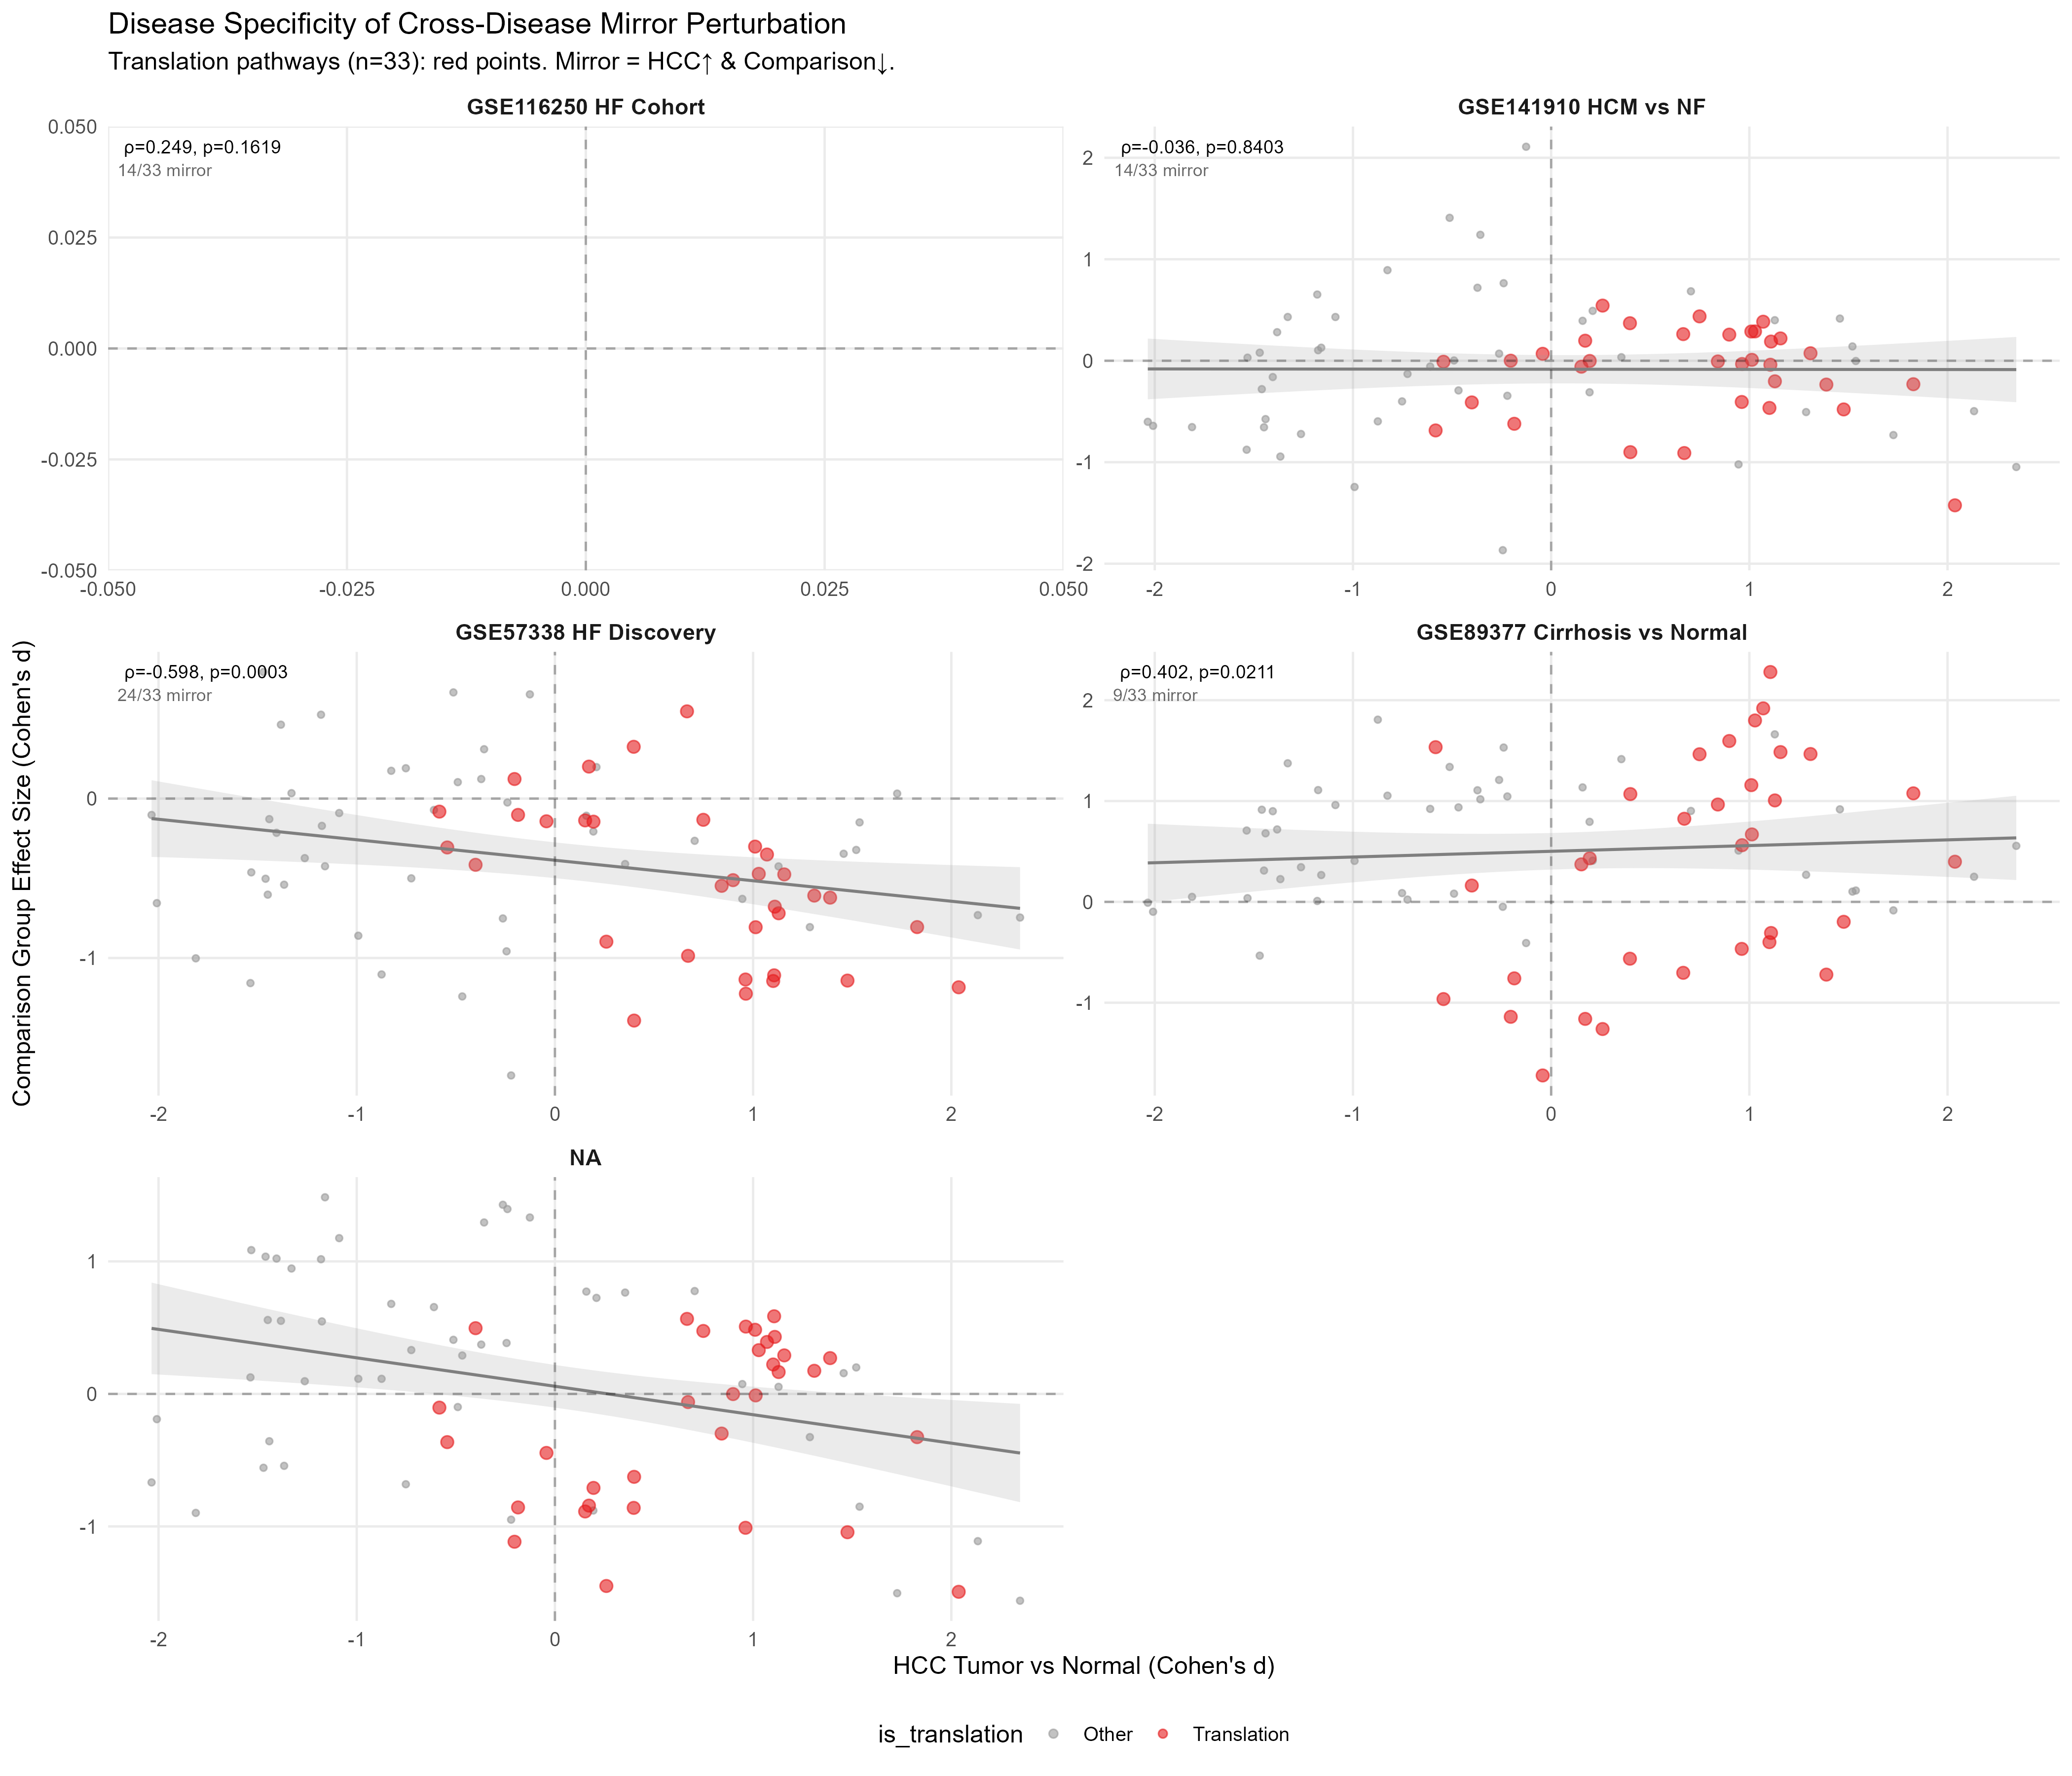
Figure 3
Fig. 3 | Cohort dependency and disease-context analyses of cross-disease mirror perturbation. Cross-disease Spearman correlation of pathway-level Cohen’s d effect sizes (x-axis: HCC, TCGA-LIHC) for 33 translation-related pathways (red) and 48 other pathways (gray). a, HF discovery cohort (GSE57338): ρ = −0.598, 24/33 mirror. b, Cardiac same-organ control (GSE141910, HCM vs. NF): ρ = −0.036 (P = 0.84) — no mirror perturbation, excluding a generic cardiac disease effect. c, Liver same-organ control (GSE89377, cirrhosis vs. normal): ρ = +0.402 (P = 0.021) — translation pathways positively correlated with HCC, consistent with progressive remodeling of translation-related programs during hepatocarcinogenesis. d, Independent HF cohort (GSE116250): overall cross-disease trend retained (all-pathway ρ = −0.283, P = 0.011); translation-subset shows cohort-dependent heterogeneity (ρ = +0.249, 14/33 mirror), indicating that the magnitude of mirror perturbation varies with disease etiology, severity, and platform. Mirror perturbation was absent in both same-organ comparisons, supporting disease-context dependence.

Exploratory assessment of TATS clinical associations
Given that translation-related programs may reflect biological states rather than prognostic determinants specific to individual diseases, we explored whether a translation-associated transcriptional score (TATS) — defined as the mean z-score normalized expression of the 227 green module genes — showed clinical outcome associations in independent HCC cohorts as an exploratory analysis. TATS was evaluated in HCC rather than HF because available HCC cohorts provide standardized survival annotation, whereas GSE57338 represents a cross-sectional transplant population without comparable long-term outcome data.
TATS was not significantly associated with overall survival in GSE141198 (n = 148, 94 events; log-rank P = 0.303; Fig. 4a). When analyzed as a continuous variable, TATS was also non-significant in Cox regression (HR = 1.68, 95% CI [0.67, 4.21], P = 0.265). Stratification by etiology (HBV, HCV, NBNC) revealed no significant association between TATS and survival in any subgroup. Across all three independent HCC cohorts — GSE141198, GSE14520 (n = 221), and GSE76427 (n = 115) — TATS showed no significant survival association. The limited survival association of TATS indicates that translation-related module activity, as measured by aggregate gene expression, was not associated with overall survival in the examined HCC cohorts. This finding is consistent with the disease-context-dependent interpretation: the transcriptional organization of translation-related genes may differ between HF and HCC, and their aggregate expression level in tumor tissue may not capture the clinical dimension most relevant to HCC outcome.
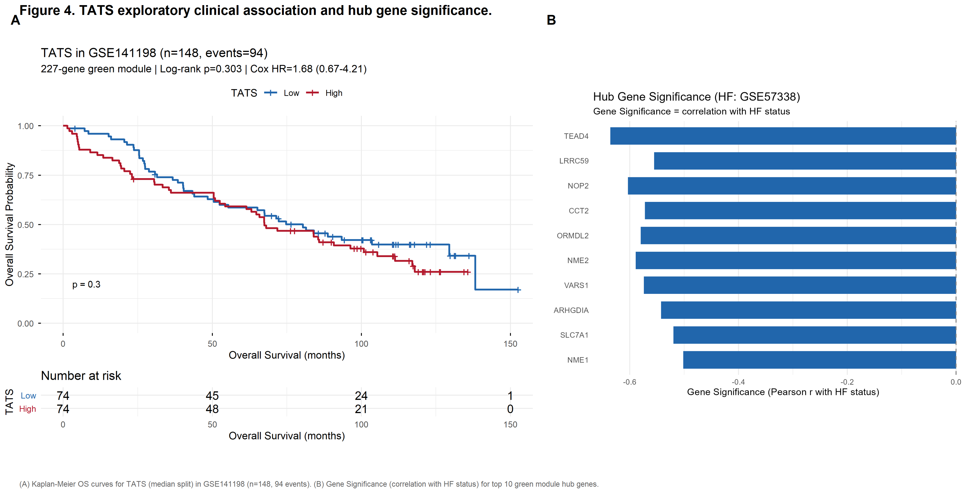
Figure 4
Fig. 4 | TATS exploratory clinical association and hub gene significance. a, Kaplan–Meier overall survival curves for TATS (median split) in the GSE141198 HCC cohort (n = 148, 94 events). Log-rank P = 0.303; Cox HR = 1.68, 95% CI [0.67, 4.21], P = 0.265. TATS was not significantly associated with overall survival. b, Gene Significance (Pearson correlation with HF status) for the top ten green module hub genes in GSE57338. All hub genes show negative Gene Significance, consistent with reduced expression of translation-associated hub genes in HF.

Regulatory associations with translation-related transcriptional programs
Given that translation-related programs exhibit disease-specific network organization and pathway-level mirror perturbation but limited clinical prognostic value, we next investigated which transcriptional programs are associated with translation-related transcriptional program activity. To address this, we performed systematic transcription factor (TF)–TATS correlation analysis across GSE141198 tumor samples (n = 148). Nineteen candidate TFs were selected, encompassing stress response-related TFs (ATF4, DDIT3, XBP1, HIF1A, NFE2L2, TP53), cell-cycle regulators (E2F family, E2F1–E2F8), and growth/proliferation regulators (MYC, MYCN, MYCL, MTOR, RPTOR).
At the pathway activity level, MYC target pathway activity showed the strongest overall correlation with TATS (MYC Targets V2: ρ = +0.753, P < 0.0001; MYC Targets V1: ρ = +0.459, P < 0.0001; Fig. 5b), showing a substantially stronger correlation than MYC mRNA level alone (ρ = +0.255). This discrepancy between TF mRNA level and target pathway activity may reflect regulation of MYC pathway activity beyond transcript abundance and the statistical benefit of aggregating multiple target genes into a pathway score. To evaluate whether the MYC Targets V2–TATS association was driven by shared gene representation rather than pathway-level concordance, we quantified the gene overlap between the TATS constituent genes (227 green module genes) and each Hallmark pathway gene set (Additional file 11: Table S7). MYC Targets V2 showed 9 overlapping genes (4.0% of TATS; Jaccard index = 0.033), MYC Targets V1 showed 12 (5.3%), and E2F Targets showed 4 (1.8%). De-overlap sensitivity analysis — removing the nine shared genes from TATS and recomputing all TF–TATS correlations — indicated that the correlation pattern remained similar: ATF4–TATS ρ = 0.499 (vs. 0.500 original), MYC mRNA–TATS ρ = 0.223 (vs. 0.255) (Additional file 11: Table S7). Of the nine overlapping genes between TATS and MYC Targets V2, eight were present in the GSE141198 expression matrix (one gene was absent due to platform annotation filtering). TATS-side de-overlap — removing these eight genes from the TATS gene set, while the ssGSEA-based MYC Targets V2 pathway score (which aggregates over the full Hallmark gene set via the GSVA algorithm) was unchanged — indicated that the MYC Targets V2–TATS association remained robust (de-overlap ρ = 0.714, bootstrap 95% CI [0.620, 0.786]; original ρ = 0.753, bootstrap 95% CI [0.666, 0.817]), consistent with reduced likelihood that the pathway-level association is solely explained by shared genes. E2F Targets (ρ = +0.409, P < 0.0001) and MTORC1 Signaling (ρ = +0.335, P < 0.0001) pathway activities were also positively associated with TATS, consistent with the proliferative association of translation-related transcriptional remodeling.
At the individual TF expression level, eleven of nineteen TFs were significantly correlated with TATS at FDR < 0.05. Among these, ATF4 showed the strongest association among individual TF transcripts (ρ = +0.500, FDR < 0.0001; bootstrap 95% CI [0.359, 0.621]; Fig. 5a). ATF4 is a central transcription factor of the integrated stress response (ISR), a conserved signaling cascade associated with stress-responsive transcriptional regulation. Additional ISR and unfolded protein response (UPR)-related TFs were also significantly associated with TATS: DDIT3 (CHOP; ρ = +0.338, FDR < 0.0001; bootstrap 95% CI [0.192, 0.475]) and XBP1 (ρ = +0.180, FDR = 0.050), indicating co-association of ISR-related transcriptional programs rather than isolated ATF4 upregulation. Among the E2F family, multiple members showed positive correlations: E2F1 (ρ = +0.352, FDR < 0.0001), E2F2 (ρ = +0.291, FDR = 0.001), E2F3 (ρ = +0.270, FDR = 0.003), E2F4 (ρ = +0.202, FDR = 0.029), and E2F6 (ρ = +0.191, FDR = 0.038). NFE2L2 was negatively correlated with TATS (ρ = −0.280, FDR = 0.002), while MYCL showed the strongest negative association (ρ = −0.388, FDR < 0.0001). Among the remaining TFs, MYC mRNA showed a significant but modest individual correlation (ρ = +0.255, FDR = 0.004; see also pathway-level MYC activity above), while E2F5 (ρ = +0.101, FDR = 0.318), E2F7 (ρ = −0.001, FDR = 0.988), E2F8 (ρ = +0.098, FDR = 0.318), MYCN (ρ = +0.001, FDR = 0.989), and RPTOR (ρ = +0.166, FDR = 0.069) showed weak or non-significant individual associations. HIF1A (ρ = −0.039, FDR = 0.756), MTOR (ρ = +0.021, FDR = 0.895), and TP53 (ρ = +0.041, FDR = 0.756) showed no significant correlation with TATS in this cohort. Complete TF–TATS correlation statistics for all 19 candidate TFs are provided in Additional file 10: Table S6.
These results identify two associated transcriptional dimensions linked to translation-related transcriptional programs in HCC: (i) proliferative demand — MYC target pathway activity (ρ = +0.753), reflecting the association between proliferative signaling and translation-related transcriptional programs; and (ii) stress-responsive signaling — ATF4/ISR (ρ = +0.500), co-associated with DDIT3 and XBP1, linking cellular stress adaptation to translation-related transcriptional changes. These dimensions are complementary rather than competing: MYC pathway activity (ρ = +0.753) and ATF4 expression (ρ = +0.500) represent distinct regulatory layers — proliferative pathway output and stress-responsive transcriptional control, respectively — that may co-occur with translation-related remodeling in HCC. These associations are correlational and require experimental validation to establish causality.
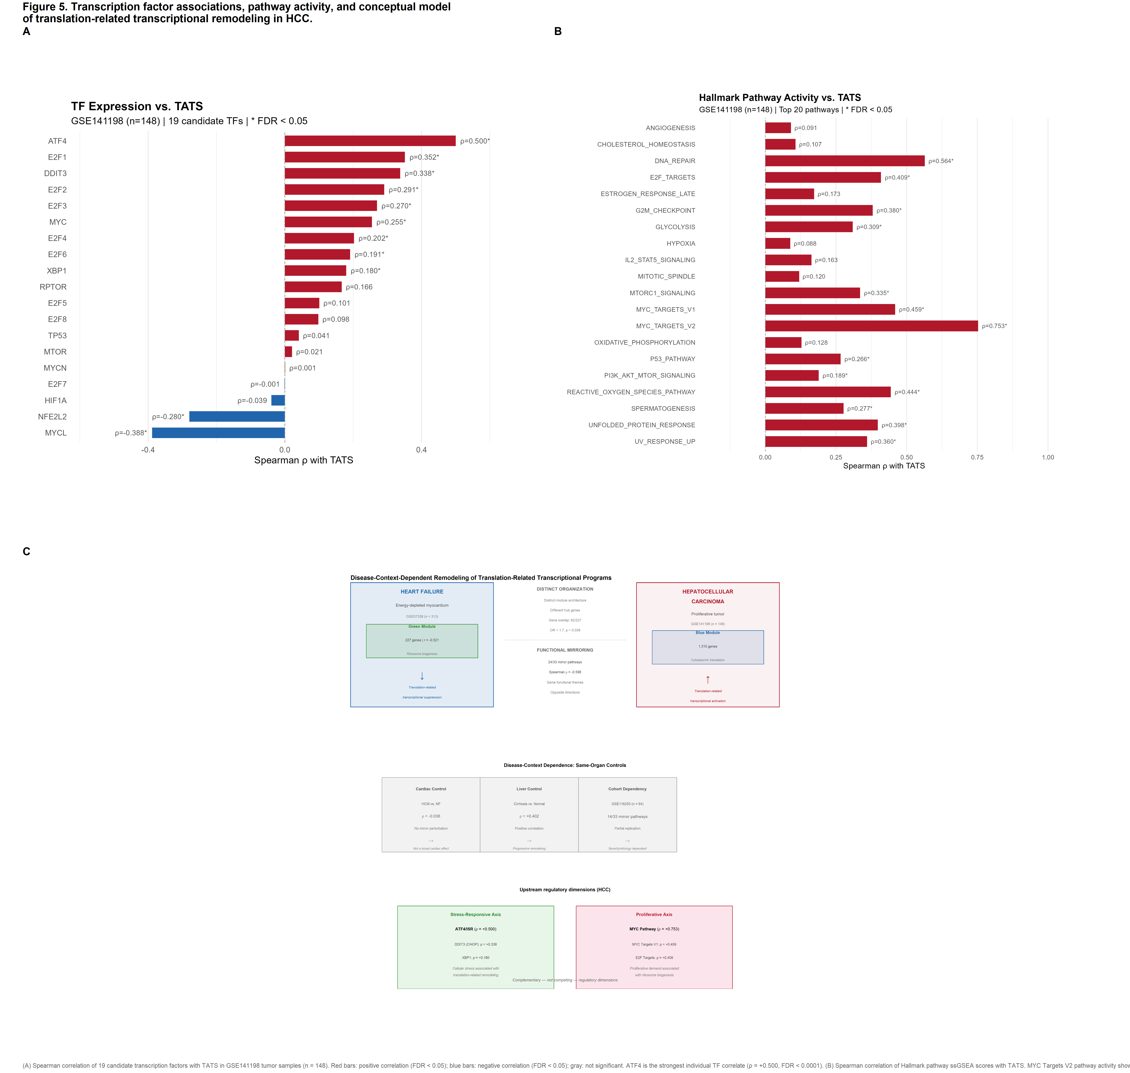
Figure 5
Fig. 5 | Transcription factor associations, pathway activity, and conceptual model of translation-related transcriptional remodeling in HCC. a, Spearman correlation of 19 candidate transcription factors with TATS in GSE141198 tumor samples (n = 148). Red bars: positive correlation (FDR < 0.05); blue bars: negative correlation (FDR < 0.05); gray: not significant. ATF4 is the strongest individual TF correlate (ρ = +0.500, FDR < 0.0001). b, Spearman correlation of Hallmark pathway ssGSEA scores with TATS. MYC Targets V2 pathway activity shows the strongest overall association (ρ = +0.753, P < 0.0001), exceeding MYC mRNA level alone (ρ = +0.255). ATF4/ISR (stress-responsive) and MYC (proliferative) represent complementary transcriptional dimensions associated with translation-related transcriptional remodeling. c, Conceptual model of disease-context-dependent remodeling. (Top) HF and HCC exhibit distinct co-expression network organization (green module, 227 genes, ribosome biogenesis vs. blue module, 1,315 genes, cytoplasmic translation) with limited gene-level overlap (Fisher’s exact test, OR = 1.7, P = 0.039), yet converge on opposite-direction pathway perturbation (24/33 mirror pathways, ρ = −0.598). (Middle) Same-organ disease controls confirm disease-context dependence: HCM vs. NF shows no mirror perturbation (ρ = −0.036), excluding a broad cardiac disease-related explanation; cirrhosis vs. normal shows positive correlation (ρ = +0.402), consistent with progressive remodeling of translation-related programs during hepatocarcinogenesis; an independent HF cohort (GSE116250) shows partial replication (14/33 mirror pathways), indicating severity/etiology-dependent variability. (Bottom) Two complementary candidate regulatory dimensions associated with TATS in HCC: stress-responsive (ATF4/ISR, ρ = +0.500) and proliferative (MYC pathway, ρ = +0.753).

Discussion
This study investigated whether translation-related transcriptional programs are organized through conserved network architectures or disease-specific remodeling across heart failure and hepatocellular carcinoma — two diseases with fundamentally opposing translational demands. Three principal findings emerge. First, systematic WGCNA-based module discovery identified translation-related co-expression modules in both diseases (HF green module, 227 genes, ribosome biogenesis; HCC blue module, 1,315 genes, cytoplasmic translation), but their network organization — module size, gene composition, and hub gene identity — differed substantially, with limited gene-level overlap (Fisher OR = 1.7, P = 0.039). Second, despite this network-level divergence, translation pathways exhibited convergent mirror perturbation at the pathway level: 24 of 33 translation-related pathways showed opposite-direction changes in HCC and HF (Spearman ρ = −0.598, P = 0.0003), representing the strongest quantitative signal in this study. Third, this mirror perturbation was absent in same-organ disease controls (HCM vs. NF, ρ = −0.036; cirrhosis vs. normal, ρ = +0.402), supporting disease-context dependence rather than organ-specific baseline confounding, and showed cohort-dependent variability in an independent HF cohort (GSE116250, 14/33 mirror pathways). Collectively, these findings identify a pattern of disease-context-dependent remodeling: translation-related transcriptional programs are independently identifiable across diseases but organized through distinct network organization, with shared functional themes emerging at the pathway level and perturbation direction shaped by disease context.
The contrast between distinct network organization and convergent pathway-level alterations is the central conceptual finding of this study. Previous cross-disease transcriptomic studies have typically sought either conserved modules or differentially expressed genes; our analysis at multiple resolutions — co-expression network topology, module composition, and aggregated pathway activity — indicates that conservation and divergence coexist at different levels of biological organization. The HF green module (227 genes, ribosome biogenesis) and the HCC blue module (1,315 genes, cytoplasmic translation) share translation-related functional themes at the GO enrichment level, yet their gene composition, hub gene identity, and regulatory architecture are disease-specific. This suggests that distinct regulatory networks may independently converge on similar biological processes under different disease contexts, rather than involving an identical conserved module altered in opposite directions. The mirror perturbation observed at the pathway level (ρ = −0.598) therefore reflects convergence of functional output — translation-related transcriptional suppression in the energy-depleted failing myocardium and activation of translation-related transcriptional programs in the proliferative HCC microenvironment — observed across disease-specific network configurations. We refer to this descriptive pattern as disease-context-dependent remodeling: shared functional themes, disease-specific network organization, and opposite perturbation directions. This framework differs fundamentally from the “conserved module” model and provides a more nuanced lens for cross-disease transcriptomic comparisons.
The same-organ disease controls provide critical context for this interpretation. The absence of mirror perturbation in hypertrophic cardiomyopathy (GSE141910; ρ = −0.036) argues against a generic cardiac disease effect, while the positive correlation in cirrhosis (GSE89377; ρ = +0.402) is consistent with progressive remodeling of translation-related transcriptional programs across hepatocarcinogenesis-associated conditions. These controls indicate that the HF–HCC mirror perturbation reflects disease-context-dependent remodeling rather than constitutive tissue-specific transcriptional programs — a distinction that single-disease analyses cannot resolve.
The translation-focused pathway subset exhibited cohort-dependent heterogeneity: the mirror perturbation was prominent in the discovery cohort (GSE57338, 24/33 mirror pathways, ρ = −0.598) but did not reproduce the same magnitude in an independent HF cohort (GSE116250, 14/33 mirror pathways; translation-subset ρ = +0.249, P = 0.162). This cohort-dependent heterogeneity suggests that the magnitude of translation-related remodeling varies with disease severity, etiology composition, and cohort characteristics. Therefore, the cross-disease mirror pattern should be interpreted as a context-dependent observation rather than a universal feature of HF. Transplant-stage HF (GSE57338) may exhibit a more pronounced reduction in translation-related transcriptional activity than cohorts spanning a broader disease spectrum (GSE116250). This interpretation is consistent with an energy-constrained state in which reduced translation-related transcriptional activity may accompany increased energetic stress^{[19,20,21]}. The smaller effect sizes in HF compared with HCC further suggest that reduced translation-associated activity in the failing heart reflects gradual, incomplete compensation rather than the robust oncogene-driven transcriptional reprogramming characteristic of cancer.
Among the transcription factors and pathways examined, MYC target pathway activity showed the highest overall correlation with the translation-associated transcriptional score (ρ = +0.753), while ATF4 showed the strongest association among individual transcription factors (ρ = +0.500, FDR < 0.0001). MYC target pathway activity (particularly MYC Targets V2, which is enriched for ribosome biogenesis and translation-related genes) likely reflects the association of proliferative signaling with cellular programs linked to ribosome biogenesis^{[8,12,22]}. The strong MYC–TATS association should be interpreted as pathway-level concordance rather than direct evidence of upstream regulation, as both TATS and MYC target gene sets share representation of translation-related genes. ATF4, a central transcription factor of the integrated stress response (ISR), has been implicated in coupling cellular stress sensing with translational regulation^{[23,24,25]}; its co-association with DDIT3 (CHOP) and XBP1 — ISR and UPR signaling components — suggests pathway-level engagement rather than isolated ATF4 upregulation. These represent distinct regulatory dimensions — proliferative (MYC) and stress-responsive (ATF4/ISR) — neither subordinate to the other, both associated with translation-related transcriptional remodeling in HCC. In this cohort, HIF1A and MTOR transcript levels were not significantly correlated with TATS, suggesting that their regulatory relationship with translation-related programs may be indirect or context-dependent rather than reflected at steady-state mRNA levels. These correlational findings nominate MYC and ATF4/ISR as candidate regulatory signals associated with translation-related transcriptional remodeling in HCC; causal validation through ChIP-seq and functional perturbation experiments is required.
The translation-associated transcriptional score (TATS) was not intended as a disease-specific biomarker but as a cross-disease transcriptional representation of a translation-associated program shared at the pathway level. TATS, defined as the mean normalized expression of the 227 green module genes, showed no significant prognostic value in GSE141198 (log-rank P = 0.303; Cox HR = 1.68, 95% CI [0.67, 4.21], P = 0.265) or in etiology-stratified subgroups. This is consistent across three independent HCC cohorts. The lack of prognostic association indicates that translation-related module activity, measured as aggregate transcript abundance, was not associated with overall survival in the examined HCC cohorts. This result is informative: it indicates that shared functional themes do not imply equivalent clinical utility, and that the relationship between translation-related transcription and clinical outcome is context-dependent. The absence of prognostic association also suggests that pathway-level transcriptional remodeling does not necessarily translate into patient-level outcome prediction, underscoring the distinction between molecular pathway activity and clinical prognostic utility. More broadly, the absence of prognostic association further suggests that shared translation-related programs represent context-dependent biological states rather than universal predictors of malignant progression.
Several limitations should be considered. Because this study is based on transcriptomic datasets, the identified translation-related programs represent transcriptional organization of translation-associated genes rather than direct measurements of translational efficiency or protein synthesis rates; ribosome footprint profiling (Ribo-seq) would substantially strengthen the evidence for altered translational activity^{[26]}. These findings represent disease-associated transcriptional organization inferred from bulk expression data and should not be interpreted as direct evidence of causal network rewiring or dynamic remodeling. Bulk transcriptomes cannot fully separate transcriptional remodeling from changes in cellular composition (e.g., cardiomyocyte loss and fibroblast proliferation in HF, tumor purity variation and stromal infiltration in HCC); cell-type deconvolution was beyond the scope of this analysis and represents an important direction for future studies. The ATF4/ISR regulatory hypothesis is derived from correlational analysis and requires causal validation. Moreover, although mirror perturbation was observed at the pathway level in both HF and HCC discovery datasets, the extent of pathway-level concordance may vary with cohort characteristics including disease subtype composition, severity distribution, and transcriptomic platform differences, as suggested by partial replication in an independent HF cohort (GSE116250). Platform differences between microarray (GSE57338) and RNA-seq (TCGA-LIHC, GSE141198) datasets, while mitigated by within-dataset effect size computation, may introduce systematic bias. Network construction parameters were independently optimized within each dataset according to WGCNA best practices (scale-free topology criterion, R² ≥ 0.8); cross-dataset comparisons of network topology should therefore be interpreted as reflecting both biological differences and dataset-specific optimization, rather than as comparisons between identically parameterized networks. Formal module preservation analysis (e.g., WGCNA modulePreservation) was not performed owing to well-documented cross-platform interpretability challenges in Zsummary threshold calibration; the gene-level overlap quantification reported here (Fisher OR = 1.7, P = 0.039) provides an empirical assessment of limited module gene sharing. While WGCNA provides a well-established framework for co-expression network discovery, alternative network inference methods may identify additional regulatory relationships. HCC cohorts are composed predominantly of individuals of Asian ancestry, and cross-population generalizability requires further evaluation. The cross-disease comparison, while internally controlled through within-dataset effect sizes, remains observational; prospective multi-omics studies with paired ribosome profiling would be required to establish causal relationships between transcriptional remodeling and translational output.

Conclusion
These findings indicate that translation-related transcriptional programs are independently identifiable in HF and HCC but organized through disease-specific network organization, with convergent functional themes emerging at the pathway level and perturbation direction shaped by disease context. The contrast between network-level divergence and pathway-level convergence — rather than module conservation — characterizes one aspect of the relationship between these two diseases. From a cardiovascular perspective, this cross-disease framework illuminates fundamental principles of translation-related remodeling that are obscured in heart-failure-only analyses: the identification of ATF4/ISR as a stress-responsive correlate suggests that the failing heart engages conserved stress-adaptive transcriptional programs that are also co-opted during hepatocarcinogenesis, and the mirror perturbation absent in HCM but present in advanced HF suggests that progressive translational suppression may represent a disease-stage-specific vulnerability rather than a generic cardiac feature. This disease-context-dependent remodeling framework (Fig. 5) provides a foundation for future mechanistic studies investigating how distinct pathological environments reshape translation-related transcriptional programs, and illustrates the value of multi-resolution cross-disease comparative frameworks for identifying regulatory principles — and potentially therapeutic entry points — difficult to resolve through single-disease analyses.

Methods

Data acquisition and preprocessing
All datasets used in this study are publicly available and were originally collected with informed consent and ethical approval as described in their respective publications. No new data involving human participants or animals were generated for this study.
Datasets were selected based on the following criteria: (i) availability of both disease and non-disease control samples within the same study; (ii) sample size ≥ 100; and (iii) raw or normalized expression matrices publicly available.
GSE57338 (HF). Downloaded from GEO, n = 313 left ventricular samples (including dilated cardiomyopathy, ischemic cardiomyopathy, and non-failing controls), platform GPL11532 (Affymetrix HuGene 1.1 ST Array). Probes were first filtered to retain those with expression above a predefined background threshold (log2 intensity ≥ 4) in at least 20% of samples, and the remaining probes were then mapped to gene symbols via the hugene11sttranscriptcluster.db annotation package, with multiple probes averaged per gene.
TCGA-LIHC (HCC discovery set). Downloaded from the TCGA GDC portal, n = 424 samples (initially 371 tumor + 50 normal + 3 recurrent tumor), RNA-seq (Illumina), using assay(se, "unstranded") for counts. Three recurrent tumor samples were excluded from differential expression and pathway analyses because they were not classified as primary tumor or normal liver tissue; all downstream analyses therefore used n = 421 (371 tumor vs. 50 normal). DESeq2 variance stabilizing transformation (VST) normalization was applied using the vst function^{[13]} with blind = TRUE and nsub = 1000 parameters (design = ~ 1), following filtering for genes with counts ≥ 10 in at least 20% of samples. Ensembl IDs were converted to gene symbols via org.Hs.eg.db.
GSE141198 (HCC validation set). Downloaded from GEO, n = 148 HCC tumors (RNA-seq), 94 OS events. Processing pipeline identical to TCGA-LIHC.
GSE14520 and GSE76427 (external validation). GSE14520 (n = 221 HCC tumors, GPL3921 Affymetrix HT Human Genome U133A Array) and GSE76427 (n = 115 HCC tumors, GPL10558 Illumina HumanHT-12 V4.0) were downloaded from GEO for external TATS validation. Processing and TATS calculation were performed identically across all validation cohorts.

WGCNA co-expression network analysis
WGCNA input data consisted of gene expression matrices filtered and normalized as described above. For GSE57338 (microarray data), the bottom 20% of genes by variance were removed, and the top 6,000 most variable genes were retained for network construction (retaining 177 of 214 ribosomal/translation-related genes in the full expression matrix). For GSE141198 (RNA-seq data), all expressed genes passing the above filters (5,003 genes) were used. Signed network analysis was performed using the WGCNA package^{[14,15]}. The soft threshold β was selected to best approximate the scale-free topology criterion (targeting R² ≈ 0.85; GSE57338: β = 17, signed R² = 0.865; GSE141198: β = 4, R² = 0.84; Additional file 3: Figure S3). Network construction parameters — including soft-threshold power, gene filtering strategy, and module detection method — were independently optimized for each dataset according to platform-specific data characteristics, rather than artificially constrained to identical settings across diseases.
For GSE57338, a manual stepwise procedure was used: Pearson correlation (stats::cor) → signed adjacency matrix [(0.5 × (1 + cor))^β] → TOM similarity (WGCNA::TOMsimilarity, TOMType = “signed”) → hierarchical clustering (hclust, method = “average”) → dynamic tree cutting (dynamicTreeCut::cutreeDynamic, deepSplit = 2, minClusterSize = 30). This manual procedure was adopted to ensure platform compatibility across R versions. For GSE141198, the WGCNA blockwiseModules one-step function was used for network construction (networkType = “signed”, minModuleSize = 30, mergeCutHeight = 0.25, TOMType = “signed”, pamRespectsDendro = FALSE, maxBlockSize = 6,000, randomSeed = 42).
Translation-related module identification. Rather than designating a translation-related module by manual inspection or prior assumption, an objective translation-enrichment scoring procedure was applied. For each module, GO Biological Process enrichment was performed using clusterProfiler^{[16]} (enrichGO, ont = “BP”, pAdjustMethod = “BH”, qvalueCutoff = 0.1). A module-level translation enrichment score was computed as: (number of significantly enriched GO terms matching translation-related keywords [“translation|ribosom|peptide|ribonucleoprotein|rRNA|translational”]) × (−log10 of the best p.adjust among those terms). The module with the highest translation-enrichment score was designated the translation-related module. In this study, “translation-related transcriptional programs” refer to coordinated expression patterns of genes involved in ribosome biogenesis, translation machinery, and associated regulatory processes, rather than direct measurements of protein synthesis activity. For GSE141198, the blue module (1,315 genes, “cytoplasmic translation” adjusted P = 6.3 × 10⁻¹²) was identified as the translation-related module using the same keyword-based functional annotation approach.
Hub gene identification. Hub genes within the translation-related module were identified post hoc using the dual criteria of intramodular connectivity (|Module Membership| > 0.80) and gene significance for the disease phenotype (|Gene Significance| > 0.20). Hub genes were ranked by the product |GS| × |MM|. No genes were pre-specified or excluded based on biological expectations.
Module internal robustness assessment. To verify that the green module represents a genuine internally robust co-expression structure rather than an artifact of the β = 17 soft-threshold parameter or top-6,000 gene filtering, intra-modular connectivity was assessed via the topological overlap matrix (TOM). Mean intra-modular TOM for the green module (227 genes) was compared against a null distribution generated from 10,000 random gene sets of equal size, yielding a Z-score and empirical P-value. Module stability was further evaluated by gene-level jackknife resampling (90% retention per iteration, 100 iterations) to assess the coefficient of variation (CV) of intra-modular connectivity. Cross-disease coherence was assessed by computing the mean absolute pairwise Pearson correlation of green module genes in the independent GSE141198 expression matrix and comparing this against 1,000 random gene sets of equal size.

ssGSEA pathway activity analysis
Gene set sources: msigdbr package (v26.1.0), including all 50 Hallmark gene sets (collection = “H”), KEGG ribosome (collection = “C2”, subcollection = “CP:KEGG_MEDICUS”, 1 set), and Reactome translation-related pathways (collection = “C2”, subcollection = “CP:REACTOME”, keyword-filtered: TRANSLATION|PEPTIDE_CHAIN_ELONGATION|EUKARYOTIC_TRANSLATION|RIBOSOME|NONSENSE_MEDIATED|TRNA_AMINOACYLATION|RRNA_PROCESSING, 32 sets), yielding 83 input gene sets. During ssGSEA scoring, the minSize = 5 parameter (requiring ≥ 5 genes from a given gene set to be present in the expression matrix) filtered two Hallmark sets with insufficient gene coverage, resulting in 81 pathways retained for cross-disease comparison.
ssGSEA scoring was performed using the GSVA package (v2.6.2): parameter objects were constructed via ssgseaParam (minSize = 5, maxSize = 500), and single-sample pathway activity scores were computed using the gsva function from the GSVA package^{[17]}, which implements the ssGSEA algorithm originally described by Barbie et al.^{[18]} Disease-associated effect size for each pathway was calculated as Cohen’s d. Cross-disease Spearman correlation of pathway effect sizes was evaluated. Statistical significance of the cross-disease correlation was assessed by a 10,000-iteration permutation test (random seed = 42), where the vector of HF pathway effect sizes was randomly shuffled in each iteration.

Translation-associated transcriptional score (TATS) and survival analysis
The translation-associated transcriptional score (TATS) was defined as the mean of z-scores of VST-normalized expression values for the green module genes (n = 227) identified in the HF WGCNA. TATS was evaluated as an exploratory measure of translation-related transcriptional activity rather than as a validated prognostic signature. For GSE141198, OS time and status were obtained from the “os days:ch1” and “os status:ch1” fields, respectively. For GSE14520 and GSE76427, OS definitions followed the respective GEO record annotations. Patients were dichotomized into high/low TATS groups by median TATS. Kaplan–Meier survival curves were compared using the log-rank test. Cox proportional hazards regression was performed using the survival package, with TATS modeled as both a continuous variable (per-IQR increase) and a binary variable (median split). Multivariate Cox models were adjusted for etiology (HBV, HCV, NBNC) in cohort-specific subgroup analyses where etiology data were available. The proportional hazards assumption was assessed using Schoenfeld residual tests.

Upstream transcription factor analysis
Nineteen candidate TFs were selected based on literature and MSigDB: ATF4, DDIT3, E2F1, E2F2, E2F3, E2F4, E2F5, E2F6, E2F7, E2F8, HIF1A, MTOR, MYC, MYCL, MYCN, NFE2L2, RPTOR, TP53, XBP1. This list encompasses the MYC family (MYC, MYCN, MYCL), the E2F family (E2F1–E2F8), mTOR pathway components, and stress-responsive TFs (ATF4, DDIT3, XBP1, HIF1A, NFE2L2, TP53).
Spearman correlation coefficients were computed between VST-normalized expression values of each TF and TATS across GSE141198 tumor samples (n = 148). Benjamini–Hochberg (BH) false discovery rate (FDR) correction was applied across all 19 tests.

Direction consistency testing
Cross-disease log2 fold-change (log2FC) values for translation-related module genes were obtained from TCGA-LIHC (tumor vs. normal, DESeq2) and GSE57338 (HF vs. non-failing, limma). Spearman correlation of cross-disease log2FC was used to assess directional consistency. Significance was evaluated by a 10,000-iteration permutation test (random seed = 42): the HCC-side log2FC vector was randomly shuffled in each iteration, and the one-sided empirical P-value was computed as the proportion of permuted Spearman ρ values exceeding the observed ρ.

Large language model usage
No large language models or generative AI tools were used in the design, execution, analysis, or writing of this study. All data analyses, statistical tests, and manuscript composition were performed by the authors.

Statistical analysis
All analyses were conducted in R version 4.6.0 (2026-04-24 ucrt). The following R packages were used: WGCNA (v1.74), DESeq2 (v1.52.0), GSVA (v2.6.2), msigdbr (v26.1.0), clusterProfiler (v4.20.0), survival (v3.8-6), survminer (v0.5.2), limma (v3.68.4), org.Hs.eg.db (v3.23.1), hugene11sttranscriptcluster.db (v8.8.0), TCGAbiolinks (v2.40.0), and dynamicTreeCut (v1.63-1). A complete session information record is available in the GitHub repository. The statistical significance threshold was set at two-sided P < 0.05 unless otherwise stated. The BH FDR correction was applied for multiple testing correction throughout (GO enrichment, TF–TATS correlations). Permutation tests used 10,000 iterations with a fixed random seed (set.seed(42)) to ensure reproducibility. Missing data were not imputed (missing rate < 5% in all datasets).

Robustness assessment across independent heart failure cohorts
To assess the cross-cohort robustness of the mirror perturbation, an independent HF cohort (GSE116250; n = 64: 14 non-failing donors, 37 dilated cardiomyopathy, 13 ischemic cardiomyopathy) was analyzed using the identical ssGSEA pipeline. RNA-seq RPKM values were log2-transformed, and Cohen’s d effect sizes were computed for the 33 translation-related pathways (DCM + ICM vs. NF). Cross-disease effect size correlation (Spearman ρ) and sign concordance (mirror pathway overlap) between GSE116250 and TCGA-LIHC were compared with the original GSE57338–TCGA-LIHC comparison.

Same-organ disease controls
To distinguish disease-specific mirror perturbation from constitutive tissue-specific differences, two same-organ disease comparisons were performed: (i) hypertrophic cardiomyopathy (HCM) vs. non-failing myocardium (GSE141910; n = 28 HCM, n = 166 NF), as a cardiac disease comparison; and (ii) cirrhosis vs. normal liver (GSE89377; n = 12 cirrhosis, n = 13 normal), as a liver disease comparison. The identical ssGSEA pipeline was applied, and cross-disease effect size correlations with TCGA-LIHC were computed for each. A null or non-negative correlation in same-organ comparisons, contrasted with the negative correlation in the HF–HCC comparison, would support disease-context dependence rather than organ-specific baseline confounding.

Availability of data and materials
All datasets used in this study are publicly available: GSE57338, GSE141198, GSE14520, and GSE76427 from the Gene Expression Omnibus (https://www.ncbi.nlm.nih.gov/geo/); TCGA-LIHC from the GDC Data Portal (https://portal.gdc.cancer.gov/).
Analysis code has been deposited in a GitHub repository and is accessible via an anonymous link during peer review: https://anonymous.4open.science/r/translation-mirror-hf-hcc-4622/. The repository (project name: translation-mirror-hf-hcc) contains the complete WGCNA, ssGSEA, TF correlation, and direction consistency analysis pipelines. Programming language: R and Python. License: MIT. Upon acceptance, the repository will be made publicly available and assigned a permanent DOI through Zenodo.

References
- Mericskay, M., Zuurbier, C. J., Lopaschuk, G. D. & Taegtmeyer, H. Cardiac intermediary metabolism in heart failure: substrate use, signalling roles and therapeutic targets. Nat. Rev. Cardiol. 22, 704–727 (2025).
- Abdellatif, M., Rainer, P. P., Sedej, S. & Kroemer, G. Hallmarks of cardiovascular ageing. Nat. Rev. Cardiol. 20, 754–777 (2023).
- Lu, X., Paliogiannis, P., Calvisi, D. F. & Chen, X. Role of the mammalian target of rapamycin pathway in liver cancer: from molecular genetics to targeted therapies. Hepatology 73, 49–61 (2021).
- Llovet, J. M. et al. Molecular pathogenesis and systemic therapies for hepatocellular carcinoma. Nat. Cancer 3, 386–401 (2022).
- Lanzer, J. D. et al. A cross-study transcriptional patient map of heart failure defines conserved multicellular coordination in cardiac remodeling. Nat. Commun. 16, 3560 (2025).
- Xie, S., Xu, M., Deng, W. & Tang, Q. Metabolic landscape in cardiac aging: insights into molecular biology and therapeutic implications. Signal Transduct. Target. Ther. 8, 114 (2023).
- Brito Querido, J., Díaz-López, I. & Ramakrishnan, V. The molecular basis of translation initiation and its regulation in eukaryotes. Nat. Rev. Mol. Cell Biol. 25, 168–186 (2024).
- Jiao, L. et al. Ribosome biogenesis in disease: new players and therapeutic targets. Signal Transduct. Target. Ther. 8, 15 (2023).
- Jia, X. et al. Protein translation: biological processes and therapeutic strategies for human diseases. Signal Transduct. Target. Ther. 9, 44 (2024).
- Goul, C., Peruzzo, R. & Zoncu, R. The molecular basis of nutrient sensing and signalling by mTORC1 in metabolism regulation and disease. Nat. Rev. Mol. Cell Biol. 24, 857–875 (2023).
- Bartish, M. et al. The role of eIF4F-driven mRNA translation in regulating the tumour microenvironment. Nat. Rev. Cancer 23, 408–425 (2023).
- Jakobsen, S. T. & Siersbæk, R. Transcriptional regulation by MYC: an emerging new model. Oncogene 44, 1–7 (2025).
- Love, M. I., Huber, W. & Anders, S. Moderated estimation of fold change and dispersion for RNA-seq data with DESeq2. Genome Biol. 15, 550 (2014).
- Zhang, B. & Horvath, S. A general framework for weighted gene co-expression network analysis. Stat. Appl. Genet. Mol. Biol. 4, Article 17 (2005).
- Langfelder, P. & Horvath, S. WGCNA: an R package for weighted correlation network analysis. BMC Bioinformatics 9, 559 (2008).
- Wu, T. et al. clusterProfiler 4.0: a universal enrichment tool for interpreting omics data. Innovation 2, 100141 (2021).
- Hänzelmann, S., Castelo, R. & Guinney, J. GSVA: gene set variation analysis for microarray and RNA-seq data. BMC Bioinformatics 14, 7 (2013).
- Barbie, D. A. et al. Systematic RNA interference reveals that oncogenic KRAS-driven cancers require TBK1. Nature 462, 108–112 (2009).
- Ritterhoff, J. & Tian, R. Metabolic mechanisms in physiological and pathological cardiac hypertrophy: new paradigms and challenges. Nat. Rev. Cardiol. 20, 739–753 (2023).
- Costa-Mattioli, M. & Walter, P. The integrated stress response: from mechanism to disease. Science 368, eaat5314 (2020).
- Wek, R. C., Anthony, T. G. & Staschke, K. A. Surviving and adapting to stress: translational control and the integrated stress response. Antioxid. Redox Signal. 39, 351–373 (2023).
- Ramalho, S., Dopler, A. & Faller, W. J. Ribosome specialization in cancer: a spotlight on ribosomal proteins. NAR Cancer 4, zcae029 (2024).
- Lu, H. J., Koju, N. & Sheng, R. Mammalian integrated stress responses in stressed organelles and their functions. Acta Pharmacol. Sin. 45, 1095–1114 (2024).
- Neill, G. & Masson, G. R. A stay of execution: ATF4 regulation and potential outcomes for the integrated stress response. Front. Mol. Neurosci. 16, 1112253 (2023).
- Lines, C. L., McGrath, M. J., Dorwart, T. & Conn, C. S. The integrated stress response in cancer progression: a force for plasticity and resistance. Front. Oncol. 13, 1206561 (2023).
- Shiraishi, C. et al. RPL3L-containing ribosomes determine translation elongation dynamics required for cardiac function. Nat. Commun. 14, 2131 (2023).

Declarations

Ethics approval and consent to participate
All datasets used in this study are publicly available and were originally collected with informed consent and ethical approval as described in their respective publications. No new data involving human participants or animals were generated for this study.

Consent for publication
Not applicable.

Competing interests
The authors declare that they have no competing interests.

Funding
This research did not receive any specific grant from funding agencies in the public, commercial, or not-for-profit sectors.

Authors’ contributions
Y.H.: Writing – original draft, Visualization, Software, Methodology, Investigation, Formal analysis, Data curation, Conceptualization. Y.L.: Methodology, Data curation, Formal analysis, Writing – review & editing. X.L.: Data curation, Investigation, Writing – review & editing. J.W.: Writing – review & editing, Supervision, Project administration, Methodology, Conceptualization. All authors have read and approved the final version of the manuscript.

Acknowledgements
We thank all TCGA, GEO, and MSigDB database researchers and patients involved in the datasets used in this study, for their willingness to share relevant data and their contributions to medical progress.

Additional files
Additional file 1: Figure S1. Green module hub gene identification. Module Membership vs. Gene Significance scatter plot for the HF green module (227 genes). Hub genes (red) satisfy |GS| > 0.2 and |MM| > 0.8 (dual criteria). (PNG)
Additional file 2: Figure S2. TATS exploratory survival analysis by etiology subgroup. Kaplan–Meier overall survival curves for TATS (median split) in GSE141198 stratified by HBV, HCV, and NBNC etiology subgroups. (PNG)
Additional file 3: Figure S3. Soft threshold selection for WGCNA. Scale-free topology fit index (R²) and mean connectivity as a function of soft-threshold power β. (a) GSE141198 (HCC, RNA-seq, β = 4). (b) GSE57338 (HF, microarray, β = 17, signed R² = 0.865). (PNG)
Additional file 4: Figure S4. Green module internal robustness and cross-disease coherence assessment. (a) Intra-modular TOM distribution for the green module (227 genes, red) versus null expectation from 10,000 random gene sets of equal size (gray). Z = 62.8, permutation P < 0.0001. (b) Gene-level jackknife resampling (90% retention, 100 iterations) assessing connectivity stability (CV = 1.6%). (c) Cross-disease coherence: mean absolute pairwise Pearson correlation of green module genes in the independent GSE141198 expression matrix (red) versus 1,000 random gene sets (gray). (PNG)
Additional file 5: Table S1. HF green module gene list (227 genes) with module membership and gene significance statistics. (CSV)
Additional file 6: Table S2. Complete ssGSEA pathway effect sizes (Cohen’s d) for all 81 pathways in HF and HCC. (CSV)
Additional file 7: Table S3. Cross-disease log2FC and FDR for translation-related module genes. (CSV)
Additional file 8: Table S4. Translation-related pathways showing mirror perturbation (HF↓ HCC↑) with binomial test statistics. (CSV)
Additional file 9: Table S5. GO Biological Process enrichment results for the HF green module (clusterProfiler, BH-adjusted). (CSV)
Additional file 10: Table S6. Complete TF–TATS Spearman correlation statistics for all 19 candidate transcription factors. (CSV)
Additional file 11: Table S7. Gene overlap analysis between TATS gene set and Hallmark pathway gene sets, with de-overlap sensitivity analysis. (CSV)

