Supplementary Information

Distinct network organization accompanies mirror perturbation of translation-related transcriptional programs in heart failure and hepatocellular carcinoma
[Author 1], [Author 2], [Corresponding Author]

Supplementary Figures
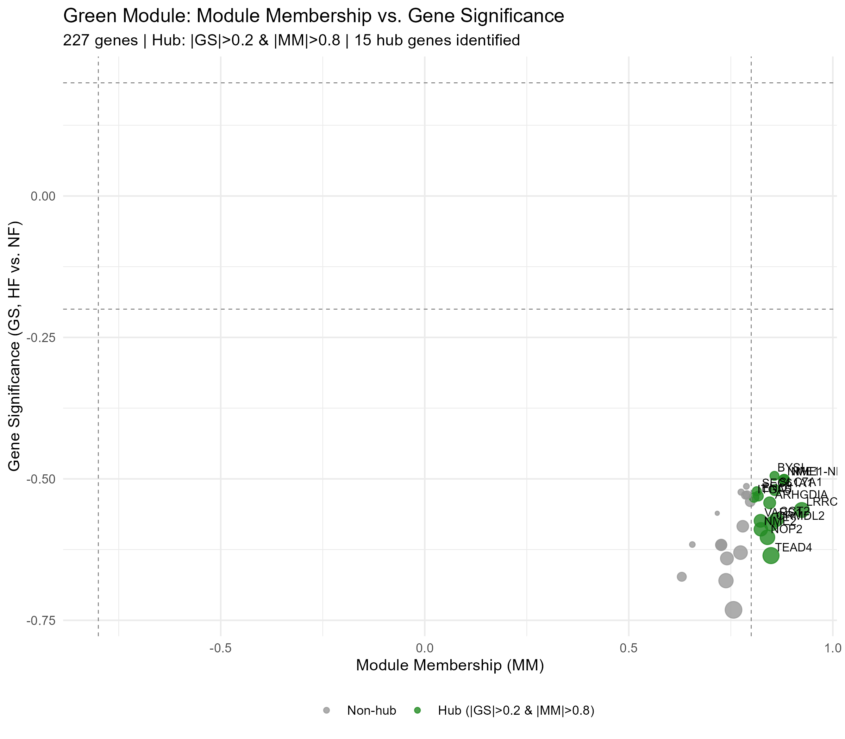
Supplementary Figure S1
Fig. S1. Green module hub gene identification. Module Membership vs. Gene Significance scatter plot for 227 green module genes. Hub genes (|GS| > 0.2 and |MM| > 0.8) are highlighted in green; top 10 hub genes are labeled.

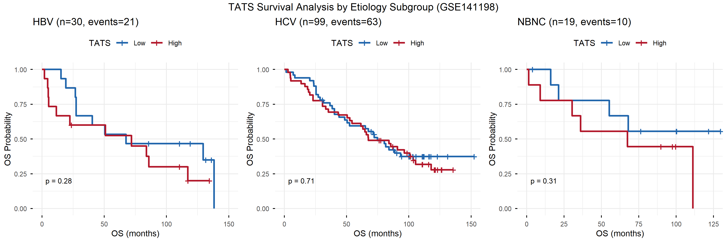
Supplementary Figure S2
Fig. S2. TATS exploratory survival analysis in GSE141198 by etiology subgroup. Kaplan–Meier survival curves stratified by HBV, HCV, and NBNC etiology. TATS (median split) shows no significant prognostic value in any subgroup, consistent with the overall cohort analysis.

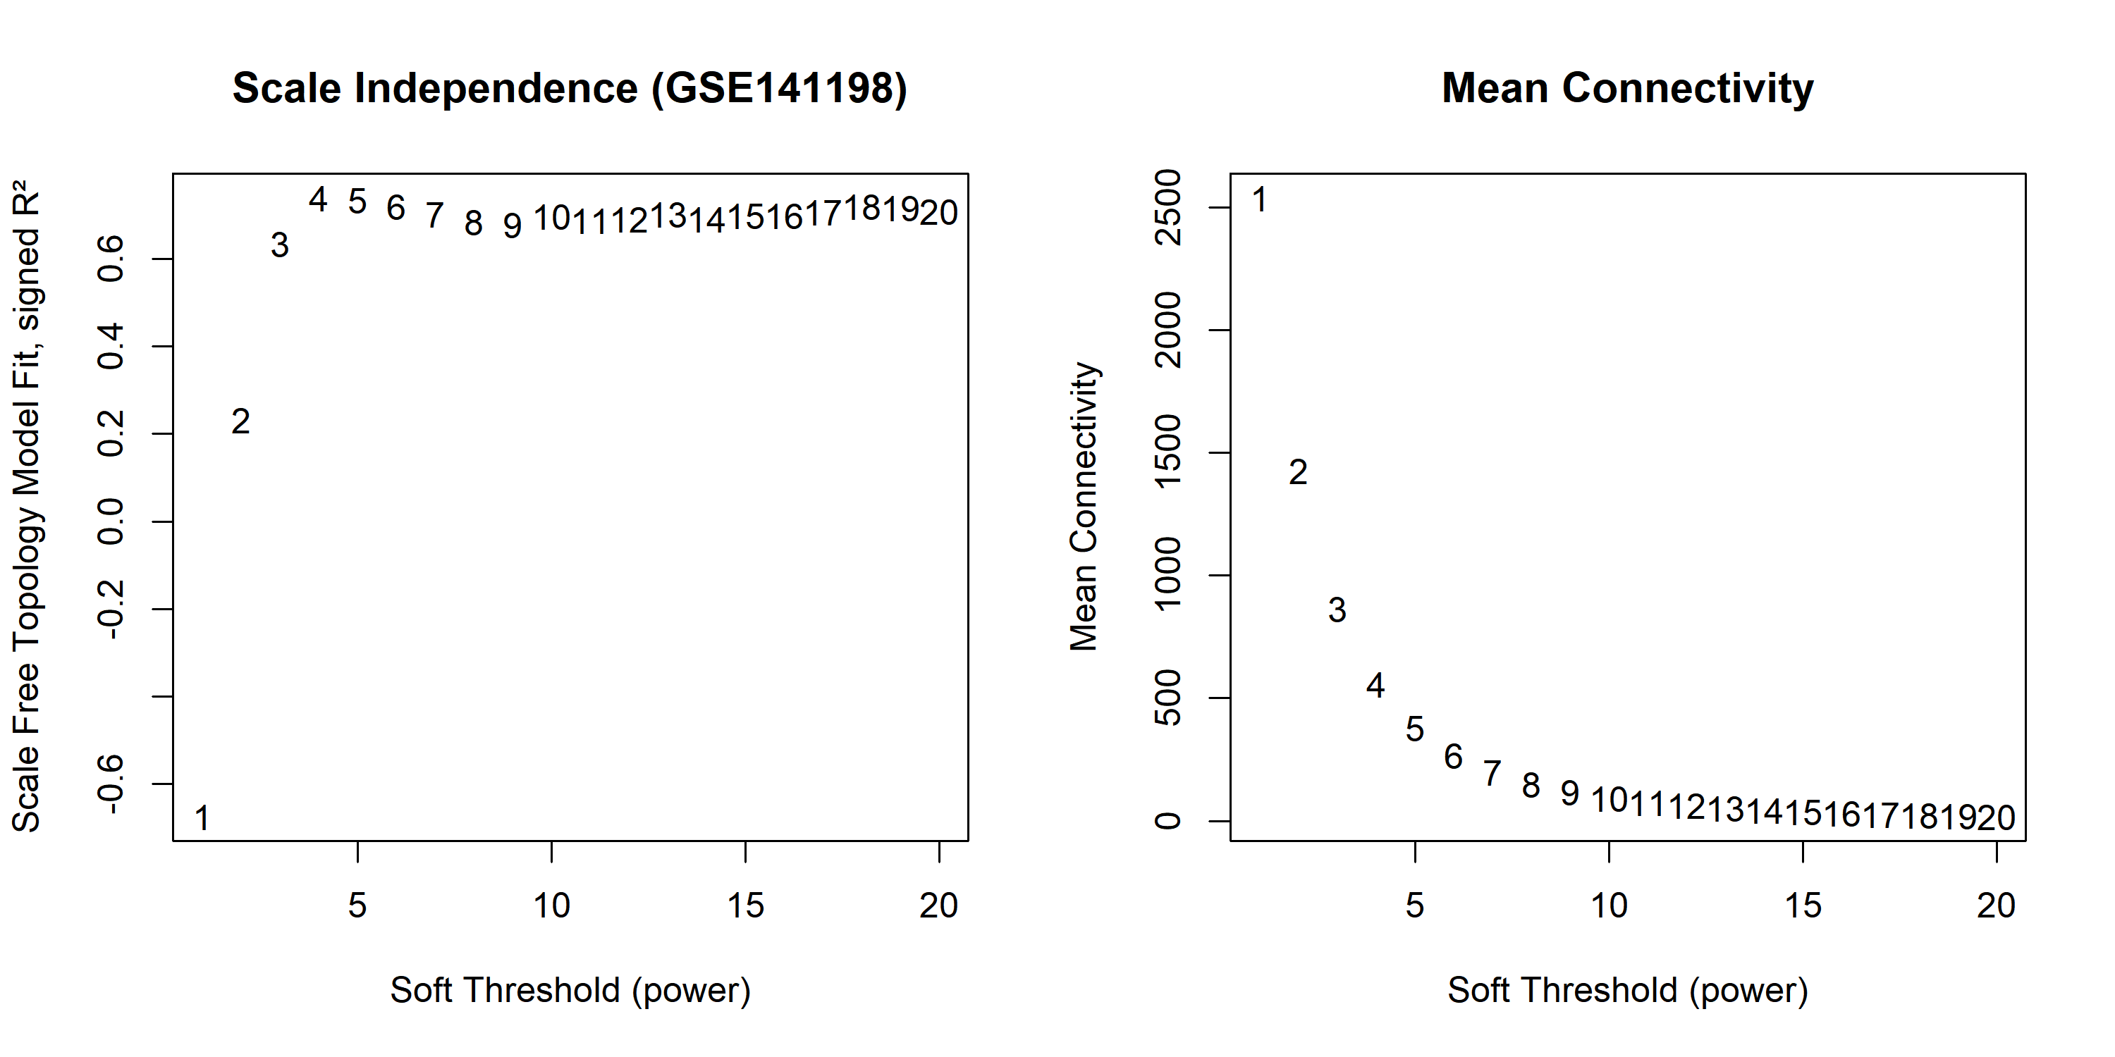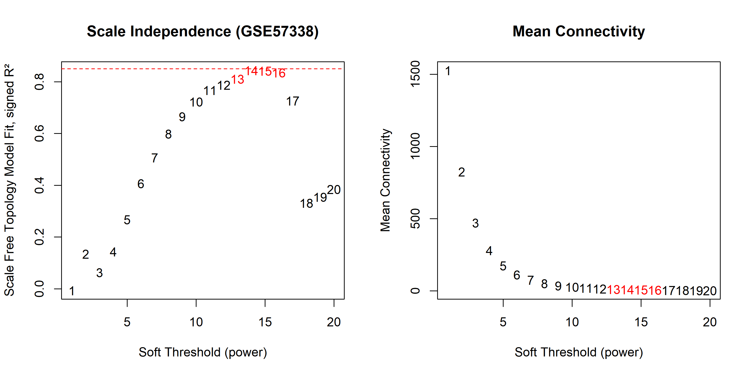
Fig. S3. Soft threshold selection for WGCNA. Scale-free topology model fit (R², left panels) and mean connectivity (right panels) as a function of soft threshold power (β). (A) GSE141198 (HCC): β = 4, signed R² = 0.84. (B) GSE57338 (HF): β = 17, signed R² = 0.865. The R² ≈ 0.85 criterion (dashed red line) was used for threshold selection.

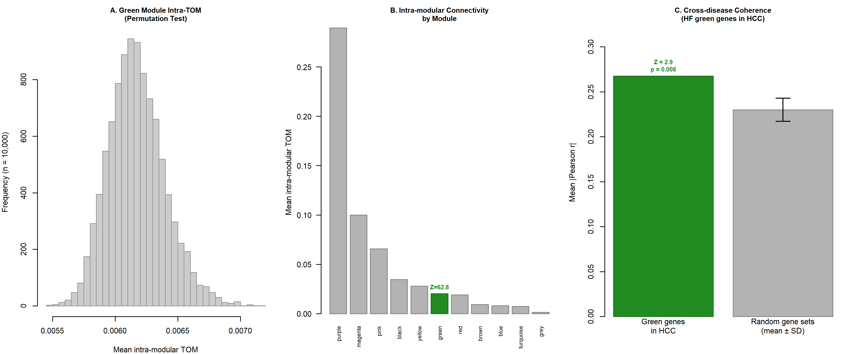
Supplementary Figure S4
Fig. S4. Module internal robustness and cross-disease coherence assessment. (A) Permutation histogram: mean intra-modular TOM for 10,000 random gene sets vs. green module (Z = 62.8, p < 0.0001). (B) Intra-modular connectivity by module. (C) Cross-disease gene set coherence: mean absolute pairwise correlation of green module genes in HCC (GSE141198) vs. random gene sets (Z = 2.9, p = 0.008).

Supplementary Tables
Table S1. HF green module gene list (227 genes) with Module Membership, Gene Significance, and hub gene annotation.
Table S2. Complete ssGSEA pathway effect sizes (Cohen’s d) for 81 pathways across HCC (TCGA-LIHC) and HF (GSE57338), with cross-disease comparison. Includes mirror direction annotation (Yes/No: whether the pathway shows HCC↑/HF↓ pattern) and pathway source (Hallmark/KEGG/Reactome).
Table S3. Cross-disease log2FC and FDR for translation-related module genes in HF (GSE57338) and HCC (TCGA-LIHC).
Table S4. Translation-related pathways showing mirror perturbation (HCC↑/HF↓) with cross-disease Cohen’s d effect sizes. Includes pathway name, source database (Hallmark/KEGG/Reactome), HF and HCC effect sizes, and mirror direction annotation for all 33 translation-related pathways.
Table S5. GO Biological Process enrichment with fold enrichment for the HF green module (227 genes). Includes GO ID, description, GeneRatio, BgRatio, fold enrichment, p-value, adjusted p-value, and translation-related annotation for 29 significantly enriched terms.
Table S6. Complete TF–TATS Spearman correlation statistics for all 19 candidate transcription factors in GSE141198 (n = 148 tumors). Includes Spearman ρ, p-value, FDR (Benjamini–Hochberg correction), and significance annotation.
Table S7. Gene overlap analysis between TATS constituent genes (227 green module genes) and Hallmark pathway gene sets (MYC Targets V1/V2, E2F Targets, MTORC1 Signaling, G2M Checkpoint, Unfolded Protein Response, and negative controls). Includes overlap count, percentage, Jaccard index, and hypergeometric test results. Also includes de-overlap sensitivity analysis results (TF–TATS correlations before and after removal of shared genes) and bootstrap 95% confidence intervals for key Spearman correlations.

