Demographic Characteristics of Students Who Do or Do Not Post in an

Undergraduate Engineering Online Discussion Forum

Authors

Affliations

1. Introduction
   1. The current schooling norm is that students can only get help during the class hours and limited office hours. The students are not being in touch wit[1]h their instructors or classmates outside the schools. The introduction of online discussion forum for a class helps students stay in touch with their peers, teaching assistants (TAs) and even instructors. Such a discussion forum also provides a public space, where ideas can be exchanged, questions can be shared, and information can be stored. Instructors and TAs could help students to clarify doubts without time and space limits. These forums can then be considered to be a social network, where Social Network Analysis (SNA) and statistical computing techniques may be applied for studying the interaction of the students and levels of participations.

Social Network Analysis (SNA) is the use of network theory to analyze social networks. This turns the network to a visualized social network diagram, where nodes represent the individuals and edges depicting the relationship between individuals. In this study nodes are represented as circles and edges as lines.

Statistical computation is aiming at the design of algorithm for implementing statistical methods. It is the application of software open-source to statistics nowadays.

Here we propose to apply SNA and statistical computation techniques on an online discussion forum to discover how frequent a student participated, and to discover how demographic characteristics related to participations. These statistical computation helps instructors better understand relations between students’ participations with backgrounds.

1. Research Questions

The following two research question guide this work:

* 1. How does students’ demographic characteristics relate to discussion forum participation?
  2. Among students who participate, what is the distribution of number of posts in terms of different aspect of demographic characteristics?

We expect students’ demographic characteristics relate to their participations, and there should be a specific type of distribution between number of posts and demographic characteristics.

1. Related Work
2. What are Online Discussion Forums?

Online discussion forums can be accessed via internet by participants in a course[5]. It allows individuals to hold conversations with each other, teach assistants and instructors by posting text-based messages. Everyone can post and check it from any place at any time, so it is a very useful source across traditional and online platforms. This study focuses on a sophomore-level dynamics and vibrations class that incorporated active, blended, and collaborative learning strategies. Any students can ask the questions based on course material and homework in a message form.

1. Social Network Analysis (SNA)

Previous studies showed that SNA is a common tool to evaluate students’ online discussion performance. He[2] uses SNA software to visualize students’ online discussion participation networks. That paper evaluates individual student’s online discussion performance based on SNA pagerank and in-degree out-degree centralities. However, based on how actively students participate in online discussion, they focus on analysis of academic performances instead of demographic characteristics. There are some previous studies digging into demographics of social network users. For example, in a case study, Yeh etc.[3] demonstrates demographics of users in terms of gender, nationality and ages. He announced that more than half users are female and at age of 16-30. Andrew[4] built a conceptual framework for demographic groups resistant to online community interaction. However, the study of demographic characteristics of students who participate in online discussions is very limited.

1. Research Method

In this session, we depict the sample data and the features we used for analysis.

* 1. Data Collection

This mechanical engineering(ME) course forum assigns each post a unique id. Posts content (i.e. post time, message, posters) is saved in a secure database.

* 1. SNA

There are several SNA methods that one can consider when analyzing a social network. Particularly in this paper for the context of evaluating student’s online discussion performances, we will use out-degree centrality to count the number of messages sent by a student. If a student acquires high numbers in out-degree, it indicates that he or she is more active in sending messages to others. There were 954 unique students participated in our course’s online discussion board and total number of messages was 1861 in three academic semesters from 2015-2016. These included students’ posts and replies, but initial posts from instructors and teaching assistants were not counted.

* 1. User Profiles

We collected all unique user profiles. We retrieved following user profiles data:

* + - * User Personal data: Gender, Nationality, Ethnicity, Major, and ADCI(Advanced demographic C)

Models based on demographic attributes are important since it helps to determine the connectivity based on social attributes[7]. We got all user personal data based on students’ answers to a survey. It is imported as a raw data. Firstly, a filter is applied based on consented status. We totally got 739 consented students, among which 360 are participants, and 379 are non participants. Three data frames of user personal data plus out-degrees are generated via R. One is of consented participants, one is of non-participants, and one is of total students. Manual validation check is applied. For example, we manually counted the number of students who post below 5 times, and it matches the data R calculated. Statistical graphics are generated for each perspective of selected demographic characteristics. Later we only focus on participants. Density plot of gender and the course’s scores versus number of posts is conducted.

1. Results and Analysis

First we give an overview of sample data we collected, including gender distribution, ethnicity distribution, major distribution, and ADCI distribution. We compare the result with …..test. Then we looked at the gender and students’ performance distribution among the number of posts.

1. Participations vs. Nonparticipations
   1. Gender Distribution

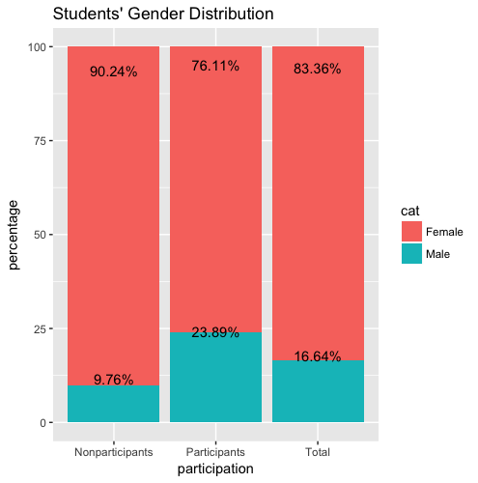

*figure 1 Student gender distribution among participants, nonparticipants and total.*

From the distribution graph above, we can tell that Female students are relatively more active in participating in this online discussion forum, with a ratio of 23.89% versus 9.76%. The gender distribution is similar to the result of many previous studies[3][6]. It also matches the Donovan’s observation[8].

* 1. Ethnicity Distribution

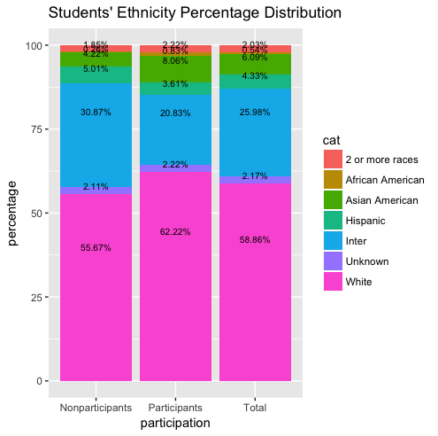

figure 2.a

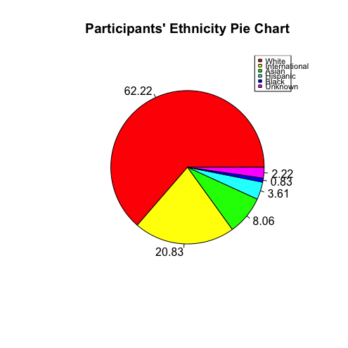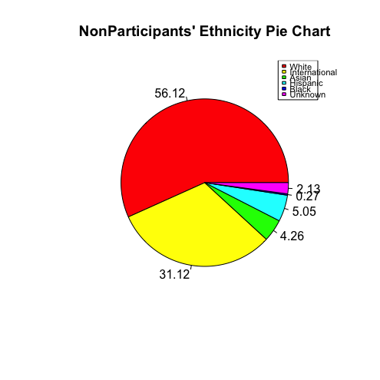

figure 2.b figure 2.c

*figure 2 Students’ Ethnicity Distribution. Figure 2.a, the distribution is of stacked histogram. Figure 2.b, 2.c are pie charts of ethnicity and nationality percentage distribution of participants and nonparticipants.*

Figure. 2 shows the nationality and ethnicity distribution of the sample data. Our data shows that the white people dominate the population, followed by International students Hispanic, and Asians. However, the whites and Asians look over-represented (white is 62.22% versus 55.67%, and Asian is 4.22% versus 8.06%) but international and Hispanic students are very under-represented (international is 30.87% versus 20.83%, and Hispanic is 5.01% versus 3.61%).

* 1. Major Distribution

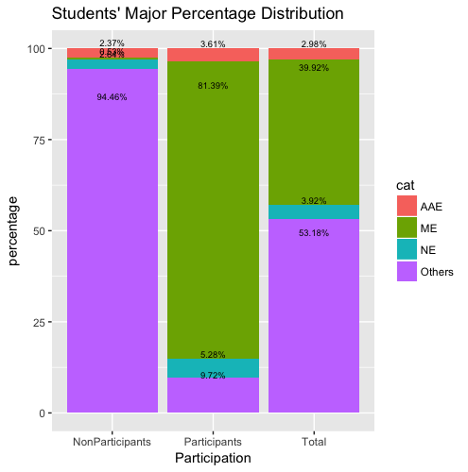

figure 3.a

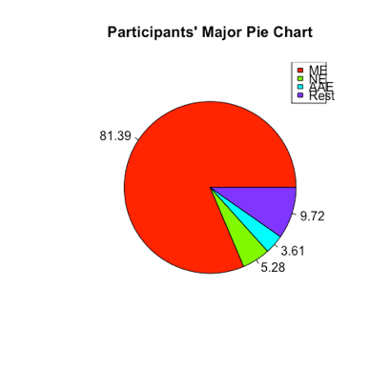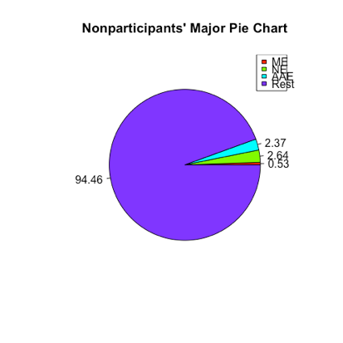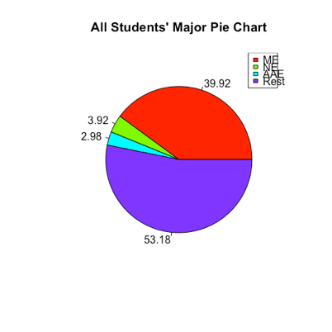

figure 3.b figure 3.c figure 3.d

*figure 3. Major Distribution among participants, nonparticipants and all students. ME represents Mechanical Engineering, AAE represents Agriculture Engineering, NE represents Nuclear Engineering.*

*Figure 3.a is the stacked histogram of major distribution. Figure 3.b, 3.c, 3.d are pie chars of major distribution for participants, nonparticipants and all students respectively.*

Figure 3 shows the major structure of the sample data. This online discussion forum is designed for a dynamic course, so all students are directly from mechanical engineering(ME), Agriculture Engineering(AAE), Nuclear Engineering, and other engineering departments, where students can take this course as a selective. The statistical computation shows that ME are the most involved than other majors, where only 2 out of 237 students didn’t post online. Beyond that, students who take the course as a selective don’t prefer to participate in online discussion at all.

1. Among Participants:

1. Gender Distribution

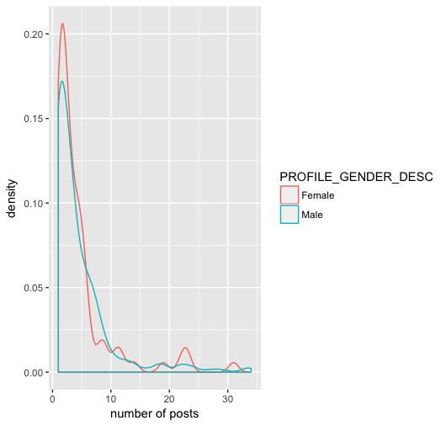

figure 4 Gender Distribution among the number of posts

The figure above shows the gender density trend among all participants. We can obviously see that women have a higher peak value at lower number of posts (0 - 5) and medium-high posts (20 - 25). Here we didn’t count one student, who posts 150 times over one semester, in order to keep the trend line more appropriate to describe the situation.

2. Grade Distribution

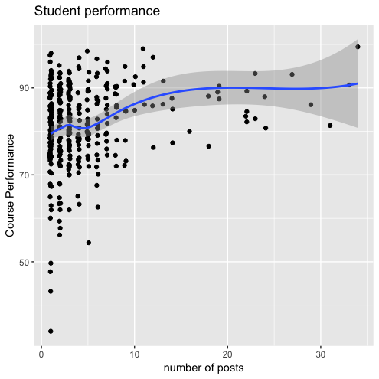

figure 5. Student Performance distribution based on scores.

Figure 5 describes the relationship between the number of posts versus students’ performance scores. The score is a 100 base, and higher score means that students did a better job in the class. We briefly could see a better academic behavior associated with the more active a student is involved.

1. Discussion

From the results we got above, we are able to conclude that gender, ethnicity and majors relate to discussion forum participation. Moreover, among students who participate, women and students who have a strong background of the course material feel more comfortable in posting on online discussion forum.

Due to the fact that we only design our research based on consented sample data, it doesn’t contain all students enrolling the class. However, consented students take up 78% of all students, so we claimed our sample is valid and persuasive.

1. Conclusion

In this paper, social network analysis combined with statistical graphics and validation check have been used to understand demographics of students who do or do not participate in online discussion forums. It is shown that female students are more likely to be involved than their male counterparts. Also, White and American Asians are overrepresented but international students are underrepresented in the engaged group.

1. Future Work

This work extends our knowledge of who uses online collaboration tools, and future work will analyze the content of posts and explore the influence of forum participations on grades via a regression model.

1. Reference
   1. P.Suraj and V. S. K. Roshni, “Social Network Analysis in Student Online Discussion Forums”, *2015 IEEE Recent Advances in Intelligent Computational System(RAICS)*, 2015.
   2. P. He, “Evaluating Students Online Discussion Performance by Using Social Network Analysis”, 2012.
   3. C. Yeh, Y. Lin, T. Lin, “Demographics of Social Network Users- a Case Study on Plurk”, 2012.
   4. D. Andrews, J. Preece, M. Turoff, “A Conceptual Framework for Demographic Groups Resistant to Online Community Interaction”, 2001.
   5. Engaging students for success in calculus with online learning forums
   6. “Analysis on the General profile of users on Plurk.com”
   7. “Demographic and Structural Characteristics to Rationalize Link Formation in Online Social Networks”
   8. “Characterizing user behavior and information propagation on a social multimedia network”