**ME274 Fall 2015 Report**

**Layout:**

**Based on our situation, we decided to apply for ForceAtlas 2 algorithm.**

* **Modularity**

I can’t run modularity on my laptop due to a software issue ;(

* **Network Diameter**

**Closeness centrality**

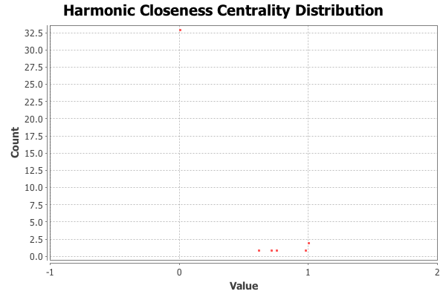

Under Network Diameter, closeness centrality indicates how close a node is to other nodes. It measures the average distance from a given node to all other nodes. From the graph, it is obvious to find that most usual distance between two nodes is between 0-2.5. Only one is over 32.5.

This graph provides how frequent a student connect to others. Teacher posted every blog and answered students’ questions. That is why teacher has the highest closeness centrality.

**Eccentricity Distribution**

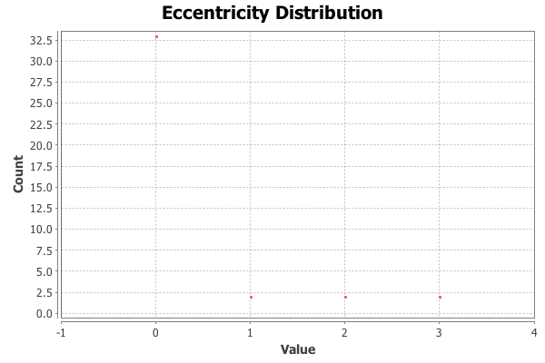

Under Network Diameter, eccentricity distribution showed us the distance between a node and the node that is furthest from it. From the graph it is shown that except the teacher others didn’t reply or comment others post.

**Betweenness centrality**

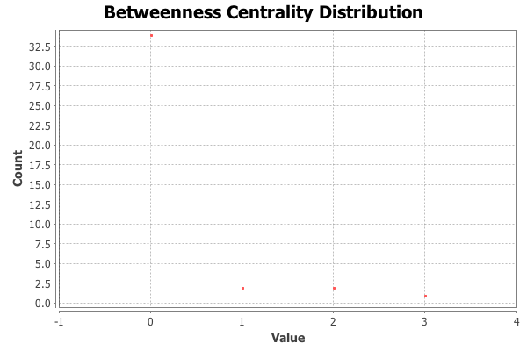

Under Network Diameter, betweenness centrality measures how often a node appears on the shortest paths between nodes in the network. From the graph we can see that the distribution is very close to eccentricity.

* **Connected Components**

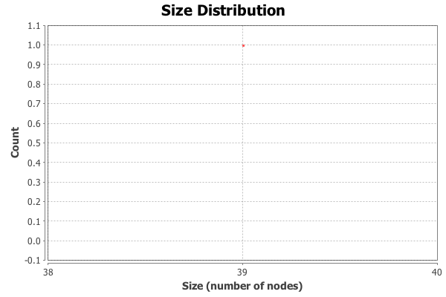

Connected components is a way to measure the extent of engagement. The report illustrates the number of weakly connected components is 1 and the strongly connected components is 39.

Those two points give us a general idea of how students build this network between each other.

* **Average Degree**

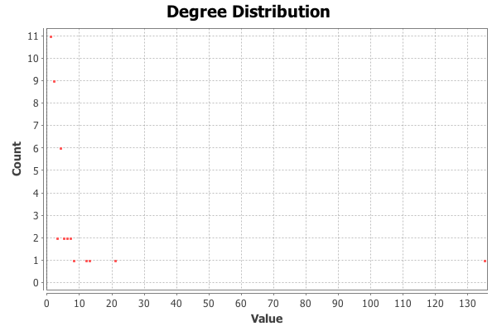

The average degree of a node shows that the number of edges that are adjacent to this node. Its main purpose is to use graph and average value to explain the relationship between edges and nodes. From the result we found that the average degree is 7.282.

The average degree here helps us understand the average engagement in this class. Unlike the 2015 one, in this semester average degree is not a bad statistic value. This is due to the fact that in 2016 there are only 39 students and 142 pieces of conversation. However, the issue here is that since only the instructor has the right to create threads, if others just post without any other replies, it still counts one edge.

* **Average weighted degree**

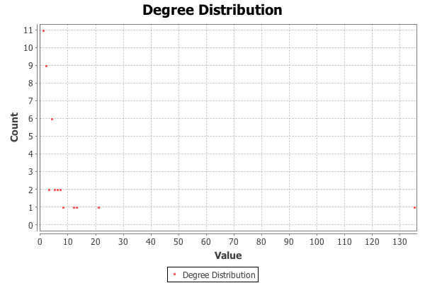

Average weighted degree is quite similar with average degree. It is based on the number of edges on a node, but it is doing the sum weight of edges. According to this formula, the weighted degree is 3.641 and the graph has the same distribution as that of average degree.

The average weighted degree in this case is like adding more physical features on all data. After weighted, the score represents the median of the sum of every engagement so that the result is closer to the balance point.

* **Graph density**

Graph density measures how close the graph is to complete. For our directed parameter, our density is 0.096.

Although density here is three times bigger than the last semester, it is still not that helpful because there are still many blogs posted without any response. That is the reason that we get a very low density.