CSE5999 Computer Vision Thesis Report 02

What I did this week:

1. Add some new test images
2. Try some cluster algorithms to isolate each object from the entire scene. And then use the Hough transform to each cluster to find the line.

K-means algorithm and DBSCAN algorithm, but the k-means algorithm result is not good enough, and the density based algorithm is cost too much time on Matlab

1. Add the project to GitHub, include Matlab version. Page: <https://github.com/zxyinz/ComputerVisionThesis>

Plan for next week:

1. Apply the Matlab code to C++, based on OpenCV.
2. Add Mean-Shift algorithm to see the result.
3. Combine all the functional part into one final project and get the alpha version.
4. The progress in this week is too slow. I plan to finish all the code before 5/31. So next I will try report each 2 days.

The new dataset which I added:

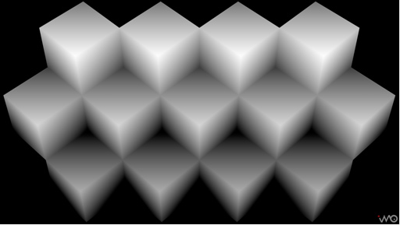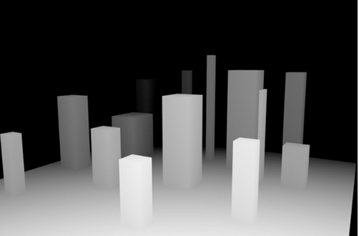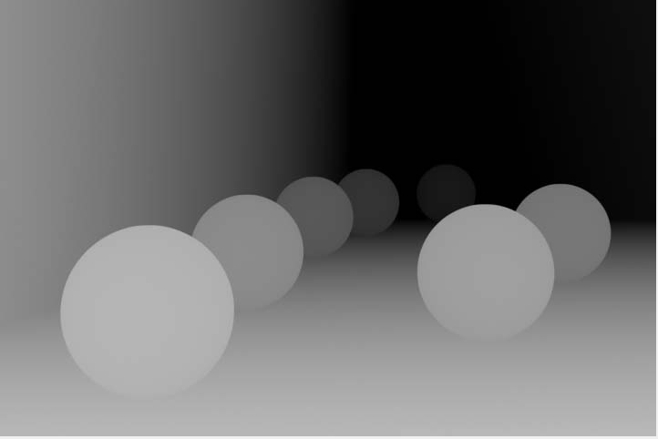

The result with naïve Hough transform:

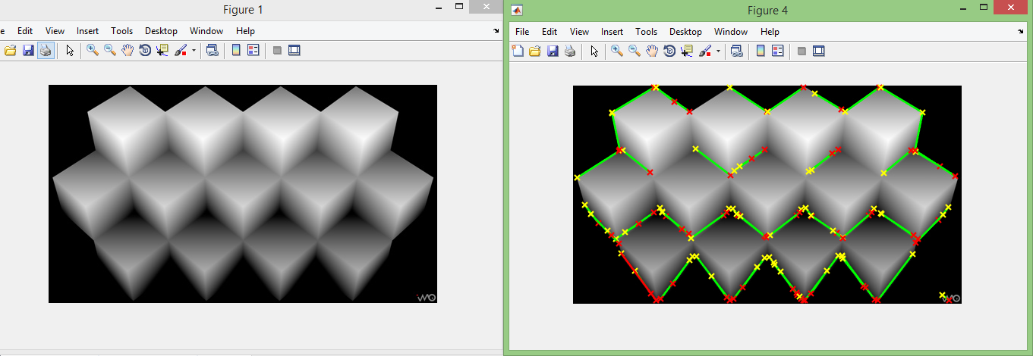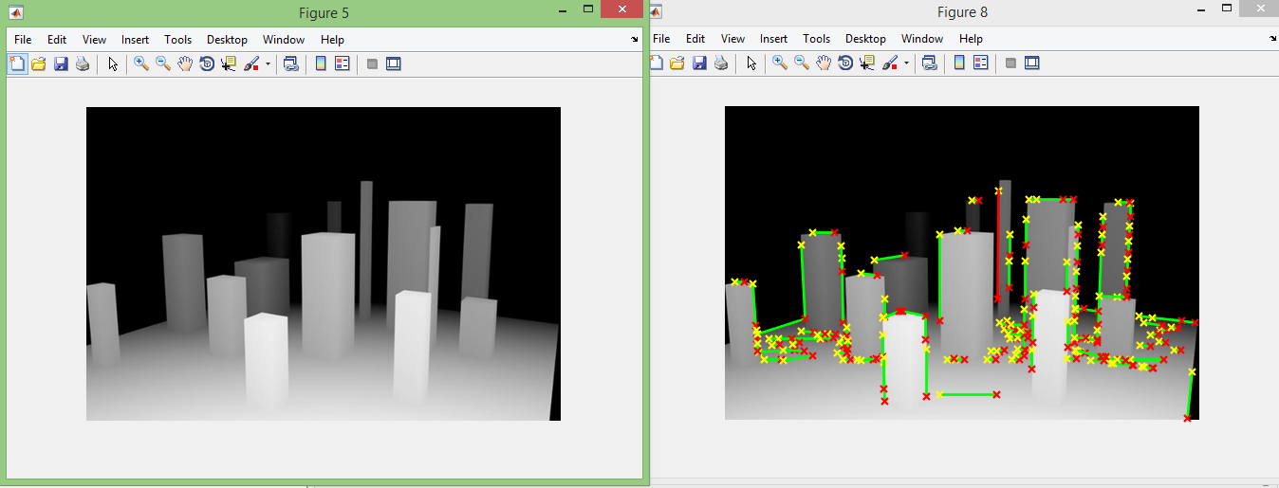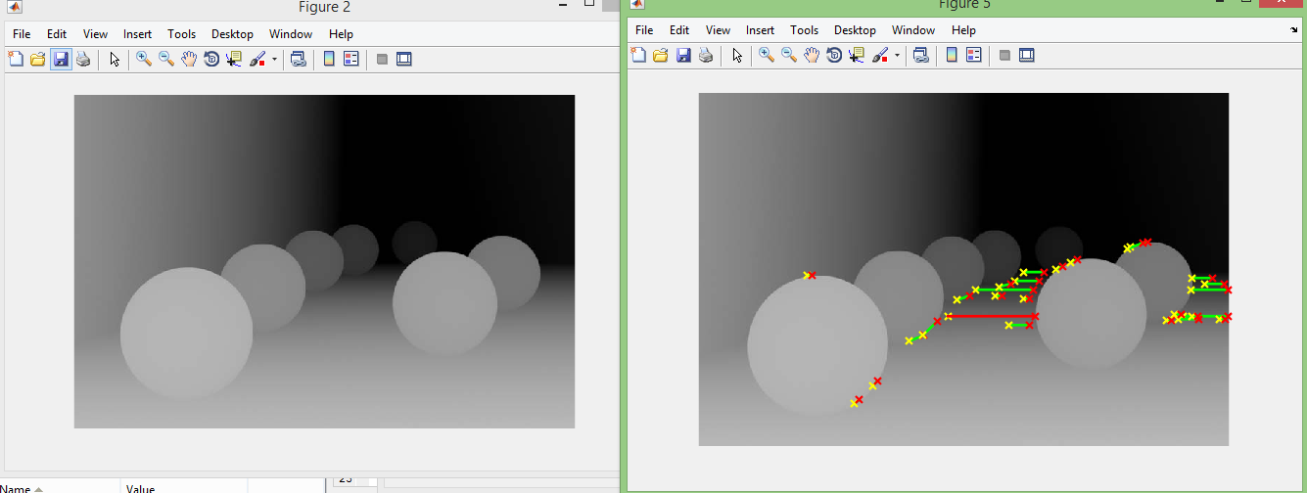

The result with k-means preprocessed Hough transform (The result even worse):

