1. What is our independent variable? What is our dependent variable?

Independent variable: ink colors

Dependent variable: time it takes to name the ink colors

1. What is an appropriate set of hypotheses for this task? What kind of statistical test do you expect to perform? Justify your choices.

Here we want to find out if the time spent on congruent set is less than the incongruent set, then we will infer the situation in the population, so we assume the null hypothesis as: the **congruent population mean** needs more or equal time than the **incongruent population mean**. The alternative hypothesis is thus: the **congruent population mean** is less than the **incongruent population mean**. By symbol it is:

H0:

H1:

I’m expecting to perform a t-test. Because here we don’t know the parameters from population but two samples. That is to say, here we just have two samples extracted from the population and the sample size is less than 30; we also don’t know the standard deviation of the population. Another assumption is that the distribution is normal distribution. Here I choose to use one-tail test because I want to find out if the incongruent set is taking more time than the congruent set instead of just finding out if there are any differences. As for the type of the t-test, a paired sample test should be chosen because the data is from the same individuals.

1. Descriptive statistics:

Congruent:

* Mean: 14.05
* Median: 14.357
* Mode: N/A
* Std: 3.56

Incongruent:

* Mean: 22.016
* Median: 21.018
* Mode: N/A
* Std: 4.797

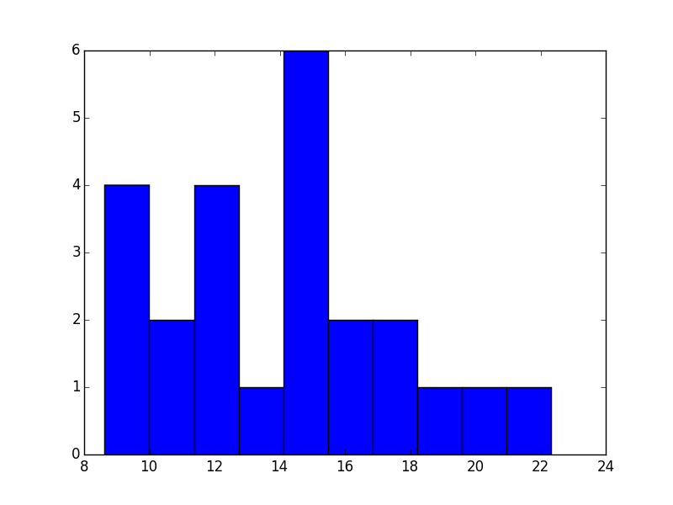

This is the histogram of the distribution of the time to name the color from the congruent set. The data from this set is more wide-spread and symmetrical compared to another.

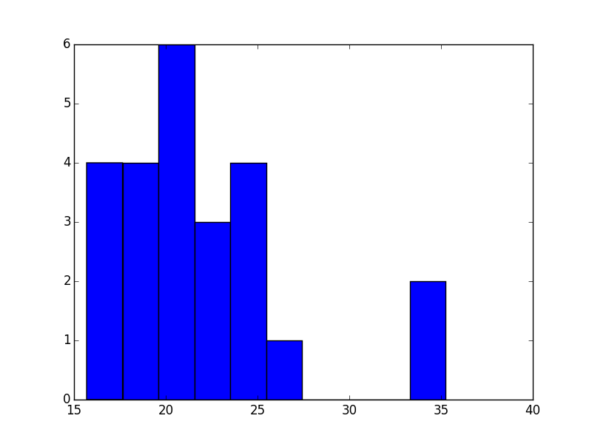

This is the histogram of the distribution of the time to name the color from the incongruent set. This set of data is right skewed, leaving an outlier at around 33-35 interval. And the data is more consistent or narrowed compared to another without considering the outlier.

1. T-test (dependent):

SE = 4.865

Tc-inc = -8.021

Meanc – Meaninc = -7.965

When , df = 23, tcritical = -2.500

99% confidence interval:

Conclusion: since the t statistic is less than the t-critical, it is significant that the time spent on congruent set is less then the time spent on incongruent set. We reject H0.