Experiment: 1.3
Student Name: Mohammad Saood | UID: 26MAI10040
Branch Name: M.E. (CSE) (AIML) | Section/Group: B
Semester: 1 | Date of Performance:
Subject: Patent and IPR | Subject Code: 26CSP – 626

Aim: Write an article and case study on the topics given below — (a) what trademarks are and their types; (b) the function of a trademark; (c) the duration of a trademark; and (d) the flow chart of trademark application filing up to acceptance.
CO Mapping: CO3 · BT1, BT2, BT3
1. Introduction: The Nature of a Trademark
A trademark is a badge of trade origin — a sign capable of distinguishing the goods or services of one undertaking from those of another. Section 2(1)(zb) of the Trade Marks Act, 1999 defines it as a mark capable of being represented graphically and capable of distinguishing the goods or services of one person from those of others, and the definition expressly extends to the shape of goods, their packaging and a combination of colours. The right emerged from a competitive economy: once more than one manufacturer began making the same class of goods, it became necessary to mark each maker's output with a symbol that let a buyer tell one manufacturer's goods from another's without inspecting the goods themselves.
A trademark differs from a patent in the shape of the right it confers. A patent rewards the disclosure of a new invention with a monopoly that necessarily expires after twenty years, after which the invention passes into the public domain. A trademark protects nothing so exhaustible as an invention; it protects the goodwill that a business builds around a sign, and for that reason the right is not built to expire — a registration lasts ten years but may be renewed every ten years indefinitely for as long as the proprietor keeps the mark in use and pays the renewal fee. Where a patent trades disclosure for a temporary monopoly, a trademark trades continued use and renewal for a potentially perpetual one.
Type of Mark | What It Distinguishes | Illustration
Trademark | Goods produced or sold by a specific enterprise from those of other enterprises. | The word “Amul” on dairy products.
Service mark | Services rendered by a specific enterprise from those rendered by others. | The mark used by an airline or a bank.
Collective mark | The goods or services of members of an association from those of non-members. | A mark used by members of a manufacturers’ association.
Certification mark | Goods or services that comply with a defined standard, certified by a certifying authority, from those that do not. | The ISI or Agmark certification marks.
Well-known mark | A mark that the relevant public associates so strongly with one proprietor that it receives protection beyond the goods for which it is registered. | Marks that courts have already recognised as well known (see the case study below).
Table 1 — Types of Marks Recognised Under Trade Mark Law
1.1 What May Function as a Mark
The statutory definition of “mark” is deliberately open — it includes a device, brand, heading, label, ticket, name, signature, word, letter, numeral, shape of goods, packaging, a combination of colours, and any combination of these. In practice a wide range of signs has been accepted for registration, provided each is capable of graphical representation and of distinguishing one trader’s goods or services from another’s.
Element | What It Means | Example
Brand name / brand mark | The utterable part of a brand is the brand name; the part that is recognised but not spoken — a symbol, design or distinctive lettering — is the brand mark. | McDonald’s (name); the golden arches (mark).
Device | A pictorial representation — an animal, bird, landscape or building. | The crocodile device on Lacoste apparel.
Letter / numeral | Letterforms or numerals registered on evidence that they have come to identify one trader’s goods. | IBM, 3M; 555, 501.
Symbol / logo | A visual depiction that gives a manufacturer or company its identity. | The BMW roundel.
Label and ticket | A composite mark with several features — devices and words — usually affixed to the goods. | A garment’s woven brand label.
Colour, sound and smell | A combination of colours, a sound, or even a scent can be registered on proof that it distinguishes the goods. | Colour bands on drug capsules; the MGM lion’s roar; a rose scent for tyres.
Table 2 — Elements That Can Function as a Trademark
Case Study — Daimler Benz Aktiengesellschaft v. Hybo Hindustan, Delhi High Court (1994). The defendant sold undergarments under the mark “Benz” together with a three-pointed star device closely resembling the plaintiff’s famous automobile emblem. The defendant argued there could be no confusion because cars and underwear are wholly different goods, so the public would not think Mercedes-Benz had entered the innerwear business. The Delhi High Court disagreed and restrained the use, holding that a mark of the standing of “Benz” is not to be allowed to be diluted by use on unrelated goods; some marks are so well known that their reputation transcends the specific goods for which they were adopted, and the law will protect that reputation from being whittled away by association with an inferior class of goods. For a student the case is the clearest illustration of why “well-known mark” is treated as a distinct category rather than an honorary label — it comes with protection an ordinary registered mark does not enjoy.
2. Function of a Trademark
A trademark is essentially a product of a competitive economy in which more than one person competes to manufacture the same product, which necessitates marking each manufacturer’s goods with a symbol that distinguishes similar goods made by others. Once that marking exists, it comes to perform three functions that together explain why the law protects it at all.
Function | What It Does | Why It Matters
Origin function | Signals that the goods or services originate from, or are put on the market by, a particular undertaking. | Lets a buyer repeat a satisfactory purchase, or avoid a poor one, without re-investigating the maker each time.
Quality / guarantee function | Assures the buyer that goods bearing the mark will meet the standard the buyer has come to associate with it. | Gives the proprietor an incentive to maintain consistent quality, since the mark itself carries that promise.
Investment / advertising function | Lets the proprietor build, and capture the value of, goodwill and reputation through advertising and consistent use. | Turns the mark into a commercial asset in its own right, separate from the goods it is presently used on.
Table 3 — The Three Functions of a Trademark
These functions explain the two limbs on which trademark law is built. Acquisition of a trademark may be by the proprietor of the goods or services for which registration is sought, or by transfer, licence, lease or assignment from the proprietor to another entity — in every case the law is protecting the origin signal, not the mark as a decorative object. Correspondingly, a suit for infringement of a registered trademark, or for passing off an unregistered one, lies before a District Court (infringement matters formerly also lay before the IP Appellate Board), and relief may include injunction, damages or an account of profits, together with an order for the delivery up of infringing labels and marks for destruction or erasure.
Case Study — The Coca-Cola Company v. Bisleri International Pvt. Ltd., Delhi High Court (2009). Bisleri had sold the trademark “MAAZA”, including formulation rights and goodwill in India, to Coca-Cola under an assignment agreement, but then licensed the same mark to a third party for sale in Turkey and applied to register it there itself. Coca-Cola sued for infringement and passing off. The Court granted an interim injunction, holding that once a trademark and the goodwill attached to it have been assigned, the assignor cannot continue to deal in the mark as though the origin signal still pointed back to it — doing so defeats the very function the mark exists to serve. The case is a useful illustration for students because it shows the origin function operating not just against strangers copying a mark, but against a seller who has already given up the right to be identified as the source.
3. Duration and Renewal of a Trademark
Use of a trademark or service mark can begin before registration, and registration is not itself a compulsory requirement of the law — unregistered use may still be protected through an action for passing off. Once an application is accepted, however, the Registrar maintains a Register of Trade Marks at the Trade Marks Registry, and the particulars of every registered mark are entered in it. Under Section 25 of the Trade Marks Act, 1999, the registration of a trademark is for a period of ten years from the date of registration, and it may be renewed for a further period of ten years, and again indefinitely thereafter, provided the proprietor files the renewal request and pays the prescribed fee before each ten-year period expires. So long as it remains valid, the registration gives its proprietor the exclusive right to use the mark in relation to the goods or services for which it is registered, and to obtain relief for its infringement.
Stage | Position Under Section 25 and the Trade Marks Rules, 2017
Initial term | Ten years from the date of registration.
Renewal window | Application for renewal (Form TM-R) may be filed within one year before expiry of the last registration.
Late renewal | A further period of six months after expiry is allowed on payment of a surcharge, failing which the Registrar may remove the mark.
Removal for non-renewal | The Registrar advertises the intention to remove and, absent renewal, the mark is taken off the register.
Restoration | A removed mark may be restored and renewed within one year of the date of removal, on the prescribed application and fee.
Position on expiry without restoration | The mark ceases to be a registered trademark; the proprietor is left, at most, to whatever passing-off protection unregistered use can support.
Table 4 — Duration, Renewal and Restoration Timeline
Case Study — Hardie Trading Ltd. v. Addisons Paint & Chemicals Ltd., Supreme Court of India (2003). The registered proprietor of a mark sought an extension of time to file evidence of use in rectification proceedings brought against it on the ground of non-use, and the question was whether the Registrar had the power to grant such an extension at all. The Supreme Court held that the power to enlarge time is not confined to the specific provisions that mention it and may be exercised generally, but it went on to underline the broader statutory scheme within which the question arose — that a trademark registration, unlike a patent, does not simply run its course and expire; it must be kept alive by renewal and, independently, can be taken off the register on the separate ground of non-use if the proprietor is not in fact using the mark. For a student the case is a reminder that duration under Section 25 and vulnerability to rectification for non-use under Section 47 are two distinct ways a registration can be lost, and that procedural diligence — filing renewals and responding to rectification notices in time — is as important to keeping a mark alive as the underlying use itself.
4. Trademark Registration — Filing to Acceptance
Filing a trademark application is only the second step in practice; a proprietor ordinarily begins with a search of the Register to check whether an identical or deceptively similar mark already exists for the same or allied goods and services, since discovering a conflict at that stage is far cheaper than discovering it after grounds for refusal have been raised in examination or after a rival files an opposition. The chart below sets out the sequence that follows, from the search to registration.
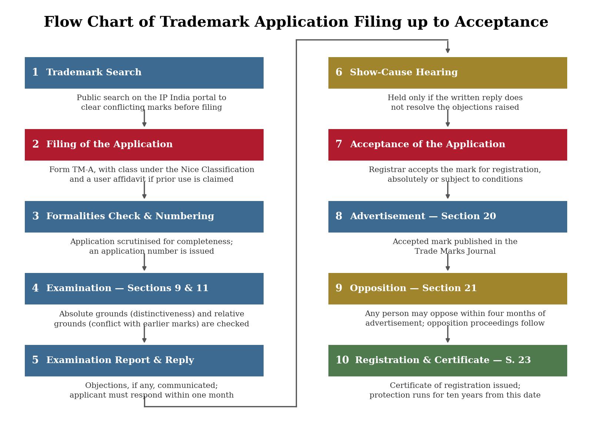
Figure 1 — Flow chart of trademark application filing up to acceptance and registration.
An application is filed on Form TM-A, specifying the class of goods or services under the Nice Classification — there are forty-five classes in all, thirty-four for goods and eleven for services — and, where the applicant claims to have used the mark before the date of filing, accompanied by an affidavit of prior use with supporting evidence. Once the formalities are checked and an application number allotted, the Registrar examines the mark under Sections 9 and 11 of the Act. Section 9 sets out the absolute grounds of refusal, which look only at the mark itself; Section 11 sets out the relative grounds, which compare the mark against marks already on the register or already well known.
Ground | What It Refuses
Devoid of distinctive character | A mark that cannot, on its own, distinguish the applicant’s goods from another trader’s.
Descriptive or generic marks | A mark that merely describes the kind, quality, quantity or intended purpose of the goods, or is the common name for them.
Deceptive or confusing marks | A mark of such a nature as to deceive the public or cause confusion as to origin, nature or quality.
Marks offending religious or public sensibilities | A mark likely to hurt the religious susceptibilities of a class of citizens, or containing scandalous or obscene matter.
Marks barred by the Emblems and Names Act, 1950 | State emblems, official seals and similarly protected names and emblems.
Functional shape marks | Shapes resulting from the nature of the goods themselves, or necessary to obtain a technical result, are excluded even if otherwise distinctive.
Conflict with an earlier trademark | A mark identical or similar to an earlier registered or well-known mark for identical or similar goods or services, where confusion is likely — Section 11.
Table 5 — Principal Grounds for Refusal of Registration
Where the examiner raises an objection, the applicant must respond within one month; if the written reply does not resolve the objection, the Registrar fixes a show-cause hearing before deciding whether to accept the mark, and acceptance may be absolute or made subject to conditions and limitations. An accepted mark is then advertised in the Trade Marks Journal under Section 20, opening a four-month window under Section 21 within which any person may file a notice of opposition. If no opposition is filed, or an opposition is decided in the applicant’s favour, the Registrar issues the certificate of registration under Section 23, and the ten-year term described in Section 3 above begins to run from that date.
Case Study — Cadila Health Care Ltd. v. Cadila Pharmaceuticals Ltd., Supreme Court of India (1999). Both parties, once part of the same group before a demerger, separately marketed drugs under the deceptively similar names “Falcigo” and “Falcitab” for treating cerebral malaria. The Supreme Court held that for medicinal products the standard applied to assess deceptive similarity must be stricter than for ordinary consumer goods, given the potential public health consequences of confusion, and it laid down a set of factors — the nature of the marks, the degree of similarity in appearance and sound, the nature of the goods, the class of purchasers and their likely care, and the mode of purchase — that examiners, opponents and courts still apply when weighing relative grounds of refusal and infringement. The case is a natural companion to the examination and opposition stages of the flow chart, since it supplies the working test behind the bare words of Section 11.
5. Viva Questions and Answers
1. Q: What is a trademark, and what does Section 2(1)(zb) of the Trade Marks Act, 1999 require of it?
A: A trademark is a sign capable of distinguishing one trader’s goods or services from another’s. Section 2(1)(zb) requires that the mark be capable of graphical representation and capable of distinguishing goods or services in that way, and it expressly includes shape of goods, packaging and combinations of colours.
2. Q: Name the principal types of marks recognised in trademark law.
A: Trademarks, service marks, collective marks, certification marks and well-known marks, distinguished by whose goods or services they identify and, for well-known marks, by the strength of protection they receive.
3. Q: What are the three functions of a trademark?
A: The origin function, which signals the source of the goods; the quality or guarantee function, which assures a consistent standard; and the investment or advertising function, which lets the proprietor build and capture goodwill through the mark.
4. Q: How long does a trademark registration last, and can it be extended?
A: Ten years from the date of registration under Section 25, renewable for successive ten-year periods indefinitely, provided the proprietor files Form TM-R and pays the renewal fee before each period expires.
5. Q: What happens if a registered mark is not renewed in time?
A: A six-month late-renewal window is available on payment of a surcharge; if that too lapses, the Registrar removes the mark from the register, though it may still be restored and renewed within one year of removal.
6. Q: Distinguish absolute grounds of refusal from relative grounds.
A: Absolute grounds under Section 9 look only at the mark itself — for example, whether it is distinctive, descriptive or deceptive. Relative grounds under Section 11 compare the mark against earlier registered or well-known marks to assess the likelihood of confusion.
7. Q: What makes a mark a ‘well-known mark’, and why does the distinction matter?
A: A well-known mark is one the relevant public associates so strongly with a proprietor that using it, even on unrelated goods, is likely to suggest a connection or dilute its distinctiveness — as in the Daimler Benz case. It matters because such marks are protected beyond the specific goods for which they were registered.
8. Q: What is the opposition procedure once a mark is accepted?
A: The accepted mark is advertised in the Trade Marks Journal under Section 20; any person may file a notice of opposition within four months under Section 21, and the application proceeds to registration only once the opposition is decided in the applicant’s favour or no opposition is filed.
9. Q: Can an unregistered mark be protected at all?
A: Yes — registration is not compulsory, and an unregistered mark that has acquired goodwill can be protected through a common-law action for passing off, though registration gives the additional statutory remedy of an infringement action.
10. Q: Why was a stricter test for deceptive similarity applied in the Cadila case?
A: Because the marks were used for medicinal products, where confusion between drugs can have serious public health consequences, so the Supreme Court held that the ordinary test for similarity between consumer goods was not strict enough and set out additional factors specific to pharmaceutical marks.
6. Learning Outcomes
- Defined a trademark as a badge of origin under Section 2(1)(zb) and distinguished its potentially perpetual, renewable right from a patent’s fixed twenty-year monopoly.
- Classified the principal types of marks — trademarks, service marks, collective marks, certification marks and well-known marks — and identified the elements, from devices to sounds and smells, that can function as a mark.
- Explained the origin, quality-guarantee and investment-advertising functions of a trademark and connected each to the protection the law affords.
- Interpreted the duration, renewal and restoration provisions of Section 25, and distinguished loss of registration for non-renewal from rectification for non-use.
- Analysed and illustrated the trademark application process from search through examination, acceptance, advertisement and opposition to registration, using the statutory forms, sections and timelines that govern each stage.
- Applied the grounds for refusal under Sections 9 and 11 to decided cases, including the stricter test for deceptive similarity applicable to pharmaceutical marks.
- Developed an understanding of brand-protection strategy, including the role of well-known-mark protection and the risks of losing a mark through inattention to renewal or use.

