**Car information Data Analysis project using Python + SQL + Power BI**

1.Data Analysis with Python:-

* Describe the data
* get the data's info
* understand each column
* Fill null values
* Show the correlation between columns
* Get value Counts of columns
* Rename columns
* Make some Visuals to help you understand your data

2.SQL KPIs For analysis:-

* Body Style Popularity

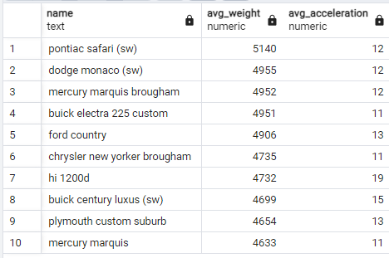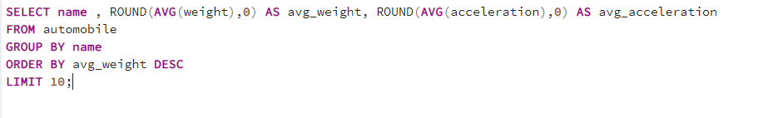

* Average Miels Per Gallon for each year

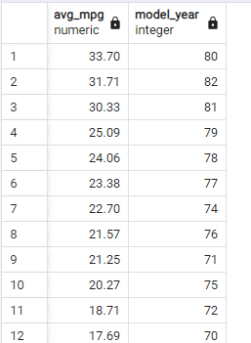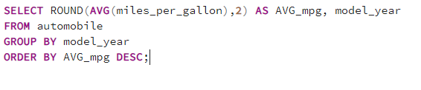

* Average hoursepower by car

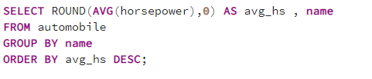

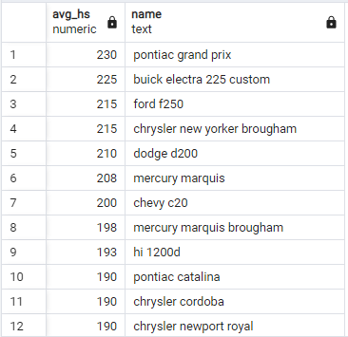

* Average car weight per model

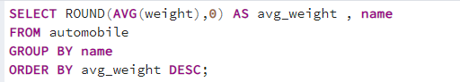

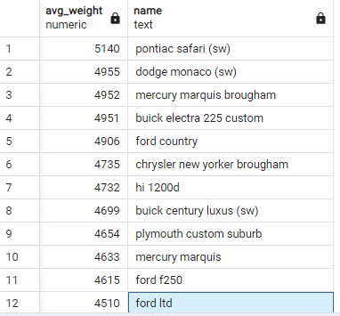

* 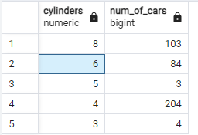Count of cars by number of cylinders

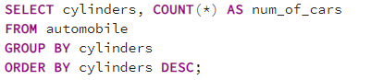

* Max/Min horsepower and Max/Min displacement by car model

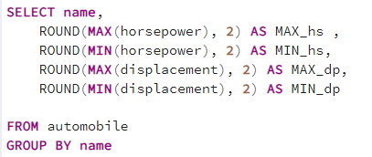

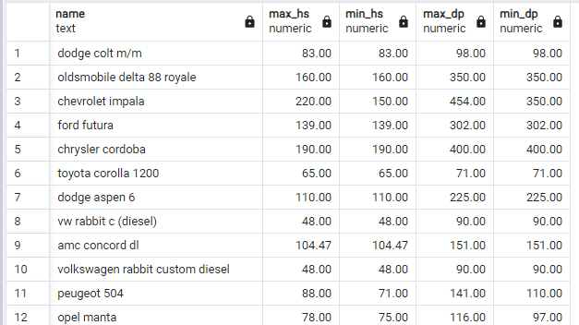

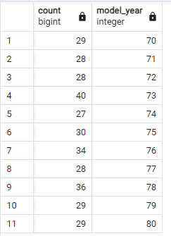

* Total cars produced between 1970 and 1980

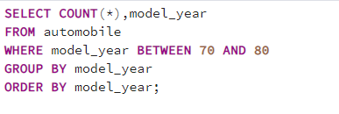

* Top 5 car manufacturers by average highway mpg

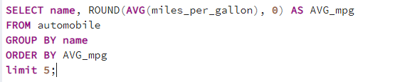

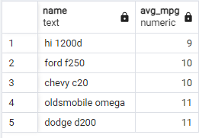

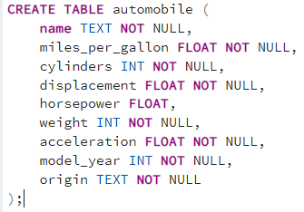CREATE QUERY :

3.Data Analysis with Power BI:-

* Power Query : first row as headers + convert datatypes
* Browse for Themes
* Visuals & filter for visuals
* DAX for counting cars over 1975