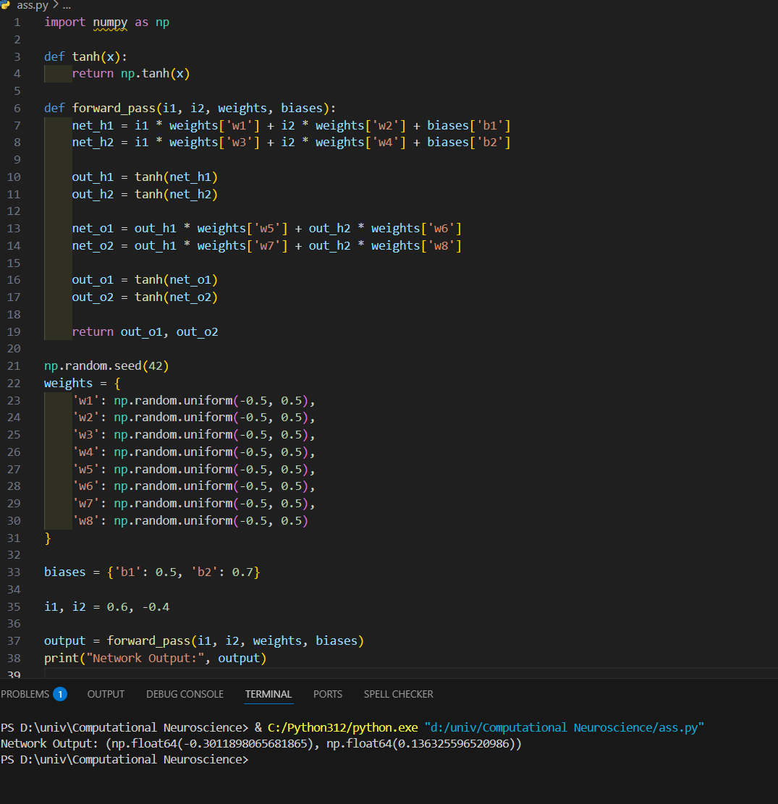

https://github.com/zyadabas/Computational-Neuroscience/blob/main/ass.py