1. ABOUT THE ORGANIZATION

**National Informatics Centre (NIC)** was established in 1976, and has since emerged as a "prime builder" of e-Government / e- Governance applications up to the grassroots level as well as a promoter of digital opportunities for sustainable development. NIC, through its ICT Network, "NICNET", has institutional linkages with all the Ministries /Departments of the Central Government, 35 State Governments/ Union Territories, and about 625 District administrations of India. NIC has been instrumental in steering e-Government/e-Governance applications in government ministries/departments at the Centre, States, Districts and Blocks, facilitating improvement in government services, wider transparency, promoting decentralized planning and management, resulting in better efficiency and accountability to the people of India.

"Informatics-led-development" programmed of the government has been spearheaded by NIC to derive competitive advantage by implementing ICT applications in social & public administration. The following major activities are being undertaken:

* Setting up of ICT Infrastructure
* Implementation of National and State Level e- Governance Projects
* Products and Services
* Consultancy to the government departments
* Research and Development
* Capacity Building

In executing all these activities, NIC has been given recognition in terms of awards and accolades in International as well as National levels, which are listed in the Awards Section.

Thus, NIC, a small program started by the external stimulus of a UNDP project, in the early 1970s, became fully functional in 1977 and since then has grown with tremendous momentum to become one of India's major S&T; organizations promoting informatics led development. This has helped to usher in the required transformation in government to ably meet the challenges of the new millennium.

**NIC Headquarters** is based in **New Delhi**. At NIC Headquarters, a large number of Application Divisions exist which provide total Informatics Support to the Ministries and Departments of the Central Government. NIC computer cells are located in almost all the Ministry Bhawans of the Central Government and Apex Offices including the Prime Minister‟s Office, Rashtrapati Bhavan and the Parliament House. Apart from this, NIC has various Resource Divisions at the Headquarters which specialize into different areas of IT and facilitate the Application Divisions as well as other NIC Centre‟s in providing state-of-the-art services to the Govt.

At the **State level**, NICs State/UTs Units provide informatics support to their respective State Government and at the District level laid the NIC District Informatics Offices. **Assam** is a northeastern state of India with its capital at Dispur, in the eastern part of Guwahati city.

**Assam State Centre (ASSC)** of the National Informatics Centre (NIC) was set up in April 1986. Various district units were set up from 1990 onwards, and now there is a NIC District Unit in each of 32 districts of the State.\

The SIO is supported at the State level by a team of technical officers and some other support staff. The NIC Assam State has a Training Division equipped with the latest training infrastructure; there is also a National Informatics Centre Services Incorporated (NICSI) office, NIC also has dedicated cells in the Guwahati High Court and Regional Passport Office, Guwahati.

* **Network:** The Network Operation Centre in NIC Assam commissioned in 2004 A Block of the Secretariat is the network gateway for the entire NE States. At present, there are two 100 Mbps links from BSNL and PGCIL. The Guwahati Delhi link is a primary link from PGCIL and the Guwahati-Hyderabad link is a failover link by BSNL. All the NE State capitals are connected to this centre either by BSNL or by PGCIL. The NOC is manned in the 24/7 mode by the hired manpower. There are various applications installed locally which are for effective monitoring of the entire network including the other NE states namely What‟s up, Nagios, MRTG and OpenNMS. There are two 63 inch plasma TV screens which are being used to monitor the status and health of the various nodes. All the 8 Blocks of the Secretariat are connected to the NOC with OFC backbone, each block having nearly 120 LAN nodes. All major and important locations inside the campus have secured WEP Wi-Fi access.23 districts of Assam are connected with dedicated 2 Mbps MLLN from the NOC in addition to DVB VSATs for data and DAMA VSATs for VC. Four new districts presently having VSATs only are being provided leased line connectivity shortly. Presently under the Citizen-centric Services Project, a state of the art Wi-Max network (5.876 GHz) is being set up in each district connecting 10 government organizations in each district headquarter in the State. These ten organizations are being connected to the NIC District Centre network HUB.As regards connectivity to other offices, district head post offices are being connected under the Department of Post (DoP) project. The Regional Passport Office (RPO), Census and Immigration Terminal at the air-port are connected to NOC with MLLN line from BSNL. The Guwahati Metropolitan Area Network (GMAN) was commissioned in 2005- 2006 when nearly 42 Directorate offices were connected with RF links. The four sites with RF hubs are connected by 2 Mbps leased line from BSNL and these lines acts as a backbone for the GMAN network. The residence of Governor of Assam and the Chief Minister are also connected with 2 Mbps leased line from BSNL and RF Link. This centre has also got a 3 TB SAN along with several mid-range servers for hosting several Intranet applications both under Windows and Linux platforms. Guwahati is also one of the HUBS for the National Knowledge Commission Network (NKN) in India. The BSNL and PGCIL have commissioned their high end network equipment‟s to support NKN at NOC Guwahati. BSNL has already installed a STM16 at NOC to give the high bandwidth network to various states in NER. IIT, Guwahati and AAU, Jorhat have been connected through NKN.
* **Video Conferencing**: With the first state-level VC Studio set up in 1998, VC facilities presently exist in almost all the districts and at the Chief Ministers Residence Office most of these are IP-based. VC facility is also available in the offices of the Chief Secretary, Minister of IT, Commissioner of IT. VC facility is regularly used by the State Government.
* **Training:** NIC, Assam State Unit, Guwahati has been imparting Training almost from its inception. Such activities were intensified since a separate Training Division was set up in 2000. Training Division conducts about 35-40 courses per year ranging from general awareness and Office Productivity courses for normal government users, Sectoral Course and Technology Update Courses for NIC personnel for the entire NE region. Total number of participants trained per year is 600-900. Ten project trainees (from MCA and BE/B Tech courses) also are accepted per semester.
* Registration: Document Registration System, Assam (e- Panjeeyan).
* Land Records
* Vahan and Sarathi.
* Geographic Information System.
* App Builder.
* N.R.C
* e-GRAS
* Websites of various Government Departments and Institutions.

|  |
| --- |
| National Informatics Centre Dispur, Rukmini Gaon  Guwahati-781006, Assam |
| Phone: +91-361-2237254  Website:dispur.nic.in |
| Email: [sio-asm@nic.in](mailto:sio-asm@nic.in) |

2. PROJECT OVERVIEW

The project is entitled as **e-GRAS MOBILE APPLICATION, GOVT OF ASSAM**.

e-GRAS MOBILE APPLICATION, GOVT OF ASSAM is an android application designed to interact with e-GRAS(Electronic Government Receipt and Accounting System), which is a government's electronic payment gateway to receive payments online. This app facilitates online tax payment and challan generation process right from Android phones. Besides, the app lets users review their transaction history and search for already generated challans.

Finance Department (FD), Government of Assam, has decided to receive payments electronically. e-payment is a mode of payment in addition to the conventional methods of payment offered by the Government of Assam. The acceptance of on-line payment of Assam State's Taxes through the internet portals of various banks have been developed, without having any implication on the existing procedure of the executive and accounting agencies of the Department. To avail of this facility the taxpayer is required to have a net-banking account with any of the banks listed by the government on this site. Facility of Payment Across the Bank Counter is made available (with limited Banks) for those who do not have net banking account with Bank participating in GRAS.

* This is a 24X7 facility and citizen can make the payment any time of the day.
* On-Line Filling of single challan form facilitates minimum fields of the challan to be filled.
* Instant online receipts for payment made and instant online banks transaction number becomes available.
* One can pay personal taxes as well as on behalf of the firm, company and others.

Currently the interaction with e-GRAS Payment Gateway has been carried out through a web portal/application. Govt departments and their respective offices use that non-mobile friendly, somewhat old, traditional web application to pay Assam State's taxes through the internet portal of various banks. They primarily use desktop web browsers for online payments and challan generation-the experience of which is alright. But, the experience of using mobile phones to interact with e-GRAS web application is not satisfactory at all.

As in this modern day and age, for any online activities, usage of mobile applications is preferred and it is growing tremendously, there is an urgent need for a mobile application which can communicate with e-GRAS and facilitate the tax payment and the challan generation process right from Android phones.

Traditional web portal and modern mobile app:

Both methods have their own advantages and disadvantages and are designed to make online tax payment and challan generation process easier.

DISADVANTAGE Of Traditional Web Portal:

Being a traditional web portal, eGRAS web portal is only suitable for desktop computing. The mobile experience of this web application is purely counter-intuitive.

Even, some of the functionalities are very hard to use in a mobile browser. Moverover, the process of converting the existing web application into a responsive, mobile-friendly is costly too. Therefore, the demand for a mobile-friendly version of eGRAS application was increasing.

e-GRAS Mobile Application

A mobile application is a program that access the internet to work online or work offline by using devices‟ native functionalities. Mobile apps can use devices‟ native features, which allows developers to create better, more intuitive and faster user experiences for customers. In e-GRAS too, users can access some parts of the app without being connected to the internet, and additionally the filling of the forms for the tax payment process has become more user friendly.

ADVANTAGE OF e-Panjeeyan app:

For e-GRAS users, the development of the mobile application has resulted in the tax payment and challan process more interactive and customized. Users only have to download and install e-GRAS on their device, and generally, as it is a native app, it offers a faster and more responsive experience compared to the web portal.

e-GRAS MOBILE APPLICATION allows users to pay Assam Govt taxes for various schemes right form their Android phones. On doing so, they can also generate the respective challan associated with the payment.

Some of the benefits and advantages of using the app are:

* **The stepwise tax payment process:** The whole tax payment process is now divided into four distinct, but related stages to make it initiative for mobile experience.
* **Ease of access to challans:** Once registered with the app, one will be able to download the challans for all of his/her successful transactions.
* **Confidentiality:** Whenever one register oneself with the app, all the personal details and information are kept confidential.
* **Customization:** Users can customize the app according to their desire, whether it be changing of the default language i.e., English to Assamese or switching from the default Light mode to Dark mode and vice-versa.
* **User friendly:** For the convenience of the users, there is a user manual available in the app which would guide the users throughout the whole time.

Traditionally the tax payment and challan generation process is carried out through the web portal, which is well-suited for desktop computing. Each and every functionality works the way it‟s supposed to work on desktop browsers. As, desktop computing was the primary focus during the development of the web portal, not much effort was made to make it suitable for mobile experience. As a result, eGRAS‟ web application does not work satisfactorily on mobile devices.To overcome this, e-Panjeeyan mobile app was needed to be built.

This project is aimed at developing a mobile app for eGRAS(Government Receipt Accounting System), GOVT OF ASSAM. The system is an online application for the various offices of Govt departments, for paying Assam Govt taxes for different schemes they undertake and generating the respectives challans. Following features are integrated in the system:

1. One should be able to create an account with the app.
2. Therefore, register/login functionality has been added.
3. Once registered with the app, one will be able to make payments and generate challans online.
4. Users will be able to see all of their transactions in list and detail form.
5. All the activities of a user inside the app will be stored and made available as Activities Logs to review in the future.
6. For the convenience of the users, there is a in-app user manual available in the app which would guide the users throughout the whole time.
7. Some user customizations like, changing app‟s theme and default language has also been included.

The e-GRAS MOBILE APPLICATION is mainly developed to make online tax payments and challan generation process easier and mobile-friendly. A friendly user interface is provided where all the services are neatly organised in an accessible manner. To use the older, traditional web portal, one has to use a Desktop- class web browser to avail all the services eGRAS offers in an accessible form. But in the e-GRAS mobile app, each and every functionality is re-designed in such a way that it works intuitively on mobile phones. Moreover, some extra features, such as customisation of the app, in-app user manual are included in eGRAS‟ mobile counterpart.

The mobile app is notably good when a person needs to complete some goals quickly and efficiently, in this case, online tax payment and challan generation. This well-designed app must give our client all opportunities to perform their tasks just in few taps or scrolls.

FEASIBILITY STUDY

After initial investigation, feasibility study is carried out to check the workability of registration system. Its impacts on the organizational ability to meet user needs and effective use of the system. Feasibility study is the testing of the proposed system according to its workability. The object of the feasibility system is not to solve the problem but to acquire a sense of its scope. During the study of the problem definition is centralized and aspects of the problem to be included in the system are determined. Consequently costs and benefits are estimated with greater accuracy at this stage. The result of the feasibility study is a normal proposal. This is simply a report a formal document detailing the nature and scope of the proposed solution. The proposal summarizes what is known and what is going to be done.

There are three key considerations involved in the feasibility analysis. They are:

* Technical feasibility.
* Economic feasibility.
* Operational feasibility.

During technical feasibility, the analyst evaluates the technical merits of the system, at the same time collecting additional information about the performance, reliability, maintain ability and product ability in some cases, this system analysis step also includes a limited amount of research and design.

We can summaries the technical feasibility of the proposed system in following points:-

* The proposed system is capable of holding data to be used.
* The proposed system being modular, if the developer wants can add more features in the future and as well as being able to expand the system.
* As far as the hardware and the software are concerned, the proposed system is completely reliable.

In economic feasibility, which is also known as cost-benefit analysis, benefits expected from registration system are composed with the cost. If the benefits outweigh the costs, then decision is made to design and implement the system. Otherwise, further justification or alteration in the proposed system will have to be made.

This project was developed using all open source software like Android Studio, VS Code, Oracle 11g Express database etc. No costs regarding purchase of software or license were required.

The proposed system is economically feasible because of the following reasons:-

* This system is one time investment system, where all the features required will be added.
* Since the project was developed using open source tools, therefore the cost of the proposed system will be much less.

In general, people resistant to change but the usage of mobile applications has been growing tremendously. A survey should be made of how strong a reaction the user staff is likely to have towards the development of the mobile-based system.This project provides user friendly interactions for getting relevant results.

From the observation made in the feasibility study described above, it can be concluded that the proposed system is feasible in all aspects and justified that the feasible study could be followed by the system analysis and system design phase. The proposed system is also capable of holding the data to be used and is capable of providing adequate response. Thus, the proposed system is technically, economically and operationally feasible.

TECHNOLOGY USED

The proposed system is comprised of the following software tools. These tools were chosen in such a manner, taking into account the need for future enhancements, system longevity and maintainability.

Operating System: Windows 10

Languages/Frameworks: Java and Android Framework, Slim PHP Framework, HTML

Web server: Apache/XAMPP

IDE used: Android Studio

Text Editor: Visual Studio Code

Web GUI Design: Bootstrap, Materialize CSS

Browsers: Google Chrome

Database: Oracle 11g Express Edition

Java and Android Framework:

The Android Framework is predominantly built on Java. The classes, methods, APIs are written in Java. So the knowledge of Java is crucial for Android development.

Java programming language was originally developed by Sun Microsystems which was initiated by James Gosling and released in 1995 as core component of Sun Microsystems' Java platform (Java 1.0 [J2SE]).

The latest release of the Java Standard Edition is Java SE 8. With the advancement of Java and its widespread popularity, multiple configurations were built to suit various types of platforms. For example: J2EE for Enterprise Applications, J2ME for Mobile Applications.

The new J2 versions were renamed as Java SE, Java EE, and Java ME respectively. Java is guaranteed to be Write Once, Run Anywhere.

Some of the features of the Java language are:

**Object Oriented** − In Java, everything is an Object. Java can be easily extended since it is based on the Object model.

**Platform Independent** − Unlike many other programming languages including C and C++, when Java is compiled, it is not compiled into platform specific machine, rather into platform independent bytecode. This byte code is distributed over the web and interpreted by the Virtual Machine (JVM) on whichever platform it is being run on.

**Simple** − Java is designed to be easy to learn. If you understand the basic concept of OOP Java, it would be easy to master.

**Secure** − With Java's secure feature it enables to develop virus-free, tamper-free systems. Authentication techniques are based on public-key encryption.

**Portable** − Being architecture-neutral and having no implementation dependent aspects of the specification makes Java portable. Compiler in Java is written in ANSI C with a clean portability boundary, which is a POSIX subset.

**Robust** − Java makes an effort to eliminate error prone situations by emphasizing mainly on compile time error checking and runtime checking.

**Multithreaded** − With Java's multithreaded feature it is possible to write programs that can perform many tasks simultaneously. This design feature allows the developers to construct interactive applications that can run smoothly.

Slim PHP - A Micro Framework for PHP:

Slim is a PHP micro framework that helps to quickly write simple yet powerful web applications and APIs. At its core, Slim is a dispatcher that receives an HTTP request, invokes an appropriate callback routine, and returns an HTTP response.

Slim is an ideal tool to create APIs that consume, repurpose, or publish data. Slim is also a great tool for rapid prototyping. Even building a full-featured web applications with user interfaces, Slim is useful too. More importantly, Slim is super fast and has very little code.

The benefits that I am getting out of Slim framework for using it, instead of using core PHP, are mentioned below:

Slim is helping me designing standard RESTful APIs

For example:

GET: „/depts

GET: „/depts/{id:[1-9]+}‟ POST: „/offices/new‟

GET: „/depts/{dept_code}/districts/{district_code}/offices‟

Excellent out-of-the-box Error Handling Support

It handles all the important HTTP errors, like, 404, 500, 405, 503, automatically using a concept called „Handlers‟.

Middleware Support

Why do we even need middleware? A quote taken directly from Slim‟s documentation:

“You can run code before and after your Slim application to manipulate the Request and Response objects as you see fit. This is called middleware. Why would you want to do this? Perhaps you want to protect your app from cross-site request

forgery. Maybe you want to authenticate requests before your app runs. Middleware is perfect for these scenarios.”

In my case, I‟m using Middleware for Authenticating and Securing the APIs with JWT. A diagrammatic representation of Middleware is given below:

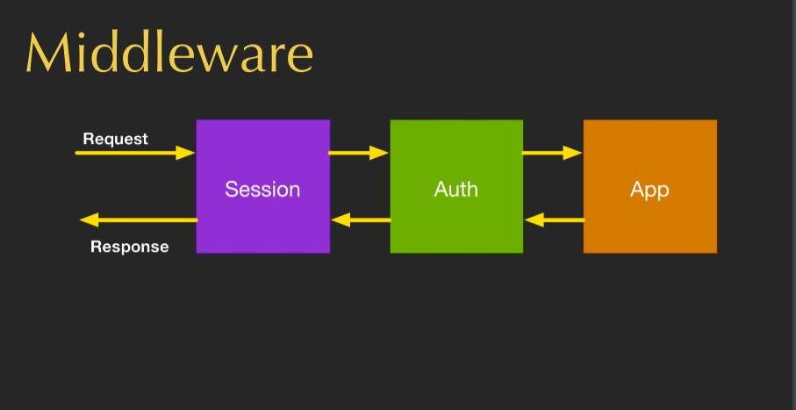

**Fig: The working of middlewares**

Apache/XAMPP Web Server:

XAMPP is a free and open-source cross-platform web server solution stack package developed by Apache Friends, consisting mainly of the Apache HTTP Server, MariaDB database, and interpreters for scripts written in PHP and Perl programming languages. Since most actual web server deployments use the same components as XAMPP, it makes transitioning from a local test server to a live server possible. XAMPP's ease of deployment means a WAMP or LAMP stack can be installed quickly and simply on an operating system by a developer.

The version that I‟m using for development is 7.1.30/ PHP 7.1.30.

Android Studio:

Android Studio is the official [integrated development](https://en.wikipedia.org/wiki/Integrated_development_environment) [environment](https://en.wikipedia.org/wiki/Integrated_development_environment) (IDE) for [Google](https://en.wikipedia.org/wiki/Google)'s [Android](https://en.wikipedia.org/wiki/Android_(operating_system)) [operating system](https://en.wikipedia.org/wiki/Operating_system), built on [JetBrains'](https://en.wikipedia.org/wiki/JetBrains) [IntelliJ IDEA](https://en.wikipedia.org/wiki/IntelliJ_IDEA) software and designed specifically for [Android development](https://en.wikipedia.org/wiki/Android_software_development). It is available for download on [Windows](https://en.wikipedia.org/wiki/Windows), [macOS](https://en.wikipedia.org/wiki/MacOS) and [Linux](https://en.wikipedia.org/wiki/Linux) based operating systems. It is a replacement for the [Eclipse Android Development Tools](https://en.wikipedia.org/wiki/Eclipse_(software)#Android_Development_Tools) (ADT) as the primary IDE for native Android application development.

VS Code(Visual Studio Code):

Visual Studio Code is a lightweight but powerful source code editor which runs on your desktop and is available for Windows, macOS and Linux. It comes with built-in support for JavaScript, TypeScript and Node.js and has a rich ecosystem of extensions for other languages (such as C++, C#, Java, Python, PHP, Go) and runtimes (such as .NET and Unity). Moreover, It includes support for debugging, embedded Git control and GitHub, syntax highlighting, intelligent code completion, snippets, and code refactoring. It is highly customizable, allowing users to change the theme, keyboard shortcuts, preferences, and install extensions that add additional functionality.

In the Stack Overflow 2019 Developer Survey, Visual Studio Code was ranked the most popular developer environment tool, with 50.7% of 87,317 respondents claiming to use it

BOOTSTRAP:

Bootstrap is a free collection of tools for creating websites and web applications. It contains HTML and CSS-based design templates for typography, forms, buttons, navigation and other interface components, as well as optional JavaScript extensions. In March 2014 it was the No.1 project on GitHub with 65,000+ stars and 23,800 forks, with a user base including MSNBC and NASA.

One Can Use Bootstrap to:

Save time and repetition with Bootstrap's powerful collection of pre-made templates, classes, and grid layouts.

Build and deploy "platform agnostic" websites at a pinch.

Fluid grid layouts and templates make mobile-first development easy.

Light weight and expandable.

Compatibility across a huge range of browsers - including Internet Explorer 6!

Bootstrap is an open-source JavaScript framework developed by the team at Twitter. It is a combination of HTML, CSS, and JavaScript code designed to help build user interface

components. Bootstrap was also programmed to support both HTML5 and CSS3.

Materialize CSS:

Materialize is a UI component library created with CSS, JavaScript, and HTML. Materialize reusable UI components help in constructing attractive, consistent, and functional web pages and web apps while adhering to modern web design principles such as browser portability, device independence, and graceful degradation.

Some of its salient features are as follows −

In-built responsive designing.

Standard CSS with minimal footprint.

New versions of common user interface controls such as buttons, checkboxes, and text fields adapted to follow Material Design concepts.

Enhanced and specialized features such as cards, tabs, navigation bars, toasts, and so on.

Free to use and requires jQuery JavaScript library to function properly.

Cross-browser, and can be used to create reusable web components.

4.1.7 Oracle 11g Express Edition:

Oracle Database Express Edition (Oracle Database XE) is a free, smaller-footprint edition of Oracle Database. Oracle Database XE is easy to install and easy to manage.

With Oracle Database XE and related tools one can:

Administer the database

Create tables, views, and other database objects

Import, export, and view table data

Run queries and SQL scripts

Express Edition (XE) is a free, downloadable version of the Oracle database server. Oracle XE can only be used on single processor machines. It can only manage up to 4 GB of data and 1 GB of memory. OEMs can embed XE in 3rd party products and redistribute it freely.

Hardware used for developing the system

✔ Processor: Intel core i5, 8th gen

✔ Memory: 8GB RAM

✔ Hard disk: 1TB

5. SYSTEM ANALYSIS

System analysis is a detailed study of the various operations performed by a system and their relationships within and outside of the system. It is a systematic technique that refines goals and objectives. The goal of the system and development is to deliver the system in line with the user‟s requirement, and analysis is the heart of the process.

System study has been conducted with the following objectives in mind:

Identify the client‟s needs.

Evaluate the system concept for feasibility

Perform economic and technical analysis.

Allocate functions to hardware, software, people, database and other system elements.

Establish cost and schedule constraints.

Both hardware and software expertise is required to successfully attain objectives listed above.

A system engineer must incorporate a development strategy to solve the actual problem in the organization. The strategy that contains the process, method and tests layers and the generic phase referred to as a software engineering paradigm. The software engineering paradigm is chosen on the basis of the nature of the project and application, the method and tools to be used, and delivers that are required.

In the proposed system, the waterfall model constitute the output of one process becomes the input to another process and this transformation continues till the results is not achieved.

**ITERATIVE WATERFALL MODEL**

Iterative Waterfall Model is an approach of software engineering in which the process is structured as a cascade of phases, when the outputs of one phase constitute the input to the next one. If any defect is detected in any phase, then engineers can go back to the phase where the defect had occurred and redo some of the work done during that phase and the subsequent phases to correct the defect and its effect on the later phases. Each phase is regarded as the set of activities that are executed by different people concurrently.

The phases involved are shown with the help of diagram as--

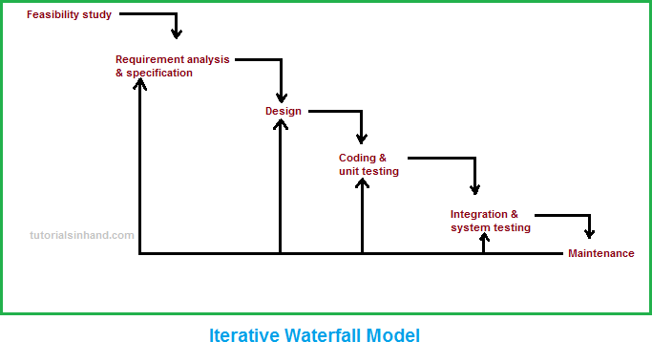

Iterative Waterfall Model:

Preliminary investigation and identification of need.

Problem definition and feasibility study.

System analysis and its specification.

System design and its specification.

Hardware, software requirements and its specification.

Coding and optimization of code.

Integration and system testing.

Implementation

Maintenance

System security measure.

Depends upon the organization the waterfall model is described in various stages, underlying philosophy is the same so that the comments we give here apply to all of them.

The various phases of waterfall model are detailed below:

**Preliminary investigation and identification of needs**- Requirements is defined and determined in the life cycle of the system development.

**Problem definition and feasibility study**- The problem is defined in this phase and technical, economic and operational feasibility is measured.

**System analysis and its specification**- This phase includes the detailed information of the requirements of both the user and software and analysis the parameters like:

Input to the system

Process required

Output expected

Constraints.

**System design and its specification-** This phase mainly deals with the software architecture and data structure, etc. This phase process the requirements into a representation of the software. This also answers to the questions raised about the tasks.

**Hardware, software requirement and specification-** This phase deals with the various components such as the tangible or intangible of the specified system.

**Coding and optimization of code-** In this phase the code required to complete the software is done and each module is tested to achieve the goal. Coding refers to the translation of the design into machine understandable form. The more detail the design the more easy is the coding and better is its reliability.

**Integration and system testing-** After completion of the coding phase of each module it is then required to be integrated with other modules and then finally all the modules are needed to be tested rigorously for correcting of the code and results. Testing may involve the individual unit and the whole system. It requires a detailed plan as to what, when and how to test.

**Implementation-** After completing the integration and system testing phase which implies that the software is not anymore required for any further tests and is corrected completely. It is then needed to be implemented at the client site.

**Maintenance-** After successful installation and implementation, it is evaluated to work satisfactory and perform all the tasks desired from it. If any further requirement arises it is to be maintained and if any modification is needed that also be done in this phase.

**System security measure-** The last phase deals with system security, which is done by authorized user name and regular password check.

One of the best approaches to system analysis is the structural analysis. Structural analysis is a set of techniques and graphical tools that allow us to develop a new kind of system specifications that is easily understandable to the developer. It is the detailed step by step investigation of related procedures to see what must be done and to determine the best way of doing it. The objection is to build a system specification that provides the basis for design and implementation.

**Data Flow Diagrams:**

Data flow diagrams illustrate how data is processed by a system in terms of inputs and outputs. Data Flow Diagramming is a means of representing a system at any level of detail with a graphic network of symbols showing data flows, data stores, data processes, and data destinations/data sources.

The Data Flow Diagram is analogous to a road map. It is a network of all possibilities with different detail shown, on different hierarchical levels. The process of representing different detail levels is called leveling or partitioning by some data flow diagram advocates. Like a road map, there is no start or stop point, no time or timing, or steps to get somewhere. We just know that the data path must exist because at some point it will be needed. A road map shows all existing or planned roads because at some point it will be detail that is not shown on the different levels of the data flow diagram such as volumes, timing, frequency, etc. is shown on supplementary diagrams or in the data dictionary. For example, data store contents may be shown in the data dictionary.

**Purpose/Objective:**

Graphical, eliminating thousands of words, logical representations, modeling what a system does, rather than physical models showing HOW it does it. Hierarchical, showing systems at any level of detail, and Jargon less, allowing user understanding and reviewing.

The goal of data flow diagramming is to have a commonly understood model of a system. The diagrams are the basis of structured systems analysis. Data Flow Diagrams are supported by other techniques of structured systems analysis such as data structure diagrams, data dictionaries and procedure representing techniques such as decision tables, decision trees and structured English. Data Flow Diagrams have the objective of avoiding the cost of User/developer misunderstanding of a system, resulting in a need to redo systems or in not using the system. Having to start documentation from scratch when the physical system changes since the logical system, what gets done often remains the same when technology changes. Systems inefficiencies shows up because a system gets computerized before it gets systematized, being unable to evaluate system project boundaries or degree automation, resulting in a project of inappropriate scope.

The DFD for eGRAS application is given below:

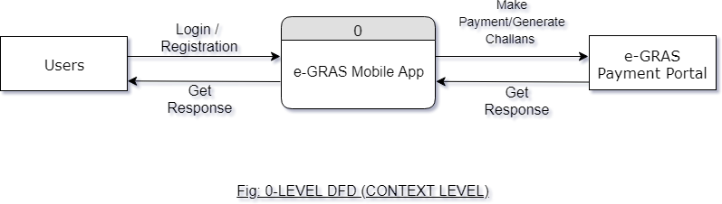

**e-GRAS MOBILE APPLICATION, GOVT OF ASSAM**

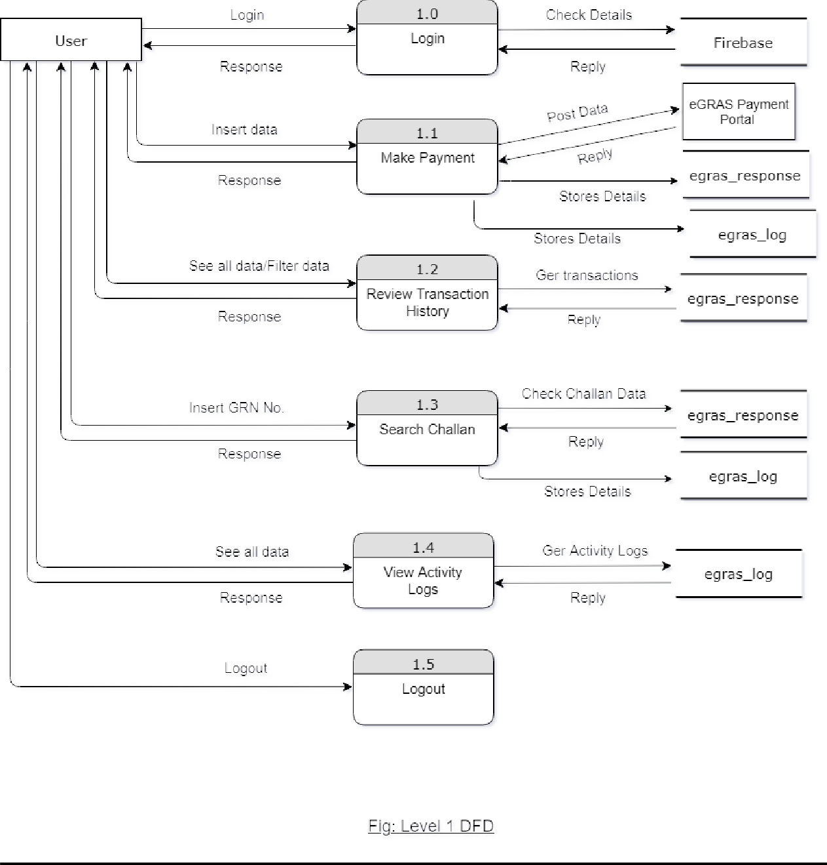

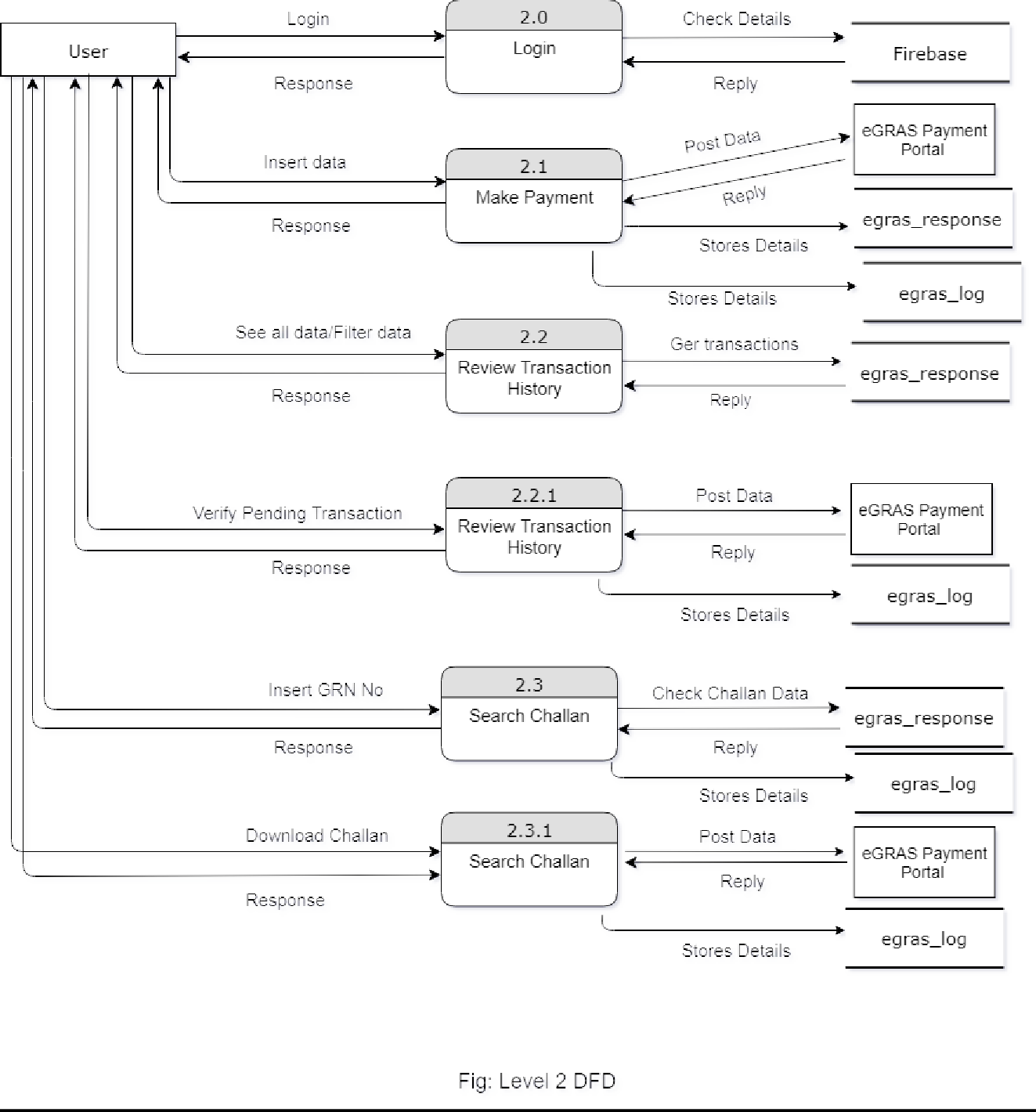

SYSTEM DESIGN

System design is the most crucial phase of a system development life cycle. It produces the details that state how a system will meet the requirements identified during system analysis. Absence of proper design is bound to lead to confusion and errors. A complete design must accommodate all of the implicit requirements desired by the customer. It must be readable, understandable guide for programmers. It should provide a complete picture of the system addressing the data, functional, and behavioral domains from an implementation perspective. System design starts after the software requirements have been analyzed and specified. System analysis specifies what a system should do to meet the needs of user, but system design specifies how the system will achieve those objectives.

The objectives in designing information system are –

Specify the logical design elements

Ensure that system features meet the user requirements

Physical factors (that affect the performance, comfort and specification of direct users) design

Provide detailed software development specification

System design goes through two phases of development.

These are –

Logical Design

Physical Design

**Logical Design:**

Logical design involves developing general specifications for how the basic information system activities of input, processing, output, storage and control can meet the end user requirements.

**Physical Design:**

Physical construction, the activity following logical design, produces program software, files and a working system. Design specifications instruct programmers about what the system does. Several development activities are carried out during the design phase, some of the most important are –

User Interface/System Interface design

Database design

**User Interface/System Interface Design:**

Generally the first step in the system design is the user interface design. The user interface design activity focuses on the preparation of input and design of output reports in a form of acceptable to the users. It concentrates on input/output method and the conversion of data and information between human and

machine-readable forms. So, user interface design includes detailed specification for display screens, interactive dialogues, audio responses, reports etc. **Forms Design** is an important phase of System Design in order to produce data in the right form for input and the information produced must be in a format acceptable to the user.

Database design is the process of producing a detailed data model of a database. This logical data model contains all the needed logical and physical design choices and physical storage parameters needed to generate a design in a Data Definition Language, which can then be used to create a database. A fully attributed data model contains detailed attributes for each entity.

The term database design can be used to describe many different parts of the design of an overall database system. Principally, and most correctly, it can be thought of as the logical design of the base data structures used to store the data. In the relational model these are the tables and views.

6.3.1 Entity Relationship Diagram (ERD)

Entity Relationship (ER) model is a popular high-level conceptual data model. The conceptual schema is a concise description of data requirements of the user and includes a detailed description of the entity type, relationships, and constraints. These concepts do not include implementations details; they are easier to understand and can be used to communicate with non-technical users. This approach enables the database designers to concentrate on specifying the properties of data, without being concerned with storage details.

Entity Relationship Diagram represents the relationship between various entities and their attributes. Relationship between entities makes up a data structure. There are three types of relationship we can find in an ERD,

One to one.

One to many

Many to many.

The Building Blocks of ERD: Entities, Relationships, and Attributes

The ER Diagrams for eGRAS is given below:

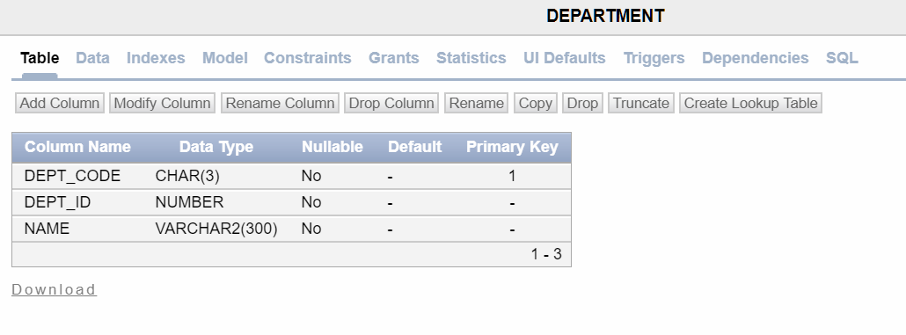

Table name: **department**

Table name: **district**

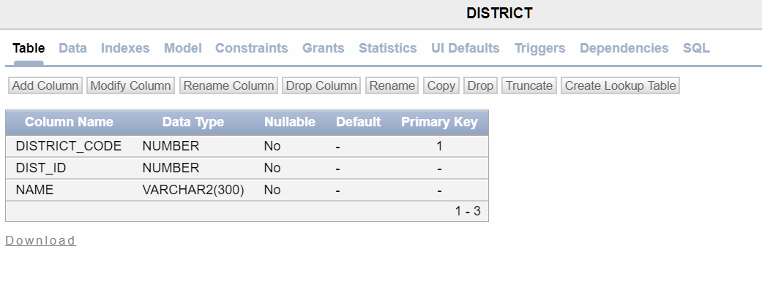

**e-GRAS MOBILE APPLICATION, GOVT OF ASSAM**

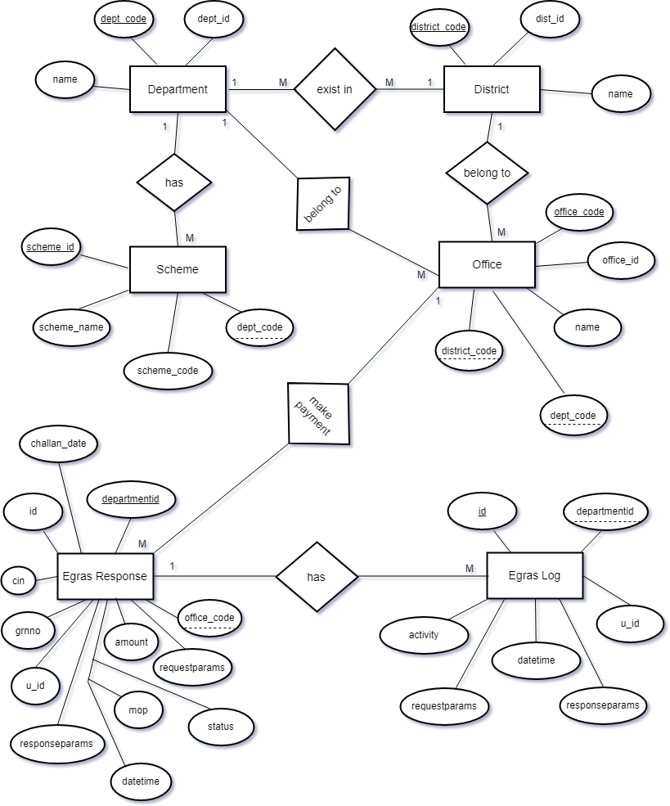

Table name: **dept_district**

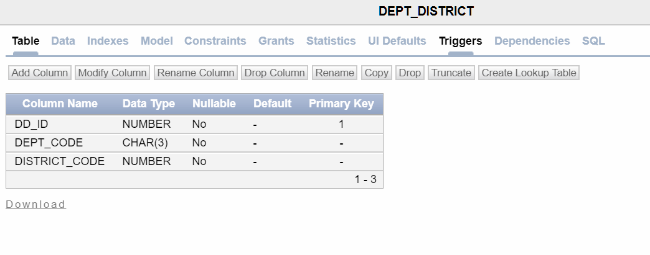

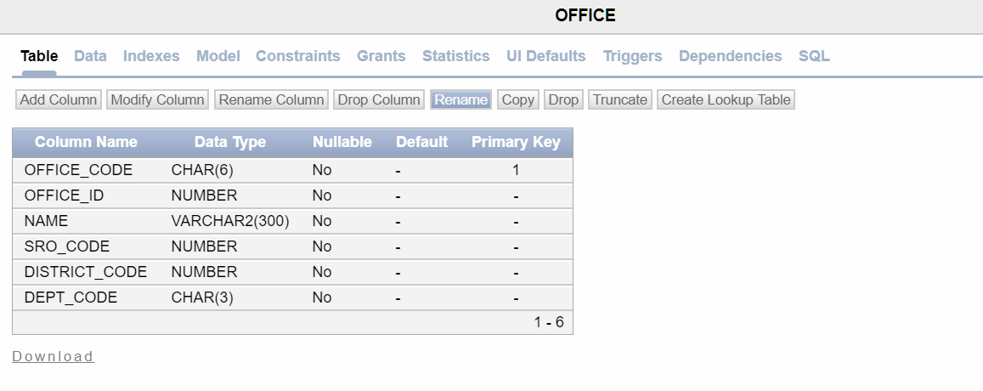Table name: **office**

Table name: **scheme**

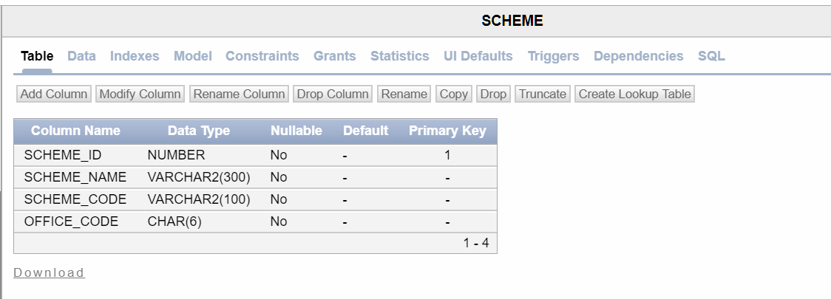

Table name: **egras_log**

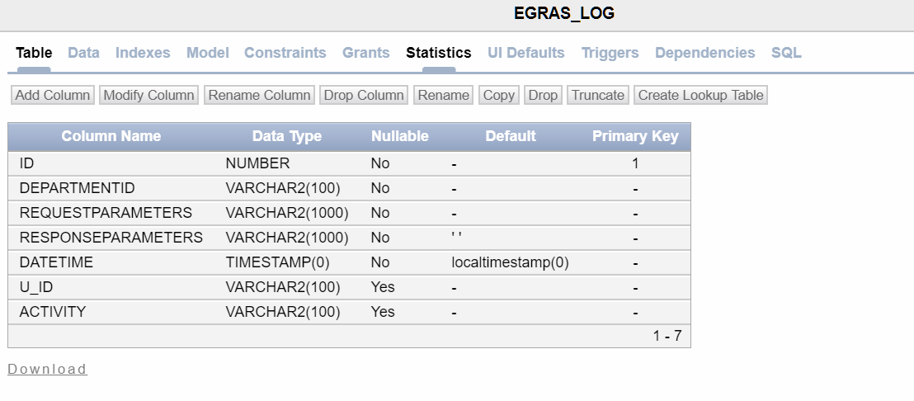

Table name: **egras_response**

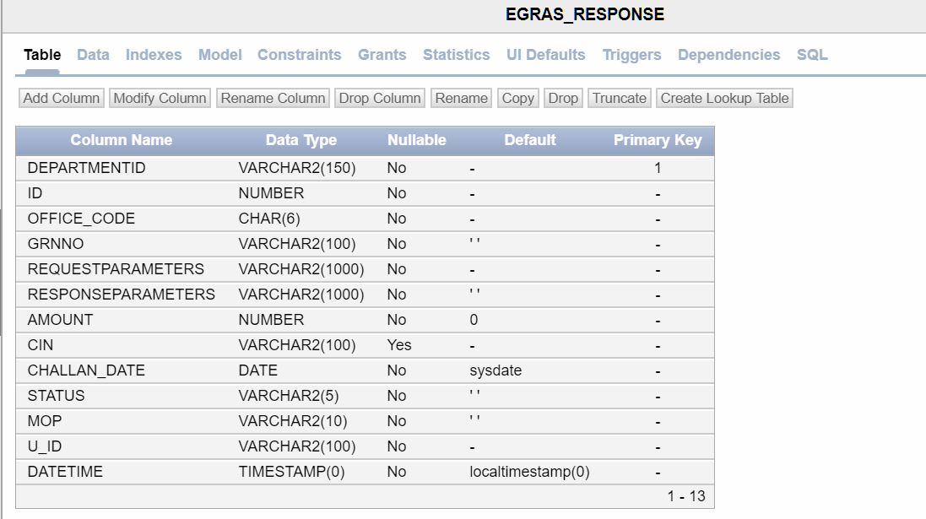

CODING

Once the design is completed, most of the major decisions about the system have been made. Now the design must be translated into a machine-readable form. The Code generation step performs this task. If the design is performed in a detailed manner, code generation can be accomplished mechanistically.

The goal of coding or programming phase is to translate the design of the system produced in design phase into code in a given programming language, which can be executed by a Computer and that performs computations specified by the design. The Code generation should be designed in a manner to reduce input, control errors and accelerate the entire process.

Normally, good software development organizations adhere to some well-defined and standard style of Coding called Standards. Most software development organizations formulate their own coding standards that suit them most, the reasons for adhering to a standard coding style are as follows-

It gives a uniform appearance to the codes written by different programmers.

It enhances code understandability.

It encourages good programming practices.

Code efficiency is one of the major tasks of the System Development Life Cycle (SDLC). It checks as to whether the access time is minimized or not, whether the errors are eliminated or not, whether the data integrity is maintained or not etc. To enhance the efficiency of the system, drop-down list are provided. Besides, drop down list box for item name entries are also provided. It is done so that the user would have the option to select the item name else they may enter incorrectly.

Code optimization is one of the main tasks of the SDLC. It supplements the efficiency of the coding and is the penultimate stage of removal of any data redundancy and unnecessary occupation of the space.

In the proposed system, different types of the codes have been optimized such as looping codes.

Example: (for an unoptimized code) If (condition 1> condition 2)

{

If (condition 1> condition 3) Statement;

}

Now Example of optimized code-

If (condition 1> condition 2 && condition 1> condition 3)

{

Statement;

}

Besides, many checking features have been accommodated to stop the entry of unoptimized code. Necessary check constraints have been declared to stop unauthorized accessing retrieving of the data. If the user enters incorrect data, the system has been designed to prompt the user, suggesting entering the correct data.

Evaluation is to identify whether the system is serving the intended purpose of the organization and meeting the expected requirements of the user, its strength and weakness. For evaluation of the system, a list of satisfied users will be given to the organization concern, which is using the identical system for seeking their opinion.

SYSTEM TESTING

The quality of an information system depends on its design, development testing and implementation. One aspect of system testing is its reliability. A system is reliable if used in a reasonable manner; it does not produce failures that are dangerous or over time costly.

An additional aspect of quality assurance is avoiding the need for enhancement on the one hand and developing software that is maintainable on the other. The need for maintenance is very high and impedes new developments. The greatest amount of maintenance is for user enhancement and improved documentation tasks that can be avoided or at least reduced in frequency through proper systems engineering. So, quality assurance is the review of software products and related documentation for complete correctness and maintainability. Besides these, it also includes assurance that the system meets the specifications and requirements for its intended use and performance.

One of the most important levels of quality assurance is system testing. Testing is the process of executing a program with the explicit intention of finding errors that is making the program fail. A successful testing is then finding the errors.

There are two strategies for testing software. These are

Code Testing

Specification Testing.

Code Testing

The code testing strategy examines the logic of the program. To follow this testing method the analyst develops the test cases resulting executing every instruction in the program or modules that is every path through the program is tested. A path is a specific combination of conditions that is handled by the program.

Specification Testing

To perform specification testing, the analyst examines the specification stating what the program is going to do and how it should perform under various conditions. By examining the results, the analyst can determine whether the program performs according to its specified requirements.

Regardless of which strategy the analyst follows, there are preferred practices to ensure that the testing is useful. The levels of tests and types of data, combined with testing libraries are important aspects of the actual test process. Systems are not designed as entire systems nor are they tested as single systems. The analyst must perform.

**UNIT TESTING**

Unit testing is testing changes made in an existing or a new program. In the unit testing the analyst test the program making up a system. The software units in a system are the modules and routines that are assembled and integrated to perform a specific function. Unit testing focuses first on the modules, independently of one another, to locate errors. This enables the tester to detect errors in coding and logic that are contained within that module alone. Those resulting from the interaction between modules are initially avoided.

SYSTEM TESTING

No system design is perfect; several factors like communication gap between user and the system developer, or time constraints create error that must be eliminated before the

system is ready for user acceptance and training. Goal achievement of a system can be recognized only after proper testing, rectification of error, if any. A small system error may conceivably explode into a much larger problem with the passage of time. Hence testing is vital to the success of a system.

System testing is executing a program to check logic changes made in it. With the intention of finding errors-making the program fails. Effective testing does not guarantee reliability. Reliability is a design consideration. The purpose of system testing is to identify and correct errors in the system.

System testing does not test software but rather the integration of the modules in the system and its original objectives, current specifications and system documentation. The primary concern is the compatibility of individual modules. The features to be tested and the plan varies from system to system, the first is to see whether it produces the correct output. Following tests have been conducted in design and development of the current application system.

**OUTPUT TESTING**

The process is testing simultaneously both program (internal processes) and its output. Output produced by the system is compared with the desired output. Each and every program is tested separately with synthetic data. Actually it is found to be identical. Corrections and modifications were required to be done in some programs.

**VOLUME TESTING**

Within this phase of various sizes were entered in the system and run to verify whether the new software function correctly or not. Since seven different data of records with different logic‟s bulk or volume testing is most important acceptance.

**RECOVERY AND SYSTEM SECURITY TEST**

Without the facilities of backup recovery and security, the system is handicapped. Even in some instances it may cause several problems like loss of data. Forced system failures were introduced to test the security of stored data.

There are also facilities to take backup from hard disk to diskette and vice versa. Disk features of the system were tested.

**DOCUMENTATION TESTING**

An adequate number of components or messages are provided in each program in order to assist the user in taking awkward situation and for ease of using the system. The user was asked about the understandability and utility of these messages; the response from the user was taken into consideration to make the system for novice users like them.

**ACCEPTANCE TESTING**

Acceptance testing is the last stage of system testing. Live data of the system having different details of information were entered and processed by the actual user of the system. They were sending to the concerned authority and found to be accepted. Then the authority recommended for implementation.

Synthetic data were composed by the system developers. During preparation of synthetic data it was in mind that the data should be exhaustive enough to revel all terms and conditions. Live data were taken from different paper files of the existing system of the host firm and inserted by real user.

DEBUGGING

Debugging occurs as a consequence of successful testing. When a test case uncovers an error, debugging is the process that results in the removal of the error. Although debugging can and should be an orderly process, it is still very much an art. A software engineer, evaluating the results of a test, is often confronted with a "symptomatic" indication of a software problem. That is, the external manifestation of the error and the internal cause of the error may have no obvious relationship to one another. Debug process always begins with the execution of a test case. The results are assessed and a lack of correspondence between the expected and actual outcome is encountered. In many cases, the non-corresponding data are a symptom of an underlying cause that is as yet hidden. The debugging process attempts to match symptoms with cause, thereby leading to error correction.

The debugging process will always have one of two outcomes:

The cause will be found corrected and removed, or The cause will not be found. In the latter case, the person performing debugging may suspect a cause, design a test case to help validate his suspicion, and work toward error correction in an iterative fashion.

In general, three categories for debugging approaches may be proposed:

The brute force category of debugging is probably the most common and least efficient method for isolating the cause of a software error. This technique is applied when all else fails. Using a "let the computer find the error" philosophy, memory dumps are taken, run-time traces are invoked, and the program is loaded with WRITE/SYSTEM.OUT/PRINT statements. It is hoped that somewhere in the morass of information that is produced, we will find a clue that can lead us to the cause of an error. Although the mass of information produced may ultimately lead to success, it more frequently leads to wasted effort and time.

This is a fairly common debugging approach that can be used successfully in small programs. Beginning at the site where a symptom has been uncovered, the source code is traced backward (manually) until the site of the cause is found. Unfortunately, as the number of source lines increases, the number of potential backward paths may become unmanageably large.

The third approach to debugging - Cause Elimination is manifested by induction or deduction and introduces the concept of binary partitioning. Data related to the error occurrence are organized to isolate potential causes. A "cause hypothesis" is devised and the above data are used to prove or disprove the hypothesis. Alternatively, a list of all possible causes is developed and tests are conducted to eliminate each. If initial tests indicate that a particular cause hypothesis shows promise, the data are refined in an attempt to isolate the bug. Each of the above-mentioned debugging approaches can be supplemented with debugging tools. In all the modules developed, a combination of brute force & cause elimination debugging methodology was used. The unit-testing portion used the former approach wherein either input statement was given to find the error or some piece of code was inserted to trace some values. Functional testing was done using the latter approach. Out of all the debugging exercises, the team members took up debugging at the functional testing stage jointly.

SYSTEM IMPLEMENTATION AND MAINTENANCE

A crucial phase in the system development life cycle is successful implementation of new system design. Implementations simply mean converting new system design into operation. This is the moment of truth the first question that strikes in every one‟s mind that whether the system will be able to give all the desired results as expected from system. System testing checks the readiness and accuracy of the system to access update and retrieve data from the new files. Once the program becomes available, test data are read into the computer and processed against the files provided for testing. If successful, the program is run with live data. Otherwise, a diagnostic procedureis used to locate and correct the errors in the program.

There are three main types of implementation-

Implementation of a computer system to replace the manual system.

Implementation of a new computer system to replace an existing one.

Implementation of a modified application to replace an existing one.

The term implementation has different meanings, ranging from the conversion of a basic application to a complete replacement of computer system. Implementation is used here to mean the process of converting a new or revised system design into an operational one. Conversion is one aspect of implementation. Since the system is mobile-based system, there is not much procedure involved in implementing the system. After completion of the development of this system and after a thorough testing of the different aspects of the system, this system will be ready for implementation. The other aspects of system implementation are the post implementation review and software maintenance.

After the system is implemented and system conversion is completed, a review of the system is usually conducted by the user and the analyst to determine whether the system is meeting its desired expectations. It should be a formal process to determine how well the system is working, and how it has been expected.

Software maintenance traditionally denotes the process of modifying a software product after it has been delivered to the customer. Maintenance is inevitable for almost any kind of product.

Most of the software products need maintenance on account of the following three main reasons:

**Corrective:** Corrective maintenance of a software product may be necessary either to rectify some bugs observed while the system is in use, or to enhance the performance of the system.

**Adaptive:** A software product might need maintenance

when the customer need the product to run on new platforms, or when they need the product to interface with new hardware or software.

**Perfective**: A software product needs maintenance to

support the new feature that the users want or to change different functionalities of the system according to customer demands.

Software maintenance is an important activity of every organization as the rate of hardware obsolescence is very high. Also the demand of user community to see the existing software product run on newer platforms, run in newer environment with enhanced features.

SECURITY

Every system must provide built in features for security and integrity of data. Without safeguard against unauthorized access, fraud, embezzlement, fire and natural disaster, a system could be so vulnerable as to threaten the survival of the organization. The end user is always concerned about security along with increased dependence on the computer. In the system development, the developer and the system analyst must consider measures for maintaining data integrity and controlling security at all times.

**Physical Security:** The most costly loss in software is program error. It is possible to eliminate such error through proper testing routines. Parallel runs should be implemented whenever possible. Physical security provides safeguards against the destruction of hardware, databases and documentation; fire, flood, theft, sabotage and eavesdropping; and loss of power through proper backup.

Database Security:

Two databases are maintained for this project, all the less sensitive data has been stored in Oracle 11g Express database and for the sensitive data, i.e., the user login credentials, are stored in Firebase‟s cloud database.

Firebase provides backend as a service. The service provides application developers an API that allows application data to be synchronized across clients and stored in Firebase's cloud. The company provides client libraries that enable integration with Android, iOS, JavaScript, Java, Objective C, Swift and Node.js apps.

Developers using the firebase database can secure their data by using the company's server-side-enforced security rules.

Application Security:

For app‟s security we have mainly focused on two measures:

**ProGuard:** To make an application is not good enough, but it also needs to make secure and optimize. It‟s the basic needs of an application. Security & Optimization play a great role in app ratings, even clients also demands a secure and optimize app. To overcome issues regarding a big size apk and security, ProGuard is the basic and recommended technique to use. It‟s a great technique to prevent our app from reverse engineering (Decompile apk, theft code). It follows a set of steps: Shrinking, Optimizer, Obfuscator and Preverifier. Shrinking: It shrink the code to by detecting and removing unused code.

Optimizer: It analyze and optimize the byte code.

Obfusator: It renames the optimize classes, methods with short names. (Used to prevent Reverse Engineering).

Preverifier: It converts the optimized code into optimize jars and libraries.

Firebase and PHP Backend Authentication:

JSON Web Token (JWT) is being used for web service/api authentication and security. Firebase generates JWTs during the time of user authentication. My job is to retrieve the JWT in the firebase client app, i.e, in the android app, and send it to my backend for verification.

There are three entities which are involved in this whole authentication process. Those are as follows:

A client android application.

An authentication server, Google Firebase, in our case, for issuing JWT tokens.

A PHP backend for validating the tokens.

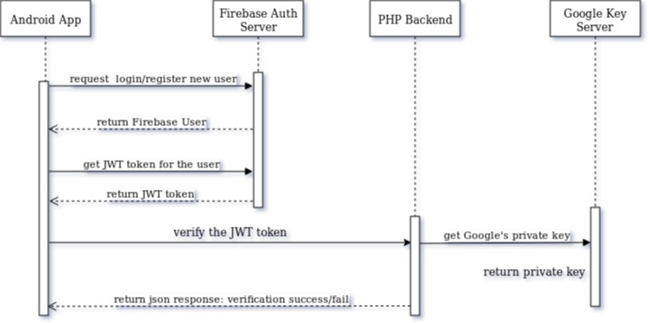

**Fig: Diagramatic representation of JWT authentication**

Necessary Steps for Implementing JWT Validation :

Create an android project to implement firebase authentication. Create a project on Firebase console as and connect the local Android app to the remote firebase project.

Let‟s first set up our PHP Backend. For that purpose:

We need to download Firebase Admin SDK for PHP and install it our PHP backend. This SDK is necessary for our backend to communicate with Firebase server.

The Link: <https://firebasephp.readthedocs.io/en/stable/overview.html>

Also, we need to create a Google service account. This is done from the settings page of the firebase project. On doing so, firebase will generate a JSON configuration file which we have to download and store in our PHP project‟s path. Now we are ready to use PHP Admin SDK.

From the Android client application, we have to use Firebase Android SDK to log in or to register a new user on Firebase. On successful login or registration, Firebase will generate a JWT token. This token, thus generated, is signed with RS256 algorithm and is valid for one hour from the time of its generation. Using Firebase Client SDK, we need to retrieve the token in our android app.

This token, that we have received on our app, needs to be verified on our PHP backend. For that purpose, the token is sent to the PHP backend as an HTTP Request Header.

There‟s a PHP script on our backend which will retrieve the JWT token from the request header and using Firebase Admin SDK for PHP it will first connect to Google's‟ Key Server to grab its public key and then using the key, it will verify the JWT token.

On successful verification, the PHP script will send back a success json response back to the client android app, otherwise a fail json response.

Using the json response, the client application can now decide, whether the authentication process was successful or not.

SCREENSHOTS

Some screenshots, illustrating various functionalities of the android application, are given below:

 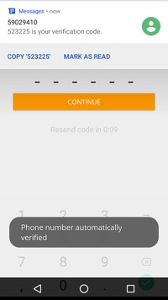

Fig: User Login/Registration Screen Fig: OTP Login

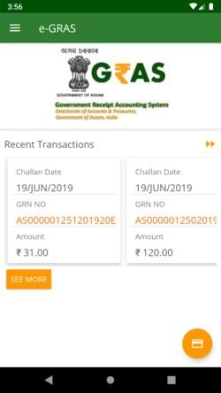 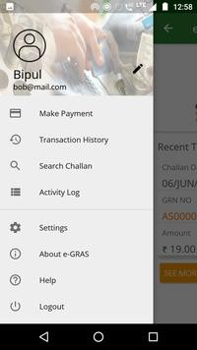

Fig: Home Screen Fig: The Navigation Menu

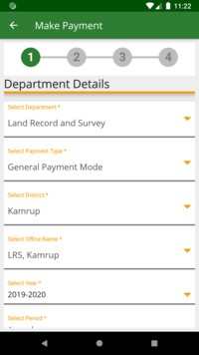 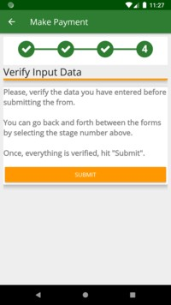

Fig: Make Payment Screen: Fig: Make Payment Screen:

Stage One Stage Four

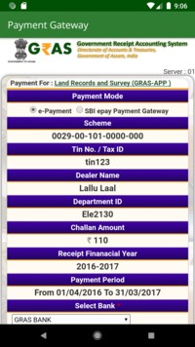 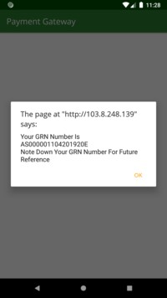

Fig: eGRAS Payment Portal Fig: GRN Number generated

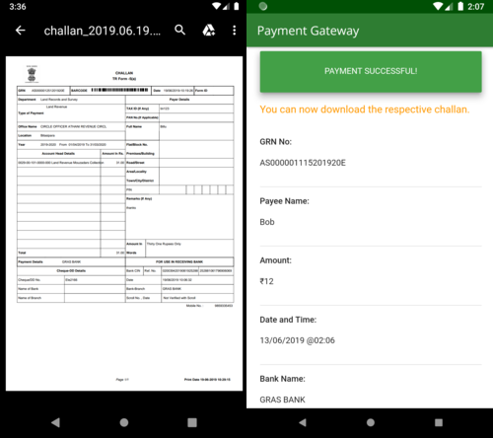

Fig: A downloaded challan Fig: A successful payment summary

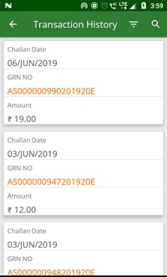 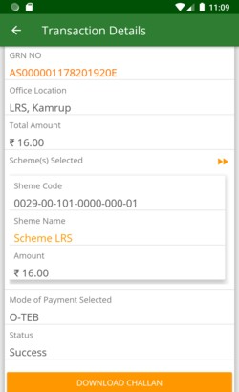

Fig: Transaction List Screen Fig: Transaction Details

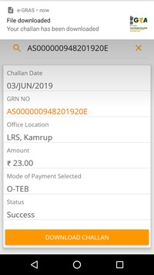

Fig: Search Challan Screen Fig: User‟s Activity Logs

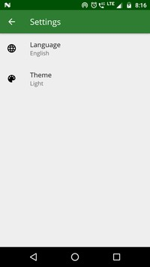 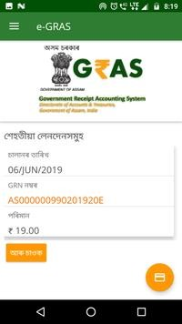

Fig: App‟s Settings Screen Fig: Language changed to

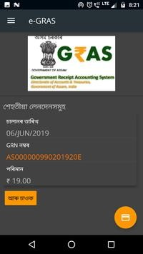 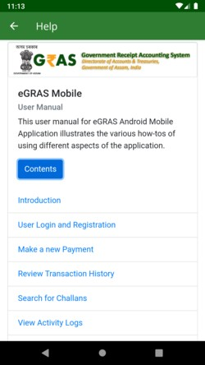

Fig: App‟s theme switched Fig: eGRAS‟ in-app User Manual

to Dark Mode

CONCLUSION

The project “**e-GRAS MOBILE APPLICATION, GOVT OF ASSAM**” is developed to make the tax payment and challan generation process easier by shifting everything online so that users can avail these services right from their Android phones. Moreover, the services - reviewing the transactions and searching for challans are also made accessible from mobile phones. The proposed system was developed by following the requirements given by **GRAS(Government Receipt Accounting System), Govt of Assam**. Coding was done as per the standards and general coding guidelines were decided so as to have a consistent coding standard across different parts of the proposed system.

The project is still in its growth phase and will be implemented soon as this system is under development, still we are putting our best effort and knowledge to make the system as much error free as possible. Thus the main objective of developing a system that is reliable, efficient and meet all the requirements was carried out.

It can be concluded that developing the System was a real learning experience. The principles of software production were well implemented throughout the system. The project has been as per as the given specification and has been made as user friendly as possible.

As there is always a scope of further development in any software product, and the same is true for this project as well. The end-user will decide its scope in future applications. This will help in developing a better system which will serve them in a better way. This project is flexible enough to incorporate any requirement changes.

BIBLIOGRAPHY

Books Referred:

1. Fundamentals of Software Engineering - by Rajib Mall

Websites referred:

<https://developer.android.com/>

<http://www.slimframework.com/docs/>

<https://guides.codepath.com/android>

<https://www.journaldev.com/>

[http://wiki.hashphp.org/PDO_Tutorial_for_MySQL_Devel opers](http://wiki.hashphp.org/PDO_Tutorial_for_MySQL_Developers)

<https://getbootstrap.com/>

<https://abhiandroid.com/>

Youtube channels referred:

[https://www.youtube.com/channel/UC3xHg20VI9mKFRa Ss1yaicw](https://www.youtube.com/channel/UC3xHg20VI9mKFRaSs1yaicw)

[https://www.youtube.com/channel/UC_Fh8kvtkVPkeihBs 42jGcA](https://www.youtube.com/channel/UC_Fh8kvtkVPkeihBs42jGcA)

[https://www.youtube.com/channel/UCocBChVv7HPx0g5 SbnOUv7w](https://www.youtube.com/channel/UCocBChVv7HPx0g5SbnOUv7w)

<https://www.youtube.com/user/smartherd>