Electric Vehicle Adoption and Insights

# Team Members: Tanvi

1. Gurjot
2. Jasleen
3. Vivek
4. Riya
5. Zyan

# Abstract

The rapid growth in electric vehicle (EV) adoption is reshaping the automotive industry and energy infrastructure by presenting both opportunities and challenges to stakeholders. This project presents a dashboard-driven analysis of EV adoption patterns using data-driven KPIs, including manufacturer count, EV types, CAFV eligibility, electric utility coverage, pricing, and geographic trends. Interactive Power BI dashboards will enable stakeholders to visually analyze and understand these trends through charts and slicers across multiple dimensions such as time, location, and cost. The goal of the report is to support future decision-making related to EV policy, planning, and sustainable growth.

# Table of Contents

1. Introduction
2. Objectives
3. Methodology
4. KPIs Tracked
5. Charts Created
6. Reports Generated
7. Detailed Analysis and Outcomes
8. Insights Generated
9. Recommendations
10. Conclusion
11. Acknowledgements

# Introduction

Electric vehicles are gaining widespread popularity due to their eco-friendly footprint, decreased usage of fossil fuels, and fewer greenhouse gas emissions. Governments, manufacturers and people across the globe are investing heavily in this changing infrastructure and vehicle development to accelerate EV adoption. However, decision-makers lack easy access to up-to date insights regarding this ever-evolving industry. This report visualizes dataset-based metrics to explore KPIs across key focus areas like make, model, year, utility coverage, and price.

# Objectives

The report presents insights through a Power BI dashboard aimed at gathering information by:

- Analyze count and distribution of EV makers and models  
- Segment EV types by market share  
- Evaluate Clean Alternative Fuel Vehicle (CAFV) eligibility  
- Study utility provider coverage for EVs  
- Examine year-on-year manufacturing trends  
- Investigate MSRP-based insights by make and utility  
- Understand geographical spread: state, city, county, and ZIP

# Methodology

- Dataset: Electric Vehicle Registration Data with attributes like make, model, year, electric type, range, eligibility, utility, and geography  
- Tool: Microsoft Power BI for dashboard development  
- Data Transformation: Power Query for shaping, DAX for KPI logic  
- Visualizations: Bar charts, pie charts, donut charts, line graphs, card KPIs, and histograms  
- Dashboards grouped into themes: Overview, CAFV, Utility, Time, MSRP, Geographic Spread, and Model Exploration

# KPIs Tracked

1. Total EV Makers: 40  
2. EV Types Count: 2 – Battery Electric (BEV) and Plug-in Hybrid Electric (PHEV)  
3. CAFV Eligibility Breakdown: Eligible, Non-Eligible, Unknown  
4. Count of Electric Utility Providers: 77  
5. YOY Manufacturing Trend from 1997–2023  
6. Avg. MSRP: 1.07K (in $1,000 units)  
7. Average MSRP by EV Make and Utility  
8. EV Count by City, County, and Model

# Charts Created

1. Pie Chart – EV makers share (e.g., Tesla 44.79%)  
2. Bar Graph – Top EV makers by count  
3. EV Type Chart – BEV vs. PHEV distribution (e.g., BEV 78.27%)  
4. Donut & Bar Charts – CAFV Eligibility percentages  
5. Electric Utility Distribution – Utility share pie + count bar  
6. Line Graph – YOY manufacturing trend (1997–2023)  
7. MSRP Chart – Avg base price by make and utility  
8. Geographic Maps/Charts – EV count by county, city  
9. Top Models by Region – Models segmented by top counties/cities

# Reports Generated

1. EV Overview – Maker share, EV type split  
2. CAFV Eligibility Analysis – Breakdown of eligible vs. ineligible EVs  
3. Electric Utility Analysis – Utility share and coverage  
4. EV Adoption Over Time – Year-wise manufacturing pattern  
5. EV MSRP Analysis – Price insights by brand and utility  
6. Geographic Insights – County and city-level EV distribution  
7. Top Model Exploration – Most popular EV models per region

# Detailed Analysis and Outcomes

1. Vehicle Make Distribution Analysis:

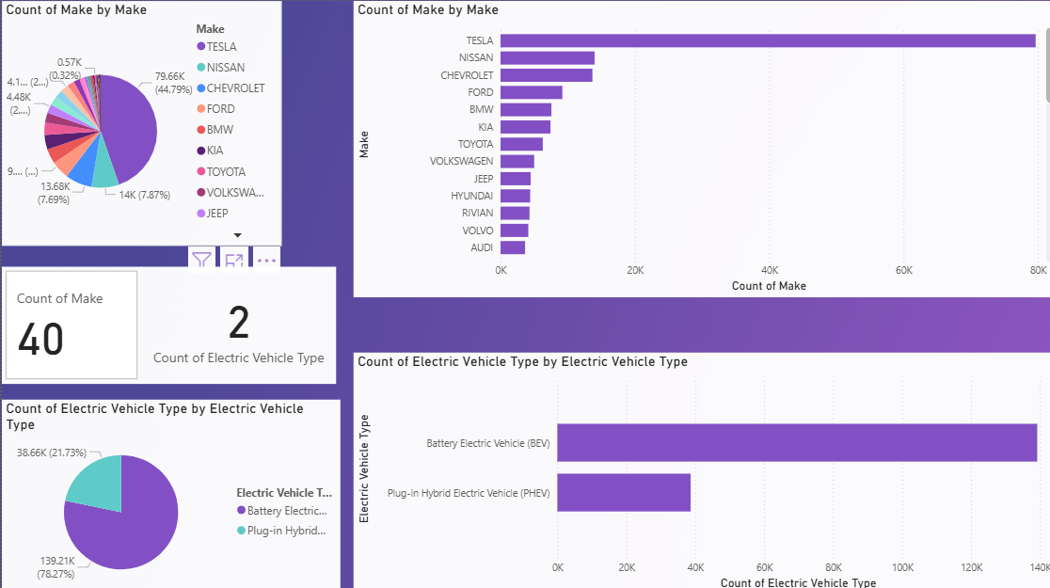

* The top 3 brands alone (Tesla, Nissan, Chevrolet) make up~60%of the total.
* The drop between the top 1 and top 2 brands (Tesla to Nissan) is steep — from ~45% to under 8%, highlighting a heavily skewed distribution.
* Chevrolet and Nissan are nearly tied, indicating competitive positioning in the mid-range market.
* Multiple brands (e.g., KIA, BMW, TOYOTA, VOLKSWAGEN, JEEP) have similar-sized segments, suggesting a cluster of mid-popularity brands without a clear leader among them.

2. Distribution of Electric Vehicle Types:

* The data indicates a strong consumer and market preference toward fully electric (battery-powered) vehicles over hybrid models.
* The ratio of BEV to PHEV is approximately 3.6:1, signaling a clear trend toward fully electric mobility.

3. Clean Fuel Eligibility Status Across Vehicles:

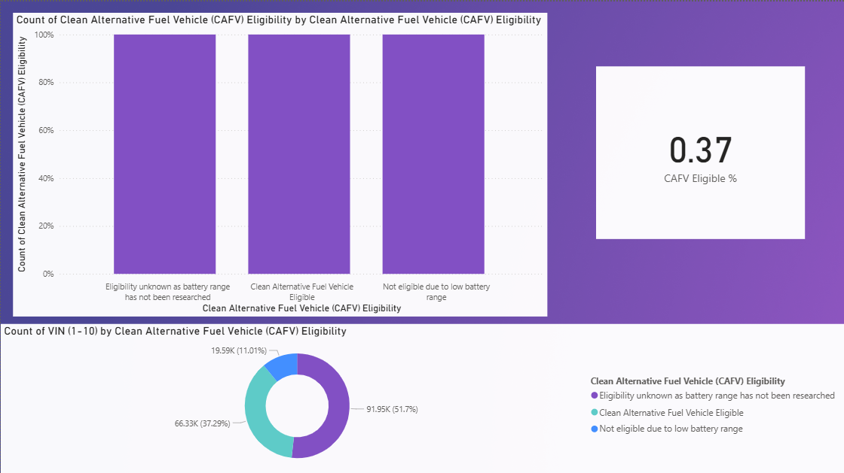

* There is an opportunity to target the 37% non-eligible segment for EV/CAFV transition programs or awareness campaigns.

4. Electric Utility Providers in EV Dataset:

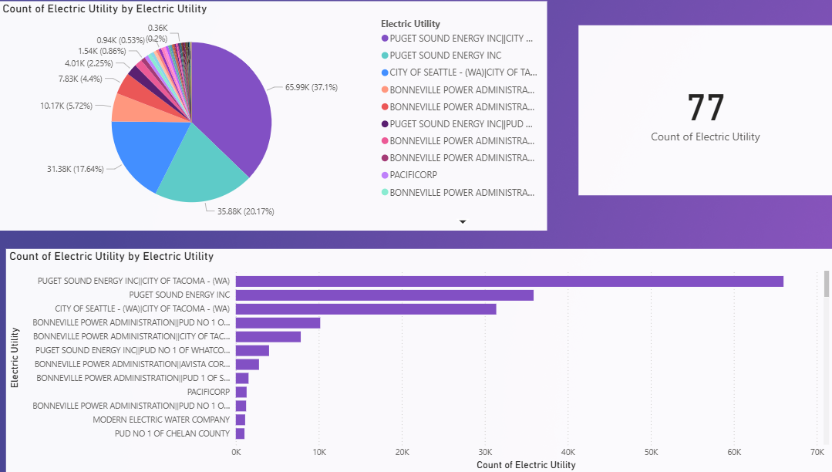

* This figure highlights how utility partnerships and EV infrastructure coverage are concentrated among a small number of key players, which is crucial for efficiently directing charging station deployment and EV policy implementation.
* Remaining utilities such as BONNEVILLE POWER ADMINISTRATION, PACIFICORP, and others hold smaller shares ranging from 2% to 6%, with many contributing less than 1% each.

5.EV Adoption Analysis:

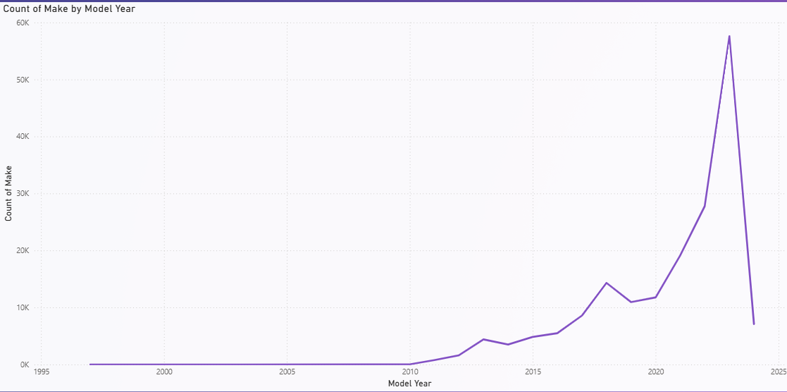

* EV adoption remained minimal before 2010, indicating limited availability or awareness of electric vehicles in the market.
* From 2015 to 2018, the market began gaining momentum with more manufacturers entering and consumer interest increasing.
* The most significant surge was observed between 2021 and 2023, suggesting rapid expansion of EV models, broader acceptance, and market diversification.
* 2023 marked the peak with the highest number of makes registered, indicating a booming period for EV manufacturing and adoption.

6. MSRP of EVs:

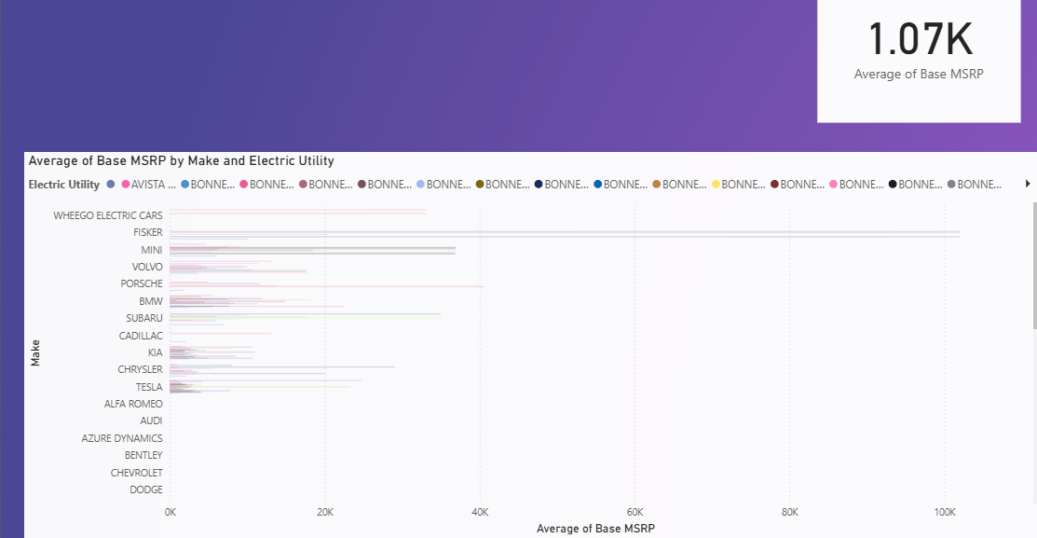

* The average MSRP across all data points is $1.07K, demonstrating the significant differences in EV base prices between manufacturers and utilities, with luxury brands having substantially higher prices and Bonneville Power Administration becoming the most popular utility provider.

7. Electric Vehicle (EV) Adoption Trends by Model Year and County:

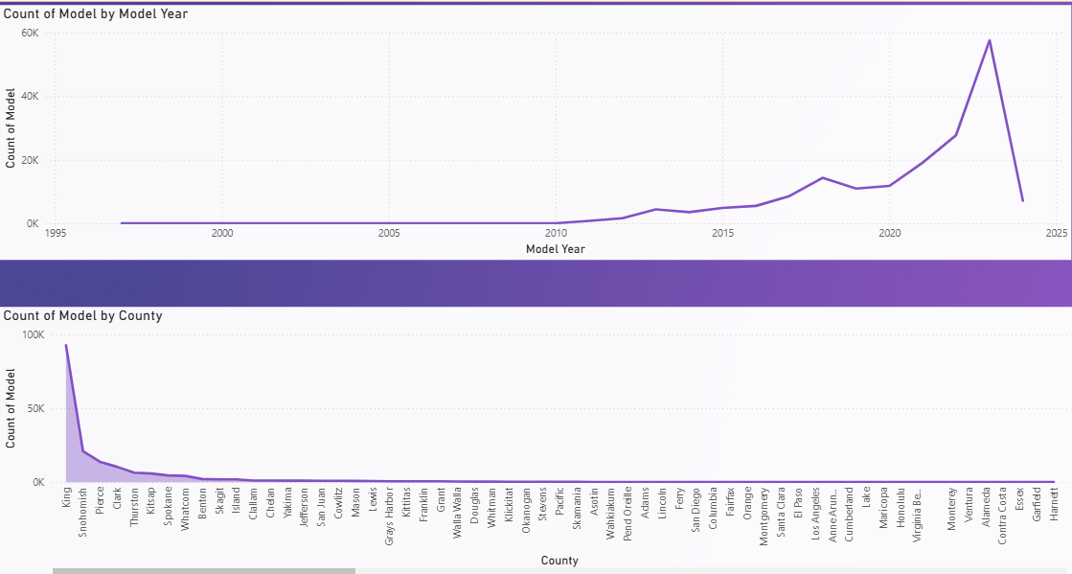

* EV adoption was almost negligible before 2010, reflecting how recent and rapid the electric vehicle market evolution has been.
* EV adoption has seen a sharp rise starting around 2012, peaking significantly in 2023, before a noticeable dip in 2024—possibly due to incomplete data or market saturation.
* King County leads overwhelmingly in EV ownership, with Snohomish and Pierce counties trailing far behind indicating a strong regional concentration.

8. Top Model:

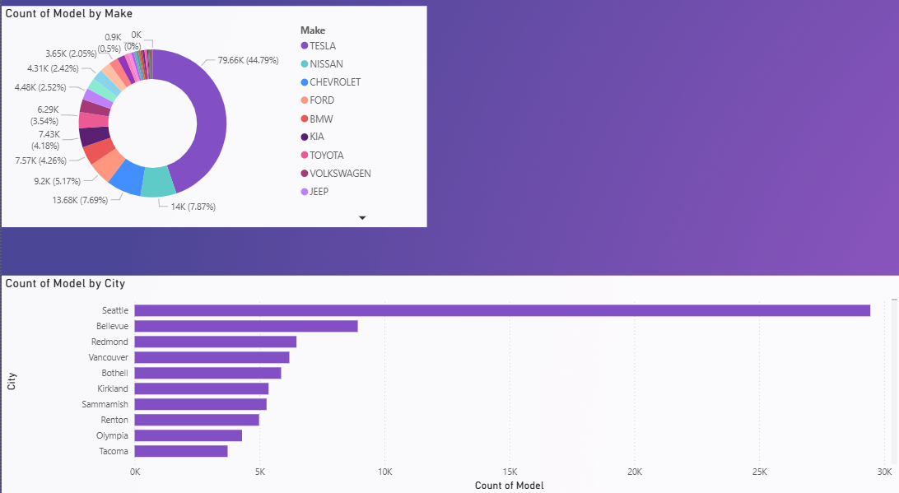

* Tesla leads the EV market significantly while Seattle is the undisputed hub of EV adoption, with nearly three times more EVs than the next leading city, Bellevue.
* Brands like Jeep, Volkswagen, and Toyota each hold less than 5% of the total share, indicating they are still emerging in the EV segment.

# Insights Gathered

Some of the important insights gathered are –

* TESLA leads the market with 44.79% of all EV’s followed by Nissan and Chevrolet, respectively under 8%.
* Battery Electric Vehicles represent the majority with 78.27% of the total share whereas the Plug-In Hybrid Electric Vehicles account for 21.73%.
* Only two electric vehicle types (BEV and PHEV) are currently tracked, indicating that fuel cell or emerging EV types are either underrepresented or absent.
* Only 0.37% of vehicles are displayed as CAFV-eligible in the KPI card; however, the donut chart shows 37.29% as eligible.
* 11.01% of vehicles are explicitly not eligible for CAFV designation due to low battery life.
* EV Adoption is Highly Concentrated with Puget Sound Energy Inc | City of Tacoma (WA) as the leading utility having 5.99K vehicles (37.1%) of total EVs.
* The top three utilities (including Puget Sound Energy Inc and City of Seattle – WA) represent over 75% of total EV distribution. The remaining 74 utilities are collectively responsible for less than 25% of all EVs indicating regional inequality.
* Some utilities (e.g., PACIFICORP, Modern Electric Water Company) have fewer than 5K EVs.

# Recommendations

The following suggestions can be kept in mind for drafting efficient changes in EV businesses –

* Policymakers should encourage OEM diversity by supporting non-Tesla manufacturers through incentives and dealership programs.
* Given BEVs dominate, investments in fast-charging infrastructure should be prioritized to support long-range electric mobility.
* In semi-urban or rural zones**,** support PHEV**s** as a transitional option until charging infrastructure becomes widespread.
* Prioritize battery range research for the large “unknown” segment to enable more accurate eligibility classification.
* Collaborate with OEMs and regulators to mandate the reporting of complete battery specs.
* Collaborate with top utilities (e.g., Puget Sound, City of Seattle) to scale up infrastructure, forecast demand, and modernize the grid.
* Investigate low-adoption regions to uncover systemic barriers (cost, awareness, access to chargers).

# Conclusion

The EV landscape is rapidly evolving, with Tesla as a clear leader and BEVs significantly outpacing PHEVs. CAFV eligibility remains an area needing attention, as a large portion lacks range data. Utilities like Puget Sound Energy play a key role in supporting EV infrastructure. Geographically, EVs are clustered in urban zones, particularly in Washington. The visual insights from this dashboard offer a clear path for optimizing EV infrastructure planning, public policy targeting, and clean energy investments.

# Acknowledgements

Special thanks to Nakul Pant sir for their support and Imarticus Pvt Ltd. for providing this opportunity to work on a real-world data project using Power BI.