API Production Readiness Submission
Library Management API | 12 October 2026

Work completed
- Added API key authentication to write endpoints: creating, updating, or deleting books and creating orders require the X-API-Key header.
- Requests to protected write endpoints without a key or with a wrong key receive HTTP 401 Unauthorized. Read-only GET endpoints remain public.
- Added structured ILogger messages for useful book and order events. The API key is not written to logs.
- Added separate development and production configuration. Local keys use .NET User Secrets; production keys come from an environment variable or deployment secret manager.
- Adjusted authentication logging so public anonymous GET requests do not produce misleading missing-key warnings.
- Updated the README with setup, security, test, and CI information.
- Checked reachable Git history for common credential, token, and password patterns; no obvious real secrets were found.

Test and CI result
- 7 unit tests passed.
- 13 integration tests passed, including missing-key and invalid-key write checks and anonymous read access.
- 20 tests passed in total; 0 failed.
- Latest commit: 013101a — Skip API key checks on public endpoints.
- Latest GitHub Actions run: Run #9 succeeded.
Repository branch: https://github.com/zyanonymoust/library/tree/codex/integration-tests-ci
README: https://github.com/zyanonymoust/library/blob/codex/integration-tests-ci/README.md
Successful CI run: https://github.com/zyanonymoust/library/actions/runs/38197923294

What remains for submission
The assignment asks for the repository, a screenshot or video, and the README. The three screenshots below document the successful latest CI run, integration tests, and unit tests. Submit this report together with the repository branch link and README link.
- GitHub also shows a Node.js and Ubuntu runner maintenance notice. These are informational CI environment notices; Run #9 succeeded.

Submission checklist
- Provide the repository branch link.
- Provide the README (or its link in the repository).
- Attach the Run #9 screenshot or video.
- Submit this report with its embedded screenshots as the screenshot evidence, or upload the PNGs separately if the portal requires image files.

CI Evidence Screenshots
Evidence 1. GitHub Actions Run #9 completed successfully.
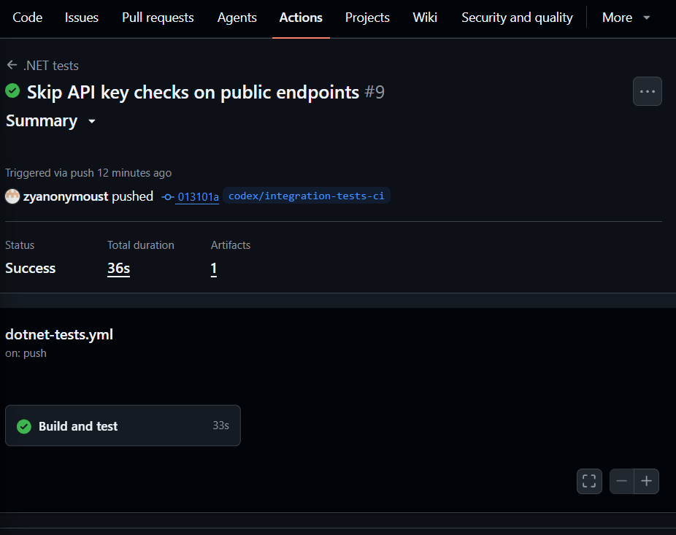

Evidence 2. Integration test output: invalid API key rejected; 13 integration tests passed.
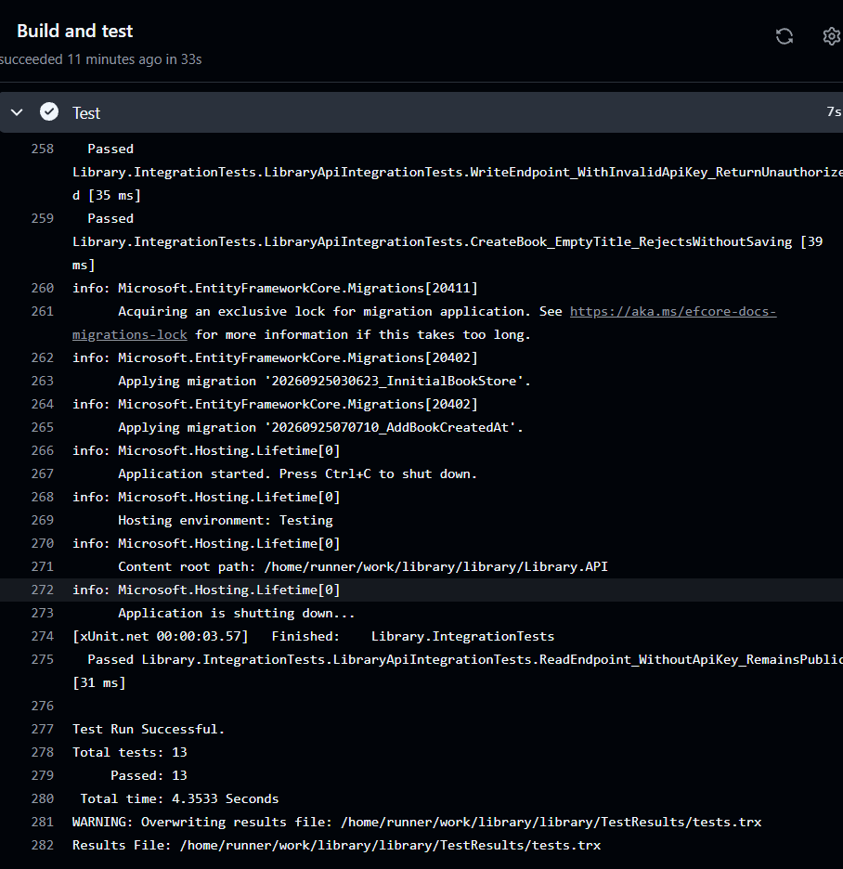

Evidence 3. Unit test output: 7 unit tests passed.
