Integration Testing and CI Submission Report
Library Management API | 12 October 2026
Repository: zyanonymoust/library Branch: codex/integration-tests-ci

Submission summary
Automated integration tests and a GitHub Actions workflow have been added to the Library API project. The passing CI run shows 7 unit tests and 10 integration tests passed. CI was also deliberately tested with an incorrect assertion: the workflow failed as expected, and a later run passed after the assertion was restored.

Implementation
- HTTP integration tests. A new test project uses WebApplicationFactory<Program> to exercise the real ASP.NET Core request pipeline and endpoints.
- Isolated test data. Tests use an in-memory SQLite database, independent from the checked-in bookstore database.
- Create and order flow. A test creates a book, places an order, then reads it in a separate request to confirm stock persisted from 10 to 8.
- Automated CI. GitHub Actions restores dependencies, builds Release, runs dotnet test on pushes and pull requests, and uploads test results.

Coverage and results
The 10 integration cases cover book creation and persisted stock changes, insufficient stock, invalid quantities and IDs, missing books, empty titles, and deletion behavior. The existing unit suite adds 7 tests. The passing workflow reports 17 passed, 0 failed, and 0 skipped.
Run #3 — deliberate failure: Expected 9, actual 8; test process exited with code 1. View run
Run #4 — passing tests: 7 unit tests and 10 integration tests passed (17 total). View run
Run #5 — documentation update: Workflow completed successfully after documentation was pushed. View run

Screenshot evidence
The first screenshot shows CI rejecting the intentionally incorrect expected stock value. The second shows the passing test totals after the assertion was restored.

CI detects the broken assertion
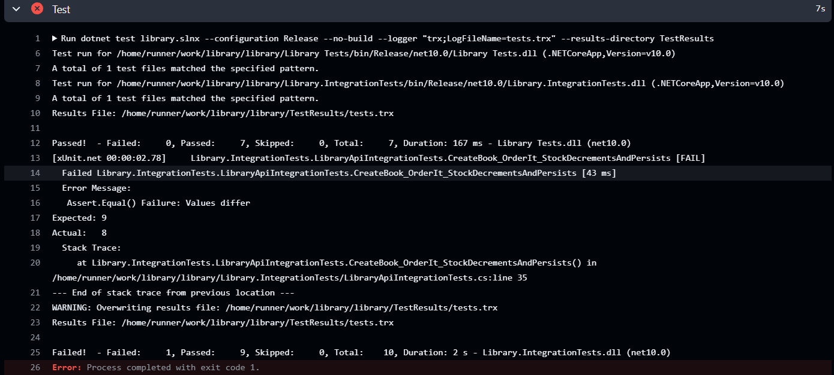
Run #3: Expected 9, Actual 8; GitHub Actions marked the test step as failed.

All 17 tests pass
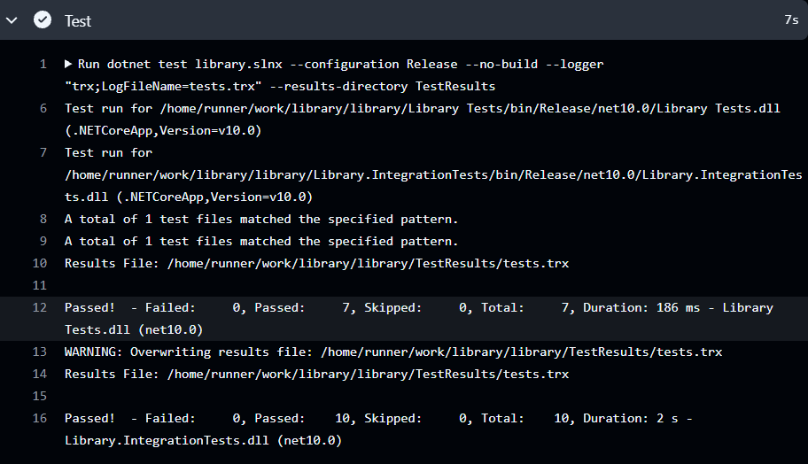
Run #4: 7 unit tests and 10 integration tests passed, 17 total.

Submission links
Branch: codex/integration-tests-ci
Repository: zyanonymoust/library
The workflow reports test status on pushes and pull requests. Branch protection and merge blocking are configured separately and are not claimed here.

