# Github的简单实用

【参数都采用--（两道杠）】

$ git config --global user.name “username”

$ git config --global user.email “e_mail [address@qq.com](mailto:address@qq.com)”

$ git init //初始化git

$ git add NOSEP //增加需要

$ git commit –m “提交说明文字”

$ git remote add origin [git@github.com:_______/_______.git](mailto:git@github.com:_______/_______.git)

或者 git remote set –url origin [git@github.com:___________/__________.git](mailto:git@github.com:___________/__________.git)

$ git pull –rebase origin master //

**//生成密钥**

$ ssh –keygen –t rsa –C “e_mail [address@qq.com](mailto:address@qq.com)”

$ 3次回车

添加ssh至 New SSH key中即可

**Tips：**$ git pull –rebase origin master //报这个错的时候，运行以下命令

$ git stash //暂存当前进行的工作

$ git pull –rebase //从git栈中读取最后一次保存的内容

# github网页访问超级慢

**1.修改hosts文件：C:\Windows\System32\drivers\etc**

# Github  
151.101.44.249 github.global.ssl.fastly.net  
192.30.253.113 github.com  
103.245.222.133 assets-cdn.github.com  
23.235.47.133 assets-cdn.github.com  
203.208.39.104 assets-cdn.github.com  
204.232.175.78 documentcloud.github.com  
204.232.175.94 gist.github.com  
107.21.116.220 help.github.com  
207.97.227.252 nodeload.github.com  
199.27.76.130 raw.github.com  
107.22.3.110 status.github.com  
204.232.175.78 training.github.com  
207.97.227.243 www.github.com  
185.31.16.184 github.global.ssl.fastly.net  
185.31.18.133 avatars0.githubusercontent.com  
185.31.19.133 avatars1.githubusercontent.com  
192.30.253.120 codeload.github.com

**2.用管理员账号打开cmd，ipconfig /flushdns刷新DNS**

# github上传到对应的库

LeiLei@LeiLei-PC MINGW64 /e/cnyulei (master)

$ git config --global user.name "cnyulei"

LeiLei@LeiLei-PC MINGW64 /e/cnyulei (master)

$ git config --global user.email "1027182258@qq.com"

LeiLei@LeiLei-PC MINGW64 /e/cnyulei (master)

$ cd ../cnyuleiup/

LeiLei@LeiLei-PC MINGW64 /e/cnyuleiup (master)

$ dir

NetDPO

LeiLei@LeiLei-PC MINGW64 /e/cnyuleiup (master)

$ git init

Initialized empty Git repository in E:/cnyuleiup/.git/

LeiLei@LeiLei-PC MINGW64 /e/cnyuleiup (master)

$ git remote add origin git@github.com:cnyulei/Test.git

LeiLei@LeiLei-PC MINGW64 /e/cnyuleiup (master)

$ git pull --rebase origin master

remote: Enumerating objects: 4, done.

remote: Total 4 (delta 0), reused 0 (delta 0), pack-reused 4

Unpacking objects: 100% (4/4), done.

From github.com:cnyulei/Test

* branch master -> FETCH_HEAD

* [new branch] master -> origin/master

LeiLei@LeiLei-PC MINGW64 /e/cnyuleiup (master)

$ git add NetDPO/

LeiLei@LeiLei-PC MINGW64 /e/cnyuleiup (master)

$ git commit -m "file about NetDPO"

LeiLei@LeiLei-PC MINGW64 /e/cnyuleiup (master)

$ git push origin master

Counting objects: 63, done.

Delta compression using up to 4 threads.

Compressing objects: 100% (63/63), done.

Writing objects: 100% (63/63), 9.06 MiB | 286.00 KiB/s, done.

Total 63 (delta 34), reused 0 (delta 0)

remote: Resolving deltas: 100% (34/34), done.

To github.com:cnyulei/Test.git

a18e2ff..2e4d6fe master -> master

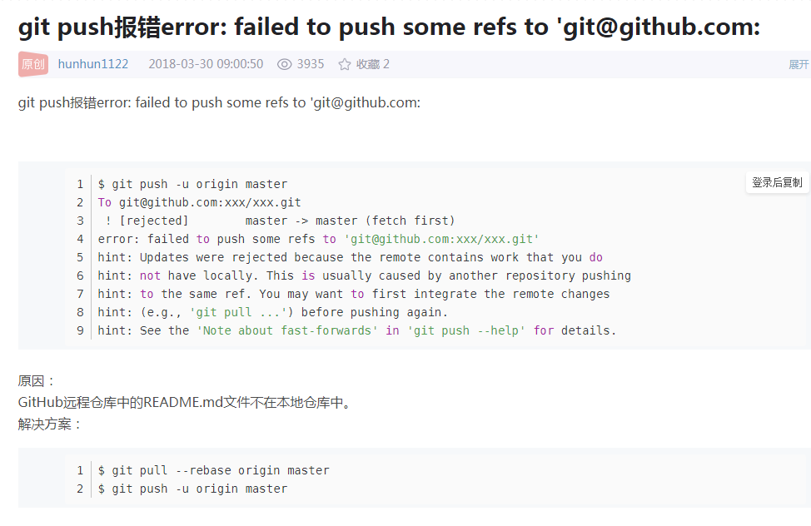

# 上传NetBack实例

LeiLei@LeiLei-PC MINGW64 ~/Desktop/新建文件夹 (master)

$ git config --global user.name "wuc567"

LeiLei@LeiLei-PC MINGW64 ~/Desktop/新建文件夹 (master)

$ git config --global user.email "wuc567@163.com"

LeiLei@LeiLei-PC MINGW64 ~/Desktop/新建文件夹 (master)

$ git init

Reinitialized existing Git repository in C:/Users/LeiLei/Desktop/新建文件夹/.git/

LeiLei@LeiLei-PC MINGW64 ~/Desktop/新建文件夹 (master)

$ git clone git@github.com:wuc567/Pattern-Matching.git

Cloning into 'Pattern-Matching'...

Connection reset by 192.30.253.113 port 22

fatal: Could not read from remote repository.

Please make sure you have the correct access rights

and the repository exists.

LeiLei@LeiLei-PC MINGW64 ~/Desktop/新建文件夹 (master)

$ git clone git@github.com:wuc567/Pattern-Matching.git

Cloning into 'Pattern-Matching'...

remote: Enumerating objects: 38, done.

remote: Counting objects: 100% (38/38), done.

remote: Compressing objects: 100% (36/36), done.

remote: Total 38 (delta 5), reused 13 (delta 0), pack-reused 0

Receiving objects: 100% (38/38), 86.91 KiB | 9.00 KiB/s, done.

Resolving deltas: 100% (5/5), done.

LeiLei@LeiLei-PC MINGW64 ~/Desktop/新建文件夹 (master)

$ cd Pattern-Matching/

LeiLei@LeiLei-PC MINGW64 ~/Desktop/新建文件夹/Pattern-Matching (master)

$ dir

NETASPNO NetBack NetNPG README.md

LeiLei@LeiLei-PC MINGW64 ~/Desktop/新建文件夹/Pattern-Matching (master)

$ git remote add origin git@github.com:wuc567/Pattern-Matching.git

fatal: remote origin already exists.

LeiLei@LeiLei-PC MINGW64 ~/Desktop/新建文件夹/Pattern-Matching (master)

$ git add NetBack/

LeiLei@LeiLei-PC MINGW64 ~/Desktop/新建文件夹/Pattern-Matching (master)

$ git commit -m "file about NetBack"

[master eaf317b] file about NetBack

2 files changed, 0 insertions(+), 0 deletions(-)

create mode 100644 NetBack/NetBack.rar

create mode 100644 NetBack/datasets.rar

LeiLei@LeiLei-PC MINGW64 ~/Desktop/新建文件夹/Pattern-Matching (master)

$ git push origin master

Counting objects: 5, done.

Delta compression using up to 4 threads.

Compressing objects: 100% (5/5), done.

Writing objects: 100% (5/5), 60.09 KiB | 165.00 KiB/s, done.

Total 5 (delta 0), reused 0 (delta 0)

To github.com:wuc567/Pattern-Matching.git

0362473..eaf317b master -> master

LeiLei@LeiLei-PC MINGW64 ~/Desktop/新建文件夹/Pattern-Matching (master)

$

# 上传NetNPG实例

LeiLei@LeiLei-PC MINGW64 ~/Desktop/新建文件夹 (master)

$ git config --global user.name "wuc567"

LeiLei@LeiLei-PC MINGW64 ~/Desktop/新建文件夹 (master)

$ git config --global user.email "wuc567@163.com"

LeiLei@LeiLei-PC MINGW64 ~/Desktop/新建文件夹 (master)

$ git init

Initialized empty Git repository in C:/Users/LeiLei/Desktop/新建文件夹/.git/

LeiLei@LeiLei-PC MINGW64 ~/Desktop/新建文件夹 (master)

$ git clone git@github.com:wuc567/Pattern-Matching.git

Cloning into 'Pattern-Matching'...

2 [sig] bash 7560! sigpacket::process: Suppressing signal 18 to win32 process (pid 7388)

2000123 [sig] bash 7560! sigpacket::process: Suppressing signal 18 to win32 process (pid 7388)

2869456 [sig] bash 7560! sigpacket::process: Suppressing signal 18 to win32 process (pid 7388)

z

LeiLei@LeiLei-PC MINGW64 ~/Desktop/新建文件夹 (master)

$ git remote add origin git@github.com:wuc567/Pattern-Matching.git

LeiLei@LeiLei-PC MINGW64 ~/Desktop/新建文件夹 (master)

$ git clone git@github.com:wuc567/Pattern-Matching.git

Cloning into 'Pattern-Matching'...

ssh: connect to host github.com port 22: Connection timed out

fatal: Could not read from remote repository.

Please make sure you have the correct access rights

and the repository exists.

LeiLei@LeiLei-PC MINGW64 ~/Desktop/新建文件夹 (master)

$ git clone git@github.com:wuc567/Pattern-Matching.git

Cloning into 'Pattern-Matching'...

remote: Enumerating objects: 21, done.

remote: Counting objects: 100% (21/21), done.

remote: Compressing objects: 100% (19/19), done.

Receiving obremote: Total 21 (delta 2), reused 5 (delta 0), pack-reused 0

Receiving objects: 100% (21/21), 19.48 KiB | 8.00 KiB/s, done.

Resolving deltas: 100% (2/2), done.

LeiLei@LeiLei-PC MINGW64 ~/Desktop/新建文件夹 (master)

$ git remote add origin git@github.com:wuc567/Pattern-Matching.git

fatal: remote origin already exists.

LeiLei@LeiLei-PC MINGW64 ~/Desktop/新建文件夹 (master)

$ git add NetNPG/

LeiLei@LeiLei-PC MINGW64 ~/Desktop/新建文件夹 (master)

$ git commit -m "file about NetNPG"

[master (root-commit) 2d8a4c6] file about NetNPG

6 files changed, 0 insertions(+), 0 deletions(-)

create mode 100644 NetNPG/INSgrow-gen.zip

create mode 100644 NetNPG/NETGAP-gen.zip

create mode 100644 NetNPG/NETLAP-gen.zip

create mode 100644 NetNPG/NetNPG-nb.zip

create mode 100644 NetNPG/NetNPG.zip

create mode 100644 NetNPG/datasets.zip

LeiLei@LeiLei-PC MINGW64 ~/Desktop/新建文件夹 (master)

$ git push origin master

ssh: connect to host github.com port 22: Connection timed out

fatal: Could not read from remote repository.

Please make sure you have the correct access rights

and the repository exists.

LeiLei@LeiLei-PC MINGW64 ~/Desktop/新建文件夹 (master)

$ git push origin master

To github.com:wuc567/Pattern-Matching.git

! [rejected] master -> master (fetch first)

error: failed to push some refs to 'git@github.com:wuc567/Pattern-Matching.git'

hint: Updates were rejected because the remote contains work that you do

hint: not have locally. This is usually caused by another repository pushing

hint: to the same ref. You may want to first integrate the remote changes

hint: (e.g., 'git pull ...') before pushing again.

hint: See the 'Note about fast-forwards' in 'git push --help' for details.

LeiLei@LeiLei-PC MINGW64 ~/Desktop/新建文件夹 (master)

$ git pull --rebase origin master

warning: no common commits

remote: Enumerating objects: 21, done.

remote: Counting objects: 100% (21/21), done.

remote: Compressing objects: 100% (19/19), done.

remote: Total 21 (delta 2), reused 5 (delta 0), pack-reused 0

Unpacking objects: 100% (21/21), done.

From github.com:wuc567/Pattern-Matching

* branch master -> FETCH_HEAD

* [new branch] master -> origin/master

First, rewinding head to replay your work on top of it...

Applying: file about NetNPG

LeiLei@LeiLei-PC MINGW64 ~/Desktop/新建文件夹 (master)

$ git push -u origin master

Counting objects: 9, done.

Delta compression using up to 4 threads.

Compressing objects: 100% (9/9), done.

Writing objects: 100% (9/9), 65.14 KiB | 66.00 KiB/s, done.

Total 9 (delta 0), reused 0 (delta 0)

To github.com:wuc567/Pattern-Matching.git

a07b686..2656dfd master -> master

Branch master set up to track remote branch master from origin.

LeiLei@LeiLei-PC MINGW64 ~/Desktop/新建文件夹 (master)

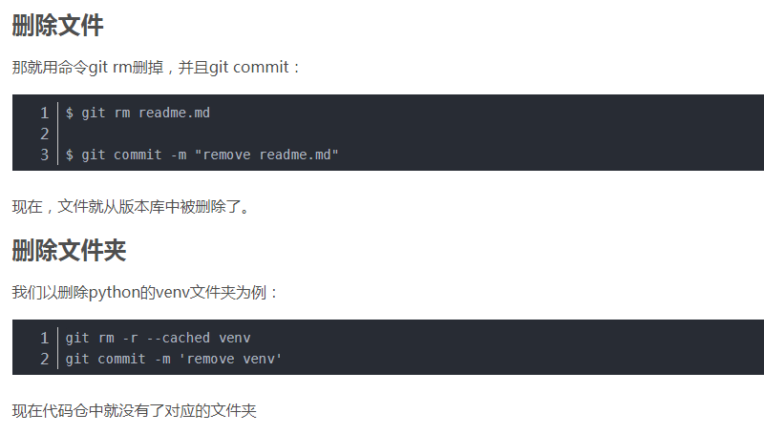

输入完成之后，记得push，和提交文件一样的操作

LeiLei@LeiLei-PC MINGW64 /f/ppp/papers (master)

$ git rm 1MAPD.rar

rm '1MAPD.rar'

LeiLei@LeiLei-PC MINGW64 /f/ppp/papers (master)

$ git commit -m "rm 1MAPD"

[master 737a768] rm 1MAPD

1 file changed, 0 insertions(+), 0 deletions(-)

delete mode 100644 1MAPD.rar

LeiLei@LeiLei-PC MINGW64 /f/ppp/papers (master)

$ git push -u origin master

# 上传一个新的pdf

LeiLei@LeiLei-PC MINGW64 ~/Desktop/新建文件夹 (master)

$ git config --global user.name "wuc567"

LeiLei@LeiLei-PC MINGW64 ~/Desktop/新建文件夹 (master)

$ git config --global user.email "wuc567@163.com"

LeiLei@LeiLei-PC MINGW64 ~/Desktop/新建文件夹 (master)

$ git init

Reinitialized existing Git repository in C:/Users/LeiLei/Desktop/新建文件夹/.git/

LeiLei@LeiLei-PC MINGW64 ~/Desktop/新建文件夹 (master)

$ git remote add origin git@github.com:wuc567/papers.git

fatal: remote origin already exists.

LeiLei@LeiLei-PC MINGW64 ~/Desktop/新建文件夹 (master)

$ git remote rm origin

LeiLei@LeiLei-PC MINGW64 ~/Desktop/新建文件夹 (master)

$ git remote add origin git@github.com:wuc567/papers.git

LeiLei@LeiLei-PC MINGW64 ~/Desktop/新建文件夹 (master)

$ git clone git@github.com:wuc567/papers.git

Cloning into 'papers'...

remote: Enumerating objects: 26, done.

remote: Counting objects: 100% (26/26), done.

remote: Compressing objects: 100% (23/23), done.

remote: Total 26 (delta 2), reused 22 (delta 1), pack-reused 0

Receiving objects: 100% (26/26), 29.37 MiB | 764.00 KiB/s, done.

Resolving deltas: 100% (2/2), done.

LeiLei@LeiLei-PC MINGW64 ~/Desktop/新建文件夹 (master)

$ git add 1\ jf012-2-定稿.pdf

LeiLei@LeiLei-PC MINGW64 ~/Desktop/新建文件夹 (master)

$ git commit -m "add paper"

On branch master

Untracked files:

papers/

nothing added to commit but untracked files present

LeiLei@LeiLei-PC MINGW64 ~/Desktop/新建文件夹 (master)

$ cd papers/

LeiLei@LeiLei-PC MINGW64 ~/Desktop/新建文件夹/papers (master)

$ dir

1\ jf012-2-定稿.pdf 6\ \ 2018\ IEEE\ ACCESS\ NETASP.pdf

2\ \ 2014\ APIN-MAPD.pdf 7\ \ 2018\ tcyb.pdf

3\ \ 2016\ JIS.pdf 8\ \ 2020\ kbs\ 1-s2.0-S0950705120301945-main.pdf

4\ \ 2015\ APIN-SETA.pdf 9\ \ 2019\ nocm-cluster\ computing.pdf

5\ \ 2017\ scis.pdf README.md

LeiLei@LeiLei-PC MINGW64 ~/Desktop/新建文件夹/papers (master)

$ git add 1\ jf012-2-定稿.pdf

LeiLei@LeiLei-PC MINGW64 ~/Desktop/新建文件夹/papers (master)

$ git commit -m "add paper"

[master 9166907] add paper

1 file changed, 0 insertions(+), 0 deletions(-)

create mode 100644 "1 jf012-2-\345\256\232\347\250\277.pdf"

LeiLei@LeiLei-PC MINGW64 ~/Desktop/新建文件夹/papers (master)

$ git push -u origin master

Counting objects: 3, done.

Delta compression using up to 4 threads.

Compressing objects: 100% (3/3), done.

Writing objects: 100% (3/3), 1.11 MiB | 2.54 MiB/s, done.

Total 3 (delta 1), reused 0 (delta 0)

remote: Resolving deltas: 100% (1/1), completed with 1 local object.

To github.com:wuc567/papers.git

0f506fc..9166907 master -> master

Branch master set up to track remote branch master from origin.

LeiLei@LeiLei-PC MINGW64 ~/Desktop/新建文件夹/papers (master)

$