# /* number 1*/

CREATE TABLE MY_EMPLOYEE(

ID NUMBER(4) NOT NULL,

LAST_NAME VARCHAR2(25),

FIRST_NAME VARCHAR2(25),

USER_ID VARCHAR2(8),

SALARY NUMBER(9,2));

INSERT INTO MY_EMPLOYEE VALUES (126, 'Popov', 'Olga', 'opopov', 8500);

INSERT INTO MY_EMPLOYEE VALUES (127, 'Chen', 'Ling', 'lcheng', 14500);

INSERT INTO MY_EMPLOYEE VALUES (128, 'Dunn', 'David', 'ddunn', NULL);

SELECT * FROM MY_EMPLOYEE;

INSERT INTO MY_EMPLOYEE(ID,Last_Name,First_Name,User_Id,Salary)

VALUES(109, 'Gomez','Rita','rgomez',NULL);

INSERT INTO MY_EMPLOYEE(ID,Last_Name,First_Name,User_Id,Salary)

VALUES(108, 'Preston','Scott','spreston',NULL);

SELECT * FROM MY_EMPLOYEE;

commit;

# O**utput for number 1**

ID LAST_NAME FIRST_NAME USER_ID SALARY

---------- ------------------------- ------------------------- -------- ----------

126 Popov Olga opopov 8500

127 Chen Ling lcheng 14500

128 Dunn David ddunn

109 Gomez Rita rgomez

108 Preston Scott spreston

# /* number 2 */

INSERT INTO MY_EMPLOYEE (ID,Last_Name,First_Name,Salary)

SELECT EMPLOYEE_ID, LAST_NAME, FIRST_NAME, SALARY

FROM EMPLOYEES

WHERE DEPARTMENT_ID = 60;

UPDATE MY_EMPLOYEE

SET USER_ID = 'generic'

WHERE USER_ID is null;

SELECT * FROM MY_EMPLOYEE;

rollback;

# O**utput for number 2**

ID LAST_NAME FIRST_NAME USER_ID SALARY

---------- ------------------------- ------------------------- -------- ----------

103 Hunold Alexander generic 9000

104 Ernst Bruce generic 6000

107 Lorentz Diana generic 4200

126 Popov Olga opopov 8500

127 Chen Ling lcheng 14500

128 Dunn David ddunn

109 Gomez Rita rgomez

108 Preston Scott spreston

# /* number 3 */

UPDATE MY_EMPLOYEE

SET LAST_NAME = 'Jones'

WHERE LAST_NAME = 'Gomez';

UPDATE MY_EMPLOYEE

SET SALARY = 9000

WHERE LAST_NAME = 'Jones';

UPDATE MY_EMPLOYEE

SET SALARY = (SALARY + 2000)

WHERE SALARY < 10500;

select * from my_employee;

commit;

# OUTPUT

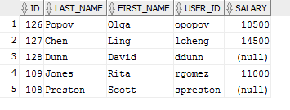

# /* number 4 */

INSERT INTO MY_EMPLOYEE

VALUES (128, 'Bob' ,'Thomas' ,'Generic' ,'13500');

DELETE FROM MY_EMPLOYEE

WHERE salary >( SELECT SALARY

FROM EMPLOYEES

WHERE LAST_NAME = 'Higgins');

savepoint ONE;

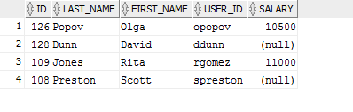

UPDATE MY_EMPLOYEE

SET SALARY = (SALARY - 1000)

WHERE SALARY > ( SELECT SALARY

FROM MY_EMPLOYEE

WHERE LAST_NAME = 'Popov');

savepoint TWO;

select* from my_employee;

;

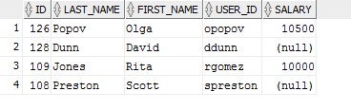

DELETE FROM MY_EMPLOYEE

WHERE ID >120;

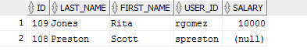

select* from my_employee;

rollback to two;

commit;

select* from my_employee;

# FINAL OUTPUT

