2025年全国统一高考英语Ⅰ卷
学校:___________姓名：___________班级：___________考号：___________
二、阅读理解：本大题共15小题，共37.5分。
A
The greening of planes, trains and automobiles
Moving goods and people around the world is responsible for a large part of global CO₂ emissions (排放). As the world races to decarbonize everything, it faces particular problems with transportation—which accounts for about a quarter of our energy-related greenhouse gas emissions. Here's the breakdown of the emissions in 2018 for different modes of transport.
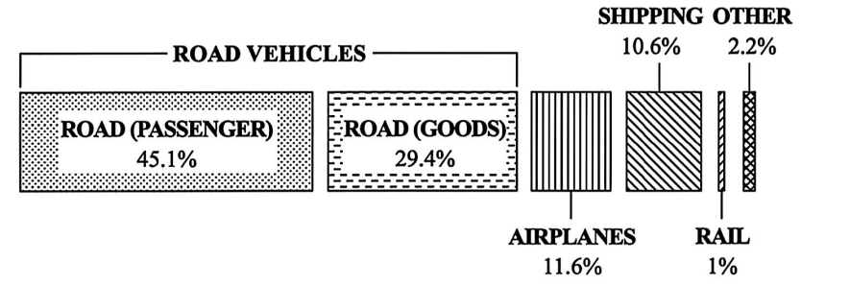
The fuels for transport need to be not just green, cheap and powerful, but also lightweight and safe enough to be carried around. Each mode of transport has its specific fuel needs. Much is still to be settled, but here are some of the solutions to get us going green.
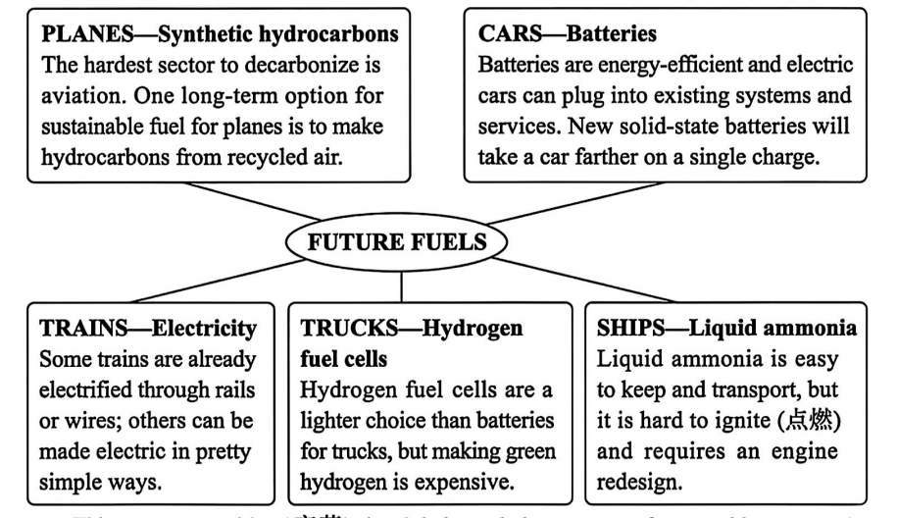
This energy transition(变革) is global, and the amount of renewable energy the world will need is "a little bit mind-blowing," says mechanical engineer Keith Wipke at the National Renewable Energy Laboratory. It's estimated that the global demand for electricity could more than double by 2050. Fortunately, analyses suggest that renewables are up to the task."We need to speed up the development of green energy, and it will all get used," says Wipke.
21.What percentage of global transport emissions did road vehicles account for in 2018?
A. 11.6% B. 45.1% C. 74.5% D. 86.1%
22.Which mode of transport can go green comparatively easily?
A. Planes. B. Trucks. C. Trains. D. Ships.
23.What does Wipke suggest regarding energy transition?
A. Limiting fuel consumption.
B. Putting more effort into renewables.
C. Improving energy efficiency.
D. Making electricity more affordable.
B
In my ninth-grade writing class last year, I met a cowboy who saved his town, a strict father who demanded his son earn straight A's, and a modern-day Juliet who died of heartbreak after her parents rejected the love of her young life. More than once, I found myself wondering just how my students, who'd created these people, knew their subjects so well.
But things were different for their first essay, which was about the question: "Why is writing important? "
Most of the essays filled less than one page, and few contained a sentence that could be interpreted as a thesis (论点) statement. I was shocked. Then I realized that the problem was the question itself. They could have written pages on the necessity of computers, but writing, in and of itself, simply didn't strike them as important. This would have to change.
As a new unit started, I asked everyone to write a persuasive piece on a health-related topic of their choice. This time they found the exercise much more interesting. For the next two assignments, a personal-narrative unit followed by a creative-writing workshop, I only required that the piece meet the specifications of its genre (体裁) and that it contain a thesis. The results were staggering. The students took on diverse topics and turned in stories, 10 to 20 pages each, with characters that broadened my view and touched my heart.
I walked into class believing that writing is important as a means of communication. However, my students demonstrated something more important to me. When the final bell rang in June, I walked away with a yearbook full of messages about writing's most powerful significance—the ability to connect people, to put us in another's skin, to teach us what it means to be human.
24.Who are the people mentioned at the beginning of paragraph 1?
A. Ninth graders. B. Students' parents.
C. Modern writers. D. Fictional characters.
25.Why did the students perform poorly in writing their first essay?
A. They were not given enough time.
B. They had a very limited vocabulary.
C. They misunderstood the question.
D. They had little interest in the topic.
26.What does the underlined word "staggering" in paragraph 3 mean?
A. Mixed. B. Amazing. C. Similar. D. Disturbing.
27.What does the author's experience show?
A. Teaching is learning. B. Still waters run deep.
C. Knowledge is power. D. Practice makes perfect.
C
While safety improvements might have been made to our streets in recent years, transport studies also show declines in pedestrian (行人) mobility, especially among young children. Many parents say there's too much traffic on the roads for their children to walk safely to school, so they pack them into the car instead.
Dutch authors Thalia Verkade and Marco te Brömmelstroet are bothered by facts like these. In their new book Movement: How to Take Back Our Streets and Transform Our Lives, they call for a rethink of our streets and the role they play in our lives.
Life on city streets started to change decades ago. Whole neighbourhoods were destroyed to make way for new road networks and kids had to play elsewhere. Some communities fought back. Most famously, a Canadian journalist who had moved her family to Manhattan in the early 1950s led a campaign to stop the destruction of her local park. Describing her alarm at its proposed replacement with an expressway, Jane Jacobs called on her mayor (市长) to champion "New York as a decent place to live, and not just rush through." Similar campaigns occurred in Australia in the late 1960s and 1970s as well.
Although these campaigns were widespread, the reality is that the majority of the western cities were completely redesigned around the needs of the motor car. The number of cars on roads has been increasing rapidly. In Australia we now have over twenty million cars for just over twenty-six million people, among the highest rate of car ownership in the world.
We invest a lot in roads that help us rush through, but we fail to account for the true costs. Do we really recognise what it costs us as a society when children can't move safely around our communities? The authors of Movement have it right: it's time to think differently about that street outside your front door.
28.What phenomenon does the author point out in paragraph 1?
A. Cars often get stuck on the road.
B. Traffic accidents occur frequently.
C. People walk less and drive more.
D. Pedestrians fail to follow the rules.
29.What were the Canadian journalist and other campaigners trying to do?
A. Keep their cities livable. B. Promote cultural diversity.
C. Help the needy families. D. Make expressways accessible.
30.What can be inferred about the campaigns in Australia in the late 1960s and 1970s?
A. They boosted the sales of cars.
B. They turned out largely ineffective.
C. They won government support.
D. They advocated building new parks.
31.What can be a suitable title for the text?
A. Why the Rush? B. What's Next? C. Where to Stay? D. Who to Blame?
D
Microplastics have become a common source of pollution across the Earth—they have settled in the deep sea and on the Himalayas, stuck inside volcanic rocks, filled the stomachs of seabirds and even fallen in fresh Antarctic snow. They are even appearing inside humans.
Now, new research suggests that a simple, cheap measure may significantly reduce the level of microplastics in water from your tap (水龙头): boiling and filtering (过滤) it. In a study published Wednesday in Environmental Science &Technology Letters, researchers from China found that boiling tap water for just five minutes—then filtering it after it cools—could remove at least 80 percent of its microplastics.
Crucially, this process relies on the water containing enough calcium carbonate (碳酸钙) to trap the plastics. In the study, boiling hard water containing 300 milligrams of calcium carbonate led to an almost 90 percent drop in plastics. But in samples with less than 60 milligrams of calcium carbonate, boiling reduced the level of plastics by just 25 percent. Additionally, the research didn't include all types of plastics. The team focused only on three common types—polystyrene, polyethylene and polypropylene—and they didn't study other chemicals previously found in water such as vinyl chloride.
Still, the findings show a potential path forward for reducing microplastic exposure—a task that's becoming increasingly difficult. Even bottled water, scientists found earlier this year, contains 10 to 1, 000 times more microplastics than originally thought.
Scientists are still trying to determine how harmful microplastics are—but what they do know has raised concerns. The new study suggests boiling tap water could be a tool to limit intake. "The way they demonstrated how microplastics were trapped through the boiling process was nice, " Caroline Gauchotte-Lindsay, an environmental engineer of the University of Glasgow in Scotland who was not involved in the research, tells New Scientist. "We should be looking into upgrading drinking water treatment plants so they remove microplastics. "
32.How does the author present the issue in the first paragraph?
A. By quoting an expert. B. By defining a concept.
C. By giving examples. D. By providing statistics.
33.What determines the effectiveness of trapping microplastics in water?
A. The hardness of water. B. The length of cooling time.
C. The frequency of filtering. D. The type of plastic in water.
34.What does the author try to illustrate by mentioning bottled water in paragraph 4?
A. The importance of plastic recycling.
B. The severity of the microplastic problem.
C. The danger in overusing pure water.
D. The difficulty in treating polluted water.
35.What is Gauchotte-Lindsay's suggestion about?
A. Choice of new research methods.
B. Possible direction for further study.
C. Need to involve more researchers.
D. Potential application of the findings.
三、阅读七选五：本大题共5小题，共12.5分。
An Unsung Hero
Need a break between classes or just a quick pick-me-up in the morning? The College Cafe has just that, and more. 36
Catherine Murphy, a cafe worker in a green shirt and black hat, makes sure that each customer gets exactly what they order. She goes back and forth between machines to make the drinks. 37 As the customer grabs the drink from her hand, she smiles and says, "Hello, how is your day?" Even when the line is getting longer, she doesn't let it get in the way of her genuine conversations.
Murphy gets up at a quarter to five and drives thirty minutes every day to get to work on time. 38 "I do so because I like to make coffee for the students. I know they need it in the morming," Murphy said. Being a mother and wife has helped her become the woman she is. She believes she is here to serve.
One thing Murphy may not know is that her smile is contagious(有感染力) and can be the difference in a student having a much better day than they were having before seeing her. Joanna Wright, a senior political science major, loves coffee and goes to the cafe at least six days a week. 39 "Catherine always has a huge smile on her face, which always puts me in a cheerful mood," Wright said.
"I enjoy working in the cafe," Murphy said. 40 She has every intention of staying and continuing doing what she loves.
A. The cafe closes at 9 pm every day.
B. She has two children aged eight and four.
C. Sometimes she arrives early to serve the students early.
D. After finishing an order, she calls out the name on the cup.
E. Not only does this cafe serve up drinks, it also serves up smiles.
F. Going to the cafe starts her day off good and gets her ready for class.
​​​​​​​G. She has served here for 17 years and can't imagine working anywhere else.

36.A. A B. B C. C D. D E. E F. F G. G
37.A. A B. B C. C D. D E. E F. F G. G
38.A. A B. B C. C D. D E. E F. F G. G
39.A. A B. B C. C D. D E. E F. F G. G
40.A. A B. B C. C D. D E. E F. F G. G
四、完形填空：本大题共15小题，共15分。
One August afternoon, I sat in my kitchen staring at a glass vase that hadn't seen daylight since my wedding.
My husband and I had just sold our house and we were busy 41 the beloved home our family had spent 23 years filling up. We had decided on key items for the 42 we were moving to in town, donated what we could, and rented a place to 43 our supposedly important objects. That left a house still 44 with things that, while not particularly 45 , didn't belong in a landfill (垃圾填埋场).
I took a picture of the vase and posted it online, for $10. A couple of messages came in, one wanting additional 46 , another asking for a price cut. As our 47 day drew near, I settled on a new price ($0) and reposted it. The 48 : "I hate this vase. Maybe you won't." In an instant, a woman raced into my house and left happily with the vase.
49 , I posted more. My daily posts and the 50 I received became a precious ray of light in the chaos of my house. Each exchange provided a chance to 51 the landfill and to please another person I might not otherwise have 52 .
I sit in my apartment today, loving each of the 53 that share our small space. I take 54 in knowing that, somewhere nearby, someone is 55 something that couldn't come with us.
41.A. painting over B. looking around C. emptying out D. pulling down
42.A. hotel B. office C. cottage D. apartment
43.A. store B. display C. sell D. repair
44.A. covered B. decorated C. stuffed D. equipped
45.A. conventional B. valuable C. complicated D. tolerable
46.A. fees B. photos C. receipts D. models
47.A. move B. pay C. market D. work
48.A. warning B. request C. description D. reply
49.A. Confused B. Interested C. Disappointed D. Encouraged
50.A. visits B. reports C. advice D. money
51.A. remove B. spare C. find D. check
52.A. investigated B. recognized C. encountered D. recommended
53.A. giveaways B. posts C. contributions D. belongings
54.A. joy B. part C. care D. time
55.A. anticipating B. appreciating C. delivering D. withdrawing
五、语法填空：本大题共1小题，共15分。
56.阅读下面短文，在空白处填人1个适当的单词或括号内单词的正确形式。
An exhibition at the Jiushi Art Museum in Shanghai is featuring artwork inspired by Go, or weiqi in Chinese, 36 originated in China more than 4, 000 years ago.
Go is one of 37 earliest binary-based (基于二元的) games. The movements of the black and white pieces reflect the basic ideas of Eastern philosophy, according to Tu Ningning, who is in charge of the exhibition.
"The exhibition brings together Go culture, cutting-edge technology and contemporary art," says Tu. "We hope 38 (present) the rather abstract Go game and AI in a visual context, and initiate dialogues with minimalist art, conceptual art and expressionism."
"In a Go game, each move should serve a long-term goal. You try to lead the opponent into your trap and force them to follow your ' 39 (guide)' till they lose," explains Wang Wei, a Go player among the visitors to the exhibition.
"The players' personalities 40 (reveal) during the game, and one's weaknesses are exposed to the opponent, " she adds. "A decent winner always 41 (try) to beat the opponent 42 no more than one or two points as a gesture(姿态) of respect for the other side."
Tu says that the balance between the black and white pieces, the beauty in the 43 (strategy) placement of the pieces, 44 the energy flow following each move inspired artists to create oil paintings, sculptures, 45 (digital) generated pictures and silk-screen prints for the exhibition.
(1)
(2)
(3)
(4)
(5)
(6)
(7)
(8)
(9)
(10)
六、任务型读写：本大题共1小题，共25分。
57.阅读下面材料，根据其内容和所给段落开头语续写两段，使之构成一篇完整的短文。
My wife and I wanted to share our new home with family and friends by hosting a small gathering in the early summer. She had prepared lots of snacks, while my job was to have the backyard in order.
There was plenty of space for the kids to run and play. There was just one thing I hadn't counted on: My brother chose to bring his dog Toby, a 50-pound ball of fire. Though friendly, he could easily knock over my niece's small boys and my six-month-old granddaughter. So, when my brother showed up, I asked him to watch Toby and keep him outside.
My plan was working out just fine. Toby was using up his energy by running back and forth in the backyard and giving the kids plenty of room. Unexpectedly, after supper, the weather changed. It started to rain and everyone went indoors.
It was an awkward moment. I didn't want Toby to be running around in the house, and my brother wasn't happy with driving home with a wet dog. Eventually, my brother decided to leave rather than force the issue.
A few days passed, and I hadn't heard anything from my brother. I texted him and expressed wishes for him to come out again. His reply came as a surprise—a shock, actually: "Not a chance." Clearly, he was unhappy over the way we had parted. After all, I had left him little choice. Well, he'll get over it, I reasoned.
Two months passed. My wife suggested I get in touch with my brother, but I resisted, thinking he should call first. However, my conscience (良心) kept bothering me. I tried to put myself in my brother's shoes. He was facing health issues and his wife of thirty-five years had passed away a few months earlier. Toby was his constant companion, the one who kept him going.
注意：
(1)续写词数应为150个左右；
(2)请按如下格式在答题卡的相应位置作答。
I realized it was me who was at fault.
_________________________________________________________________
_________________________________________________________________
With the biscuits my wife had made, I arrived at my brother's door.​​​​​​​
​​​​​​​_________________________________________________________________
​​​​​​​_________________________________________________________________
七、书面表达：本大题共1小题，共15分。
58.假定你是李华，你班的英语报要增设一个栏目。外教Jenny提出“Fun at my school”和“ Guess who I am”两个选项供大家选择。请给Jenny写一封邮件，内容包括：
(1)你的选择；
(2)说明理由。
注意：
(1)写作词数应为80个左右；
(2)请按如下格式在答题卡的相应位置作答。
Dear Jenny,
​​​​​​​ I really like the idea of adding a new column to our English newspaper.
__________________________________________________________________
__________________________________________________________________
__________________________________________________________________
Yours,
Li Hua

