主从复合句
一、定语从句
定语从句在句子中起定语的作用,功能上相当于形容词,用于修饰名词或代词。定
语从句的难点在于如何准确判断应该使用关系代词还是关系副词。
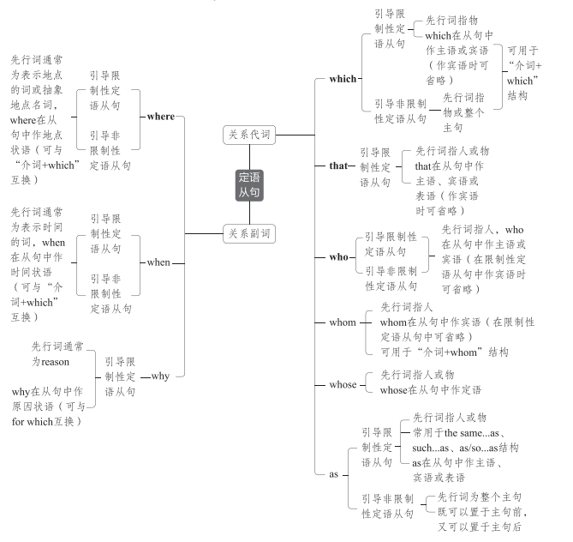
1.限制性定语从句VS非限制性定语从句
限制性定语从句：对先行词起修饰、限制作用,是先行词不可缺少的定语,如果省略,所修饰的先行词往往不明确,因此前面不用逗号。
非限制性定语从句：为先行词提供补充信息,起附加说明作用,即使去掉也不会影响先行词的明确性,常用逗号与主句隔开;除用于对具体事物补充信息外,还可以是针对整个主句内容的说明。
We knew the scientist who had studied the problem. 我们知道那个研究过该问题的科学家。
(若把从句去掉,则不知道是哪位科学家)
We knew the scientist Hawkins, who had studied the problem. 我们知道科学家霍金斯,他
研究过该问题。(若把从句去掉,仍然知道是哪位科学家)
Laura couldn't come to our party, which was a pity. 劳拉不能来参加我们的聚会,这真遗憾。
(针对整个主句内容的说明)

2.常用that不用which的情况
(1)当先行词是all、little、much、few、everything、nothing、none等不定代词或被
all、little、much、few、every、no等修饰时
He did everything that he could to help us.
他竭尽全力帮助我们。
(2)先行词前有形容词最高级或序数词修饰时
This is the most interesting film that I've ever seen. 这是我看过的最有趣的电影。
(3)先行词前有the last、the only、the very、the right、the same等词修饰时
The only thing that we can do is to give you some practical advice. 我们唯一能做的事就
是给你一些实用的建议。
(4)当主句是what(about)引导的疑问句时
What about using the tools that don't need power supply?
用那些不需要电源的工具怎么样?
(5)当先行词既有人又有物时
Later they talked of things and persons that they remembered in the school. 后来,他们谈论
了他们记得的学校里的人和事。
(6)当关系代词在从句中作表语时(只限于限制性定语从句)
China is no longer the country that it used to be.中国不再是过去的那个国家了。
(7)为避免重复
The businessman built up a small factory, which produced things that were suitable for
children.这个商人建了一家小工厂,生产适合孩子们用的东西。

- “介词+关系代词”结构
(1)当介词放在关系代词前面时,关系代词常用which(指代物)或whom(指代人),并且不
能省略。
In the dark street, there wasn't a single person, to whom she could turn for help.
在黑暗的街道上,没有一个她可以求助的人。
(2)“介词+关系代词”引导定语从句时,可用与之意义对应的关系副词when、where、
why替换;“名词+of which”引导定语从句时,可用“whose+名词”替换。
It dates back several thousand years to the use of longgu—animal bones and shells on
which (=where) symbols were carved by ancient Chinese people.它可以追溯到数千年前使用龙骨——动物骨头和贝壳的时期,中国古人在其上雕刻符号。
The house the window of which(=whose window) faces south is mine.
窗户朝南的那所房子是我的。

4、where的用法
关系副词where的先行词除了可以是表示具体地点的词外,还可以是case、condi-
tion、part、point、situation、stage等表示抽象地点的词。
It's helpful to put children in a situation where they can see themselves differently.
让孩子们处在他们能以不同的方式看待自己的状况中是有帮助的。
注意 occasion作先行词时,若指“时候;时刻;时机”,要用关系副词when;若指“仪式;
庆典;场合”,则要用关系副词where。
I can remember very few occasions when he had to cancel the meeting because of ill health.
我记得他因健康状况不佳而被迫取消会议的情况绝无仅有。

- 名词性从句
名词性从句在句子中起名词的作用,功能上相当于名词(短语),可在主从复合句中
充当主语、宾语、表语、同位语。因此,名词性从句可分为主语从句、宾语从句、表
语从句、同位语从句。

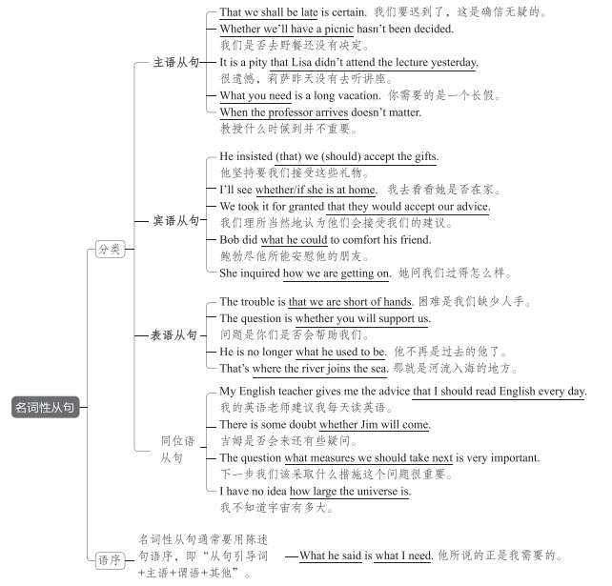
名词性从句常用的引导词有以下三类:
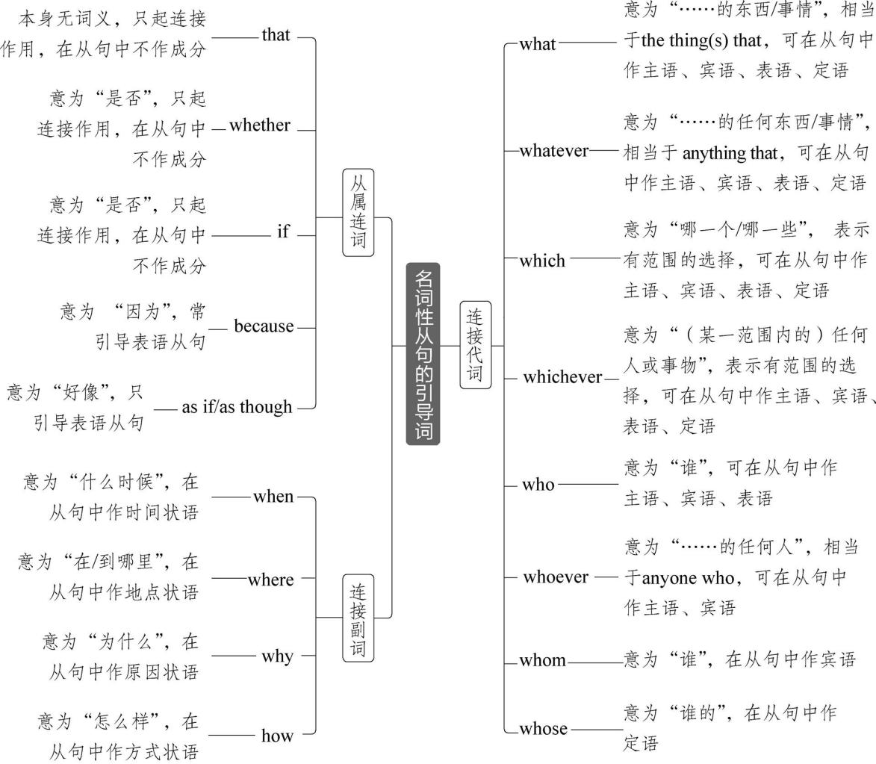
重难透析
1.that的用法
(1)that引导主语从句
that引导主语从句时,如果从句过长,为避免句子头重脚轻,我们常用it作形式主语,
而把主语从句放在句尾。常见的句型有:
It+be+形容词+that 从句（obvious、true、natural、surprising、good、wonderful、funny、possible、likely、certain、probable等）
Eg. It is certain that she will do well in her exam.她肯定会考得很好。
It+be+名词(短语)+that 从句（no wonder、an honor、a good thing、a pity、no surprise等）
Eg. It's no surprise that our team has won the game.我们队赢了那场比赛并不令人惊奇。
It+be+过去分词+that从句(said、reported、thought、expected、decided、announced、arrange等)
Eg. It is said that Mr. Green has arrived in Beijing.据说,格林先生已经到北京了。
It+动词(短语)+that从句(seem、appear、happen、occur、turn out、make no difference等)
Eg. It happened that he was out. 他碰巧出去了。
It turns out that he is silly. 事实证明他很愚蠢。
(2)that引导宾语从句
that可引导宾语从句,作及物动词或介词的宾语。
Do you know (that) he has joined the army?
你知道他参军了吗?
注意 以下两种情况,常用it作形式宾语:
①find、feel、think、consider、make、believe等后有宾语补足语时,需用it作形式宾语,
而将that引导的宾语从句后置。
He has made it clear that the meeting will not be postponed.
他清楚地表明会议不会被推迟。
②一些动词短语,如see to、depend on、rely on 等常用it作形式宾语,而将宾语从句后置。
I shall see to it that he is taken good care of when you are absent.
你不在的时候,我保证会照顾好他。
(3)that的省略
that引导主语从句、表语从句、同位语从句时一般不省略,但在口语中或用于引导及物
动词后的宾语从句时,that可以省略。
注意 以下两种情况,that一定不省略:
①that引导的从句位于句首时。
That different countries have different cultures is natural.
不同的国家有不同的文化是很自然的。
②动词后有多个that引导的宾语从句时,只有第一个that可以省略,从第二个从句开始,
that不可省略。
He said (that) he would attend the party and that he would announce a piece of inspiring
news.他说他将参加这个聚会,并将宣布一个鼓舞人心的消息。
2.whether与if的区别
whether可用于引导主语从句、宾语从句、表语从句和同位语从句。
if主要用于引导及物动词后的宾语从句,有时可用于引导主语从句(只能置于句末)。
注意 常用whether不用if的情况
①引导介词后的宾语从句、表语从句、同位语从句时。
It all depends on whether the sky will clear up. (介词后的宾语从句)
这完全取决于天是否会放晴。
The question is whether the film is well worth seeing.(表语从句)
问题是这部电影是否很值得看。
They raised the question whether we ought to call in a specialist. (同位语从句)
他们提出了我们是否应请专家来的问题。
②引导主语从句,且从句置于句首时。
Whether it is true remains a problem. 这是否属实仍然是个问题。
③后紧跟or not时。
Can you tell me whether or not the train has left?
你能告诉我火车是否已经开了吗?
注意:当or not不紧跟在后面时,whether与if可以互换。
Please tell me if/whether you will go to the lecture tomorrow or not.
请告诉我你明天是否去听讲座。
④与动词不定式连用时。
I don't know whether to refuse or accept. 我不知道是拒绝还是接受。
3.because的用法
because常用于引导表语从句,且常用于“It/This/That is because...”结构。
This is because people believe in the importance of carrying on space exploration despite
the huge risks. 这是因为尽管有巨大的风险,人们还是相信进行太空探索的重要性。
4.as if/though的用法
as if/though引导名词性从句时,只引导表语从句,意为“好像”。
She looked as if she had had some bad news.
她看上去好像听到了什么坏消息似的。
It sounds as though he's been really ill.
听起来他好像真的病了。
5.连接代词的用法
(1)what与who
what一般指事物,而who一般指人物的身份或特征。
He told us what had happened.(事情) 他告诉我们发生了什么事。
I firmly believe that what he said at the meeting is right.(他所说的话的内容)
我坚信他在会上说的是对的。
After what seemed a long time, the beggar left without a word.(时间)
似乎过了很长时间,乞丐一言不发地走了。
Nelson Mandela not only made South Africans feel good about being who they are, but he
was also an amazing gift to humankind.(身份)纳尔逊·曼德拉不仅让南非人对自己的身份感到满意,他还是给人类的一件令人惊叹的礼物。
Who is brave enough to face the challenge will be rewarded.(特征)敢于面对挑战的人将会得到奖励。
(2)what与which
what一般没有具体的范围,而which一般指在具体范围内进行选择。
Can you tell me what coffee you would like to have?(没有给出选择范围)
你能告诉我你想喝什么咖啡吗?
Can you tell me which coffee you would like to have, black or white?
(在黑咖啡和加奶咖啡中选择)
你能告诉我你想喝哪种咖啡吗,黑咖啡还是加奶咖啡?
知识链接 定语从句与名词性从句
①众所周知,地球绕着太阳转。
As is universally acknowledged, the earth runs around the sun.(As引导定语从句)
The earth runs around the sun, which is universally acknowledged.(which引导非限制性定语从句)
That the earth runs around the sun is universally acknowledged.(That引导主语从句)
=It is universally acknowledged that the earth runs around the sun.(that引导主语从句)
What is universally acknowledged is that the earth runs around the sun.(What引导主语从句,that引导表语从句)
②that引导的同位语从句和定语从句的区别
The news that our football team won the game was encouraging.
(that引导同位语从句,起连接作用,不充当句子成分)
The news (that) we heard on the radio was not true.(that引导定语从句,在从句中作宾语,可省略)

三、状语从句
状语从句在句子中起状语的作用,可用来修饰主句或主句中的动词、形容词或副词。与定语从句和名词性从句一样,状语从句通常有引导词。根据其意义和在句中作用的不同,状语从句可分为以下9种:
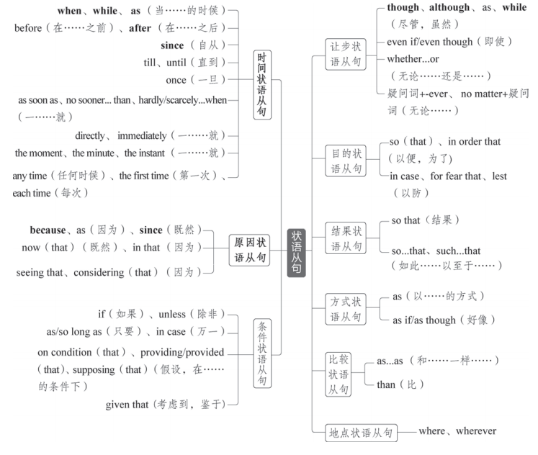
时间状语从句
1.when和while
when和while都可以用于引导时间状语从句,两者用法有很多共同之处,但也有区别:
(1)when引导时间状语从句可表示主句动作与从句动作同时发生,也可以表示从句动作
与主句动作先后发生。
It was snowing when we arrived. 我们到达时,天正下着雪。
I'll let you know when it is arranged. 此事安排好后,我会告诉你。
(2)while引导时间状语从句可表示主句动作与从句动作同时发生,意为“一边……一边
……”。
While she sang, she danced. 她边唱边跳。
注意
①while可置于句首,引导让步状语从句,意为“虽然,尽管”。(详见本专题“让
步状语从句”部分)
②while可用作并列连词,表示前后对比,意为“而”。(详见专题七“并列连词与并列
复合句”)
2.as引导时间状语从句的用法
as可用于引导时间状语从句,常译为“当……时”,可与when或while互换,也可以
转化为with的复合结构。此外,as也有“随着”的意思。
When/While/As the earth travels round the sun, it turns around on its own.
地球绕太阳转的同时还自转。
As time goes by, private cars are more and more popular.
=With time going by, private cars are more and more popular.
随着时间的推移,私家车越来越受欢迎。
注意 as还可以引导原因状语从句(详见本专题“原因状语从句”部分)、让步状语从
句(详见本专题“让步状语从句”部分)、比较状语从句和方式状语从句。
2.as引导时间状语从句的用法
as可用于引导时间状语从句,常译为“当……时”,可与when或while互换,也可以
转化为with的复合结构。此外,as也有“随着”的意思。
When/While/As the earth travels round the sun, it turns around on its own.
地球绕太阳转的同时还自转。
As time goes by, private cars are more and more popular.
=With time going by, private cars are more and more popular.
随着时间的推移,私家车越来越受欢迎。
注意 as还可以引导原因状语从句(详见本专题“原因状语从句”部分)、让步状语从
句(详见本专题“让步状语从句”部分)、比较状语从句和方式状语从句。
3.since引导时间状语从句的用法
(1)since的基本用法
since意为“自从……以来/之后”,引导的时间状语从句的谓语动词一般是非延续性动
词,用一般过去时;主句的谓语动词是延续性的或者是反复发生过的动作,其时态常用现
在完成时或现在完成进行时。
I have written home four times since I came here.
自从来到这儿,我已经给家里写过四次信了。
She has been working in this factory since she left school.
她离开学校以后就一直在这个工厂工作。
(2)It+be+一段时间+since从句
在这个句型中,since引导的从句的谓语动词若是延续性动词,则时间从since从句的动作
或状态结束时算起;若since引导的从句的谓语动词是非延续性动词,则时间从动作开始
时算起。
It is three years since the young man joined the army. 那个年轻人已经参军三年了。
(join为非延续性动词,时间从动作开始时算起,即自“他参军”那一刻起已经有三年了)
It is three years since the young man was in the army. 那个年轻人已经退伍三年了。
(be为延续性动词,时间从动作结束时算起,即自“他在军队”这件事结束已经有三年了)
注意 since还可以引导原因状语从句(详见本专题“原因状语从句”部分)。
- before的用法
(1)用在“It was/will be...before...”结构中,表示“要过……才……”
It will be another five days before we finish this task.
我们还需要五天才能完成这项任务。
(2)用在“It wasn't/won't be...before...”结构中,表示“没过……就……”
It was not long before I forgot it all. 没过多久我就把这一切都忘了。
(3)before有时可以翻译为“还没来得及……就”或“以免”
The roof fell before he had time to dash into the room to save his baby.
他还没来得及冲进房间救他的孩子,房顶就塌了。
I must write it down before I forget it. 我必须把它记下来,以免忘了。

原因状语从句
because引导的原因状语从句语气最强,回答由why提出的问题通常用because引导
的句子。as、since和now (that)引导的原因状语从句语气较弱,通常表示已知的事实,且
since一般置于句首。
The ground is wet because it rained last night.由于昨晚下雨,地面是湿的。
As/Since/Now (that) you are a student, I am strongly for the activity because it is very
meaningful and helpful.
由于你是一名学生,我非常支持这个活动,因为它很有意义,也很有帮助。

条件状语从句
引导条件状语从句的词或词组有if(如果)、unless(除非)、as/so long as(只要)等。
He'll accept the job unless the salary is too low./He'll accept the job if the salary is not too
low. 除非工资太低,否则他会将受这份工作的。
/如果工资不是太低,他会接受这份工作的。
As/So long as we don't lose heart, we'll find a way to overcome the difficulty.
只要我们不灰心,我们将会找到克服困难的办法。

让步状语从句
1.although与though
Even though Tu Youyou is not interested in fame, she has become a scientist whose work is internationally renowned.
虽然屠呦呦对名望不感兴趣,但她已经成为一名研究成果享誉国际的科学家。
2.as引导让步状语从句的用法
as引导的让步状语从句一定要倒装。
Simple as/though the picture is, the underlying meaning cannot be ignored.
尽管图片很简单,但其隐含的意义不容忽视。
3.while引导让步状语从句的用法
while引导让步状语从句时,一般置于句首,且不倒装。
While I admit that there are problems, I don't agree that they cannot be solved.
尽管我承认有问题,但我认为这些问题不是不能解决。
4.“疑问词+-ever”VS“no matter+疑问词”
“no matter+疑问词”只能用于引导让步状语从句(此时可与“疑问词+-ever”互
换,从句谓语动词一般与情态动词may/might连用以加强语气)。
“疑问词+-ever”除可以引导让步状语从句以外,还可以引导其他状语从句和名词性
从句。
If the baby is put into an unfamiliar playroom without its mother, the baby ignores the toys
no matter how interesting they might be.(引导让步状语从句) 如果这个婴儿被放在一个陌生的没有妈妈在的游戏室,那么无论玩具多有趣,这个婴儿都会忽略这些玩具。
Whichever and whatever you like, there is an incredible theme park that will appeal to you!
(引导让步状语从句)无论你喜欢哪一个或喜欢什么,都有一个非常棒的主题公园会吸
引你!
Studying hard isn't always fun, but I'll be well prepared for university or whatever else
comes in the future. (引导介词后的宾语从句)努力学习并不总是有趣的,但我会为大学
或未来发生的其他任何事情做好充分准备。
We can download software, documents, and images whenever we need them. (引导时间状
语从句)我们可以随时下载需要的软件、文档和图像。
5.whether...or的用法
whether...or意为“无论/不管/不论……还是”,其引导的让步状语从句有时可用虚
拟语气,动词用原形。
Whether we beat them or they beat us, the match will be enjoyable. 不管是我们打赢他们,
还是他们打赢我们,这场比赛都将是好看的。
注意 当whether...or引导的让步状语从句中谓语动词用虚拟语气,且动词为be时,可以
省略whether,将动词be移至句首,用动词命令式引导让步状语从句。
Whether the figures be accurate or not, they have to be rechecked.
=Be the figures accurate or not, they have to be rechecked. 不管这些数字准确与否, 都必须重新检查。

目的状语从句
so (that)、for fear that、in order that引导的目的状语从句常带有can、may、
could、might等情态动词。
I am always attentive in all classes and think actively,so that I can have more free time to
do other things that I'm interested in after school.
在所有课上,我总是专心听讲,并积极思考,以便放学后我能有更多的空闲时间去做其
他我感兴趣的事情。
The traveller set off early for fear that he might miss the early bus. 这位旅客很早就出发
了,生怕赶不上早班车。

结果状语从句
so...that与such...that的区别
Mr. Moore is such a learned and wise person that we can never admire him too much.
=Mr. Moore is so learned and wise a person that we can never admire him too much.
摩尔先生是一位如此博学且睿智的人,我们对他再怎么钦佩也不为过。

