**Inspiration from User-evaluated Experiments of HCI and Web Design**

The Australian National University

COMP6780 - Web Development and Design

Author: Zeyuan Cheng

Student ID: u7148404

**Abstract**

**Introduction**

这应该是几个段落，反映了你学到了什么关于网站设计，而实际上这样做。如果你早些意识到你会做不同的事吗？

总的来说，我从这门课学到了通过应用当前的网页设计原则，准则和启发式方法，开发和设计包括多媒体内容在内的交互式网站。从基础的使用JSbin创建Html页面到用CSS修饰我的网页，比如背景，字体，表格，调整图片等。除了平常的MOOC lecture和tutorial之外，我还了解到很多其他的来源比如Youtube和W3School并且从中学习到了很多课程之外的网站开发技术。此外，我在不断地学习中了解到了以用户为中心应用于网站的设计和开发。使用JavaScript和CSS结合可以显著提升网页的交互性。

In general, I learned from this course to develop and design interactive websites including multimedia content by applying current web design principles, guidelines and heuristic methods. From the basic use of JSBin to create HTML page to modify my webpage with CSS, such as background, font, table, adjust picture, etc. In addition to the usual MOOC and tutorial, I also learned a lot of other sources, such as YouTube and W3School, and learned a lot of website development technology besides courses. Furthermore, I have learned from my continuous learning that user centered application is used in website design and development. Using JavaScript and CSS can significantly improve the interactivity of web pages.

一些关于反思的实例：

1. 导航栏的home按键。之前是鼠标悬停弹出下拉菜单。之后在此基础上增加鼠标点击跳转至主页的最上端。
2. The home button in the navigation bar. It used to be a mouse over pop-up drop-down menu. Then add mouse click to jump to the top of the home page.
3. 网站底部的contact me部分，从简单的列出我的邮箱改为了通过多种社交平台的按钮来快速和我取得联系。
4. The contact me section at the bottom of the website changes from simply listing my email address to quickly getting in touch with me through a variety of social platform buttons.

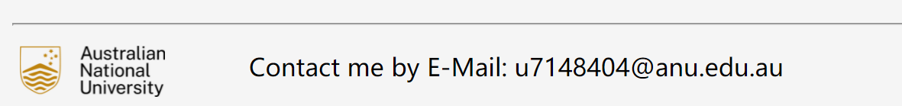

改为

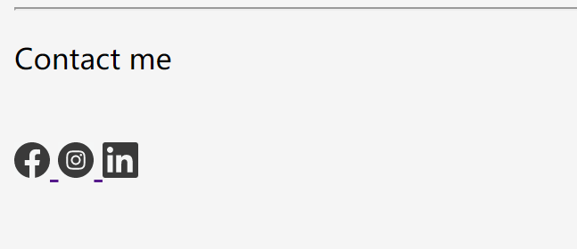

1. 删除多余的css文件，将多个css文件合并。并在新的css文件中给每部分加注释标签，以便查找和更改。这样做的好处除了方便查找还有当我们有多个html页面时方便导入。
2. Delete redundant CSS files and merge multiple CSS files. And in the new CSS file, each part is annotated to find and change. The advantage of this is not only easy to find, but also easy to import when we have multiple HTML pages.