CSS3过渡

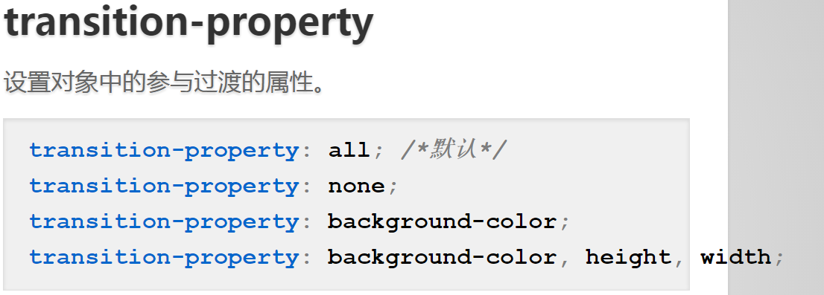

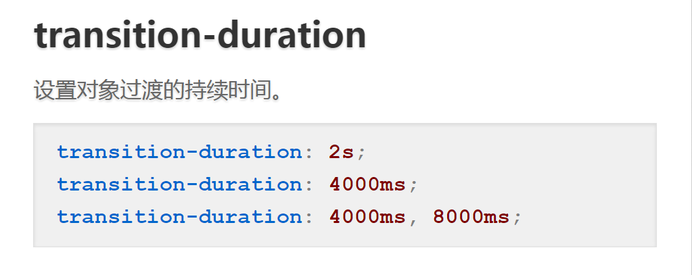

transition-timing-function 属性

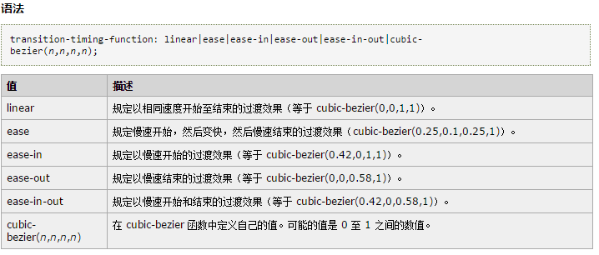

# transition-delay 属性

语法：transition-delay: *time*; //可为负

transition复合语法

**transition: width 3s, height 2s 2s;**

**transition: background-color 3s linear 1s;**

**transition: 4s ease-in-out;**

**transition: 5s;**