JJ IS40BXPA Setup and Integration Guide
English Product Documentation
Hardware specifications, ACServer deployment, configuration and data interface reference for the JJ-IS40BXPA Bluetooth AoA gateway.
Jinju Intelligence (Beijing) Technology Co., Ltd. | zydc0915@gmail.com
Figures retain the original hardware labels and software interface. The accompanying English instructions identify the controls and installation steps.

JJ-IS40BXPA Bluetooth Gateway
Product Specifications and User Manual

1 Copyright and Notices
Copyright. All rights reserved.
Confidentiality: This document contains confidential information for the designated recipient only and must not be disclosed to third parties.
Disclaimer: No express or implied representation or warranty is made in this document. No responsibility is accepted for merchantability or fitness for a particular purpose.

2 Hardware Specifications

2.1 Product Overview
The JJ-IS40BXPA is a Bluetooth 5.1 AoA (Angle of Arrival) indoor ceiling gateway. Its on-board antenna array is designed for precise indoor positioning, with accuracy within 0.5 m in unobstructed conditions. A dual-core ARM M4F processor, PoE and DC power options support healthcare, warehousing, personnel and asset tracking applications.

2.2 Core Technical Specifications

2.2.1 Processor and Memory
Main MCU: Dual-core ARM M4F at 64 MHz
Flash： 1MB + 512KB
RAM： 256KB + 128KB

2.2.2 RF and Positioning Performance
Bluetooth protocol: Bluetooth 5.1 / 4.2, backward compatible
Operating frequency: 2.4 GHz
Transmit power: 10 dBm
Receiver sensitivity: > -95 dBm
Positioning accuracy: < 0.5 m in unobstructed conditions
Coverage: Radius approximately 1.5 times the installation height
Antenna: On-board antenna array

2.2.3 Electrical Specifications and Interfaces
Power supply: PoE or DC 5 V / 1 A
Rated power: 3 W
Network interface: 10/100 Mbps auto-negotiating LAN
Network protocols: UDP, DHCP / static IP

2.2.4 Physical and Environmental Specifications
Dimensions: 230 x 230 x 40 mm
Weight: 500 g
Housing material: ABS
Operating temperature: -20 to 60 degrees C
Operating humidity: 0 to 95%, non-condensing

2.3 Product Appearance
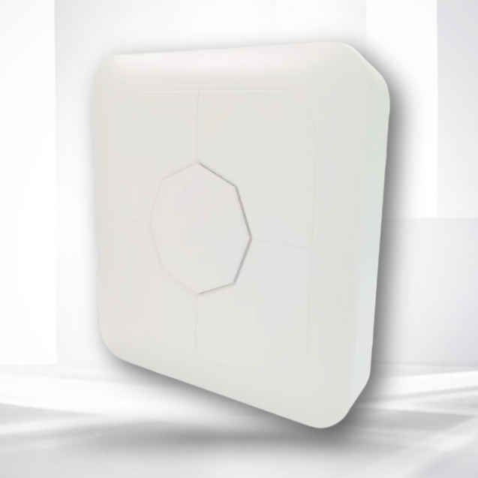

3 ACServer Software

3.1 Software Overview
ACServer is the positioning engine for this system. It supports Windows 7 and later and Linux distributions. It manages AoA gateways, processes raw azimuth and elevation data, calculates target positions and pushes results to application platforms through standard interfaces.

3.2 Main Functions
Gateway management: Online configuration, parameter readback, status monitoring with online/offline notifications, and traffic statistics.
Live tag monitoring: View positioning-tag battery levels, online status and current locations.
Positioning engine: Receive raw gateway observations, optimize the calculations and output final coordinates.
Data push: Socket (TCP/UDP), WebSocket, MQTT and HTTP interfaces are supported.

4 Deployment and Configuration

4.1 Hardware Connection and Network Access
Power connection
PoE: Connect one end of the Ethernet cable to a PoE switch and the other to the gateway.
DC: Connect a 5 V / 1 A power adapter, then connect the Ethernet cable.
IP address configuration
The gateway uses DHCP by default. On a DHCP-enabled LAN, it acquires its network configuration after power-up.
For static IP configuration, use the WeChat mini program named Smart Bluetooth Gateway Tool and enable Bluetooth permissions on the phone. The original tool uses a Chinese interface.
Keep the gateway and ACServer computer on the same subnet. For tests on the same LAN, the destination address can remain 0.0.0.0 (broadcast mode), allowing ACServer to discover the gateway. For a remote subnet or cloud server, set the destination to the server's public IP address.

4.2 Starting ACServer
Windows: The source procedure instructs the operator to disable the firewall and double-click start.bat. Deployment note: use a controlled test network; in production, configure the required firewall rules instead of disabling protection globally.
Linux
Foreground: ./acserver -v=7 -alsologtostderr
Background: nohup ./acserver -v=7 -alsologtostderr &
Management login
Open http://[server-IP]:8888/v/user/login.html in a browser.
Default username: admin. Default password: 123.
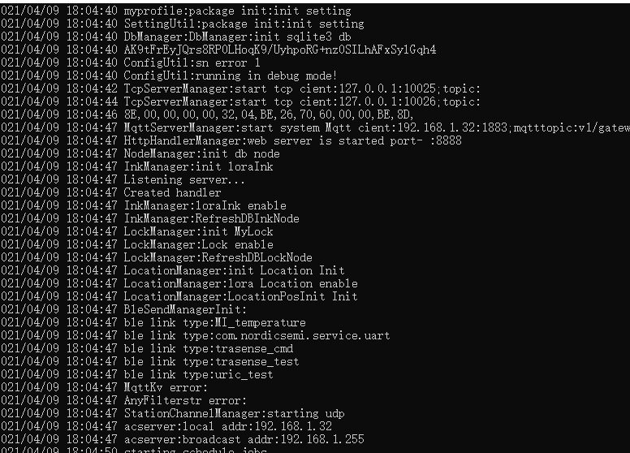

4.3 System Parameter Configuration
Important: Complete the following configuration after the first login to establish system communications.
Open System Parameter Configuration.
Set Local IP to the actual IP address of the computer or server running ACServer.
Select the ACServer network type: LAN or public network, as appropriate.
Save the settings, then close and restart ACServer for the changes to take effect.

4.4 Data Push
AoA tag data push
{
"Gateway":"10000060",
"NodeId":"00000000",
"Group":"group1",
"SystemId":"10990145",
"Type":"AOA_data",
"conx":-0.8987940462991669,
"ka":206,
"ke":42,
"mac":"19,00,00,00,60,C2",
"rssi":8,
"siny":-0.43837114678907746,
"tanh":0.9004040442978399,
"x":-0.5547684731158157,
"y":-0.27453919672639904
}
Parameter | Type | Description
Gateway | String | ID of the AoA gateway uploading this record
NodeId | String | Currently unused; replaced by mac
SystemId | String | ACServer ID identifying the uploading instance when multiple servers are deployed
Type | String | Message type; a fixed value for this message
mac | String | Unique identifier of the tag
rssi | Int | Tag signal strength
Ka | Int | Raw AoA azimuth value
ke | Int | Raw AoA elevation value
conx | Float | Raw X-direction value calculated at a unit distance of 1 m
siny | Float | Raw Y-direction value calculated at a unit distance of 1 m
tanh | Float | Distance from the gateway calculated for a height of 1 m
x | Float | Final calculated X coordinate
Y | Float | Final calculated Y coordinate

