iBeacon Beacon Series
English Product Documentation
Indoor, industrial-protection and wristband variants support standard iBeacon broadcasts. Configure UUID, Major, Minor, interval and transmit power by phone.
Jinju Intelligence (Beijing) Technology Co., Ltd. | zydc0915@gmail.com

Selection Notes
The source lists up to ten years for indoor/industrial variants and three to six months for the wristband; battery, broadcast configuration and temperature affect endurance. Confirm explosion-protection certificates and scope when selecting a model.

JJ-IB Series iBeacon Specifications
Jinju Intelligence Beijing Technology Co Ltd - Haidian Beijing
Date: 19 September 2024
Product enquiries and technical support: zydc0915@gmail.com

Revision History
Version | Changes | Author | Reviewer | Date
V1.0.0 | Initial release |  |  | 19.11.15
V1.0.1 | Added wristband iBeacon |  |  | 20.06.02

Important Notices

Copyright
Copyright 2019. All rights reserved.

No Warranty
No express or implied representation or warranty is made concerning this document. No liability is accepted for merchantability, fitness for a particular purpose, or indirect, special or consequential loss.

Confidentiality
This document, including its attachments, contains confidential information. The recipient acknowledges its confidential nature and may use it only for the specified purpose. It must not be disclosed to any third party.

JJ-IB32I Indoor Beacon

Electrical Specifications
Battery capacity | 2400mAh
Peak current | 5.5mA
Sleep current | <1uA
Average current | <30uA*
Operating temperature | -20℃—60℃
Operating humidity | 0 to 95%, non-condensing

Average current depends on the broadcast interval and power. The stated default is 500 ms at 0 dBm.
Operating frequency
Bluetooth frequency | 2.4~2.485GHz

Physical Specifications
Dimensions | 53*23mm
Color | White
Weight | 45g
Housing material | ABS

Note: Physical specifications vary with the packaging variant.
Colors can be selected for bulk orders; stocked units ship according to availability.
Weight varies slightly by model.

Additional Specifications
Transmit power | -20 dB to 4 dB in 4 dB steps
Coverage | Maximum diameter: 100 m
Battery life | Up to 10 years*
Tamper detection | Limit-switch tamper detection*
Water resistance | IP55
Security | AES encryption, tamper protection, connectable and non-connectable modes
Supported protocols | Apple standard iBeacon protocol; Bluetooth 5.0

*
Battery life depends on transmit power, transmission interval and ambient temperature.
Optional function; not included in the standard configuration.

Configuration Functions
Phone configuration | Configure UUID, Major, Minor, broadcast interval, transmit power and tamper-protection key.
Over-the-air update | OTA supported

Product Drawings
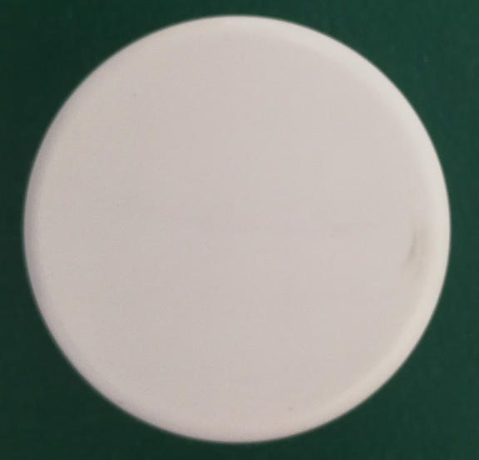
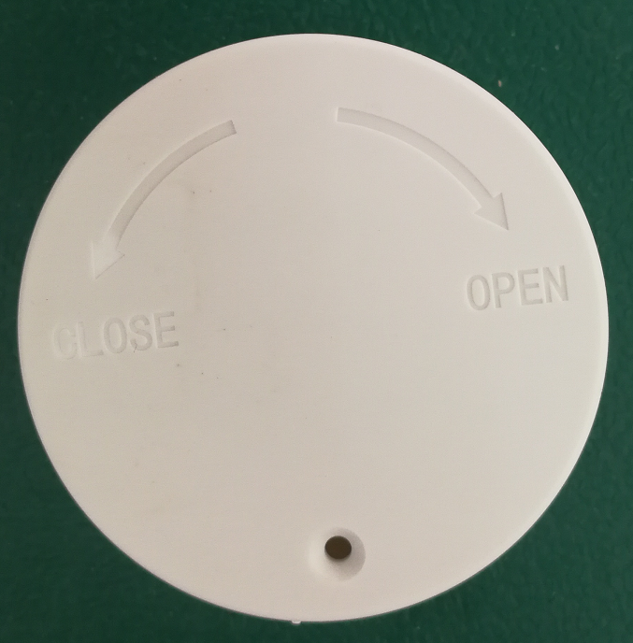
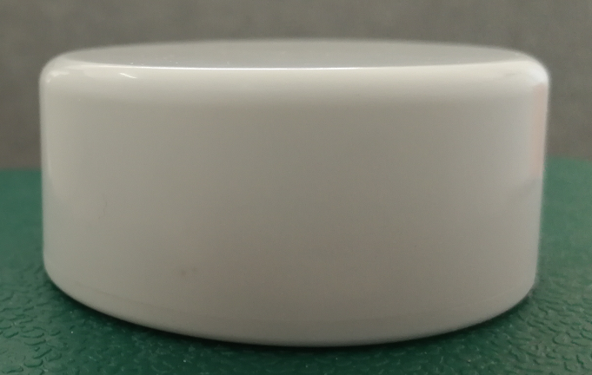

Packaging Specifications
48 units per carton

JJ-IB100 Explosion Protected Beacon

Electrical Specifications
Battery capacity | 2600 mAh; optional 5200 mAh. Default: 2600 mAh.
Peak current | 5.5mA
Sleep current | <1uA
Average current | <30uA*
Operating temperature | -20℃—60℃
Operating humidity | 0 to 95%, non-condensing

Average current depends on the broadcast interval and power. The stated default is 500 ms at 0 dBm.
Operating frequency
Bluetooth frequency | 2.4~2.485GHz

Physical Specifications
Dimensions | 120*120*24mm
Color | Industrial yellow, black, blue, off-white and other optional colors
Weight | 185-195g
Housing material | Modified ABS

Notes
Colors can be selected for bulk orders; stocked units ship according to availability.

Additional Specifications
Transmit power | -40dB-4dB
Coverage | Maximum diameter: 100 m
Battery life | Up to 10 years with maximum battery capacity
Water resistance | IP68
Compression resistance | 10 tonnes
Certification | Explosion-protection certification
Security | AES encryption, tamper protection, connectable and non-connectable modes
Supported protocols | Apple standard iBeacon protocol; Bluetooth 5.0

Configuration Functions
Phone configuration | Configure UUID, Major, Minor, broadcast interval, transmit power and tamper-protection key.
Over-the-air update | OTA supported

Product Images
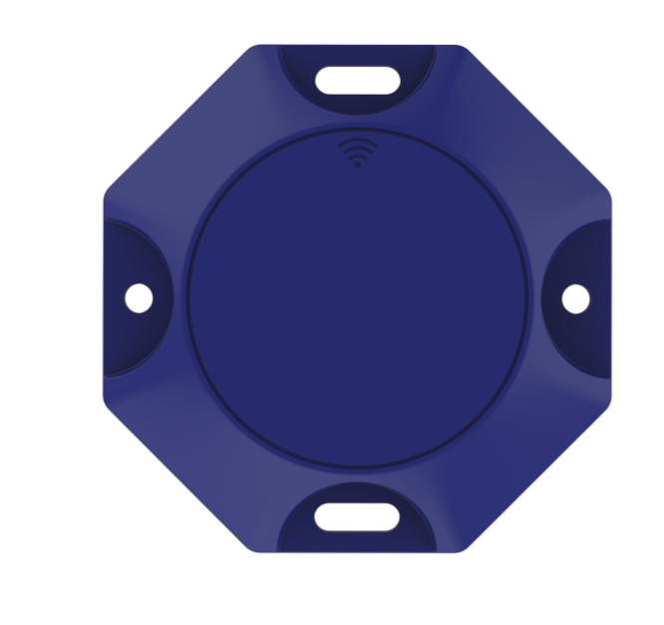
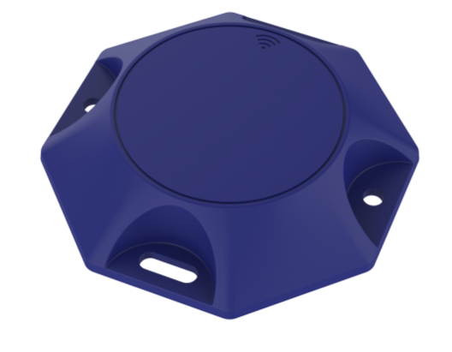
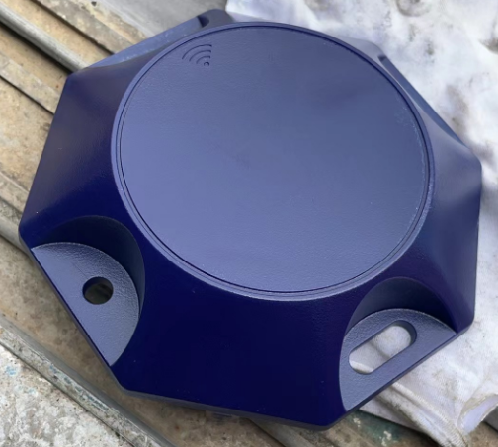

Packaging Specifications
60 units per carton

JJ-IB32W Wristband iBeacon

Electrical Specifications
Battery capacity | 50mAh
Power supply | Rechargeable lithium battery
Charging method | Mirco usb
Charging voltage | 5V
Peak current | 5.5mA
Sleep current | <1uA
Average current | <30uA*
Operating temperature | -20℃—60℃
Operating humidity | 0 to 95%, non-condensing

Average current depends on the broadcast interval and power. The stated default is 500 ms at 0 dBm.
Operating frequency
Bluetooth frequency | 2.4~2.485GHz

Physical Specifications
Dimensions | 250*40*11mm
Color | White, pink, blue, black, orange or green
Weight | 30g
Housing material | Plastic

Note: Colors can be selected for bulk orders; stocked units ship according to availability.

Additional Specifications
Transmit power | -40dB-4dB
Coverage | Maximum diameter: 100 m
Battery life | 3 to 6 months
Water resistance | IP53
Security | AES encryption, tamper protection, connectable and non-connectable modes
Supported protocols | Apple standard iBeacon protocol; Bluetooth 5.0

Configuration Functions
Phone configuration | Configure UUID, Major, Minor, broadcast interval, transmit power and tamper-protection key.
Over-the-air update | OTA supported

Product Images
