Anti Tamper Dual Mode Asset Tags
English Product Documentation
Choose between an anti-tamper Bluetooth tag and a Bluetooth LoRa tag. Match the model to attachment, movement and communication requirements, with configurable reporting policies.
Jinju Intelligence (Beijing) Technology Co., Ltd. | zydc0915@gmail.com

Selection Notes
Confirm AoA and remote finding for the exact model. LoRa carries data and does not independently guarantee outdoor coordinates.

JJ-IP Series Asset Location Tags

Product Specifications
Jinju Intelligence Beijing Technology Co Ltd - Haidian Beijing
Date: 1 October 2021
Product enquiries and technical support: zydc0915@gmail.com

Revision History
Version | Changes | Author | Reviewer | Date
V1.0.0 | Initial release |  |  | 21.10.01

Important Notices

Copyright
Copyright 2021 Jinju Intelligence Beijing Technology Co Ltd. All rights reserved.

No Warranty
No express or implied representation or warranty is made concerning this document. No liability is accepted for merchantability, fitness for a particular purpose, or indirect, special or consequential loss.

Confidentiality
This document, including its attachments, contains confidential information. The recipient acknowledges its confidential nature and may use it only for the specified purpose. It must not be disclosed to any third party.

Chapter 1 JJ-IP33B Tamper Detecting Asset Tag Specifications
The JJ-IP asset tag series is designed by Jinju Intelligence for asset visibility and lean management. It combines location tracking with AoA positioning, active finding, tamper alarms and intelligent status sensing for logistics, manufacturing, healthcare and enterprise IT asset management.
Core Functions and Applications
Tamper alarms protect instruments, toolboxes and valuable-item cabinets against unauthorized removal. Detaching the tag triggers a system alarm.
Motion detection identifies whether an asset is moving, supporting goods-turnover monitoring and equipment-use statistics.
Adjustable reporting intervals and motion sensitivity let users match frequent movement or long-term storage, optimizing battery life and useful data reporting.
Low-power Bluetooth communication works with a phone app or Bluetooth gateway for inventory, location checks and inbound/outbound asset management.
Example Applications
Factory equipment inspection and management
Medical equipment location and loss prevention
Warehouse pallet and returnable-container tracking
Exhibition equipment theft prevention and status monitoring

Electrical Specifications
Operating voltage | 3.6V
Battery specification | 2 x 14250 cells
Maximum current | <8.5mA@3.6V
Listening current | <6mA@3.6v
Bluetooth transmit current | <8.5mA@3.6v
Sleep current | <10uA@3.6V
Operating temperature | -20℃—60℃
Operating humidity | 0 to 95%, non-condensing

Operating frequency
Bluetooth frequency | 2.4~2.485GHz

Physical Specifications
Dimensions | 51*51*25mm
Color | Black
Weight | 150g
Housing material | PC

Additional Specifications
Tamper alarm | Supported
Motion and stationary detection | Supported
Low-battery notification | Flashing LED
Firmware update | Individual phone updates or gateway batch updates supported

Configuration Functions
Beacon filtering | Supported
Data transmission interval | Adjustable
Motion amplitude trigger | Adjustable sensitivity
Data transmission after becoming stationary | Supported

Note: Configuration requires a phone supporting Bluetooth 4.2 or later.
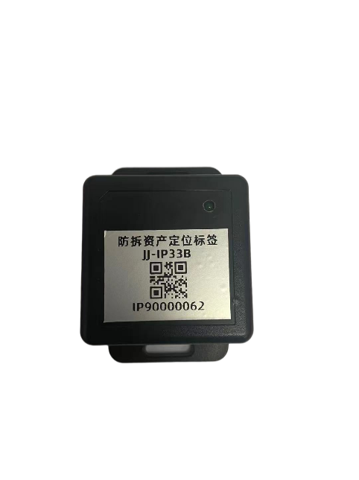

Product Appearance
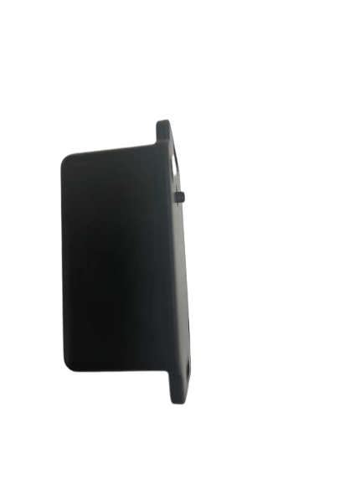

Chapter 2 JJ-IP32BL Dual Mode Asset Tag Specifications
Core Functions and Applications
Bluetooth AoA Positioning and Long Range LoRa Backhaul
Function: Bluetooth AoA provides submeter indoor positioning, while LoRa carries location data over longer distances to the cloud in outdoor areas or large factories with low power consumption.
Application: Track assets between campus buildings: indoor warehouse positioning, outdoor LoRa data backhaul during transport, then indoor positioning after arrival at the workshop.
Active Finding with Remote LED Indication
Function: The management platform can remotely trigger the tag LED to identify an asset in mixed indoor/outdoor environments.
Application: Find a selected forklift among many vehicles in a logistics campus, or identify equipment requiring maintenance in a large workshop.
Wide Area and Obstructed Area Coverage
The source describes the LoRa module as providing reliable data uplinks in steel-structure factories and underground garages where GPS or 4G reception is weak.
Example Applications
Campuses and logistics hubs: Track and dispatch forklifts, trailers and containers across indoor and outdoor areas.
Infrastructure projects: Locate distributed generators and large equipment and trigger asset finding.
Power maintenance: Manage mobile equipment and instrument cases within substation campuses.

2.1 Electrical Specifications
Operating voltage | 3.6V
Battery specification | 1 x power-type 14505 cell
Maximum Bluetooth listening current | <6mA@3.6v
Maximum Bluetooth transmit current | <8.5mA@3.6v
Maximum LoRa transmit current | <110mA@3.6
Maximum LoRa receive current | <12mA@3.6
Sleep current | <10uA@3.6V
Operating temperature | -20℃—60℃
Operating humidity | 0 to 95%, non-condensing

2.2 Operating Frequencies
LoRa frequency | 470MHz~510MHz
Bluetooth frequency | 2.4~2.485GHz

2.3 Physical Specifications
Dimensions | 81*41*20mm
Color | White
Weight | 100g
Housing material | PC

2.4 Additional Specifications
Motion and stationary detection | Supported
Low-battery notification | Supported
Firmware update | Individual updates by phone or batch updates through a gateway

2.5 Configuration Functions
Beacon filtering | Supported
Data transmission interval | Adjustable
Motion amplitude trigger | Adjustable sensitivity
Data transmission after becoming stationary | Supported

Note: Configuration requires a phone supporting Bluetooth 4.2 or later.

2.6 Product Appearance
