Indoor Bluetooth LoRa Gateway
English Product Documentation
An indoor metal gateway combining Bluetooth and LoRa collection. The SX1301 supports eight uplink channels and one downlink channel for personnel tags and sensor data.
Jinju Intelligence (Beijing) Technology Co., Ltd. | zydc0915@gmail.com

Selection Notes
Classified as indoor according to the filename. One source heading says outdoor, but the protection rating is listed as none; no waterproof capability is claimed. LoRa does not automatically mean LoRaWAN.

JJ-IS40BL Series Bluetooth LoRa Gateway

Product Specifications
Jinju Intelligence Beijing Technology Co Ltd - Haidian Beijing
Date: 19 December 2020
Product enquiries and technical support: zydc0915@gmail.com

Revision History
Version | Changes | Author | Reviewer | Date
V1.0.0 | JJ-IS40BL |  |  | 19.04.23

Important Notices

Copyright
Copyright 2019 Jinju Intelligence Beijing Technology Co Ltd. All rights reserved.

No Warranty
No express or implied representation or warranty is made concerning this document. No liability is accepted for merchantability, fitness for a particular purpose, or indirect, special or consequential loss.

Confidentiality
This document, including its attachments, contains confidential information. The recipient acknowledges its confidential nature and may use it only for the specified purpose. It must not be disclosed to any third party.

JJ-IS40BL Outdoor Gateway

Electrical Specifications
Power supply | POE
Operating temperature | -20℃—60℃
Operating humidity | 0 to 95%, non-condensing

Technical Specifications
Main MCU | 32-bit ARM M4
Operating frequency | Bluetooth: 2.4 GHz; LoRa: 480 MHz
Transmit power | Bluetooth: 8 dBm; LoRa: 25 dBm
Protocol | Bluetooth 5.0; LoRa
Receiver sensitivity | BLE:<-101dBm LORA: <-138dBm
Transmission range* | BLE：300m ； LORA：1Km
Device capacity | BLE: More than 100 nodes scanned per second; LoRa: More than 20 nodes scanned per second
Encryption | AES encryption supported
LoRa channels | 8 uplink channels and 1 downlink channel
LoRa data rate | 0~37.5kbps
LoRa controller | Sx1301

Note: Transmission range is specified for line-of-sight conditions.

Physical Specifications
Dimensions | Mounting ears folded: 185 x 140 x 30 mm; extended: 210 x 140 x 30 mm. Antenna height: 230 mm.
Color | Black
Weight | 600g
Material | Sheet metal
Ingress protection | None

Additional Specifications
Network connection | 10/100 Mbps LAN port
Network addressing | DHCP or static IP
Network transport | UDP
Antenna | External magnetic-base antenna
Antenna connector | SMA

Configuration Functions
Destination IP | Domain name or IP address supported
Over-the-air update | OTA supported
Configuration method | Bluetooth mini program or ACServer

Bluetooth antenna connector | SMA connector

Antenna connector

Product Appearance
Front
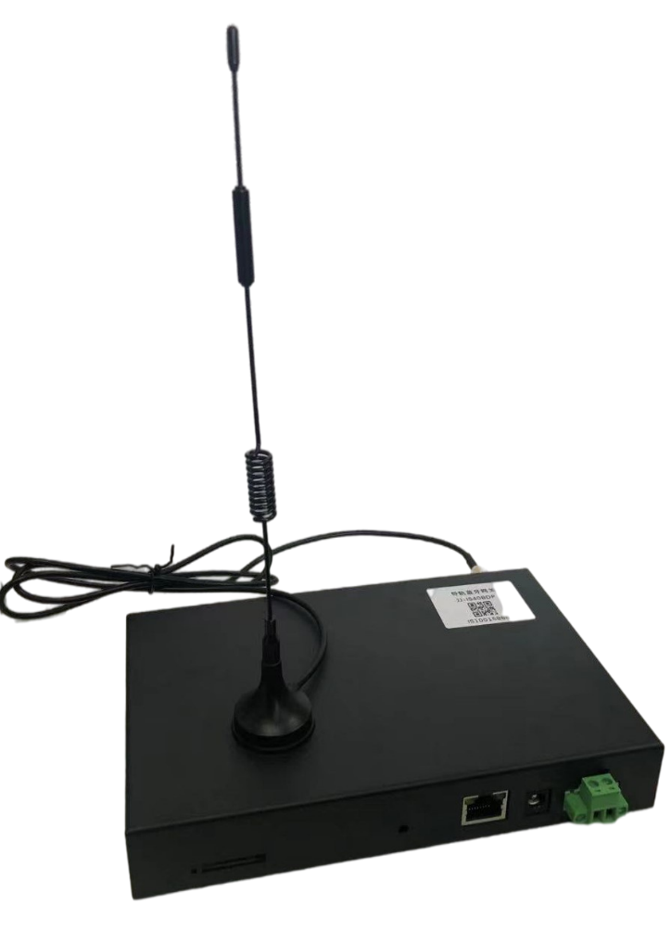
Rear
