Indoor UWB Positioning Station
English Product Documentation
A Bluetooth and UWB station for factories, healthcare and offices, with support for two-dimensional systems and deployment in three-dimensional warehouse applications. Ceiling installation and PoE simplify cabling.
Jinju Intelligence (Beijing) Technology Co., Ltd. | zydc0915@gmail.com

Selection Notes
The source describes accuracy both as down to 30cm and greater than 30cm, so no guaranteed accuracy is stated here. Confirm frequency, channel and TDoA/PDoA firmware support.
JJ-U Indoor UWB Positioning Station
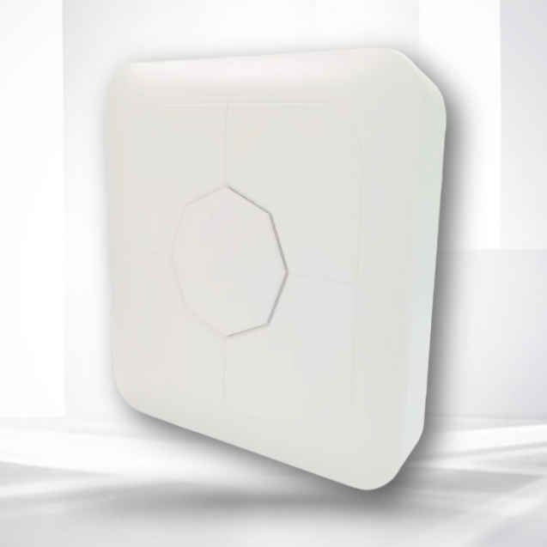

1.1 Product Description
The UWB station supports two- and three-dimensional IoT positioning applications, half-duplex and full-duplex communication, and 10/100 Mbps Ethernet connectivity to a cloud server. Integrated Bluetooth and UWB baseband chips provide UWB data transfer, planar positioning and ranging. Bluetooth/UWB dual-mode communication serves healthcare, factories and offices in 2D applications, and warehousing and logistics in 3D applications.

1.2 Product Features
Supports 2D positioning and cascaded gateways to reduce installation cost. The overview specifies accuracy down to 30 cm and describes improved accuracy and stability relative to Wi-Fi and Bluetooth positioning.
Maintenance: Phone mini-program configuration and centralized AC management.
Installation: Ceiling mounting reduces installation complexity and cost.
Power: Standard 48 V PoE carries power and return data over Ethernet, reducing cabling requirements.

1.3 Electrical Specifications
Power supply | POE48V
Operating temperature | -20℃—70℃
Operating humidity | 0 to 95%, non-condensing
Power consumption | Less than 3 W

1.4 Technical Specifications
Main MCU | 32-bit ARM M4
Operating frequency | BLE：2.4GHz；UWB：6.0 to 6.5 GHz
Transmit power | BLE：8dBm UWB：-10dBm
Protocol | BLE5.0 802.15.4
Receiver sensitivity | BLE:<-101dBm UWB: <-110dBm
Transmission range* | BLE：200m ； UWB：40m
Encryption | AES encryption supported
UWB channels | 5, 9
UWB data rates | 850 kbps, 6.8 Mbps
Coverage radius | Greater than 30 m
Ranging accuracy | Greater than 30 cm

Note: Transmission range is specified for line-of-sight conditions.

1.5 Physical Specifications
Dimensions | 230*230*40mm
Color | White
Weight | 500g
Material | ABS

1.6 Additional Specifications
Network connection | 10/100 Mbps LAN port
Network addressing | DHCP or static IP
Network transport | UDP
Antenna | Internal antenna matrix

1.7 Configuration Functions
Destination IP | Domain name or IP address supported
Over-the-air update | OTA supported
Configuration method | Bluetooth mini program or AC

Network interface | RG-45 port (source designation)

1.8 Interfaces

1.9 Operating Environment
1. Mount securely and horizontally on a ceiling where there is no significant movement, shock or vibration.
2. The environment must contain no gas or vapor that could damage the insulation or protective structure.
3. Use in a non-corrosive environment.
1.10 Packing List
Accessory | JJ-U
Accessory | UWB positioning station
Main unit | 1 unit
Certificate of conformity | 1 copy
Mounting screws and nuts | 1 set
Mounting backplate | 1 piece

