Outdoor AoA Positioning Gateway
English Product Documentation
An on-board antenna array and IP67 enclosure bring Bluetooth direction finding to campuses and semi-open spaces. PoE or DC power and Ethernet backhaul simplify network integration.
Jinju Intelligence (Beijing) Technology Co., Ltd. | zydc0915@gmail.com

Selection Notes
The file is named JJ-IS40BXPAO; its body also uses JJ-IS40BAXPO. Confirm the full model code when ordering.

JJ-IS40BXPA Bluetooth Gateway

Product Specifications
Jinju Intelligence Beijing Technology Co Ltd - Haidian Beijing
Date: 19 December 2022
Product enquiries and technical support: zydc0915@gmail.com

Revision History
Version | Changes | Author | Reviewer | Date
V1.0.6 | Added JJ-IS40BXPA | LH |  | 23.05.18

Important Notices

Copyright
Copyright 2019 Jinju Intelligence Beijing Technology Co Ltd. All rights reserved.

No Warranty
No express or implied representation or warranty is made concerning this document. No liability is accepted for merchantability, fitness for a particular purpose, or indirect, special or consequential loss.

Confidentiality
This document, including its attachments, contains confidential information. The recipient acknowledges its confidential nature and may use it only for the specified purpose. It must not be disclosed to any third party.

Chapter 1 JJ-IS40BAXPO Bluetooth 5.1 AoA Outdoor Gateway

1.1 Electrical Specifications
Item | Specification
Power supply | PoE or DC 5 V / 1 A
Rated power | 3W
Operating temperature | -45℃—60℃
Operating humidity | 0 to 95%, non-condensing

1.2 Technical Specifications
Item | Specification
Main MCU | Dual-core ARM M4F at 64 MHz
Flash | 1MB+512KB
RAM | 256KB+128B
Frequency | 2.4Ghz
Protocol | Bluetooth 5.1, 4.0 and 4.2
Data rate | 250 Kbps, 1 Mbps and 2 Mbps supported
Transmit power | 10dBm；
Receiver sensitivity | >-95dBm
Encryption | Hardware AES encryption supported

1.3 Physical Specifications
Item | Specification
Dimensions | 280*280*100mm
Color | White
Weight | 2300g
Housing material | ABS
Water resistance | IP67

1.4 Additional Specifications
Network connection | 10/100 Mbps LAN port
Network addressing | DHCP or static IP
Network transport | UDP
Antenna | On-board antenna array

1.5 Configuration Functions
Destination IP | Domain name or IP address supported
Over-the-air update | OTA supported
Configuration method | WeChat mini program or ACServer

1.6 Bluetooth Functions
AoA coverage | Circular coverage with radius 1.5 times the installation height
AoA accuracy | Within 1 m in unobstructed conditions
Bluetooth 5.1 support | Yes
Positioning with earlier Bluetooth versions | Yes
Bluetooth data transmission support | Yes

1.7 Product Appearance
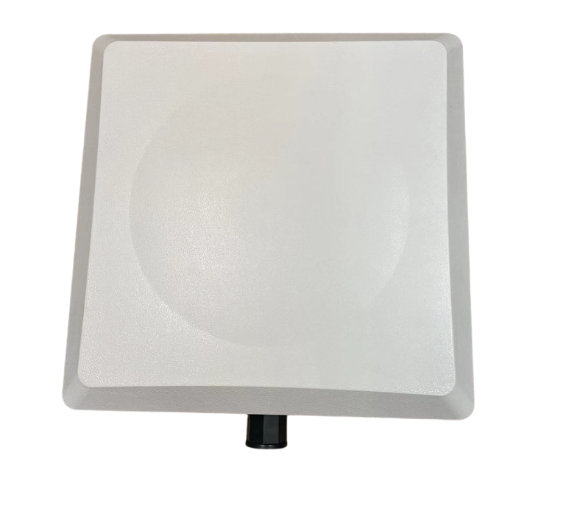
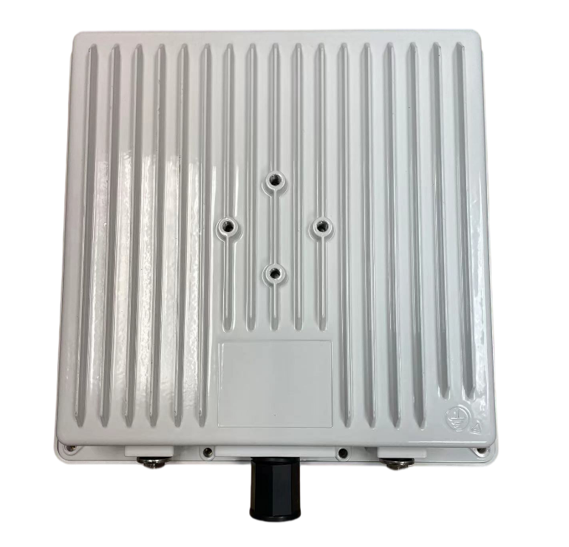

1.8 Packaging Specifications
Samples: One unit per carton with cardboard and EPE foam. Bulk orders: Six bagged units per carton.

1.9 Product Logo
Neutral packaging by default; custom logos available.
1.10 Accessories
Power adapter not included by default; purchase separately.

