Bluetooth Ceiling Gateway
English Product Documentation
An indoor Bluetooth 5.0 gateway with an on-board omnidirectional antenna and Long Range support. Collect Bluetooth broadcasts and positioning data through a ceiling- or wall-mounted network device.
Jinju Intelligence (Beijing) Technology Co., Ltd. | zydc0915@gmail.com
Figures retain the original hardware labels and software interface. The accompanying English instructions identify the controls and installation steps.

Selection Notes
This model is not waterproof. A Bluetooth 5.0 broadcast gateway is not an AoA array gateway.
JJ-IS40BXP Ceiling Gateway Specifications and Installation Manual

1 Product Specifications

1.1 Electrical Specifications
Item | Specification
Rated power | 3W
Power supply | Standard PoE PD (IEEE 802.3af) or DC 5 V / 1 A
Operating temperature | -20℃—60℃
Operating humidity | 0 to 90%, non-condensing

1.2 Technical Specifications
Item | Specification
Main MCU | ARM M4 64MHz
Flash | 1M
RAM | 256kB
Frequency | 2.4Ghz
Protocol | Bluetooth 5.0 with Long Range support
Data rate | 250Kbps、1Mbps、2Mbps
Transmit power | 10dBm
Receiver sensitivity | >-104dBm
Encryption | Hardware AES encryption supported

1.3 Physical Specifications
Item | Specification
Dimensions | 190*190*40mm
Color | White
Weight | 300g
Housing material | ABS

1.4 Additional Specifications
Network connection | 10/100 Mbps LAN port
Network addressing | DHCP or static IP
Network transport | UDP
Antenna | On-board omnidirectional antenna

1.4 Configuration Functions
Destination IP | Domain name or IP address supported
Over-the-air update | OTA supported
Configuration method | WeChat mini program or ACServer, the company's in-house management software provided free of charge

2 Operating Environment
1. Altitude must not exceed 2000 m.
2. Mount securely where there is no significant movement, shock or vibration.
3. The environment must contain no harmful gas or vapor.
4. Use in a non-corrosive environment.

3 Packing List
1. One main unit with a white ABS housing.
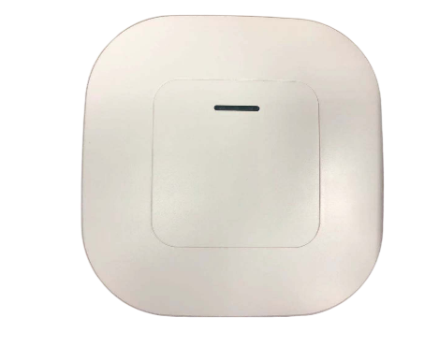
2. One screw pack: Three M3 x 25 screws and three M3 wing nuts.
For ceiling mounting only. Supply suitable fasteners separately for wall mounting.
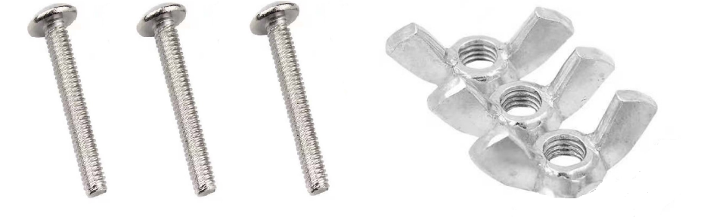
3. One installation manual.

4 Installation

4.1 Removable Ceiling Mounting
1. Mark the holes. Remove the selected ceiling tile and center the mounting bracket on it. Mark the bracket's three fixing holes. Following the Ethernet-port direction on the bracket, mark a 10 mm cable hole within the shaded area shown in the figure.
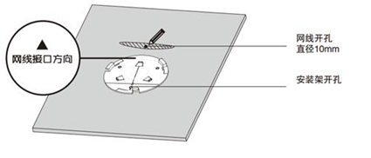
Ceiling template: Ethernet-port direction; 10 mm cable opening; mounting-bracket screw holes.
2. Drill three 2.5 mm screw holes and one 10 mm Ethernet-cable hole at the marked positions.
3. Secure the bracket to the removed ceiling tile using the M3 screws and nuts as shown.
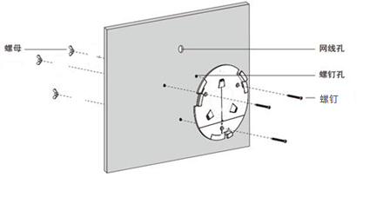
Ceiling fixing: nuts on the opposite side of the tile; Ethernet cable hole; screw holes; M3 screws.
4. Pass the Ethernet cable through the opening, reinstall the ceiling tile and terminate the connector. Alternatively, enlarge the opening to pass a pre-terminated cable through it.
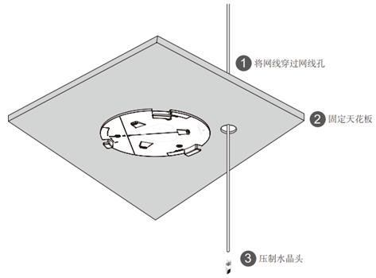
Sequence: 1 pass the cable through the opening; 2 reinstall the ceiling tile; 3 terminate the Ethernet plug.
5. Connect the Ethernet cable to the gateway PoE/LAN port. A green indicator shows correct power-up. Fit the gateway into the bracket. The three retaining tabs have different sizes, so only one alignment is correct.
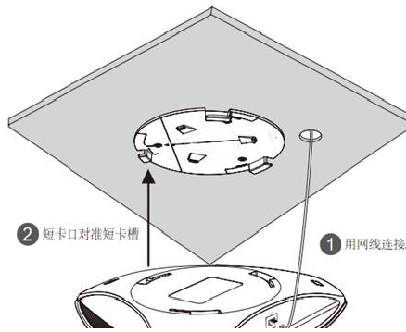
Connection: 1 connect Ethernet; 2 align the large, medium and small retaining tabs before inserting the gateway.
6. Rotate the gateway clockwise until it clicks securely into place.
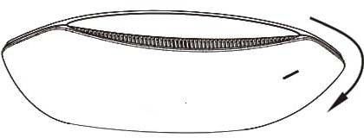
Rotate clockwise until the mounting tabs lock.

4.2 Wall Mounting
1. Place the bracket against the selected wall, aligning the Ethernet-port direction with the cable route. Mark its three fixing holes and drill three 2.5 mm holes.
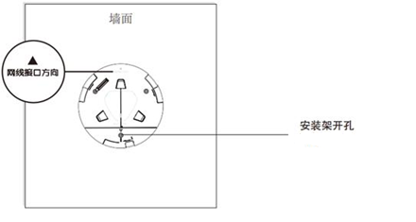
Wall template: wall surface; Ethernet-port direction; bracket fixing holes.
2. Secure the bracket using plastic wall plugs and M3 self-tapping screws.
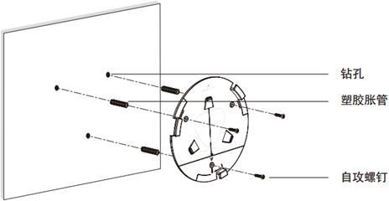
Wall fixing: drilled holes; plastic wall plugs; self-tapping screws.
3. Insert the Ethernet cable into the gateway PoE/LAN port; the source labels this port POE/ANC.
4. Fit the gateway into the bracket. Its large, medium and small retaining tabs allow only one correct alignment.
5. Rotate the gateway clockwise until it clicks securely into place.

5 Wiring
1. PoE power: Connect the powered Ethernet cable to PoE/LAN. One power indicator should illuminate. A flashing orange Ethernet indicator shows network activity.
2. DC power: Connect the DC plug to the 5 V / 1 A socket. Two power indicators should illuminate. A flashing orange Ethernet indicator shows network activity.
Orange Ethernet indicator
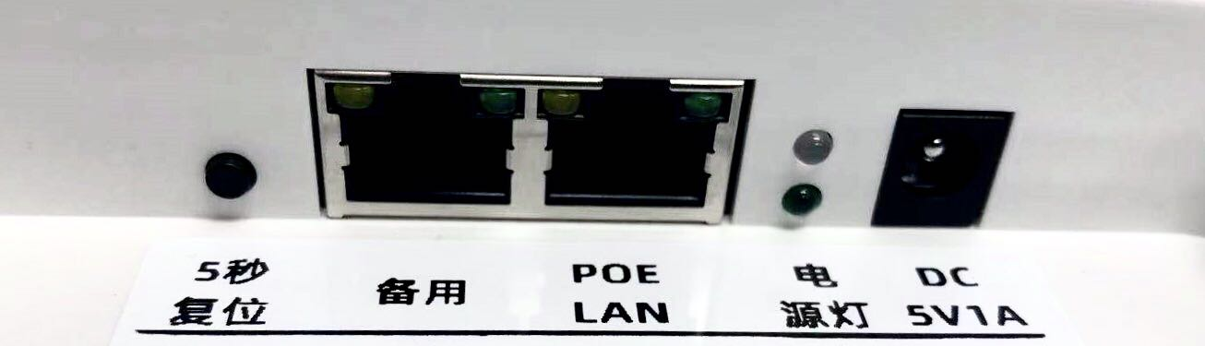
Ports from left to right: reset button (hold 5 seconds), spare Ethernet port, PoE/LAN port, power/status indicators, DC 5 V / 1 A input. The orange Ethernet LED indicates network activity.

6 Additional Precautions
1. This gateway is not waterproof. Contact the supplier for waterproof or explosion-protected models.
2. Horizontal ceiling installation provides the best performance. Vertical wall mounting may reduce performance.
3. The internal omnidirectional antenna permits any azimuth orientation when mounted horizontally.
4. Before ceiling installation, verify the load capacity and material strength of the ceiling.
5. Record the device ID at each installation point for maintenance and management.

