Expandable Bluetooth Gateway
English Product Documentation
A general-purpose gateway for broadcast collection, downlink broadcasts and bidirectional connections. Compatible expansion cards and firmware can add LoRa, Zigbee, 4G Cat.1 or RFID connectivity.
Jinju Intelligence (Beijing) Technology Co., Ltd. | zydc0915@gmail.com
Figures retain the original hardware labels and software interface. The accompanying English instructions identify the controls and installation steps.

Selection Notes
Expansion modules are optional and require matching hardware and firmware. No ingress protection rating is specified.
JJ-IS40B Series Bluetooth Gateway User Manual
Jinju Intelligence Beijing Technology Co Ltd - Haidian Beijing
Date: 19 December 2020
Product enquiries and technical support: zydc0915@gmail.com

Revision History
Version | Changes | Author | Reviewer | Date
V1.0.0 | Product release |  |  | 19.10.22

Important Notices

Copyright
Copyright 2019 Jinju Intelligence Beijing Technology Co Ltd. All rights reserved.

No Warranty
No express or implied representation or warranty is made concerning this document. No liability is accepted for merchantability, fitness for a particular purpose, or indirect, special or consequential loss.

Confidentiality
This document, including its attachments, contains confidential information. The recipient acknowledges its confidential nature and may use it only for the specified purpose. It must not be disclosed to any third party.

Product Overview

Product Background
The JJ-IS40B series uses Bluetooth 5.0 and is designed for indoor positioning, medical equipment, industrial controls, access locks, parking locks and industrial IoT data links. It provides AES-128 encryption with optional customized hardware encryption, compatibility with standard Bluetooth 4.2 and later devices, concurrent connections, low power consumption and long range. Applications include meter-level indoor positioning, asset monitoring, personnel check-in and IoT device monitoring.

Product Introduction
This general-purpose gateway uses a 32-bit ARM M4 processor. It collects Bluetooth broadcasts, transmits broadcasts such as time synchronization and data, and supports bidirectional connections to Bluetooth devices. Configuration, centralized management and data exchange are designed for Bluetooth IoT integration.

Using the Product
Configure the gateway using a WeChat mini program with Bluetooth 4.2 or later. Check the phone's supported Bluetooth version and enable Bluetooth before testing.

Connecting the Device
Open the package and check the equipment inventory.
Connect the power adapter.
For PoE, correctly connect the power-sourcing equipment first, then plug in the Ethernet cable.

Parameter Configuration
Configure through the WeChat mini program Jinju Toolbox or ACServer. Initial ACServer configuration requires the gateway and server to be on the same DHCP-enabled LAN.

WeChat Mini Program Configuration
Check that the gateway is powered and the Ethernet cable is connected. Without the cable, the mini program reads all addresses as 0.0.0.0 and the gateway cannot be configured, as shown below.
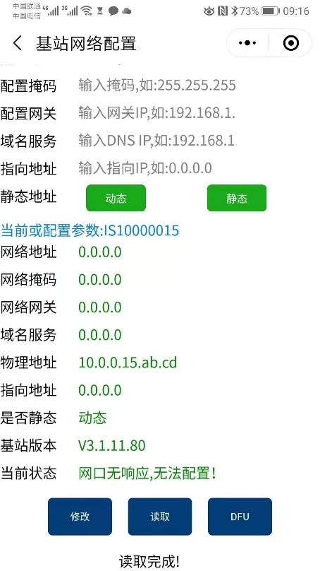
Connect the Ethernet cable before configuring the gateway.
If connected directly to a computer or a network without DHCP, wait approximately one minute for the gateway to enter its default static-IP mode on the 192.168.1 subnet.
In WeChat, find the Jinju Toolbox mini program. Original screenshots show the Chinese-language tool.
Open the mini program, which the source says requires no registration, then select Station Configuration.
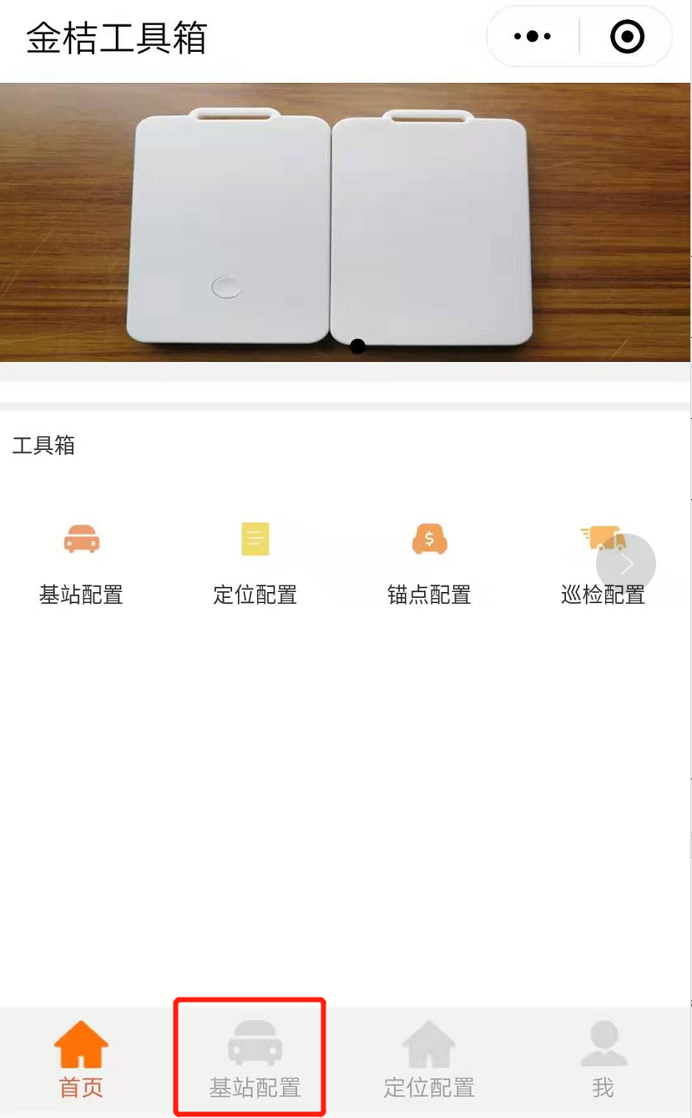
Select the gateway, then choose Parameter Configuration.
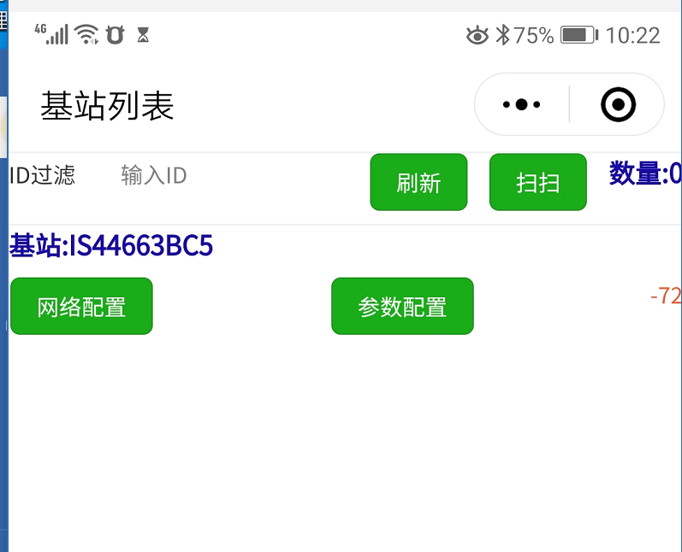
The list contains all gateways detected by the phone's Bluetooth scan. Select the intended device.
Network Configuration controls network settings; Parameter Configuration controls Bluetooth settings.
Select Read to retrieve gateway parameters. If the display does not update, pull down to refresh.
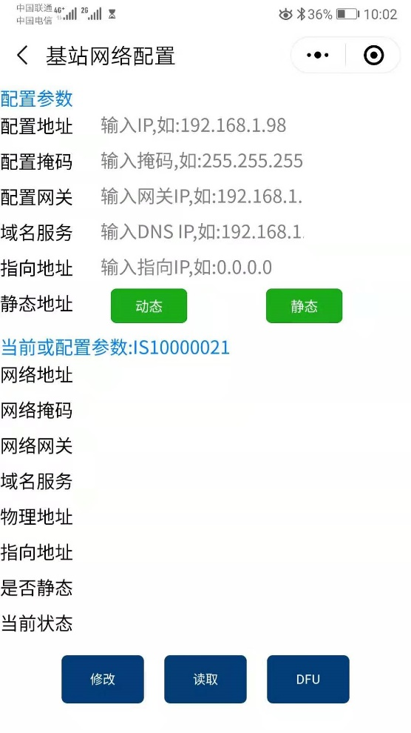
Some Android phones may fail on the first read. Select Read again if this occurs.
Enter the configuration values.
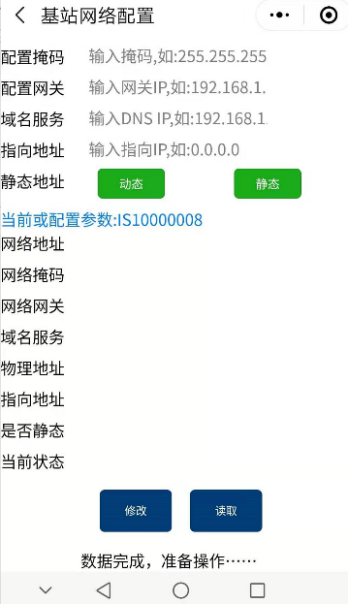
Fill in every parameter for both DHCP and static-IP modes. When targeting the local computer, enter its IP address or 0.0.0.0 as the destination.
The mini program does not support domain-name destinations. Use ACServer for this function.

ACServer Configuration
1. Start ACServer and open its login page.
http://127.0.0.1:8888/v/user/login.html
Username: admin. Password: 123.
2. Change the destination IP.
Set Local IP to the address of the computer running ACServer.
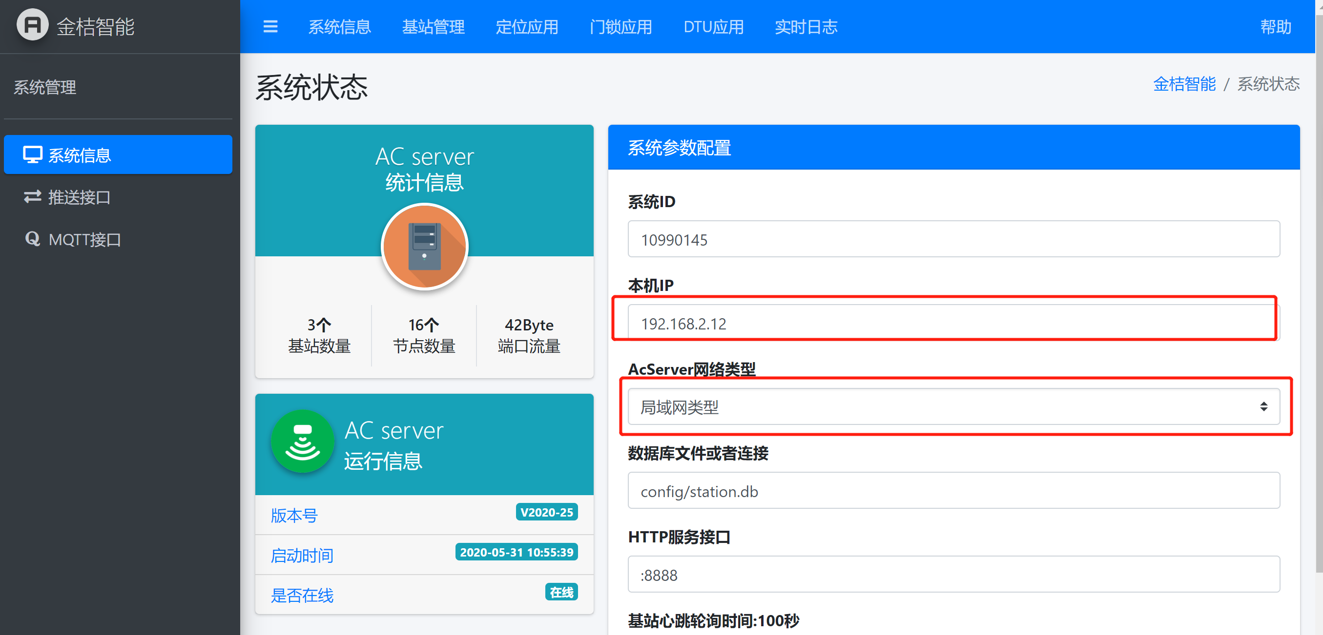
Open Station Management.
Select Station Configuration.
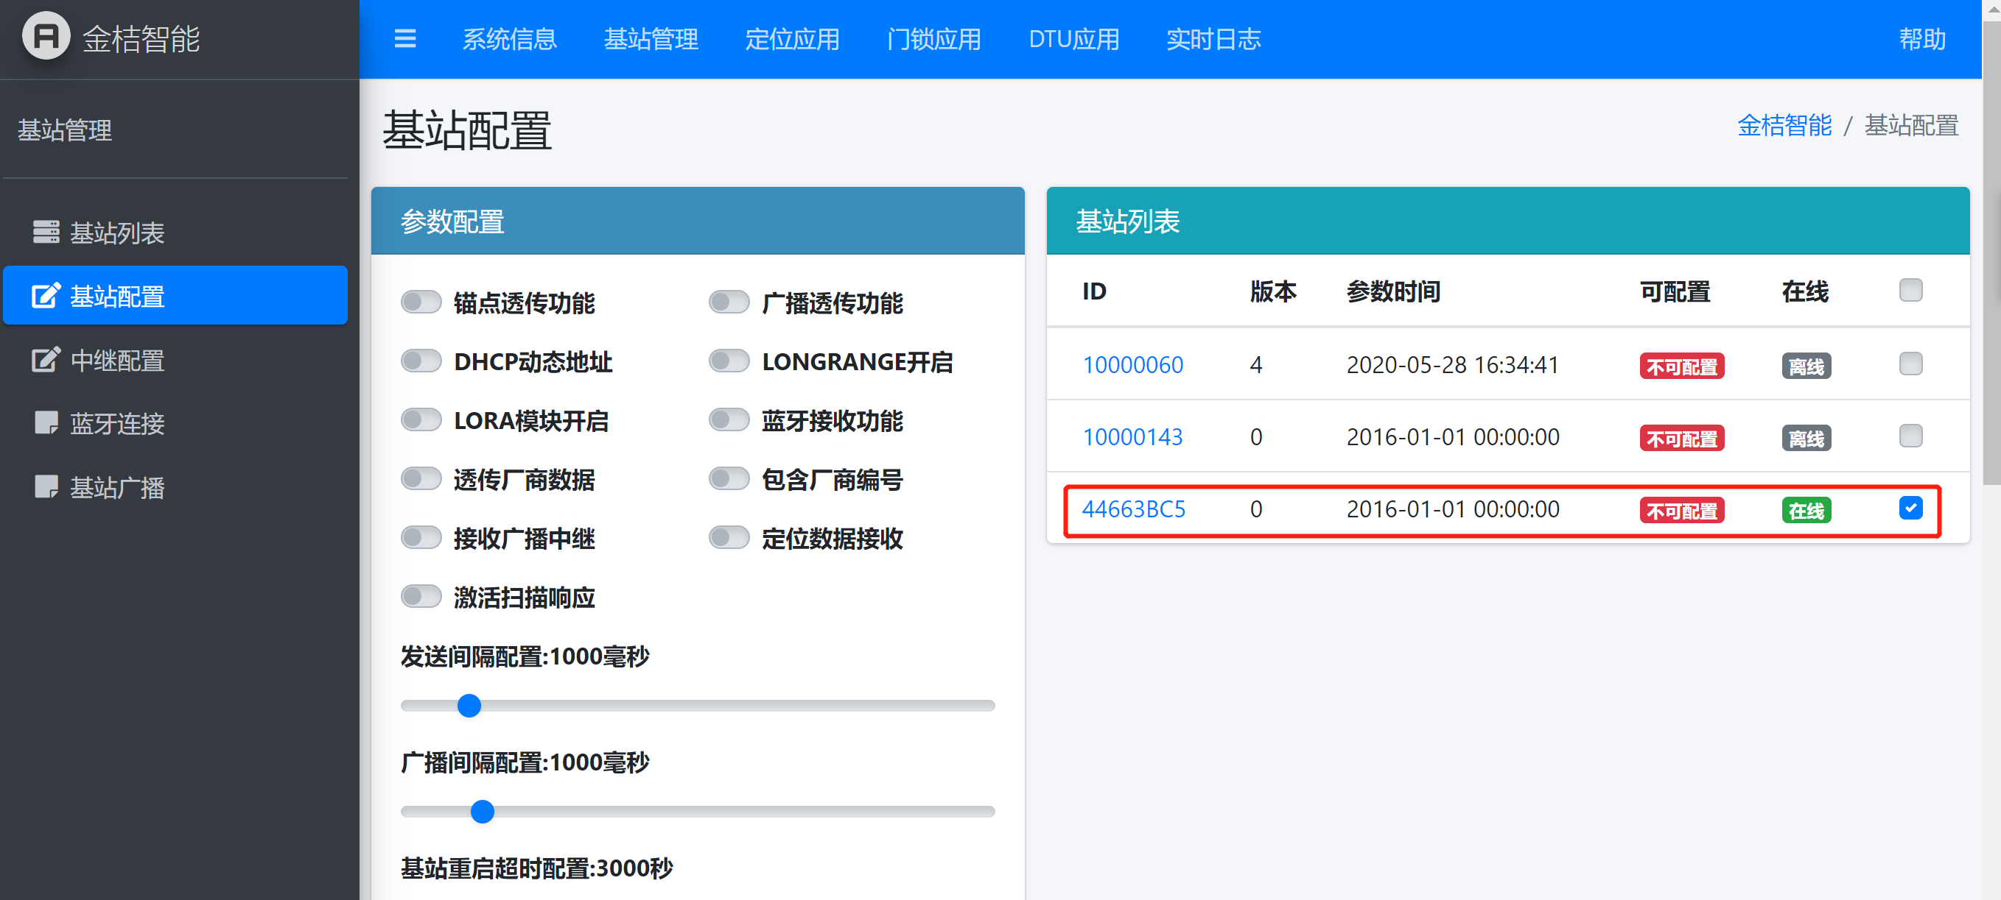
If configuration is disabled, read the station parameters first to enable editing.
Important: Confirm that the gateway and ACServer configuration versions match. An ACServer version older than the gateway version may cause gateway software faults. Confirm compatibility with the manufacturer before configuration.

Configuration Reference
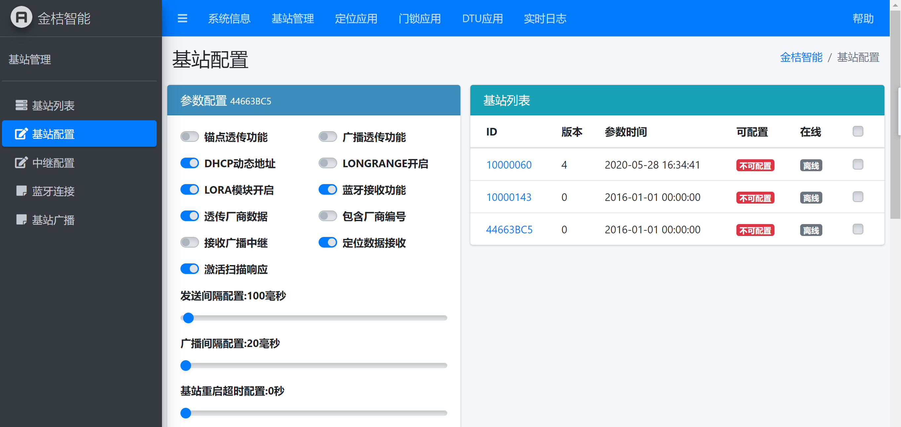
Anchor pass-through: Receive and report positioning-anchor, beacon and iBeacon data.
Broadcast pass-through: Receive manufacturer broadcasts and upload them to the server.
DHCP: If disabled, configure a static address.
Enable Long Range: Activate Bluetooth 5.0 Long Range mode.
Enable LoRa module: Keep disabled if the gateway has no LoRa module.
Bluetooth reception: Must be enabled to receive Bluetooth data.
Manufacturer-data pass-through: Forward only manufacturer-specific broadcast data.
Include manufacturer ID: Include the manufacturer identifier in forwarded data.
Receive relay broadcasts: Enable when receiving data from relay devices.
Receive positioning data: Enable for Jinju personnel badges, asset tags and related positioning devices.
Active scan response: Enable if the terminal requires scan responses. Otherwise, enabling this may introduce irrelevant data.
Send interval: Interval for forwarding collected data to the server. Recommended: 2000 ms.
Broadcast interval: Gateway Bluetooth broadcast interval. Recommended: 100 to 500 ms; an excessive interval can prevent device discovery.
Station restart timeout: Automatically restart if the station cannot connect to the server. Recommended: More than 300 seconds.
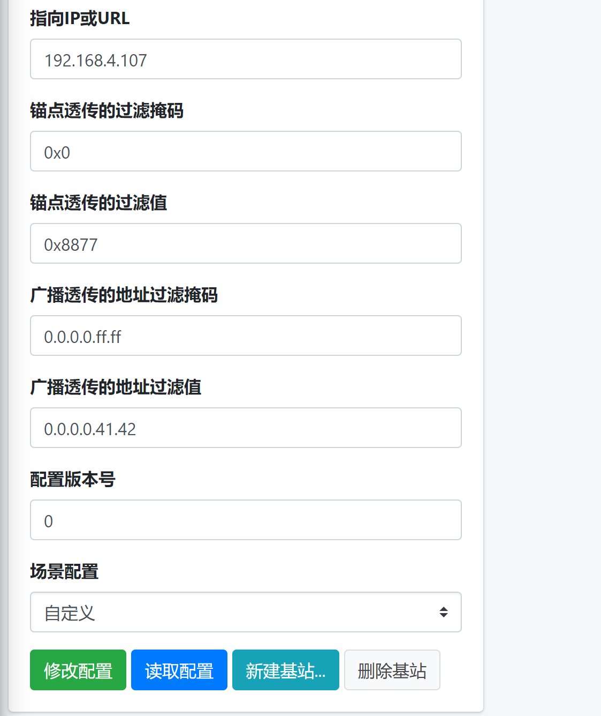
Destination IP or URL: The gateway server destination supports domain names; an IP address is recommended.
Anchor pass-through filter mask: Filter positioning anchors and beacons using the MAJOR mask.
Broadcast pass-through address mask: Filter by device MAC address. Setting the entire mask to zero prevents mini-program configuration.
Configuration version: Current gateway configuration version.
Scenario presets: Use a preset if the individual parameters are unfamiliar.
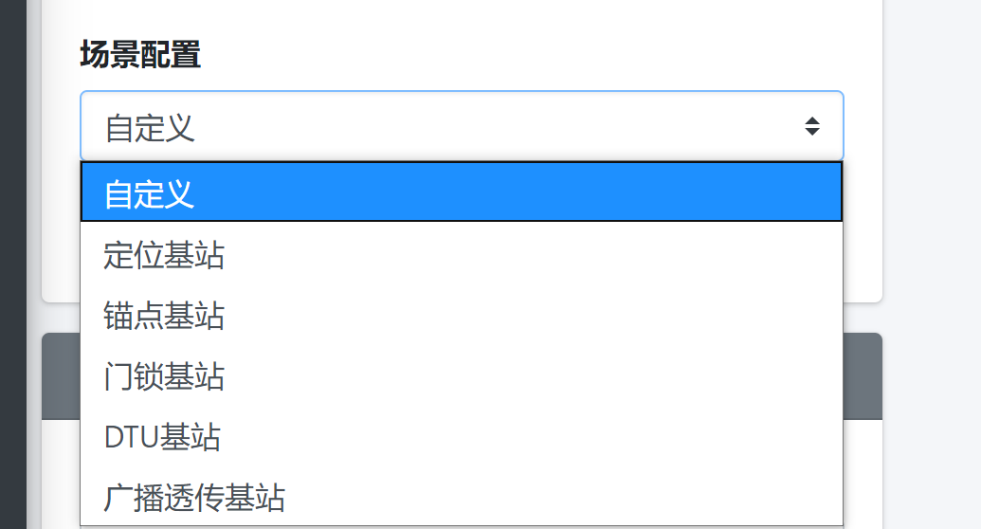
Custom: Advanced users configure the parameters manually.
Positioning station: Preset for Jinju positioning products.
Anchor station: For gateway-based positioning or collecting anchor and iBeacon data.
Door-lock station: For Jinju smart door locks.
DTU station: For Jinju Bluetooth DTUs.
Broadcast pass-through station: For receiving broadcasts from other vendors' devices.
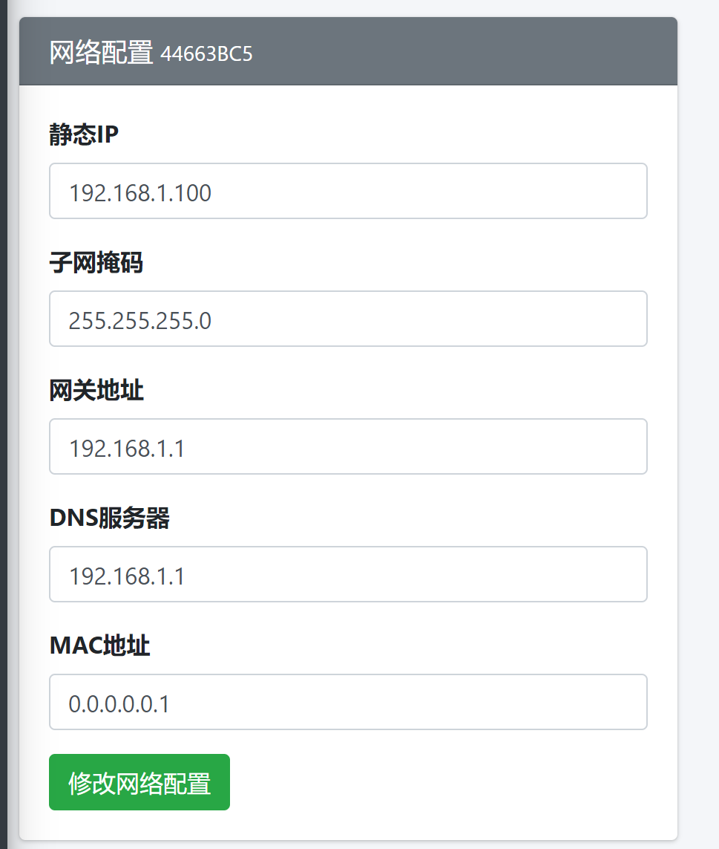
Network configuration can be applied to only one gateway at a time.
Do not duplicate MAC addresses within the same network; retain the manufacturer's defaults where appropriate.
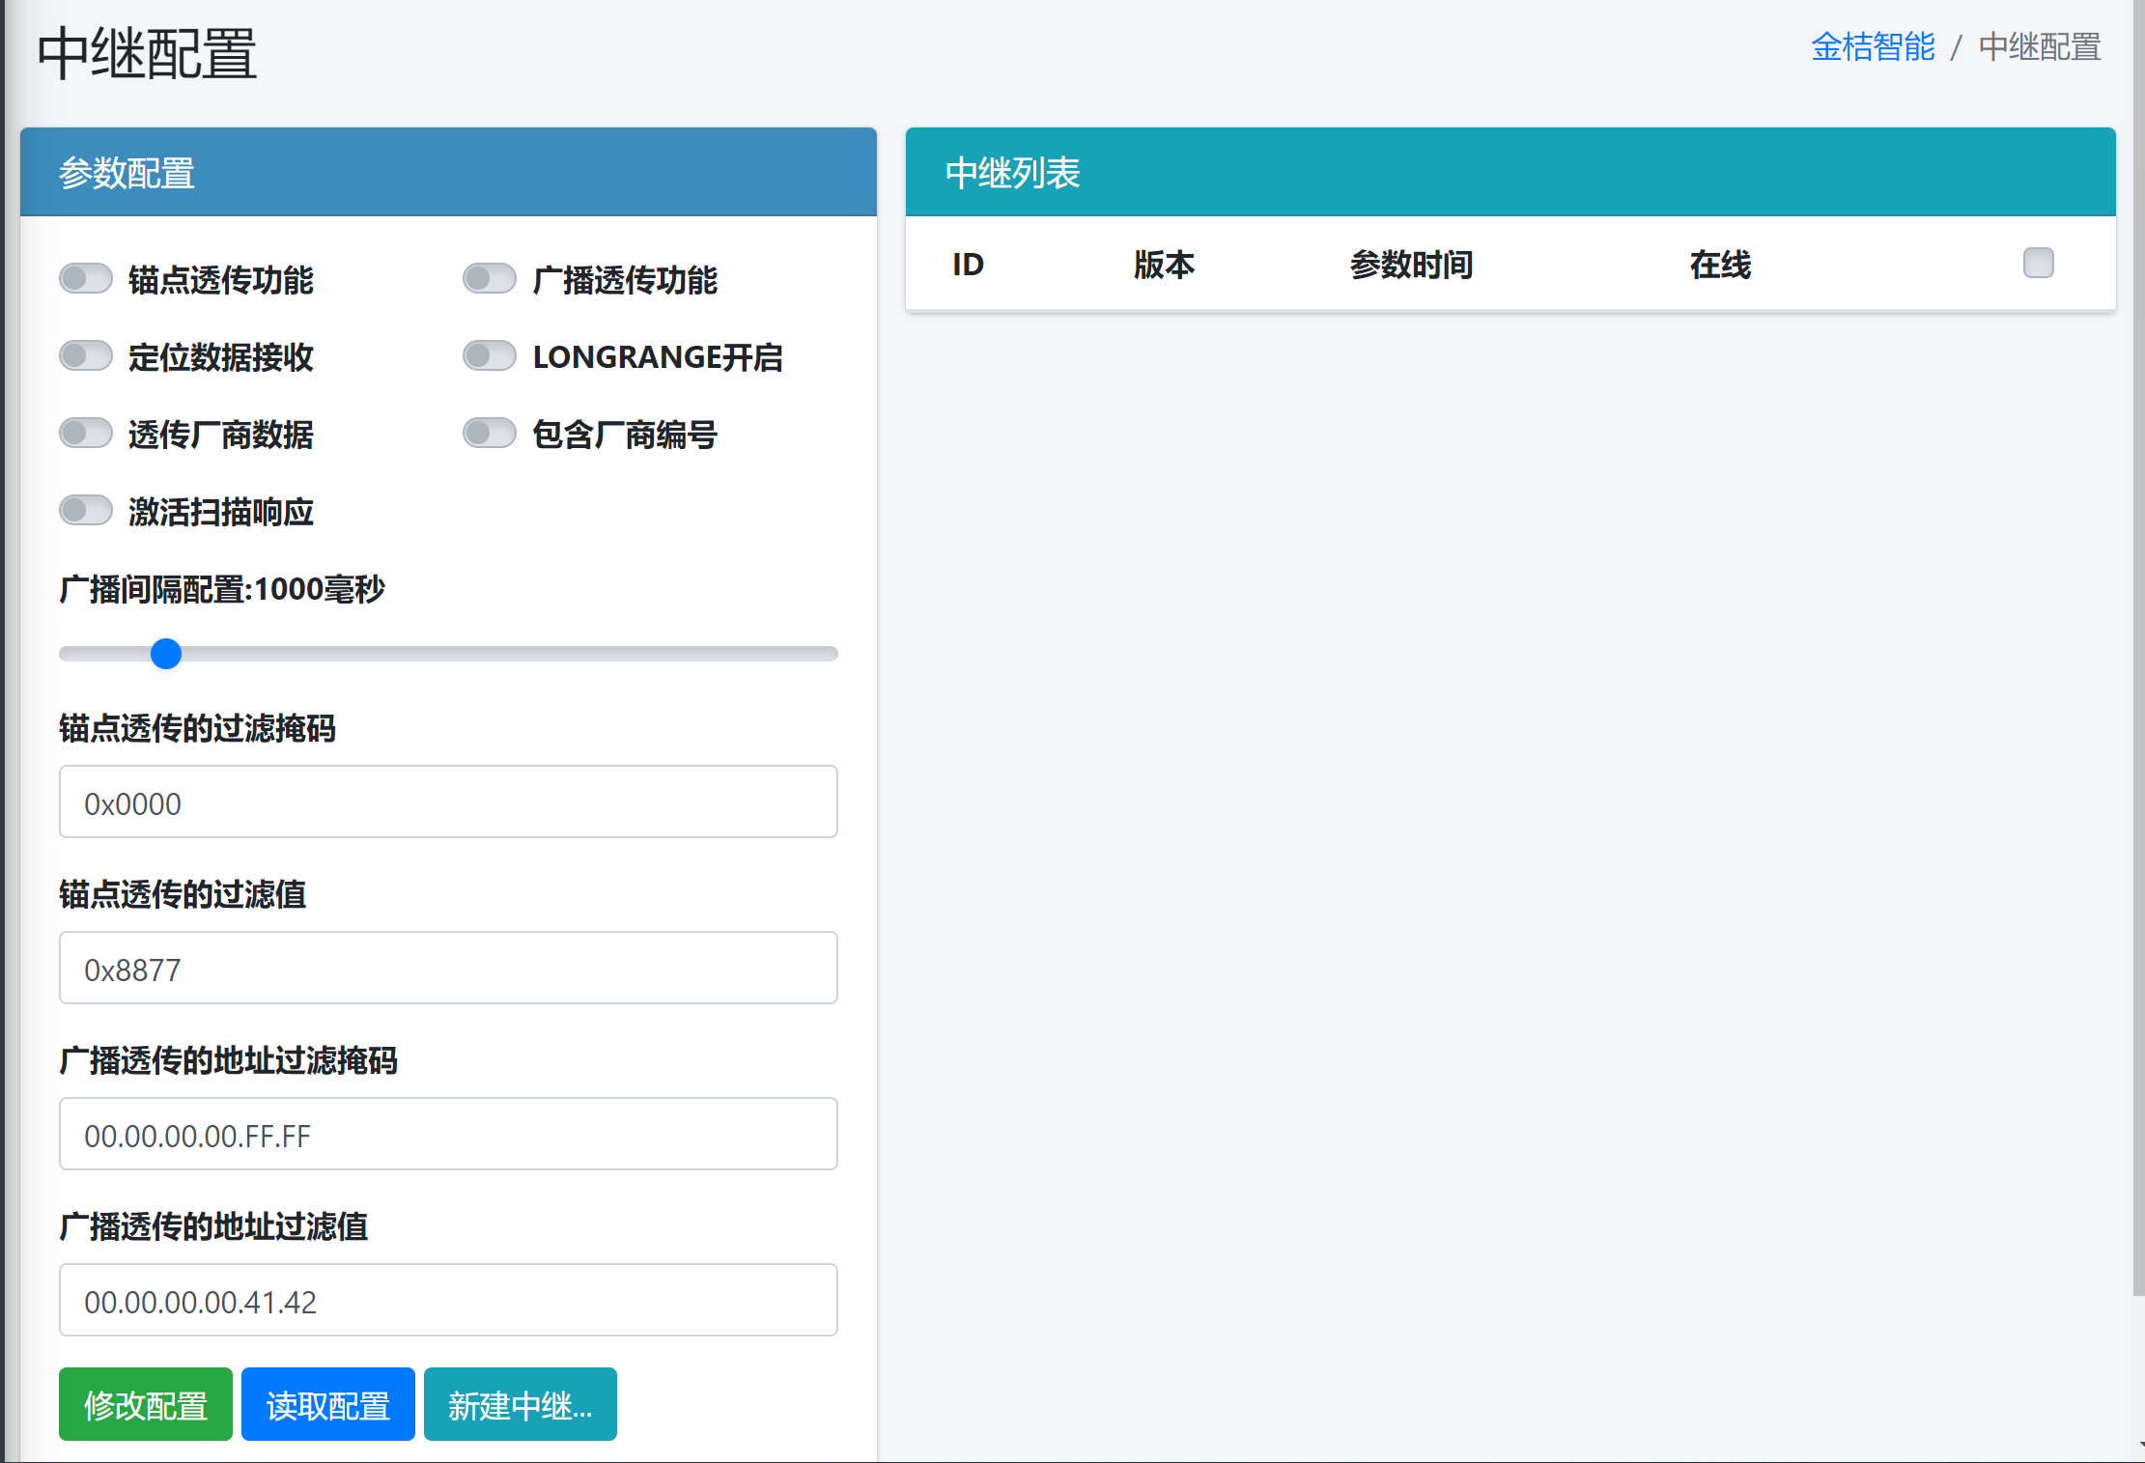
Relay-mode parameters follow the same business logic as gateway parameters.
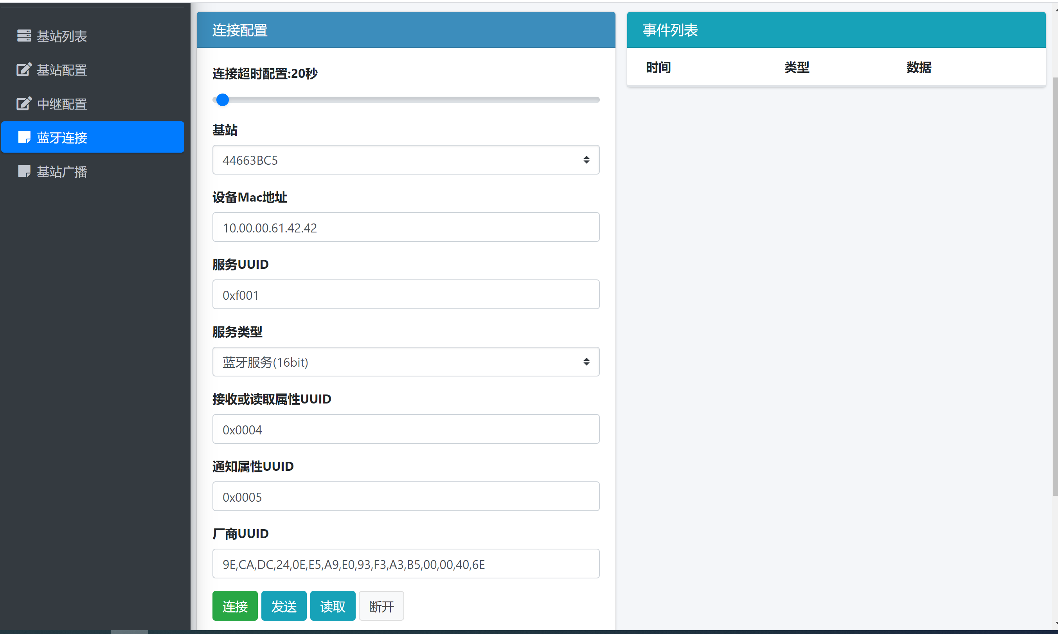
Parameters required when connecting the gateway to terminal devices.

Station Broadcasts
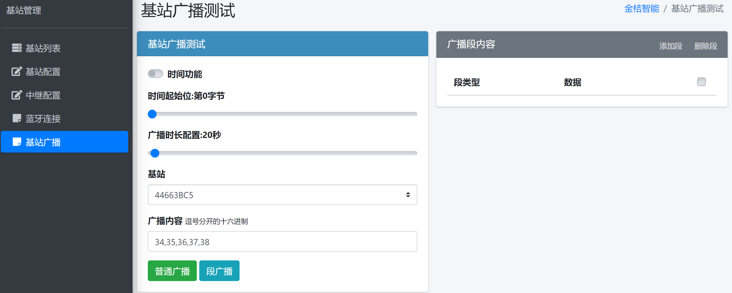
Station broadcasts include time synchronization, normal broadcasts and segmented broadcasts.
For segmented broadcasts, the custom content value must be greater than 0x3E.
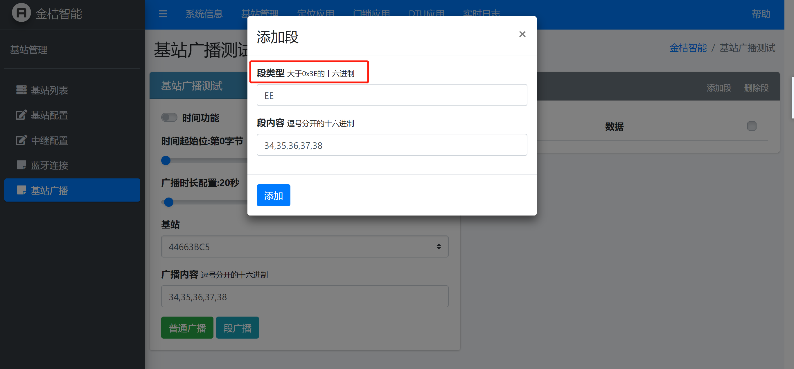

Ports
Default Bluetooth gateway ports
Inbound: UDP 10352
Outbound: UDP 10604
Port changes are an advanced function intended for users with development expertise. Contact the manufacturer if required.
.

Expansion Cards
Expansion cards add functions such as LoRa, Zigbee and RFID device access, using SPI or the UART signals on the PCI-E-style connector.

Function Overview
The gateway supports multiple expansion protocols. A standard PCI-E-style edge connector provides the physical connection, carrying SPI and UART hardware buses and control signals directly.
Installing an expansion card and switching its OTA firmware adds IoT communication links, combining BLE with long-range or heterogeneous networks for edge processing and data exchange.
Supported Expansion Cards and Applications
The following four module types use the physical PCI-E slot, with their corresponding underlying buses for communication with the gateway mainboard.
LoRa Expansion Card Using SPI
Function: Low-power wireless broadcasts and node data collection over 1 to 5 km, supporting LoRa and ad-hoc pass-through networking.
Applications: Agriculture, factory energy management and distributed pipeline monitoring. The gateway aggregates local BLE sensor data and sends it over LoRa to a base station.
Interface: SPI synchronous communication with BUSY/NSS control pins. The source describes this arrangement as preventing RF packet loss.
Zigbee Expansion Card Using UART
Function: Zigbee 3.0 coordinator or router, supporting mesh networking and node management.
Applications: Home and building automation and commercial lighting. A BLE/Zigbee gateway supports device-group interaction and local scenario control.
Interface: UART asynchronous serial communication with RTS/CTS hardware flow control for buffering and processing concurrent node messages.
4G Cat 1 Expansion Card Using UART
Function: Cellular access supporting the three major Chinese operators and IoT SIM cards, allowing deployment without wired Ethernet or Wi-Fi.
Applications: Outdoor mobile assets, vehicle cold-chain transport and remote equipment maintenance. BLE sensor data is sent from the gateway to the cloud over 4G.
Interface: High-baud-rate UART with AT-command processing and PWRKEY/RESET control pins, supporting power-loss detection and network recovery.
RFID Expansion Card Using SPI or UART
Function: HF/NFC or UHF tag reading and writing, with multi-tag anti-collision algorithms.
Applications: Warehouse inbound/outbound management, production-stage check-in and high-value asset theft checks.
Interface: SPI for dense UHF reading or UART for basic reading, according to reading-rate requirements.
Expansion Card Installation
Warning: The expansion slot connects directly to the mainboard buses and does not support hot plugging. Disconnect gateway power before replacing hardware.
1. Disconnect power and confirm that all indicator lights are off.
2. Install the expansion card.
Align the card with the PCI-E-style slot and insert its edge connector at approximately 30 degrees.
Press the card down gently, align the mounting holes with the mainboard standoffs and secure it using the supplied screws.
3. Connect the correct-band SMA/IPEX antenna securely to the card's RF connector. Avoid transmitting without an antenna, which can overheat the RF front end.
4. Restore power. The system enters standby or waits for OTA configuration.

4 OTA Firmware Updates and Function Switching
Each expansion-card type requires dedicated firmware. After changing a card, send its matching firmware using OTA; a wired programmer is not required to switch the gateway function.

4.1 Preparation
Obtain an OTA package matching the installed card from the official platform. Packages normally use ZIP format, for example Gateway_LoRa_Firmware_v1.2.zip or Gateway_4G_Firmware_v1.2.zip.

4.2 Wireless OTA Procedure
Each expansion card uses dedicated firmware. After replacement, use the nRF Connect smartphone app to send the matching protocol firmware by OTA without attaching a hardware programmer.

4.1 Before Updating
1. Download the matching Nordic-format OTA ZIP package from official support or the management platform, for example Gateway_LoRa_Firmware_v1.2.zip, and save it on the phone.
2. Install Nordic's nRF Connect for Mobile from the iOS or Android app store.

4.3 Updating with nRF Connect

Step 1 Scan and Connect
1. Open nRF Connect and enable Bluetooth and location permissions.
2. Select SCAN at the upper right of the home screen.
3. Find the gateway broadcasting in update mode, typically named IS********.
4. Select CONNECT to establish the BLE control link.

Step 3 Select and Send the ZIP Firmware Package
1. After connection, the app displays the Services list.
2. Select the circular DFU icon with an upward arrow at the upper right.
3. Choose Distribution packet (ZIP).
4. In the phone's file manager, select the firmware ZIP package
downloaded in preparation step 4.1 for the installed expansion card.

Step 4 Wait for the Update and Restart
1. The app checks the package signature, displays progress and transfer-rate information, and begins sending the firmware wirelessly.
Keep the phone close to the gateway during the transfer, typically 30 to 60 seconds. Do not close the app, disconnect Bluetooth or remove gateway power.
2. When DFU completed successfully appears and progress reaches 100%, the phone disconnects from the gateway automatically.
3. The gateway restarts and loads the new protocol driver. The new firmware initializes the expansion card through SPI or UART and starts the selected function.

4 Automatic Activation
At 100% progress, the gateway restarts and the new firmware initializes the installed expansion card through SPI or UART.

Specifications

Technical Specifications
Main MCU | 32-bit ARM M4
Operating frequency | 2.4GHz
Transmit power | 10dBm
Protocol | Bluetooth 5.0
Receiver sensitivity | BLE:>-104dBm
Transmission range* | BLE：300m
Encryption | AES encryption supported
Supported connections | More than 5 Bluetooth terminal connections

Physical Specifications
Dimensions | Mounting ears folded: 185 x 140 x 30 mm; extended: 210 x 140 x 30 mm. Antenna height: 230 mm.
Color | Black
Weight | 580g
Material | Sheet metal
Ingress protection | None

Additional Specifications
Network connection | 10/100 Mbps LAN port
Network addressing | DHCP or static IP
Network transport | UDP/MQTT
Antenna | External magnetic-base antenna
Antenna connector | N-type female

Product Appearance
