Dual Mode LoRaWAN Gateway
English Product Documentation
An eight-channel LoRaWAN gateway built around an SX1302 concentrator, with integrated Bluetooth and multiple backhaul protocols for low-power IoT collection.
Jinju Intelligence (Beijing) Technology Co., Ltd. | zydc0915@gmail.com

Selection Notes
4G is optional. Verify the regional frequency plan, terminal compatibility and shipping configuration for the project.
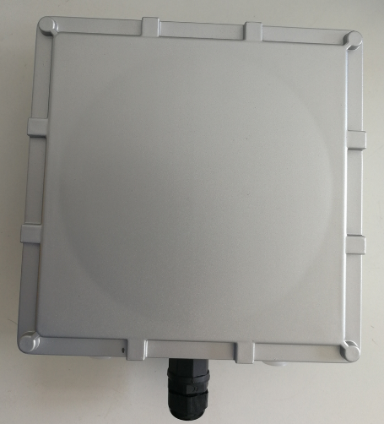

Product Description
The JJ-IS40BL outdoor gateway supports low-power wide-area IoT, half-duplex and full-duplex communication, and 10/100 Mbps Ethernet cloud connectivity. Integrated Bluetooth and SX1302 baseband processing provide eight parallel uplink channels and one downlink channel for Bluetooth and LoRa terminals.

Product Features
Full-duplex LoRa with eight receive channels and one downlink channel
Ethernet and optional 4G
UDP, TCP, MQTT, WebSocket and HTTP protocols
LoRaWAN standard protocol
LoRaWAN Class A/B/C
Transmit power up to 27 dBm and receiver sensitivity down to -142 dBm at SF12
Global LoRaWAN regional frequency plans and user-defined frequencies
Watchdog design for system stability
OTA firmware updates
Connection-recovery mechanisms designed to maintain terminal connectivity
ACServer management tools for configuration and administration
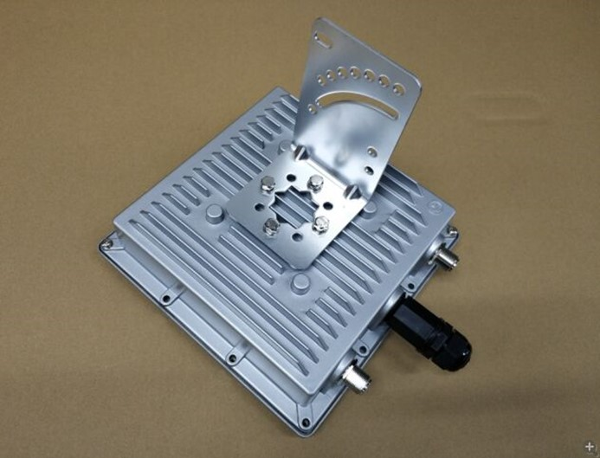

Hardware Specifications
Bluetooth: BLE 5.0
Supports Bluetooth Long Range, connections, broadcast collection and other node functions.
LoRa concentrator: Eight channels plus an independent downlink channel, with maximum transmit power of 27 dBm and receiver sensitivity down to -142 dBm.

Performance Specifications

LoRa Specifications
Parameter | Description
Output power | -1~27dBm
Input power | ＜10dBm
Bandwidth | 7.8~500kHz
Spreading factor | SF7~SF12
Receiver sensitivity | -142dBm@SF12 BW125kHz
Harmonics | ＜-40dBm @ 1GHz
Frequency range | EU868 , AS923 , AU915 , KR920 ,RU864 ,IN865,US915  Global LoRaWAN regional frequency plans
Channels | Full duplex; eight LoRa receive channels and one LoRa downlink channel

Bluetooth Specifications
Parameter | Description
Output power | -40~10dBm
Protocol | BLE 4, BLE 4.2 and BLE 5.0 supported
Data rate | Uncoded:1Mbps/2Mbps,Coded:125kbps(S=8)/500kbps(S=2)
Receiver sensitivity | <-97dBm
Coverage | >300M

Electrical Specifications
Category | Description
Power supply | DC 12 V or PoE
Current | Max . 1A
Power consumption | ＜5W

Physical Characteristics
Characteristic | Description
Dimensions | 216mm*216mm*70mm
Weight | Approximately 1.2 kg
Temperature | Operating: -20 to 70 degrees C; storage: -40 to 85 degrees C
Humidity | 5 to 95%, non-condensing

Interfaces
Category | Description
Power connector | RJ45@poe
Ethernet port | RJ45
LoRa antenna connector | N-type fiberglass antenna
Bluetooth antenna connector | N-type fiberglass antenna

