E paper Location Badge
English Product Documentation
A 2.13-inch e-paper badge with Bluetooth, LoRa and GPS/BeiDou positioning. The source also lists AIS and solar charging specifications for projects needing visible identification and personnel location.
Jinju Intelligence (Beijing) Technology Co., Ltd. | zydc0915@gmail.com

Selection Notes
The typical four-nautical-mile AIS range assumes a receiving antenna ten meters above sea level. Confirm AIS and solar capabilities in the actual shipping configuration.

E Paper Personnel Location Badge Specifications
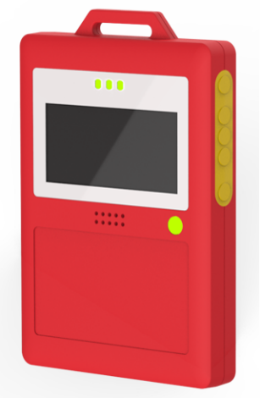

Electrical Specifications
Operating voltage | 3.3V~4.2V
Charging supply | 5V1A
Maximum current | <800mA@3.3V
Listening current | <6Ma@3.3v
Bluetooth transmit current | <10Ma@3.3v
Sleep current | <30Ua@3.3V
Operating temperature | -20℃—60℃
Operating humidity | 0 to 95%, non-condensing

Solar Charging Specifications
Operating voltage | 5V
Operating current | 50mA
Operating power | 0.3W
Open-circuit voltage | 6V
Short-circuit current | 66mA
Operating conditions | Unobstructed sunlight

Display Specifications
Screen size | 2.13In
Screen resolution | 122×250 pixel
Active display area | 23.7×48.5MM

AIS Specifications
Coverage | Typical range: 4 nautical miles with the receiving antenna 10 m above sea level
Positioning mode | GPS / BeiDou
Positioning accuracy | <5m (CEP50)

Operating frequency
LoRa frequency | 470MHz~510MHz
Bluetooth frequency | 2.4~2.485GHz
AIS frequency | AIS channel 1: 161.975 MHz  AIS channel 2: 162.025 MHz

Physical Specifications
Dimensions | 104*70*14.5mm
Color | Red
Weight | 110g
Water resistance | IP68
Housing material | ABS

Additional Specifications
Charging method | Magnetic charging
Charge protection | Overcharge protection
Low-voltage protection | Battery undervoltage and over-discharge protection
Emergency alarm | Supported
Motion and stationary detection | Supported
Vibration notification | Supported
Low-battery notification | Flashing LED
Firmware update | OTA supported

Configuration Functions
Filtering enable | Supported
Transmission frequency | Supported
Motion trigger | High, normal or low sensitivity
Transmission duration after becoming stationary | Supported

Note: Configuration requires a phone supporting Bluetooth 4.2 or later.

