Outdoor Dual Channel UWB Station
English Product Documentation
Designed for one-dimensional positioning in tunnels, utility corridors and metro works. Dual directional antennas and a cast-aluminum enclosure support single-station linear positioning in long, narrow spaces.
Jinju Intelligence (Beijing) Technology Co., Ltd. | zydc0915@gmail.com

Selection Notes
The source also lists up to 800m coverage diameter and a radius greater than 300m. Actual range depends on visibility, antenna direction and the corridor environment. Verify compatible tag channels.
JJ-U Outdoor Dual Channel UWB Positioning Station
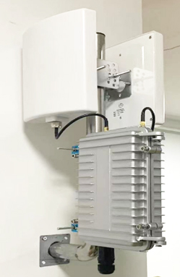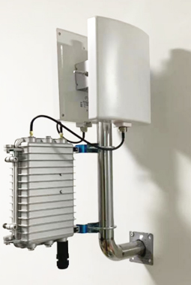

1.1 Product Description
This outdoor long-range dual-channel station supports 1D IoT positioning, half-duplex and full-duplex communication, and 10/100 Mbps Ethernet cloud connectivity. Integrated Bluetooth and UWB baseband chips provide data transfer and ranging. Bluetooth/UWB dual-mode communication serves linear applications such as tunnels, utility corridors and metro works.

1.2 Product Features
One station supports 1D positioning without requiring two UWB stations, reducing equipment and cabling.
The stated maximum coverage diameter is 800 m, reducing station count and installation cost.
The overview specifies 30 cm positioning accuracy and describes improved accuracy and stability relative to Wi-Fi and Bluetooth.
IP67 protection supports demanding tunnel, utility-corridor and metro environments.
Maintenance: Phone mini-program configuration and centralized AC management.
The antennas and station can be mounted together on an L-shaped bracket to simplify installation.
Power: Standard 48 V PoE carries power and return data over Ethernet, reducing cabling requirements.

1.3 Electrical Specifications
Power supply | POE48V
Operating temperature | -20℃—70℃
Operating humidity | 0 to 95%, non-condensing
Power consumption | Less than 3 W

1.4 Technical Specifications
Main MCU | 32-bit ARM M4
Operating frequency | BLE：2.4GHz；UWB：3.5 to 6.5 GHz
Transmit power | BLE：8dBm UWB：-10dBm
Protocol | BLE5.0 802.15.4
Receiver sensitivity | BLE:<-101dBm UWB: <-110dBm
Transmission range* | BLE：200m ； UWB：400m
Encryption | AES encryption supported
UWB channels | 1, 2, 3, 4, 5, 7
UWB data rates | 110 kbps, 850 kbps, 6.8 Mbps
Coverage radius | Greater than 300 m
Ranging accuracy | 30cm

Note: Transmission range is specified for line-of-sight conditions.

1.5 Physical Specifications
Dimensions | 210*130*60
Color | Silver
Weight | 1200g
Material | Cast aluminum
Ingress protection | IP67

1.6 Additional Specifications
Network connection | 10/100 Mbps LAN port
Network addressing | DHCP or static IP
Network transport | UDP
Antenna | Directional panel antenna
Antenna gain | 14dbi
Antenna connector | N-type female

1.7 Configuration Functions
Destination IP | Domain name or IP address supported
Over-the-air update | OTA supported
Configuration method | Bluetooth mini program or AC

UWB antenna connector | N-type
Network interface | RG-45 port (source designation)

1.8 Interfaces

1.9 Operating Environment
1. Mount securely where there is no significant movement, shock or vibration.
2. The environment must contain no gas or vapor that could damage the insulation or protective structure.
3. Use in a non-corrosive environment.
1.10 Packing List
Accessory | JJ-U
Accessory | Dual-channel UWB positioning station
Waterproof main unit | 1 unit
PoE power module | 1 piece
Mounting bracket | 1 piece
Pole mounting clamps | 1 piece
UWB directional antenna | 2 pieces
RF feeder cable | 2 pieces

